**_____________________________________________________________________________**

***Draft Indian Standard***

**SPECIFICATION FOR PNEUMATIC COUPLING BETWEEN**

**TRACTORS AND TRAILERS**

*( First Revision Of IS : 9905 )*

ICS 43.040.70;65.060.10

Not to be reproduced without permission Last date for receipt of

of BIS or used as standard comments is 15.08.2018

## ___________________________________________________________________________

## FOREWORD

This Standard was adopted by the Indian Standards Institution on 31 August 1981, after the draft finalized by the Transport Tractors and Trailers Sectional Committee had been \ approved by the Marine, Cargo Movement and Packaging Division Council.

This standard had been formulated to ensure interchangeability of the pneumatic braking connections between tractors and trailers.

This standard was based on IS0 1728 : 1980 ‘Road vehicles — Pneumatic braking connections between motor vehicles and towed vehicles — Interchangeability’, issued by the International Organization for Standardization.

Revision of this standard has been taken up to accommodate the advancement in technology and to adopt the changes introduced in ISO 1728 :2006.

For the purpose of deciding whether a particular requirement of this standard is complied with, the final value, observed or calculated, expressing the result of a test or analysis, shall be rounded off in accordance with IS 2 : 2005 ‘Rules for rounding off numerical values ( fourth revision)’. The number of significant places retained in the rounded off value should be the same as that of specified value in this standard

***Draft Indian Standard***

**SPECIFICATION FOR PNEUMATIC COUPLING BETWEEN**

**TRACTORS AND TRAILERS**

*( First Revision of IS : 9905 )*

## SCOPE

This standard specifies the requirements which ensure interchangeability of the pneumatic braking connections between motor vehicles and towed vehicles.

It concerns vehicle combinations equipped with pneumatic braking systems with two lines: one control line and one supply line.

## REFERENCES

The standard listed below contain provisions which, through reference in this text, constitute provisions of this standard. At the time of publication, the edition indicated was` valid . Standard is subject to revision, and parties to agreements based on this standard are encouraged to investigate the possibility of applying the most recent edition of the standard listed below.

ISO 4009 : 2000 Commercial vehicles – Location of electrical and pneumatic connections between towing vehicles and trailers.

## Requirements

### General

The towing vehicle shall be equipped with an automatic device ensuring, without manual operation, the continuity of the pipelines when they are coupled, and their closure on uncoupling; this device shall not affect interchangeability.

The coupling head shall make provision for any type of valve to be fitted to the towing vehicle, provided that the valve may be opened by the standard coupling head on the towed vehicle and that the ability to be coupled with all coupling heads corresponding to this standard is not compromised.

### Coupling Head Type

The “Palm type” coupling head shall be used. It shall be fitted with an inhibiting device to prevent incorrect coupling (see Fig. 1 and 2).

### Coupling Head Dimensions

The dimensions of the coupling heads shall be as given in Tables 1 and 2, and as shown in Fig.1 and 2.

NOTE — This standard specifies only the dimensional details necessary for the coupling. All other dimensions not shown, as well as details of design, are left to the discretion of the manufacturer*.*

### Location of Coupling Heads and Flexible Pipe Connections

The locations of both electrical and pneumatic connections between towing and towed vehicles are specified in ISO 4009. The location of coupling heads and flexible pipe connections on the towing and towed vehicles shall comply with ISO 4009.

### Colour Coding for Connections

For the supply line: RED.

For the control line: YELLOW.

The colour shall be related to the coupling head or to a clearly visible point close to the head, for example, pipes or an identification tag.

### Orientation of Coupling Heads

The coupling axis of the fixed coupling heads shall be horizontal. The vertical sealing face shall be located as follows, according to whether it concerns a road train or an articulated road train:

Truck : Towards the right when the vehicle is viewed from the rear;

Semi-trailer : Towards the left when the vehicle is viewed from the rear.

### Length of Flexible Pipe Connections

The length of the flexible pipe connections between towing and towed vehicles is specified in ISO 4009. The length of flexible pipe connections on the towing and towed vehicles shall comply with ISO 4009.

#### Table 1 Dimensions for coupling head for supply line

#### ( *Clause* 3.3)

|  |  |  |
| --- | --- | --- |
| **Connection** | *A* a)  mm | *B*  mm |
| With resilient sealing ring (for heads “tractor” and “trailer”) | 2.7 ± 0.5 | ∅ 19 ± 2 |
| With mobile part providing for the opening of the automatic valve (see 4.1) | 3.5 + 1 | ∅ 21 max.  ∅ 11 min. |
| a) The opening of the automatic device shall be assured even when two coupling heads with the most adverse tolerances for pushing down the mobile part are connected together. It shall be possible to push down the sealing face until the dimension *A* is at zero. | | |

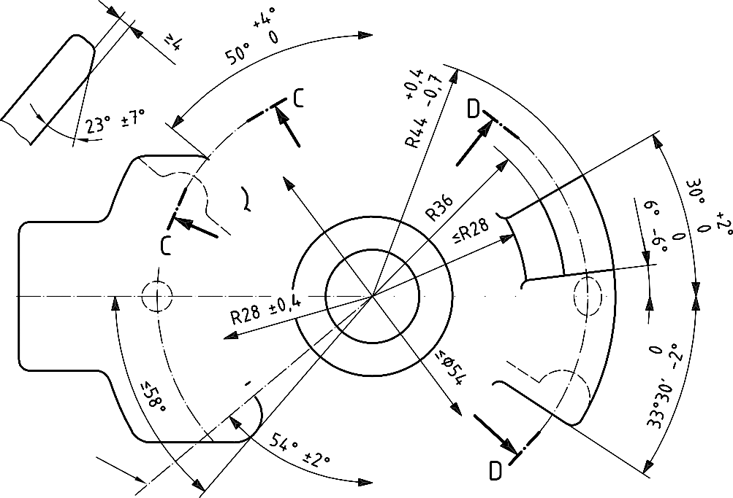

**Key**

1. Sealing face 3 Inhibiting device
2. Coupling axis 4 Stop

#### ( All dimensions in millimeters)

#### FIG. 1 Coupling Head for Supply Line

**ISO 1728:2006(E)**

Dimensions in millimetres

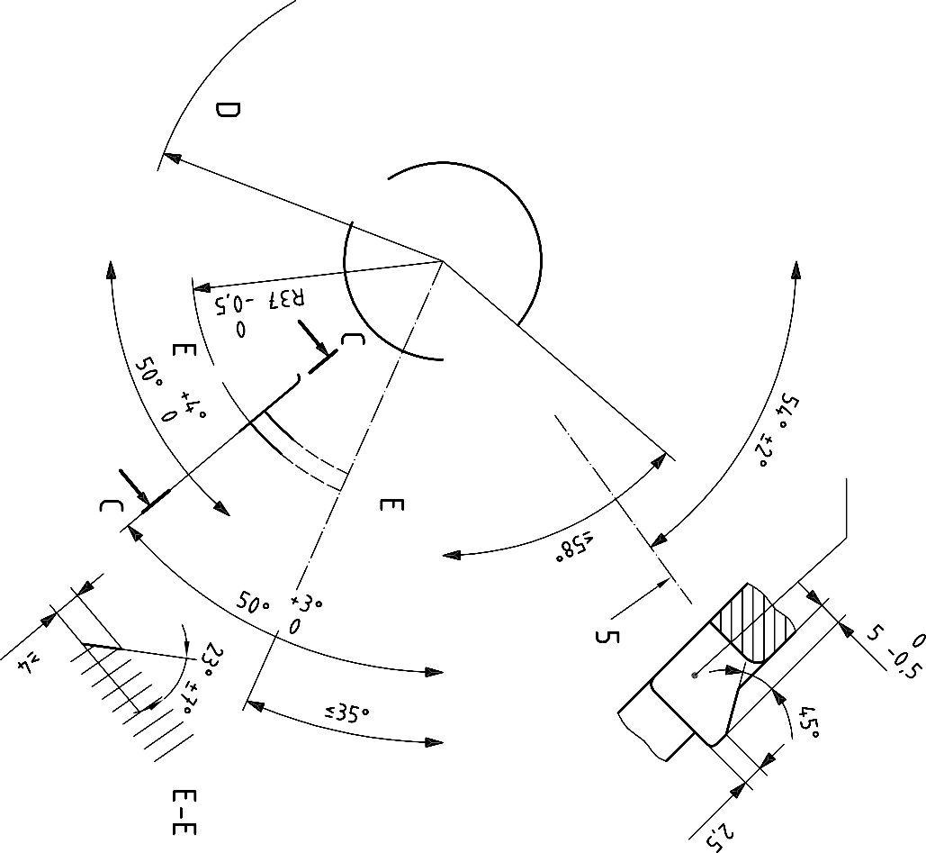

**Key**

1. Minimum free space for the crossing of inhibiting device of the other head
2. Sealing face; 3 Coupling axis; 4 Inhibiting device; 4 Stop

#### ( All dimensions in millimeters)

FIG. 2 Coupling Head for Control Line

#### Table 2 Dimensions for coupling head for control line

#### ( *Clause* 3.3)

|  |  |  |
| --- | --- | --- |
| **Connection** | *A* a)  mm | *B*  mm |
| With resilient sealing ring (for heads “tractor” and “trailer”) | 2.7 ± 0.5 | ∅ 19 ± 2 |
| With mobile part providing for the opening of the automatic valve (see 4.1) | 3.5 + 1 | ∅ 21 max.  ∅ 11 min. |
| a) The opening of the automatic device shall be assured even when two coupling heads with the most adverse tolerances for pushing down the mobile part are connected together. It shall be possible to push down the sealing face until the dimension *A* is at zero. | | |

**Bibliography**

ISO 1726 Road vehicles – Mechanical coupling between tractors and semi-trailers – Interchangeability

**ISO 1728:2006(E)**