**IS 9030 : 2024**

***भारतीय मानक***

***Indian Standard***

**वस्त्रादि — लेमिनेट्स सहित पटसन कपड़ों की सीवन क्षमता — परीक्षण पद्धतियाँ**

*( पहला पुनरीक्षण )*

**Textiles — Seam Strength of Jute Fabrics including their Laminates — Methods of Test**

( *First Revision )*

ICS 59.080.30

© BIS 2024

भारतीय मानक ब्यूरो

BUREAU OF INDIAN STANDARDS

मानक भवन, 9 बहादुर शाह ज़फर मार्ग, नई दिल्ली - 110002

MANAK BHAVAN, 9 BAHADUR SHAH ZAFAR MARG

NEW DELHI - 110002

[www.bis.gov.in](http://www.bis.org.in) [www.standardsbis.in](http://www.standardsbis.in)

**September 2024 Price Group X**

Physical Methods of Test Sectional Committee, TXD 01

FOREWORD

This Indian Standard (First Revision) was adopted by the Bureau of Indian Standards, after the draft finalized by the Physical Methods of Test Sectional Committee had been approved by the Textiles Division Council.

This standard was first published in 1979. This standard was made for prescribing the test method for determination of seam strength of jute fabrics including their laminates on the tensile testing machines based on constant rate of extension (CRE), constant rate of loading (CRL) and constant rate of traverse (CRT) principles. This revision has been brought to incorporate the following major changes:

1. Testing machine based on CRL principle has been excluded;
2. Terms and definitions have been incorporated;
3. Gauge length for grab method has been modified;
4. Test report format has been modified; and
5. References to standards have been updated.

Internationally, CRE based tensile testing machine is being adopted while CRT and CRL are considered to be obsolete. In India, constant-rate-of-elongation (CRE) and constant-rate-of-traverse (CRT) based tensile testing machines are still used. The results obtained by using different test specimens on different tensile testing machines may differ and no simple relationship could generally be given between the various test results.

The performance of made-up items such as bags and tents of jute fabrics and their laminates depends on the seam strength, which is affected by the type of seam, sewing threads, etc, used for giving them the intended shape.

This standard lay down a method of test for determining the behaviour of seams under stress. It does not give details of sewing conditions which should be agreed to between the concerned parties or specified in the relevant specification for made-up finished materials. In case it is intended to compare the seam breaking load values with the fabric breaking load values, it would be advisable to use the same size of the test specimens in both the cases. Until such time the grab test is introduced in the material specifications, strip test should be followed for all jute fabrics including bonded and laminated.

In the preparation of this standard, considerable assistance has been derived from the following standards:

ISO 13935-1 : 2014 Textiles — Seam tensile properties of fabrics and made-up textile articles — Part 1: Determination of maximum force to seam rupture using the strip method

ISO 13935-2 : 2014 Textiles — Seam tensile properties of fabrics and made-up textile articles — Part 2: Determination of maximum force to seam rupture using the grab method

The composition of the Committee responsible for the formulation of this standard is given in Annex A.

In reporting the result of a test or analysis made in accordance with this standard, if the final value, observed or calculated, is to be rounded off, it shall be done in accordance with IS 2 : 2022 ‘Rules for rounding off numerical values (*second revision*)’.

**IS 9030 : 2024**

*Indian Standard*

TEXTILES — SEAM STRENGTH OF JUTE FABRICS INCLUDING THEIR LAMINATES — METHODS OF TEST

**1 SCOPE**

**1.1** This standard prescribes a method for determination of seam breaking strength of jute fabrics including their laminates when the load is applied perpendicularly to the seam using strip and grab method.

**1.2** The sewn seams may be obtained from previously sewn articles, such as bags, tents, etc, or may be prepared from fabric samples. This method only applies to seams in straight line and not to curved seams.

**1.3** This standard is normally not applicable to geotextiles, nonwovens, coated fabrics, textile-glass woven fabrics and fabrics made from carbon fibres.

**2 REFERENCES**

The standards given below contain provisions which, through reference in this text, constitute provisions of this standard. At the time of publication, the edition indicated were valid. All standards are subject to revision, and parties to agreements based on this standard are encouraged to investigate the possibility of applying the most recent edition of the standard indicated below:

|  |  |
| --- | --- |
| *IS No.* | *Title* |
| IS 196 : 2024 | Atmospheric conditions for testing (*second revision*) |
| IS 6359 : 2023 | Method for conditioning of textiles (*first revision*) |

**3 TERMS AND DEFINITIONS**

**3.1 Constant-Rate-of-Extension (CRE) Testing Machine —** A tensile-testing machine provided with one clamp which is stationary and another clamp which moves with a constant speed throughout the test, the entire testing system being virtually free from deflection.

**3.2 Constant-Rate-of-Traverse (CRT) Testing Machine —** Atensile-testing machine provided with one clamp that is being pulled at a uniform rate and the load is applied through the other clamp which moves appreciably to actuate a load measuring mechanism so that the rate of increase of either load or elongation does not remain constant.

**3.3 Gauge Length —** Distance between the two effective clamping points of a testing device.

**3.4 Grab Test —** Tensile test in which only the centre part of the test specimen is gripped in the jaws of the testing machine.

**3.5 Maximum Force to Seam Rupture —** Maximum force recorded when a test specimen with a seam perpendicular to the direction of extension is taken to seam rupture during a tensile test under the specified conditions.

**3.6 Strip Test —** Tensile test in which the full width of the test specimen is gripped in the jaws of the testing machine.

**4 PRINCIPLE**

A rectangular fabric test specimen is prepared with the seam at the middle of the specimen. The specimen is gripped between the two jaws and a longitudinal force perpendicular to the seam is applied till the specimen breaks. The maximum breaking load of the test specimen is recorded.

**5 SAMPLING**

The samples from the previously prepared articles shall be so drawn as to be representative of the lot. Samples drawn in accordance with the procedure laid down in the specification of the material shall be taken as representative of the lot.

**6 APPARATUS**

**6.1 CRE or CRT Machine**

The CRE and CRT machine shall have the general characteristics given in **6.1.1** to **6.1.5**.

**6.1.1** The tensile-testing machine shall be provided with means for indicating or recording the force applied to the test specimen in stretching it to rupture.

**6.1.2** Means for driving by power one of the pair of clamps at a specified constant-rate-of-elongation or constant-rate-of-traverse, as the case may be, so that the test specimen breaks in (20 ± 3) s.

NOTE ⎯ If the arrangement for breaking the specimen within (20 ± 3) s is not there, the test shall be carried out at a constant-rate-of-traverse machine (which is very popular and widely used in India) at the rate of (460 ± 15 mm/min) for strip test and (300 ± 15) mm/min for grab test. In case of constant-rate-of-extension machine (now widely used Internationally), the testing may be carried out at the rate of (100 ± 10) mm/min for strip test and (50 ± 5) mm/min for grab test.

**6.1.3** The machine shall be capable of setting the gauge length to (200 ± 1) mm for strip method and (100 ± 1) mm for grab method or agreed by the parties interested in the results.

**6.1.4** The clamping device of the machine shall be positioned with the centre of the two jaws in the line of applied force, the front edges shall be at right angles to the line of applied force and their clamping faces shall be in the same plane. The jaws shall be capable of holding the test specimen without allowing it to slip and designed so that they do not cut or otherwise weaken the test specimen. The faces of the jaws shall be smooth and flat, except that when, even with packing, the test specimen cannot be held satisfactorily with flat-faced jaws, engraved or corrugated jaws can be used to prevent slippage. Other auxiliary materials for use with either smooth or corrugated jaws to improve specimen gripping include paper, leather, plastics or rubber. It is recommended that serrated metal faced jaws are used when testing fabrics with stretch properties. Different jaw face surfaces may lead to different elongation results.

**6.1.5** The jaws preferably should have a width of at least 60 mm but shall not be less than the width of the test specimen for strip method. For the grab test, the dimensional clamping area of the fabric shall be (25 mm ± 1 mm) × (25 mm ± 1 mm). This area can be achieved by either the method given in a) or b) as follows:

1. One clamp (25 mm) × (40 mm, *Min*, preferably 50 mm), positioned with the wider direction of the clamp perpendicular to the line of application of the force; a second clamp of the same dimensions positioned perpendicular to the first so that the wider direction of the clamp is parallel to the direction of application of the force.
2. One clamp (25 mm) × (40 mm, *Min*, preferably 50 mm), positioned with the wider direction of the clamp perpendicular to the line of application of the force; a second clamp (25 mm) × (25 mm).

NOTE **—** If jaw breaks or slippage cannot be prevented with flat jaws, capstan jaws have often been found suitable.

**6.2** The load range of the machine shall be such that all the observed values would lie between 10 percent and 90 percent of the full-scale load. The permissible error in the machine at any point in this range shall not exceed ± l percent.

**6.3** A pair of scissors or a sharp blade along with measuring scale and stopwatch, etc shall be provided with the tensile-testing machine.

**7 ATMOSPHERIC CONDITIONS FOR CONDITIONING AND TESTING**

Prior to test, the specimens shall be conditioned to moisture equilibrium in the standard atmosphere of (65 ± 2) percent relative humidity and 27 °C ± 2 °C temperature from dry side as laid down in IS 6359 and the test shall be carried out in the standard atmosphere (*see* IS 196). It is recommended that samples be conditioned for at least 24 h in the relaxed state.

**8 PREPARATION OF TEST SPECIMENS**

**8.1** From each sample cut at least five test specimens with the length across the seam and the width parallel to the seam. The size of the specimen shall be as given in Table 1 when read with Fig. 1 and Fig. 2 for strip method and Fig. 3 for grab method. The seam shall be at the middle of the specimen.

NOTE — In case of fabrics where the seams are to be prepared for testing, the concerned parties should agree to the conditions of sewing before testing.

**Table 1 Size of Test Specimens and Jaw Faces**

(*Clause* 8.1)

|  |  |  |
| --- | --- | --- |
| **Sl No.** | **Type of Test** | **Size of Test Specimen**  **[Length (*Min*) × Width]** |
| (1) | (2) | (3) |
|  | Strip test (*see* Note) | 350 mm × 100 mm |
|  | Grab test | 250 mm × 100 mm |
| NOTE **—** Effective width after ravelling = 50 mm. | | |

**8.1.1** During the ravelling of the strip, care shall be taken that wherever possible no thread perpendicular to the seam is cut in the final width of the specimen. Make four cuts of 25 mm length at 10 mm distance from the seam as shown in Fig. 1. Fray down the area shown as shaded in Fig. 1, so that an effective sample width of 50 mm is obtained. In the area within 10 mm of the seam, the full width of 100 mm is maintained and the sample shape when ready for testing is as shown in Fig. 2.

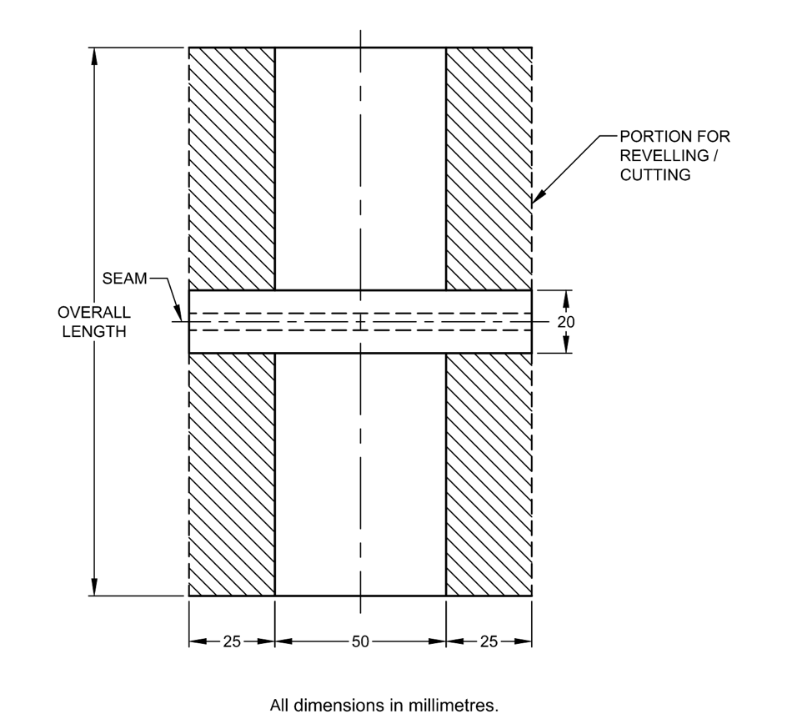

Fig. 1 Shape and Dimensions of Test Specimens (Strip Method)

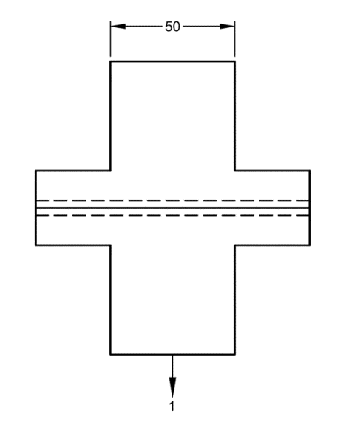

Fig. 2 Test Specimen ready for Testing

**8.1.2** In the case of grab method, draw a line perpendicular to the seam at 37 mm away from one edge of the specimen as shown in Fig. 3.

Fig. 3 Shape and Dimensions of Test Specimens (Grab Method)

**8.2** In case the seams are in both warp and weft directions of the fabric separate specimens shall be prepared and marked with ‘*W*’ for warp and ‘*F*’ for weft, for identification purposes.

**9 PROCEDURE**

**9.1** Set the clamps of the testing machine so that the distance between them is (200 ± 1) mm for strip method and (100 ± 1) mm for grab method or agreed by the parties interested in the results. Take a test specimen and insert it in the clamps of the testing machine so that its longer side is parallel to the direction of application of load with approximately the same length of the fabric extending beyond the jaws of at each end and the seam in the middle of the two clamps. In the case of grab method, the line drawn along the length of the specimen, as mentioned in **8.1**, must coincide with the left-hand side of the 25 mm wide jaws. Secure the test specimen between the jaws of one of the clamps. Through the free end of the specimen, apply a pretension of about one percent of the expected breaking load, and secure it between the jaws of the other clamp.

**9.2** Operate the machine and carry the test to rupture and record the breaking load of the specimen. Also record whether the seam rupture is caused by: (a) fabric yarn breakage, (b) sewing thread breakage, (c) fabric yarn slippage, or (d) a combination of two or more of these reasons.

NOTE — If the specimen slips in the jaw, breaks in the jaws or breaks within 5 mm from the edge, of the jaws, the results shall be excluded but recorded and another specimens tested in lieu thereof.

**9.3** Open both clamps and remove the broken specimen. Take a fresh specimen and determine its breaking load as given in **9.1** and **9.2** and repeat the test with the remaining test specimens. The number of test specimens shall be minimum five or according to the material specification.

**10 CALCULATIONS**

**10.1** Calculate the arithmetic mean of seam breaking force, in newtons/kilograms, of all the test specimens excluding rejections, separately for warp way and weft way.

**10.2** Round-off the result for values:

1. less than 100 N to the nearest 1 N;
2. greater than or equal to 100 N to less than 1 000 N to the nearest 10 N; and
3. greater than or equal to 1 000 N to the nearest 100 N.

**10.3** If required, calculate the coefficient of variation to the nearest 0.1 percent and the 95 percent confidence limits rounded to the same precision as the mean value.

**11 TEST REPORT**

The test report shall include the following information:

1. Description of the material tested and information of seam;
2. Type of test (strip method or grab method);
3. Type of machine used (CRE or CRT);
4. Type of stitch (if applicable);

e) Number of specimens tested;

f) Number of specimens breaking due to:

1) fabric yarn breakage;

2) sewing thread breakage; and

3) a combination of two of the above.

g) Number of tests rejected and reasons/defects for this;

1) fabric yarn slippage;

2) sewing yarn slippage; or

3) specimen breaks at jaw.

h) Arithmetic mean, minimum and a maximum of breaking force of seam;

j) If required, the coefficient of variation of the mean value, in percent; and

k) If required, the 95 percent confidence limits of the mean value, in newtons.

**ANNEX A**

(*Foreword*)

**COMMITTEE COMPOSITION**

Physical Methods of Test Sectional Committee, TXD 01

| *Organization* | *Representative(s)* |
| --- | --- |
| ICAR - Central Institute for Research on Cotton Technology, Mumbai | Dr A. S. M. Raja **(*Chairperson*)** |
| Ahmedabad Textile Industries Research Association, Ahmedabad | Shrimati Deepali Plawat  Shri Jigar Dave (*Alternate*) |
| Central Silk Technological Research Institute, Bengaluru | Dr S. Periyasamy  Dr Prakash N. Bhat (*Alternate*) |
| Delta Ropes Manufacturing Company, Kolkata | Shri Anand Majaria  Shri Aayush Majaria (*Alternate*) |
| Directorate General of Quality Assurance, New Delhi | Shri R. K. Baruah  Shri P. H. Tembhekar (*Alternate*) |
| Garware Technical Fibres Limited, Pune | Shri Kishor J. Darda  Shri Sachin P. Kulkarni (*Alternate*) |
| ICAR - Central Institute for Research on Cotton Technology, Mumbai | Dr T. Senthilkumar  Dr A. Arputharaj (*Alternate*) |
| ICAR - National Institute of Natural Fibre Engineering and Technology, Kolkata | Dr Surajit Sengupta  Dr Nagesh Kumar (*Alternate*) |
| Imposub Solutions, Vadodara | Shri Girish T. Masand |
| Indian Institute of Technology Delhi, Department of Textile and Fibre Engineering, New Delhi | Prof R. S. Rengasamy  Prof Apurba Das (*Alternate*) |
| Indian Jute Industries Research Association, Kolkata | Shrimati Saumita Choudhury  Shri Debi Prasad Gon (*Alternate*) |
| Indian Jute Mills Association, Kolkata | Shri Samir Kumar Chandra  Shri Bhudipta Saha (*Alternate*) |
| Kusumgar Corporates Private Limited, Vapi | Shri Y. K. Kusumgar  Dr M. K. Talukdar (*Alternate*) |
| MSME Testing Center, New Delhi | Shri Phool Singh |
| Northern India Textile Research Association, Ghaziabad | Shri Sanjeev Shukla |
| Office of the Jute Commissioner, Kolkata | Shri Soumyadipta Datta  Shri Mahadeb Dutta (*Alternate*) |
| Office of the Textile Commissioner, Mumbai | Shri Sivakumar S.  Shri Gaurav Gupta (*Alternate*) |
| SGS India Private Limited, Mumbai | Dr Karthikeyan K.  Dr Anitha Jeyaraj (*Alternate*) |
| Testtex India Laboratories Private Limited, Noida | Shrimati Meeta Shingala  Shri Mahesh Sharma (*Alternate*) |
| Texanlab Laboratories Private Limited, Navi Mumbai | Shri Harit Sardana  Shri Vivek Patil (*Alternate*) |
| Textiles Committee, Mumbai | Shri Kartikay Dhanda  Dr P. Ravichandran (*Alternate*) |
| Thanawala and Company, Mumbai | Shri Hemal M. Thanawala  Shri Vivaan Thanawala (*Alternate*) |
| The Bombay Textile Research Association, Mumbai | Shri R. A. Shaikh |
| The Synthetic and Art Silk Mills Research Association, Mumbai | Dr Manisha Mathur  Shrimati A Sudam (*Alternate*) |
| Tirupati Technik, Mumbai | Shri Vishal Masand |
| TUV Rhineland (India) Private Limited, Mumbai | Dr P. S. Sundaram  Shri Shivendra Parmar (*Alternate*) |
| Uster Technologies Private Limited, Mumbai | Shri Jagdish Kulkarni |
| Veermata Jijabai Technological Institute, Mumbai | Dr Suranjana Gangopadhyay  Shri S. P. Borkar (*Alternate*) |
| Welspun India Limited, Mumbai | Shri Rajeev Chauhan  Shri Sridhar Devarakonda (*Alternate*) |
| Wool Research Association, Thane | Shrimati Seema Patel  Shri Mayur Basuk (*Alternate*) |
| World Traders Manufacturing Company, Mumbai | Shri Varun Gupta  Shri Aditya Gupta (*Alternate*) |
| BIS Directorate General | Shri J. K. Gupta, Scientist ‘E’/Director and Head (Textiles) [Representing Director General (*Ex-officio*)] |

*Member Secretary*

Shri Amit Kumar Pandey

Scientist ‘B’/Assistant Director

(Textiles), BIS