**IS 2910 : 2024**

**Doc.No: TXD 14 (24703)**

***भारतीय मानक***

**वस्त्रादि — जूट ब्रॉड लूम्स के लिए शटल्स — विशिष्टि**

*( दूसरा पुनरीक्षण )*

*Indian Standard*

**Textiles** — **Shuttles for Jute Broad Looms** — **Specification**

*( Second Revision )*

ICS 59.120.30

© BIS 2024

**B U R E A U OF I N D I A N S T A N D A R D S**

MANAK BHAWAN, 9 BAHADUR SHAH ZAFAR MARG

NEW DELHI 110002

**July 2024 Price Group**

Textile Machinery and Accessories Sectional Committee, TXD 14

FOREWORD

This Indian Standard (Second Revision) was adopted by the Bureau of Indian Standards, after the draft finalized by the Textile Machinery and Accessories Sectional Committee had been approved by the Textiles Division Council.

A shuttle is a tool designed to neatly and compactly store a holder that carries the thread of the weft yarn while weaving with a loom. Shuttles are thrown or passed back and forth through the shed, between the yarn threads of the warp in order to weave in the weft.

This standard was first published in 1964 and subsequently revised in 1971. The present revision has been made to incorporate the following changes:

a) Forward has been incorporated;

b) Scope of the standard has been incorporated;

c) Reference clause has been incorporated;

d) Marking clause has been modified; and

e) Sampling clause has been incorporated.

The composition of the Committee responsible for the formulation of this standard is given in Annex A.

For the purpose of deciding whether a particular requirement of this standard is complied with, the final value, observed or calculated, expressing the result of a test, shall be rounded off in accordance with IS 2 : 2022 ‘Rules for rounding off numerical values (*second revision*)’. The number of significant places retained in the rounded off value should be the same as that of the specified value in this standard.

*Indian Standard*

TEXTILES — SHUTTLES FOR JUTE BROAD LOOMS — SPECIFICATION

*( Second Revision )*

**1 SCOPE**

This standard prescribes the requirements of the shuttle used in jute broad looms.

**2 REFERENCES**

The standards given below contain provisions which, through reference in this text, constitute provisions of this standard. At the time of publication, the editions indicated were valid. All standards are subject to revision, and parties to agreements based on this standard are encouraged to investigate the possibility of applying the most recent edition of these standards:

|  |  |
| --- | --- |
| *IS No.* | *Title* |
| IS 196 : 1966 | Atmospheric conditions for testing (*revised*) |
| IS 1141 : 1993 | Seasoning of timber — Code of practice (*second revision*) |
| IS 2500 (Part 1) : 2000/ ISO 2859-1:1999 | Sampling procedure for inspection by attributes: Part 1 Sampling schemes indexed by acceptance quality limit (AQL) for lot-by-lot inspection (*third revision*) |
| IS 5944 : 1971 | Specification for accessories for use in shuttles for jute looms |

**3 SHAPE AND DIMENSIONS**

The shape and dimensions of shuttle shall be as shown in Fig. 1 when read with Table 1.

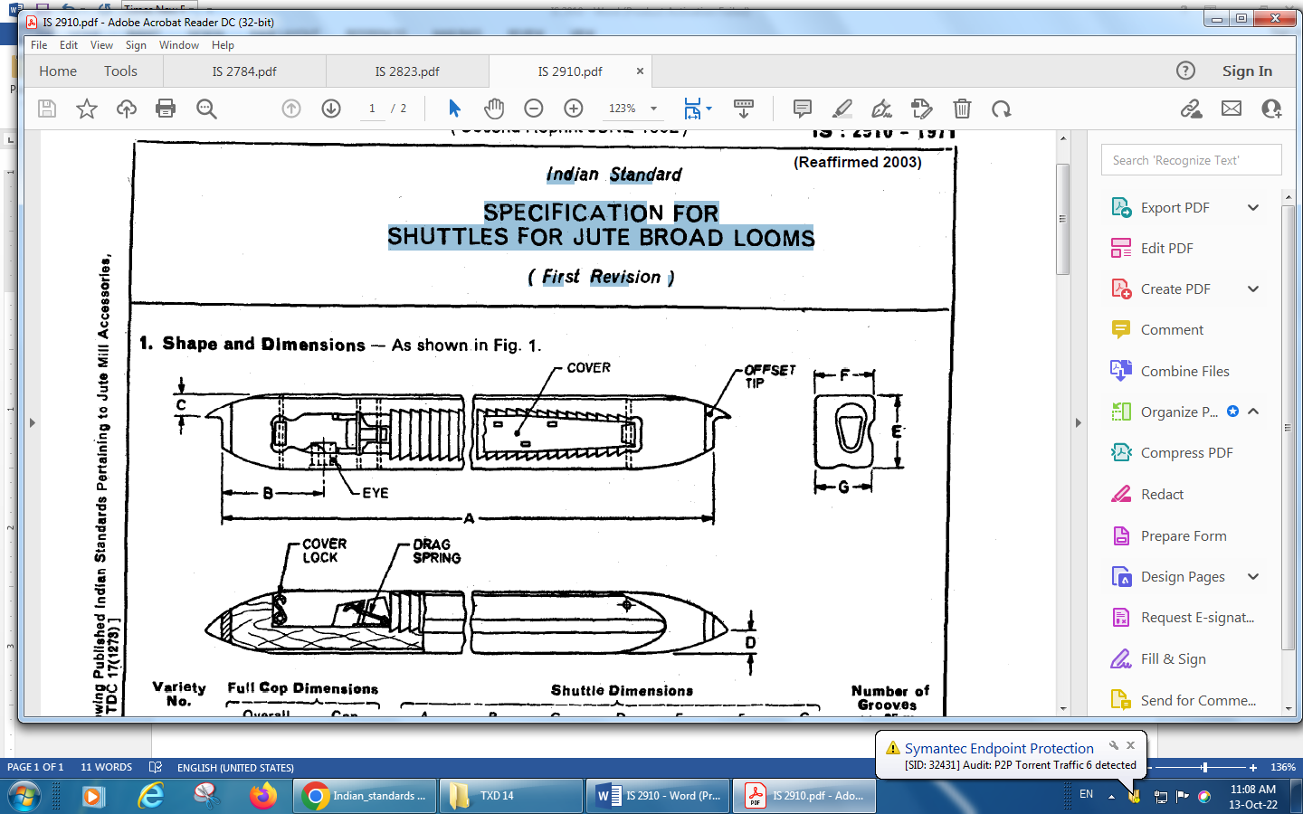

All dimensions in millimetres.

Fig. 1 A Typical Shuttle for Jute Broad Looms

**Table 1 Dimensions of Shuttle for Jute Broad looms**

(*Clause* 3)

|  |  |  |  |  |  |  |  |  |  |  |  |
| --- | --- | --- | --- | --- | --- | --- | --- | --- | --- | --- | --- |
| **Sl No.** | **Variety No.** | **Full Cop Dimensions** | | **Shuttle Dimensions** | | | | | | | **Number of Grooves per 25 mm** |
| **Overall Length of Cop** *Max* | **Cop diameter**  *Max* | **A** | **B** | **C** | **D** | **E** | **F** | **G** |
| (1) | (2) | (3) | (4) | (5) | (6) | (7) | (8) | (9) | (10) | (11) | (12) |
| i) | B1 | 305 | 45 | 612 | 125 | 21 | 21 | 64 | 53 | 51 | 4 |
| ii) | B2 | 355 | 45 | 612 | 110 | 21 | 21 | 64 | 53 | 51 | 4 |
| iii) | B3 | 380 | 45 | 612 | 99 | 21 | 21 | 66 | 53 | 51 | 4 |
| Tolerance, mm | | — | — | ± 2 | ± 1 | ± 1 | ± 1 | ± 0.5 | ± 1 | ± 1 | — |

**4 MATERIAL**

As agreed to between the buyer and the seller, the body of the shuttle shall be made of natural wood or solid compressed from or compressed laminated wood having solid wood as center piece and veneer laminations on the sides.

**5 SHUTTLE ACCESSORIES**

Various accessories used in making shuttles shall preferably conform to the relevant requirements laid down in IS 5944.

**6 WEIGHT**

The weight of individual shuttle shall be 1 550 g ± 175 g.

**7 WORKMANSHIP AND FINISH**

**7.1** Tire wood for the manufacture of shuttles shall be fully seasoned (*see* IS 1141).

NOTE **—** If an agreement between the buyer and the seller so provides, the shuttles made of natural uncompressed wood shall be soaked in raw linseed, groundnut, mineral (spindle), or sperm oil immediately after manufacture for 12 h and then allowed to stand for another 12 h to drain off excess oil.

**7.2** Shuttles shall be free from big knots, cracks and any other visible defect which is likely to affect the life or usefulness of shuttles.

**7.3** The surface shall be sanded smooth.

**7.4** Angle of shuttle (bevel) shall normally be 86° ± 1°.

**8 ATMOSPHERIC CONDITIONS FOR CONDITIONING AND TESTING**

In case of dispute or if agreed to between the buyer and the seller, the test sample shall be conditioned to moisture equilibrium and tested in the standard atmospheric conditions, that is, 65 percent ± 2 percent relative humidity and 27 °C ± 2 °C temperature (*see* *also* IS 196).

**9 SAMPLING**

**9.1** **Lot**

In any consignment, the number of shuttles delivered to a buyer against a dispatch note, shall constitute a lot.

**9.2** Unless otherwise agreed to between the buyer and the seller, the number of shuttles to be selected for inspection, shall be according to co1 (2) and col (3) of Table 2 [*see* IS 2500 (Part 1)].

**9.3** **Criteria for Conformity**

The lot shall be considered conforming to the requirements if the following conditions are satisfied:

|  |  |  |  |
| --- | --- | --- | --- |
| Sl No. | *Characteristic(s)* | *Number of Samples* | *Criteria for Conformity* |
| (1) | (2) | (3) | (4) |
| i) | Shape and dimensions | According to co1 (3) of Table 2 | Number of defective shuttles shall not exceed the corresponding number given in col (5) of Table 2 |
| ii) | Material and all other requirements | According to co1 (4) of Table 2 | All shuttles meet the relevant requirements |

**Table 2 Sample Size and Permissible Number of Defectives**

(*Clauses* 9.2 *and* 9.3)

|  |  |  |  |  |
| --- | --- | --- | --- | --- |
| **Sl No.** | **Lot Size** | **Sample Size** | **Sub-Sample Size** | **Permissible Number of Defectives** |
| (1) | (2) | (3) | (4) | (5) |
| i) | Up to 150 | 8 | 3 | 1 |
| ii) | 151 to 280 | 13 | 3 | 1 |
| iii) | 281 to 500 | 20 | 3 | 2 |
| iv) | 501 and above | 32 | 5 | 3 |

**10 MARKING**

Each shuttle shall bear the name of manufacturer or trade-mark, and a code number to trace the month and year of manufacture.

**10.1** Each shuttle for the jute broad looms shall also bear the following information:

1. Type of the wood used in the shuttle;
2. Net weight of the content;
3. Code number to trace back the history of production;
4. Hand of the shuttle whether right hand (R) or left hand (L);
5. Dimension of the shuttle;
6. Number of shuttles in lot;
7. Gross and net mass;
8. Lot/batch number;
9. Country of origin; and
10. Any other information required by the law in force and/or by the buyer.

**10.2 BIS Certification Marking**

The product(s) conforming to the requirements of this standard may be certified as per the conformity assessment schemes under the provisions of the *Bureau of Indian Standards Act*, 2016 and the Rules and Regulations framed thereunder, and the products may be marked with the Standard Mark.

**11 PACKING**

Shuttles shall be suitably packed as may be agreed to between the concerned parties. The package should contain fixed number of Shuttles essentially of the same variety.

**ANNEX A**

(*Foreword*)

**COMMITTEE COMPOSITION**

Textile Machinery and Accessories Sectional Committee, TXD 14

|  |  |  |
| --- | --- | --- |
| *Organization* |  | *Representative(s)* |
| Central Manufacturing Technology Institute, Bengaluru |  | Dr Nagahanumaian (***Chairperson***) |
| ATE Enterprises Private Limited, New Delhi |  | Shri Abhijit Kulkarni  Shri Anil Kumar Sharma (*Alternate*) |
| Bajaj Industries Private Limited, Kolkata |  | Representative |
| Bhowmick Calculator, Kolkata |  | Shri Goutam Bhowmick  Shri Vivekananda Bhowmick (*Alternate*) |
| Bombay Textile Research Association, Mumbai |  | Shri Vijay Gawde  Shri R. A. Shaikh (*Alternate*) |
| Central Manufacturing Technology Institute, Bengaluru |  | Shri B. R. Mohanraj  Shri K. Saravanan (*Alternate*) |
| Confederation of Indian Textile Industry, New Delhi |  | Shrimati Chandrima Chatterjee  Shri Anmol Gupta (*Alternate*) |
| ICAR-Central Institute for Research on Cotton Technology, Mumbai |  | Dr N. Shanmugam  Dr T. Senthil Kumar (*Alternate*) |
| India ITME Society, Mumbai |  | Shri S. Senthil Kumar  Shrimati Seema Srivastava (*Alternate*) |
| Indian Jute Industries Research Association, Kolkata |  | Shrimati Saumita Choudhury  Shri Partha Sanyal (*Alternate*) |
| Indian Jute Mills Association, Kolkata |  | Shri Bhudipta Saha  Shri Tanmoy Singha (*Alternate*) |
| Indian Textile Accessories and Machinery Manufacturers Association, Mumbai |  | Shri N. D. Mhatre  Shri Chandresh Shah (*Alternate*) |
| Inspiron Engineering Private Limited, Ahmedabad |  | Shri Ankur Soni |
| Kusters Calico Machinery Limited, Karjan |  | Shri Devang Parikh  Shri Shubhasis Sur (*Alternate*) |
| Lagan Engineering Company Limited, Kolkata |  | Representative |
| Lakshmi Machine Works Limited, Coimbatore |  | Shrimati Kalpana A.  Shrimati Divya V. (*Alternate*) |
| *Organization* |  | *Representative(s)* |
| Laxmi Shuttleless Looms Private Limited, Ahmedabad |  | Shri Ketan Sanghvi |
| Ludlow Jute Limited, Kolkata |  | Representative |
| Ministry of Heavy Industries and Public Enterprises, Department of Heavy Industry, New Delhi |  | Shri Sanjeev Gupta  Shri S. Sundar |
| National Safety Council, Navi Mumbai |  | Shri Lalit R. Gabhane  Shri R. R. Deoghare (*Alternate*) |
| Office of the Textile Commissioner, Mumbai |  | Shri N. K. Singh  Shri Narottam Kumar (*Alternate*) |
| Peass Industrial Engineers Private Limited, Navsari |  | Shri Ravi S. Rao  Shri Naimishkumar Ramanlal Tandel (*Alternate*) |
| Technocraft Industries India Limited, Mumbai |  | Shri Ravinder Kumar  Shri R. Murali (*Alternate*) |
| Synthetic and Art Silk Mills Research Association, Mumbai |  | Dr Manisha Mathur  Shri Sanjay Saini (*Alternate*) |
| Truetzschler India Private Limited, Ahmedabad |  | Shri Pravin Kandge  Shri Shiladitya Joshi (*Alternate*) |
| Veermata Jijabai Technological Institute, Mumbai |  | Dr Suranjana Gangopadhyay  Dr S. P. Borkar (*Alternate*) |
| BIS Directorate General |  | Shri J. K. Gupta, Scientist ‘E’/Director and Head (Textiles) [Representing Director General (*Ex-officio*)] |

*Member Secretary*

Shri Swapnil

Scientist ‘B’/ Assistant Director

(Textiles), BIS