**TED 18 (21883) F  
 IS 9496: XXXX**

***भारतीय मानक***

***Indian Standard***

**प्लास्टिक फिशिंग फ्लोट — विशिष्टि**

*(* पहला *पुनरीक्षण )*

**PLASTIC FISHING FLOATS — SPECIFICATION**

*( First Revision )*

ICS 65.150

© BIS 2024



भारतीय मानक ब्यूरो

BUREAU OF INDIAN STANDARDS

मानक भवन, 9 बहादुर शाह ज़फर मार्ग, नई दिल्ली 110002

MANAK BHAVAN, 9 BAHADUR SHAH ZAFAR MARG

NEW DELHI 110002

[www.bis.gov.in](http://www.bis.org.in) [www.standardsbis.in](http://www.standardsbis.in)

**December 2024 Price Group**

Inland Harbour Crafts and Fishing Vessels Sectional Committee, TED 18

FOREWORD

This Indian Standard (First Revision) was adopted by Bureau of Indian Standards, after the draft finalized by the Inland Harbour Crafts and Fishing Vessels Sectional Committee is approved by the Transport Engineering Division Council.

Floats are one of the accessories of the fishing net and are buoyant objects.

Buoyancy of the floats changes with the sizes and mass in the case of hollow floats and with the size and density in the case of the sponge plastic. Therefore, the size alone is not the sole indication of the buoyancy of a float. Further, since the hydrodynamic behavior of the float changes with the trawling speed, it is important to consider this aspect in deciding the characteristics of these floats.

This standard was first published in 1980 as IS 9496 (Part 1) covering floats made of aluminium alloy and glass. The other part of the standard was to cover the floats of other materials, especially of plastics.

With the introduction of new materials like high density polyethylene (HDPE), poly vinyl chloride (PVC), acrylonitrile-butadiene-styrene (ABS), ethylene vinyl acetate (EVA), expanded polystyrene etc, plastic floats have, almost completely, replaced floats made of wood, glass and aluminium due to their high buoyancy, pressure withstanding capacity and durability.

This revision is being undertaken to update the standard and to incorporate latest technological advancement/development that has taken place in various fields. The salient features of this first revision are:

1. The designation of Indian Standard has been changed from IS 9496 (Part 1) to IS 9496;
2. The Indian Standard is now covering floats made of plastic material only;
3. The standard has been drafted as per latest drafting guidelines; and
4. Reference to Indian Standard has been updated.

The composition of the Committee responsible for the formulation of this standard is given at Annex C.

In reporting the result of a test or analysis made in accordance with this draft standard, if the final value, observed or calculated, is to be rounded off it shall be done in accordance with IS 2 : 2022 ‘Rules for rounding off numerical values (*second revision*)’. The number of significant places retained in the rounded off value should be the same as that of the specified value in this standard.

*Indian Standard*

PLASTIC FISHING FLOATS — SPECIFICATION

( *First Revision* )

**1 SCOPE**

**1.1** This standard prescribes shape and performance requirements of plastic floats used in fishing net.

**1.2** Section 2 covers floats made of high density polyethylene (HDPE) having spherical, apple and disc shape while Section 3 covers floats made of poly vinyl chloride (PVC), having apple, disc and egg shape.

**2 REFERENCE**

This standard given below contain provisions, which through reference in this text, constitutes provisions of this standard. At the time of publication the edition indicated were valid. This standard is subject to revision and parties to agreements based on this standard is encouraged to investigate the possibility of applying the most recent edition of these standard:

|  |  |
| --- | --- |
| *IS No.* | *Title* |
| IS 2500 (Part 1) : 2000 | Sampling inspection procedures: Part 1 Attribute sampling plans indexed by acceptable quality limit (AQL) for lot-by-lot inspection (*third revision*) |
| IS 7328 : 2020 | Specification for polyethylene material for moulding and extrusion (*third revision*) |
| IS 17658 : 2021 | Poly vinyl chloride (PVC) homopolymers — Specification |

**3 TERMINOLOGY**

**3.1 Extra Buoyancy —** The net upward thrust of the float when fully submerged in water.

**SECTION 1 GENERAL REQUIREMENTS APPLICABLE TO BOTH TYPES OF PLASTIC FLOATS**

**4 REQUIREMENT**

**4.1 Material**

The material of float shall be as specified in respective section.

**4.2** Shape and dimensions of the floats shall be as specified in respective section.

**4.3** Manufacture and shape of the floats shall be as specified in respective section.

**5 TESTING**

The selected samples of the floats shall be subjected to the extra buoyancy test and pressure test, according to the method given in Annex A and Annex B respectively. The pressure test shall be carried out for a period of 48 h.

**6 DESIGNATION**

The float shall be designated in terms of its material, shape, extra buoyancy and the maximum depth of its operation.

*Example:*

An HDPE spherical float of extra buoyancy 400 g and 70 m maximum depth of operation shall be designated as:

Float — HDPE — Spherical — 400 —70

**7 MARKING**

**7.1** The floats shall be marked with indelible printing or embossed with the following information:

1. Name, initials or recognized trade-mark of the manufacturer; and
2. Designation of float.

**7.2 BIS Certification Marking**

The product(s) conforming to the requirements of this standard may be certified as per the conformity assessment schemes under the provisions of the *Bureau of Indian Standards*  *Act*, 2016 and the Rules and Regulations framed thereunder, and the product(s) may be marked with the Standard Mark.

**8 SAMPLING**

Unless otherwise agreed upon between a supplier and purchaser, the inspection sampling shall be as per IS 2500 (Part 1)*.*

**SECTION 2 HIGH DENSITY POLYETHYLENE (HDPE) FLOATS**

**9 REQUIREMENT**

**9.1 Material**

The floats shall be made of high density polyethylene conforming to IS 7328.

**9.2** The dimensions of the float shall be as specified in Table 1.

**10 MANUFACTURE**

HDPE spherical shaped floats are made of two hemispheres joined at the seam and provided with an eye at the end through which float line is passed for attaching to the net (Fig. 1). apple shaped (Fig. 2) and disc shaped (Fig. 3) floats shall have a hole in the centre for attaching with the floatline.

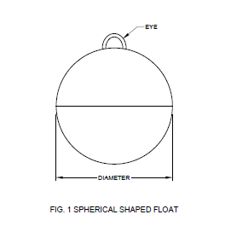

Fig. 1 Spherical Shaped Float

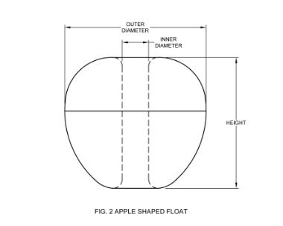

Fig.2 Apple Shaped Float

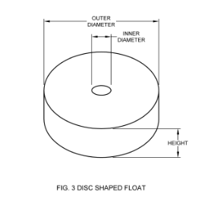

Fig. 3 Disc Shaped Float

**SECTION 3 POLYVINYL CHLORIDE (PVC) FLOATS**

**11 REQUIREMENT**

**11.1 Material**

The floats shall be made of polyvinyl chloride conforming to IS 17658.

**11.2** The dimensions of the float shall be as specified in Table 2.

**12 MANUFACTURE**

Floats of Polyvinyl Chloride shall be disc shaped (Fig. 4), apple shaped (Fig. 5) and egg shaped (Fig. 6) having a hole in the centre for attaching with the floatline.

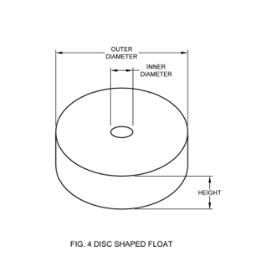

Fig. 4 Disc Shaped Float

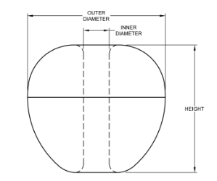

Fig.5 Apple Shaped Float

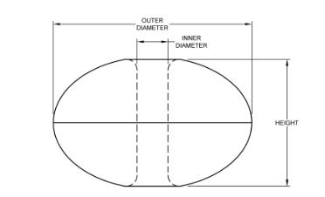

Fig. 6 Egg Shaped Float

**Table 1 Requirements of HDPE Fishing Floats**

(*clause* 9.2)

|  |  |  |  |  |  |
| --- | --- | --- | --- | --- | --- |
| **Sl No.** | **Shape** | **Dimension** | **Extra Buoyancy** | **Pressure the Floats Shall Withstand in Water** | **Maximum Depth Upto Which Float Can be Operated** |
|  |  | (mm)  Diameter | g | kgf/cm2 | metre |
| (1) | (2) | (3) | (4) | (5) | (6) |
| i) | Spherical | 125 | 600 | 9 | 90 |
| 100 | 400 | 7 | 70 |
| 75 | 230 | 6 | 60 |
| ii) | Apple shape | Outer Diameter  × height × inner  diameter |  | | |
| 110 × 86 × 21 | 550 | 2 | 20 |
| 107 × 77 × 20 | 435 | 3.5 | 35 |
| 97 × 74 × 18 | 360 | 2.4 | 24 |
| 87 × 58 × 17 | 220 | 2.4 | 24 |
| 64 × 41 × 11 | 80 | 3.2 | 32 |
| 56 × 31 × 10 | 50 | 2 | 20 |
| 45 × 35 × 7 | 25 | 5 | 50 |
| 25 × 20 × 6 | 5 | 10 | 100 |
| iii) | Dis shape | Outer Diameter  × height × inner  diameter |  |  |  |
| 15 × 20 × 13 | 70 | 10 | 100 |
| 130 × 15 × 9 | 60 | 10 | 100 |
| 100 × 20 × 14 | 130 | 10 | 100 |
| 80 × 10 × 8 | 40 | 10 | 100 |
| 70 × 20 ×14 | 55 | 10 | 100 |
| 60 × 20 × 8 | 35 | 8 | 80 |
| 50 × 15 × 7 | 15 | 8 | 80 |
| 50 × 10 × 6 | 15 | 5 | 50 |
| 45 × 25 × 8 | 20 | 10 | 100 |
| 40 × 20 × 9 | 20 | 10 | 100 |
| 40 × 15 × 8 | 10 | 10 | 100 |
| 35 × 12 × 6 | 6 | 10 | 100 |
| 25 × 10 × 5 | 4 | 10 | 100 |
| NOTE — A tolerance of ±10 percent may be allowed to the requirements given in the above Table for acceptance. | | | | | |

**Table 2 Requirements of PVC Fishing Floats**

(*clause* 11.2)

|  |  |  |  |  |  |
| --- | --- | --- | --- | --- | --- |
| **Sl No.** | **Shape** | **Dimension** | **Extra Buoyancy** | **Pressure the Floats Shall Withstand**  **in Water** | **Maximum Depth**  **Upto Which Float Can Be Operated** |
|  |  | (mm) | g | kgf/cm2 | metre |
| (1) | (2) | (3) | (4) | (5) | (6) |
| i) | Disc shape | Outer diameter ×  height × inner  diameter |  |  |  |
| 150 × 190 × 22 | 2795 | 5 | 50 |
| 150 × 20 × 12 | 272 | 5 | 50 |
| 150 × 15 × 10 | 215 | 5 | 50 |
| 125 × 20 × 12 | 197 | 5 | 50 |
| 100 × 125 × 14 | 769 | 5 | 50 |
| 100 × 75 × 12 | 464 | 5 | 50 |
| 100 × 50 × 13 | 330 | 5 | 50 |
| 100 × 20 × 12 | 121 | 5 | 50 |
| 90 × 20 × 12 | 100 | 5 | 50 |
| 80 × 60 × 12 | 235 | 5 | 50 |
| 80 × 40 × 10 | 160 | 5 | 50 |
| 80 × 20 × 10 | 80 | 5 | 50 |
| 70 × 60 × 9 | 160 | 5 | 50 |
| 70 × 30 × 8 | 90 | 5 | 50 |
| 70 × 20 × 10 | 67 | 5 | 50 |
| 60 × 50 × 9 | 108 | 5 | 50 |
| 60 × 20 × 9 | 46 | 5 | 50 |
| 50 × 40 × 11 | 70 | 5 | 50 |
| 50 × 30 × 10 | 50 | 5 | 50 |
| 50 × 20 × 9 | 30 | 5 | 50 |
| 50 × 10 × 9 | 17 | 5 | 50 |
| 45 × 20 × 9 | 20 | 5 | 50 |
| ii) | Apple  shape | 100 × 70 × 9 | 370 | 50 | 50 |
| 70 × 50 × 9 | 110 | 50 | 50 |
| iii) | Egg  shape | 80 × 150 × 12 | 425 | 5 | 50 |
| 70 × 125 × 10 | 250 | 5 | 50 |
| NOTE — A tolerance of +10 percent may be allowed to the requirements given in the above table for acceptance | | | | | |

**ANNEX A**

(*Clause* 5)

**EXTRA BOUYANCY TEST**

**A-1 APPARATUS**

It consists of a circular iron frame to which loose webbings of netting yarns is attached to form a bag. From the frame two strings are attached which are held up by a wooden plank. Another set of 3 strings of suitable length attached to the frame join below and carries weight. part of the system consisting of the iron frame, set of strings with weight and a portion of the part of the strings holding the wooden platform is immersed in water container (Fig. 7).

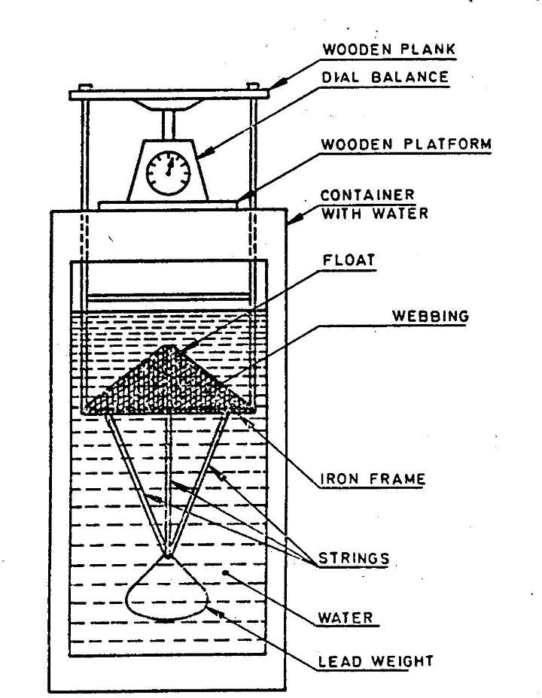

Fig. 7 Experimental Set Up to Measure the Extra Buoyancy of Floats

**A-2 PROCEDURE**

Extra buoyancy of fishing floats is determined in the experimental setup as depicted in Fig. 7 A weighing balance is placed over the water container to measure the extra buoyancy. The initial reading on the balance is noted. The weights are adjusted to see that the net remain completely submerged under water. Then the float is introduced under the webbing which is kept submerged in water. The buoyancy of the float causes a reduction in the reading. After noting down the final reading the float is removed. The difference between initial and final readings corresponds to the extra buoyancy of that float. Ten such floats are tested and the mean value can be taken.

**A-3 ASSESSMENT OF RESULTS**

The specimen when tested as above shall meet the requirements given in Table 1.

**ANNEX B**

(*Clause* 5)

**PRESSURE TEST**

**B-1 APPARATUS**

The pressure withstanding capacity of the floats are tested using specially designed high pressure autoclave/high pressure testing chamber (HP Chamber) as given in Fig. 8.

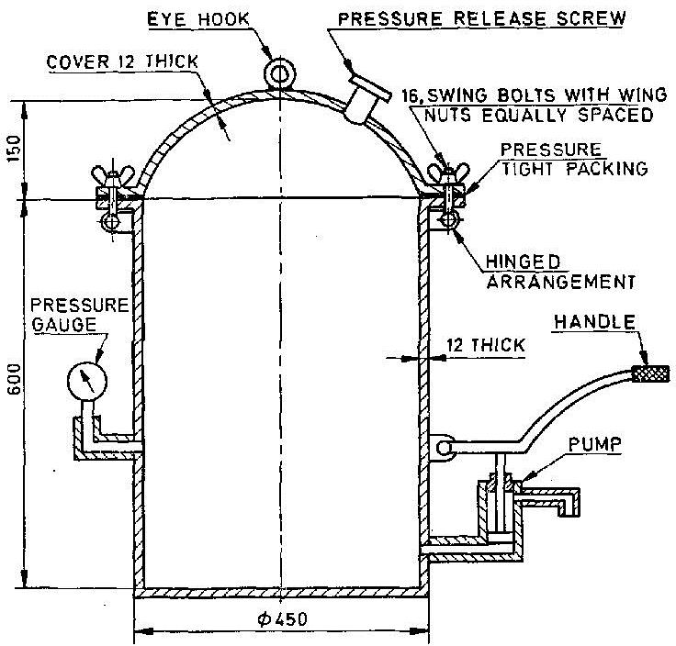

All measurements in millimetre

Fig 8. High Pressure Tank

**B-2 PROCEDURE**

The float to be tested is placed inside the high pressure test chamber (Fig. 8) and tied to a clamp to maintain the float at the centre of the chamber to prevent it from floating to the top of the chamber. The lid of the chamber is closed and water pumped in, filling the chamber completely using a pump leaving no air pockets inside. The pressure is then increased gradually to the required level till the float fails. This is accomplished by pumping in more water inside the closed chamber. If the float bursts at a certain pressure there will be a deflection on the pressure gauge connected to the chamber. The deflection on the pressure gauge is monitored and the pressure at burst is noted. This gives the maximum pressure that the float can withstand under operation. Afterwards, the pressure is released slowly, water emptied and the float is taken out and examined for the extent of physical damages and its condition after the test.

**B-3 ASSESSMENT OF RESULTS**

The specimen when tested as above shall meet the requirements given in Table 1.

**ANNEX C**

(*Foreword*)

**COMMITTEE COMPOSITION**

Inland, Harbour Crafts and Fishing Vessels Sectional Committee, TED 18

| *Organization* |  | *Representative(s)* |
| --- | --- | --- |
| Indian Register of Shipping, Mumbai |  | Shri H.V. Ramesh **(*Chairperson*)** |
| American Bureau of Shipping, Mumbai |  | Shri A. N. Das  Shri Arnab Ghosh (*Alternate*) |
| Ashok Leyland Ltd, Mumbai |  | Shri C. G. Belsare  Shri Sumit Vyas (*Alternate*) |
| Central Institute of Fisheries Nautical and Engineering Training, Kochi |  | Shri Sunil B. Rangari |
| Central Institute of Fisheries Technology (ICAR), Kochi |  | Dr Leela Edwin  Shri M.V. Baiju (*Alternate*) |
| Chowgule and Co Private Limited, Mormugao |  | Shri P Chakrabarty  Shri Khrisler Mascarenhas (*Alternate*) |
| Cochin University of Science and Technology, Department of Ship Technology, Cochin |  | Dr K. Shivaprasad  Shri Anishkumar M. N (*Alternate*) |
| Cyriac Elias Voluntary Association (CEVA), Kochi |  | Fr Varghese Kokkadan  Dr Antony Gregory (*Alternate*) |
| Delhi Earth Station Space Applications Centre, Department of Space, New Delhi |  | Shrimati Shahana K. |
| Directorate General of Quality Assurance, New Delhi |  | Shri S. M. Bhosale  Shri Moninder Pal Singh (*Alternate*) |
| Directorate General of Shipping, Mumbai |  | Shri J. Senthil Kumar  Shri Gopikrishna C (*Alternate*) |
| Directorate of Naval Architecture, Naval Headquarters, New Delhi |  | Shri Sujit Baxi  Shri Pankaj Grover (*Alternate*) |
| Directorate of Naval Design, Naval Headquarters,  New Delhi |  | Shri K. S. N. Kumar |
| Dredging Corporation of India Ltd, Vizag |  | Prof G. Y. V. Victor  Capt S. Divakar (*Alternate*) |
| Fine Finish Organics Pvt Ltd, Mumbai |  | Shri G. S. Prabhu  Shrimati Karishma Prabhu (*Alternate*) |
| Fishery Survey of India, Mumbai |  | Shri Shailendra Kumar Jaiswal |
| Goa Glass Fibre Limited, Goa |  | Shri Emani Venkata Rama Krishna  Shri Nitin Pandurang Sonam (*Alternate*) |
| Goa Shipyard Ltd, Goa |  | Shri Santosh Kumar Singh  Shri Dominic Cardoso (*Alternate*) |
| Indian Diesel Engine Manufacturers Association, (IDEMA), New Delhi |  | Shri Arvind Ranganathan  Shri Karthik Sarma (*Alternate*) |
| Indian Institute of Technology Kharagpur |  | Shri Vishwanath Nagarajan  Prof O. P. Sha (*Alternate*) |
| Indian Institute of Technology Madras, Chennai |  | Shri Rajiv Sharma  Prof S. K. Bhattacharya (*Alternate*) |
| Indian Maritime University (IMU), Visakhapatnam |  | Shri Sheeja Janardhanan  Shri G. V. V. Pavan Kumar (*Alternate*) |
| Indian Register of Shipping, Mumbai |  | Shri S. Renganathan |
| Inland Waterways Authority of India, Noida |  | Shri S. V. K. Reddy |
| Institute of Marine Engineers India, Mumbai Engineers (India), Mumbai |  | Shri Sivaram Narayana Swami  Shri Anand Mohan Mani (*Alternate*) |
| Kerala Shipping and Inland Navigation Corporation Ltd., Kochi |  | Shri K. K. Abdul Gaffoor  Shri K. R. Anoop Kumar (*Alternate*) |
| Kolkata Port Trust, Kolkata |  | Capt A. K. Bagchi |
| Lloyd’s Register Asia, Mumbai |  | Shri C. R. Dash  Shri Srikanth Saripaka (*Alternate*) |
| Mazagon Dock Ltd., Mumbai |  | Shri Biju George  Shri Manoj R. Pai (*Alternate*) |
| Ministry of Ports, Shipping and Waterways, New Delhi |  | Shri Anil Pruthi  Shri Ramji Singh (*Alternate*) |
| Raksha Polycoats Pvt. Ltd., Pune |  | Shri Abhijit Sarkar  Shri Abhijit Andurkar (*Alternate*) |
| Saertex India Pvt. Ltd., Pune |  | Shrimati Deepa S.  Shri Milind Pande (*Alternate*) |
| Shipyards Association of India, New Delhi |  | Shri P. R. Govil |
| Shoft Shipyard Private Limited, Thane |  | Shri Binod Kumar Sah  Shri P. Ganesh Kumar (*Alternate*) |
| Timblo Drydocks Pvt Ltd., Margao |  | Cdr Subhash Mutreja  Cdr Raju Ganapathy (*Alternate*) |
| Titagarh Wagons Limited, Kolkata |  | Shri Vineet Shrivastava |
| Vedam Design and Technical Consultancy Pvt Ltd Mumbai |  | Shri Paritosh Barui |
| In Personal Capacity (*A-1201, Raheja Sherwood, Near HUB Mail W. Exp. Highway, Goregaon (East), Mumbai – 400063*) |  | Shri S. M. Rai |
| BIS Directorate General |  | Shri P V Srikanth, Scientist ‘D’/ Joint Director and Head (Transport Engineering) [Representing Director General (*Ex-officio*)] |
| *Member Secretary*  Shri Sharad Kumar  Scientist ‘D’/ Joint Director  (Transport Engineering Department) | | |