**TED 26 (18380) F**

***भारतीय मानक***

***Indian Standard***

**IS 15722: XXXX**

**सड़क वाहन – संपीड़ित प्राकृतिक गैस (सीएनजी)/जैव-संपीड़ित प्राकृतिक गैस (जैव-सीएनजी) – ईंधन प्रणाली के घटक – सिरे कनेक्शन सहित सीएनजी निम्न दाब नम्य ईंधन लाईन [2.15 मैगापास्कल (21.5 बार) से कम दाब की सीएनजी ईंधन लाईन]**

*( पहला पुनरीक्षण )*

**Road Vehicles — Compressed Natural Gas (CNG) / Bio- Compressed Natural Gas (Bio - CNG) — Fuel System Components — Flexible Fuel Line with End Connections [CNG Fuel Line Having Pressure Not Exceeding 2.15MPA (21.5 Bar)]**

( *First Revision* )

ICS 43.060.40

© BIS 2024

भारतीय मानक ब्यूरो

BUREAU OF INDIAN STANDARDS

मानक भवन, 9 बहादुर शाह ज़फर मार्ग, नई दिल्ली - 110002

MANAK BHAVAN, 9 BAHADUR SHAH ZAFAR MARG

NEW DELHI - 110002

[www.bis.gov.in](http://www.bis.org.in) [www.standardsbis.in](http://www.standardsbis.in)

**October 2024 Price Group X**

Automotive Vehicles Running on Non-Conventional Energy Sources Sectional Committee, TED 26

FOREWORD

This Indian Standard (First Revision) was adopted by the Bureau of Indian Standards, after the draft finalized by the Automotive Vehicles Running on Non-Conventional Energy Sources Sectional Committee had been approved by the Transport Engineering Division Council.

This standard was first published in 2006 to specify definitions, test methods and requirements of CNG low-pressure flexible fuel line with end connections of CNG onboard fuel system component having service pressure not exceeding 2.15 MPa (21.5 bar), intended for use on motor vehicles defined in IS 14272. This version of the standard incorporates the content of the amendment issued to the standard in 2012. In this Revision, Bio- CNG is also added to the scope of this standard keeping in view the technological advancements that have taken place since its last publication.

In the formulation of this standard considerable assistance has been derived from the following AIS Standards issued by the Automotive Research Association of India:

AIS 024 (Rev. 1) (Part A) — Safety and procedural requirements for type approval of gaseous fuelled vehicles — Part A (Automotive application)

AIS 024 (Rev. 1) (Part B) — Safety and procedural requirements for type approval of gaseous fuel agricultural tractors — Part B (Agricultural tractors application)

AIS 024 (Rev. 1) (Part C) — Safety and procedural requirements for type approval of gaseous fuel vehicles — Part C (CEV’s application)

AIS 028 (Rev. 1) (Part A) — Code of practice for use of gaseous fuels in internal combustion engine vehicles — Part A (Automotive application)

AIS 028 (Rev. 1) (Part B) — Code of practice for use of gaseous fuels in internal combustion engine agricultural tractors — Part B (Agricultural tractors application)

AIS 028 (Rev. 1) (Part C) — Code of practice for use of gaseous fuels in internal combustion engine construction equipment vehicles (CEV’s) — Part C (CEV’s application)

SAE J30 : 1998 — Fuel and oil hoses

This standard is one of the series of Indian Standards published on CNG/bio-CNG onboard fuel system components. Other standards in the series are:

| *IS No.* | *Title* |
| --- | --- |
| IS 15710 : 2024 | Road vehicles — Compressed natural gas (CNG)/bio-compressed natural gas (bio-CNG) fuel system components — General requirements and definitions |
| IS 15711 : 2024 | Road vehicles — Compressed natural gas (CNG)/bio-compressed natural gas (bio-CNG) fuel system components — Performance and general test methods (*first revision*) |
| IS 15712 : 2024 | Road vehicles — Compressed natural gas (CNG)/bio-compressed natural gas (bio-CNG) fuel system components — Automatic valve (solenoid valve) (*first revision*) |
| IS 15713 : 2024 | Road vehicles — Compressed natural gas (CNG)/bio-compressed natural gas (bio-CNG) fuel system components — Pressure regulator (*first revision*) |
| IS 15714 : 2024 | Road vehicles — Compressed natural gas (CNG)/bio-compressed natural gas (bio-CNG) fuel system components — Gas air mixer (*first revision*) |
| IS 15715 : 2024 | Road vehicles — Compressed natural gas (CNG)/bio-compressed natural gas (bio-CNG)/ Liquefied petroleum gas (LPG) fuel system components — CNG/bio-CNG/LPG conduit (ventilation hose/pipe) (*first revision*) |
| IS 15716 : 2024 | Road vehicles — Compressed natural gas (CNG)/bio-compressed natural gas (bio-CNG) fuel system components — CNG/bio-CNG high pressure fuel line (rigid) with end connections [having pressure exceeding 2.15 MPa (21.5 bar)] |
| IS 15717 : 2024 | Road vehicles — Compressed natural gas (CNG)/bio-compressed natural gas (bio-CNG)/ Liquefied petroleum gas (LPG) fuel system components — Petrol valve (automatic/manual) |
| IS 15718 : 2024 | Road vehicles — Compressed natural gas (CNG) /bio-compressed natural gas (bio-CNG) fuel system components — CNG/bio-CNG high pressure fuel line (flexible hose) with end connections (having pressure exceeding 2.15 MPa) |
| IS 15719 : 2024 | Road vehicles — Compressed natural gas (CNG)/bio-compressed natural gas (bio-CNG)/ liquefied petroleum gas (LPG) fuel system components — Electrical wiring kit |
| IS 15720 : 2024 | Road vehicles — Compressed natural gas (CNG)/bio-compressed natural gas (bio-CNG) /liquefied petroleum gas (LPG) fuel system component — Compartments/ sub-compartments |
| IS 15721 : 2024 | Road vehicles — Compressed natural gas (CNG)/bio-compressed natural gas (bio-CNG)/ liquefied petroleum gas (LPG) fuel system components — Fire retardant material for seat, upholstery, roof and side lining |

The composition of the Committee responsible for the formulation of this standard is given in Annex B.

For the purpose of deciding whether a particular requirement of this standard is complied with, the final value, observed or calculated, expressing the result of test or analysis, shall be rounded off in accordance with IS 2 : 2022 ‘Rules for rounding off numerical values (Second Revision)’. The number of significant places retained in the rounded off value should be the same as that of the specified value in this standard.

*Indian Standard*

ROAD VEHICLES — COMPRESSED NATURAL GAS (CNG)/BIO-COMPRESSED NATURAL GAS (BIO-CNG) — FUEL SYSTEM COMPONENTS — FLEXIBLE FUEL LINE WITH END CONNECTIONS [CNG FUEL LINE HAVING PRESSURE NOT EXCEEDING 2.15 MPa (21.5 BAR)]

*(* *First Revision )*

**1 SCOPE**

**1.1** This standard specifies definitions, test methods and requirements of CNG/bio-CNG flexible fuel line with end connection of CNG/bio-CNG onboard fuel system component having service pressure not exceeding 2.15 MPa (21.5 bar), intended for use on motor vehicles defined in IS 14272.

**1.1.1** This standard is applicable to CNG/bio-CNG fuel system components intended to be used on vehicles using compressed natural gas/bio-compressed natural gas in accordance with IS 15320 (Part 1) (mono-fuel or bi-fuel applications or dual fuel applications).

**1.1.2** This standard is not applicable to the following:

a) Liquefied natural gas (LNG) fuel system components located upstream of, and including, the vaporizer;

b) Fuel containers;

c) Stationary gas engines;

d) CNG / Bio- CNG fuel systems components for the propulsion of marine craft; and

e) Hydrogen Natural Gas Blend (HCNG) Fuel system components

**1.1.3** This standard is based upon a service pressure for compressed natural gas/bio-compressed natural gas as a fuel at 20 MPa (200 bar) settled at 15 °C. Other service pressures could be accommodated by adjusting the pressure by the appropriate factor (ratio). For example, a 25 MPa (250 bar) service pressure system will require pressures to be multiplied by 1.25. All references to pressure are to be considered gauge pressures unless otherwise specified.

**2 REFERENCES**

The standards listed in Annex A contain provisions which, through reference in this text, constitute provisions of this standard. At the time of publication, the editions indicated were valid. All standards are subject to revision and parties to agreements based on this standard are encouraged to investigate the possibility of applying the most recent edition of these standards.

**3 DEFINITIONS**

For the purpose of this standard definitions given in IS 15710 shall apply.

**4 CLASSIFICATION**

**4.1** CNG/bio-CNG flexible fuel lines are classified into following three classes:

a) Class 1 — Hose suitable for use in temperature up to 100 °C;

b) Class 2 — Hose suitable for use in temperature up to 125 °C; and

c) Class 3 — Hose suitable for use in temperature up to 150 °C intermittently and 135 °C continuously.

**4.2** Depending upon the service pressure the pipes are classified into following two types:

a) Type 1 — Hose having service pressure not exceeding 100 kPa (1 bar); and

b) Type 2 — Hose having service pressure exceeding 100 kPa (1 bar) and less than 2.15 MPa (21.5 bar).

**5 REQUIREMENTS OF CNG/bio-CNG FLEXIBLE FUEL LINE**

**5.1 Hydrostatic Strength**

Flexible fuel line shall be tested for hydrostatic strength test as per **5** of IS 15711. Test pressure shall be 4 times of the working pressure.

**5.2 Vacuum Collapse Test**

Hoses having sizes less than 12.70 mm ID shall be subjected to 81 kPa vacuum. Size 12.70 mm to 25.40 mm ID shall be subjected to 34 kPa vacuum. This requirement shall not apply to sizes larger than 25.40 mm ID. During the vacuum test a 915 mm length of hose assembly shall be held in a straight line, and diameter shall not decrease by more than 20 percent during application of vacuum for a minimum of 15 s and not more than 30 s. The vacuum collapse test shall be performed on the finished parts.

**5.3 Cold Flexibility**

For straight hose 19.05 mm ID and under, two samples of whole hose shall be used. One sample shall be immersed in oil No. 3 [*see* IS 3400 (Part 6)] for 70 h at required temperature (*see* Tables 1 to 3) and one shall be used as unaged. The unaged sample shall be conditioned at - 40 °C ± 2 °C for 5 h and then flexed in cold chamber through 180° from centreline to a diameter of 10 times the maximum OD of hose. The aged sample shall be conditioned at required temperature (*see* Tables 1 to 3) for 5 h and then shall be flexed in cold chamber through 180° from centreline to a diameter of 10 times the maximum OD of hose. The flexing shall take place within 4 s and the hose shall not fracture or show any cracks, checks, and breaks in tube or cover. Proof pressure of 0.68 MPa may be applied to determine tube damage.

For straight hose above 19.05 mm ID and all preformed hose, six specimens of 100 mm × 6 mm from whole hose wall shall be prepared. One set of 3 shall be unaged and other shall be aged in oil No. 3 [*see* IS 3400 (Part 6)] for 70 h at required temperature (*see* Tables 1 to 3). The unaged set shall be conditioned at - 40 °C ± 2 °C for 5 h in an unrestrained loop positioned between 2 jaws 50.8 mm wide and 63.5 mm apart. The aged samples shall be conditioned for 5 h at required cold temperature (*see* Tables 1 to 3) in an unrestrained loop positioned between two jaws 50.8 mm wide and 63.5 mm apart.

While still in cold chamber, the jaws shall be brought together as rapidly as possible until 25.40 mm apart. The specimens shall not fracture nor show any cracks, checks, or breaks.

**5.4 Tensile Strength and Elongation**

When tested as per IS 3400 (Part 1) tensile strength and elongation at break on tube and cover of hose shall be as given below:

|  |  |
| --- | --- |
| Tensile strength of cover : | 7.0 MPa, *Min* |
| Tensile strength of tube : | 8.0 MPa, *Min* |
| Elongation at break of tube and cover : | 200 percent, *Min* |

**5.5 Dry Heat Resistance**

When tested for resistance to dry heat of tube (lining) and cover as per IS 3400 (Part 4) with conditions and requirements specified in Tables 1 to 3 for 70 h, the reduction in tensile strength and elongation of specimens taken from the tube and cover shall not exceed the values as shown in Tables 1 to 3.

**5.6 Fuel Resistance**

After 48 h immersion at room temperature, 23 °C ± 2 °C in reference fuel C (50 toluene – 50 iso- octane, percent by volume), physical values of specimens taken from the tube shall not exceed the change in values listed in Tables 1 to 3.

**5.7 Oil Resistance**

When tested as per IS 3400 (Part 6) for 70 h immersion at the required temperature (*see* Tables 1 to 3) in oil No. 3, physical values of specimens taken from the tube and cover shall not exceed the values listed in Tables 1 to 3.

**5.8 Test for Extractable in Hose**

**5.8.1** *Apparatus and Reagents*

a) Reference fuel C (50 toluene – 50 isooctane, percent by volume);

b) Methanol 99 percent minimum purity;

c) Gooch crucible;

d) Glass fibre filter, Grade 934 AH;

e) Beaker;

f) Heating unit; and

g) Metal control rod and end plugs (*see* Fig. 1 and Table 4).

**Table 1 Requirements for CNG/Bio-CNG Flexible Fuel Lines (Class 1)**

(*Clauses* 5.3, 5.5, 5.6, 5.7, 5.8.3, 5.12 *and* 5.12.1.1)

|  |  |  |  |  |  |  |  |  |
| --- | --- | --- | --- | --- | --- | --- | --- | --- |
| **Sl No.**  (1) | **Specification** | | **Cold Flex** | **Dry Heat Resistance** | **Fuel Resistance** | **Oil Resistance** | **Extractable, g/m2** | **Permeation *Max* Rate/24 h** |
| (2) | | (3) | (4) | (5) | (6) | (7) | (8) |
| i) | Ageing temperature, °C | | 100 | 100 | 23 | 100 | − | − |
| ii) | Cold temperature, °C | | - 34 | − | − | − | − | − |
| iii) | Tube | Tensile change, percent | − | - 20 | - 45 | - 40 | − | − |
| Elongation change, percent | − | - 50 | - 45 | - 40 | − | − |
| Volume change,  percent | − | − | 0 to + 50 | - 5 to + 25 | − | − |
| iv) | Cover | Tensile change, percent | − | - 20 | − | − | − | − |
| Elongation change, percent | − | - 50 | − | − | − | − |
| Volume change, percent | − | − | − | 0 to + 100 | − | − |
| Extractable | − | − | − | − | 7.75 | − |
| Permeation – Fuel C, 8 days total, g/m2 | − | − | − | − | − | 600 |

**Table 2 Requirements for CNG/Bio-CNG Flexible Fuel Lines (Class 2)**

(*Clauses* 5.3, 5.5, 5.6, 5.7, 5.8.3, 5.12 *and* 5.12.1.1)

|  |  |  |  |  |  |  |  |  |
| --- | --- | --- | --- | --- | --- | --- | --- | --- |
| **Sl No.**  (1) | **Specification** | | **Cold Flex** | **Dry Heat Resistance** | **Fuel Resistance** | **Oil Resistance** | **Extractable g/m2** | **Permeation *Max* Rate/24h** |
| (2) | | (3) | (4) | (5) | (6) | (7) | (8) |
| i) | Ageing temperature, °C | | 125 | 125 | 23 | 125 | − | − |
| ii) | Cold temperature, °C | | - 34 | − | − | − | − | − |
| iii) | Tube | Tensile change, percent | − | - 20 | - 45 | - 50 | − | − |
| Elongation change, percent | − | - 60 | - 45 | - 50 | − | − |
| Volume change,  percent | − | − | 0 to + 50 | - 5 to + 30 | − | − |
| iv) | Cover | Tensile change, percent | − | − | − | − | − | 550 |
| Elongation change, percent | − | 60 | − | − | − | − |
| Volume change, percent | − | − | − | 0 to + 75 | − | − |
| Extractable | − | − | − | − | 5.00 | − |
| Permeation – Fuel C, 8 days total, g/m2 | − | − | − | − | − | 550 |

**Table 3 Requirements for CNG / Bio-CNG Flexible Fuel Lines (Class 3)**

(*Clauses* 5.3, 5.5, 5.6, 5.7, 5.8.3, 5.12 *and* 5.12.1.1)

|  |  |  |  |  |  |  |  |  |
| --- | --- | --- | --- | --- | --- | --- | --- | --- |
| **Sl No.**  (1) | **Specification** | | **Cold Flex** | **Dry Heat Resistance** | **Fuel Resistance** | **Oil Resistance** | **Extractable g/m2** | **Permeation *Max* Rate/24h** |
| (2) | | (3) | (4) | (5) | (6) | (7) | (8) |
| i) | Ageing temperature, °C | | 150 | 150 | 23 | 150 | − | − |
| ii) | Cold temperature, °C | | - 40 | − | − | − | − | − |
| iii) | Tube | Tensile change, percent | − | - 25 | - 35 | - 20 | − | − |
| Elongation change, percent | − | - 50 | - 35 | - 50 | − | − |
| Volume change, percent | − | − | 0 to + 35 | - 5 to + 15 | − | − |
| iv) | Cover | Tensile change, percent | − | - 25 | − | − | − | − |
| Elongation change, percent | − | - 50 | − | − | − | − |
| Volume change, percent | − | − | − | 0 to + 15 | − | − |
| Extractable | − | − | − | − | 2.50 | − |
| Permeation − Fuel C, 8 days total, g/m2 | − | − | − | − | − | 200 |

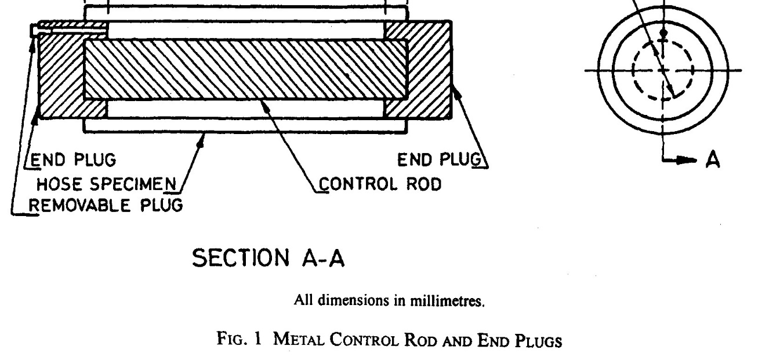

All dimensions in millimetres.

Fig.1 Metal Control Rod And End Plates

**Table 4 Control Rod Dimensions**

[*Clauses* 5.8.1(g) *and* 5.8.2**]**

|  |  |  |
| --- | --- | --- |
| **Sl No.** | **Hose Size (Nominal ID)** mm | **Control Rod Diameter**  mm |
| (1) | (2) | (3) |
| i) | Below 19.05 | N/A |
| ii) | 19.05 | 7.8 |
| iii) | 25.40 | 15.5 |
| iv) | 31.75 | 22.4 |
| v) | 34.92 | 25.9 |
| vi) | 38.10 | 29.1 |
| vii) | 44.45 | 35.6 |
| viii) | 50.80 | 42.1 |
| ix) | 57.35 | 48.6 |
| x) | 63.50 | 55.0 |

**5.8.2** *Specimens*

Hose under test shall be 300 mm long plugged at both ends with metal, aluminium or steel, plugs to retain the fluid. Calculate inside surface area based on the actual insider diameter of the hose for its total effective length.

NOTES

1) Total effective length of hose with end plugs inserted shall be 275 mm; and

2) A round metal (aluminum or steel) control rod conforming to the dimensions shown in Table 4 for hose sizes 19.05 mm ID and larger shall be inserted into hose ID as shown in Fig. 1. The rod shall be positioned in the end plugs that it will not contact the hose ID.

**5.8.3** *Procedure*

a) Record hose actual inside diameter, length and inside surface area. Preferred method is with plug ID gauges to nearest 0.025 mm;

b) Fill hose with reference fuel C;

c) Allow to stand for 24 h at temperature of 23 °C ± 2 °C with both ends sealed;

d) Drain fluid from hose into a tared beaker;

e) Rinse inside of the specimen with an amount of fish reference fuel C approximately equal to the volume of the original filling and add to the original extraction;

f) Remove solvent by evaporation by heating at 80 °C to 95 °C until no fuel odor is detectable and then store sample at room temperature of 23 °C ± 2 °C under a fume hood for a minimum of 16 h.

g) Take up residue with 30 ml of room temperature, 23 °C ± 2 °C methanol.

h) Filter this solution on the tared crucible, rinsing beaker twice with 10 ml of room temperature, 23 °C ± 2 °C methanol.

j) Place crucible in beaker and dry in a 65 °C to 90 °C oven to insure complete evaporation of methanol.

k) Weigh the Gooch crucible and tared beaker and determine mass of extractable expressed as g/m2 using surface area of hose in contact with reference fuel C.

m) Value of total g/m2 shall be values shown in Tables 1 to 3.

NOTE — Solubility of waxy hydrocarbons is affected by temperature.

**5.9 Ozone Resistance Test**

The test shall be carried out in accordance with IS 3400 (Part 20). For straight hose, 25.40 mm ID and under, a specimen of hose of sufficient length shall be bent around a mandrel with OD 8 times the nominal OD of the specimen. The two ends shall be tied at their crossing with enamelled copper or aluminum wire. After mounting, the specimen shall be allowed to rest in an ozone flee atmosphere for 24 hat room temperature of 23 °C ± 2 °C. The mounted specimen shall be placed in a test chamber with ozone concentration of 100 MPa ± 5 MPa at a temperature of 40 °C ± 2 °C. After 70 h of exposure, the specimen shall be removed and allowed to cool to a temperature of 23 °C ± 2 °C and then inspected. The specimen shall be visually inspected under 7 × magnification and must meet ‘0’rating except for the area immediate adjacent to the wire, which shall be ignored. For hoses over 25.40 mm ID and preformed parts, prepare a specimen by cutting a strip of whole hose 12.70 mm wide by 100 mm long and tie the specimen (cover out) around a 12.70 mm diameter mandrel. Condition in the same manner as for whole hose and apply the same requirements. The test applies to the cover only and cracks in the exposed tube or cut edges of the cover shall be ignored.

**5.10 Adhesion Test**

The minimum load required to separate a 25.40 mm width of tube and cover shall be 27 N.

**5.11 Kink Resistance Test**

When tested to the following procedure, a ball having a diameter equal to half the nominal inside diameter of the hose shall pass freely through the hose. Use fixture consisting of a 19 mm thick board or plate with holes and centre distances shown in Table 5.

Condition a 300 mm long specimen of hose for 2 h at room temperature, 23 °C ± 2 °C. Insert one end of hose into board with end flush with opposite side of the board. Carefully bend hose along its natural curvature and insert the other end carefully into the second hole until it projects 63 mm out the other side.

After hose has been in this position for 5 min, insert a steel ball having a diameter equal to half the hose nominal ID. The ball must pass freely from one end to the other.

# Table 5 Kink Resistance

# (*Clause* 5.11)

|  |  |  |  |
| --- | --- | --- | --- |
| **Sl No.** | **Nominal Hose ID**  mm | **Hole Center Distance**  mm | **Hole Diameter**  mm |
| (1) | (2) | (3) | (4) |
| i) | 4.76 | 12.7 | 12.7 |
| ii) | 6.35 | 19.0 | 14.3 |
| iii) | 7.94 | 25.4 | 15.9 |
| iv) | 9.53 | 76.2 | 19.0 |
| v) | 12.70 | 127.0 | 23.0 |

**5.12 Rate of Fuel Permeation**

A hose of free length of 1 m shall be connected to a container filled with fuel C having a temperature of 23 °C ± 2 °C. The test shall be carried out in compliance with the reservoir method described in **5.12.1**. The hose shall meet the limits listed in Tables 1 to 3.

**5.12.1** *Unified Method for Hose Permeation*

**5.12.1.1** *Rate of fuel permeation*

Hoses tested by the reservoir method shall meet those limits listed.in Tables 1 to 3 when tested with reference fuel C. Exposure of these hoses to gasoline or diesel fuel which contain high levels, greater than 5 percent by volume, of oxygenates, that is, ethanol, methanol, or MTBE (methyl tertiary butyl ether), may result in significantly higher permeation rates than those listed in Tables 1 to 3.

a) *Reservoir units (see Table* 6 *for size of reservoir)* — A screw-top can may be modified by the addition of a standard hose nipple, or fitting, cold soldered into the base at the corner opposite its opening (*see* Fig. 2 for typical equipment). Other types of reservoir units may be used. Examples are cylindrical aluminium and steel containers with appropriate standard hose nipples at one end, and a fill opening if required at the other end. The materials used for construction of the reservoirs shall be compatible with the test fuel;

b) *Screw cap* — A metal foil or fluroelastomer-lined cap to seal the reservoir unit. Where the threaded fill opening is designed to seal with an O-ring, a fluroelastomer O-ring shall be used. The threaded till opening may be either a female or male thread and sealed with a threaded male plug or female cap;

c) *Scale or balance* — A weighing unit with sufficient capacity to weigh the filled assemblies, and with a resolution of + 0.01 g;

d) *Impermeable plug* — An impermeable plug of sufficient size to seal one end of hose to a depth of 25 mm; and

e) *Hose clamps* — Standard hose clamps of the correct size for the hose being tested.

**5.12.2** *Procedure*

a) Cut hose to the required length (active length plus the fitting lengths), (*see* Table 6);

b) Measure the inside diameter of the hose and record, in mm;

c) Plug one end of hose to the required depth using an impermeable plug and hose clamp;

d) Attach the other end of hose to the fitting on the reservoir and clamp;

e) Measure the active or exposed length of the installed hose in mm and record;

f) Fill the reservoir with the specified amount (*see* Table 6) of desired fuel blend;

g) Seal reservoir with cap or plug;

h) Weigh reservoir assembly to the nearest 0.01 g and record;

j) To insure complete filling of the hose, orient assembly vertically and gently tap hose to eliminate the possibility of trapped air in the hose (*see* Fig. 3);

k) Place assembly with the hose horizontal in its storage position for liquid permeation (*see* Fig. 4);

m) Weigh the assembly each 24 h ± 0.5 h for the required time interval and record each value;

n) After each weighing, invert assembly to drain hose, gently mix fuel and refill hose as in step ‘j)’ and replace in storage position;

p) Calculate the exposed tube area (A) in m2:

A= L (mm) × ID (mm) × 3.14 × 10-6; and

q) Calculate the rate of fuel permission in terms of g/m2/24 h of exposed tube area on a daily basis.

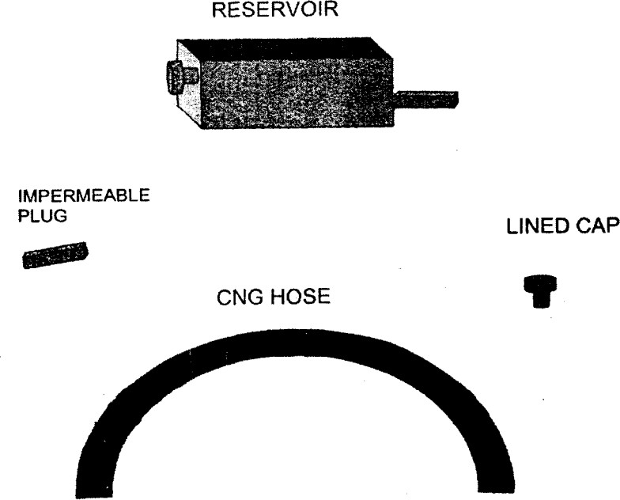

CNG/Bio-CNG Hose

Fig. 2 Fuel Permeation Test Apparatus

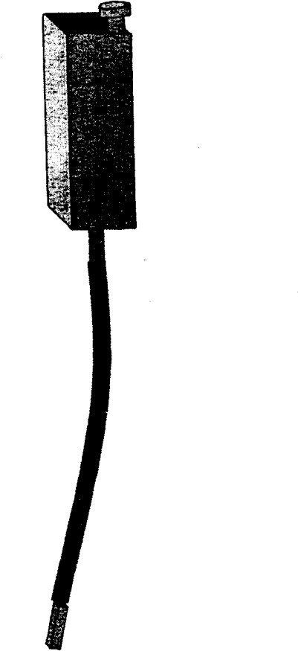

Fig. 3 Fuel Permeation Test-Air Bubble Removal

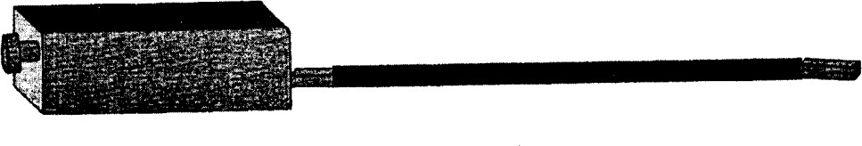

Fig. 4 Fuel Permeation Reservoir Test Assembly

**Table 6 Test Piece Size Parameters**

[*Clauses* **5.12.1.1(a)** *and* **5.12.2(a)**]

|  |  |  |  |  |
| --- | --- | --- | --- | --- |
| **Sl No.**  (1) | **Inside Diameter of Test Hose**  mm  (2) | **Active Length of Test Hose**  mm(3) | **Reservoir Size ml**  (4) | **Fuel Fill**  **Amount**  ml  (5) |
| i) | ≤ 16.0 | 300 | 460 to 490 | 300 |
| ii) | > 16.0 to 25.0 | 300 | 940 to 1 000 | 750 |
| iii) | > 25.0 to 32.0 | 300 | 3750 to 4 000 | 2500 |
| iv) | > 32.0 | 150 | 3750 to 4 000 | 2500 |

NOTES

1) Storage location should be temperature controlled to 23 ± 2°C with free-flowing air to prevent fume build-up; and if weekend weighing are to be eliminated and the results averaged for the weekends, then the test must be started on a monday.

**6 MARKING**

**6.1** Each flexible fuel line shall be legibly and indelibly marked with the following at every 300 mm length:

a) Manufactures name, trade-mark or symbol;

b) Part No. or unique identification mark;

c) Type and class;

d) Size;

e) Working pressure;

f) Batch number; and

g) CNG/bio-CNG

**6.2** **BIS Certification Marking**

Each flexible hose assembly may also be marked with the Standard Mark.

**6.2.1** The provisions of the *Bureau of Indian Standards Act*, 2016, govern the use of the Standard Mark and the Rules and Regulations made thereunder. The details of conditions under which the licence for the use of the Standard Mark may be granted to manufacturers or producers may be obtained from the Bureau of Indian Standards.

**7 TYPE TEST (TYPE APPROVAL)**

For the purpose of type test CNG/bio-CNG fuel lines of a particular Type/class shall conform to all the test requirements as specified in this standard.

**8 ACCEPTANCE TEST (CONFORMITY OF PRODUCTION)**

CNG/bio-CNG fuel line approved under this standard shall be so manufactured as to conform following test requirements as specified in relevant clauses of this standard.

a) Burst test;

b) Ozone resistance test;

c) Cold flexibility test;

d) Adhesion test; and

e) Rate of fuel permeation.

**9 TECHNICAL INFORMATION TO BE SUBMITTED BY THE COMPONENT MANUFACTURER**

Technical information to be submitted by the component manufacturer for component type approval/type test shall contain at least following information:

a) Name of the hose manufacturer;

b) Manufacturing plant address;

c) Part number;

d) Type and class of pipe (*see* **4**);

e) Hose inner diameter (ID);

f) Hose outer diameter (OD);

g) Working pressure; and

h) Drawings with relevant dimensions and materials.

**10 NUMBER OF SAMPLES FOR TESTING**

Minimum 8 numbers of 500 mm length hose with end connections having preferably BSP threading shall be submitted to the test agency for testing.

**ANNEX A**

(*Clause* 2)

**LIST OF REFERRED STANDRADS**

|  |  |  |
| --- | --- | --- |
| *IS No.* | | *Title* |
| IS 3400 (Part 1) : 2021/ISO 37 : 2017 | Methods of test for vulcanized rubber — Part 1 Tensile stress-strain properties (*fourth revision*) | |
| IS 3400 (Part 4) : 2012/ ISO 188 : 2011 | Methods of test for vulcanized rubber — Part 4 Accelerated ageing and heat resistance (*third revision*) | |
| IS 3400 (Part 6) : 2018/ISO 1817 : 2015 | Methods of test for vulcanized rubbers — Part 6 Determination of the effect of liquids (*fourth revision*) | |
| IS 3400 (Part 20) : 2018/ISO 1431-1 : 2012 | Methods of test for vulcanized rubbers — Part 20 Resistance to ozone cracking — Static strain test (*second revision*) | |
| IS 14272 : 2011 | Automotive vehicles — Types — Terminology | |
| IS 15710 : 2024 | Road vehicles — Compressed Natural Gas (CNG)/bio-compressed natural gas (bio-CNG) fuel system components — General requirements and definitions | |
| IS 15711 : 202421) | Road vehicles — Compressed natural gas (CNG)/bio-compressed Natural gas (bio-CNG) fuel system components — Performance and general test methods | |

**ANNEX B**

(*Foreword*)

**COMMITTEE COMPOSITION**

Automotive Vehicles Running on Non-Conventional Energy Sources Sectional Committee, TED 26

| *Organization* | *Representative(s)* |
| --- | --- |
| Automotive Research Association of India (ARAI), Pune | Dr S. S. Thipse **(*Chairperson*)**   Shri A. D. Dekate |
| A B Process Technologies, Pune | Shri Kunal Chopde |
| Ashok Leyland Ltd, Chennai | Shrimati Suchismita C.   Shri Muthukumar N. (*Alternate*) |
| Automotive Component Manufactures Association of India, New Delhi | Shri Sanjay Tank   Miss Seema Babal (*Alternate*) |
| Bajaj Auto Ltd, Pune | Shri Milind J. Pagare   Shri Arvind V. Kumbhar (*Alternate*) |
| Bosch Limited, Bengaluru | Shri Bharadwaj M. Krishnamurthy  Shri Vikram K. (*Alternate*) |
| Central Institute of Road Transport, Pune | Shri Samir Sattigeri   Shri V. V. Joshi (*Alternate*) |
| Central Pollution Control Board, New Delhi | Shri A. Sudhakar  Shri Suneel Dave (*Alternate* I)  Shri Kedarnath Das (*Alternate* II) |
| CLH Gaseous Fuel Applications Ltd, Gurugram | Shri Shishir Agrawal   Shri Gagan Agrawal (*Alternate*) |
| Delhi Transport Corporation, New Delhi | Shri Vikas Batra |
| GAIL (India) Limited, New Delhi | Shri Ashish Kumar Mittal  Shri Lokesh Mehta (*Alternate*) |
| Indian Auto LPG Coalition, Faridabad | Shri Shishir Agrawal  Shri Suyash Gupta (*Alternate*) |
| Indian Institute of Petroleum, Dehradun | Shri Wittison Kamei  Shri Robindro Lairenlakpam (*Alternate*) |
| Indian Institute of Science, Bengaluru | Prof R.V. Ravikrishna |
| Indian Institute of Technology Ropar, Rupnagar | Shri Dhiraj Kumar Mahajan  Dr Debaprasad Mandal (*Alternate*) |
| Indian Oil Corporation Ltd, (R & D Centre), Faridabad | Dr M. Sithananthan |
| Indian Rubber Manufacturers Research Association, Thane, Mumbai | Dr K. Raj Kumar  Dr Bharat Kapgate (*Alternate*) |
| International Centre for Automotive Technology (ICAT), Manesar | Shri Vaibhav Prashant Yadav  Shri Vijayanta Ahuja (*Alternate*) |
| Mahindra & Mahindra Ltd, Mumbai | Shri Rajamani Parthiban  Shri Shailesh Kulkarni (*Alternate*) |
| Mahindra & Mahindra Ltd (Truck and Bus Division), Pune | Shri V. G. Kulkarni |
| Maruti Suzuki India Limited, Gurugram | Shri Gururaj Ravi  Shri Arun Kumar (*Alternate*) |
| Minda Emer Technologies Limited, Gurugram | Shri Vivek Jain  Shri Bibhuti Kumar (*Alternate*) |
| Ministry of New and Renewable Energy, New Delhi | Shri Dipesh Pherwani |
| Petroleum and Explosive Safety Organization,  Nagpur | Shri D. K. Gupta  Shri Vivek Kumar (*Alternate*) |
| Petronet LNG Ltd, New Delhi | Shri Pankaj Wadhwa (*Alternate*) |
| Prodair Air Products India Private Ltd, Pune | Shri Ravi Subramanian  Shri Arun Kuruvangattil (*Alternate*) |
| Renault India Private Limited, Mumbai | Shri Rajendra Khile  Shri Vijay Dinakaran (*Alternate*) |
| Rohan BRC Gas Equipment Pvt Ltd, Ahmedabad | Shri Stefano De Carolis  Shri Parthiv Shukla (*Alternate*) |
| Society of Indian Automobile Manufacturers, New Delhi | Shri P. K. Banerjee   Dr Sandeep Garg (*Alternate*) |
| Swagelok – Bombay Fluid System components Pvt Ltd, Mumbai | Shri Sachin Koulgi   Shri Harish Takke (*Alternate*) |
| Tata Motors Ltd, Pune | Shri P. S. Gowrishankar  Shri Shailendra Dewangan (*Alternate*) |
| TVS Motor Company Ltd, Hosur | Shri V. Pattabiraman  Shri K. M. Srikanth (*Alternate*) |
| Vanaz Engineers Ltd, Pune | Shri S. J. Vispute   Shri J. S. Dhumal (*Alternate*) |
| Volkswagen India Pvt Ltd, Mumbai | Shri Joreg Bouzek  Shri Pankaj Gupta (*Alternate*) |
| BIS Directorate General | Shri Deepak Agarwal, Scientist ‘F’/ Senior Director and Head (Transport Engineering) [Representing Director General (*Ex-officio*)] |
| *Member Secretary*  Shri Gaurav Jayaswal  Scientist ‘C’/Deputy Director  (Transport Engineering), BIS | |