***भारतीय मानक***

***Indian Standard***

**IS 5225 : 2024**

***मौसम विज्ञान — वर्षा मापी*, *नॉन-रिकॉर्डिंग — विशिष्टि***

*(* दूसरा पुनरीक्षण *)*

**Meteorology — Rain Gauge, Non-Recording — Specification**

( *Second Revision )*

ICS 07:060

© BIS 2024

भारतीय मानक ब्यूरो

BUREAU OF INDIAN STANDARDS

मानक भवन, 9 बहादुर शाह ज़फर मार्ग, नई दिल्ली - 110002

MANAK BHAVAN, 9 BAHADUR SHAH ZAFAR MARG

NEW DELHI - 110002

[www.bis.gov.in](http://www.bis.org.in) [www.standardsbis.in](http://www.standardsbis.in)

**November 2024 Price Group X**

Meteorological Instruments Sectional Committee, PGD 21

FOREWORD

This Indian Standard (Second Revision) was adopted by the Bureau of Indian Standards after the draft finalized by the Meteorological Instruments Sectional Committee had been approved by the Production and General Engineering Division Council.

Accuracy in the measurement of rainfall is of great importance in almost all fields of national economy and is of special significance in agriculture, irrigation, design of waterways, flood control, power generation and the conservation of water resources on both national and international scales.

The rain gauge consists essentially of a collector which intercepts the sample of rainfall to be measured and a receiver consisting of a base and a bottle in which the rainfall collected is stored. The collector is exposed above ground level while the receiver is fixed partially below ground level**.**

This standard was first published in 1969 and subsequently revised in 1992. This revision has been brought out to keep pace with the latest technological developments and international practices.

The following major changes have been made:

1. UDC number has been replaced by ICS number on first cover page;
2. Reference clause has been updated; and
3. Fig. 1 has been modified based on an improved model of non-recording rain gauge.

The composition of the Committee, responsible for the formulation of this standard is given in Annex A.

For the purpose of deciding whether a particular requirement of this standard is complied with, the final value, observed or calculated, expressing the result of a test or analysis, shall be rounded off in accordance with IS 2 : 2022 ‘Rules for rounding off numerical values (*second revision*)’. ’The number of significant places retained in the rounded off value should be the same as that of the specified value in this standard.

*Indian Standard*

METEOROLOGY — RAIN GAUGE, NON-RECORDING — SPECIFICATION

*( Second Revision )*

**1 SCOPE**

This standard specifies the requirements for non-recording rain gauges with capacities of 100 mm, 200 mm, 400 mm and 1 000 mm rainfall.

**2 REFERENCES**

The standards given below contain provisions which, through reference in this text, constitute provisions of this standard. At the time of publication, the editions indicated were valid. All standards are subject to revision, and parties to agreements based on this standard are encouraged to investigate the possibility of applying the most recent edition of these standards:

|  |  |
| --- | --- |
| *IS No.* | *Title* |
| IS 617 : 2024 | Aluminium and aluminium alloys ingots for remelting and castings for general engineering purposes ― Specification (*fourth revision*) |
| IS 4849 : 1992 | Meteorology — Rain measures — Specification (*first revision*) |

**3 TYPES**

**3.1** This standard specifies collectors of 100 cm2 and 200 cm2 in area, two bases and three bottles of capacities 2 litres, 4 litres and 10 litres. All components are completely interchangeable and combinations of these provide the rain gauges as given in Table 1.

**Table 1 Nominal Measuring Capacity and Combinations**

(*Clauses* 3.1 *and* 8)

|  |  |  |  |  |
| --- | --- | --- | --- | --- |
| **Sl No.** | **Nominal Measuring Capacity, rainfall**  mm | **Collector** | **Base** | **Bottle** |
| (1) | (2) | (3) | (4) | (5) |
| i) | 100 | 200 cm2 | Small | 2 litre |
| ii) | 200 | 200 cm2 | Small | 4 litre |
| iii) | 400 | 100 cm2 | Small | 4 litre |
| iv) | 1 000 | 100 cm2 | Large | 10 litre |
| mm | | | | |

**3.2** The 200 mm capacity rain gauges shall meet the requirements of most of the stations in the country. The 400 mm capacity and 1 000 mm capacity gauges with 100 cm2 collectors are recommended for use in heavy and very heavy rainfall areas.

1. **MATERIAL**

**4.1** The material used for the manufacture of the rain gauges shall have the following properties:

* + 1. Rigidity and strength with no distortion or other deterioration when exposed to widely varying climatic conditions in the open air, while at the same time, being light in weight, the addition of a suitable ultra-violet inhibitor is recommended for increasing its durability;
    2. Freedom from attack of insect or fungoid life;
    3. Smooth and permanent surface finish to facilitate free flow of precipitation;
    4. Low thermal conductivity to minimize evaporation losses or condensation gains;
    5. A life of not less than 15 years in the open; and
    6. Pin in locking arrangement, hasp and staple shall be of brass or stainless steel to prevent corrosion/rusting.

**4.2** While any material satisfying the requirements given in **4.1** may be used, fibre glass reinforced polyester is considered as a suitable material.

NOTE — Galvanized iron sheet is not considered as a suitable material for this purpose.

**4.3** The material for the rim of the collector shall be gun metal or aluminium alloy conforming to grade AlSi11MgMn of IS 617.

**4.4** The material for the locking ring shall be rigid plastic of a suitable composition or metal satisfying the requirements specified in **4.1**

**5 DIMENSIONS**

**5.1** The dimensions for collectors, bottles, bases and locking rings shall be as given in Fig. 1 to Fig. 4.

**5.2** The inside diameter of the collector rim shall be within ± 0.5 mm of the specified value when measured in any four directions and the mean of the four values shall be within ± 0.2 mm of the specified value.

**5.3** Where no tolerances have been indicated, normal manufacturing tolerances shall apply.

**6 GENERAL REQUIREMENTS**

**6.1 Collector**

The collector shall have a rim cemented firmly at the top. If the collector is made of fibre glass reinforced polyester, the nominal thickness of the material where the gun metal rim is cemented shall be suitably increased to ensure strength and a firm and permanent adhesion. The entire inner surface of the funnel with rim shall have a smooth finish. The body of collector shall be tapered. All seams of the collector shall be of adequate strength and shall be water-tight. The funnel shall be firmly joined to the collector with a leak-proof joint. The junction of the funnel outlet pipe shall be reinforced as shown in Fig. 2. When assembled, the funnel outlet pipe shall extend inside the bottle in the base.

**6.1.1** The lower end of the collector shall have a ring fitted inside it. The ring shall have five locking lugs for locking the collector to the base (*see* Fig. 3). The locking ring shall be bonded to the collector with a suitable and strong adhesive or moulded with the collector.

**6.1.2** The lower ends of the 200 cm2 and 100 cm2 collectors shall be identical and shall provide an interchangeable fitting with the rain gauge base.

**6.1.3** A suitable locking arrangement shall be provided for locking the collector to the base.

**6.2 Base**

The design of the base shall be such as to permit direct and interchangeable fitting of collectors of either size.

**6.2.1** A locking ring (*see* Fig. 3) shall be fitted inside at the top end of the base to provide means for locking the collector funnel on it. The ring shall be either bonded to the base with a suitable and strong adhesive or moulded to the base. A suitable stop shall be provided in the locking ring so that it does not rotate further and get unlocked.

**6.2.2** The special large capacity base and 10 litres bottle for very heavy rainfall stations may be as suggested in Fig. 4; the base shal1 has the standard interchangeable fitting for the 100 cm2 collector.

**6.3 Bottle**

The bottle shall be of polythene, with nominal capacities of 2 litres, 4 litres or 10 litres and shall be provided with one or more handles for lifting it out of the receiver. The bottle shall be completely contained within the base. The upper portions of the bottle shall be smoothly curved so that when tilted, all the water from inside drains out completely leaving no water in the bottle. The mouth of the bottle shall not be less than 45 mm in diameter.

**6.4 Additional Cylinder**

The inner surface of the additional cylinder provided shall be smooth and the top edge shall be slightly thickened to provide a grip for conveniently lifting it out when required.

**6.5 Rain Measures**

Appropriate rain measures conforming to IS 4849 shall be used in conjunction with non-recording rain gauge for the accurate determination of the catch.

**7 WORKMANSHIP AND FINISH**

**7.1** Allparts shall be leak-proof and when assembled, the rim of the collector shall be truly horizontal.

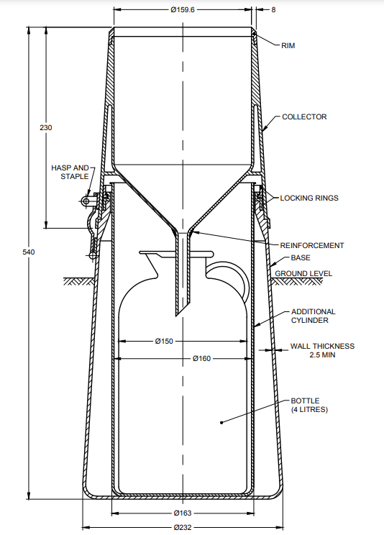

All dimensions in millimetres.

Fig. 1 Rain Gauge, Non-Recording (200 cm2), General Assembly

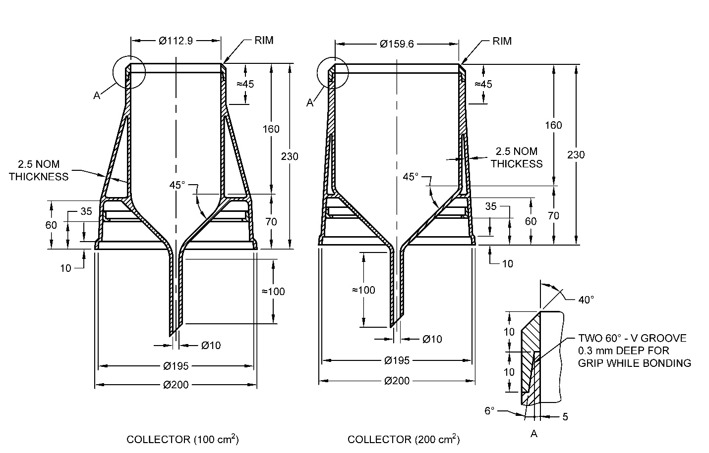

All dimensions in millimetres.

Fig. 2 Dimensions of Collectors

**7.2** The external surface of the complete rain gauge shall have a smooth and permanent finish.

**7.3** The rain gauge shall be of any light colour but a light shade of grass green or cream is preferred.

**8 DESIGNATION**

For the purpose of inquiry or order, the rain gauge shall be designated by the nominal measuring capacity as shown in Table 1 and the IS number.

*Example*:

A rain gauge with a nominal measuring capacity of 200 mm of rainfall shall be designated as:

Rain Gauge, 200 mm rainfall IS 5225

**9 MARKING**

**9.1** Each rain gauge shall bear the following inscription engraved legibly and indelibly on a name plate which shall be cemented firmly on the collectors:

1. The inscription ‘200 cm2 collector’ or ‘100 cm2 collector’, as the case may be;
2. Manufacturer’s name or recognized trade-mark as agreed to between the supplier and the purchaser; and
3. Serial number and year of manufacture, for example, No.123/24.

**9.2** The bottle shall be legibly and permanently marked with its capacity in litres.

**9.3 BIS Standard Marking**

The product(s) conforming to the requirements of this standard may be certified as per the conformity assessment schemes under the provisions of the *Bureau of Indian Standards Act*, 2016 and the Rules and Regulations framed thereunder, and the products may be marked with the standard mark.

**10 PACKING**

Each rain gauge shall be wrapped in corrugated cardboard sheet and packed in a stout bonded cardboard carton having a lid. Further, packing shall be as agreed to between the supplier and the purchaser.

**11 TESTING AND INSPECTION**

All the rain gauges shall be tested individually for conformity to all the requirements of this specification.

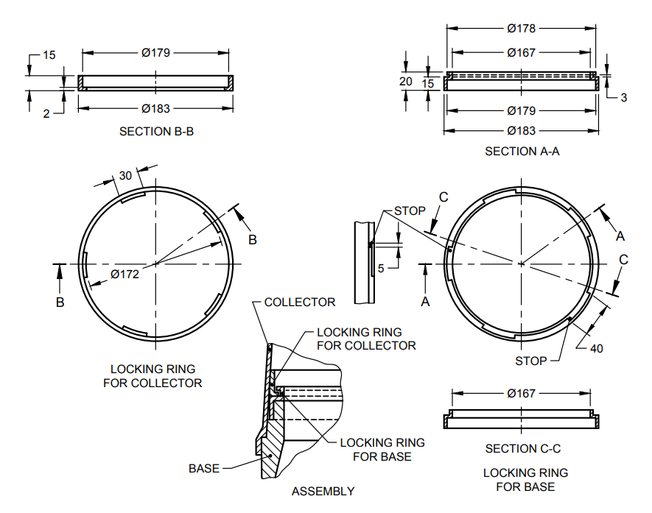

All dimensions in millimetres.

Fig. 3 Dimensions of Locking Ring for Collector and Locking Ring for Base

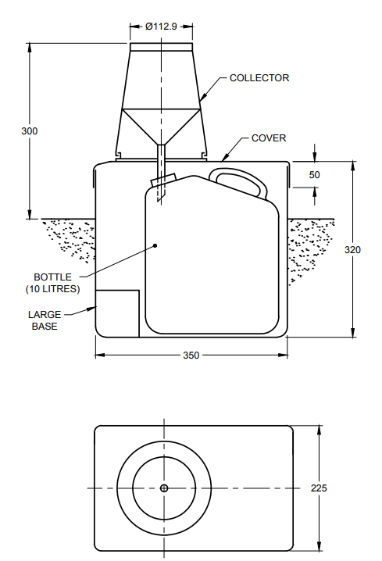

All dimensions in millimetres.

Fig. 4 Rain Gauge, 1 000 mm Rainfall

**ANNEX A**

(*Foreword*)

**COMMITTEE COMPOSITION**

Meteorological Instruments Sectional Committee, PGD 21



| *Organization* | *Representatives(s)* |
| --- | --- |
| India Meteorological Department, Pune | Shri K. S. Hosalikar **(*Chairperson*)** |
| Central Water Commission, New Delhi | Shri Deepak Kumar  Shri Pankaj Kumar Sharma (*Alternate*) |
| CSIR - National Aerospace Laboratories, Bengaluru | Dr G. Sivakumar |
| CSIR - National Environmental Engineering Research Institute, Nagpur | Dr T. V. B. P. S. Ramakrishna  Dr Anirban Middey (*Alternate*) |
| CSIR - National Institute of Oceanography, Dona Paula | Dr Neetu S. |
| CSIR - National Physical Laboratory, New Delhi | Dr Shankar G. Agarwal  Dr Dilip Dhondiram Shivagan (*Alternate*) |
| Defence Geoinformatics Research Establishment (DRDO), Chandigarh | Shri Rajesh Kumar Garg  Shri Neeraj Sharma (*Alternate*) |
| Directorate of Naval Oceanology and Meteorology, Department of Navy HQ, New Delhi | Cdr Dp Gautam |
| Dynalab Weathertech Private Limited, Pune | Shri G. Venugopal  Shri Kaushik Brahmchari (*Alternate*) |
| Hindustan Clock Works, Pune | Shri Shrirang J. Agashe  Shri Balraj Agashe (*Alternate*) |
| India Meteorological Department, Pune | Shri U. K. Shende  Shri Anjit Anjan (*Alternate*) |
| Indian Agricultural Research Institute Library, New Delhi | Dr Deb Kumar Das  Dr Vinay Kumar Sehgal (*Alternate*) |
| Indian Air Force, New Delhi | Shri Birendra Nepal  Wing Cdr Prabodh Shukla (*Alternate* I)  Wing Cdr Rahul Sharma (*Alternate* II) |
| Indian Institute of Technology Delhi, New Delhi | Dr Ravi Kumar Kunchala  Prof Manju Mohan (*Alternate*) |
| Indian Institute of Tropical Meteorology, Pune | Shri G. Pandithurai |
| Indian Space Research Organization, Bengaluru | Shri Darshan Kumar Patel  Shrimati Shivani M. Shah (*Alternate*) |
| Office of the Director General of Civil Aviation, New Delhi | Shrimati Vinita Jain  Shri Ram Babu Verma (*Alternate*) |
| Pawan Rubbers, Pune | Shri Hemant Thakkar |
| In Personal Capacity (*C, Building Flat No. 704,Mohite Township, Sinhgad Road, Near Santosh Hall, Pune - 411051*) | Shri R. R. Mali |
| BIS Directorate General | Shri Rajeev Ranjan Singh, Scientist ‘F’/ Senior Director And Head (Production And General Engineering) [Representing Director General (Ex-Officio)] |
| *Member Secretary*  Shri Ashutosh Rai  Scientist ‘C’/Deputy Director  (Production and General Engineering), BIS | |