***भारतीय मानक* IS 4003 (Part 1) : 2024**

***Indian Standard***

**पाइप रिंच — विशिष्टि**

**भाग 1 सामान्य प्रयोजन**

*( दूसरा पुनरीक्षण )*

**Pipe Wrenches — Specification Part 1 General Purpose**

*( Second Revision )*

ICS 25.140.30

© BIS 2024



**भारतीय मानक ब्यूरो**

BUREAU OF INDIAN STANDARDS

मानक भवन, 9 बहादुर शाह ज़फरमार्ग, नई दिल्ली -110002

MANAK BHAVAN, 9 BAHADUR SHAH ZAFAR MARG

NEW DELHI - 110002

[www.bis.gov.in](http://www.bis.gov.in) [www.standardsbis.in](http://www.standardsbis.in)

**August 2024 Price Group**

Hand Tools Sectional Committee, PGD 34

FOREWORD

This Indian Standard (Second Revision) was adopted by the Bureau of Indian Standards after the draft finalized by the Hand Tools Sectional Committee had been approved by the Production and General Engineering Division Council.

This standard was first published in 1967 and was subsequently revised in 1978*.* This revision has been brought out to keep pace with the latest technological developments and international practices.

In this second revision, the following changes have been made:

1. Clause on references has been added; and
2. Material designations have been updated as per the latest Indian Standards.

This standard has been published in two parts. Other part in this series is:

|  |  |
| --- | --- |
| Part 2 | Heavy duty |

The composition of the Committee, responsible for the formulation of this standard is given in Annex A.

For the purpose of deciding whether a particular requirement of this standard is complied with, the final value, observed or calculated, expressing the result of a test, shall be rounded off in accordance with IS 2 : 2022 ‘Rules for rounding off numerical values (*second revision*)’*.* The number of significant places retained in the rounded off value should be the same as that of the specified value in this standard.

*Indian Standard*

PIPE WRENCHES — SPECIFICATION

**PART 1 GENERAL PURPOSE**

*( Second Revision )*

**1 SCOPE**

This standard specifies requirements for general purpose pipe wrenches.

**2 REFERENCES**

The following standards given below contain provisions which through reference in this text, constitute provisions of this standard. At the time of publication, the editions indicated were valid. All standards are subject to revision, and parties to agreements based on this standard are encouraged to investigate the possibility of applying the most recent editions of these standards:

|  |  |
| --- | --- |
| *IS No.* | *Title* |
| IS 1570 | Schedules for wrought steels: |
| (Part 2/Sec 1) : 1979 | Carbon steels (unalloyed steels), Sec 1 Wrought products (other than wires) with specified chemical composition and related properties (*first revision*) |
| (Part 4 ) : 1988 | Alloy steels (alloy constructional and spring steels) with specified chemical composition and related mechanical properties (*first revision*) |
| IS 1865 : 1991 | Iron castings with spheroidal or nodular graphite — Specification (*third revision*) |
| IS 2500 (Part 1) : 2000/ ISO 2859-1 : 1999 | Sampling procedures for inspection by attributes: Part 1 Sampling schemes indexed by acceptance quality limit (AQL) for lot-by-lot inspection (*third revision*) |
| IS 14329 : 1995 | Malleable iron castings — Specification |

**3 TERMINOLOGY**

For the purpose of this standard, following definitions shall apply:

**3.1 Nominal Size** — The overall length of the tool when the jaws are open to the maximum capacity (*see* **4**).

**3.2** **Maximum Capacity** — The maximum diameter of pipe that shall be gripped with safety when the end of the movable jaw flushes with back face of the frame.

**3.3** **Greatest Angle Movement** — The difference in angles between the jaws at their minimum and maximum possible angular positions.

**4 DIMENSIONS**

The dimensions of pipe wrenches (general purpose) shall be as given in Table 1.

**Table 1 Dimensions of Pipe Wrenches (General Purpose)**

(*Clauses* 4 *and* 6.2)

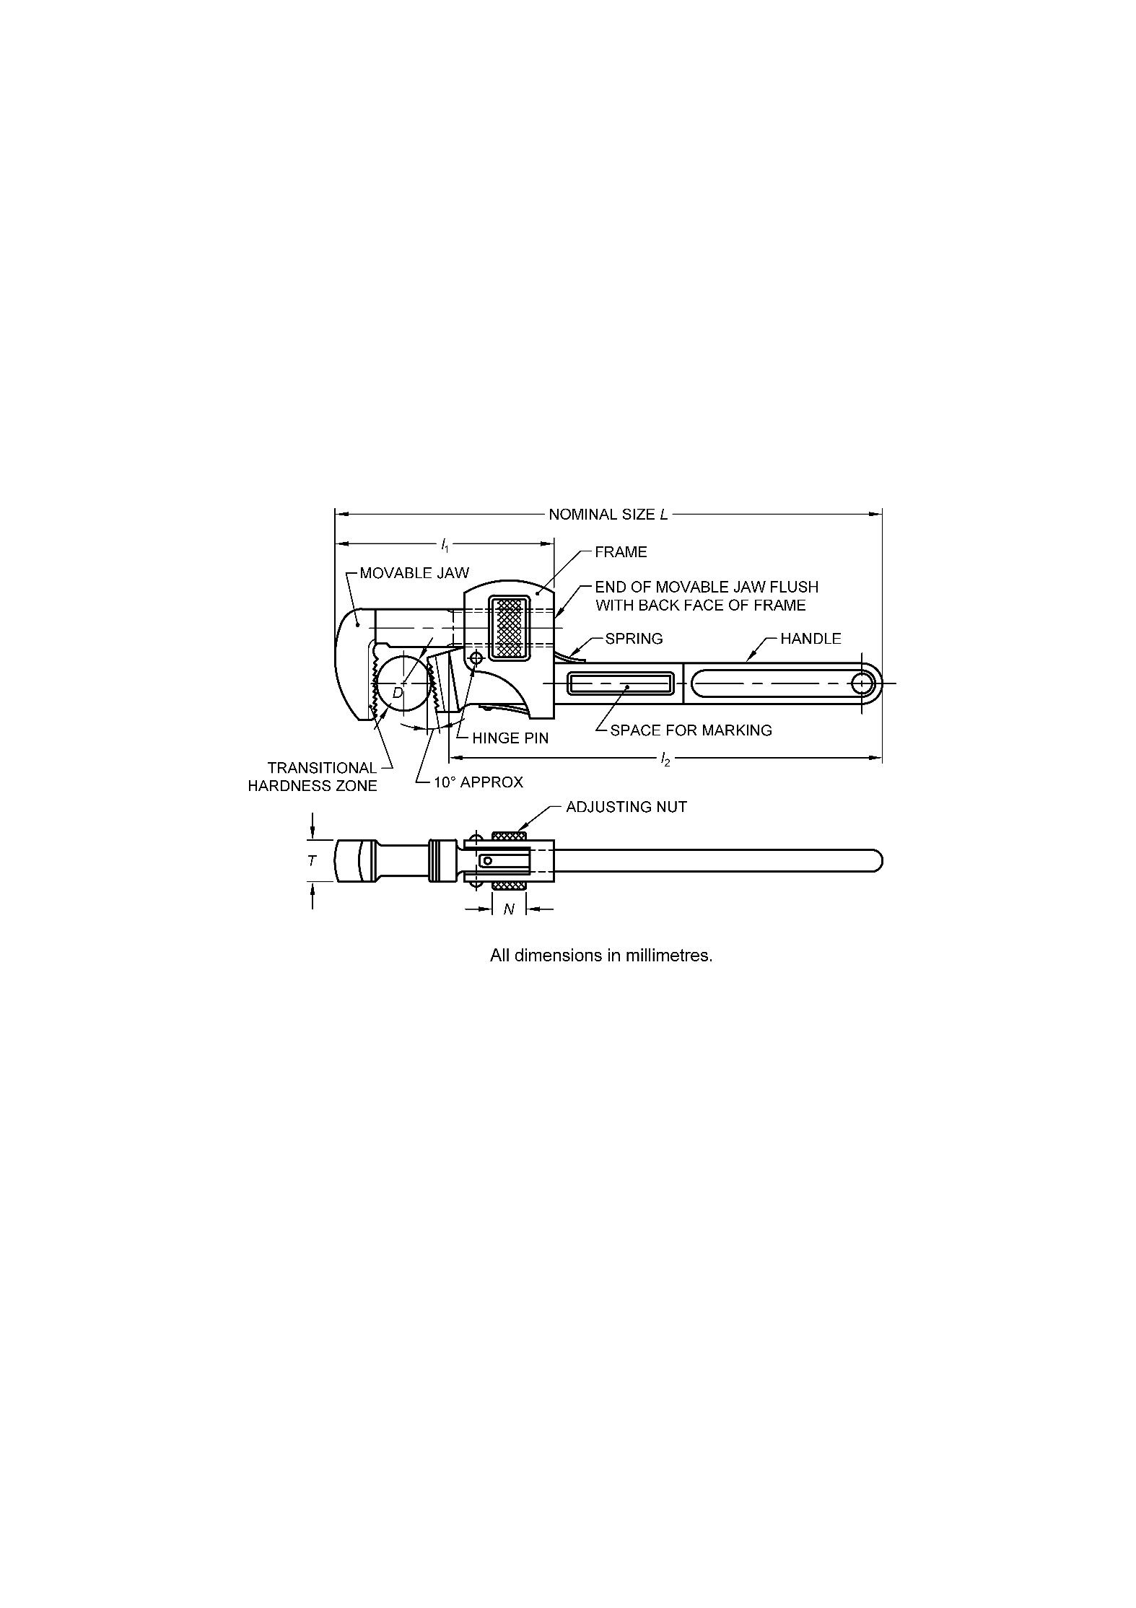

Fig. 1 Pipe Wrenches (General Purpose)

All dimensions are in millimeters.

|  |  |  |  |  |  |  |  |
| --- | --- | --- | --- | --- | --- | --- | --- |
| **Sl No.** | **Nominal Size**  *L* | **Minimum Capacity** | **Maximum** **Jaw**  **Capacity** **Thickness**  *D T* | | **Approximate Length of Movable Jaw**  *l*1 | **Approximate Length of Handle**  *l*2 | **Width off Nut**  *N*  *Min* |
|  | *Min* |
| (1) | (2) | (3) | (4) | (5) | (6) | (7) | (8) |
| i) | 200 | 6 | 20 | 15 | 85 | 160 | 12 |
| ii) | 250 | 6 | 26 | 17 | 110 | 200 | 13 |
| iii) | 300 | 9 | 32 | 19 | 125 | 240 | 16 |
| iv) | 350 | 13 | 38 | 21 | 140 | 285 | 17 |
| v) | 450 | 25 | 52 | 24 | 165 | 370 | 18 |
| vi) | 600 | 38 | 65 | 28 | 200 | 495 | 25 |
| vii) | 900 | 50 | 95 | 34 | 260 | 750 | 35 |
| viii) | 1 200 | 65 | 130 | 40 | 330 | 1 000 | 35 |

**5** **MATERIAL**

**5.1** Material for the construction of different components of pipe wrenches (general purpose) shall be as given in Table 2.

**Table 2** **Material Used for Various Parts of Pipe Wrenches (General Purpose)**

(*Clause* 5.1)

|  |  |  |
| --- | --- | --- |
| **Sl. No**  (1) | **Component**  (2) | **Material**  (3) |
| i) | Handle and movable jaw | 40C8, 50C4, 55C4, 55C8, 60C4, 65C6 of IS 1570 (Part 2/Sec 1), 31CrV3 or 40Cr |
| ii) | Frame | Malleable cast iron conforming to IS 14329 or SG Iron grade SG 500/7, 450/10 of IS 1865 or 20C8, 25C4 or 15C4, 15C8 of IS 1570 (Part 2/Sec 1) |
| iii) | Spring | Steel to designation 50Cr4 of IS 1570 (Part 4) or any suitable grade from IS 1570 (Part 4) |
| iv) | Adjusting nut and  hinge pin | Suitable carbon steel selected from IS 1570 (Part 2/Sec 1) |

**5.2** Chemical composition of31CrV3 and 40Cr used in the handle and movable jaw shall be as given in Table 3.

**Table 3 Chemical Composition of Steel Grades**

(*Clause* 5.2)

|  |  |  |  |  |  |  |  |  |
| --- | --- | --- | --- | --- | --- | --- | --- | --- |
| **Sl No.** | **Grade** | **C** | **Si** | **Mn** | **S**  (*Max*) | **P**  (*Max*) | **Cr** | **V** |
| (1) | (2) | (3) | (4) | (5) | (6) | (7) | (8) | (9) |
| i) | 31CrV3 | 0.28 to 0.35 | 0.25 to 0.40 | 0.40 to 0.60 | 0.030 | 0.030 | 0.40 to 0.70 | 0.07 to 0.12 |
| ii) | 40Cr | 0.37 to 0.44 | 0.17 to 0.37 | 0.50 to 0.80 | 0.030 | 0.030 | 0.80 to 1.10 | Nil |
| NOTE − Composition limit in weight percent maximum, unless shown as a range or a minimum. | | | | | | | | |

**6 HARDNESS**

**6.1** The hardness of jaws, handle and shank of the movable jaw shall be as given in below:

|  |  |  |
| --- | --- | --- |
| *Sl No.* | *Component* | *Hardness* |
|  |  |  |
|  | Jaws | 490 to 700 HV (48 to 60 HRC) when measured at any point within the triangular profile of any tooth or within one millimeter of the root of the tooth |
|  | Handle and shank of the movable jaw | 285 HV to 400 HV(30 HRC to 41 HRC) |

**6.2** The transitional hardness zone (Table 1) shall not extend beyond a point defined as twice the height of the teeth measured back from the tooth root.

**7 MANUFACTURE**

**7.1** **Handle**

The handle shall be a one-piece forging with integral teeth. The teeth shall be of a definite number, shape and size to enable the assembled tool to meet the test requirements without slipping and to grip positively during normal operation any appropriate diameter of pipe within the safe capacity as given in **4**. The toothed portion of the handle shall be so positioned that the common plane of the crests of the teeth shall be inclined at an angle of 10° relative to a plane perpendicular to the longitudinal axis of the handle (*see* **4**). The crests of the teeth shall be parallel and square relative to the lateral axis of the handle.

**7.2 Movable Jaw**

The movable jaw shall be a one-piece forging with integral teeth. The teeth shall be of adequate number, shape and size to enable the assembled tool to meet the test requirements without slipping and to grip positively during operation any appropriate diameter of pipe within the safe capacity.

**7.2.1** The shank of the movable jaw shall be threaded in order to engage the internal threads of the adjusting nut.

**7.2.2** The toothed portion of the movable jaw shall be so positioned that the common plane of the crests of the teeth shall be square relative to the axis of the threaded shank. The crests of the teeth shall be parallel and shall be square relative to the lateral axis of the threaded shanks.

**7.3** **Adjusting Nut**

The adjusting nut shall be suitably knurled or longitudinally serrated. The threads shall be of sufficiently robust form and pitch so that with the jaws set at any point of adjustment within the appropriate capacity (*see* **4**), the wrench shall be capable of passing the tests given in **11**.

**7.4** **Frame**

The frame shall be a one-piece casting or one steel piece. It shall be integral with the handle or be attached to the handle by means of a riveted pin. It shall allow easy adjustment of the movable jaw allowing easy and proper operation of the wrench both forward and backward.

**7.5** **Hinge Pin**

When in position the hinge pin shall have heads formed at each end by riveting. Alternatively, it shall be provided with equally effective securing means.

**7.6** **Spring**

One or more spring shall be provided; the greatest angle movement shall not exceed 10°. The spring or springs provided in the wrench assembly shall properly balance the movable jaw so that action, both forward and backward, is provided. The spring or springs shall be secured to the frame by riveting or any other suitable means.

**8 WORKMANSHIP AND FINISH**

**8.1** The wrenches shall be free from flaws, cracks, rust, burrs and other injurious defects. The movable jaw shall be properly finished.

**8.2** All unmachined surfaces shall either be painted or suitably treated with rust preventives. The machined surfaces shall be protected by any rust-preventive treatment.

**9 OPERATION**

The motion between the various parts of the wrench shall permit the teeth to grip and hold the pipe for successive turns without the necessity of altering the adjusting nut. The wrench shall release freely when the direction of pressure on the handle is reversed.

**10** **SAMPLING**

The representative samples shall be drawn as specified in IS 2500 (Part1).

**11 TESTS**

**11.1** **Static Load Test**

A cylindrical steel test bar shall be rigidly mounted in a test as illustrated diagrammatically in Fig. 2. The test bar shall be of diameter as given in Table 4 and shall have hardness within the range 300 HV to 380 HV at any point on its circumferential surface.

The wrench shall be mounted in the rig with the teeth in normal working engagement with the test bar (*see* Fig. 2) and a load shall be supplied sufficient to result in a proof torque at point 'P' as given in Table 4. On the completion of test there shall be no permanent deformation or cracking of any portion of the wrench. The threads on the adjusting nut and movable jaw and the adjusting nut itself shall also not show any sign of permanent deformation.

**11.2** **Static-Shock Load Test**

The wrench shall be in position as described in **11.1** with static load reduced by 25 percent, with this load in operation the shock load as given in Table 4 shall be applied at the point 'P'. Following this test, the wrench shall release freely when the direction of force on the handle is reversed. The teeth shall then grip and release freely without recourse to alteration of the adjusting nut. On removal from the test fig, the wrench shall be capable of normal finger and thumb adjustment over the whole length of the transverse. The component parts shall not have suffered any permanent set on the completion of the test.

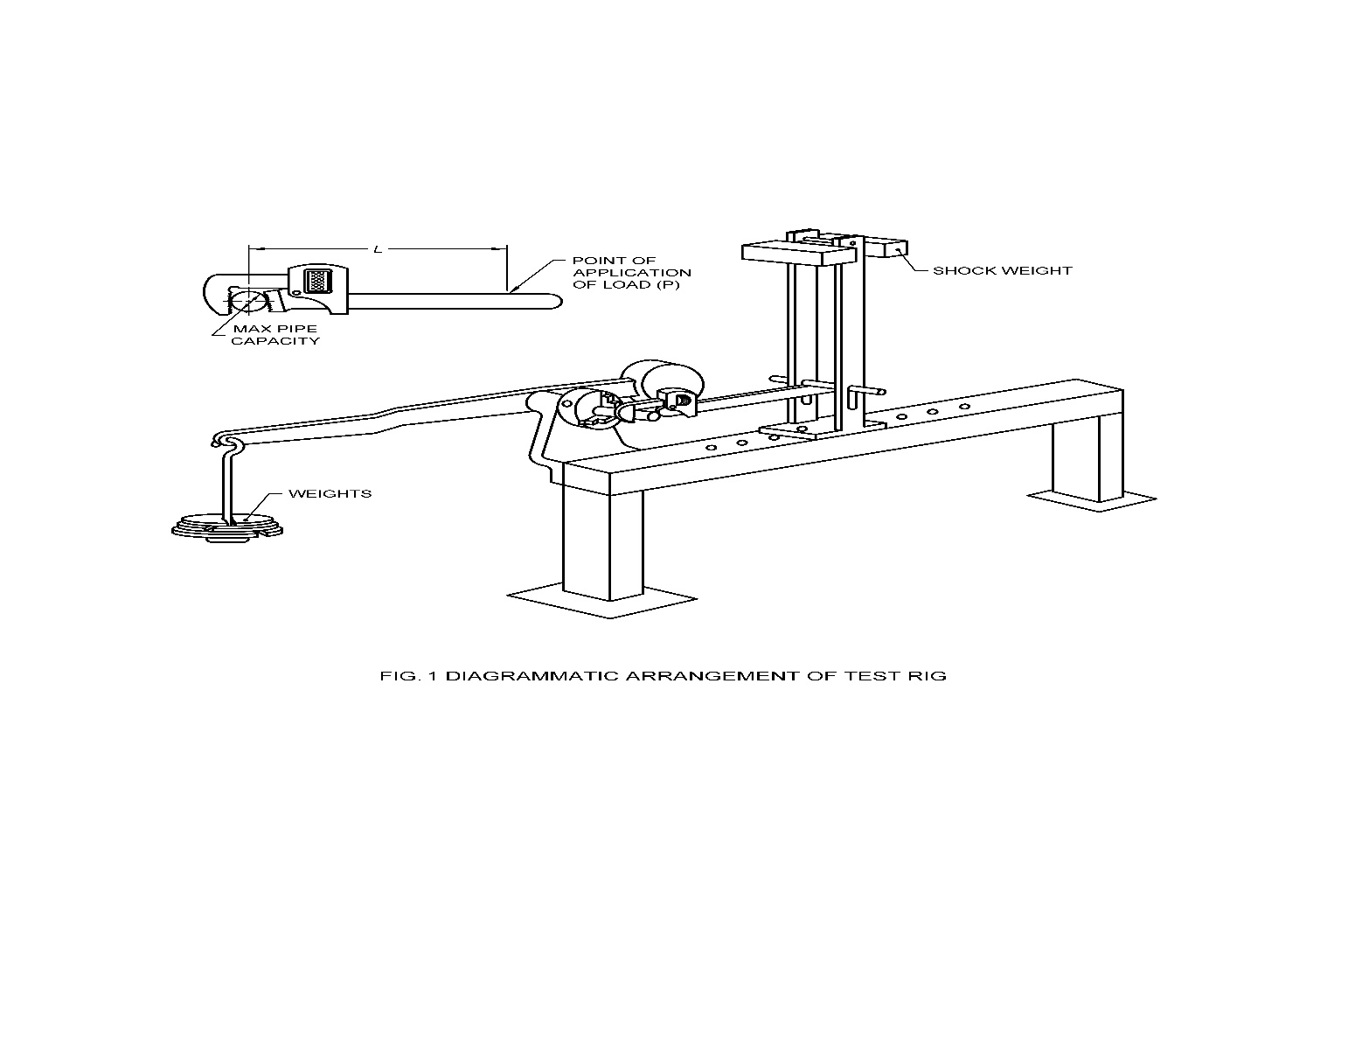

Fig. 2 Diagrammatic Arrangement of test Rig.

**Table 4 Test Loads for Pipe Wrenches**

(*Clauses* 11.1 *and* 11.2)

| **Sl No.** | **Nominal Size**  mm | **Diameter of Test Bar**  mm | **Proof Torque**  N-m | **Load Position**  *L* | **Shock Load Dropped Through 600 mm at Point ‘P’**  kg |
| --- | --- | --- | --- | --- | --- |
| (1) | (2) | (3) | (4) | (5) | (6) |
| i) | 200 | 16 | 180 | 150 | 13 |
| ii) | 250 | 20 | 330 | 200 | 13 |
| iii) | 300 | 25 | 500 | 225 | 13 |
| iv) | 350 | 30 | 650 | 262 | 18 |
| v) | 450 | 40 | 1 000 | 362 | 18 |
| vi) | 600 | 52 | 1 450 | 500 | 22 |
| vii) | 900 | 75 | 2 350 | 762 | 27 |
| viii) | 1 200 | 100 | 3 250 | 1 025 | 27 |

**12 DESIGNATION**

A general-purpose pipe wrench of 200 mm nominal size shall be designated as follows:

Pipe Wrench G 200 IS 4003 (Part 1)

**13 MARKING**

**13.1** Pipe wrenches shall be marked with the nominal size, manufacturer's name and/or trademark and month and year of manufacture/batch no.

**13.2 BIS Certification Marking**

The product(s) conforming to the requirements of this standard may be certified as per the conformity assessment schemes under the provisions of the *Bureau of Indian Standards Act*, 2016 and the Rules and Regulations framed thereunder, and the product(s) may be marked with the Standard Mark.

**14 PACKING**

Each pipe wrench shall be wrapped in grease or waxed paper and then suitably packed in cardboard carton bearing the designation and size of the wrench and the manufacturer's name initials and/or trade-mark.

**ANNEX A**

(*Foreword*)

**COMMITTEE COMPOSITION**

Hand Tools Sectional Committee, PGD 34



| *Organization* |  | *Representatives(s)* |
| --- | --- | --- |
| Institute for Auto Parts and Hand tools Technology, Ludhiana |  | Shri Sanjeev Katoch **(*Chairperson*)** |
| Ajay Industries Private Limited, Jalandhar |  | Shri Ajay Goswami  Shri Rajat Goswami (*Alternate*) |
| Bharat Heavy Electrical Limited, New Delhi |  | Shri M. Ravi  Shri J. S. Roy (*Alternate*) |
| Central Institute of Hand Tools, Jalandhar |  | Shri Amit Kumar |
| Directorate General of Quality Assurance, Ministry of Defence, New Delhi |  | Shri Manoj Pandey  Shri D. K. Mohapatra (*Alternate*) |
| Engineering Export Promotion Council, New Delhi |  | Shri Opinder Singh  Shri Ashwani Kumar (*Alternate*) |
| Falcon Garden Tools Private Limited, Ludhiana |  | Shri Gurchintan Singh  Shri Surinder Pal Singh (*Alternate*) |
| Gardex Industries, Jalandhar |  | Shri Paramjit Singh  Shri Ashutosh Datta (*Alternate*) |
| Gujarat Matikam Kalakari and Rural Technology Institute, Gandhinagar |  | Shri K. R. Dhaloria  Shri Satendra Pal Singh (*Alternate*) |
| Hand Tools Industries Association, Nagaur |  | Shri Julphikar Ali  Shri Ashfaq Ali (*Alternate*) |
| Hand Tools Manufacturers Association, Jalandhar |  | Shri Sukhdev Raj  Shri Ashwani Kumar (*Alternate*) |
| Inder Industries, Jalandhar |  | Shri Vijay Chatrath  Shri Sunil Chatrath (*Alternate*) |
| Indian Oil Corporation Limited, New Delhi |  | Ms Neeta Agarwal  Shri Abhishek Anupam (*Alternate*) |
| Institute for Auto Parts and Hand tools Technology, Ludhiana |  | Shivani Thakur  Shri Pankaj Kaundal (*Alternate*) |
| Kudale Instruments Private Limited, Pune |  | Shri Putambekar C. M.  Shri Sangram Kudale (*Alternate*) |
| Ludhiana Hand Tools Association, Ludhiana |  | Shri Ashok Gupta  Shri S. C. Ralhan (*Alternate*) |
| Mekaster Tools Limited, Chennai |  | Shri Salil Agarwal |
| Oaykay Forgings Private Limited, Jalandhar |  | Shri Sharad Aggarwal |
| Office of Development Commissioner (MSME), New Delhi |  | Shri K. L. Rao  Shri K. K. Funda (*Alternate* I)  Shri G. Shanmuganathan (*Alternate* II) |
| Osho Tools Private Limited, Jandiali |  | Shri Rajesh Peshion  Shri Ashok Gupta (*Alternate*) |
| Passi Agro-tech Enterprises, Ludhiana |  | Shri Bikramjit Singh  Shri Sarbagh Singh (*Alternate*) |
| Pye Tools Private Limited, Ludhiana |  | Shri Gaurav Sehgal |
| Research Designs and Standards Organization (RDSO), Lucknow |  | Executive Director |
| Taparia Tools Limited, Mumbai |  | Shri N. B. Borse  Shri Nikhil Bhutuja (*Alternate*) |
| Tata Motors Limited, Pune |  | Shri Anoop Toby  Shri Hanamant Gurav (*Alternate*) |
| Tata Steel Limited, Kolkata |  | Shri Rahul Mishra  Shri Jayant Bhardwaj (*Alternate*) |
| Victor Forgings, Jalandhar |  | Shri Anil Kumar  Shri Sukhdev Raj (*Alternate*) |
| BIS Directorate General |  | Shri Rajeev Ranjan Singh, ‘F’/Senior Director and Head (Production and General Engineering) [Representing Director General (*Ex-officio*)] |

*Member Secretary*

Shri Vimal Kumar

Scientist ‘B’/Assistant Director

(Production And General Engineering), BIS