***भारतीय मानक***

***Indian Standard***

**IS 5684 : 2024**

**पाइप शिकंजे (चेन टाइप) — विशिष्टि**

*( पहला पुनरीक्षण )*

**Pipe Vices (Chain Type) — Specification**

*( First Revision )*

ICS 25.140.30

© BIS 2024



भारतीय मानक ब्यूरो

BUREAU OF INDIAN STANDARDS

मानक भवन, 9 बहादुर शाह ज़फर मार्ग, नई दिल्ली ‒ 110002

MANAK BHAVAN, 9 BAHADUR SHAH ZAFAR MARG

NEW DELHI ‒ 110002

[www.bis.gov.in](http://www.bis.org.in) [www.standardsbis.in](http://www.standardsbis.in)

**October 2024** **Price Group X**

Hand Tools Sectional Committee, PGD 34

FOREWORD

This Indian Standard (First Revision) was adopted by the Bureau of Indian Standards after the draft finalized by the Hand Tools Sectional Committee had been approved by the Production and General Engineering Division Council.

This standard was first published in 1970. This revision has been brought out to align it with the latest technological developments and international practices.

In this revision, the following major changes have been made:

1. Clause on references has been added; and
2. Material designations have been updated as per latest standards.

This standard covers requirements for chain type pipe vices generally used for plumbing jobs and erection of pipelines. For open side type and fixed sides type pipe vices may be referred IS 2587 : 1975 ‘Specification for pipe vices (open side type and fixed sides type)’(*first revision*).

The composition of the Committee, responsible for the formulation of this standard is given in Annex C.

For the purpose of deciding whether a particular requirement of this standard is complied with the final value, observed or calculated, expressing the result of a test or analysis shall be rounded off in accordance with IS 2 : 2022 ‘Rules for rounding off numerical values (*second revision*)’. The number of significant places retained in the rounded off value should be same as that of the specified value in this standard.

*Indian Standard*

PIPE VICES (CHAIN TYPE) — SPECIFICATION

*( First Revision )*

**1 SCOPE**

This standard specifies requirements for chain type pipe vices.

**2 REFERENCES**

The standards listed in Annex A contain provisions which through reference in this text, constitute provisions of this standard. At the time of publication, the editions indicated were valid. All standards are subject to revision and parties to agreements based on this standard are encouraged to investigate the possibility of applying the most recent edition of these standards.



**3 MATERIAL**

The materials for the manufacture of different components of vices shall be such as to fulfil the requirements laid down in **4** and **9**. Some of the suitable materials for the manufacture of different components are given below:

|  |  |  |
| --- | --- | --- |
| *Sl No.* | *Component* | *Material* |
|  |  |  |
|  | Base and nut | Steel casting conforming to Grade 230-450N of IS 1030  or  Gary cast iron conforming to Grade FG 350 of IS 210 |
|  | Jaws | Tool steel conforming to designation TC 6 of IS 1570 (Part 6) |
|  | Screw spindle and handle | Steel conforming to designation Fe 410 of IS 1570 (Part 1) |

**4 HARDNESS**

The hardness measured at the jaws shall be within the range of 45 HRC to 55 HRC or 450 HV to 550 HV when determined in accordance with IS 1586 (Part 1) or IS 1501 (Part 1) as applicable.

**5 SHAPES AND DIMENSIONS**

1. The dimensions of the vices shall be as given in Fig. 1 and Table 1.
2. The dimensions of jaws shall be as given in Fig. 2 and Table 2.
3. The dimensions for screw nut assembly shall be as given in Fig. 3 and Table 3.
4. The shapes given in the Fig. 1, Fig. 2 and Fig. 3 are only to illustrate the dimensions. The actual shape and other design details are left to the discretion of manufacturer. The untoleranced dimensions may have a variation of ± 2 percent.

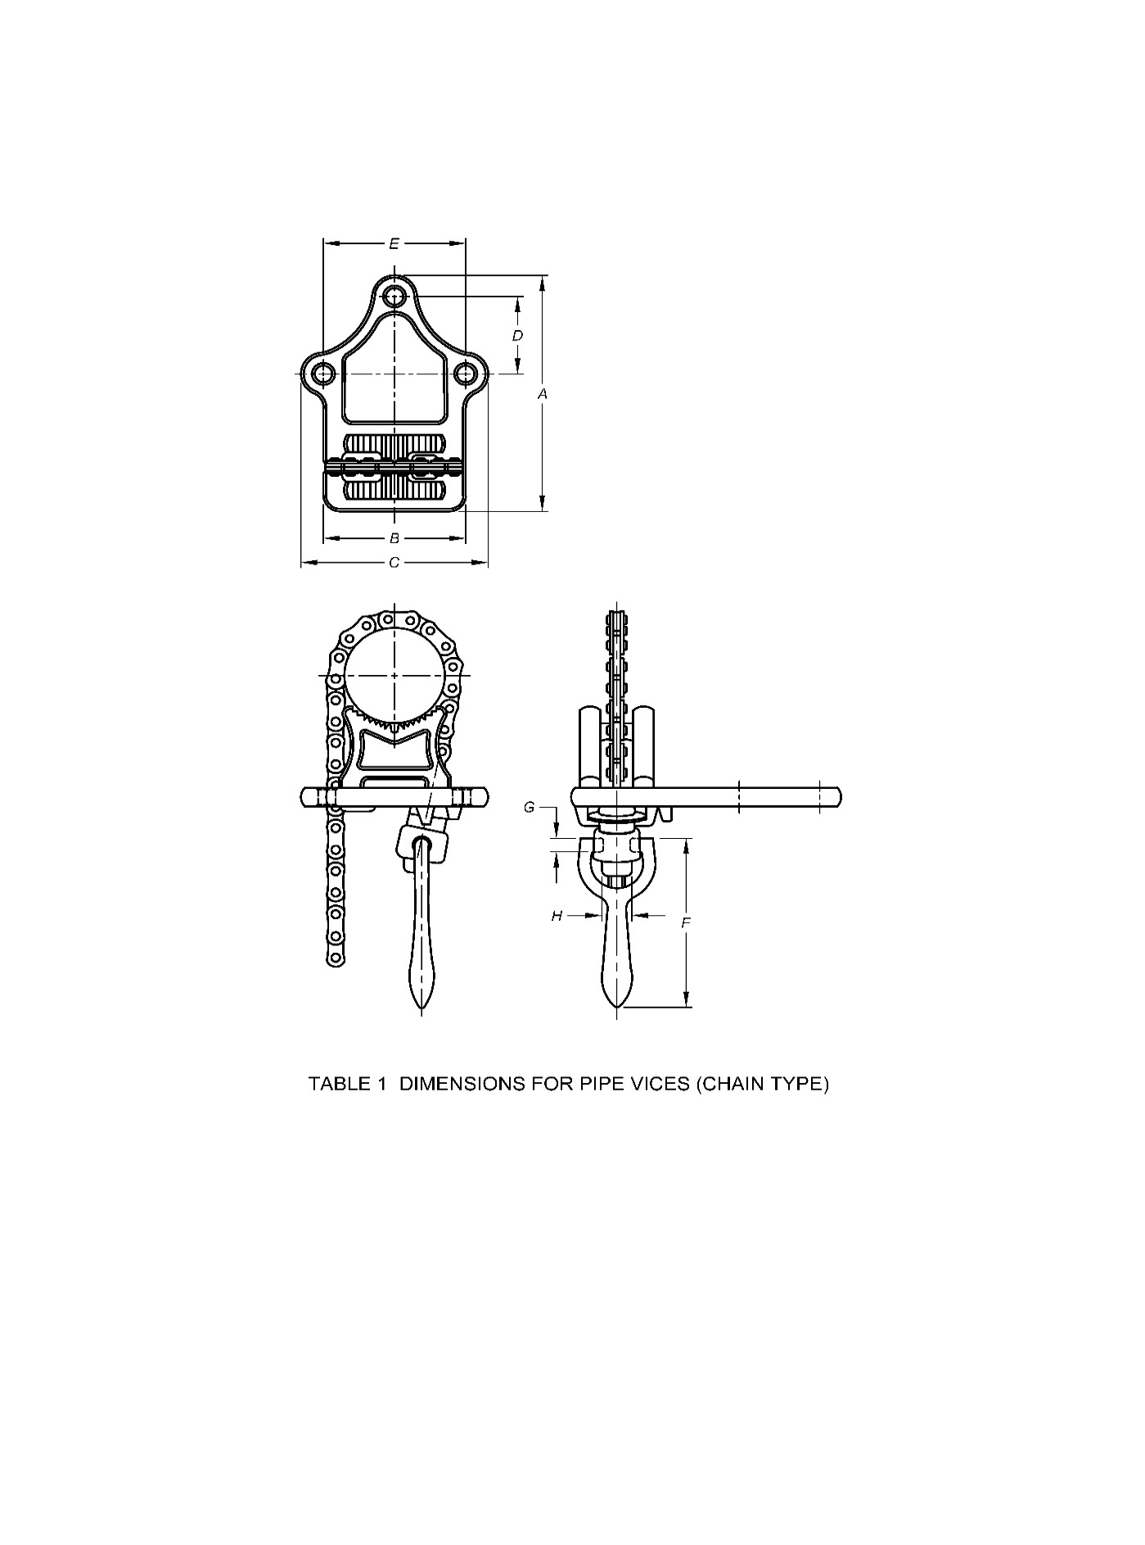

Fig. 1 Dimensions for Pipe Vices (Chain Type)

**Table 1 Dimensions for Pipe Vices (Chain Type)**

(*Clause* 5.1)

All dimensions are in millimetres.

|  |  |  |  |  |  |  |  |  |  |  |
| --- | --- | --- | --- | --- | --- | --- | --- | --- | --- | --- |
| **Sl No.** | **Nominal Size** | **Capacity**  (Outside pipe diameter) | ***A*** | ***B*** | ***C*** | ***D*** | ***E*** | ***F*** | ***G*** | ***H*** |
| (1) | (2) | (3) | (4) | (5) | (6) | (7) | (8) | (9) | (10) | (11) |
| i) | 63 | 3 to 63 | 135 | 75 | 100 | 45 | 75 | 115 | 11 | 24 |
| ii) | 102 | 6 to 102 | 213 | 119 | 160 | 70 | 121 | 153 | 11 | 30 |
| iii) | 152 | 10 to 152 | 248 | 150 | 197 | 89 | 153 | 115 | 12.5 | 36.5 |

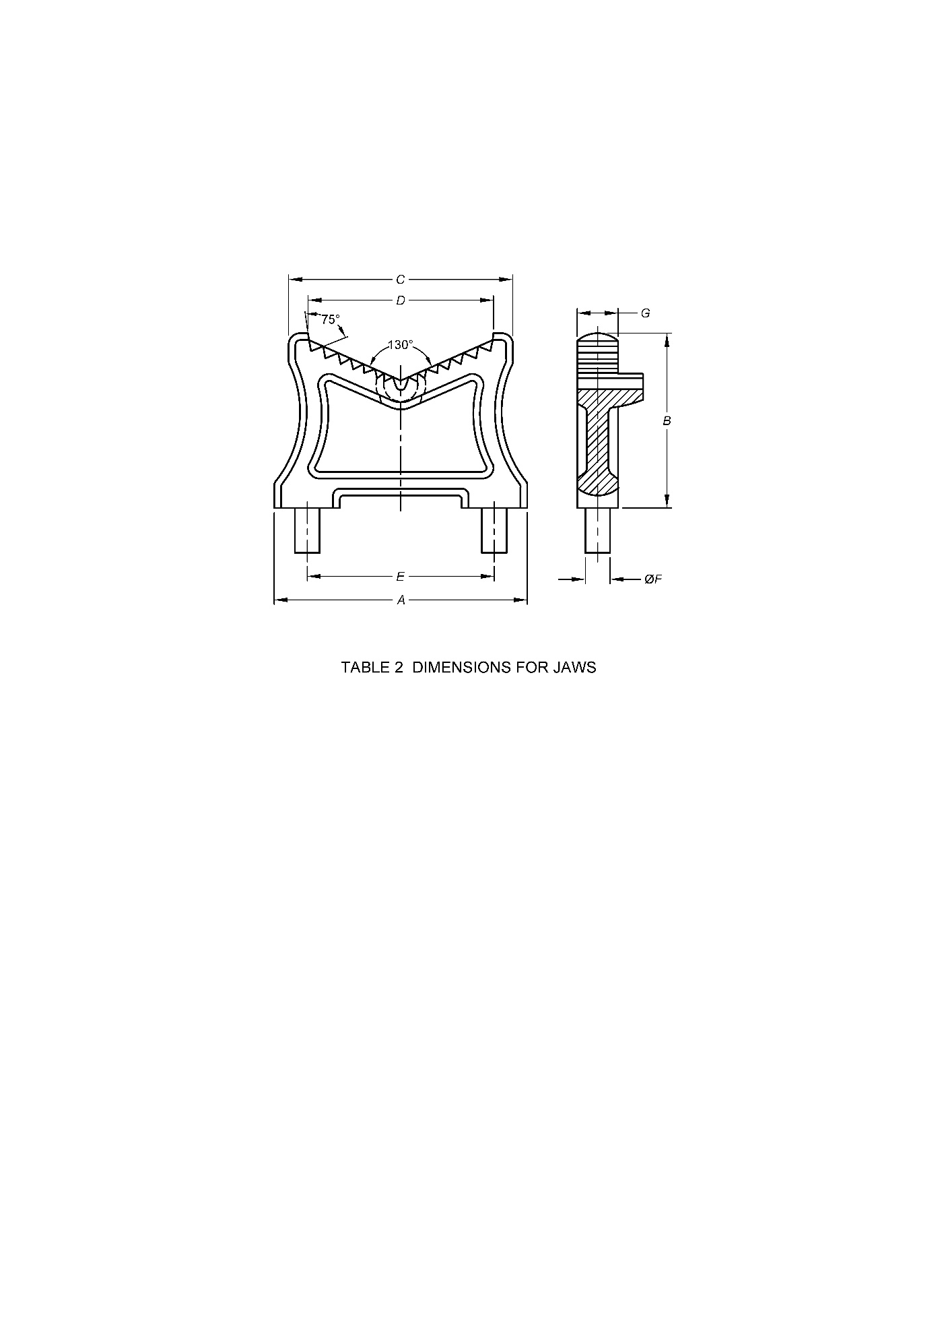

Fig. 2 Dimensions for Jaws

**Table 2 Dimensions for Jaws**

(*Clause* 5.2)

All dimensions are in millimetres.

|  |  |  |  |  |  |  |  |  |
| --- | --- | --- | --- | --- | --- | --- | --- | --- |
| **Sl No.** | **Nominal Size** | ***A*** | ***B*** | ***C*** | ***D*** | ***E*** | ***F*** | ***G*** |
| (1) | (2) | (3) | (4) | (5) | (6) | (7) | (8) | (9) |
| i) | 63 | 62 | 12 | 60 | 50 | 50 | 8 | 12 |
| ii) | 102 | 95 | 73 | 89 | 73 | 73 | 10 | 16 |
| iii) | 152 | 133 | 95 | 118 | 100 | 108 | 13 | 20 |

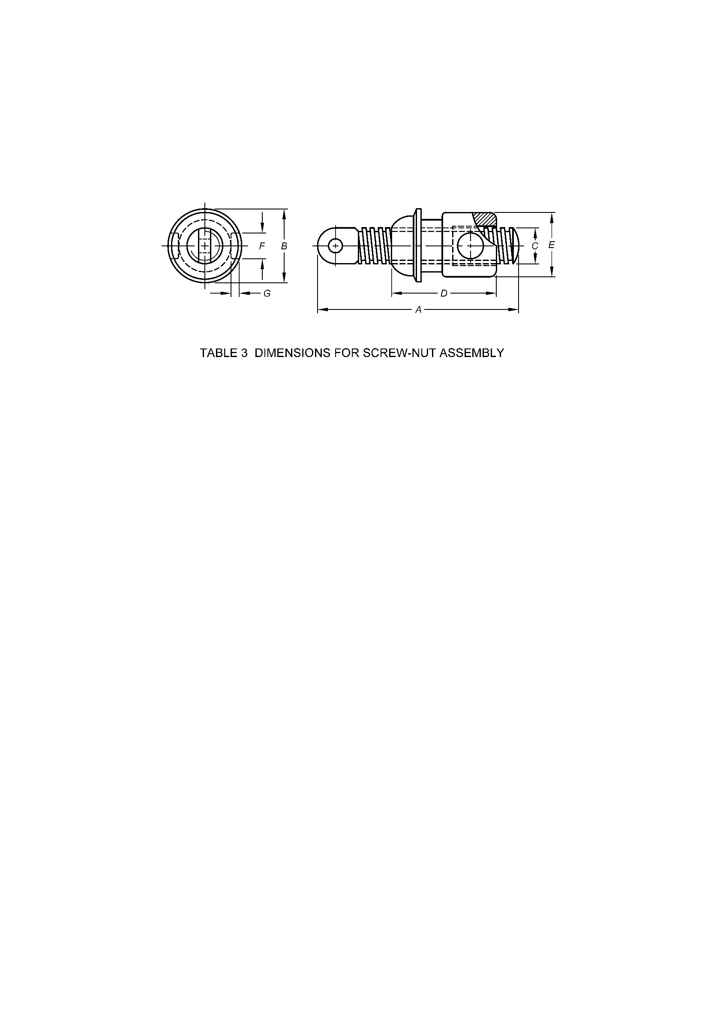

Fig. 3 Dimensions for Screw-Nut Assembly

**Table 3 Dimensions for Screw-Nut Assembly**

(*Clause* 5.3)

All dimensions are in millimetres.

|  |  |  |  |  |  |  |  |  |
| --- | --- | --- | --- | --- | --- | --- | --- | --- |
| **Sl No.** | **Nominal Size** | ***A*** | ***B*** | ***C*** | ***D*** | ***E*** | ***F*** | ***G*** |
| (1) | (2) | (3) | (4) | (5) | (6) | (7) | (8) | (9) |
| i) | 63 | 80 | 35 | TT 16 × 3  Or  SQ 16 × 2 | 35 | 30 | 9 | 4 |
| ii) | 102 | 105 | 45 | Tr 22 × 5  Or  SQ 22 × 2 | 50 | 40 | 14 | 6 |
| iii) | 125 | 125 | 45 | Tr22 × 5  Or  SQ 22 × 5 | 65 | 40 | 14 | 6 |

**6 MANUFACTURE**

1. **Base**

The base shall be notched or other means shall be provided to anchor the chain by means of the chain pins.

1. **Jaws**

The jaws shall be rigidly mounted on the base or integral with base. The clamping surface of the jaw shall be V-shaped or semi-circular and shall have mill cut V-shaped teeth for gripping the pipe.

1. **Chain**

The chain shall be of the flat link type with projecting link pins to engage the slot in the base. The chain shall be replaceable and of such length as to grip the pipe of the maximum size for which the vice is designed. The chain shall conform to Chain No. LH 1222 of IS 1072.

1. **Screw**

The screw shall have square or ISO metric trapezoidal screw threads shall be properly and accurately cut. The ISO metric trapezoidal screw threads shall conform to IS 7008 (Part 1).

**7 WORKMANSHIP AND FINISH**

The vices shall be smooth all over, and shall be free from burrs, cracks or other manufacturing defects. The movement of the screw shall be easy without undue slackness or resistance throughout.

**8 PRESERVATIVE TREATMENT**

The vices shall be painted on all non-working surfaces. The working surface shall be covered with rust-proofing material.

**9 TESTS**

**9.1 Clamping Test**

A bar of 30 mm diameter and of smooth surface having a hardness not less than 50 HRC or 510 HV shall be gripped in the vice and a turning moment as given in Table 4 shall be applied to the screw. The bar shall then be twisted with a turning moment as given in Table 4. The bar shall not rotate and the vice shall not show any sign of damage.

**Table 4 Turning Moment for Pipe Vices (Chain Type)**

(*Clause* 9.1)

|  |  |  |  |
| --- | --- | --- | --- |
| **Sl No.** | **Nominal Size** | **Turning Moment**  kgfm(N-m) | |
| To be Applied to Screw | To be Applied to Test Bar |
| (1) | (2) | (3) | (4) |
| i) | 63 | 8 (78) | 10 (98) |
| ii) | 102 | 9 (88) | 12 (117) |
| iii) | 152 | 10 (98) | 14 (137) |

**9.1.1** A mild steel bar of 30 mm of smooth surface shall be gripped in the vice and then removed. After removal of the bar, the lines on the bar shall show a uniform pressure throughout the contact area.

**10 DESIGNATION**

The pipe vices (chain type) shall be designated by:

1. Commonly used name;
2. Nomination size; and
3. Number of this standard.

*Example*:

A Pipe vice (chain type) of 63 mm nominal size shall be designated as:

Pipe Vice 63, IS 5684

**11 MARKING**

**11.1** The vices shall be marked with the nominal size and manufacturer’s trademark and month and year of manufacture/batch no.

**11.2 BIS Certification Marking**

The product(s) conforming to the requirements of this standard may be certified as per the conformity assessment schemes under the provisions of the *Bureau of Indian Standards Act*, 2016 and the Rules and Regulations framed thereunder, and the product(s) may be marked with the Standard Mark.

**12 SAMPLING**

Unless otherwise agreed upon between the purchaser and the manufacturer, the sampling plan and criterion for conformity given in Annex B shall be followed.

**ANNEX A**

(*Clause* 2)

**LIST OF REFERRED STANDARDS**

|  |  |
| --- | --- |
| *IS No.* | *Title* |
| IS 210 : 2009 | Grey iron castings — Specification (*fifth revision*) |
| IS 1030 : 1998 | Carbon steel castings for general engineering purposes — Specification (*fifth revision*) |
| IS 1072 : 2024 | Leaf chains, clevises and sheaves — Dimensions, measuring forces and tensile strengths and dynamic strengths (*fourth Revision*) |
| IS 1501 (Part 1) : 2020 | Metallic materials — Vickers hardness test: Part 1 Test method (*fifth* *revision*) |
| IS 1570 | Schedules for wrought steels: |
| (Part 1) : 1978 | Steels specified by tensile and/or yield properties (*first revision*) |
| (Part 6) : 1996 | Carbon and alloy tool steels (*first revision*) |
| IS 1586 (Part 1) : 2018 | Metallic materials — Rockwell hardness test: Part 1 Test method (*fifth revision*) |
| IS 4905 : 2015 | Random sampling and randomization procedures (*first revision*) |
| IS 7008 (Part 1) : 2021 | ISO metric trapezoidal screw threads: Part 1 Basic and design profile (*third revision*) |



**ANNEX B**

(*Clause* 12)

**SAMPLING OF PIPE VICES AND CRITERIA FOR CONFORMITY**

**B-1 SCALE OF SAMPLING**

**B-1.1 Lot**

In any consignment all the pipe vices of the same designation and manufactured under essentially similar conditions of manufacture shall be grouped together to constitute a lot.

**B-1.2** For ascertaining the conformity of the lot to the requirements of this specifications, test shall be carried out for each lot separately. The number of pipe vices to be selected at random for this purpose shall be in accordance with col (2) and col (3) of Table 5. To ensure the randomness of selection. IS 4905 shall be followed.

**Table 5 Scale of Sampling**

(*Clause* B-1.2)

|  |  |  |
| --- | --- | --- |
| **Sl No.** | **No. of Vices in the Lot**  *N* | **No. of Vices to be Selected**  *n* |
| (1) | (2) | (3) |
| i) | Up to 5 | All |
| ii) | 6 to 25 | 5 |
| iii) | 26 to 50 | 8 |
| iv) | 51 to 100 | 13 |
| v) | 101 and above | 20 |

**B-2 NUMBER OF TESTS AND CRITERION FOR CONFORMITY**

Vices selected according to **B-1.2** shall be examined for the requirements of this specification. If none of the sample vices fails to meet these requirements, the lot shall be declared to conform to this specification.

**ANNEX C**

(*Foreword*)

**COMMITTEE COMPOSITION**

Hand Tools Sectional Committee, PGD 34

|  |  |
| --- | --- |
| *Organization* | *Representatives(s)* |
| Institute for Auto Parts and Hand tools Technology, Ludhiana | Shri Sanjeev Katoch **(*Chairperson*)** |
| Ajay Industries Private Limited, Jalandhar | Shri Ajay Goswami  Shri Rajat Goswami (*Alternate*) |
| Central Institute of Hand Tools, Jalandhar | Shri Amit Kumar |
| Engineering Export Promotion Council, New Delhi | Shri Ashwani Kumar  Shri Opinder Singh (*Alternate*) |
| Hand Tools Industries Association, Nagaur | Shri Ashfaq Ali  Shri Zulfiqar Ali (*Alternate*) |
| Hand Tools Manufacturers Association, Jalandhar | Shri Sukhdev Raj  Shri Ashwani Kumar (*Alternate*) |
| Inder Industries, Jalandhar | Shri Vijay Chatrath  Shri Sunil Chatrath (*Alternate*) |
| Indian Oil Corporation Limited, New Delhi | Ms Neeta Agarwal  Shri Abhishek Anupam (*Alternate*) |
| Institute for Auto Parts and Hand tools Technology, Ludhiana | Shri Pankaj Kaundal  Shivani Thakur (*Alternate*) |
| Ludhiana Hand Tools Association, Ludhiana | Shri S. C. Ralhan  Shri Ashok Gupta (*Alternate*) |
| Mansarovar Forgings Pvt. Ltd, Ludhiana | Shri Khushvir Singh |
| Oaykay Forgings Private Limited, Jalandhar | Shri Sharad Aggarwal |
| Osho Tools Private Limited, Jandiali | Shri Ashok Gupta  Shri Rajesh Peshion (*Alternate*) |
| Pahwa Metal Tech Pvt Ltd Pune. | Shri Lalit Kumar Pahwa  Shri Aakash Pahwa (*Alternate*) |
| Precise Fasteners Private Limited, Mumbai | Shri Parag Prakash Shah |
| Pye Tools Private Limited, Ludhiana | Shri Gaurav Sehgal  Shri Rajender Pal (*Alternate*) |
| Taparia Tools Limited, Nashik | Shri Nikhil Bhutuja  Shri N. B. Borse (*Alternate*) |
| Tata Motors Limited, Pune | Shri Anoop Toby  Shri Hanamant Gurav (*Alternate*) |
| Victor Forgings, Jalandhar | Shri Sukhdev Raj  Shri Anil Kumar (*Alternate*) |
| BIS Directorate General | Shri Rajeev Ranjan Singh, Scientist‘F’/Senior Director and Head (Production and General Engineering) [Representing Director General (*Ex-officio*)] |

*Member Secretary*

Shri Vimal Kumar

Scientist ‘C’/Deputy Director

(Production And General Engineering), BIS