**Doc. No: PCD 01 (18454) F**

***भारतीय मानक***

***Indian Standard***

**IS 1448 part 196: 2024**

**पेट्रोलियम और उसके उत्पाद —**

**परीक्षण पद्धतियाँ**

**भाग 196 ऑटोमोटिव व्हील**

**बियरिंग ग्रीस की रिसाव प्रवृत्ति**

**का निर्धारण**

**Petroleum and its**

**Products — Methods of Test**

**Part 196 Determination of the**

**Leakage Tendencies of**

**Automotive Wheel**

**Bearing Greases**

ICS 75.080

© BIS 2024



भारतीय मानक ब्यूरो

BUREAU OF INDIAN STANDARDS

मानक भवन, 9 बहादुर शाह ज़फर मार्ग, नई दिल्ली - 110002

MANAK BHAVAN, 9 BAHADUR SHAH ZAFAR MARG

NEW DELHI - 110002

[www.bis.gov.in](http://www.bis.org.in) [www.standardsbis.in](http://www.standardsbis.in)

**August 2024 Price Group X**

Methods for Sampling and Test for Petroleum and Related Products of Natural or Synthetic Origin (Excluding Bitumen) Sectional Committee, PCD 01

FOREWORD

This Indian Standard (Part 196) was adopted by the Bureau of Indian Standards, after the draft finalized by the Methods for Sampling and Test for Petroleum and Related Products of Natural or Synthetic Origin (Excluding Bitumen) Sectional Committee had been approved by the Petroleum, Coal and Related Products Division Council.

In the formulation of this standard, assistance has been derived from ASTM D1263-94 ‘Standard test method for leakage tendencies of automotive wheel bearing greases’.

This standard is one of the series of Indian Standards on IS 1448 ‘Methods of test for petroleum and its products’.

The composition of the Committee responsible for the formulation of this standard is given in Annex A.

In reporting the results of a test analysis made in accordance with this standard, if the final value, observed or calculated, is to be rounded off, it shall be done in accordance with IS 2 : 2022 ‘Rules for rounding off numerical values (*second revision*).’

*Indian Standard*

PETROLEUM AND ITS PRODUCTS — METHODS OF TEST

**PART 196 DETERMINATION OF THE LEAKAGE TENDENCIES OF AUTOMOTIVE WHEEL BEARING GREASES**

**1 SCOPE**

This standard (Part 196) prescribes the method of test for assessment of the leakage tendencies of wheel bearing greases.

**2 TERMINOLOGY**

**2.1 Automotive Wheel Bearing Grease —** A lubricating grease categorically composed to lubricate automotive wheel bearings at relatively high temperature of grease and bearing speed.

**2.2 —**

**2.3 Lubricant —** Any material, which when interposed in between two surfaces, lowers down the friction or wear between them.

**2.4 Lubricating Grease**

**2.4.1** A semi-fluid to solid product of a dispersion of a thickener in a liquid lubricant

**2.4.2** A two-phase system is formed by the dispersion of thickener, immobilizing the liquid lubricant due to surface tension and other physical forces. Other ingredients are added to get other special properties.

**2.5 Thickener**

**2.5.1**  In lubricating grease, a substance used to form the structure of product, composed of finely-divided particles dispersed in a liquid lubricant.

**2.5.2** The solid thickener can be spheres (such as certain non-soap thickeners) or fibers (such as various metallic soaps) or plates. The solid particles are insoluble or, at the most, only very slightly soluble in the liquid lubricant. Solid particles should generally be uniformly dispersed, extremely small, and capable of forming a gel-like, relatively stable structure with the liquid lubricant.

**3 PRINCIPLE**

**3.1** The grease is distributed in a specialized front-wheel hub and spindle assembly. Spindle temperature is raised to and maintained at (105 ± 1.2) °C. The hub is rotated at a speed of (660 ± 30) rpm for 6 h ± 5 min. Leakage of oil or grease, or both is measured, and at the end of the test, the condition of the bearing surface is noted.

**3.2** A screening device is provided by the test method that allows differentiation among products of distinctly different leakage characteristics. This test method is not equivalent to long time service tests and it is also not aimed at distinguishing between wheel bearing greases showing similar or borderline leakage.

NOTE — Skilled operators may observe significant changes in other important grease characteristics that occur during the test. Such additional information can be of special interest to individual operators. The observations, however, cannot be used effectively for quantitative rating, as these are subjective to the operators.

**4 APPARATUS**

**4.1** The suitable apparatus is shown in Fig. 1, Fig. 2A and Fig. 2B. The tester has a special front wheel hub and spindle assembly and the hub is rotated by an electric motor using a V-belt drive. The assembly is encased in a thermostatically controlled air bath. There are means to measure both ambient (cabinet) and spindle temperatures. A torque wrench is also required, which is suitable for use on 31.75 mm hexagonal nuts.

**4.2** The apparatus (spindle, case, and motor) shall be electrically grounded, otherwise the thermocouples will not function due to accumulated static charges. Details provided in Fig. 2A and Fig. 2B.

**4.3** A heater of suitable wattage should be used to enable proper temperature balance. Usually 660 W heaters can provide sufficient heat input.

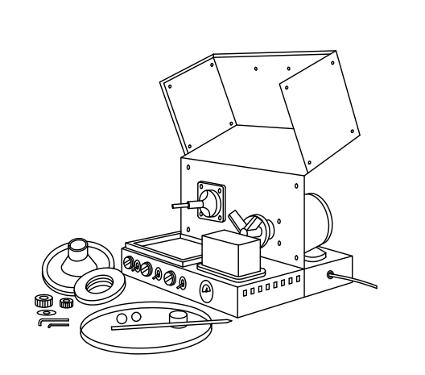

Fig. 1 Apparatus for Testing Leakage Tendencies of Wheel Bearing Greases

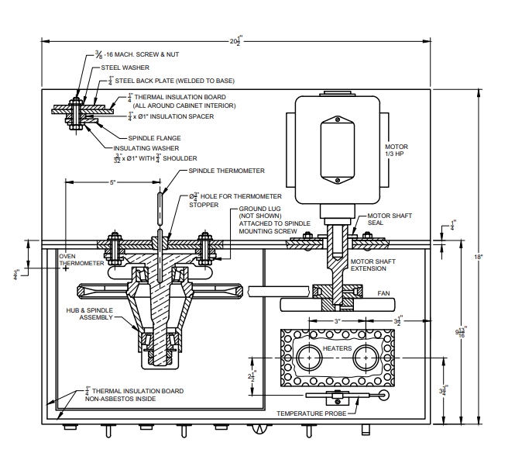

All dimensions in inch.

Fig. 2A Details of Main Assembly

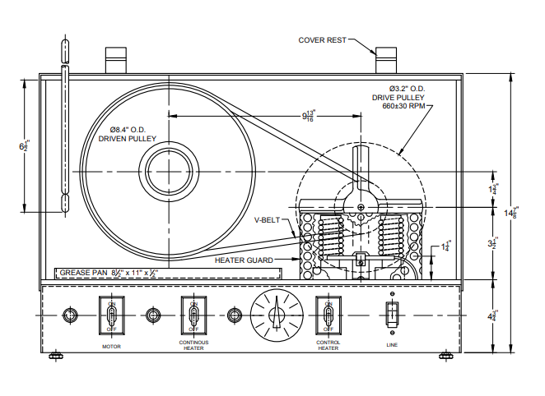

All dimensions in inch.

Fig. 2B Details of Main Assembly

**4.4 Main Assembly**

The main assembly shall consist of spindle assembly mounted in a thermostatically controlled air bath and a special front-wheel hub. The assembly is arranged so that the hub will be rotated by an electric motor through a V-belt drive, as shown in Fig. 2B. One continuous and one intermittent heater shall be mounted on the base of the apparatus and shall be controlled thermostatically.

**4.5 Bearing Spindle**

The spindle shall be constructed as shown in Fig. 3.

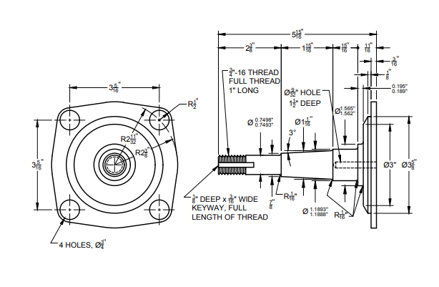

Fig. 3 Details of Main Spindle

**4.6 Bearing Hub**

The bearing hub shall be constructed as shown in Fig. 4.

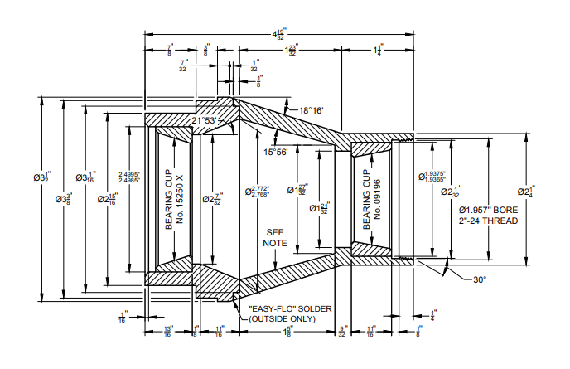

Fig. 4 Details of Bearing Hub

NOTE — Polish inside tapered surfaces with waterproof paper. Do not round off sharp corners when polishing. Make both parts of hub assembly from 3.5 inch round cold drawn steel rod.

**4.7 Leakage Collector**

A cup-shaped ring shall be used as a leakage collector to catch any leaked grease from the inner end of the hub, as shown in Fig. 5. The ring shall be removable providing a method for determining the grease loss. The ring is held in place by the large bearing.

NOTE — The regular grease retainer is not suitable for this purpose as, at the laboratory level, it is beneficial to accelerate any leakage that may occur. Also, regular retainers are frequently found to be defective.

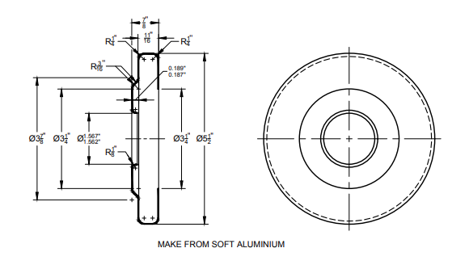

Fig. 5 Details of Grease Collector

**4.8 Fan**

The fan shall be constructed as shown in Fig. 6.

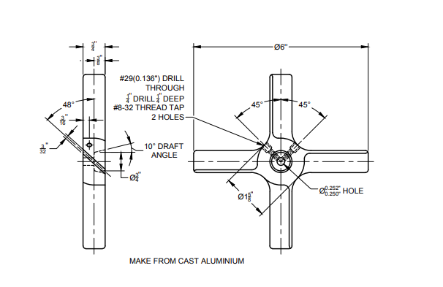

Fig. 6 Details of Fan

**4.9 Test Bearings**

**4.9.1** *Inner Bearing* (*Tapered Roller*) — Timken 15118. The corresponding cup No. 15250.

**4.9.2** *Smaller Outer Bearing* — Timken 09074. The corresponding cup No. 09196.

**5 REAGENT**

**5.1 Heptane** — 99.0 percent purity

**WARNING** **—** Flammables Harmful if inhaled.

**6 PROCEDURE**

**6.1** Weigh (90 ± 1) g of sample on a flat plate. Pack (2 ± 0.1) g of grease in the small bearing using a spatula. Similarly, pack (3 ± 0.1) g of grease in the large bearing.

**6.2** On the inside of the hub, distribute the balance of the test grease in a uniform layer. Apply a thin film of grease to the bearing races in the hub.

NOTES

**1** A narrow, wedge-cut spatula is suitable for packing the bearings.

**2** Rest of the grease will fill the hub sufficiently, even with the races and except for very fibrous greases, it can be distributed quickly and uniformly with a spatula of 150 mm blade.

**6.3** Weigh the leakage collector and the hub cap to the nearest 0.1 g separately. Put the large (inner) bearing and leakage collector in the proper position on the spindle. Put small (outer) bearing and the hub on the spindle, followed by the loose-fitting retainer ring. Tighten the hexagonal nut which holds the hub assembly in place, applying a torque of (6.8 ± 0.1) Nm using the torque wrench. Then back off the hexagonal nut (60 ± 5)° (or one flat), and lock it in position with a second hexagonal nut. Put screws on the hub cap and V-belt on the pulleys, and close the cabinet.

**CAUTION**—Inspect all the grease collectors carefully to make sure that the inner lip is flush with the sealing face, otherwise this lip will interfere with the correct seating of the inner bearing.

**CAUTION**—Prevent contact between grease pack and spindle, while assembling the packed hub on the spindle.

**CAUTION**—From time to time, the drive pulley and the driven pulley should be checked for alignment. Misalignment can introduce leakage variations.

NOTE — For this, check the bearing for signs of wear before filling it with grease at the start of the test. Excessive end play of the hub assembly is sometimes due to worn bearings. Therefore, new bearings, both cups and cones, should be installed after each 250 tests.

**6.4** Close the cabinet and turn on both the heaters and motor. Operate at a speed of (660 ± 30) rpm for 6 h ± 5 min. The spindle temperature to be raised to and then maintained at (105 ± 1.4) °C during the test period. Maintain the ambient temperature at (115 ± 3) °C to obtain the spindle temperature of (105 ± 1.4) °C. Keep the auxiliary heater on till an ambient or oven temperature of 115 °C is attained. Keep the thermoregulatory previously adjusted to maintain oven temperature of 115 °C, or to have a reproducible setting for this temperature. The ambient temperature of (115 ± 3) °C shall be attained within (15 ± 5) min. The spindle temperature of (105 ± 1.4) °C shall be attained within (60 ± 10) min. These two combining result in the spindle maintaining at (105 ± 1.4) °C for 5 h ± 15 min.

**CAUTION** — Rate of heating can be affected by drafts. Therefore, location of the tester should be carefully chosen.

**6.5** Shut off the power after 6 h from the time motor and heater are turned on and dismantle the apparatus while hot. Wear appropriate protective clothing while handling the hot equipment.

**6.6** Let the apparatus cool and measure the weight of the hub cap and leakage collector separately to the nearest 0.1 g.

NOTE — In case of overflow from leakage collector, the amount of overflow grease/oil or both, should be weighed and included in the reported total leakage.

**6.7** Wash the two bearings with heptane at room temperature for at least 2 min to remove the grease. Inspect for varnish, gum, or lacquer-like deposits.

NOTE — In case of some wheel bearing greases, soaps are not completely washed from the bearings with n-heptane and film of soap may remain on the bearings. Such film is easily distinguishable from varnish, gum, or lacquer-like deposits resulting from deterioration of the lubricant.

**7 REPORT**

The total amount of leakage of grease/oil or both, into the collector and into the hub cap is to be reported. Also report the presence of any adherent deposit of varnish, gum, or lacquer-like material on the bearing surface, which is evident after removal of the grease.

**8 PRECISION AND BIAS**

**8.1 Repeatability**

The difference between two test results, obtained by the same operator with the same apparatus under constant operating conditions on identical test material, would in the long run, in the normal and correct operation of the test method, exceed the following values only in one case in twenty:

|  |  |  |
| --- | --- | --- |
| *Sl No.* | *Leakage in Area of* | *Acceptable Difference* |
|  |  |  |
|  | 2 g | 1.5 g |
|  | 15 g to 20 g | 9 g |

**8.2 Reproducibility**

The difference between two single and independent results obtained by different operators working in different laboratories on identical test material would, in the long run, in the normal and correct operation of the test method, exceed the following values only in one case in twenty:

|  |  |  |
| --- | --- | --- |
| *Sl No.* | *Leakage in Area of* | *Acceptable Difference* |
|  |  |  |
|  | 2 g | 1.5 g |
|  | 15 g to 20 g | 9 g |

**8.3 Bias**

The procedure in this test method for measuring leakage tendencies of automotive wheel bearing greases has no bias because the value of leakage can be defined only in terms of a test method.

**ANNEX A**

(*Foreword*)

**COMMITTEE COMPOSITION**

Methods for Sampling and Test for Petroleum and Related Products of Natural or Synthetic Origin (Excluding Bitumen) Sectional Committee, PCD 01

| *Organization* | *Representative(s)* |
| --- | --- |
| [CSIR - Indian Institute of Petroleum, Dehradun](javascript:;) | Dr Harender Singh Bisht **(*Chairperson*)** |
| [Air Headquarters, Ministry of Defence, New Delhi](javascript:;) | Wg Cdr Y. Bhardwaj  Wg Cdr V. S. Choudhary (*Alternate* I)  Gp Capt Asheesh Shrivastava (*Alternate* II) |
| [Bharat Petroleum Corporation Limited, Mumbai](javascript:;) | Shri R. Subramanian  Shri C. Shanmuganathan (*Alternate*) |
| [Castrol India Limited, Mumbai](javascript:;) | Shri Raman Rai |
| [Central Institute of Plastics Engineering and Technology, Bhuwaneshwar](javascript:;) | Dr Smita Mohanty  Dr R. Ananthakumar (*Alternate*) |
| [Central Revenue Control Laboratory, New Delhi](javascript:;) | Shri V. Suresh |
| [Chennai Petroleum Corporation Limited, Chennai](javascript:;) | Shri H. Ramakrishnan  Shri M. Balaguru (*Alternate*) |
| [CSIR - Central Institute for Mining and Fuel Research, Dhanbad](javascript:;) | Shri S. R. K. Rao  Shri P. K. Singh (*Alternate* I)  Shri S. Dutta (*Alternate* II) |
| [CSIR - Indian Institute of Petroleum, Dehradun](javascript:;) | Dr G. D. Thakre  Dr Pankaj Kumar Kanaujia (*Alternate*) |
| [Directorate General of Aeronautical Quality Assurance, New Delhi](javascript:;) | Shri Santosh Namdeo |
| [Directorate General of Quality Assurance, Ministry of Defence, Kanpur](javascript:;) | Dr Om Prakash Singh  Shri A. K. Kanaujia (*Alternate*) |
| [Elico Limited, Hyderabad](javascript:;) | Shri T. V. Shiva K. Rao  Shri N. Raju (*Alternate*) |
| [GAIL (India) Limited, New Delhi](javascript:;) | Dr Nityananda Panda  Dr Gopal Dayal (*Alternate*) |
| [Gulf Oil Lubricants India Limited, Mumbai](javascript:;) | Shri Sanjay Kumar  Shri Mayuresh Godbole (*Alternate* I)  Shri S. Ganesh (*Alternate* II) |
| [Hindustan Petroleum Corporation Limited, Mumbai](javascript:;) | Shri Elecheran Kumar  Shri S. N. Sheshachala (*Alternate* I)  Shri Mahesh Totla (*Alternate* II)  Shri Samir Mandal (*Alternate* III) |
| [HPCL Mittal Energy Limited, Noida](javascript:;) | Dr Hemant Tyagi  Shri Narendra Kumar Gupta (*Alternate*) |
| [Indian National Ship-Owners Association, Mumbai](javascript:;) | Shri Chitta Ranjan Dash  Shri Shrikant Shyamkant Madiwale (*Alternate*) |
| [Indian Oil Corporation (MKTG), Mumbai](javascript:;) | Shri A. S. Krishnamoorthy  Shri Sreekumar N. V. (*Alternate*) |
| [Indian Oil Corporation (R and D Centre), Faridabad](javascript:;) | Dr Ajay Kumar Arora |
| [Indian Oil Corporation Limited - Refineries and Pipelines Division, New Delhi](javascript:;) | Dr Ashutosh Mishra  Dr Shashi Pal Singh (*Alternate*) |
| [Lubrizol India Limited, Mumbai](javascript:;) | Shri Anil Mane  Shrimati Reena Kuril (*Alternate*) |
| [Mangalore Refinery and Petro Chemical Limited, Mangaluru](javascript:;) | Shri Yogeesha  Shri R. M. Prakash (*Alternate* I)  Shrimati Anitha Shetty (*Alternate* II) |
| [Ministry of Railways, Lucknow](javascript:;) | Shri Rajesh Srivastava  Shri Sonam Gupta (*Alternate*) |
| [National Test House, Kolkata](javascript:;) | Shri Vinod Kumar Amirchandram  Shrimati Ishita Sur (*Alternate*) |
| [Nayara Energy Limited, Mumbai](javascript:;) | Shri Narhar Deshpande  Shri Ketankumar Patel (*Alternate* I)  Shri Arpan Shah (*Alternate* II) |
| [Numaligarh Refinery Limited, Golaghat](javascript:;) | Shri K. Srinivas  Shri Partha Jyoti Sharma (*Alternate*) |
| [Oil and Natural Gas Corporation Limited, New Delhi](javascript:;) | Shri Gour Mohan Dass  Shrimati Leena John (*Alternate* I)  Shri Dinesh S. R. Reddy Kakuturi (*Alternate* II) |
| [Oil India Limited, Duliajan](javascript:;) | Shri Surajit Bora |
| [Reliance India Limited, Mumbai](javascript:;) | Shri Pramod Mall |
| [Shriram Institute for Industrial Research, Delhi](javascript:;) | Shri Rajesh Kumar  Dr Mukesh Garg (*Alternate*) |
| BIS Directorate General | Shrimati Meenal Passi, Scientist ‘F’/ Senior Director And Head (Petroleum, Coal and Related Products) [Representing Director General (*Ex-officio*)] |
| *Member Secretary*  Shri Hari Mohan Meena  Scientist ‘C’/Deputy Director  (Petroleum, Coal and Related Products), BIS | |

Test Methods for Lubricants, Greases, Speciality Products and Additives Subcommittee, PCD 1:6

|  |  |
| --- | --- |
| *Organization* | *Representative(s)* |
| [CSIR - Indian Institute of Petroleum, Dehradun](javascript:;) | Dr G. D. Thakre **(*convenor*)**  Dr Sailesh Kumar Singh (*Alternate*) |
| [Apar Industries Limited, Mumbai](javascript:;) | Dr T. C. S. M. Gupta |
| [Balmer Lawrie and Company Limited, Kolkata](javascript:;) | Shri Madhab Chandra Dash  Dr Somnath Chattopadhyay (*Alternate*) |
| [Bharat Petroleum Corporation Limited, Mumbai](javascript:;) | Shri Tarunendra Singh |
| [Gulf Oil Lubricants India Limited, Mumbai](javascript:;) | Shri C. T. Chidambaram |
| [Hindustan Petroleum Corporation Limited, Mumbai](javascript:;) | Shri Lokender Singh Tevathiya |
| [Indian Oil Corporation Limited, New Delhi](javascript:;) | Dr M. Sithanathan |