***भारतीय मानक***

***Indian Standard***

**IS 1254 : 2024**

***एल्युमिनियम की नालीदार चद्दर***

*(* पाँचवां पुनरीक्षण )

**Corrugated Aluminium Sheet**

( *Fifth Revision )*

ICS 77.150.10

© BIS 2024

भारतीय मानक ब्यूरो

BUREAU OF INDIAN STANDARDS

मानक भवन, 9 बहादुर शाह ज़फर मार्ग, नई दिल्ली - 110002

MANAK BHAVAN, 9 BAHADUR SHAH ZAFAR MARG

NEW DELHI - 110002

[www.bis.gov.in](http://www.bis.org.in) [www.standardsbis.in](http://www.standardsbis.in)

**November 2024 Price Group X**

Ores and Feed Stock for Aluminium Industry, its Metals/Alloys and Products Sectional Committee, MTD 07

FOREWORD

This Indian Standard (Fifth Revision) was adopted by the Bureau of Indian Standards, after the draft finalized by the Ores and Feed Stock for Aluminium Industry, its Metals/Alloys and Products Sectional Committee had been approved by the Metallurgical Engineering Division Council.

This standard was first published in 1958 and subsequently revised in 1965, 1975, 1991 and 2007. This revision has been brought out to bring the standard in the latest style and format of the Indian Standards.

In addition, following significant modifications have been made:

1. Additional nine grades are added in material clause;
2. References clause has been updated;
3. A new clause on ordering information has been added;
4. Material clause has been modified;
5. New clauses on packaging and rejection and retest have been added; and
6. Marking clause has been modified.

Figure for width of corrugated Aluminium Sheet is given in Annex A ( for information/reference only).

The composition of the Committee responsible for the formulation of this standard is given in Annex B.

For the purpose of whether a particular requirement of this standard is complied with the final value, observed or calculated, expressing the result of a test or analysis shall be rounded off in accordance with IS 2 : 2022 ‘Rules for rounding off numerical values (*second revision*)’. The number of significant places retained in the rounded off value should be the same as that of the specified value in this standard.

*Indian Standard*

CORRUGATED ALUMINIUM SHEET

*( Fifth Revision )*

**1 SCOPE**

This standard specifies the material, profile dimensions and finish for the corrugated aluminum sheets meant for following uses:

1. General purpose;
2. Industrial;
3. Building; and
4. High stiffness industrial sheet.

**2 REFERENCES**

The standards given below contain provisions which through reference in this text, constitute provision of this standard. At the time of publication, the editions indicted were valid. All standards are subject to revision and parties to agreements based on this standard are encouraged to investigate the possibility of applying the most recent editions of these standards:

|  |  |
| --- | --- |
| *IS No.* | *Title* |
| IS 737 : 2024 | Wrought aluminium and aluminium alloy sheet and strip for general engineering purposes ― Specification (*fifth revision*) |
| IS 2676 : 1981 | Dimensions for wrought aluminium and aluminium alloys, sheet and strip (*first revision*) |
| IS 5052 : 1993 | Aluminium and its alloys ― Temper designations (*first revision*) |
| IS 10259 : 1982 | General condition of delivery and inspection of aluminium and aluminium alloy products |

**3 ORDERING INFORMATION**

The ordering information shall include the following information:

1. Alloy/temper quantity, in pieces or in kg;
2. Width (mm);
3. Cut length (mm);
4. Packing mode; and
5. Profile type.

**4 FREEDOM FROM DEFECTS**

Corrugated sheet shall be clean and reasonably free from harmful defects.

**5 SUPPLY OF MATERIALS**

General requirements for the supply of material shall be as specified in IS 10259.

**6 PROFILE**

**6.1** Profile of the four types of sheet may preferably be as shown (*see* Fig. 1). However, if agreed between the manufacturer and the purchaser other profiles can also be used.

**6.2** The corrugations shall be uniform and parallel with the sides of the sheet.

**7 MATERIAL**

**7.1** Corrugated aluminum sheet shall be made from alloys 19000, 19002, 31000, 31000A, 31200, 31500, 31500B, 31500C, 40800, 41352, 51300, 53800, 81400 and 81400A as specified in IS 737.

**7.2** Temper designated for corrugated aluminum sheet shall be HX4 or HX6 or HX8 of IS 5052.

**8 DIMENSIONS AND TOLERANCES**

**8.1** The thickness of the corrugated sheet shall be as agreed to between the purchaser and the supplier. Tolerance on the thickness of the sheet shall be subject to the general thickness tolerance specified in IS 2676.

**8.2 Width**

The width of the corrugated sheet shall be as agreed between the purchaser and the manufacturer. Tolerance on the width of the corrugated sheet shall be ±10 mm.

**8.3 Length**

The length of the sheet shall be as agreed to between the purchaser and the manufacturer, subject to a tolerance of + 6 mm. However, preferred lengths are 1 800 mm, 2 400 mm, 3 000 mm, and 3 600 mm.

**8.4 Squareness**

Unless otherwise specified by the purchaser, the diagonal distance between corners of any finished sheet shall not differ by more than 20 mm for sheet from and including 0.45 mm and above in thickness. The tolerance on squareness for sheets less than 0.45 mm in thickness, shall be subject to mutual agreement between the purchaser and the supplier.

**8.5 Depth and Pitch of the Corrugation**

**8.5.1** For the general purpose sheet, the depth of the corrugation shall be 12.5 mm or 17.5 mm subject to a tolerance of + 2.5 mm. The pitch of the corrugation shall be 75 mm subject to a tolerance of + 5 mm

**8.5.2**. For other types of sheet, the depth and pitch of corrugation shall be as per details in (*see* Fig. 1), subject to a tolerance of + 2.5 mm and + 5 mm respectively.

**9 REJECTION AND RETEST**

For the purpose of this standard, the clauses as given in IS 10259 shall apply.

**10 FINISH**

The finish shall be ‘as rolled’ unless a special surface finish has been agreed to between the manufacturer and the purchaser.

**11 PACKAGING**

**11.1** For the purpose of this standard, the packaging methods given in IS 10259 shall apply.

**11.2** The packing mode should be such as to ensure prevention of water corrosion and mechanical damage during transit and storage.

**12 MARKING**

**12.1** The material shall be marked with the following:

1. Name of the manufacturer;
2. Profile type and grade of material (*see* **7**);
3. Width and thickness of the sheet;
4. Length of the sheet; and
5. Lot number.

**12.2 BIS Certification Marking**

The products (s) conforming to the requirements of this standard may be certified as per the conformity assessment schemes under the provision of the *Bureau of Indian Standards Act*, 2016 and the Rules and Regulations framed thereunder, and the product may be marked with the Standard Mark.

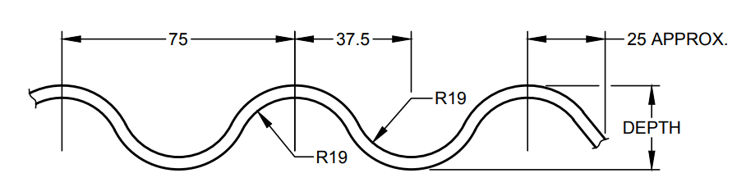

Fig 1 a, GENERAL PURPOSE SHEET

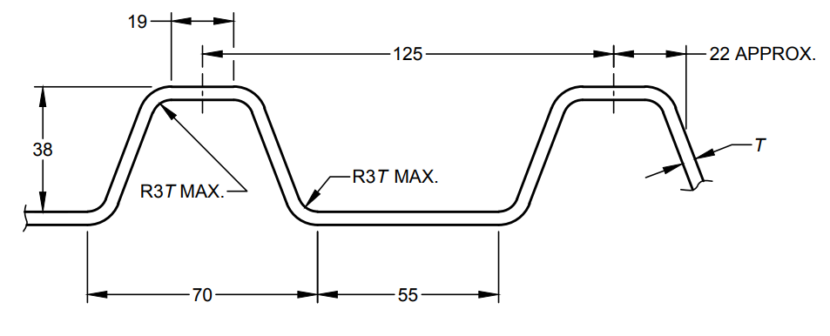

Fig 1 b, INDUSTRIAL SHEET

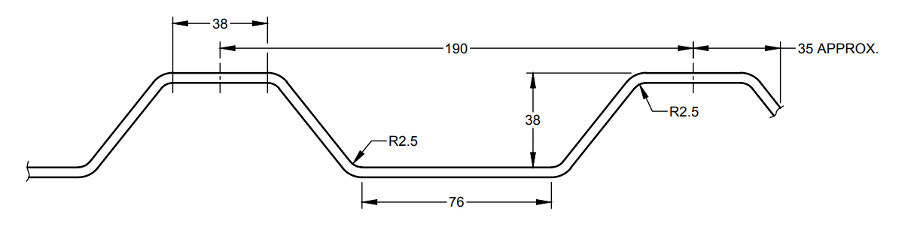

Fig 1 c. BUILDING SHEET

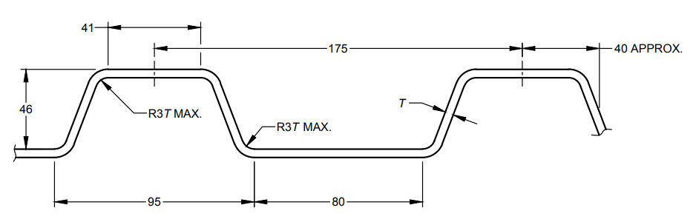

Fig 1 d, HIGH STIFFNESS INDUSTRIAL SHEET

T = thickness of sheet

All dimensions in millimetres.

Fig. 1 (a, b, c and d) (Profiles of Corrugated Aluminium Sheet

**ANNEX A**

*(Foreword)*

**WIDTH FOR CORRUGATED ALUMINIUM SHEET**

(For information only)

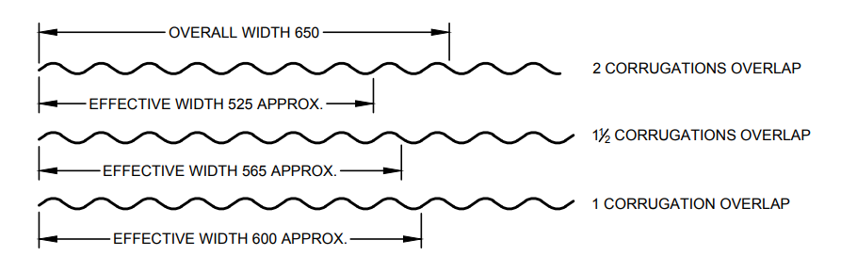

Fig 2 a, 8/75 GENERAL PURPOSE SHEET

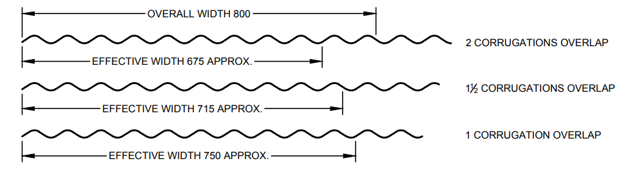

Fig 2 b, 10/75 GENERAL PURPOSE SHEET

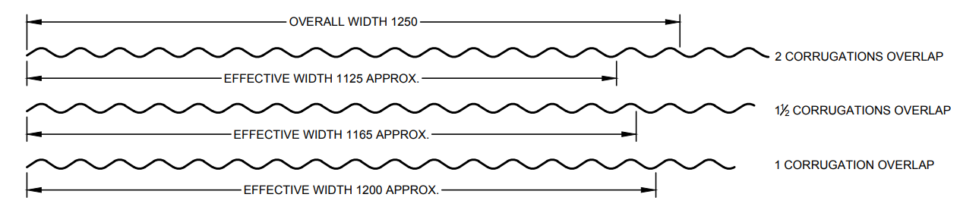

Fig 2 c, 16/75 GENERAL PURPOSE SHEET

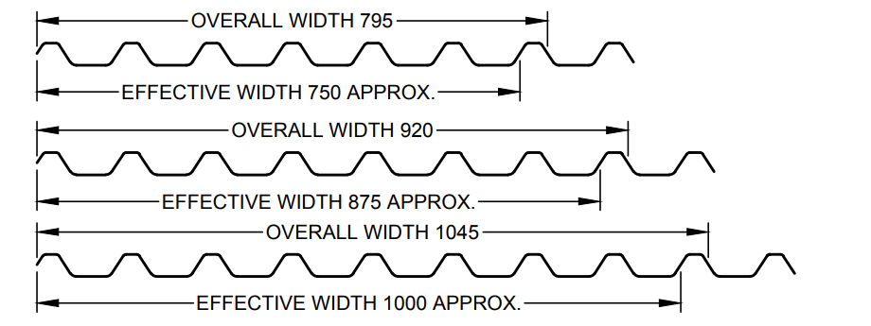

Fig 2 d, INDUSTRIAL SHEET

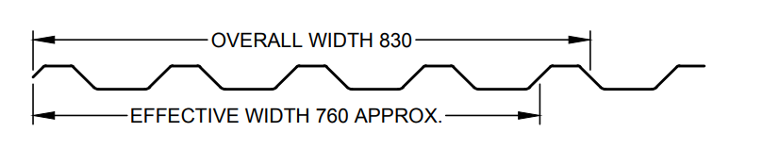

Fig 2 e, BUILDING SHEET

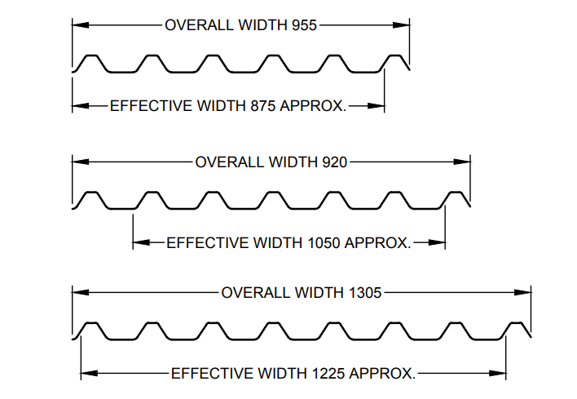

Fig 2 f, HIGH STIFFNESS INDUSTRIAL SHEET

All dimensions in millimetres.

Fig. 2 (a, b, c, d, e and f) Width for Corrugated Aluminium Sheet

**ANNEX B**

(*Foreword*)

**COMMITTEE COMPOSITION**

Ores and Feedstock for Aluminium Industry, its Metals/Alloys and Products Sectional Committee, MTD 07

| *Organization* |  | *Representative(s)* |
| --- | --- | --- |
| CSIR - Institute of Minerals and Materials Technology, Bhubaneswar |  | Dr Kali Sanjay **(*Chairperson*)** |
| Aluminium Association of India, Bengaluru |  | Shri Anil Mathew |
|  | Shri T. Vimal Raj (*Alternat*e) |
| Aluminium Secondary Manufacturers Association, New Delhi |  | Shri Naveen Pant |
|  | Shri Praveen Dixit (*Alternat*e) |
| Bharat Aluminium Company Limited, New Delhi |  | Shrimati Anjali Pawar |
|  | Shri Jitendra Kumar Verma (*Alternat*e) |
| Century Extrusions Limited, Kolkata |  | Shri V. Jhunjhunwala |
|  | Shri Sanjay Singh Sehrawat (*Alternat*e) |
| Century Metal Recycling Limited, Faridabad |  | Shri Mohan Agarwal |
| CSIR - Advanced Materials and Processes Research Institute, Bhopal |  | Dr D. P. Mondal |
| CSIR - National Metallurgical Laboratory, Jamshedpur |  | Dr Kanai Sahoo |
|  | Dr V. C. Srivastava (*Alternat*e) |
| Defence Metallurgical Research Laboratory, Ministry of Defence, Hyderabad |  | Dr G. Jagan Reddy |
|  | Dr S. N. Sahu (*Alternat*e) |
| Defence Research and Development Laboratory, Ministry of Defence, Hyderabad |  | Dr G. Raja Singh |
|  | Dr N. A. Arun (*Alternat*e) |
| Directorate General Quality Assurance, New Delhi |  | Shri K. Saha |
|  | Shri Ajay Kumar (*Alternat*e) |
| Hindalco Industries Limited, Mumbai |  | Shri Ranjan Kumar Sur Chaudhury |
|  | Shri Tushar Panda (*Alternat*e) |
| Jawaharlal Nehru Aluminium Research Development and Design Centre, Nagpur |  | Dr Anupam Aghinotri |
|  | Shri R. N. Chauhan (*Alternat*e) |
| Jindal Aluminium Limited, Bengaluru |  | Shri O. K. Sharma |
|  | Shri P. Devaraj (*Alternat*e) |
| Material Recycling Association of India (MRAI), Mumbai |  | Shri Dhawal Shah |
|  | Shri Jayant Jain (*Alternat*e) |
| National Aluminium Company Limited, Bhubaneswar |  | Shri Tarun Kant |
|  | Shrimati Kiran Kandeyang (*Alternat*e) |
| National Test House, Kolkata |  | Dr Nishi Srivastava |
|  | Shri Buddh Prakash (*Alternat*e) |
| Vedanta Limited, Mumbai |  | Shri Vivek Saxena |
|  | Shri Ram Sandipam (*Alternat*e) |
| BIS Directorate General |  | Shri Sanjiv Maini, Scientist ‘F’ Senior Director and Head (Metallurgical Engineering) [Representing Director General (*Ex-officio*)] |

*Member Secretary*

Shri Ashish Prabhakar Wakle

Scientist ‘D’/Joint Director

(Metallurgical Engineering), BIS