**IS 8093 : 2024**

***भारतीय मानक***

***Indian Standard***

**ईएनटी शल्य चिकित्सा उपकरण — क्यू रेट — बैलेंस पैटर्न — विशिष्टि**

*(* पहला पुनरीक्षण )

**ENT Surgery Instruments — Curette — Ballance’s Pattern — Specification**

*( First Revision )*

ICS 11.040.30

© BIS 2024

भारतीय मानक ब्यूरो

BUREAU OF INDIAN STANDARDS

मानक भवन, 9 बहादुर शाह ज़फर मार्ग, नई दिल्ली - 110002

MANAK BHAVAN, 9 BAHADUR SHAH ZAFAR MARG

NEW DELHI - 110002

[www.bis.gov.in](http://www.bis.org.in) [www.standardsbis.in](http://www.standardsbis.in)

**November 2024 Price Group X**

Ear, Nose, Throat and Head & Neck Surgery (ENT - H&N) Instruments Sectional Committee, MHD 04.

FOREWORD

This Indian Standard (First Revision) was adopted by the Bureau of Indian Standards after the draft Finalized by the Ear, Nose, Throat and Head & Neck Surgery (ENT - H&N) Instruments Sectional Committee had been approved by the Medical Equipment and Hospital Planning Division Council.

This standard was first published in 1976. This revision of this standard has been brought out to align it with recent developments and to bring the standard in line with the latest style and format of Indian Standards.

The composition of the committee responsible for formulation of this standard is given in Annex A.

For the purpose of deciding whether a particular requirement of this standard is complied with the final value, observed or calculated, expressing the result of a test or analysis shall be rounded off in accordance with IS 2 : 2022 ‘Rules for rounding off numerical values (*second revision*)’. The number of significant places retained in the rounded-off value should be same as that of the specified value in this standard.

*Indian Standard*

ENT SURGERY INSTRUMENTS — CURETTE — BALLANCE’S PATTERN — SPECIFICATION

*( First Revision )*

**1 SCOPE**

This standard covers dimensional and other requirement of Ballance’s pattern double-ended curette fenestrated with scoop used in ENT surgery.

**2 REFERENCES**

The standards given below contain provisions which, through reference in this text, constitute provisions of this standard. At the time of publication, the editions indicated were valid. All standards are subject to revision, and parties to agreements based on this standard are encouraged to investigate the possibility of applying the most recent edition of these standards:

|  |  |
| --- | --- |
| *IS No.* | *Title* |
| IS 1501 (Part 1) : 2020/ ISO 6507-1 : 2018 | Metallic materials — Vickers hardness test: Part 1 Test method (*fifth revision*) |
| IS/ISO 7153 (Part 1) : 2016 | Surgical instruments — Materials: Part 1 metals |
| IS 7531 : 1990 | Surgical instruments — Corrosion resistance of stainless-steel surgical instruments — Methods of tests (*first revision*) |

**3 SHAPE AND DIMENSIONS**

**3.1** The shape and dimensions of Ballance’s Pattern Curette shall be as shown in Fig. 1.

**3.2** A deviation of ± 2.5 percent shall be allowed on all dimensions.

**4 MATERIAL**

The materials used to manufacture curette shall be as specified in IS/ISO 7153-1.

**5 WORKMANSHIP AND FINISH**

**5.1** The surfaces of the curette shall be free from pits, dents, burrs, scale and other surface defects.

**5.2** All the edges shall be even and rounded off except the working ends, which shall be semi- sharp at the curette end and blunt at the scoop end.

**5.3** The curette shall be uniformly hardened and tempered.

**5.4** The fenestration shall be neatly cut.

**5.5** The curette shall be polished bright and passivated.

**5.6** The curette shall be well-balanced and symmetrical on its centerline.

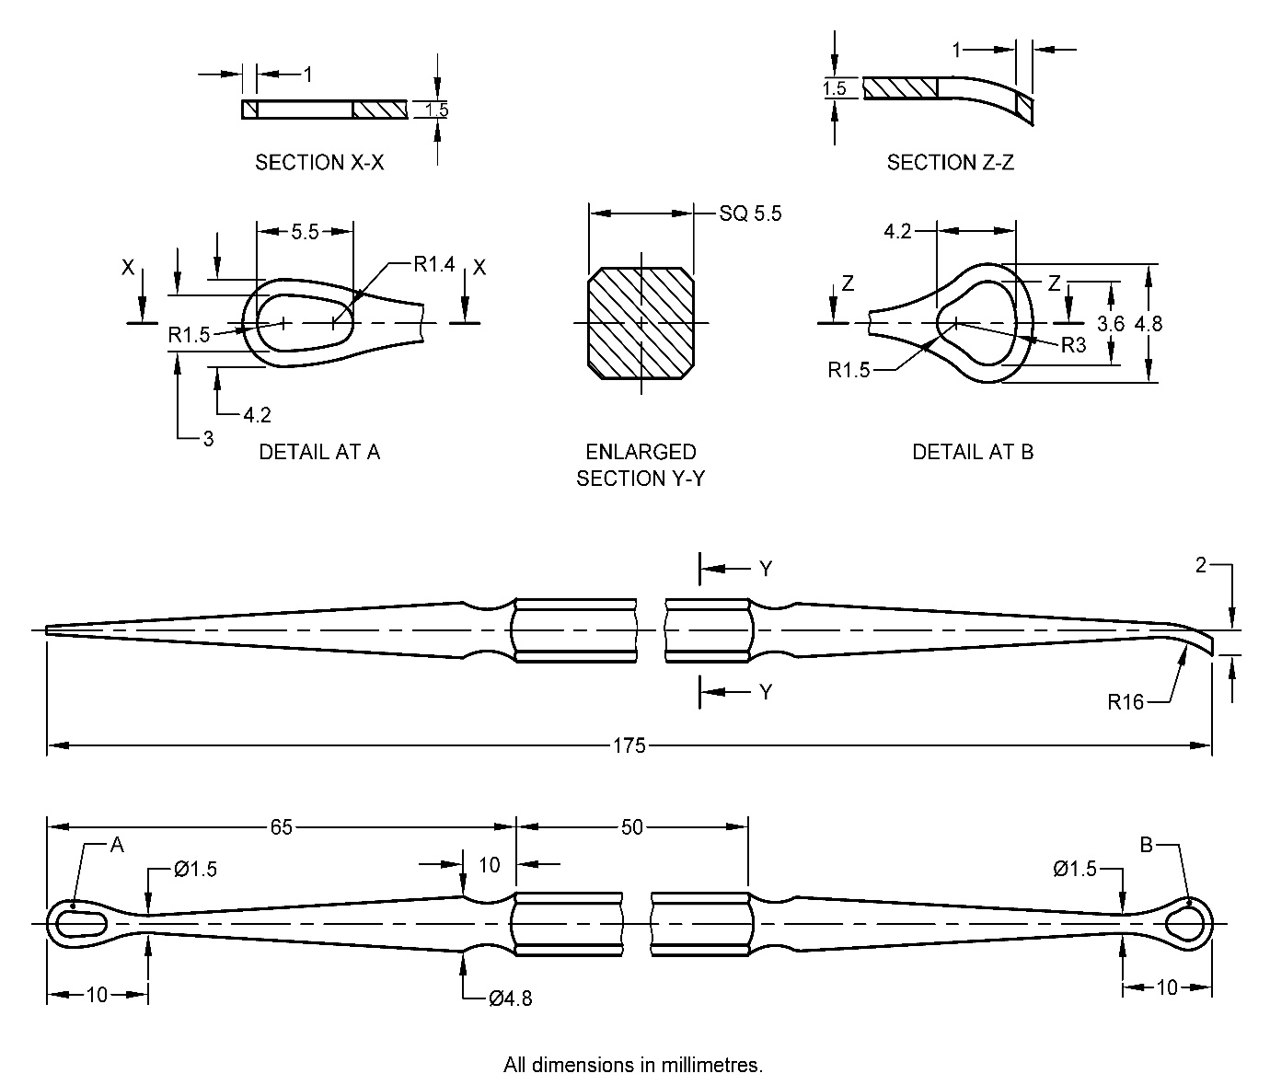

All dimension in millimetres.

Fig. 1 Ballance's Pattern Curette

**6 HEAT TREATMENTAND HARDNESS**

**6.1 General**

The curette shall be heat treated using hardening and tempering procedures to produce specified hardness.

**6.2 Hardness**

The vickers hardness of the finished instrument shall be within the range of 400 HV to 450 HV, when tested in accordance with IS 1501 (Part 1).

**7 TESTS**

**7.1 Performance Test**

Clamp the middle portion of the curette in a suitable vice so that each end projects about 40 mm from the vice in the horizontal plane. Apply a force of 40 N (4 kgf approx.) gradually from the working end at a distance of 15 mm from the tip. Similarly apply the force at the other end through the same distance. On completion of the test on both sides, the curette shalt show no sign of damage or permanent set.

**7.2 Corrosion Resistance Test**

The curette shall satisfy the boiling and autoclaving test as mentioned in IS 7531.

**8 MARKING**

**8.1** The curette shall be marked with the manufacturer’s name, initials or registered trademark.

**8.2 BIS Certification Marking**

The product(s) conforming to the requirements of this standard may be certified as per the conformity assessment schemes under the provisions of the *Bureau of Indian Standards Act*, 2016and the Rules and Regulations framed thereunder, and the product(s) may be marked with the Standard Mark.

**9 PACKING**

The curette shall be wrapped in moisture-proof paper or packed in polyethylene bags avoiding contact with one another. The curette may also be packed as agreed to between the purchaser and the supplier. On the package of the product batch number, lot number, and serial number shall be mentioned.



**ANNEX A**

(*Foreword*)

**COMMITTEE COMPOSITION**

Ear, Nose, Throat and Head & Neck Surgery (ENT - H&N) Instruments Sectional Committee, MHD 04

| *Organization* | *Representative(s)* |
| --- | --- |
| All India Institute of Medical Sciences, New Delhi | Dr Rakesh Kumar **(*Chairperson*)** |
| All India Institute of Medical Sciences, Bhopal | Dr Vikas Gupta |
| Dr Ganakalyan Behera (*Alternate*) |
| All India Institute of Medical Sciences, New Delhi | Dr Prem Sagar |
| Dr Arvind Kumar (*Alternate*) |
| Association of Indian Medical Device Industry, New Delhi | Shri Tarlochan Dev |
| Shri Ankur Bhargava (*Alternate* I) |
| Dr C. S. Prasad (*Alternate* II) |
| ALPS International, New Delhi | ShriAlok Narang, |
|  | Shri Karan Narang (*Alternate*) |
| Directorate General of Health Services, New Delhi | Dr Pallika Kumar |
| Government Medical College & Hospital, Chandigarh | Dr Surinder K. Singhal |
| Shri Nitin Gupta (*Alternate*) |
| Happy Reliable Surgeries Private Limited, Bangalore | Shri Hemant Savale |
| Shri Sanjeev Gautam (*Alternate*) |
| India Medtronic Private Limited, Gurugram | Shrimati Latika Vats |
| Shri Saurabh Sable (*Alternate* I) |
| Shri. Sandeep Verma (*Alternate* II) |
| Indian Institute of Technology Kanpur, Kanpur | Dr A. R. Harish |
| Kalam Institute of Health Technology, Vishakhapatnam | Dr Arjun Thimmaiah |
| Shri Amit Sharma (*Alternate*) |
| Karl Storz Endoscopy India Private Limited, New Delhi | Shri Sandeep Sethi |
| Shri Kapil Rana (*Alternate*) |
| Serwell MediEquip, Chennai | Shri T. Jebin Samuel |
| Shri R. Radhakrishnan (*Alternate* I*)* |
| Shri G. Sathish (*Alternate* II) |
| Tata Memorial Center (Hospital), Mumbai | Dr RICHA VAISH |
| Shri Vijay Yashwant Mestri (*Alternate* I) |
| Dr Arjun Singh (*Alternate* II) |
| Postgraduate Institute of Medical Education and Research, Chandigarh | Dr Jaimanti Bakshi |
| In Personal Capacity (*D-2 ,Tower 7, Type 5, East Kidwai Nagar, New Delhi – 110023*) | Dr Kapil Sikka |
| BIS Directorate General | Shri A. R. Unnikrishnan Scientist ‘G’ and Head (Medical Equipment and Hospital Planning) [Representing Director General (*Ex-officio*)] |

*Member Secretary*

Shri Karthik Reddy Katipally

Scientist ‘B’/Assistant Director

(Medical Equipment and Hospital Planning), BIS