***भारतीय मानक***

***Indian Standard***

**IS 5377 : 2024**

**ईएनटी शल्य चिकित्सा उपकरण — नाक स्पेकुलम — थुडीचम पैटर्न — विशिष्टि**

*(* पहला पुनरीक्षण )

**ENT Surgery Instruments — Nasal Speculum — Thudichum's Pattern — Specification**

*( First Revision )*

ICS 11.040.30

© BIS 2024

भारतीय मानक ब्यूरो

BUREAU OF INDIAN STANDARDS

मानक भवन, 9 बहादुर शाह ज़फर मार्ग, नई दिल्ली - 110002

MANAK BHAVAN, 9 BAHADUR SHAH ZAFAR MARG

NEW DELHI - 110002

[www.bis.gov.in](http://www.bis.org.in) [www.standardsbis.in](http://www.standardsbis.in)

**November 2024 Price Group X**

Ear, Nose, Throat and Head & Neck Surgery (ENT - H&N) Instruments Sectional Committee, MHD 04

FOREWORD

This Indian Standard (First Revision) was adopted by the Bureau of Indian Standards after the draft Finalized by the Ear, Nose, Throat and Head & Neck Surgery (ENT - H&N) Instruments Sectional Committee had been approved by the Medical Equipment and Hospital Planning Division Council.

This standard was first published in 1969. This revision of the standard has been brought out to align it with recent developments and to bring the standard in line with the latest style and format of Indian Standards. This revision incorporates the Amendment 1 issued in 1969 and test on hardness.

The composition of the Committee responsible for formulation of this standard is given in Annex A.

For the purpose of deciding whether a particular requirement of this standard is complied with the final value, observed or calculated, expressing the result of a test or analysis shall be rounded off in accordance with IS 2 : 2022 ‘Rules for rounding off numerical values (*second revision*)’. The number of significant places retained in the rounded-off value should be same as that of the specified value in this standard.

*Indian Standard*

ENT SURGERY INSTRUMENTS — NASAL SPECULUM — THUDICHUM'S PATTERN — SPECIFICATION

*( First Revision )*

**1 SCOPE**

This standard covers dimensional and other requirements of Thudichum's Pattern nasal speculum.

**2 REFERENCES**

The standards given below contain provisions, which, through reference in this text, constitute provisions of this standard. At the time of publication, the editions indicated were valid. All standards are subject to revision, and parties to agreements based on this standard are encouraged to investigate the possibility of applying the most recent edition of these standards:

|  |  |
| --- | --- |
| *IS No.* | *Title* |
| IS 1570 (Part 5) : 1985 | Schedules for wrought steels: Part 5 stainless and heat — Resisting steels (*second revision*) |
| IS 7531 : 1990 | Surgical instruments — Corrosion resistance of stainless steel surgical instruments — Methods of tests (*first revision*) |

**3 SHAPE AND DIMENSIONS**

**3.1** The shape and dimensions of Thudichum's nasal speculum as shown in Fig. 1.

|  |  |  |  |  |  |
| --- | --- | --- | --- | --- | --- |
| **Size No.** | **A** | **B** | **C** | **D** | **E Radius** |
| 1 | 10 | 40 | 80 | 25 | 30 |
| 2 | 12 | 45 | 85 | 25 | 30 |
| 3 | 14 | 50 | 95 | 25 | 30 |
| 4 | 18 | 55 | 110 | 40 | 10 |
| 5 | 20 | 60 | 115 | 40 | 10 |
| 6 | 22 | 65 | 120 | 40 | 10 |
| 7 | 24 | 70 | 145 | 40 | 10 |

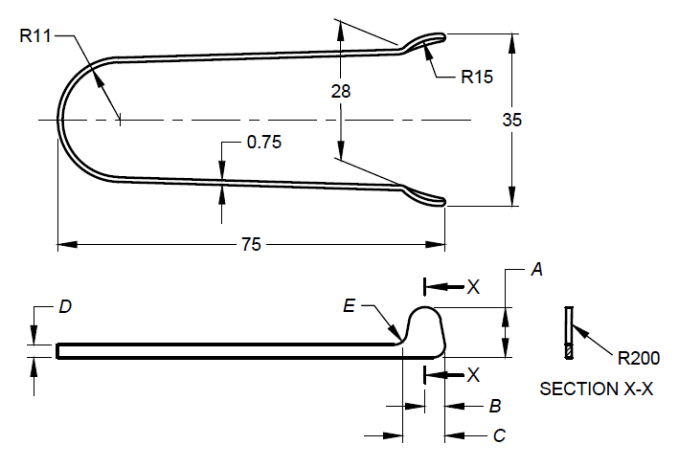

All dimensions in millimetres.

Fig. 1 Thudichum's Pattern Nasal Speculum

**4 MATERIAL**

The material shall be stainless steel conforming to designation X04Cr19N19 or X07Cr19N19 of IS 1570 (Part 5).

**5 WORKMANSHIP AND FINISH**

**5.1** Speculum shall be of one-piece construction free from pits and other surface flaws.

**5.2** All edges shall be even, rounded and not sharp.

**5.3** On closure the blades shall come in contact with each other starting from the tips of the blades and progressing along the edges towards the bases of the blades while edges near the bases are in contact, the tips shall not gape. On release, the prongs shall return to their original positions.

**5.4** The speculum shall be finished dull.

**6 TEST**

**6.1 Load Closure Test**

Apply a force at the point where the blade ends to make the tips of the blades Just touch. The force required shall be as given in Table 1. Tolerance of load is ± 0.2 N (± 20 gf approximately).

**Table 1 Load**

|  |  |  |
| --- | --- | --- |
| **Sl No.** | **Size No** | **Load** |
|  |  |  |
|  | 1 to 3 | 1.5 (150 gf) |
|  | 4 to 7 | 2.5 (250 gf) |

**6.2 Corrosion Resistance**

The instrument shall satisfy the boiling and autoclaving test as specified in IS 7531.

**7 MARKING**

**7.1** Mark with the following:

1. Manufacturer's name, initials, or recognized trademark;
2. Words ' stainless steel '; and
3. Size of the speculum.

**7.2 BIS Certification Marking**

The product(s) conforming to the requirements of this standard may be certified as per the conformity assessment schemes under the provisions of the *Bureau of Indian Standards Act*, 2016 and the Rules and Regulations framed there under, and the product(s) may be marked with the Standard Mark.

**8 PACKING**

Speculum shall be wrapped in moisture-proof paper and packed in cardboard cartons. On the package of the product batch number, lot number, and serial number shall be mentioned.



**ANNEX A**

(*Foreword*)

**COMMITTEE COMPOSITION**

Ear, Nose, Throat and Head & Neck Surgery (ENT - H&N) Instruments Sectional Committee, MHD 04

| *Organization* | *Representative(s)* |
| --- | --- |
| All India Institute of Medical Sciences, New Delhi | Dr Rakesh Kumar **(*Chairperson*)** |
| ALPS International, New Delhi | Shri Alok Narang |
| Shri Karan Narang (*Alternate*) |
| All India Institute of Medical Sciences, New Delhi | Dr Prem Sagar |
| Dr Arvind Kumar (*Alternate*) |
| All India Institute of Medical Sciences, Bhopal | Dr Vikas Gupta |
| Dr Ganakalyan Behera (*Alternate*) |
| Association of Indian Medical Device Industry, New Delhi | Shri. Tarlochan Dev |
| Shri Ankur Bhargava (*Alternate* I) |
| Dr C. S. Prasad (*Alternate* II) |
| Directorate General of Health Services, New Delhi | Dr Pallika Kumar |
| Government Medical College & Hospital, Chandigarh | Dr Surinder K Singhal |
| Shri Nitin Gupta (*Alternate*) |
| Happy Reliable Surgeries Private Limited, Bangalore | Shri Hemant Savale |
| Shri Sanjeev Gautam (*Alternate*) |
| India Medtronic Private Limited, Gurugram | Shrimati Latika Vats |
| Shri Saurabh Sable (*Alternate* I) |
| Shri Sandeep Verma (*Alternate* II) |
| Indian Institute of Technology Kanpur, Kanpur | Dr A. R. Harish |
| Kalam Institute of Health Technology, Vishakhapatnam | Dr Arjun Thimmaiah |
| Shri Amit Sharma (*Alternate*) |
| Karl Storz Endoscopy India Private Limited, New Delhi | Shri Sandeep Sethi |
| Shri Kapil Rana (*Alternate*) |
| Serwell MediEquip, Chennai | Shri T. Jebin Samuel |
| Shri R. Radhakrishnan (*Alternate* I) |
| Shri G. Sathish (*Alternate* II) |
| Tata Memorial Center (Hospital), Mumbai | Dr Richa Vaish |
| Shri Vijay Yashwant Mestri (*Alternate* I) |
| Dr Arjun Singh (*Alternate* II) |
| *Organization* | *Representative(s)* |
| Postgraduate Institute of Medical Education and Research, Chandigarh | Dr Jaimanti Bakshi |
| In Personal Capacity (*D-2 ,Tower 7, Type 5, East Kidwai Nagar, New Delhi - 110023*) | Dr Kapil Sikka |
| BIS Directorate General | Shri A. R. Unnikrishnan Scientist ‘G’ and Head (Medical Equipment and Hospital Planning) [Representing Director General (*Ex-officio*)] |

*Member Secretary*

Shri Karthik Reddy Katipally

Scientist ‘B’/Assistant Director

(Medical Equipment and Hospital Planning), BIS