***भारतीय मानक***

***Indian Standard***

**IS 5412 : 2024**

**ईएनटी शल्य चिकित्सा उपकरण –– नाक आरी –– जोसेफ पैटर्न –– विशिष्टि**

*( पहला पुनरीक्षण )*

**ENT Surgery Instruments –– Nasal Saws –– Joseph's Pattern –– Specification**

*( First Revision )*

ICS 11.040.30

© BIS 2024

भारतीय मानक ब्यूरो

BUREAU OF INDIAN STANDARDS

मानक भवन, 9 बहादुर शाह ज़फर मार्ग, नई दिल्ली - 110002

MANAK BHAVAN, 9 BAHADUR SHAH ZAFAR MARG

NEW DELHI - 110002

[www.bis.gov.in](http://www.bis.org.in) [www.standardsbis.in](http://www.standardsbis.in)

**November 2024 Price Group X**

Ear, Nose, Throat and Head & Neck Surgery (ENT - H&N) Instruments Sectional Committee, MHD 04

FOREWORD

This Indian Standard (First Revision) was adopted by the Bureau of Indian Standards after the draft Finalized by the Ear, Nose, Throat and Head & Neck Surgery (ENT - H&N) Instruments Sectional Committee had been approved by the Medical Equipment and Hospital Planning Division Council.

This standard was first published in 1991. This revision of the standard has been brought out to align it with recent developments and to bring the standard in line with the latest style and format of Indian Standards. This revision incorporates the Amendment 1 issued in 1978 and test on hardness.

The composition of the Committee responsible for formulation of this standard is given in Annex A.

For the purpose of deciding whether a particular requirement of this standard is complied with the final value, observed or calculated, expressing the result of a test or analysis shall be rounded off in accordance with IS 2 : 2022 ‘Rules for rounding off numerical values (*second revision*)’. The number of significant places retained in the rounded-off value should be same as that of the specified value in this standard.

*Indian Standard*

ENT SURGERY INSTRUMENTS –– NASAL SAWS –– JOSEPH'S PATTERN –– SPECIFICATION

*( First Revision )*

**1 SCOPE**

This standard covers dimensional and other requirement for nasal saw joseph's pattern used in ENT surgery.

**2 REFERENCES**

The standards given below contain provisions which, through reference in this text, constitute provisions of this standard. At the time of publication, the editions indicated were valid. All standards are subject to revision, and parties to agreements based on this standard are encouraged to investigate the possibility of applying the most recent edition of these standards:

|  |  |
| --- | --- |
| *IS No.* | *Title* |
| IS 1068 : 1993 | Electroplated coatings of nickel plus chromium and copper plus nickel plus chromium — Specification (*third revision*) |
| IS 1501 (Part 1) : 2020 ISO 6507-1 : 2018 | Metallic materials — Vickers hardness test: Part 1 Test method (*fifth revision*) |
| IS 1570 (Part 5) : 1985 | Schedules for wrought steels: Part 5 stainless and heat — Resisting steel (*second revision*) |
| IS 4170 : 1967 | Specification for brass rods for general engineering purposes |
| IS 7531 : 1990 | Surgical instruments — Corrosion resistance of stainless steel surgical instruments — Methods of tests (*first revision*) |

**3** **SHAPE AND DIMENSIONS**

**3.1** The shape and dimensions of nasal saw joseph's pattern shall be as shown in Fig. 1.

**3.2** The shape and dimensions of blade shall be as shown in Fig. 2.

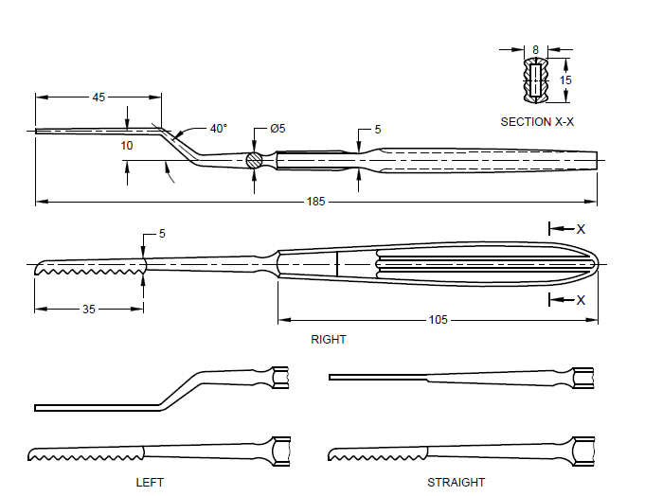

All dimensions in millimetres.

Fig. 1 Nasal Saw Joseph's Pattern

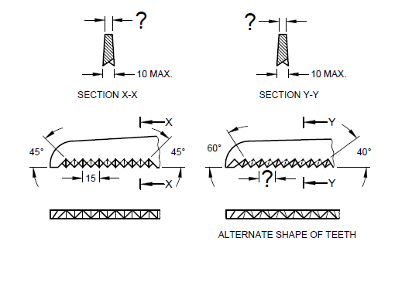

All dimensions in millimetres.

Fig. 2 Detail of Blade

**4 MATERIAL**

**4.1 Blade**

The material shall be stainless steel conforming to designation X30Cr13 of IS 1570 (Part 5).

**4.2 Handle**

The material shall be brass alloy grade CuZn30 of IS 4170 or stainless-steel conforming to designation X04Cr19N19 of IS 1570 (Part 5).

**5 WORKMANSHIP AND FINISH**

**5.1** The blade and handle shall be free from burrs, pits, scale and other defects.

**5.2** The blade shall be straight true to shape and size and shall be fixed in the handle by brazing.

**5.3** Teeth shall be well cut, sharp, regular in spacing, clean and uniform along the edge.

**5.4** Blade shall be finished smooth and even except at the teeth.

**5.5** Blade and stainless-steel handles shall be passivated and polished bright.

**5.6** The brass handle shall be plated chromium over nickel conforming to service grade no. 2 of IS 1068.

**6 HEAT TREATMENT** **HARDNESS**

**6.1 General**

The blade shall be heat treated using hardening and tempering procedures to produce specified hardness.

**6.2 Hardness**

The vickers hardness of the finished instrument shall be within the range of 420 HV to 480 HV, when tested in accordance with IS 1501 (Part 1).

**7 TESTS**

**7.1** Saw through a well-seasoned teak wood piece 2.0 mm square three times. The cutting edge of the saw shall show no sign of damage and the cut through the teak wood piece shall be neat.

**7.2** Grip the handle in a vice with its axis horizontal and with the entire length of the blade and shank protruding. Apply force at the tip to deflect it by 3 mm in a plane at right angles to its own plane. Release the force. The saw shall not acquire a new set.

**7.3 Corrosion Resistance**

The instrument shall satisfy the boiling and autoclaving test as prescribed in IS 7531.

**8 MARKING**

**8.1** Mark with the following: Manufacturer's name, initials or recognized trademark, and the word stainless steel on the shank.

**8.2 BIS Certification Marking**

The product(s) conforming to the requirements of this standard may be certified as per the conformity assessment schemes under the provisions of the *Bureau of Indian Standards Act*,2016and the Rules and Regulations framed thereunder, and the product(s) may be marked with the Standard Mark.

**9 PACKING**

Wrap individually in wax paper or polyethylene bag and pack in cardboard cartons or as agreed to between the purchaser and the supplier. On the package of the product batch number, lot number, and serial number shall be mentioned.

**ANNEX A**

(*Foreword*)

**COMMITTEE COMPOSITION**

Ear, Nose, Throat and Head & Neck Surgery (ENT - H&N) Instruments Sectional Committee, MHD 04



| *Organization* | *Representative(s)* |
| --- | --- |
| All India Institute of Medical Sciences, New Delhi | Dr Rakesh Kumar **(*Chairperson*)** |
| ALPS International, New Delhi | Shri Alok Narang |
| Shri Karan Narang (*Alternate*) |
| All India Institute of Medical Sciences, New Delhi | Dr Prem Sagar |
| Dr Arvind Kumar (*Alternate*) |
| All India Institute of Medical Sciences, Bhopal | Dr Vikas Gupta |
| Dr Ganakalyan Behera (*Alternate*) |
| Association of Indian Medical Device Industry, New Delhi | Shri. Tarlochan Dev |
| Shri Ankur Bhargava (*Alternate* I) |
| Dr C. S. Prasad (*Alternate* II) |
| Directorate General of Health Services, New Delhi | Dr Pallika Kumar |
| Government Medical College & Hospital, Chandigarh | Dr Surinder K Singhal |
| Shri Nitin Gupta (*Alternate*) |
| Happy Reliable Surgeries Private Limited, Bangalore | Shri Hemant Savale |
| Shri Sanjeev Gautam (*Alternate*) |
| India Medtronic Private Limited, Gurugram | Shrimati Latika Vats |
| Shri Saurabh Sable (*Alternate* I) |
| Shri Sandeep Verma (*Alternate* II) |
| Indian Institute of Technology Kanpur, Kanpur | Dr A. R. Harish |
| Kalam Institute of Health Technology, Vishakhapatnam | Dr Arjun Thimmaiah |
| Shri Amit Sharma (*Alternate*) |
| Karl Storz Endoscopy India Private Limited, New Delhi | Shri Sandeep Sethi |
| Shri Kapil Rana (*Alternate*) |
| Serwell MediEquip, Chennai | Shri T. Jebin Samuel |
| Shri R. Radhakrishnan (*Alternate* I) |
| Shri G. Sathish (*Alternate* II) |
| Tata Memorial Center (Hospital), Mumbai | Dr Richa Vaish |
| Shri Vijay Yashwant Mestri (*Alternate* I) |
| Dr Arjun Singh (*Alternate* II)  \ |
| *Organization* | *Representative(s)* |
| Postgraduate Institute of Medical Education and Research, Chandigarh | Dr Jaimanti Bakshi |
| In Personal Capacity (*D-2 ,Tower 7, Type 5, East Kidwai Nagar, New Delhi - 110023*) | Dr Kapil Sikka |
| BIS Directorate General | Shri A. R. Unnikrishnan Scientist ‘G’ and Head (Medical Equipment and Hospital Planning) [Representing Director General (*Ex-officio*)] |

*Member Secretary*

Shri Karthik Reddy Katipally

Scientist ‘B’/Assistant Director

(Medical Equipment and Hospital Planning), BIS