*भारतीय मानक*

**रक्त संक्रमण के लिए फिल्टर और फिल्टर चैम्बर — विशिष्टि**

*( पहला पुनरीक्षण )*

*Indian Standard*

**Filter and Filter Chamber for Blood Transfusion — Specification**

*( First Revision )*

ICS 11.040.20

Hospital Equipment and Surgical Disposable Products Sectional Committee, MHD 12

FOREWORD

This Indian Standard (First Revision) was adopted by the Bureau of Indian Standards after the draft finalized by the Hospital Equipment and Surgical Disposable Products Sectional Committee had been approved by the Medical Equipment and Hospital Planning Division Council.

This standard was first published in 1967 with the title ‘Specification for Filter and filter chamber for blood transfusion’. This revision has been brought out to align the cross-references to the latest editions.

The composition of the Committee responsible for formulation of this standard is given in Annex A.

For the purpose of deciding whether a particular requirement of this standard is complied with the final value, observed or calculated, expressing the result of a test or analysis shall be rounded off in accordance with IS 2 : 2022 ‘Rules for rounding off numerical values (*second revision*)’. The number of significant places retained in the rounded off value should be same as that of the specified value in this standard.

*Indian Standard*

FILTER AND FILTER CHAMBER FOR BLOOD TRANSFUSION — SPECIFICATION

*( First Revision )*

1. **SCOPE**

This specification covers the requirements of filter and filter chamber used in the blood transfusion apparatus.

1. **REFERENCES**

The standards given below contain provisions which, through reference in this text, constitute provisions of this standard. At the time of publication, the editions indicated were valid. All standards are subject to revision, and parties to agreements based on this standard are encouraged to investigate the possibility of applying the most recent edition of these standards.

|  |  |
| --- | --- |
| *IS No.* | *Title* |
| IS 1382 : 1981 | Glossary of terms relating to glass and glassware (*first revision*) |
| IS 2303 (Part 1/Sec 1): 2021/ISO 719 : 2020 | Grading glass for alkalinity: Part 1 hydrolytic resistance of glass grains, Section 1 Determination and classification of hydrolytic resistance at 98 °C (*third revision*) |
| IS 3692 : 1975 | Specification for rubber closures, pharmaceutical (*first revision*) |

1. **MATERIAL**
   1. The filter tube and chamber shall be made from clear, colorless, neutral glass (for definition see IS 1382). The glass shall pass the alkalinity test prescribed in IS 2303 (Part 1/ Sec 1)/ISO 719 for Type I glass.
   2. The filter shall be made from silk.
   3. The bung shall be made from rubber; conforming to IS 3692**.**
2. **SHAPE AND DIMENSIONS**

The shape and dimensions shall be as per Fig. 1.

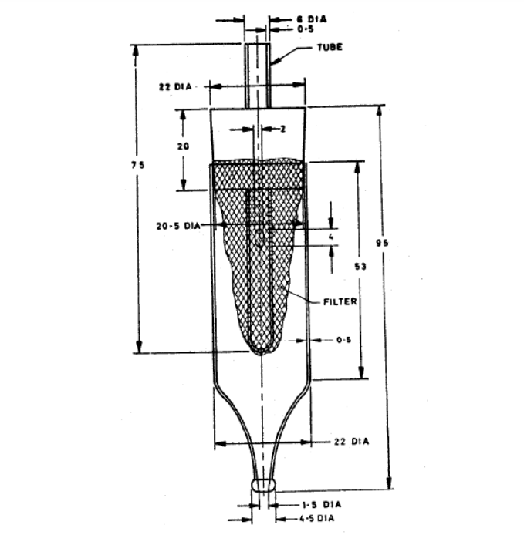

All dimensions in millimetres (Nom).

Fig. 1 Filter and Filter Chamber For Blood Transfusion

1. **WORKMANSHIP AND FINISH**

**5.1** The filter tube and chamber shall be well-annealed, free from bubbles and as far as possible, free from striae, stones and other visible defects (for definitions see IS 1382). The ends shall be smoothly rounded in the flame. It shall be capable of being easily cleaned. It shall pass the thermal shock test, dry heat test and autoclave test specified in **6.1, 6.2** and **6.3** respectively.

**5.2** The filter shal1 have a filtering area of not less than 32 cm2. The filter material shall be minimum of 80 percent as efficient as a sieve having a mesh with an average pore size of 0.212 mm square and a thread of 0.1 mm diameter (the reference filter material). The filter shall be disposed of after using it for one transfusion.

**6 TESTS**

**6.1 Thermal Shock Test**

The filter tube and chamber shall be boiled in water for 30 min, then transferred to water at about 20 °C. The glass shall not develop any chipping or cracking.

**6.2 Dry Heat Test**

The filter tube and chamber shall be subjected to a dry heat test in a sterilizing oven at 180 °C ± 2 °C for 30 min. The glass shall not show deterioration in any way nor develop any crack or chipping.

**6.3 Autoclave Test**

The filter tube and chamber shall be autoclaved at a steam pressure of 1.4 kg/cm2 for a period of 30 min. The glass shall not show deterioration in any way nor develop any crack or chipping.

**7 MARKING**

**7.1** The filter and chamber shall be marked with the name of the manufacturer, his initials or trade-mark.

**7.2** **BIS Certification Marking**

The product(s) conforming to the requirements of this standard may be certified as per the conformity assessment schemes under the provisions of the *Bureau of Indian Standards Act*, 2016 and the Rules and Regulations framed thereunder, and the product(s) may be marked with the Standard Mark.

**8 PACKING**

The filter tube and chamber shall be packed as agreed to between the manufacturer and the purchaser. However, the recommended procedure is as follows:

‘Each set of filter tube and chamber shall be wrapped in suitable paper and packed in lots of 24 in suitable cartons’.

**ANNEX A**

(*Foreword*)

**COMMITTEE COMPOSITION**

Hospital Equipment and Surgical Disposable Products Sectional Committee, MHD 12

|  |  |
| --- | --- |
| *Organization* | *Representative(s)* |
| In Personal Capacity, (*AIIMS Vijaypur, Jammu 184120*) | Lt Gen Sunil Kant **(*Chairperson*)** |
| In Personal Capacity (*Flat 315; Shelter Apt.; 15, Palm Grove Road; Victoria Layout; Bangalore 560047*) | Shri Kulveen Singh Bali |
| 3M India Limited, Bengaluru | Dr Prabha Hegde |
| Ms Kavitha Kulkarni (*Alternate*) |
| Asia Pacific Medical Technology Association (APACMed), Gurugram | Shri R. Ashok Kumar |
| Shri Parveen Jain (*Alternate*) |
| Association of Indian Medical Device Industry, New Delhi | Shri Ravi Abraham |
| Shri Rajiv Nath (*Alternate*) |
| B Braun Medical India Private Limited, New Delhi | Shri Vivek Veerbhan |
| Ms Ishita Dhingra (*Alternate*) |
| B Medical Systems India Private Limited, New Delhi | Shri Kishor Tukaram |
| Shri Anshuman Tuli (*Alternate*) |
| Boston Scientific India Private Limited, Gurugram | Shri Prashanth Prabhakar |
| Shri Dev Chopra (*Alternate*) |
| Central Drugs Standard Control Organization, New Delhi | Shri Aseem Sahu |
| Ms Shyamni Sasidharan (*Alternate*) |
| ESIC Dental College and Hospital, New Delhi | Shri Nagraj M. |
| Dr Mansi Atri (*Alternate*) |
| Hindustan Syringes and Medical Devices Limited, Ballabhgarh, Faridabad | Shri Praveen Kumar Sharma |
| Shri Upinder Vishen (*Alternate*) |
| Indian Rubber Gloves Manufacturers Association, New Delhi | Shri Manmohan Singh Gulati |
| Shri Vikas Anand (*Alternate*) |
| Johnson and Johnson Private Limited, Mumbai | Shri Hemant Sonawane |
| Kalam Institute of Health Technology, Vishakhapatnam | Shri Amit Sharma |
| Shri Mohan Ragul (*Alternate*) |
| Kanam Latex India Private Limited, Kottayam | Shri Abraham C. Jacob |
| Shri Donald S. K. (*Alternate*) |
| Microtrol Sterilization Services Private Limited, Mumbai | Shri Bansidhar S Dhurandhar |
| Shri Manoj Mishra (*Alternate*) |
| National Institute of Health and Family Welfare, New Delhi | Shri Hitesh Kumar |
| Shri Shivley Sageer (*Alternate*) |
|  |  |
| *Organization* | *Representative(s)* |
| Post Graduate Institute of Medical Education and Research, Chandigarh | Dr Navneet Dhaliwal |
| Dr Shweta Talati (*Alternate* I) |
| Shri Sanjeev Sharma (*Alternate* II) |
| Shriram Institute for Industrial Research, New Delhi | Dr Sanjay Rajput |
| Ms Manish Rawat (*Alternate*) |
| Terumo Penpol Private Limited, Thiruvananthapuram | Shri Manoj A. |
| Shri V. M. Shajahan (*Alternate*) |
| BIS Directorate General | Shri A. R. Unnikrishnan Scientist 'G' and Head (Medical Equipment and Hospital Planning) (*Ex-officio*) |

*Member Secretary*

Ms. Uroosa Warsi,

Scientist ‘C’/Deputy Director

(Medical Equipment and Hospital Planning), BIS