*भारतीय मानक*

**प्लास्टिक सर्जरी उपकरण —** किलनेर सीज़र्स

*(पहला पनरीक्षण)*

*Indian Standard*

**Plastic Surgery Instruments — Kilner Scissors**

*(First Revision)*

**ICS 11.040.30**

Surgical Instruments Sectional Committee, MHD 01

FOREWORD

This Indian Standard was adopted by the Bureau of Indian Standards after the draft finalized by the Surgical Instruments Sectional Committee had been approved by the Medical Equipment and Hospital Planning Division Council.

This standard was first published in 1967 as ‘IS 4275 : 1967 Scissors, kilner's for plastic surgery’. This first revision has been taken up to align the cross-references to the latest standards.

This standard was originally published in 1967. The first revision of this standard has been taken up in order to incorporate all amendments issued till date and aligns the cross-references to the latest standards.

The composition of the Committee responsible for formulation of the standard is given in Annex A.

For the purpose of deciding whether a particular requirement of this standard is complied with, the final value, observed or calculated expressing the result of a test or analysis, shall be rounded off in accordance with IS 2 : 2022 ‘Rules for rounding off numerical values (*second revision*)’. The number of significant places retained in the rounded off value should be same as that of the specified value in the standard.

*Indian Standard*

PLASTIC SURGERY INSTRUMENTS — KILNER SCISSORS

*( First Revision )*

# 1 SCOPE

This standard covers the requirements for Kilner's scissors, curved on flat, fine, with rounded dissector points and Kilner's scissors, straight, extra fine sharp pointed for plastic surgery.

# 2 REFERENCES

The standards given below contain provisions which through reference in this text, constitute provision of this standard. At the time of publication, the editions indicated were valid. All standards are subject to revision and parties to agreements based on this standard are encouraged to investigate the possibility of applying the most recent edition of these standards:

|  |  |
| --- | --- |
| *IS No.* | *Title* |
| IS 3642 (Part 1): 1990 | Surgical instruments — Specification: Part 1 Non-cutting, articulated instruments (*second revision*) |
| IS 4218 (Part 1): 2001/ISO 68-1 : 1998 | ISO general purpose metric screw threads: Part 1 Basic profile (*second revision*) |
| IS/ISO 7153-1: 2016 | Surgical instruments — Materials: Part 1 Metals |
| IS 7531: 1990 | Surgical instruments — Corrosion resistance of stainless-steel surgical instruments — Methods of tests (*first revision*) |

**3 MATERIAL**

Scissors and screws shall be made from stainless steel as specified in IS/ ISO 7153-1.

# 4 SHAPE AND DIMENSIONS

**4.1** Scissors shall conform generally to the shape and dimensions as shown in Fig.1 and Fig. 2.

## 4.2 Screw

Screw used shall be slotted-cheese head pattern as shown in Fig. 3. The profile of the screw thread shall conform to IS 4218 (Part 1). The thread shall be of such length as to allow sufficient shank for proper bearing surface and to adequately secure component parts of scissors. Screw shall retain position after setting without binding or loosening during use and shall be ground flush with surface of the blades.

## 4.3 Finger Loop

Finger loops shall be properly shaped and the size shall conform to size No. 1 as specified in Section 6 of IS 3642 (Part 1).

# 5 WORKMANSHIP AND FINISH

**5.1** Scissors shall be symmetrical and well-balanced.

**5.2** The blades along their length and the tips shall coincide and shall not override, when the scissors is fully closed.

**5.3** The blades shall open and close without stiffness and shall have a slight cross-over action to give a continuous pinch, and shall have no play at the joint.

**5.4** Scissors shall be free from cracks, seams, burrs, flaws and other defects. The surfaces of the scissors shall be finished smooth, passivated and polished bright. The edges shall be even and rounded except for the cutting edge which shall be sharp. The cutting edge shall not have any feather.

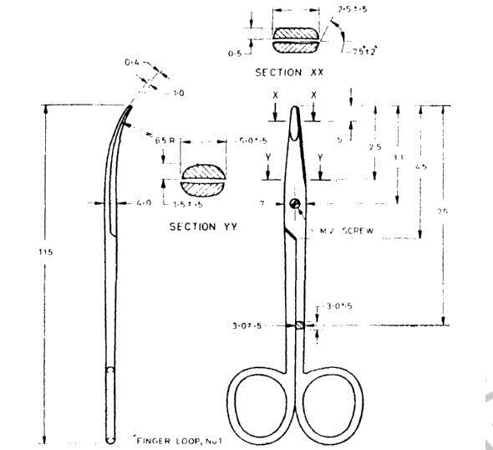

All dimensions in millimetres.

Fig. 1 Kilner's Scissors, Curved on Flat, Fine with Rounded Dissector Points

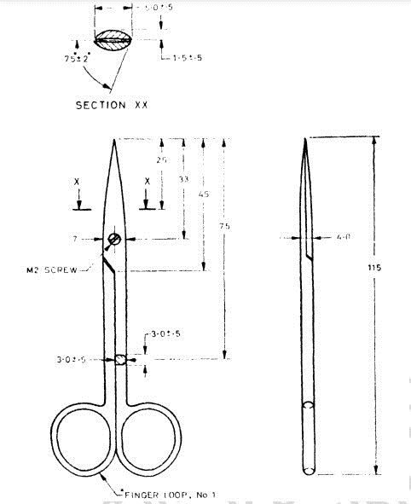

All dimensions in millimetres.

Fig. 2 Kilner's Scissors, Straight, Extra Fine Sharp Point

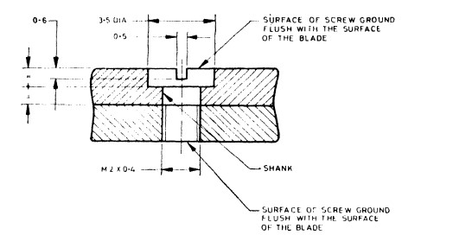

All dimensions in millimetres.

Fig. 3 Detils of Screw Assembly

**6 HARDNESS**

Scissors shall be evenly hardened and tempered to 550 HV to 600 HV*.*

# 7 TESTS

## 7.1 Performance

The scissors shall cut wet tissue paper, teased-out cotton wool, fine hairs and frayed lint accurately and cleanly from pinch to tip.

## 7.2 Hardness

When tested on a hardness testing machine, the scissors shall have a Vicker's diamond pyramid hardness number as specified in **6.**

## 7.3 Flexibility

The flexibility shall be tested as given in **7.3.1** and **7.3.2.**

**7.3.1** The finger ring of one arm of the scissors shall be fixed at its equator in a vice, with the shank and the blade projecting above the vice. By the application of force at a point 75 mm above the vice, the shank shall be deflected at right angles to the plane of the linger loop to a distance of 15 mm as measured at the tip of the blade. On release of the force, no permanent set shall be observed.

**7.3.2** The test shall be repeated on the same arm with the arm fixed in the vice near the joint so that 75 mm of the shank (as measured from the upper surface of the vice jaws to the upper pole of the linger loop) protrudes above the vice. The deflecting force shall be applied at the upper pole of the finger loop and shall act in a plane at right angles to the plane of the linger loop. The shank shall be deflected by 7 mm as measured at the upper pole of the linger loop. On release of force, no permanent set shall be observed.

## 7.4 Corrosion Resistance

The instrument shall show no sign of corrosion when put to boiling and autoclaving test in accordance with IS 7531.

# 8 MARKING

**8.1** The scissors shall be clearly and indelibly marked with the following:

1. Manufacturer’s name, initials or recognized trade-mark;
2. The words ‘stainless steel’ or ‘SS’; and
3. Batch number.

## 8.2 BIS Certification Marking

## The product(s) conforming to the requirements of this standard may be certified as per the conformity assessment schemes under the provisions of the *Bureau of Indian Standards Act*, 2016 and the Rules and Regulations framed thereunder, and the products may be marked with the Standard Mark.

# 9 PACKING

Each pair of scissors shall be wrapped in moisture-proof polyethylene bag and packed in cartons in a manner that coming into contact with one another is avoided or as agreed to between the purchaser and supplier.

**ANNEX A**

(*Foreword*)

**COMMITTEE COMPOSITION**

Surgical Instruments Sectional Committee, MHD 01

| *Organization* | *Representative(s)* |
| --- | --- |
| Maulana Azad Medical College, New Delhi | Dr Pawanindra Lal **(*Chairperson*)** |
| 3M India Limited, Bengaluru | Shri Kulveen Singh Bali  Dr Prabha Hegde (*Alternate*) |
|  |
| All India Institute of Medical Sciences, New Delhi | Dr Peush Sahani  Dr Pramod Garg (*Alternate*) |
|  |
| Association of Indian Medical Device Industry, New Delhi | Dr Atul Sardana |
| B. Braun Medical India Private Limited, New Delhi | Shri Anmol Kumar Ray  Ms Gayatri Garg (*Alternate*) |
|  |
| Baxter R&D, Bengaluru | Shri Rahul Gupta |
| Becton Dickinson India Private Limited, Gurugram | Shri Sudhakar Mairpady |
| Carl Zeiss India (Bangalore) India Private Limited, Bangalore | Shri Sunil Punshi |
| Central Drugs Standard Control Organization, New Delhi | Shri Arvind R. Hiwale  Dr Ravi Kant Sharma (*Alternate*) |
|  |
| HCL, Noida | Shri Makesh Ramalingam |
| Indian Institute of Technology Kanpur, Kanpur | Dr K. S. Venkatesh |
| Intuitive Surgical India Private Limited, Bengaluru | Shrimati Indira B. Narayan Murthy |
| Johnson and Johnson Private Limited, Mumbai | Shri Aaditya Vats  Shri Yateen Shah |
| Kalam Institute of Health Technology, Vishakhapatnam | Shri Dilip Kumar Chekuri (*Alternate*) |
|  | Shri Amit Sharma |
|  | Ms Sushmita Roy Chowdhury |
| Karl Storz Endoscopy India Private Limited, New Delhi | Shri Kapil Rana |
| Kehr Surgical Private Limited, Kanpur | Shri Rajiv Kehr |
|  | Shri Vishal Kehr (*Alternate*) |
| Lady Hardinge Medical College, New Delhi | Dr Yogesh Kumar Sarin |
|  | Dr Subhasis Roy Choudhury (*Alternate*) |
|  | Dr Vikram Khanna (*Alternate*) |
| Maulana Azad Medical College, New Delhi | Dr Chandra Bhushan Singh (*Alternate*) |
|  | Dr Rajdeep Singh |
|  | Dr Anubhav Vindal (*Alternate*) |
| Medical Technology Association of India, Gurugram | Shri Nadeem Anam |
|  | Shri Mohammad Afraz Alam (*Alternate*) |
| Medtronic India Private Limited, Gurugram | Shri Priyanshu Garg |
| Ministry of Consumer Affairs, Food and Public Distribution, New Delhi | Shri Raj Kumar Tyagi (*Alternate*) |
|  | Shri B. N. Dixit |
| Ministry of Environment Forest and Climate Change, New Delhi | Dr Satyendra Kumar  Shri N. Subrahmanyam (*Alternate*) |
|  |
| Ministry of Railways, Lucknow | Dr Pankaj Kumar Arora |
|  | Dr B. N. Tiwari (*Alternate*) |
| Olympus Medical Systems India Private Limited, Gurgaon | Ms Neha Gupta  Shri Lalit (*Alternate* I)  Shri Lovedeep Nagar (*Alternate* II) |
|  |
|  |
| Rajindra Surgical Industries, Jalandhar | Shri Harvinder Singh |
| South India Surgical Company Limited (SISCO), Chennai | Shri Ashok Bajaj (*Alternate*) |
|  | Shri Dilip Bajaj |
| Stryker India Private Limited, Gurugram | Shri Shivkumar Hurdale  Shri Gajender Sharma (*Alternate* I)  Shri Arijit Bhowmick (*Alternate* II)  Shri Deepak Sharma (*Alternate* III) |
|  |
|  |
|  |
| The Surgical Manufacturers and Traders Association, New Delhi | Shri Rakesh Sawhney  Shri Naresh Grover (*Alternate*) |
|  |
| The Urological Society of India, Mumbai | Dr Ashish Vishwas Rawandale Patil  Dr Rajiv T. P. (*Alternate*) |
|  |
| BIS Directorate General | Shri A. R. Unnikrishnan Scientist, ‘F’/Senior Director and Head (Medical Equipment and Hospital Planning) [Representing Director General (***Ex*-*officio*)]** |
| *Member Secretary*  Ms Nagavarshini M.  Scientist ‘B’/Assistant Director  (Medical Equipment And Hospital Planning), BIS | |