*भारतीय मानक मसौदा*

**पुनः श्वशन को रोकने वाले वाल्व — विविष्टि**

**भाग २ अम्बु - हेस्से प्रतिरूप**

*(पहला पुनरीक्षण IS 8254 (भाग 2) का)*

*Draft Indian Standard*

**Specification for Valve, Non-Rebreathing**

**Part 2 Ambu-Hesse’s Pattern**

*(First Revision of IS 8254 (Part 2))*

**[ICS 11.040.10]**

Anaesthetic, Resuscitation and Allied Equipment Sectional Committee, MHD 23

FOREWORD

This Indian Standard (Part 2) was adopted by the Bureau of Indian Standards, after the draft was finalized by the Anaesthetic, Resuscitation, and Allied Equipment Sectional Committee and approved by the Medical Equipment and Hospital Planning Division Council.

This standard was first published in 1976 as Specification for valve, non-rebreathing Part 2 Ambu-hesse’s pattern. This first revision has been taken up to align with latest practice.

The composition of the Committee responsible for formulation of this standard is given in Annex A.

For the purpose of deciding whether a particular requirement of this standard is complied with the final value, observed or calculated, expressing the result of a test or analysis shall be rounded off in accordance with IS 2 : 2022 ‘Rules for rounding off numerical values (*second revision*)’. The number of significant places retained in the rounded off value should be same as that of the specified value in this standard.

*Indian Standard*

VALVE, NON-REBREATHING — SPECIFICATION

**PART 2 AMBU-HESSE’S PATTERN**

**1 SCOPE**

This Indian standard specifies dimensional and other requirements for Ambu-Hesse’s pattern valve used for preventing rebreathing during ventilation of lungs and for equipment for resuscitation

**2 REFERENCES**

The standard given below contain provisions which, through reference in this text, constitute provisions of this standard. At the time of publication, the editions indicated were valid. All standards are subject to revision, and parties to agreements based on this standard are encouraged to investigate the possibility of applying the most recent editions of these standards:

|  |  |
| --- | --- |
| *IS No.* | *Title* |
| IS/ISO 5356-1 : 2015 | Anaesthetic and respiratory equipment — Conical connectors: Part 1 Cones and sockets (*first revision*) |

**3 MATERIALS**

**3.1** The plastics parts shall be sturdy, non-breakable, clean, transparent and free from scratches. They shall be resistant to anaesthetic vapours and gases. They shall withstand the normal steam or chemical sterilization.

**3.2** The rubber parts shall be made of good quality natural, antistatic rubber. The rubber shall be resistant to anaesthetic vapours and gases. It shall withstand ageing in an air-oven for 168 hours at 70 °C ± 1 °C without showing appreciable stiffening, softening, cracking or other change in condition. It shall have a minimum tensile strength of 10 MN/m2 before and after ageing and a minimum elongation at break of 500 percent before ageing and 400 percent after ageing.

**4 SHAPE AND DIMENSIONS**

**4.1** The shape and dimensions shall be as shown in Fig. 1.

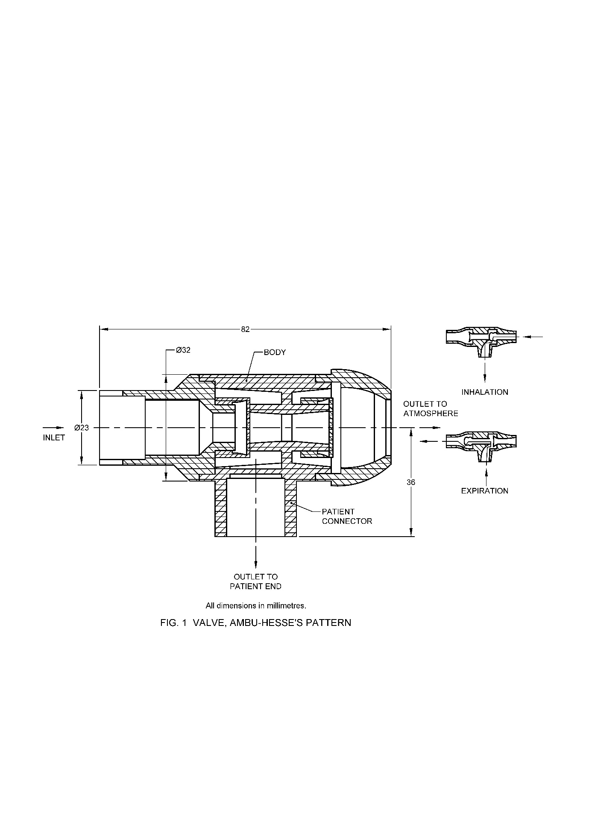

All dimensions in millimeters.

Fig. 1 Valve, Ambu-Hesse’s Pattern

**5 WORKMANSHIP AND FINISH**

**5.1** The valve shall be designed to prevent rebreathing by ensuring unidirectional flow of all expired gases.

**5.2** The valve shall not stick at any stage.

**5.3** All the surfaces of the valve shall be smooth and free from pinholes, wrinkles, creases, embedded foreign matter and other defects.

**5.4** The inlet and outlet to patient end connections shall be suitable for conical fittings of adult and paediatric sizes conforming to IS/ISO 5356-1.

**6 TESTS**

**6.1** The valve shall be tested for inspiration and expiration pressures. The resistance to flow at 25 litre/min shall not be more than 78 N/m2 (approximately 0.8 cm of water) during inspiration and 98 N/m2 (approximately 1.0 cm of water) during expiration.

**6.2** The functioning of the valve shall remain unimpaired when the valve is operated at a frequency of 40 respirations per minute.

**6.3 Non-return Action**

**6.3.1** The closing of the valve for inspiratory action shall not require a flow of air more than 35 litre/min from the inlet side.

**6.3.2** The leakage through the valve, when the valve is closed in either direction under a gas pressure of 1.96 kN/m2 (approximately 20 cm of water), shall not be more than 400 ml/min.

**7 MARKING AND PACKING**

**7.1** The valve shall be marked with the manufacturer’s name, initials or recognized trademark; and an arrow mark on the body to indicate the direction of flow of gas.

**7.2** The packing shall be as agreed to between the purchaser and the manufacturer

**7.3 BIS Certification Marking**

The product(s) conforming to the requirements of this standard may be certified as per the conformity assessment schemes under the provisions of the *Bureau of Indian Standards Act*, 2016 and the Rules and Regulations framed thereunder, and the product(s) may be marked with the Standard Mark.

**ANNEX A**

(*Foreword*)

**COMMITTEE COMPOSITION**

Anaesthetic, Resuscitation and Allied Equipment Sectional Committee, MHD 23

| *Organization* | *Representative(s)* |
| --- | --- |
| In individual capacity [*Postgraduate Institute of Medical Education and Research (PGIMER), Chandigarh*] | Dr G. D. Puri **(Chairperson)** |
| All India Institute of Medical Sciences, New Delhi | Dr Lokesh Kashyap |
| Dr Ganga Prasad (Alternate) |
| Allied Medical Services Private Limited, New Delhi | Shri Akhil Kohli |
| Association of Indian Medical Device Industry, New Delhi | Shri C. S. Prasad |
| Becton Dickinson India Private Limited, Gurugram | Shri Sudhakar Mairpady |
| Ms Nitilesh Kumarii (Alternate) |
| Central Drugs Standard Control Organization, New Delhi | Shri Aseem Sahu |
| Shri Ajai Basil (Alternate I) |
| Shri Gulhane Akshay Dinkar (Alternate II) |
| Draeger India Pvt Ltd, Mumbai | Ms Jhankana Gyani |
| Shri Prashant A. Purohit (Alternate I) |
| Shri Roopesh Veettil (Alternate II) |
| Shri Vijay Sharma (Alternate III) |
| Employees State Insurance Corporation (ESIC), New Delhi | Dr Madhu Gupta |
| Indian Society of Anaesthesiologists, Kolkata | Dr Rakesh Garg |
| Dr Rajiv Gupta (Alternate I) |
| Dr Amit Kumar (Alternate II) |
| Kalam Institute of Health Technology, Vishakhapatnam | Ms Ankitha S. |
| Shri Pramod (Alternate I) |
| Shri Sripada Shankaracharya (Alternate II) |
| Mandev Tubes Private Limited, Mumbai | Shri Aditya Munot |
| Shri Sanjiv Kumar Gupta (Alternate I) |
| Shri Surendra Kamalakar Parab (Alternate II) |
| Medtronic India Private Limited, Gurugram | Shri Amit Kumar |
| Shri Gurpreet Singh (Alternate) |
| Philips India Limited, Gurugram | Shri A. V. A. Rajendra Prasad |
| Ms Radhika Devi (Alternate) |
| Post Graduate Institute of Medical Education and Research, Chandigarh | Dr L. N. Yaddanapudi |
| Dr Sandhya Yaddanapudi (Alternate I) |
| Dr Aakriti Gupta (Alternate II) |
| Shriram Institute for Industrial Research, Delhi | Dr Binu Bhat |
| Dr Priyanka Sharma (Alternate) |
| Sir Ganga Ram Hospital, New Delhi | Dr Bimla Sharma |
| Dr Manish Gupta (Alternate) |
| Vardhman Mahavir Medical College and Safdarjung Hospital, New Delhi | Dr Abhishek Verma |
| Wipro G.E. Healthcare Private Limited, New Delhi | Shri Dorai Subramaniam |
| Shri Nandhakumar A. (Alternate) |
| BIS Directorate General | Shri A. R. Unnikrishnan Scientist, 'G' And Head (Medical Equipment and Hospital Planning) [Representing Director General (***Ex-officio***)] |
| *Member Secretary*  Shri Satyam Rathore  Scientist ‘B’/Assistant Director  (Medical Equipment and Hospital Planning), BIS | |