***भारतीय मानक***

***Indian Standard***

**IS 15449 (Part 2) : 2024**

***घरेलू प्रयोजनों के लिए जिग-जैग सिलाई मशीन/हैड***

***भाग* 2 *परिशुद्धता अपेक्षाएँ***

*(* पहला पुनरीक्षण )

**Household Zig-Zag Sewing Machine/Head**

**Part 2 Accuracy Requirements**

( *First Revision )*

ICS 61.080

© BIS 2024

भारतीय मानक ब्यूरो

BUREAU OF INDIAN STANDARDS

मानक भवन, 9 बहादुर शाह ज़फर मार्ग, नई दिल्ली - 110002

MANAK BHAVAN, 9 BAHADUR SHAH ZAFAR MARG

NEW DELHI - 110002

[www.bis.gov.in](http://www.bis.org.in) [www.standardsbis.in](http://www.standardsbis.in)

**September 2024 Price Group X**

Sewing Machines Sectional Committee, MED 29

FOREWORD

This Indian Standard (Part 2) (First Revision) was adopted by the Bureau of Indian Standards, after the draft finalized by the Sewing Machine Sectional Committee had been approved by the Mechanical Engineering Division Council.

This standard was first published in 2004. This standard is being revised to keep pace with the latest technological developments and international practices. Also, in this revision, the standard has been brought into the latest style and format of Indian Standards. The following major modifications have been incorporated in this revision of the standard:

1. Title has been changed;
2. Scope has been amended to include electronically controlled zig-zag operation;
3. Functional dimensionshas been updated and another note has been added to cover the rotary hook mechanism (full rotation) machines in **2.1**;
4. Assembly clearance has been amended to include accuracy requirements for rotary hook mechanism in **2.2**;
5. Figure 3 in Annex A for needle and shuttle has been updated; and
6. Relevant changes have been made in Annex A.

This standard has been formulated to facilitate standardization and with a view to establish quality and accuracy requirements of household zig-zag sewing machine/head, which includes machines with mechanical/ electronically operated zig-zag operations.

In the preparation of this standard, assistance has been derived from IS 7491 : 1989 ‘Sewing machine, household — Accuracy requirements (*first revision*)’*.*

The standard on household zig-zag sewing machine, which includes machines with mechanical/electronically operated zig-zag operations, is being brought in four parts, the other parts in the series are:

Part 1 General requirements

Part 3 Sewing requirements

Part 4 Durability requirements

This standard covers all types of zig-zag sewing machine/head, excluding embroidery sewing machines.

The composition of the Committee responsible for the formulation of this standard is given in Annex B.

For the purpose of deciding whether a particular requirement of this standard is complied with, the final value, observed or calculated, expressing the result of a test or analysis, shall be rounded off in accordance with IS 2 : 2022 ‘Rules for rounding off numerical values (*second revision*)’. The number of significant places retained in the rounded off value should be the same as that of the specified value in this standard.

*Indian Standard*

HOUSEHOLD ZIG-ZAG SEWING MACHINE/HEAD

**PART 2 ACCURACY REQUIREMENTS**

( *First Revision )*

**1 SCOPE**

This standard (Part 2) covers the accuracy requirements for household zig-zag sewing machine/head, which includes machines with mechanical/electronically operated zig-zag operations.

NOTE — This standard covers all types of zig-zag sewing machine/head, excluding embroidery sewing machines.

**2 ACCURACY REQUIREMENT**

**2.1 Functional Dimensions**

Clearance and heights at various points on the machine shall be as follows:

|  |  |  |  |  |  |
| --- | --- | --- | --- | --- | --- |
| *Sl No.* | *Item* | *Measuring Condition* | *Measuring Direction* | *Ref to Figure* | *Standard Assembly Dimension*  mm |
|  |  |  |  |  |  |
| i) | Feed dog | Height of the feed dog teeth above needle/throat plate | Feed dog raised to its highest position | 1 | 1.2, *Max* |
| ii) | Shuttle and shuttle driver1) | Clearance between heel of shuttle and corresponding tip of shuttle driver | Shuttle heel at bottom most position | 2 | 0.25, *Min*  0.55, *Max* |
| iii) | Needle and shuttle for oscillation mechanism  Needle and shuttle  for rotary hook | Clearance between needle and corresponding face of shuttle  Clearance between needle and corresponding face of shuttle | Needle at bottom most position  Needle at bottom most position | 3 | 0, *Min*  0.05, *Max*  0, *Min*  0.10 *Max* |
| iv) | Presser foot | Gap between pressure foot and needle/throat plate | Presser foot in lifted condition | 4 | 5.0, *Min* |
| v) | Width (zig-zag) | Distance between two extreme needle positions when needle vibration adjustment is at its maximum | Zig-zag width knob or control at its maximum position | 5A  5B | 5.01), *Min* |
| vi) | Disc follower1) | Clearance between disc follower pin and the highest point of disc no. 1 | Needle bar at its bottom most position | 6 | 0.25, *Max* |
| NOTES  **1** For sewing machines with rotary hook mechanism (full rotation – top loaded or front loaded) in place of oscillating shuttle mechanism requirements under Sl No. (ii) shall not be applicable.  **2** Sl No. (vi) shall not be applicable for sewing machine with electronically controlled zig-zag operations. | | | | | |

1) Optional requirements depending upon the design specifications of the sewing machine.

**2.2 Assembly Clearance**

The assembly clearances on the machine at various points shall meet the following requirements:

| *Sl No.* | *Item* | *Measuring Condition* | *Measuring Direction* | *Indicator Position* | *Ref to Figure* | *Maximum Assembly Clearance*  mm |
| --- | --- | --- | --- | --- | --- | --- |
| (1) | (2) | (3) | (4) | (5) | (6) | (7) |
| i) | Needle bar | Needle bar at lower most position | 1. In the direction of motion 2. At right angle to the direction of motion | 1. Top of needle bar 2. Near the bottom of needle bar | 7A  7B | 0.35  0.20 |
| ii) | Thread take-up lever | Thread take-up lever at top, intermediate and bottom positions | 1. In the direction of motion 2. At right angle to the direction of motion | 1. Around thread hole 2. Around thread hole | 8A  8B | 0.65  0.75 |
| iii) | Shuttle  For rotary hook mechanism | 1. Tip of shuttle pin at top most/bottom most position of needle bar 2. Difference between two indicator readings when needle bar is at its highest and lowest position   With bobbin-case removed, play of bobbin case holder | 1. Along the axis of shuttle pin 2. Along the axis of shuttle pin 3. In and out 4. Up and down | 1. Tip of shuttle pin 2. Tip of shuttle pin   a) On the center pin  b) Top of the holder | 9  9 | 0.20  0.08  0.07  0.16 |
| iv) | Arm shaft | At different arm shaft positions (turn wheel by hand). Axial push/pull to be given: | Axial direction | Face of rim of wheel: | 10 | 0.10 |
| v) | Wheel | 1. Rotate arm shaft to measure wobbling 2. Rotate arm shaft to measure eccentricity | Axial direction  Radial direction | 1. Face of rim of wheel 2. Any point on the periphery of rim of wheel | 11A  11B | 0.25  0.30 |
| vi) | Feed section | At the highest position of feed dog above needle plate | In the direction of motion | Front edge of the feed dog | 12 | 0.35 |
| NOTE — The product and figures on measurement methods are for reference purpose only and may vary across different models and manufacturers. | | | | | | |

**3 METHOD OF TESTS**

The method for carrying out various accuracy tests are given in Annex A.

**ANNEX A**

(*Clause* 3)

**METHOD OF TESTS**

**A-1 FEED DOG HEIGHT**

For measurement of feed dog height, the arm shaft shall be rotated so as to bring the feed dog to its highest position above the needle plate. The dial indicator shall be so set as to accommodate both the top of the feed dog as well as the needle plate surface within its range. At this position, two readings shall be taken, one at the top of feed dog and the other at the needle plate surface. The difference between these two observations shall indicate the maximum height of the feed dog above the needle plate (*see* Fig. 1).

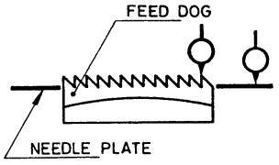

Fig. 1 Feed Dog Height

**A-2 SHUTTLES AND SHUTTLE DRIVER** **CLEARANCE**

For measurement of the clearance, between shuttle and shuttle driver the machine shall be held in the inclined position. The arm shaft shall be rotated while observing the relative position of the shuttle and its driver till the shuttle heel comes to the bottom most position. At this stage, the measurement for clearance between the heel of the shuttle and the corresponding tip of the shuttle driver shall be made by using a feeler gauge. This clearance indicates the clearance existing between the shuttle and shuttle driver (*see* Fig. 2).

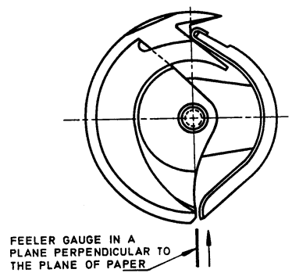

Fig. 2 Shuttles and Shuttle Driver Clearance

**A-3 NEEDLE AND SHUTTLE**

For measurement of the clearance, between needle and the corresponding face of shuttle, the machine shall be held in the inclined position. The arm shaft shall be rotated while observing the relative position of the needle and the corresponding face of shuttle, till needle comes to the bottom most position. At this stage, the measurement for clearance between the needle and the corresponding face of the shuttle shall be made by using a feeler gauge. This indicates the clearance existing between the needle and the corresponding face of shuttle (*see* Fig. 3).

~~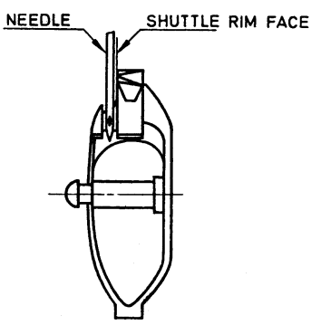~~

Fig. 3 Full Rotary Needle and Shuttle Clearance

**A-4 PRESSER FOOT GAP**

For measurement of the presser foot gap, the presser foot shall be lifted to its highest position. The gap between the bottom face of presser foot and the surface of needle plate shall be measured with a suitable gauge. This gap indicates the maximum clearance available between the presser foot and the needle plate of a sewing machine (*see* Fig. 4).

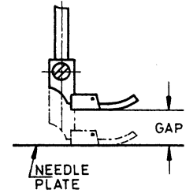

Fig. 4 Pressure Foot Gap

**A-5 ZIG-ZAG WIDTH**

**A-5.1** For measurement of the zig-zag width or the distance between two needle penetrations (in the needle plate) on the left and right sides respectively, the zig-zag width knob/on the display control panel shall be set at its maximum position. The feed regulator (FR) thumbscrew/display control panel shall be set at zero position or the feed throw out (FTO) knob shall be adjusted to feed drop position (*see* Fig. 5A).

**A-5.2** The arm shaft shall be rotated to take the two penetrations on a piece of paper (instead of cloth), placed between the needle plate and presser foot. The paper shall be taken out from the machine and the distance between the two penetrations measured with the help of a scale. This measurement shall be the width of the zig-zag sewing machine (*see* Fig. 5B).

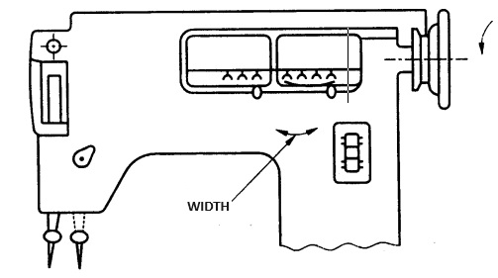

Fig. 5A Zig-Zag Width

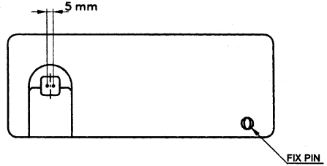

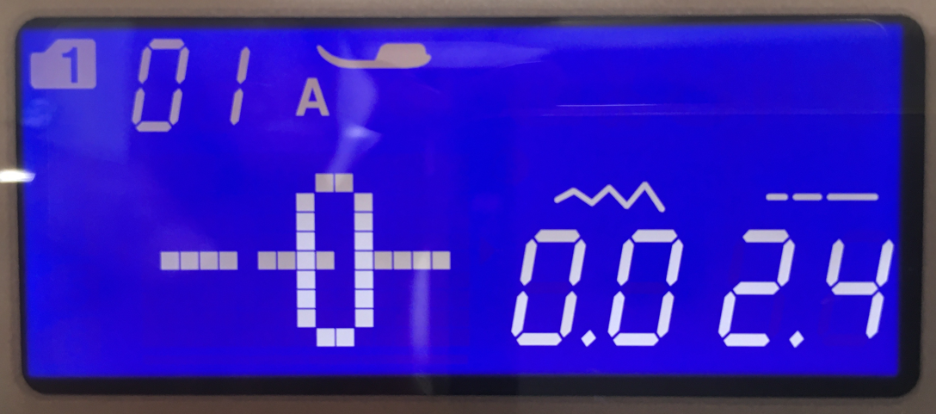

**5 mm**

Fig. 5B Zig-Zag Width

**A-6 DISC FOLLOWER**

For measurement of the clearance, between disc follower pin and the highest point of disc no. 1, rotate the section of panel upwards as shown in Fig. 6. The arm shaft shall be rotated, while observing the relative position of the disc follower pin and the disc no. 1, till the needle bar comes to its bottom most/top most position. At this stage, the measurement for clearance shall be made by using a feeler gauge. This measurement shall indicate the clearance existing between the disc follower pin and the highest point of disc no. 1 (*see* Fig. 6).

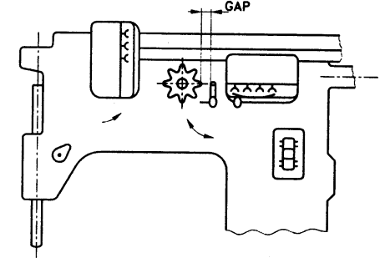

Fig. 6 Disc Follower

**A-7 NEEDLE BAR**

**A-7.1** With the zig-zag width knob/on the display control panel at straight stitch position, move the needle bar to its lowest position and place the dial indicator on the top of the needle bar using an extension piece, if necessary. Apply light hand pressure at the bottom of the needle bar to push it up and note the indicator reading. Similarly, pull the needle bar down with the same pressure and take the second indicator reading. The difference between the two readings shall indicate the assembly clearance for needle bar in the direction of motion (*see* Fig. 7A).

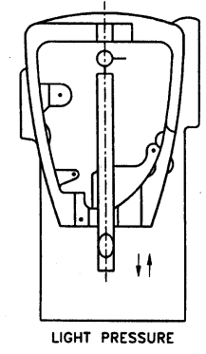

Fig. 7A Assembly Clearance for Needle Bar in the Direction of Motion

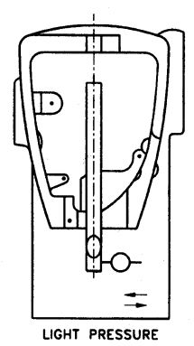

Fig. 7B Assembly Clearance for Needle Bar in the Direction of Right Angle to the Motion

**A-8 THREAD TAKE UP LEVER**

**A-8.1** Bring the thread take up lever at its top/intermediate/bottom position. Place the indicator above the lever around the thread hole. Pull the lever down with very light hand pressure and note the indicator reading. Similarly, push the lever up with the same pressure and observe the second reading. The difference between the two readings will indicate the clearance in the direction of motion for thread take up lever at its given position (*see* Fig. 8A).

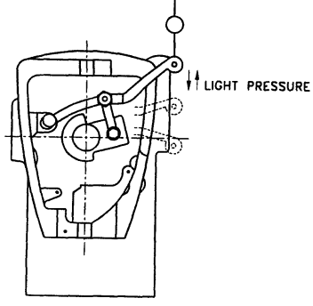

Fig. 8A Thread Take Up Lever

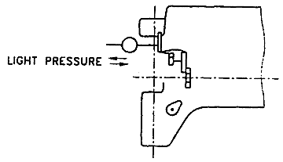

Fig. 8B Thread Take Up Lever (Right Angle)

**A-9 SHUTTLE**

Set the indicator on the top of shuttle pin in the axial direction. Hold the pin and apply very light axial pull and push and take one reading of the indicator at each of these two positions. The difference between the two readings indicates the assembly clearance for the shuttle in the axial direction. An indicator attachment may be necessary for this measurement (*see* Fig. 9).

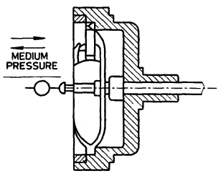

Fig. 9 Shuttle

**A-10 ARM SHAFT**

Place the indicator in contact with the side face of the rim of arm shaft at any convenient point. Apply medium hand pressure and pull and push the arm shaft in the axial direction of the arm shaft. Take one reading of the indicator at each of these two positions. The difference between the two readings shall indicate the clearance for the arm shaft in the axial direction (*see* Fig. 10).

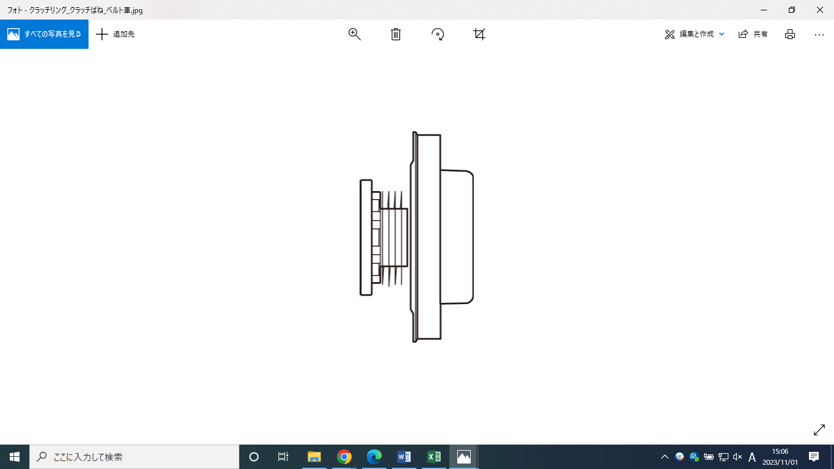

Fig. 10 Arm Shaft Clearance

**A-11 WHEEL**

**A-11.1** For determination of the wobbling of the arm shaft, bring the indicator in contact with the side face of the rim of the wheel. Rotate the wheel by at least one revolution and note the total difference in indicator reading. This reading will indicate the wobbling of the arm shaft in the axial direction (*see* Fig. 11A).

Fig. 11A Arm Shaft (Wobbling)

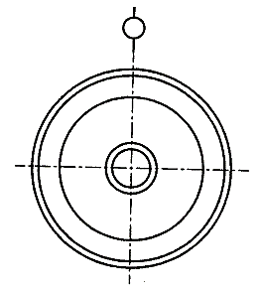

Fig. 11B Arm Shaft (Eccentricity)

**A-12 FEED DOG SECTION**

For measurement of the feed dog section, the arm shaft shall be rotated so as to bring the feed dog to its highest position above the needle plate. The dial indicator shall be set on the front edge of the feed dog. The maximum feed amount shall be measured with dial indicator in the direction of motion (*see* Fig. 12).

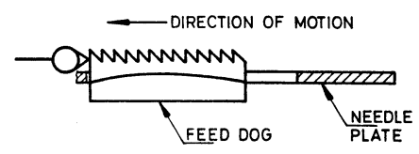

Fig. 12 Feed Dog Section

**ANNEX B**

(*Foreword*)

**COMMITTEE COMPOSITION**

Sewing Machines Sectional Committee, MED 29

|  |  |  |  |
| --- | --- | --- | --- |
| *Organization* |  | *Representative (s)* | |
| Research & Development Centre for Bicycle and Sewing Machines, Ludhiana |  | Shri Sanjeev Katoch (***Chairperson***)  Shri Papinder Singh (*Alternate* I)  Shri Vishwas Mehta (*Alternate* II)  Shri Manpreet Singh (*Alternate* III) | |
| Brother International (India) Private Limited, Mumbai |  | Shri Mathew Yohannan | |
| C.R. Auluck & Sons Private Limited, Ludhiana |  | Shri Sunil Auluck  Shri Kuljeet Singh (*Alternate*) | |
| Directorate General of Quality Assurance, New Delhi |  | Shri R.V. Jain | |
| G.D. Rupal Industries, Ludhiana |  | Shri Gurmukh Singh | |
| Gee Tech Hooks, Ludhiana |  | Shri Manjeet Singh | |
| Geminy Industrial Enterprises Private Limited, Ludhiana |  | Shri Vinay Dua  Shri B.C. Pandey (*Alternate*) | |
| Ludhiana Sewing Machine Association, Ludhiana |  | Shri Hardeep Singh  Shri Rajvinder (*Alternate*) | |
| Makhan Sewing Machines, Ludhiana |  | Shri Dalbir Singh Dhiman | |
| Mechanical Engineering Research and Development Organization (MERADO) , Ludhiana |  | Shri Syed Salman Mojiz  Shri Bhagwant Singh Lal (*Alternate*) | |
| Narindera and Company, Ludhiana |  | Shri S. Baldev Singh  Shri Harinder Jit Singh (*Alternate*) | |
| Navrang Manufacturing Corporation, Ludhiana |  | Shri Dinesh Kapila  Shri Sudesh Kapila (*Alternate*) | |
| Northern India Textile Research Association, Ghaziabad |  | Shri Vikas Sharma  Shri Vivek Agarwal (*Alternate*) | |
| Novel Sewing Machine Technologies, Pune |  | Shri Bharat Narayendas Parmar  Shri Arjun Bharat Parmar (*Alternate*) | |
| ORAA International, Ludhiana |  | Shri Ashish Gupta | |
| Office of Development Commissioner (MSME), New Delhi |  | Shri Suvankar Santra  Ms Maitreyee Talapatra (*Alternate*) | |
| Ranew Engineering (India) Private Limited, Ludhiana |  | Shri Sanjeev Kumar Jain  Shri Abhilash Jain (*Alternate*) | |
| Rita Machines India Private Limited, Ludhiana |  | Shri Sunil Kumar Jain  Shri Jagdish Chandra Auluck (*Alternate*) | |
| Singer India Limited, New Delhi |  | Shri Prashant Aggarwal  Shri Atul Kumar Seth (*Alternate*) | |
| Swan Mechanical Works, Ludhiana |  | Shri Amarjeet Singh | |
| United Sewing Machines and Parts Manufacturing Association, Ludhiana |  | Shri Dalbir Singh Dhiman | |
| Usha International Limited, New Delhi |  | Shri Rup Lal Kangla  Shri Pranay Sriwastav (*Alternate*) | |
| Uttam Sewing Machine Company (Private) Limited, Jalandhar |  | Shri Jagdeep Rai  Shri Manohar Lal (*Alternate*) | |
| Virindra Engineering Works, Ludhiana |  | Shri Amarpreet Singh Panesar  Shri Swarn Singh (*Alternate*) | |
| Voluntary Organisation in Interest of Consumer Education (VOICE), New Delhi |  | Shri M. A. U. Khan | |
| BIS Directorate General |  | Shri K. Venkateswara Rao, Scientist ‘F’/Senior Director and Head (Mechanical) [Representing Director General (*Ex-officio*)] | |

*Member Secretary*

Shri Shubham Tiwari

Scientist ‘D’/Joint Director

(Mechanical), BIS