**IS 8166 : 2024**

*भारतीय मानक*

**मुख्यत: कोयले में वेधन करने हेतु घूर्णी वेध बिट्स — विशिष्टि**

*( दूसरा पुनरीक्षण )*

*Indian Standard*

**Rotary Drill Bits for Drilling Principally in Coal — Specification**

*( Second Revision )*

ICS 73.020

 BIS 2024

भारतीय मानक ब्यूरो

**B U R E A U O F I N D I A N S T A N D A R D S**

मानक भवन, 9 बहादुर शाह ज़फर मार्ग, नई दिल्ली - 110002

MANAK BHAVAN, 9 BAHADUR SHAH ZAFAR MARG

NEW DELHI - 110002

www.bis.gov.in www.standardsbis.in

**August 2024 Price Group**

Mining Techniques and Equipment Sectional Committee, MED 08

FOREWORD

This Indian Standard (Second Revision) was adopted by the Bureau of Indian Standards after the draft finalized by the Mining Techniques and Equipment Sectional Committee had been approved by the Mechanical Engineering Divisional Council.

This standard was first published in 1976 and then subsequently revised in 1988. This revision has been taken up with a view to incorporate the modification found necessary as a result of experience gained in the use of this standard. Also, in this revision, the standard has been brought into the latest style and format of Indian Standards, and references to Indian Standards, wherever applicable have been updated. BIS certification marking clause has been modified to align with the revised *Bureau of Indian Standard Act*, 2016. The following major modifications have been incorporated in this revision of the standard.

1. A reference clause has been added mentioning the latest version of all the referred standards.

The composition of the Committee responsible for the formulation of this standard is given in Annex A.

For the purpose of deciding whether a particular requirement of this standard is complied with, the final value, observed or calculated, expressing the result of a. test or analysis, shall be rounded off in accordance with   
IS 2 : 2022 ‘Rules for rounding off numerical values (*second revision*)’. The number of significant places retained in the rounded-off value should be the same as that of the specified value in this standard.

*Indian Standard*

ROTARY DRILL BITS FOR DRILLING PRINCIPALLY IN   
COAL — SPECIFICATION

*( Second Revision )*

**1 SCOPE**

**1.1** This standard covers the requirements for rotary drill bits used for drilling holes. The tools are principally for use in coal but are applicable to other materials having appropriate driving characteristics.

**1.2** This standard also covers the pilot and reamer bits for drilling large diameter holes.

**2 REFERENCES**

The standard given below contains provisions which, through reference in this text, constitute provision of this standard. At the time of publication, the edition indicated was valid. All standards are subject to revision, and parties to agreements based on this standard are encouraged to investigate the possibility of applying the most recent edition of this standard.

|  |  |
| --- | --- |
| *IS No.* | *Title* |
| IS 4005 : 1967 | Specification for tungsten carbide for mining tools |

**3 TYPES**

1. Type A — One piece bits; and
2. Type B — Two piece bits consisting of pilot and reamer bits.

**4 NOMINAL SIZES**

|  |  |  |  |
| --- | --- | --- | --- |
| *Sl No.* | *Type A* | *Type B* | |
| *Pilot* | *Reamer* |
| (1) | (2) | (3) | (4) |
|  | 35 | 35 | 63 |
|  | 38 | 43 | 75 |
|  | 43 | - | - |
|  | 52 | - | - |

**5 DIMENSIONS**

**5.1 Shanks**

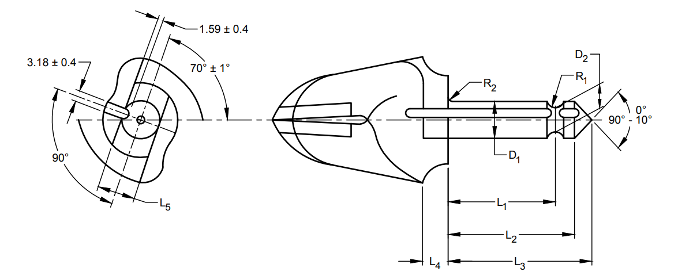

All dimensions in millimetres.

|  |  |  |  |  |  |  |  |  |  |  |
| --- | --- | --- | --- | --- | --- | --- | --- | --- | --- | --- |
| *Sl No.* | *Type of Bit* | *D*1  0  - 0.10 | *D*2  0  - 0.25 | *L*1  + 0.15  0 | *L*2  ± 0.4 | *L*3  *Max* | *L*4  ± 0.3 | *L*5  0  -0.33 | *R*1  ± 0.13 | *R*2  *Max* |
| (1) | (2) | (3) | (4) | (5) | (6) | (7) | (8) | (9) | (10) | (11) |
|  | A | 12.7 | 8.6 | 23.0 | 29.9 | 39.3 | 9.7 | 13.1 | 3.2 | 0.3 |
|  | B | 12.7 | 8.6 | 40.5 | 47.4 | 57.2 | 9.7 | 13.1 | 3.2 | 0.3 |

**5.2 Body**

**5.2.1** *Type A Bits and Pilot Bits for Type B Bits*

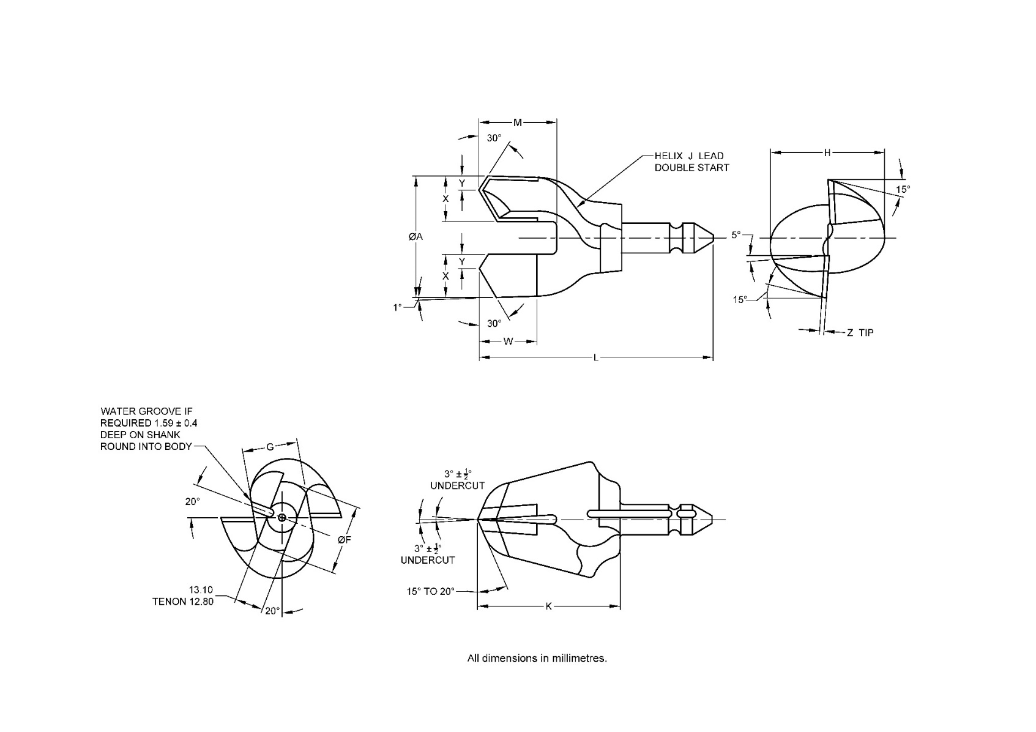

All dimensions in millimetres.

|  |  |  |  |  |  |  |  |  |  |  |  |  |  |  |
| --- | --- | --- | --- | --- | --- | --- | --- | --- | --- | --- | --- | --- | --- | --- |
| *Sl No.* | *Nomi-nal Size* | *Cutti-ng Dia*  *A*  *+0.76*  *0* | *Tip Width*  *X* | *Tip Chamfer*  *Y* | *Tip Height*  *W* | *Tip Thickness*  *Z*  *Min* | *Tenon Dia.*  *F* | *Body Width*  *G* | *Core Width*  *H* | *Lead*  *J* | *Body length*  *K* | *Overall Length*  *L* | | *Gap Height*  *M* |
| Type A | Type B |
| (1) | (2) | (3) | (4) | (5) | (6) | (7) | (8) | (9) | (10) | (11) | (12) | (13) | (14) | (15) |
|  | 35 | 35 | 14 | 4 | 19 | 3 | 20 | 22 | 32 | 64 | 52 | 91.3 | 109.2 | 24 |
|  | 38 | 38 | 14 | 4 | 19 | 3 | 21 | 19 | 32 | 76 | 52 | 91.3 | — | 27 |
|  | 43 | 43 | 16 | 4 | 24 | 3 | 22 | 22 | 40 | 76 | 56 | 95.3 | 113.2 | 30 |
|  | 52 | 52 | 19 | 6 | 25 | 4 | 29 | 24 | 49 | 127 | 60 | 99.3 | — | 32 |

**5.2.2** *Reamer Bits for Type B Bits*

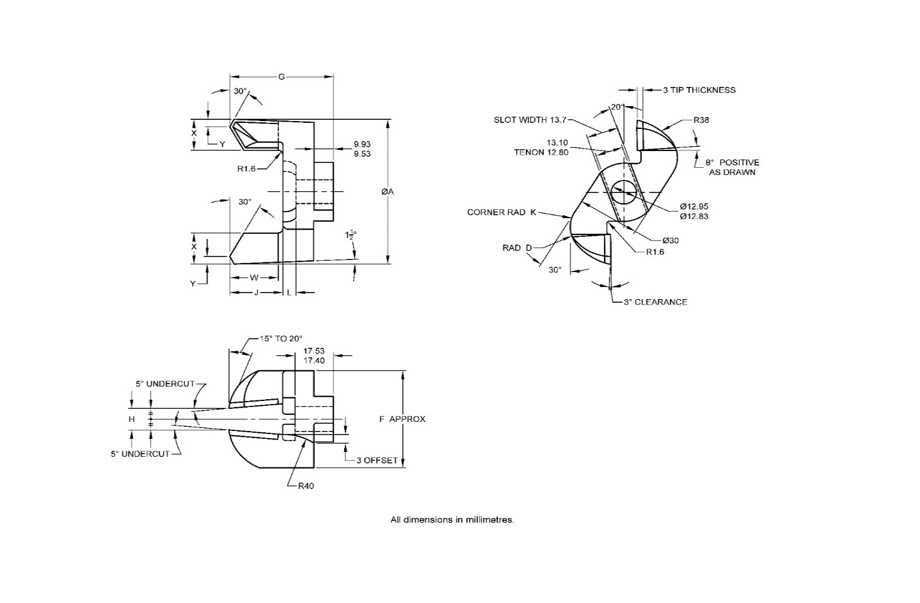

All dimensions in millimetres.

|  |  |  |  |  |  |  |  |  |  |  |  |  |  |
| --- | --- | --- | --- | --- | --- | --- | --- | --- | --- | --- | --- | --- | --- |
| *Sl No.* | *Nominal Size* | *Cutting Dia.*  *A*  *+0.51*  *0* | *Tip Width*  *X* | *Tip Chamfer*  *Y* | *Heal Radius*  *D* | *Tip Length*  *W* | *Bit Width*  *F* | *Bit Height*  *G* | *Gap Width*  *H* | *Gas Height*  *J* | *Corner Radius*  *K* | *Slot Depth*  *L* | *Clearance Angle*  *θ* |
| (1) | (2) | (3) | (4) | (5) | (6) | (7) | (8) | (9) | (10) | (11) | (12) | (13) | (14) |
|  | 63 | 63 | 14 | 4 | 10 | 19 | 48 | 51 | 9 | 25 | 3 | 9 | 15° NEG |
|  | 75 | 75 | 16 | 4 | 16 | 24 | 51 | 51 | 11 | 25 | 6 | 6 | 3° POS |

**6 MATERIAL**

1. Shank and body — High tensile steel with 0.55 percent carbon, *Min*;
2. Tips — Tungsten carbide conforming to IS 4005. Grade used shall be at the option of the purchaser.

**7 DESIGNATION**

A rotary drill bit of Type A, nominal size 38 and having tip of H grade of tungsten carbide shall be designated as:

Rotary Drill Bit A38H

**8 HARDNESS**

210 *HV*, *Min* for bit bodies.

**9 GENERAL REQUIREMENTS**

**9.1** The bit body shall allow an unrestricted flow of cuttings away from the bit when the latter is fitted into the rod.

**9.1.1** The attachment of the bit to the drill rod shall be streamlined to give unobstructed flow of the cuttings.

**9.2** The tips shall be firmly brazed to the body of the bits.

**9.3** Rotary drill bits shall be supplied with or without water grooves as specified by the purchaser.

**9.4** Rotary drill bit shall have rake angle normally of + 3°. However, if required by the purchaser, rotary drill bit with 0 to - 4° rake angle may be supplied.

**10 IDENTIFICATION**

Except for the shank, the bits shall be painted with the colour appropriate to the grade of tungsten carbide used in the manufacture of the tip (*see* IS 4005).

**11 MARKING**

Each rotary drill bit shall be marked on the driving flats with the following:

1. Manufacturer’s name or trademark;
2. Letter H, M, T or XT to identify the grade of tungsten carbide; and
3. Nominal size.

**11.1 BIS Certification Marking**

The product(s) conforming to the requirements of this standard may be certified as per the conformity assessment schemes under the provisions of the *Bureau* *of Indian Standards Act*, 2016 and the Rules and Regulations framed thereunder, and the products may be marked with the Standard Mark.

**ANNEX A**

(*Foreword*)

**COMMITTEE COMPOSITION**

Mining Techniques and Equipment Sectional Committee, MED 08

|  |  |
| --- | --- |
| *Organization* | *Representative*(*s*) |
| Directorate General of Mines Safety, Dhanbad | Shri Saifullah Ansari **(*Chairperson*)** |
| Automotive Research Association of India, Pune | Shri Milind Kandalkar  Shri Dhondiram Mole (*Alternate*) |
| BEML Limited, Bengaluru | Shri V. R. S. Prasad Rao  Shri H. G. Suresh (*Alternate*) |
| CSIR - Central Institute for Mining and Fuel Research, Dhanbad | Dr Manoj Kumar Singh  Shri Surajit Dey (*Alternate* I)  Prof S. K. Kashyap (*Alternate* II) |
| Directorate General of Mines Safety, Dhanbad | Shri M. arumugam |
| Eastern Coalfields Limited, Dishergarh | Shri Sarvesh Kumar  Shri Ajay Bhowmik (*Alternate*) |
| Eimco Elecon (India) Limited, Vallabh Vidyanagar | Shri Ram Ramesh Kale  Shri Vinay Jaynarayan Sharma (*Alternate*) |
| Hutti Gold Mines Company Limited, Bengaluru | Dr Prabhakar Sangoormath  Shri Mallikarjun Sarapur (*Alternate* I)  Miss Mega Hiremath (*Alternate* II) |
| Indian Institute of Technology (ISM), Dhanbad | Shri L. A. Kumaraswamidhas |
| Manganese Ore Limited, Nagpur | Shri Rakesh Kumar Verma  Shri Atul Sharma (*Alternate* I)  Shri Ashwini Baghele (*Alternate* II) |
| Metso Outotec India Private Limited, Vadodara | Shri Sandeep Deokisan Bhattad |
| Nanda Millar Company, Kolkata | Shri J. P. Goenka  Shri Madhur Goenka (*Alternate*) |
| Tata Steel Limited, Dhanbad | Shri Soumendhu Manjhi  Shri Abinash Jha (*Alternate*) |
| BIS Directorate General | Shri K. Venkateswara Rao, Scientist ‘F’/Senior Director and Head (Mechanical Engineering) [Representing Director General (*Ex-officio*)] |

*Member Secretary*

Shri Shubham Tiwari

Scientist ‘C’/Deputy Director

(Mechanical Engineering), BIS