**IS 3817 : 2024**

*भारतीय मानक*

**घरेलू सिलाई मशीनें — आर्म शाफ्ट — विशिष्टि**

*( दूसरा पुनरीक्षण )*

*Indian Standard*

**Household Sewing Machines — Arm Shaft — Specification**

( *Second Revision* )

ICS 61.080

 BIS 2024

भारतीय मानक ब्यूरो

**B U R E A U O F I N D I A N S T A N D A R D S**

मानक भवन, 9 बहादुर शाह ज़फर मार्ग, नई दिल्ली - 110002

MANAK BHAVAN, 9 BAHADUR SHAH ZAFAR MARG

NEW DELHI - 110002

www.bis.gov.in www.standardsbis.in

**July 2024 Price Group**

Sewing Machines Sectional Committee, MED 29

FOREWORD

This Indian Standard (Second Revision) was adopted by the Bureau of Indian Standards, after the draft finalized by the Sewing Machine Sectional Committee had been approved by the Mechanical Engineering Division Council.

This standard was first published in 1966 and subsequently revised in 1991. This standard is being revised to keep pace with the latest technological developments and international practices. Also, in this revision, the standard has been brought into the latest style and format of Indian Standards, and references of Indian Standards, wherever applicable have been updated. BIS certification marking clause has been modified to align with the revised *Bureau of Indian Standards Act,* 2016. The major change in this revision is in the dimensions of the arm shaft such as diameter, length, width, taper, timing hole distance, timing hole angle, and pitch.

The composition of the Committee responsible for the formulation of this standard is given in Annex B.

For the purpose of deciding whether a particular requirement of this standard is complied with the final value, observed or calculated, expressing the result of a test or analysis, shall be rounded off in accordance with IS 2 : 2022 ‘Rules for rounding off numerical values (*second revision*)’. The number of significant places retained in the rounded off value should be the same as that of the specified value in this standard.

*Indian Standard*

HOUSEHOLD SEWING MACHINES —  
ARM SHAFT — SPECIFICATION

( *Second Revision* )

**1 SCOPE**

This standard specifies the requirements for arm shafts for sewing machines for household purposes.

**2 REFERENCES**

The standards given below contain provisions which, through reference in this text, constitute provision of this standard. At the time of publication, the editions indicated were valid. All standards are subject to revision, and parties to agreements based on this standard are encouraged to investigate the possibility of applying the most recent edition of these standards:

|  |  |
| --- | --- |
| *IS No.* | *Title* |
| IS 1501 (Part 1) : 2020/  ISO 6507-1 : 2018 | Metallic materials — Vickers hardness test: Part 1 Test method (*fifth revision*) |
| IS 2102 (Part 1) : 1993/  ISO 2768-1 : 1989 | General tolerances : Part 1 Tolerances for linear and angular dimensions without individual tolerance indications (*third revision*) |
| IS 2500 (Part 1) : 2000/  ISO 2859-1 : 1999 | Sampling procedures for inspection by attributes: Part 1 Sampling schemes indexed by acceptance quality limit (AQL) for lot-by-lot inspection (*third revision*) |
| IS 4905 : 2015/  ISO 24153 : 2009 | Random sampling and randomization procedures (*first revision*) |

**3 TERMINOLOGY**

The terminology of the arm shaft is shown in Fig. 1.

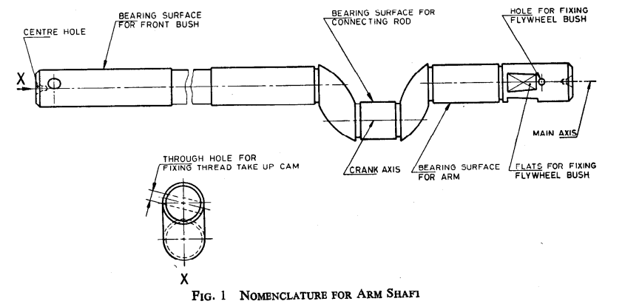

Fig. 1 Terminology for Arm Shaft

**4 TYPES**

The arm shaft shall be of the following two types:

1. Type A; and
2. Type B.

**5 MATERIAL**

Suitable material shall be used for the manufacture of arm shaft.

**6 HARDNESS**

The bearing surfaces of the arm shaft shall be case hardened to attain a hardness value of minimum 500 HV [*see* IS 1501 (Part 1)].

**7 DIMENSIONS AND TOLERANCES**

**7.1** The main dimensions for arm shafts shall be as given in Fig. 2.

**7.2** Tolerances on untoleranced dimensions shall be in accordance with medium class of IS 2102 (Part 1).

NOTE — The arm shafts may be supplied without thread take up timing screw hole, if so desired by the purchaser.

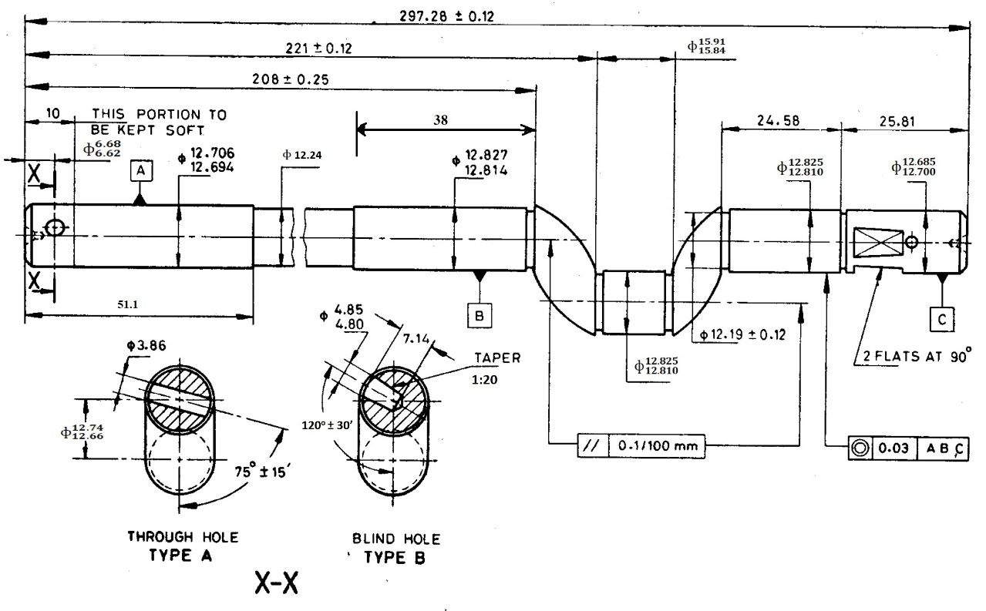

|  |  |  |  |
| --- | --- | --- | --- |
| *Sl No.* | *Item* | *Type* A | *Type* B |
| (1) | (2) | (3) | (4) |
|  | Hole for fixing thread take-up cam | Through tape hole for taper dowel pin (drilled in assembly) | Taper hole for screw |
|  | Fixing of fly wheel bush | Two flats at right angles | Through taper hole for taper dowel pin (drilled in assembly) |

All dimensions in millimetres.

Fig. 2 Dimensions for Arm Shaft

**8 WORKMANSHIP AND FINISH**

The arm shafts shall be well finished and free from any defects such as crack, burr, flaw, and rust.

**9 MARKING**

The arm shafts may be marked with the manufacturer’s name or trademark.

**9.1 BIS Certification Marking**

The product(s) conforming to the requirements of this standard may be certified as per the conformity assessment schemes under the provisions of the *Bureau of Indian Standards Act*, 2016 and the Rules and Regulations framed thereunder, and the product(s) may be marked with the Standard Mark.

**10 PACKING**

Each arm shaft shall be given a suitable antirust coating and wrapped in polyethylene bags. The wrapped arm shaft shall be securely packed in accordance with the best prevalent trade practice. Each package shall bear indication of the source of manufacture, type and description of contents.

**11 SAMPLING**

Unless otherwise agreed to between the purchaser and the supplier the sampling plan as given in Annex A shall be followed. For further information, reference may be made to IS 2500 (Part 1).

**ANNEX A**

(*Clause* 11)

**SCALE OF SAMPLING AND CRITERIA FOR CONFORMITY**

**A-1 SCALE OF SAMPLING**

**A-1.1 Lot**

In any consignment, all the arm shafts of the same type and manufactured from the same material under essentially similar conditions of manufacture shall be grouped together to constitute a lot.

**A-1.2** For ascertaining the conformity of the lot to the requirements of the specification, tests shall be carried out for each lot separately. The number of arm shafts to be selected at random for this purpose shall be in accordance with col (2) and col (3) of Table 1.

**A-1.3** If the arm shafts are packed individually in order to ensure the randomness of selection, IS 4905 shall be used.

**A-1.4** If the arm shafts are packed in different cartons, a suitable number of cartons (not less than 20 percent of the total in the lot subject to a minimum of 2) shall be chosen, at random. From each of the cartons so chosen an approximately equal number of arm shafts shall be picked up from its different parts so as to obtain the required number of arm shafts specified in col (3) of Table 1.

**A-2 NUMBER OF TESTS AND CRITERIA FOR CONFORMITY**

**A-2.1** The arm shafts selected according to **A-1.2** and **A-1.3** or **A-1.4** shall be examined for dimensions and tolerances (*see* **7**) and workmanship and finish (*see* **8**). If the number of arm shaft failing to meet one or more of the requirements mentioned above is less than or equal to the permissible number of defectives given in col (4) of the Table 1, the lot shall be declared as conforming to the requirements of these characteristics.

**A-2.2** In case of those lots which have been found satisfactory according to **A-2.1**, a number of arm shafts equal to the sample size indicated in col (5) of Table 1, shall be subjected to hardness test (*see* **6**). Any arm shaft failing to meet the requirement for hardness shall be considered to be defective.

If no defectives are found among the arm shafts subjected to the hardness test (*see* **A-2.2**), the lot shall be declared as conforming to the requirements of the specification, otherwise not.

**Table 1 Scale of Sampling and Permissible Number of Defectives**

(*Clauses* A-1.2, A-1.4, A-2.1 *and* A-2.2)

|  |  |  |  |  |
| --- | --- | --- | --- | --- |
| **Sl No.** | **No. of Arm Shafts in the Lot** | **For Dimensions, Tolerances, Workmanship,**  **Finish and Test** | | |
| Sample Size  *n* | Permissible No. of Defectives1) | Sample Size for Hardness |
| (1) | (2) | (3) | (4) | (5) |
|  | Upto 15 | 5 | 0 | 2 |
|  | 16 to 40 | 8 | 0 | 3 |
|  | 41 to 110 | 13 | 0 | 3 |
|  | 111 to 300 | 20 | 1 | 5 |
|  | 301 to 500 | 32 | 1 | 6 |
|  | 501 to 800 | 50 | 2 | 8 |
|  | 801 to 1 300 | 80 | 3 | 10 |
|  | 1 301 and above | 125 | 5 | 15 |
| 1)This ensures that lots containing one and half percent or less defective will be accepted most of the time | | | | |

**ANNEX B**

(*Foreword*)

**COMMITTEE COMPOSITION**

Sewing Machines Sectional Committee, MED 29

|  |  |
| --- | --- |
| *Organization* | *Representative (s)* |
| Research & Development Centre for Bicycle and Sewing Machines, Ludhiana | Shri Rakesh Pathak **(*Chairperson*)** |
| Brother International (India) Private Limited, Mumbai | Shri Mathew Yohannan |
| C.R. Auluck & Sons Private Limited, Ludhiana | Shri Sunil Auluck  Shri Kuljeet Singh (*Alternate*) |
| Directorate General of Quality Assurance, New Delhi | Shri Shri R.V. Jain |
| G.D. Rupal Industries, Ludhiana | Shri Gurmukh Singh |
| Gee Tech Hooks, Ludhiana | Shri Manjeet Singh |
| Geminy Industrial Enterprises Private Limited, Ludhiana | Shri Vinay Dua  Shri B.C. Pandey (*Alternate*) |
| Ludhiana Sewing Machine Association, Ludhiana | Shri Hardeep Singh  Shri Rajvinder (*Alternate*) |
| Makhan Sewing Machines, Ludhiana | Shri Dalbir Singh Dhiman |
| Mechanical Engineering Research and Development Organization (MERADO) , Ludhiana | Shri Syed Salman Mojiz  Shri Bhagwant Singh Lal (*Alternate*) |
| Narindera & Company, Ludhiana | Shri S. Baldev Singh  Shri Harinder Jit Singh (*Alternate*) |
| Navrang Manufacturing Corporation, Ludhiana | Shri Dinesh Kapila  Shri Sudesh Kapila (*Alternate*) |
| Northern India Textile Research Association, Ghaziabad | Shri Vikas Sharma  Shri Vivek Agarwal (*Alternate*) |
| Novel Sewing Machine Technologies, Pune | Shri Bharat Narayendas Parmar  Shri Arjun Bharat Parmar (*Alternate*) |
| ORAA International, Ludhiana | Shri Ashish Gupta |
| Office of Development Commissioner (MSME), New Delhi | Shri Suvankar Santra  Ms Maitreyee Talapatra (*Alternate*) |
| Research & Development Centre for Bicycle and Sewing Machines, Ludhiana | Shri Vishwas Mehta  Shri Suriender Pal Singh (*Alternate*) |
| Ranew Engineering (India) Private Limited, Ludhiana | Shri Sanjeev Kumar Jain  Shri Abhilash Jain (*Alternate*) |
| Rita Machines India Private Limited, Ludhiana | Shri Sunil K. Jain  Shri Jagdish Chandra Auluck (*Alternate*) |
| Singer India Limited, New Delhi | Shri Prashant Aggarwal  Shri Atul Kumar Seth (*Alternate*) |
| Swan Mechanical Works, Ludhiana | Shri Amarjit Singh |
| *Organization* | *Representative (s)* |
| United Sewing Machines and Parts Manufacturing Association, Ludhiana | Shri Dalbir Singh Dhiman |
| Usha International Limited, New Delhi | Shri Rup Lal Kangla  Shri Pranay Sriwastav (*Alternate*) |
| Uttam Sewing Machine Company (Private) Limited, Jalandhar | Shri Jagdeep Rai  Shri Manohar Lal (*Alternate*) |
| Virindra Engineering Works, Ludhiana | Shri Amanpreet Singh  Shri Swarn Singh (*Alternate*) |
| Voluntary Organisation in Interest of Consumer Education (VOICE), New Delhi | Shri . M. A. U. Khan |
| BIS Directorate General | Shri K. Venkateswara Rao, Scientist ‘F’/Senior Director and Head (Mechanical Engineering ) [Representing Director General *(Ex-officio*)] |

*Member Secretary*

Shri Shubham Tiwari

Scientist ‘C’/Deputy Director

(Mechanical Engineering), BIS