**IS 10208 : 2024**

***भारतीय मानक***

***Indian Standard***

**हीरक कोर वेधन उपस्कर — विशिष्टि**

*( पहला पुनरीक्षण )*

**Diamond Core Drilling Equipment**

**— Specification**

( *First Revision )*

ICS 73.100.30

© BIS 2024

भारतीय मानक ब्यूरो

BUREAU OF INDIAN STANDARDS

मानक भवन, 9 बहादुर शाह ज़फर मार्ग, नई दिल्ली - 110002

MANAK BHAVAN, 9 BAHADUR SHAH ZAFAR MARG

NEW DELHI - 110002

[www.bis.gov.in](http://www.bis.org.in) [www.standardsbis.in](http://www.standardsbis.in)

**November 2024 Price Group X**

Diamond Core and Waterwell Drilling Sectional Committee, MED 21

FOREWORD

This Indian Standard (First Revision) was adopted by the Bureau of Indian Standards, after the draft finalized by the Diamond Core and Waterwell Drilling Sectional Committee had been approved by the Mechanical Engineering Divisional Council.

This standard was first published in 1982.The diamond core drilling equipment as specified in this standard are characterised by a series of hole sizes specifically designed for wide nesting, permitting relatively greater reduction in the hole diameters as the depth of the hole increases and employing relatively heavy casings between the hole sizes.

Major changes in this revision are as follows:

1. Amendment 1 and Amendment 2 has been incorporated;
2. Basic dimension for HW drill rod has been changed from 86.90 mm to 88.90 mm;
3. Tolerances for eccentricity and straightness have been modified; and
4. Mechanical properties of material have been revised.

The circulation rotary drilling rigs are being employed to construct water wells for the supply of water for drinking, irrigation, and industrial purposes.

In the preparation of this standard, considerable assistance has been derived from the following:

ISO 3551-1:1992 ‘Rotary core diamond drilling equipment— System A: Part 1 Metric units ' issued by the International Organization for Standardization.

The composition of the Committee responsible for the formulation of this standard is given in Annex A.

For the purpose of deciding whether a particular requirement of this standard is complied with, the final value, observed or calculated, expressing the result of a test or analysis shall be rounded off in accordance with IS 2 : 2022 ‘Rules for rounding off numerical values (*second revision*)’. The number of significant places retained in the rounded off value should be the same as that of the specified value in this standard.

*Indian Standard*

**DIAMOND CORE DRILLING EQUIPMENT — SPECIFICATION**

( *First Revision* )

1 SCOPE

1.1 This standard covers the requirements for the following components of the diamond core drilling equipment:

1. Drill rods and rod couplings;
2. Casings, casing couplings, casing bits, casing shoe bits, drive shoes and casing reaming shells; and
3. Core barrels, core bits, core lifters, core lifter case and reaming shells.

**1.2** It also covers the nomenclature, basic dimensions for drill rods, casings, core barrels and  
their related diamond set items for the various designs of the core drilling equipment.

**1.3** The equipment covered by this standard are suitable for drilling holes from 30 mm to 200 mm diameter yielding cores of 18.5 mm to 165 mm diameter.

**2 REFERENCES**

The standards listed below contain provisions which, through reference in this text, constitute provisions of this standard. At the time of publication, the editions indicated were valid. All standards are subjected to revision, and parties to agreements based on this standard are encouraged to investigate the possibility of applying the most recent editions of the standards listed below:

|  |  |
| --- | --- |
| *IS No.* | *Title* |
| IS 1570 (Part 2) | Schedules for wrought steels: Part 2 carbon steels (Unalloyed Steels): |
| Sec 1 : 1979 | Sec 1 wrought products (other than wires) with specified chemical composition and related properties (*first revision*) |
| Sec 1 : 1987 | Sec 2 carbon steel wires with related properties (*first revision*) |
| IS 1570 (Part 4) : 1988 | Schedules for wrought steels: Part 4 Alloy steels (Alloy constructional and spring steels) with specified chemical composition and mechanical properties (*first revision*) |

**3 TERMINOLOGY**

**3.1 Identification Symbols**

For the identification of the equipment, the symbols given in Table 1 shall be used for various designs of the equipment

**Table 1** **Identification Symbols**

(*Clause* 3.1)

|  |  |  |  |  |  |  |  |  |  |  |  |
| --- | --- | --- | --- | --- | --- | --- | --- | --- | --- | --- | --- |
| **Sl No.** | **Components** | **Hole Size** | | | | | | | | | |
| *R* | *E* | *A* | *B* | *N* | *H* | *P* | *s* | *U* | *z* |
| (1) | (2) | (3) | (4) | (5) | (6) | (7) | (8) | (9) | (10) | (11) | (12) |
|  | Drill rods | RW | EW | AW | BW | NW | HW | ⸻ | ⸻ | ⸻ | ⸻ |
|  | Casing-flush coupled | RX | EX | AX | BX | NX | HX | PX | SX | UX | ZX |
|  | Casing-flush jointed | RW | EW | AW | BW | NW | HW | PW | SW | UW | ZW |
|  | 'WF' design, face discharge core barrel | ⸻ | ⸻ | ⸻ | BWF | NWF | HWF | PWF | SWF | UWF | ZWF |
|  | 'WG' design, bottom discharge core barrel | ⸻ | EWG | AWG | BWG | NWG | HWG | ⸻ | ⸻ | ⸻ | ⸻ |
|  | 'WM' design, internal discharge core barrel11) | ⸻ | EWM | AWM | BWM | NWM | ⸻ | ⸻ | ⸻ | ⸻ | ⸻ |
|  | 'WT' design, thin wall, internal discharge core barrel | RWT | EWT | AWT | BWT | NWT | HWT | ⸻ | ⸻ | ⸻ | ⸻ |
|  | 'WTM' design, thin wall bottom discharge core barrel | ⸻ | EWTM | AWTM | BWTM | NWTM | HWTM | ⸻ | ⸻ | ⸻ | ⸻ |
| 1)These may be used with face discharge bits. | | | | | | | | | | | |

**3.2 Identification Letters for Dimensional Details**

For denoting various dimensions in this standard the identifications as given in Fig. 1 and Table 2 are used:

**Table 2 System of Dimensional Identification Letters**

(*Clause* 2.2)

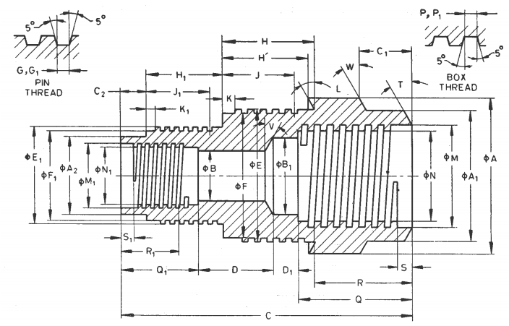

Fig. 1 System of Dimensional Identification Letters

|  |  |  |
| --- | --- | --- |
| **Sl No.** | **Key** | **Description** |
| (1) | (2) | (3) |
|  | *A, A*1, etc. | Outside diameters — *A* being largest; *A*1, *A*2*,* etc, progressively smaller. |
|  | *B, B*1, etc. | Inside diameters — *B* being smallest; *B*1, *B*2, etc, progressively larger. |
|  | *C*, *C*1, etc. | External lengths — *C* being longest; *C*1*, C*2*,* etc, progressively shorter. |
|  | \**C'*, *C*1*',* etc. | External lengths — C being longest; *C'*1*, C'*2, etc, progressively shorter. |
|  | *D, D*1*,* etc. | Internal lengths — *D* being longest; *D*1*,* D2, etc, progressively shorter. |
|  | *E*, *E*1, etc. | Major diameter of pin threads — *E* being largest; *E*1, *E*2, etc, progressively smaller. |
|  | *F*, *F*1, etc. | Minor diameter of pin threads — *F* being largest; *F*1, *F*2 etc, progressively smaller. |
|  | Thread or pitch | Pin threads. |
|  | *G*, *G*1, etc. | Width at root of pin thread. |
|  | *H*, *H*1, etc. | Length of outside diameter machined for external threading. |
|  | †*H'*, *H*1*'*, etc. | Length of outside diameter machined for external threading. |
|  | *J*, *J*1, etc. | Minimum length for full depth of pin threads. |
|  | *K*, *K*1, etc. | Length of relief at the starting point of pin threads. |
|  | *L*, *L*1, etc. | Length of relief at the starting point of pin threads. |
|  | *M, M*1*,* etc. | Major diameter of box threads — *M* being largest; *M*1 *M*2*,* etc, progressively smaller. |
|  | *N*, *N*1, etc. | Minor diameter of box threads — *N* being largest; *N*1, *N*2*,* etc, progressively smaller. |
|  | Thread pitch | Box threads. |
|  | *P*, *P*1*,* etc. | Width at root of box threads. |
|  | *Q*, *Q*1 etc. | Length of Inside diameter machined for internal threading. |
|  | *R, R*1*,* etc. | Minimum length for full depth of box threads. |
|  | *S*, *S*1, etc. | Minimum length for full depth of box threads. |
|  | *T*, *T*1, etc. | Angle of bevel for box thread shoulder. |
|  | *U*, *U*1*,* etc. | Included angles — Internal and external. |
|  | *V*, *V*1, etc. | Internal angles — not pertaining to threaded connections. |
|  | *W, W*1, etc. | External angles — not pertaining to threaded connections. |
|  | *X* | Diamond set dimensions — external (OD). |
|  | *Y* | Diamond set dimensions — internal (ID). |
| *Wherever the values of *C'*, *C*1*'*, etc, are given in addition to *C*, *C*1, etc, the dimensions *C*, *C*1, etc, are for reference only and dimensions *C'*, *C'*1, etc., are for actual measurements.  †Wherever the values of *H'*, *H*1*'*, etc, are given in addition to *H*, *H*1, etc, the dimensions *H*, *H*1, etc, are for reference only and dimensions *H'*, *H*1, etc, are for actual measurement. | | |

NOTES

**1** All decimal dimensions indicate allowable tolerances.  
**2** *C'*, *C'*1, *H*1*'*, *U* and *U*1 not shown in the figure.

4 DIMENSIONS

**4.1 Basic Dimensions**

**4.1.1** *Drill Rods, Casings and Their Related Diamond Set Items*

|  |  |  |  |  |  |  |  |  |  |  |  |  |  |  |
| --- | --- | --- | --- | --- | --- | --- | --- | --- | --- | --- | --- | --- | --- | --- |
| *Sl No.* | *Drill Rod* | *Rod Tube* | *Rod Coupling* | *Casing Flush Coupling* | *Casing Tube* | *Casing Coupling* | *Casing Flush Jointed* | *Casing* | | *Casing Reaming Shell Set* | *Casing Bit Set* | | *Casing Shoe Set* | |
| *OD* | *ID* | *OD* | *ID* | *OD* | *ID* | *OD* | *OD* | *ID* | OD | ID |
| (1) | (2) | (3) | (4) | (5) | (6) | (7) | (8) | (9) | (10) | (11) | (12) | (13) | (14) | (15) |
|  | RW | 27.89 | 10.57 | RX | 36.63 | 30.48 | RW | 36.63 | 30.48 | Not required | 37.85 | 25.53 | 37.85 | 30.18 |
| 27.76 | 10.19 | 36.50 | 30.23 | 36.50 | 30.23 | 37.59 | 25.27 | 37.59 | 30.05 |
|  | EW | 35.05 | 11.35 | EX | 46.28 | 38.35 | EW | 46.28 | 38.35 | 48.13 | 47.75 | 35.81 | 47.75 | 38.02 |
| 34.93 | 10.97 | 46.02 | 38.10 | 46.02 | 38.10 | 47.88 | 47.50 | 35.56 | 47.50 | 37.80 |
|  | AW | 43.89 | 16.13 | AX | 57.40 | 48.67 | AW | 57.40 | 48.67 | 60.07 | 59.69 | 45.34 | 59.69 | 48.31 |
| 43.64 | 15.75 | 57.15 | 48.41 | 57.15 | 48.41 | 59.82 | 59.44 | 45.09 | 59.44 | 48.18 |
|  | BW | 54.23 | 19.30 | BX | 73.28 | 60.58 | BW | 73.28 | 60.58 | 75.82 | 75.44 | 56.39 | 75.44 | 60.25 |
| 53.98 | 18.92 | 73.03 | 60.33 | 73.03 | 60.33 | 75.56 | 75.18 | 56.13 | 75.18 | 60.12 |
|  | NW | 66.93 | 35.18 | NX | 89.28 | 76.58 | NW | 89.28 | 76.58 | 92.33 | 91.95 | 72.26 | 91.95 | 76.12 |
| 66.68 | 34.80 | 88.90 | 76.20 | 88.90 | 76.20 | 92.08 | 91.69 | 72.01 | 91.69 | 75.87 |
|  | HW | 89.28 | 60.71 | HX | 114.68 | 100.38 | HW | 114.68 | 101.60 | Not required | 117.65 | 96.06 | 117.65 | 99.82 |
| 88.90 | 60.32 | 114.30 | 100.00 | 114.30 | 101.22 | 117.27 | 95.81 | 117.27 | 99.57 |
|  |  | | | PX | 140.74 | 127.38 | PW | 140.74 | 127.38 | 143.76 | 117.86 | 143.76 | 121.54 |
| 138.66 | 122.30 | 136.66 | 123.57 | 143.26 | 117.48 | 143.26 | 121.16 |
|  | SX | 169.55 | 152.45 | SW | 169.55 | 155.56 | 172.72 | 143.26 | 172.72 | 146.94 |
| 167.00 | 147.70 | 167.00 | 151.21 | 172.21 | 142.88 | 172.21 | 146.55 |
|  | UX | 195.12 | 179.20 | UW | 195.12 | 180.54 | 198.50 | 171.83 | 198.50 | 175.64 |
| 192.23 | 176.20 | 192.23 | 175.79 | 197.74 | 171.32 | 197.74 | 175.13 |
|  | ZX | 220.73 | 205.94 | ZW | 220.73 | 208.46 | 224.16 | 197.23 | 224.16 | 201.04 |
| 217.42 | 201.60 | 217.42 | 203.00 | 223.39 | 196.72 | 223.39 | 200.53 |

**4.1.2** *Core Barrels and Their Related Diamond Set Hems*

|  |  |  |  |  |  |  |  |  |  |  |  |  |  |  |  |
| --- | --- | --- | --- | --- | --- | --- | --- | --- | --- | --- | --- | --- | --- | --- | --- |
| *Sl No.* | *Core Barrel Designs* | | | | | *Coring Bits Set ID* | *Coring Bits Set OD* | *Reaming Shells Set OD* | *Kerf Width Min* | *Kerf Area cm2* | *Core Area cm2* | *Hole Area cm2* | *Core to Hole Ratio Percent* | *Nominal Core Size* | *Nominal Hole Size* |
| *WE* | *WG* | *WM* | *WT* | *WTM* |
| (1) | (2) | (3) | (4) | (5) | (6) | (7) | (8) | (9) | (10) | (11) | (12) | (13) | (14) | (15) | (16) |
|  | - | - | - | RWT | - | 18.80 | 29.59 | 29.97 | 5.59 | 4.25 | 2.74 | 6.99 | 39.1 | 18.5 | 30.0 |
| 18.54 | 29.34 | 29.72 |
|  | - | EWG | EWM | - | - | 21.59 | 37.46 | 37.85 | 8.13 | 7.55 | 3.62 | 11.17 | 32.4 | 21.5 | 38.0 |
| 21.34 | 37.21 | 37.59 |
|  | - | - | - | EWT | EWTM | 23.11 | 37.46 | 37.85 | 7.37 | 7.03 | 4.15 | 11.17 | 37.1 | 23.0 | 38.0 |
| 22.86 | 37.21 | 37.59 |
|  | - | AWG | AWM | - | - | 30.23 | 47.75 | 48.13 | 8.94 | 10.99 | 7.12 | 18.10 | 39.3 | 30.0 | 48.0 |
| 29.97 | 47.50 | 47.88 |
|  | - | - | - | AWT | AWTM | 32.66 | 47.75 | 48.13 | 7.72 | 9.79 | 8.32 | 18.10 | 45.9 | 32.5 | 48.0 |
| 32.41 | 47.50 | 47.88 |
|  | - | BWG | BWM | - | - | 42.16 | 59.69 | 60.07 | 8.94 | 14.34 | 13.88 | 28.22 | 49.1 | 42.0 | 60.0 |
| 41.91 | 59.44 | 59.82 |
|  | - | - | - | BWT | BWTM | 44.58 | 59.69 | 60.07 | 7.75 | 12.70 | 15.52 | 28.22 | 55.0 | 44.5 | 60.0 |
| 44.32 | 59.44 | 59.82 |
|  | - | NWG | NWM | - | - | 54.86 | 75.44 | 75.82 | 10.46 | 21.46 | 23.53 | 44.99 | 52.2 | 54.5 | 76.0 |
| 54.61 | 75.18 | 75.56 |
|  | - | - | - | NWT | NWTM | 58.88 | 75.44 | 75.82 | 8.46 | 19.88 | 27.11 | 44.99 | 60.0 | 58.5 | 76.0 |
| 58.62 | 75.18 | 75.56 |
|  | HWF | HWG | - | - | - | 76.33 | 98.98 | 99.36 | 11.51 | 31.74 | 45.61 | 77.34 | 59.0 | 76.0 | 99.0 |
| 76.07 | 98.60 | 99.11 |
|  | - | - | - | HWT | HWTM | 81.08 | 98.98 | 99.36 | 9.14 | 25.88 | 51.46 | 77.34 | 66.5 | 81.0 | 99.0 |
| 80.82 | 98.60 | 99.11 |
|  | PWF | - | - | - | - | 92.33 | 120.27 | 120.78 | 14.22 | 47.53 | 66.68 | 114.21 | 58.4 | 92.0 | 121.0 |
| 91.95 | 119.76 | 120.40 |
|  | SWF | - | - | - | - | 112.95 | 145.67 | 146.18 | 16.61 | 67.52 | 99.86 | 167.39 | 59.7 | 112.5 | 146.0 |
| 112.57 | 145.16 | 145.80 |
|  | UWF | - | - | - | - | 140.08 | 174.12 | 174.75 | 17.32 | 85.59 | 153.56 | 239.15 | 64.2 | 140.0 | 175.0 |
| 139.57 | 173.36 | 174.24 |
|  | ZWF | - | - | - | - | 165.48 | 199.52 | 200.15 | 17.32 | 99.43 | 214.41 | 313.84 | 68.3 | 165.0 | 200.0 |
| 164.97 | 198.76 | 199.64 |

**4.2 Detailed Dimensions**

Seevarious sections as given below for detailed dimensions:

SECTION 1 — Drill rods  
SECTION 2 — Casings  
SECTION 3 — Core barrels — 'WF' Design  
SECTION 4 — Core barrels — 'WG' Design  
SECTION 5 — Core barrels — 'M' Design  
SECTION 6 — Core barrels — 'WT' Design  
SECTION 7 — Core barrels — 'WTM' Design

**5 TOLERANCES**

**5.1 Eccentricity**

Eccentricity is the distance between the centres of the outer and inner diameters. It shall not exceed 10 percent of the nominal wall thickness *t.* The eccentricity is calculated as follows:

$$\frac{t_{max}-t_{min}}{2t}×100$$

where

*t*max and *t*minare measured values in the same section.

**5.2 Straightness**

The straightness when measured over the whole length of the tube by rolling against a straight edge, the maximum deviation shall not exceed 1 in 1 200.

**6 MATERIAL**

**6.1** Unless agreed between the manufacturers and purchaser, the material used for the manufacturer of the equipment shall have the mechanical properties as given in Table 3.

**Table 3 Mechanical Properties**

(*Clause* 6.1)

|  |  |  |  |  |  |  |  |  |
| --- | --- | --- | --- | --- | --- | --- | --- | --- |
| **Sl No.** | **Component** | **Tensile Strength**  ***Min*** | | **Yield Stress**  ***Min*** | | **Elongation 5.65 √ So *Min* percent** | **Hardness HB, Min (for information only)** | **Heat treatment (for information only)** |
| N/mm2 | kg/mm2 | N/mm2 | kg/mm2 |
| (1) | (2) | (3) | (4) | (5) | (6) | (7) | (8) | (9) |
|  | Parallel wall rods | 725 | 73.9 | 620 | 63.2 | 15 | 200 | Tempered  And Stress  relived |
|  | Upset or forged ends of the above parallel wall rods | 500 | 51 | 310 | 31.6 | 18 | ⸻ | ⸻ |
|  | Casings and inner and outer tubes, sizes *R* to *H* | 720 | 73.2 | 680 | 69.3 | 15 | 229 | Tempered |
|  | Casings and inner and outer tubes, sizes *R* to *Z* | 500 | 51 | 310 | 31.6 | 18 | 146 | Normalized |
|  | Casing coupling sizes *R* to *H* | 780 | 79.5 | 680 | 69.3 | 15 | 229 | Tempered |
|  | Casing coupling sizes *P* to *Z* | 500 | 51 | 310 | 31.6 | 18 | 146 | Normalized |
|  | Rod coupling and adaptors | 849 | 86.6 | 680 | 69.3 | 13 | 248 | Tempered and Stress  relieved |
|  | Core lifter case | 620 | 63.2 | 525 | 53.6 | 12 | 370 | Tempered |
|  | Core lifter | ⸻ | ⸻ | ⸻ | ⸻ | ⸻ | 370 | Hardened at 820 oC and quenched in oil and tempered |

**6.1.1** The suitable material for the manufacture of various components is given below for guidance:

|  |  |  |
| --- | --- | --- |
| *Sl No.* | *Components* | *Material* |
| (1) | (2) | (3) |
|  | Rod couplings and adaptors. | Steel designation 40Cr1Mo28 according  to IS 1570 (Part 4) or equivalent which  will meet the physical properties specified in **6.1**. |
|  | Drill rods, casings, casing couplings, core barrel Inner and outer tubes, reaming shells, core bits, core lifter case, casing show bits. | Steel designation 35C8 as per IS 1570  (Part 2) or 40Cr1Mo28 according to IS  1570 (Part 4) or equivalent which will  meet the physical properties specified in  **6.1**. |
|  | Core lifter. | Steel designation 55Si2Mn90 or 40Cr1Mo28 according to IS 1570 or equivalent which will meet the physical properties specified in **6.1**. |

**6.1.2** If welding is used in place of upsetting, the mechanical properties of the welded joint shall conform to values specified in **6.1**. The design of the welded joint is at the discretion of the manufacturer.

**7 DESIGNATION**

The components of the diamond core drilling equipment conforming in all respects to this standard shall be designated by the commonly used name of the component, design, type of core barrel and the identification symbol and the number of this Indian Standard.

*Examples:*

1. A 'W’ design drill rod for hole of size '*H'* and having an effective length of 1.5 m shall be designated as:

Drill rod HW — 1.5 IS 10208.

1. A 'X' design casing for hole of size '*E*' and having an effective length of 3 m shall be designated as:

Casing EX — 3.0 IS 10208.

1. A 'W' design casing reaming shell for hole of size '*B*' shall be designated as:

Reaming Shell — W Design Casing BW IS 10208.

1. A ‘WF’ design double tube core barrel for hole of size ‘*U*’ and having core barrel length of 3 m shall be designated as:

Double Tube Core Barrel UWF — 3.0 IS 10208.

1. The inner tube of 'WF' design double tube core barrel for hole of size '*S*' and having core barrel length of 3 m shall be designated as:

Inner Tube — WF Design Double Tube Core Barrel SWF — 3.0 IS 10208

1. A single tube core barrel of 'WG' design and for hole of size *'H'* and having core barrel length of 3 m shall be designated as:

Single Tube Core Barrel HWG — 3.0 IS 10208.

1. A reaming shell of the single tube core barrel of the 'WG' design for hole of size '*B*' shall be designated as:

Reaming Shell — WG Design Single Tube Core Barrel BWG IS 10208.

1. A double tube core barrel of 'WG' design and for hole of size '*H*' and having a core barrel length of 6 m shall be designated as:

Double Tube Core Barrel HWG — 6.0 IS 10208.

1. The head of the 'WG' design double tube core barrel of size *'A'* shall be designated as:

Head — WG Design Double Tube Core Barrel AWG IS 10208.

1. The core lifter of 'WM' design double tube core barrel for hole of size *'B'* shall be designated as:

Core Lifter — WM Design Double Tube Core Barrel BWM IS 10208.

**8 GENERAL REQUIREMENTS**

**8.1** Drill rods, inner tubes of double tube core barrels and single tube core barrel heads may be of  
welded construction but shall conform in all respects with the requirements of this standard.

**8.2** All outer tubes of core barrels shall be chrome plated on outside to a length of 450 mm from  
the bottom end. The plating shall have a thickness of 0.1 mm minimum.

**8.3** Unless specified by purchaser, blank core bit and blank reaming shell shall not be supplied  
with core barrels.

**9 MARKING**

Each assembly or any component, if ordered separately, of the diamond drilling equipment shall be marked with the following:

1. Manufacturer's name or identification mark; and
2. Identification symbol of the component as given in **3.1**.

**9.1 BIS Certification Mark**

The product(s) conforming to the requirements of this standard may be certified as per the conformity assessment schemes under the provisions of the *Bureau of Indian Standards Act*, 2016 and the Rules and Regulations framed thereunder, and the product(s) may be marked with the Standard Mark.

**10 PACKING**

All exposed threads shall be suitably protected against damage during storage and transit.

**SECTION 1 DRILL RODS**

**11 NOMENCLATURE**

(*see* Fig. 2)

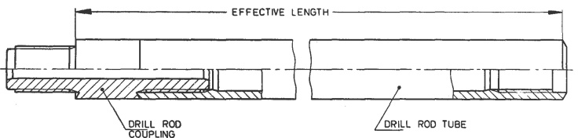

NOTE — Thread may be left-hand, if required.

Fig. 2 Nomenclature for Drill Rods

All dimensions are in millimetres

|  |  |  |  |  |
| --- | --- | --- | --- | --- |
| *Sl No.* | *Symbol* | *Rod OD* | *Coupling ID* | *Effective Length* |
| (1) | (2) | (3) | (4) | (5) |
|  | RW | 27.8 | 10.4 | 3 000, 1 500, or 750 |
|  | EW | 35.0 | 11.2 |
|  | AW | 43.8 | 15.9 |
|  | BW | 54.1 | 19 |
|  | NW | 66.8 | 35 |
|  | HW | 89.1 | 60.5 |

**12 DETAILED DIMENSIONS**

**12.1 Drill Rod Tube**

(*see* Fig. 3)

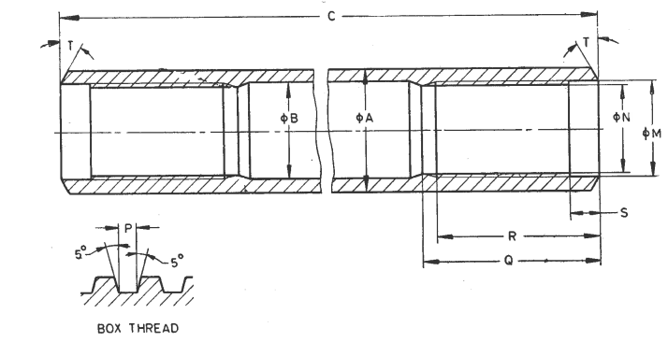

NOTES

**1** The *B* diameter dimension is maximum and may apply equally to upset end rods and parallel wall rods in RW size only. On all other sizes, this dimension refers to upset end rods only.

**2** Rods of sizes RW, EW and AW shall normally be supplied as parallel wall rods and rods of sizes BW, NW and HW as upset end rods unless otherwise specified.

Fig. 3 Drill Rod Tube Dimensions

All dimensions are in millimetres

|  |  |  |  |  |  |  |  |  |
| --- | --- | --- | --- | --- | --- | --- | --- | --- |
| *Sl No.* | *Dimension* | | *RW* | *EW* | *AW* | *BW* | *NW* | *HW* |
| (1) | (2) | | (3) | (4) | (5) | (6) | (7) | (8) |
|  | *A* | *Max* | 27.89 | 35.05 | 43.89 | 54.23 | 66.93 | 89.28 |
| *Min* | 27.76 | 34.93 | 43.64 | 53.98 | 66.68 | 88.90 |
|  | *B* | *Max* | 18.26 | 25.40 | 34.14 | 44.45 | 57.15 | 77.77 |
|  | *C* | *Max* | 2 972.57 | 2 967.23 | 2 968.12 | 2 956.44 | 2 955.93 | 2 943.61 |
| *Min* | 2 971.04 | 2 965.71 | 2 966.60 | 2 954.92 | 2 954.41 | 2 942.09 |
|  | *M* | *Max* | 21.67 | 27.13 | 35.05 | 42.93 | 56.49 | 77.06 |
| *Min* | 21.62 | 27.08 | 35.00 | 42.88 | 56.44 | 77.01 |
|  | *N* | *Max* | 18.95 | 23.95 | 31.88 | 38.94 | 51.71 | 72.24 |
| *Min* | 18.90 | 23.90 | 31.83 | 38.89 | 51.66 | 72.19 |
|  | Thread pitch | | 6.350 | 8.466 | 8.466 | 8.466 | 8.466 | 8.466 |
|  | *P* | *Max* | 3.18 | 4.22 | 4.22 | 4.22 | 4.22 | 4.22 |
| *Min* | 3.10 | 4.11 | 4.11 | 4.11 | 4.11 | 4.11 |
|  | *Q* | *Max* | 40.17 | 44.95 | 54.48 | 64.00 | 76.70 | 90.97 |
| *Min* | 39.67 | 44.45 | 53.98 | 63.50 | 76.20 | 90.47 |
|  | *R* | *Max* | 37.00 | 40.17 | 48.13 | 57.65 | 70.35 | 83.05 |
| *Min* | 36.50 | 39.67 | 47.63 | 57.15 | 69.85 | 82.55 |
|  | *S* | *Max* | 6.60 | 8.18 | 9.78 | 9.78 | 9.78 | 9.78 |
| *Min* | 6.10 | 7.67 | 3.27 | 9.27 | 9.27 | 9.27 |
|  | *T* | — | 30o | 30o | 30o | 30o | 30o | 30o |

**12.2 Drill Rod Coupling**

(*see* Fig. 4)

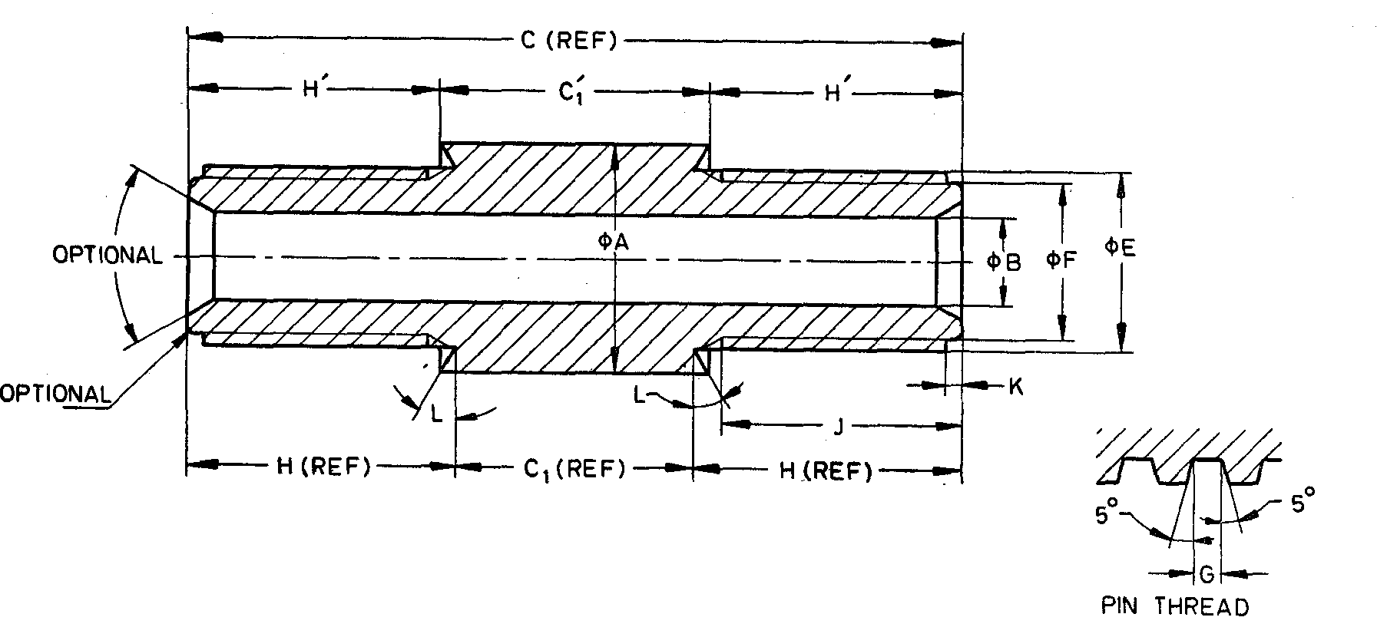

NOTE— Dimensions shown apply to both ends.

FIG. 4 DRILL ROD COUPLING DIMENSION

All dimensions are in millimetres

|  |  |  |  |  |  |  |  |  |
| --- | --- | --- | --- | --- | --- | --- | --- | --- |
| *Sl No.* | *Dimension* | | *RW* | *EW* | *AW* | *BW* | *NW* | *HW* |
| (1) | (2) | (3) | (4) | (5) | (6) | (7) | (8) | (9) |
|  | *A* | *Max* | 27.89 | 35.05 | 43.89 | 54.23 | 66.93 | 89.28 |
| *Min* | 27.69 | 34.85 | 43.54 | 53.87 | 66.55 | 88.77 |
|  | *B* | *Max* | 10.57 | 11.35 | 16.13 | 19.30 | 35.18 | 60.71 |
| *Min* | 10.19 | 10.97 | 15.75 | 18.92 | 34.80 | 60.32 |
|  | *C* | — | 92.25 | 117.48 | 133.35 | 165.10 | 190.50 | 228.60 |
|  | *C*1 | *Max* | 28.45 | 33.78 | 32.89 | 44.58 | 45.08 | 57.40 |
| *Min* | 27.94 | 33.27 | 32.39 | 44.07 | 44.58 | 56.90 |
|  | *C*1’ | *Max* | 32.05 | 38.40 | 37.99 | 51.10 | 51.10 | 54.41 |
| *Min* | 31.55 | 37.89 | 37.49 | 50.60 | 50.60 | 53.91 |
|  | *E* | *Max* | 21.56 | 26.97 | 34.90 | 42.77 | 56.34 | 76.91 |
| *Min* | 21.51 | 26.92 | 34.85 | 42.72 | 56.29 | 76.86 |
|  | *F* | *Max* | 18.85 | 23.80 | 31.72 | 38.79 | 51.56 | 72.09 |
| *Min* | 18.72 | 23.67 | 31.60 | 38.66 | 51.44 | 71.96 |
|  | Thread pitch | | 6.350 | 8.466 | 8.466 | 8.466 | 8.466 | 8.466 |
|  | *G* | *Max* | 3.18 | 4.22 | 4.22 | 4.22 | 4.22 | 4.22 |
| *Min* | 3.10 | 4.11 | 4.11 | 4.11 | 4.11 | 4.11 |
|  | *H* | *Max* | 33.78 | 42.21 | 50.65 | 60..63 | 73.08 | 84.43 |
| *Min* | 33.27 | 41.71 | 50.14 | 60.12 | 72.57 | 83.92 |
|  | *H’* | *Max* | 31.98 | 39.90 | 48.10 | 57.37 | 70.07 | 80.93 |
| *Min* | 31.47 | 39.40 | 47.59 | 56.86 | 69.56 | 80.42 |
|  | *J* | *­—* | 28.58 | 36.50 | 44.45 | 53.93 | 66.68 | 79.38 |
|  |
|  | *K* | *Max* | 1.83 | 5.00 | 6.60 | 8.18 | 9.80 | 9.78 |
| *Min* | 1.32 | 4.50 | 6.10 | 7.67 | 9.27 | 9.27 |
|  | *L* | *—* | 30o | 30o | 30o | 30o | 30o | 30o |

**SECTION 2 CASINGS**

**13 NOMENCLATURE**

(*see* Fig. 5)

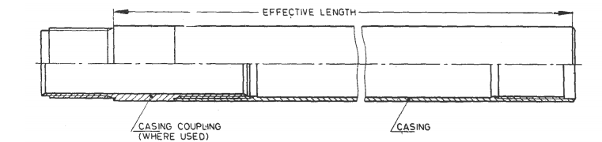

NOTE — Thread shall be right-hand unless otherwise specified.

Fig. 5 Casings Nomenclature

**14 MAIN DIMENSIONS**

**14.1 Diameters of Casing Tubes**

**14.1.1** *'W' Design Flush Jointed Casings* (*see* Fig. 6)

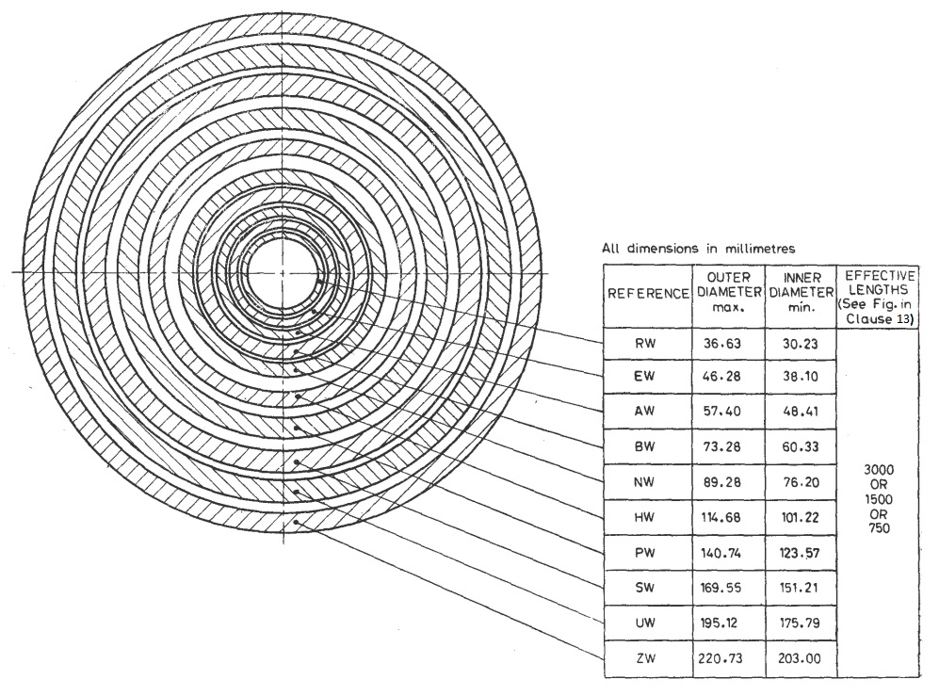

Fig. 6 'W' Design Flush Jointed Casings

**14.1.2** '*X*' *Design Flush Coupled Casing* (*see* Fig. 7)

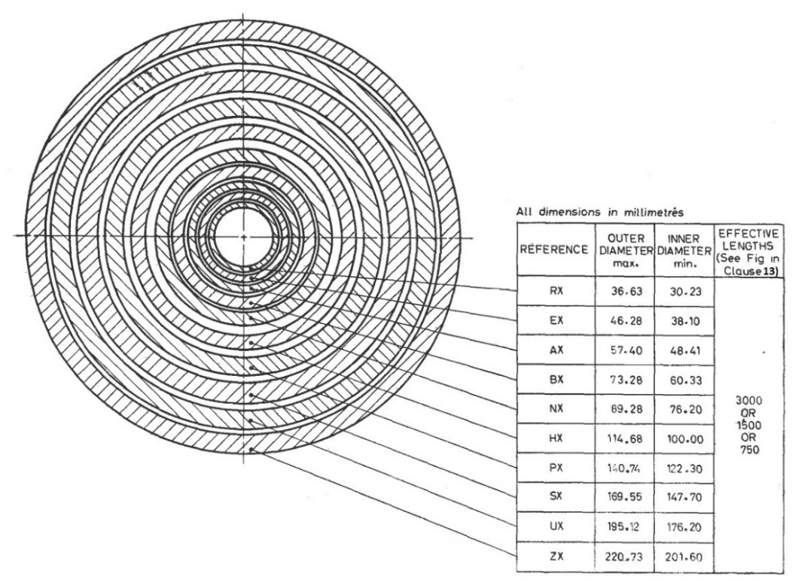

Fig. 7 'X' Design Flush Coupled Casing

**14.2 Relation of Casing to Core Bit**

(*see* Fig. 8)

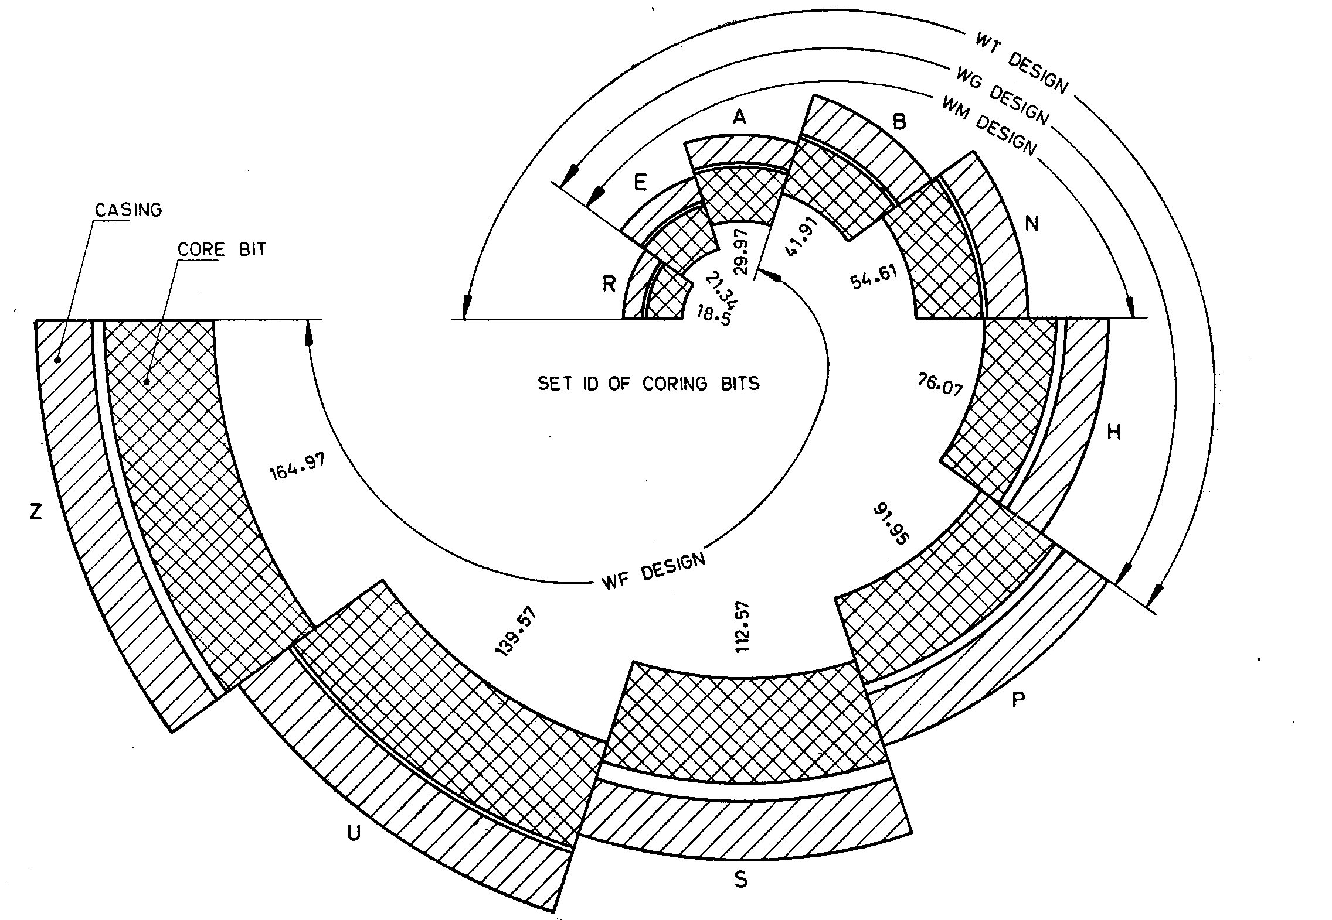

Fig. 8 Casing to Core Bit Relation

**15 DETAILED DIMENSIONS**

**15.1 'W' Design Flush Jointed Casings**

**15.1.1** *'W' Design Flush Jointed Casings — Casing Tube* (*see* Fig. 9)

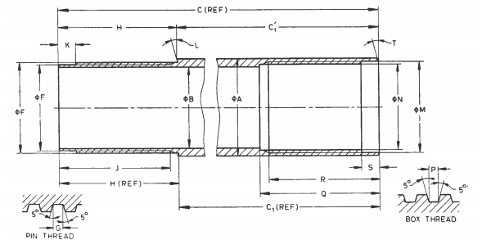

Fig. 9 'W' Design Flush Jointed Casings — Casing Tube

All dimensions are in millimetres

|  |  |  |  |  |  |  |  |  |  |  |  |  |
| --- | --- | --- | --- | --- | --- | --- | --- | --- | --- | --- | --- | --- |
| *Sl No.* | *Dimension* | | *RW* | *EW* | *AW* | *BW* | *NW* | *HW* | *PW* | *SW* | *UW* | *ZW* |
| (1) | (2) | | (3) | (4) | (5) | (6) | (7) | (8) | (9) | (10) | (11) | (12) |
|  | *A* | *Max* | 36.63 | 46.28 | 57.40 | 73.28 | 89.28 | 114.68 | 140.74 | 169.55 | 195.12 | 220.73 |
| *Min* | 36.50 | 46.02 | 57.15 | 73.03 | 88.90 | 114.30 | 138.66 | 167.00 | 192.23 | 217.42 |
|  | *B* | *Max* | 30.48 | 38.35 | 48.67 | 60.58 | 76.58 | 101.60 | 127.38 | 155.55 | 180.54 | 208.46 |
| *Min* | 30.23 | 38.10 | 48.41 | 60.32 | 7620 | 101.22 | 123.57 | 151.21 | 175.79 | 203.00 |
|  | *C* | *Max* | 3 045.52 | 3 051.87 | 3 058.22 | 3 064.57 | 3 070.92 | 3 077.27 | 3 083.62 | 3 089.97 | 3 096.32 | 3 102.67 |
| *Min* | 3 043.23 | 3 049.58 | 3 055.93 | 3 062.28 | 3 068.63 | 3 074.98 | 3 081.33 | 3 087.68 | 3 094.03 | 3 100.38 |
|  | *C*1 | *Max* | 3 001.19 | 3 001.19 | 3 001.19 | 3 001.19 | 3 001.19 | 3 001.19 | 3 001.19 | 3 001.19 | 3 001.19 | 3 001.19 |
| *Min* | 2 998.78 | 2 998.78 | 2 998.78 | 2 998.78 | 2 998.78 | 2 998.78 | 2 998.78 | 2 998.78 | 2 998.78 | 2 998.78 |
|  | *C*1*’* | *Max* | 3 001.51 | 3 001.57 | 3 001.62 | 3 001.89 | 3 001.88 | 3 001.91 | 3 001.88 | 3 001.93 | 3 001.93 | 3 001.77 |
| *Min* | 2 999.10 | 2 999.16 | 2 999.21 | 2 999.48 | 2 999.47 | 2 999.50 | 2 999.52 | 2 999.52 | 2 999.52 | 2 999.36 |
|  | *E* | *Max* | 34.19 | 43.38 | 54.10 | 68.00 | 84.00 | 109.14 | 134.59 | 162.84 | 188.26 | 214.81 |
| *Min* | 34.11 | 43.31 | 54.00 | 67.89 | 83.90 | 109.02 | 134.47 | 162.71 | 188.11 | 214.66 |
|  | *F* | *Max* | 32.61 | 41.07 | 51.79 | 65.68 | 81.69 | 106.86 | 131.55 | 159.79 | 184.43 | 210.97 |
| *Min* | 32.56 | 41.02 | 51.71 | 65.61 | 81.61 | 106.76 | 131.45 | 159.69 | 184.30 | 210.85 |
|  | Thread pitch | | 5.080 | 6.350 | 6.350 | 6.3.50 | 6.350 | 6.350 | 8.466 | 8.4.66 | 12.700 | 12.700 |
|  | *G* | *Max* | 2.64 | 3.25 | 3.25 | 3.25 | 3.25 | 4.29 | 4.29 | 4.29 | 6.40 | 6.40 |
| *Min* | 2.54 | 3.15 | 3.15 | 3.15 | 3.15 | 4.19 | 4.19 | 4.19 | 6.30 | 6.30 |
|  | *H* | *Max* | 44.45 | 50.80 | 57.15 | 63.50 | 69.85 | 76.20 | 82.56 | 88.90 | 95.25 | 101.60 |
| *Min* | 44.32 | 50.67 | 57.02 | 63.37 | 69.72 | 76.07 | 82.42 | 88.77 | 95.12 | 101.47 |
|  | *H’* | *Max* | 44.13 | 50.42 | 56.72 | 62.80 | 69.10 | 75.48 | 81.87 | 88.16 | 94.51 | 101.02 |
| *Min* | 44.00 | 50.29 | 56.89 | 62.67 | 69.03 | 75.35 | 81.73 | 88.03 | 94.38 | 100.89 |
|  | *J* | *Min* | 41.28 | 47.62 | 53.98 | 60.33 | 66.68 | 73.02 | 79.38 | 85.73 | 92.08 | 98.43 |
|  | *K* | *Max* | 6.60 | 7.62 | 7.62 | 7.62 | 7.62 | 7.62 | 9.14 | 9.14 | 11.18 | 11.18 |
| *Min* | 6.10 | 7.11 | 7.11 | 7.11 | 7.11 | 7.11 | 8.64 | 8.64 | 10.67 | 10.67 |
|  | *L* | *—* | 15o | 15o | 15o | 15o | 15o | 15o | 15o | 15o | 15o | 15o |
|  | *M* | *Max* | 34.34 | 43.54 | 54.31 | 68.20 | 84.20 | 109.42 | 134.87 | 163.12 | 188.62 | 215.16 |
| *Min* | 34.26 | 43.46 | 54.20 | 68.10 | 84.10 | 109.30 | 134.75 | 162.99 | 188.47 | 215.01 |
|  | *N* | *Max* | 32.72 | 41.17 | 51.94 | 65.84 | 81.84 | 107.06 | 131.75 | 159.99 | 184.68 | 211.23 |
| *Min* | 32.66 | 41.12 | 51.87 | 65.76 | 81.76 | 106.96 | 131.65 | 159.89 | 184.56 | 211.10 |
|  | Thread pitch | | 5.080 | 6.350 | 6.350 | 6.350 | 6.350 | 6.350 | 8.466 | 8.466 | 12.700 | 12.700 |
|  | *P* | *Max* | 2.64 | 3.25 | 3.25 | 3.25 | 3.25 | 3.25 | 4.29 | 4.29 | 6.40 | 6.40 |
| *Min* | 2.54 | 3.15 | 3.15 | 3.15 | 3.15 | 3.15 | 4.19 | 4.19 | 6.30 | 6.30 |
|  | *Q* | *Max* | 44.58 | 50.93 | 57.28 | 63.63 | 69.98 | 76.33 | 82.68 | 89.03 | 95.38 | 101.73 |
| *Min* | 44.45 | 50.80 | 57.15 | 63.50 | 69.85 | 76.20 | 82.55 | 88.90 | 95.25 | 10.60 |
|  | *R* | *Max* | 41.78 | 48.13 | 54.48 | 60.83 | 67.18 | 73.53 | 79.98 | 86.23 | 92.58 | 98.93 |
| *Min* | 41.28 | 47.63 | 53.98 | 60.33 | 56.68 | 73.03 | 79.38 | 85.73 | 92.08 | 98.43 |
|  | *S* | *Max* | 6.60 | 7.62 | 7.62 | 7.62 | 7.62 | 7.62 | 9.14 | 9.14 | 11.18 | 11.18 |
| *Min* | 6.10 | 7.11 | 7.11 | 7.11 | 7.11 | 7.11 | 8.64 | 8.64 | 10.67 | 10.67 |
|  | *T* | *—* | 15o | 15o | 15o | 15o | 15o | 15o | 15o | 15o | 15o | 15o |

NOTE — Exception to dimension *B* — Manufacturers shall be responsible for maintaining a minimum dimension *B* for a minimum length of 100 mm from each end. This diameter shall be concentric within 0.10. mm of the thread diameter. Over remainder of bore, stated tolerances must be maintained.

**15.1.2** '*W*' *Design Flush Jointed Casings — Casing Drive Shoes* (*see* Fig. 10)

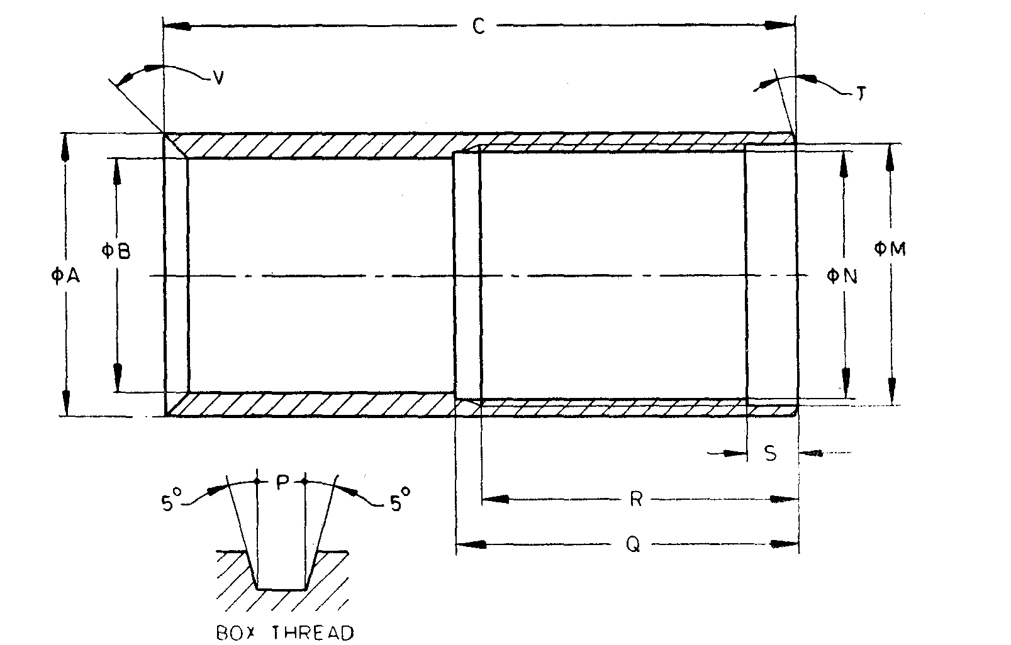

NOTE — Bevel edge shall have a hardness of 392 to 445 *HV* (40 to 45 *HRC*)

Fig. 10 'W' Design Flush Jointed Casings — Casing Drive Shoes

All dimensions are in millimetres

|  |  |  |  |  |  |  |  |  |  |  |  |  |
| --- | --- | --- | --- | --- | --- | --- | --- | --- | --- | --- | --- | --- |
| *Sl No.* | *Dimension* | | *RW* | *EW* | *AW* | *BW* | *NW* | *HW* | *PW* | *SW* | *UW* | *ZW* |
| (1) | (2) | | (3) | (4) | (5) | (6) | (7) | (8) | (9) | (10) | (11) | (12) |
|  | *A* | *Max* | 36.98 | 46.53 | 58.34 | 73.96 | 90.47 | 115.93 | 142.37 | 171.20 | 196.72 | 222.38 |
| *Min* | 36.88 | 46.43 | 58.24 | 73.86 | 90.37 | 115.82 | 142.24 | 171.07 | 196.60 | 222.25 |
|  | *B* | *Max* | 30.73 | 38.61 | 48.92 | 60.83 | 76.96 | 100.97 | 122.86 | 148.26 | 177.22 | 202.62 |
| *Min* | 30.23 | 38.10 | 48.41 | 60.33 | 76.20 | 100.20 | 122.10 | 147.50 | 176.20 | 201.60 |
|  | *C* | *Min* | 82.55 | 88.90 | 95.25 | 107.95 | 114.30 | 127.00 | 133.35 | 146.05 | 152.40 | 158.75 |
|  | *M* | *Max* | 34.34 | 43.54 | 54.31 | 68.20 | 84.20 | 109.42 | 134.87 | 163.12 | 188.62 | 215.16 |
| *Min* | 34.26 | 43.46 | 54.20 | 68.10 | 84.10 | 109.30 | 134.75 | 162.99 | 188.47 | 215.01 |
|  | *N* | *Max* | 32.72 | 41.17 | 51.94 | 65.84 | 81.81 | 107.06 | 131.75 | 159.99 | 184.68 | 211.23 |
| *Min* | 32.66 | 41.12 | 51.87 | 65.76 | 81.76 | 106.96 | 131.65 | 159.89 | 184.56 | 211.10 |
|  | Thread pitch | | 5.080 | 6.350 | 6.350 | 6.350 | 6.350 | 6.350 | 8.466 | 8.466 | 12.700 | 12.700 |
|  | *P* | *Max* | 2.64 | 3.25 | 3.25 | 3.25 | 3.25 | 3.25 | 4.29 | 4.29 | 6.40 | 6.40 |
| *Min* | 2.54 | 3.15 | 3.15 | 3.15 | 3.15 | 3.15 | 4.19 | 4.19 | 6.30 | 6.30 |
|  | *Q* | *Max* | 44.58 | 50.93 | 57.28 | 63.63 | 69.98 | 76.33 | 82.68 | 89.03 | 95.38 | 101.73 |
| *Min* | 44.45 | 50.80 | 57.15 | 63.50 | 69.85 | 76.20 | 82.55 | 88.90 | 95.25 | 101.60 |
|  | *R* | *Max* | 41.78 | 48.13 | 54.48 | 60.83 | 67.18 | 73.53 | 79.88 | 86.23 | 92.58 | 98.92 |
| *Min* | 41.28 | 47.63 | 53.98 | 60.33 | 66.68 | 73.03 | 79.38 | 85.73 | 92.08 | 98.42 |
|  | *S* | *Max* | 6.60 | 7.62 | 7.62 | 7.62 | 7.62 | 7.62 | 9.14 | 9.14 | 11.18 | 11.18 |
|  | *Min* | 6.10 | 7.11 | 7.11 | 7.11 | 7.11 | 7.11 | 8.64 | 8.64 | 10.67 | 10.67 |
|  | *T* | *—* | 15o | 15o | 15o | 15o | 15o | 15o | 15o | 15o | 15o | 15o |
|  | *V* | *—* | 45o | 45o | 45o | 45o | 45o | 45o | 45o | 45o | 45o | 45o |

**15.1.3** *'W' Design Flush Jointed Casings* — *Casing Shoe Bit* (*see* Fig. 11)

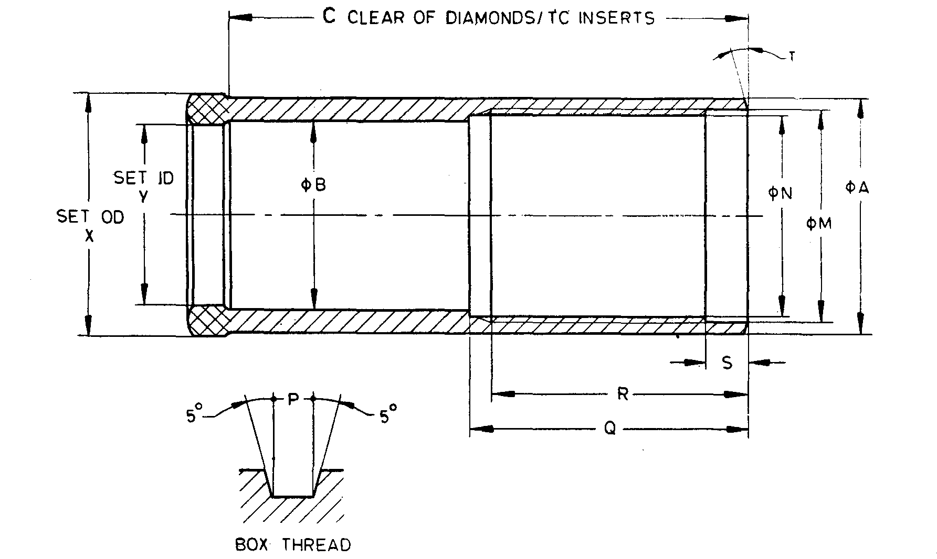

Fig. 11 'W' Design Flush Jointed Casings — Casing Shoe Bit

All dimensions are in millimetres

|  |  |  |  |  |  |  |  |  |  |  |  |  |
| --- | --- | --- | --- | --- | --- | --- | --- | --- | --- | --- | --- | --- |
| *Sl No.* | *Dimension* | | *RW* | *EW* | *AW* | *BW* | *NW* | *HW* | *PW* | *SW* | *UW* | *ZW* |
| (1) | (2) | | (3) | (4) | (5) | (6) | (7) | (8) | (9) | (10) | (11) | (12) |
|  | *A* | *Max* | 36.98 | 46.53 | 58.34 | 73.96 | 90.47 | 115.93 | 141.33 | 169.90 | 195.30 | 220.70 |
| *Min* | 36.83 | 46.43 | 58.24 | 73.86 | 90.37 | 115.82 | 141.17 | 169.75 | 195.07 | 220.47 |
|  | *B* | *Max* | 30.73 | 38.61 | 48.92 | 60.83 | 76.96 | 100.84 | 122.86 | 148.26 | 177.22 | 202.62 |
| *Min* | 30.23 | 38.10 | 48.41 | 60.33 | 76.20 | 100.08 | 122.10 | 147.50 | 176.20 | 201.60 |
|  | *C* | *Min* | 82.55 | 88.90 | 95.25 | 107.95 | 114.30 | 127.00 | 133.35 | 145.05 | 152.40 | 158.75 |
|  | *M* | *Max* | 34.34 | 43.54 | 54.31 | 68.20 | 84.20 | 109.42 | 134.87 | 163.12 | 188.62 | 215.16 |
| *Min* | 34.26 | 43.46 | 54.20 | 68.10 | 84.10 | 109.30 | 134.75 | 162.99 | 188.47 | 215.01 |
|  | *N* | *Max* | 32.72 | 41.17 | 51.94 | 65.84 | 81.84 | 107.06 | 131.75 | 159.99 | 184.68 | 211.23 |
| *Min* | 32.66 | 41.12 | 51.87 | 65.76 | 81.76 | 106.96 | 131.65 | 159.89 | 184.56 | 211.10 |
|  | Thread pitch | | 5.080 | 6.350 | 6.350 | 6.350 | 6.350 | 6.350 | 8.466 | 8.466 | 12.700 | 12.700 |
|  | *P* | *Max* | 2.64 | 3.25 | 3.25 | 3.25 | 3.25 | 3.25 | 4.29 | 4.29 | 6.40 | 6.40 |
| *Min* | 2.54 | 3.15 | 3.15 | 3.15 | 3.15 | 3.15 | 4.19 | 4.19 | 6.30 | 6.30 |
|  | *Q* | *Max* | 44.58 | 50.93 | 57.28 | 63.63 | 69.98 | 76.33 | 82.68 | 89.03 | 95.38 | 101.73 |
| *Min* | 44.45 | 50.80 | 57.15 | 63.50 | 69.85 | 76.20 | 82.55 | 88.90 | 95.25 | 101.60 |
|  | *R* | *Max* | 41.78 | 48.13 | 54.48 | 60.83 | 67.18 | 73.53 | 79.88 | 86.23 | 92.58 | 98.93 |
| *Min* | 41.28 | 47.63 | 53.98 | 60.33 | 66.68 | 73.03 | 79.38 | 85.73 | 92.08 | 98.43 |
|  | *S* | *Max* | 6.60 | 7.62 | 7.62 | 7.62 | 7.62 | 7.62 | 9.14 | 9.14 | 11.18 | 11.18 |
| *Min* | 6.10 | 7.11 | 7.11 | 7.11 | 7.11 | 7.11 | 8.64 | 8.64 | 10.67 | 10.67 |
|  | *T* | *—* | 15o | 15o | 15o | 15o | 15o | 15o | 15o | 15o | 15o | 15o |
|  | *X* | *Max* | 37.85 | 47.75 | 59.69 | 75.44 | 91.95 | 117.65 | 143.76 | 172.72 | 198.50 | 224.16 |
| *Min* | 37.59 | 47.50 | 59.44 | 75.18 | 91.69 | 117.27 | 143.26 | 172.21 | 197.74 | 223.39 |
|  | *Y* | *Max* | 30.18 | 38.02 | 48.31 | 60.25 | 76.12 | 99.82 | 121.54 | 146.94 | 175.64 | 201.04 |
| *Min* | 30.05 | 37.90 | 48.18 | 60.12 | 75.87 | 99.57 | 121.16 | 146.56 | 175.13 | 200.53 |

**15.1.4** '*W' Design Flush Jointed Casings — Casing Reaming Shell* (*see* Fig. 12)

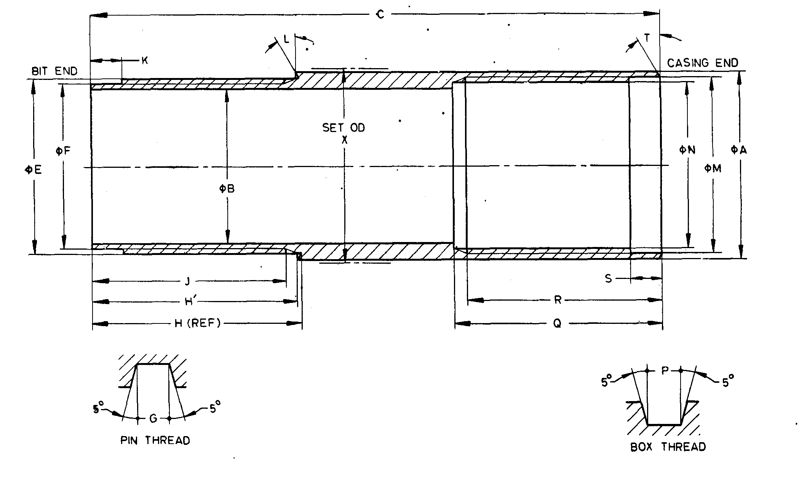

Fig. 12 'W' Design Flush Jointed Casings — Casing Reaming Shell

All dimensions are are in millimetres.

|  |  |  |  |  |  |  |
| --- | --- | --- | --- | --- | --- | --- |
| *Sl No.* | *Dimension* | | *EW* | *AW* | *BW* | *NW* |
| (1) | (2) | | (3) | (4) | (5) | (6) |
|  | *A* | *Max* | 46.53 | 58.34 | 73.96 | 90.47 |
| *Min* | 46.43 | 58.24 | 73.86 | 90.37 |
|  | *B* | *Max* | 38.35 | 48.67 | 60.58 | 76.58 |
| *Min* | 38.10 | 48.41 | 60.33 | 76.20 |
|  | *C* | *Min* | 139.70 | 152.40 | 171.45 | 184.15 |
|  | *E* | *Max* | 43.38 | 54.10 | 68.00 | 84.00 |
| *Min* | 43.31 | 54.00 | 67.89 | 83.90 |
|  | *F* | *Max* | 41.07 | 51.79 | 65.68 | 81.69 |
| *Min* | 41.02 | 51.71 | 65.61 | 81.61 |
|  | Thread pitch | | 6.350 | 6.350 | 6.350 | 6.350 |
|  | *G* | *Max* | 3.25 | 3.25 | 3.25 | 3.25 |
| *Min* | 3.15 | 3.15 | 3.15 | 3.15 |
|  | *H* | *Max* | 50.80 | 57.15 | 63.50 | 69.85 |
| *Min* | 50.67 | 57.02 | 63.37 | 69.72 |
|  | *H’* | *Max* | 50.38 | 56.58 | 62.70 | 68.98 |
| *Min* | 50.25 | 56.45 | 62.57 | 68.85 |
|  | *J* | *Min* | 47.62 | 53.98 | 60.32 | 66.68 |
|  | *K* | *Max* | 7.62 | 7.62 | 7.62 | 7.62 |
| *Min* | 7.11 | 7.11 | 7.11 | 7.11 |
|  | *L* | *—* | 15o | 15o | 15o | 15o |
|  | *M* | *Max* | 43.54 | 54.31 | 68.20 | 84.20 |
| *Min* | 43.46 | 54.20 | 68.10 | 84.10 |
|  | *N* | *Max* | 41.17 | 51.94 | 65.84 | 81.84 |
| *Min* | 41.12 | 51.87 | 65.76 | 81.76 |
|  | Thread pitch | | 6.350 | 6.350 | 6.350 | 6.350 |
|  | *P* | *Max* | 3.25 | 3.25 | 3.25 | 3.25 |
| *Min* | 3.15 | 3.15 | 3.15 | 3.15 |
|  | *Q* | *Max* | 50.93 | 57.28 | 63.63 | 69.98 |
| *Min* | 50.80 | 57.15 | 63.50 | 69.85 |
|  | *R* | *Max* | 48.13 | 54.48 | 60.83 | 67.18 |
| *Min* | 47.63 | 53.98 | 60.33 | 66.68 |
|  | *S* | *Max* | 7.62 | 7.62 | 7.62 | 7.62 |
| *Min* | 7.11 | 7.11 | 7.11 | 7.11 |
|  | *T* | *—* | 15o | 15o | 15o | 15o |
|  | *X* | *Max* | 48.13 | 60.07 | 75.82 | 92.33 |
| *Min* | 47.88 | 59.82 | 75.56 | 92.08 |

**15.1.5** '*W*' *Design Flush Jointed Casings — Casing Bit* (*see* Fig. 13)

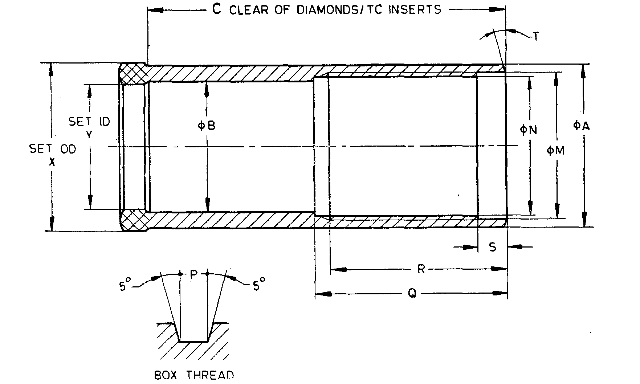

Fig. 13 'W' Design Flush Jointed Casings — Casing Bit

All dimensions are in millimetres.

|  |  |  |  |  |  |  |  |  |  |  |  |  |
| --- | --- | --- | --- | --- | --- | --- | --- | --- | --- | --- | --- | --- |
| *Sl No.* | *Dimension* | | *RW* | *EW* | *AW* | *BW* | *NW* | *HW* | *PW* | *SW* | *UW* | *ZW* |
| (1) | (2) | | (3) | (4) | (5) | (6) | (7) | (8) | (9) | (10) | (11) | (12) |
|  | *A* | *Max* | 36.98 | 46.53 | 58.34 | 73.96 | 90.47 | 115.93 | 141.33 | 169.90 | 195.30 | 220.70 |
| *Min* | 36.88 | 46.43 | 58.24 | 73.86 | 90.37 | 115.82 | 141.17 | 169.75 | 195.07 | 220.47 |
|  | *B* | *Max* | 26.54 | 37.21 | 46.74 | 57.86 | 73.74 | 98.35 | 120.65 | 146.05 | 175.13 | 200.53 |
| *Min* | 26.04 | 36.45 | 45.97 | 57.10 | 72.97 | 97.33 | 119.38 | 144.78 | 173.61 | 199.01 |
|  | *C* | *Min* | 82.55 | 88.90 | 95.25 | 107.95 | 114.30 | 127.00 | 133.35 | 146.05 | 152.40 | 153.75 |
|  | *M* | *Max* | 34.34 | 43.54 | 54.31 | 68.20 | 84.20 | 109.42 | 134.87 | 163.12 | 188.62 | 215.16 |
| *Min* | 34.26 | 43.46 | 54.20 | 68.10 | 84.10 | 109.30 | 134.75 | 162.99 | 188.47 | 215.01 |
|  | *N* | *Max* | 32.72 | 41.17 | 51.94 | 65.84 | 81.84 | 107.06 | 131.75 | 159.99 | 184.68 | 211.23 |
| *Min* | 32.66 | 41.12 | 51.87 | 65.76 | 81.76 | 106.96 | 131.65 | 159.39 | 184.56 | 211.10 |
|  | Thread pitch | | 5.080 | 6.350 | 6.350 | 6.350 | 6.350 | 6.350 | 8.466 | 8.466 | 12.700 | 12.700 |
|  | *P* | *Max* | 2.64 | 3.25 | 3.25 | 3.25 | 3.25 | 3.25 | 7.29 | 4.29 | 6.40 | 6.40 |
| *Min* | 2.54 | 3.15 | 3.15 | 3.15 | 3.15 | 3.15 | 4.19 | 4.19 | 6.30 | 6.30 |
|  | *Q* | *Max* | 44.58 | 50.93 | 57.28 | 63.63 | 69.98 | 76.33 | 82.68 | 89.03 | 95.38 | 101.73 |
| *Min* | 44.45 | 50.80 | 57.15 | 63.50 | 69.85 | 76.20 | 82.55 | 88.90 | 95.25 | 101.60 |
|  | *R* | *Max* | 41.70 | 48.13 | 54.48 | 60.83 | 67.18 | 74.53 | 79.88 | 86.23 | 92.58 | 98.93 |
| *Min* | 41.28 | 47.63 | 53.98 | 60.33 | 66.68 | 73.03 | 79.38 | 85.73 | 92.08 | 98.43 |
|  | *S* | *Max* | 6.60 | 7.62 | 7.62 | 7.62 | 7.62 | 7.62 | 9.14 | 9.14 | 11.18 | 11.18 |
| *Min* | 6.10 | 7.11 | 7.11 | 7.11 | 7.11 | 7.11 | 8.64 | 8.64 | 10.67 | 10.67 |
|  | *T* | *—* | 15o | 15o | 15o | 15o | 15o | 15o | 15o | 15o | 15o | 15o |
|  | *X* | *Max* | 37.85 | 47.75 | 59.69 | 75.44 | 91.95 | 117.65 | 143.76 | 172.72 | 198.50 | 224.16 |
| *Min* | 37.59 | 47.50 | 59.44 | 74.18 | 91.69 | 117.27 | 143.26 | 172.21 | 197.74 | 223.39 |
|  | *Y* | *Max* | 25.53 | 35.81 | 45.34 | 56.39 | 72.26 | 96.06 | 117.86 | 143.26 | 171.83 | 197.23 |
| *Min* | 25.27 | 35.56 | 45.09 | 56.13 | 72.01 | 95.81 | 117.48 | 142.88 | 171.32 | 196.72 |

**15.2 *'X'*****Design Casings**

**15.2.1** '*X*' *Design Flush Coupled Casings — Casing Tube* (*see* Fig. 14)

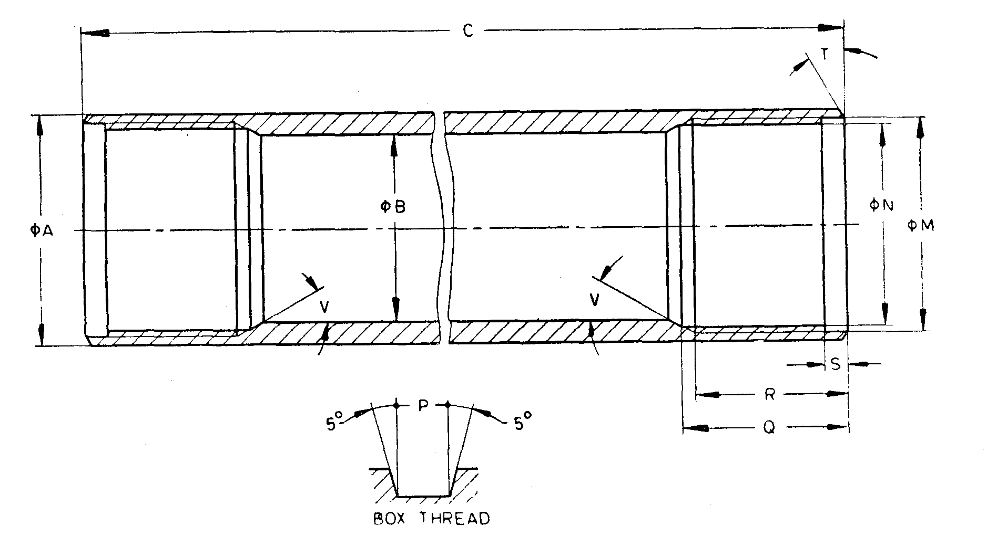

NOTE— Dimensions shown apply to both ends.

Fig. 14 'X' Design Flush Coupled Casings — Casing Tube

All dimensions are in millimetres.

|  |  |  |  |  |  |  |  |  |  |  |  |  |
| --- | --- | --- | --- | --- | --- | --- | --- | --- | --- | --- | --- | --- |
| *SL No.* | *Dimension* | | *RX* | *EX* | *AX* | *BX* | *NX* | *HX* | *PX* | *SX* | *UX* | *ZX* |
| (1) | (2) | | (3) | (4) | (5) | (6) | (7) | (8) | (9) | (10) | (11) | (12) |
|  | *A* | *Max* | 36.63 | 46.28 | 57.40 | 73.28 | 89.28 | 114.68 | 140.74 | 169.55 | 195.12 | 220.73 |
| *Min* | 36.50 | 46.02 | 57.15 | 73.03 | 88.90 | 114.30 | 138.66 | 167.00 | 192.23 | 217.42 |
|  | *B* | *Max* | 30.48 | 41.28 | 50.80 | 65.07 | 80.95 | 104.78 | 130.51 | 158.80 | 184.00 | 208.99 |
| *Min* | 30.23 | 41.02 | 50.55 | 64.82 | 80.57 | 104.39 | 125.30 | 151.21 | 175.79 | 203.00 |
|  | *C* | *Max* | 2 946.76 | 2 964.19 | 2 926.54 | 2 914.81 | 2 914.81 | 2 902.72 | 2 900.94 | 2 888.19 | 2 875.74 | 2 862.48 |
| *Min* | 2 945.24 | 2 962.66 | 2 925.02 | 2 913.28 | 2 913.28 | 2 901.19 | 2 899.42 | 2 886.67 | 2 874.02 | 2 860.96 |
|  | *M* | *Max* | 34.32 | 43.71 | 54.05 | 68.33 | 84.20 | 108.48 | 133.65 | 162.03 | 187.76 | 212.75 |
| *Min* | 34.26 | 43.66 | 54.00 | 68.28 | 84.14 | 108.38 | 133.53 | 161.85 | 187.58 | 212.57 |
|  | *N* | *Max* | 32.79 | 42.14 | 52.45 | 65.94 | 8181 | 106.05 | 131.24 | 159.56 | 184.81 | 209.80 |
| *Min* | 32.74 | 42.09 | 52.40 | 65.89 | 81.76 | 105.97 | 131.14 | 159.46 | 184.68 | 209.68 |
|  | Thread pitch | | 3.175 | 3.175 | 3.175 | 3.175 | 3.175 | 5.080 | 5.050 | 5.080 | 6.350 | 6.350 |
|  | *P* | *Max* | 1.63 | 1.63 | 1.63 | 1.60 | 1.60 | 2.59 | 2.57 | 2.57 | 3.18 | 3.18 |
| *Min* | 1.55 | 1.55 | 1.55 | 1.52 | 1.52 | 2.51 | 2.46 | 2.46 | 3.07 | 3.07 |
|  | *Q* | *Max* | 25.90 | 51.30 | 57.65 | 60.83 | 67.18 | 64.00 | 70.35 | 76.70 | 83.05 | 89.48 |
| *Min* | 25.40 | 50.80 | 57.15 | 60.33 | 66.68 | 63.50 | 69.85 | 76.20 | 82.55 | 88.98 |
|  | *R* | *Max* | 24.30 | 48.13 | 54.48 | 57.65 | 64.00 | 57.65 | 67.18 | 73.33 | 79.88 | 86.23 |
| *Min* | 23.80 | 47.63 | 53.98 | 57.15 | 63.50 | 57.15 | 66.68 | 73.03 | 79.38 | 85.73 |
|  | *S* | *Max* | 3.43 | 6.60 | 6.60 | 6.60 | 6.60 | 8.13 | 9.78 | 9.78 | 9.78 | 9.78 |
| *Min* | 2.92 | 6.10 | 6.10 | 6.10 | 6.10 | 7.62 | 9.27 | 9.27 | 9.27 | 9.27 |
|  | *T* | *—* | 0o | 30o | 30o | 30o | 30o | 30o | 15o | 15o | 15o | 15o |
|  | *V* | *—* | — | — | does not apply | | — | — | 30o | 30o | 30o | 30o |

**15.2.2** *'X' Design Flush Coupled Casings — Casing Shoe Bit* (*see* Fig. 15)

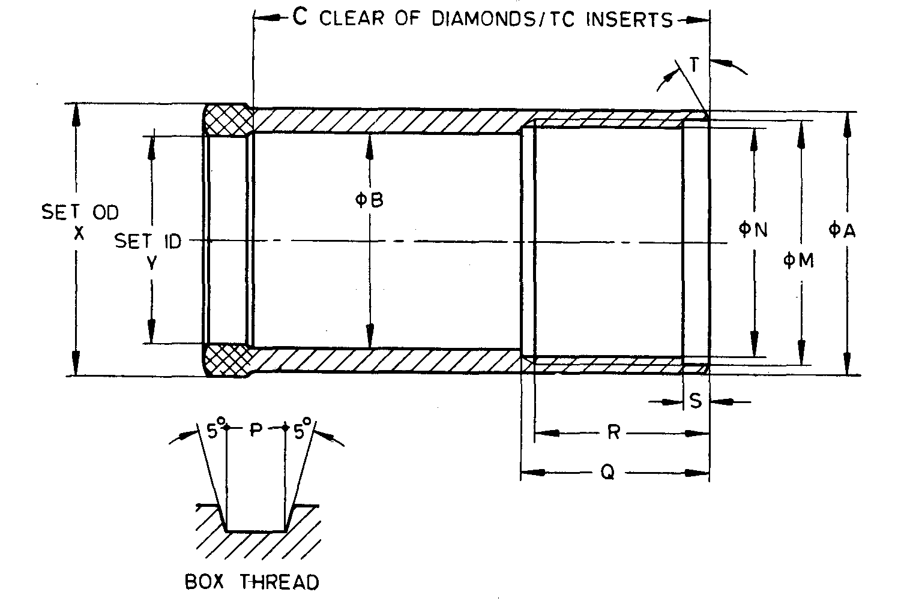

Fig. 15 'X' Design Flush Coupled Casings — Casing Shoe Bit

All dimensions are in millimetres

|  |  |  |  |  |  |  |  |  |  |  |  |  |
| --- | --- | --- | --- | --- | --- | --- | --- | --- | --- | --- | --- | --- |
| *Sl No.* | *Dimension* | | *RX* | *EX* | *AX* | *BX* | *NX* | *HX* | *PX* | *SX* | *UX* | *ZX* |
| (1) | (2) | | (3) | (4) | (5) | (6) | (7) | (8) | (9) | (10) | (11) | (12) |
|  | *A* | *Max* | 36.98 | 46.53 | 58.34 | 73.96 | 90.47 | 115.93 | 141.33 | 169.90 | 195.30 | 220.70 |
| *Min* | 36.88 | 46.43 | 58.24 | 73.86 | 90.37 | 115.82 | 141.17 | 169.75 | 195.07 | 220.47 |
|  | *B* | *Max* | 30.73 | 38.61 | 48.92 | 60.83 | 76.96 | 100.84 | 122.86 | 148.26 | 177.22 | 202.62 |
| *Min* | 30.23 | 38.10 | 48.41 | 60.33 | 76.20 | 100.08 | 122.10 | 147.50 | 176.20 | 201.60 |
|  | *C* | *Min* | 63.50 | 88.90 | 95.25 | 104.78 | 111.13 | 114.30 | 133.35 | 146.05 | 152.40 | 158.75 |
|  | *M* | *Max* | 34.32 | 43.71 | 54.05 | 68.33 | 84.20 | 108.48 | 133.65 | 162.03 | 187.76 | 212.75 |
| *Min* | 34.26 | 43.66 | 54.00 | 68.28 | 84.15 | 108.38 | 133.53 | 161.85 | 187.58 | 212.57 |
|  | *N* | *Max* | 32.79 | 42.14 | 52.45 | 65.94 | 81.81 | 106.05 | 131.24 | 159.56 | 184.81 | 209.80 |
| *Min* | 32.74 | 42.09 | 52.40 | 65.89 | 81.76 | 105.97 | 131.14 | 159.46 | 184.68 | 209.68 |
|  | Thread pitch | | 3.175 | 3.175 | 3.175 | 3.175 | 3.175 | 5.080 | 5.050 | 5.080 | 6.350 | 6.350 |
|  | *P* | *Max* | 1.63 | 1.63 | 1.63 | 1.60 | 1.60 | 2.59 | 2.57 | 2.57 | 3.18 | 3.18 |
| *Min* | 1.55 | 1.55 | 1.55 | 1.52 | 1.52 | 2.51 | 2.46 | 2.46 | 3.07 | 3.07 |
|  | *Q* | *Max* | 25.90 | 51.30 | 57.65 | 60.83 | 67.18 | 64.00 | 70.35 | 76.70 | 83.05 | 80.40 |
| *Min* | 25.40 | 50.80 | 57.15 | 60.33 | 66.68 | 63.50 | 69.85 | 76.20 | 82.55 | 88.90 |
|  | *R* | *Max* | 24.30 | 48.13 | 54.18 | 57.65 | 64.00 | 57.65 | 67.18 | 73.53 | 79.88 | 86.23 |
| *Min* | 23.80 | 47.63 | 53.98 | 57.15 | 63.50 | 57.15 | 66.68 | 73.03 | 79.38 | 85.73 |
|  | *S* | *Max* | 3.43 | 6.60 | 6.60 | 6.60 | 6.60 | 8.13 | 9.78 | 9.78 | 9.78 | 9.78 |
| *Min* | 2.92 | 6.10 | 6.10 | 6.10 | 6.10 | 7.62 | 9.27 | 9.27 | 9.27 | 9.27 |
|  | *T* | *—* | 0o | 30o | 30o | 30o | 30o | 30o | 15o | 15o | 15o | 15o |
|  | *X* | *Max* | 37.85 | 47.75 | 59.69 | 75.44 | 91.95 | 117.65 | 143.76 | 172.72 | 195.50 | 224.16 |
| *Min* | 37.59 | 47.50 | 59.44 | 75.18 | 91.69 | 117.27 | 143.26 | 172.21 | 197.74 | 223.39 |
|  | *Y* | *Max* | 30.18 | 38.02 | 48.31 | 60.25 | 76.12 | 99.82 | 121.54 | 146.94 | 175.64 | 201.04 |
| *Min* | 30.05 | 37.90 | 48.18 | 60.12 | 75.87 | 99.57 | 121.16 | 146.56 | 175.13 | 200.53 |

**15.2.3** '*X*' *Design Flush Coupled Casings — Casing Bit* (*see* Fig. 16)

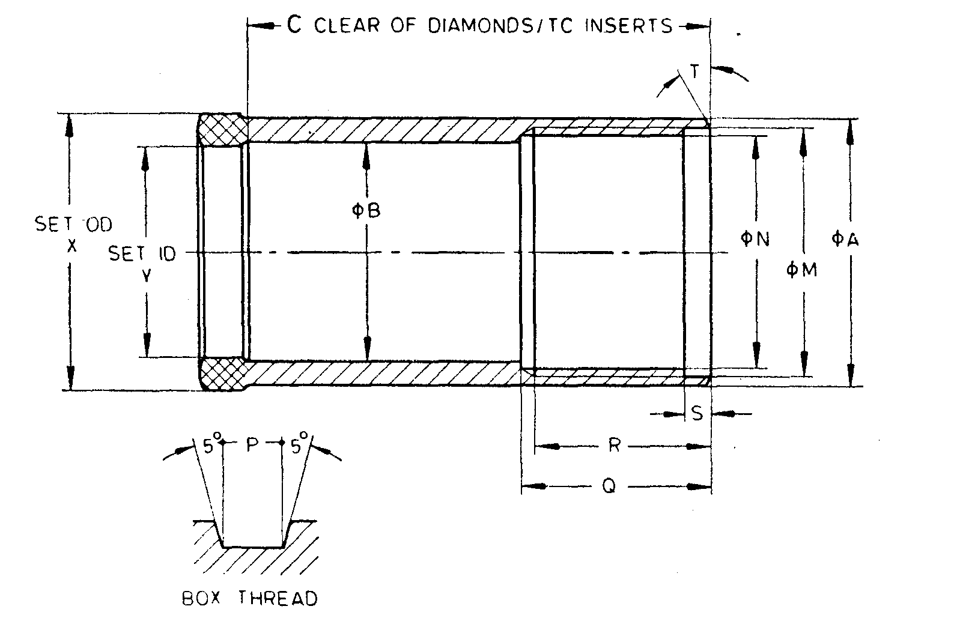

Fig. 16 'X' Design Flush Coupled Casings — Casing Bit

All dimensions are in millimetres.

|  |  |  |  |  |  |  |  |  |  |  |  |  |
| --- | --- | --- | --- | --- | --- | --- | --- | --- | --- | --- | --- | --- |
| *SL No.* | *Dimension* | | *RX* | *EX* | *AX* | *BX* | *NX* | *HX* | *PX* | *SX* | *UX* | *ZX* |
| (1) | (2) | | (3) | (4) | (5) | (6) | (7) | (8) | (9) | (10) | (11) | (12) |
|  | *A* | *Max* | 36.98 | 46.53 | 58.34 | 73.96 | 90.47 | 115.93 | 141.33 | 169.90 | 195.30 | 220.70 |
| *Min* | 36.88 | 46.43 | 58.24 | 73.86 | 30.37 | 115.82 | 141.17 | 169.75 | 195.07 | 220.47 |
|  | *B* | *Max* | 26.54 | 37.21 | 46.74 | 57.86 | 73.74 | 98.35 | 120.65 | 146.05 | 175.13 | 200.53 |
| *Min* | 26.04 | 36.45 | 45.97 | 57.10 | 72.97 | 97.33 | 119.38 | 144.78 | 173.61 | 199.01 |
|  | *C* | *Min* | 63.50 | 88.90 | 95.25 | 104.78 | 111.13 | 114.30 | 133.35 | 146.05 | 152.40 | 158.75 |
|  | *M* | *Max* | 34.32 | 43.71 | 54.05 | 68.33 | 84.20 | 108.48 | 133.65 | 162.03 | 187.76 | 212.75 |
| *Min* | 34.26 | 43.66 | 54.00 | 68.28 | 84.15 | 108.38 | 133.53 | 161.85 | 187.58 | 212.57 |
|  | *N* | *Max* | 32.79 | 42.14 | 52.45 | 65.94 | 81.81 | 106.05 | 131.24 | 159.56 | 184.81 | 209.80 |
| *Min* | 32.74 | 42.09 | 52.40 | 65.89 | 81.76 | 105.97 | 131.14 | 159.46 | 184.68 | 209.68 |
|  | Thread pitch | | 3.175 | 3.175 | 3.175 | 3.175 | 3.175 | 5.080 | 5.050 | 5.350 | 3.350 | 6.350 |
|  | *P* | *Max* | 1.63 | 1.63 | 1.63 | 1.60 | 1.60 | 2.59 | 2.57 | 2.57 | 3.18 | 3.18 |
| *Min* | 1.55 | 1.55 | 1.55 | 1.52 | 1.52 | 2.51 | 2.46 | 2.46 | 3.07 | 3.07 |
|  | *Q* | *Max* | 25.90 | 51.30 | 57.65 | 60.83 | 67.18 | 64.00 | 70.35 | 76.70 | 83.05 | 89.40 |
| *Min* | 25.40 | 50.80 | 57.15 | 60.33 | 66.68 | 63.50 | 69.85 | 76.20 | 82.55 | 88.90 |
|  | *R* | *Max* | 24.30 | 48.13 | 54.48 | 57.65 | 64.00 | 57.65 | 67.18 | 73.53 | 79.88 | 86.23 |
| *Min* | 23.80 | 47.63 | 53.98 | 57.15 | 63.50 | 57.15 | 66.68 | 73.03 | 79.38 | 85.73 |
|  | *S* | *Max* | 3.43 | 6.60 | 6.60 | 6.60 | 6.60 | 8.13 | 9.78 | 9.78 | 9.78 | 9.78 |
| *Min* | 2.92 | 6.10 | 6.10 | 6.10 | 6.10 | 7.62 | 9.27 | 9.27 | 9.27 | 9.27 |
|  | *T* | *—* | 0o | 30o | 30o | 30o | 30o | 30o | 15o | 15o | 15o | 15o |
|  | *X* | *Max* | 37.85 | 47.75 | 59.69 | 75.44 | 91.95 | 117.65 | 143.76 | 172.72 | 198.50 | 224.16 |
| *Min* | 37.59 | 47.50 | 59.44 | 75.18 | 91.69 | 117.27 | 143.26 | 172.21 | 197.74 | 223.39 |
|  | *Y* | *Max* | 25.53 | 35.81 | 45.34 | 56.39 | 72.26 | 96.06 | 117.86 | 143.26 | 171.83 | 197.23 |
| *Min* | 25.27 | 35.56 | 45.09 | 56.13 | 72.01 | 95.81 | 117.48 | 142.88 | 171.32 | 196.72 |

**15.2.4** *'X' Design Flush Coupled Casings — Reaming Shell* (*see* Fig. 17)

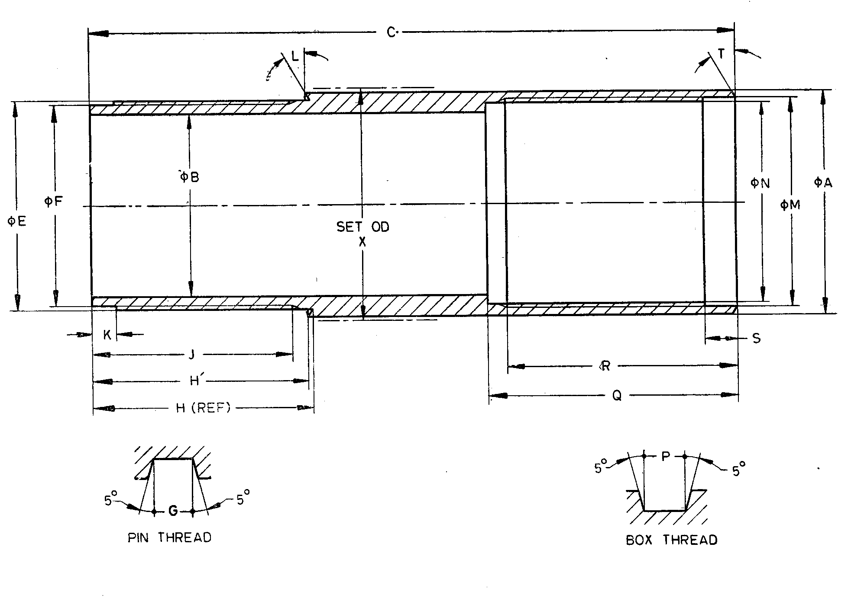

Fig. 17 'X' Design Flush Coupled Casings — Reaming Shell

All dimensions are in millimetres.

|  |  |  |  |  |  |  |
| --- | --- | --- | --- | --- | --- | --- |
| *Sl No.* | *Dimension* | | *EX* | *AX* | *BX* | *NX* |
| (1) | (2) | | (3) | (4) | (5) | (6) |
|  | *A* | *Max* | 46.53 | 58.34 | 73.96 | 90.47 |
| *Min* | 46.43 | 58.24 | 73.86 | 90.37 |
|  | *B* | *Max* | 38.35 | 48.67 | 60.58 | 76.58 |
| *Min* | 38.10 | 48.41 | 60.33 | 76.20 |
|  | *C* | *Min* | 133.35 | 146.05 | 158.75 | 171.45 |
|  | *E* | *Max* | 43.61 | 53.95 | 68.22 | 84.10 |
| *Min* | 43.56 | 53.90 | 68.17 | 84.05 |
|  | *F* | *Max* | 42.04 | 52.35 | 65.84 | 81.71 |
| *Min* | 41.91 | 52.22 | 65.71 | 81.58 |
|  | Thread pitch | | 3.175 | 3.175 | 3.175 | 3.175 |
|  | *G* | *Max* | 1.63 | 1.63 | 1.60 | 1.60 |
| *Min* | 1.55 | 1.55 | 1.52 | 1.52 |
|  | *H* | *Max* | 45.47 | 52.07 | 55.75 | 61.98 |
| *Min* | 44.96 | 51.56 | 55.24 | 61.47 |
|  | *H’* | *Max* | 44.63 | 50.81 | 54.10 | 60.15 |
| *Min* | 44.12 | 50.30 | 53.59 | 59.64 |
|  | *J* | *Min* | 41.28 | 47.63 | 50.80 | 57.15 |
|  | *K* | *Max* | 5.03 | 5.03 | 5.03 | 5.03 |
| *Min* | 4.52 | 4.52 | 4.52 | 4.52 |
|  | *L* | *—* | 30o | 30o | 30o | 30o |
|  | *M* | *Max* | 43.71 | 54.05 | 68.33 | 84.20 |
| *Min* | 43.66 | 54.00 | 68.28 | 84.15 |
|  | *N* | *Max* | 42.14 | 52.45 | 65.94 | 81.81 |
| *Min* | 42.09 | 52.40 | 65.89 | 81.76 |
|  | Thread pitch | | 3.175 | 3.175 | 3.175 | 3.175 |
|  | *P* | *Max* | 1.63 | 1.63 | 1.60 | 1.60 |
| *Min* | 1.55 | 1.55 | 1.52 | 1.52 |
|  | *Q* | *Max* | 51.56 | 57.91 | 61.09 | 67.44 |
| *Min* | 5.80 | 57.15 | 60.33 | 66.68 |
|  | *R* | *Max* | 48.13 | 54.48 | 57.65 | 64.00 |
| *Min* | 47.63 | 53.98 | 57.15 | 63.50 |
|  | *S* | *Max* | 6.60 | 6.60 | 6.60 | 6.60 |
| *Min* | 6.10 | 6.10 | 6.10 | 6.10 |
|  | *T* | *—* | 30o | 30o | 30o | 30o |
|  | *X* | *Max* | 48.13 | 60.07 | 75.82 | 92.33 |
| *Min* | 47.88 | 59.82 | 75.57 | 92.08 |

**15.2.5** *'X' Design Flush Coupled Casings* — *Casing Coupling* (*see* Fig. 18)

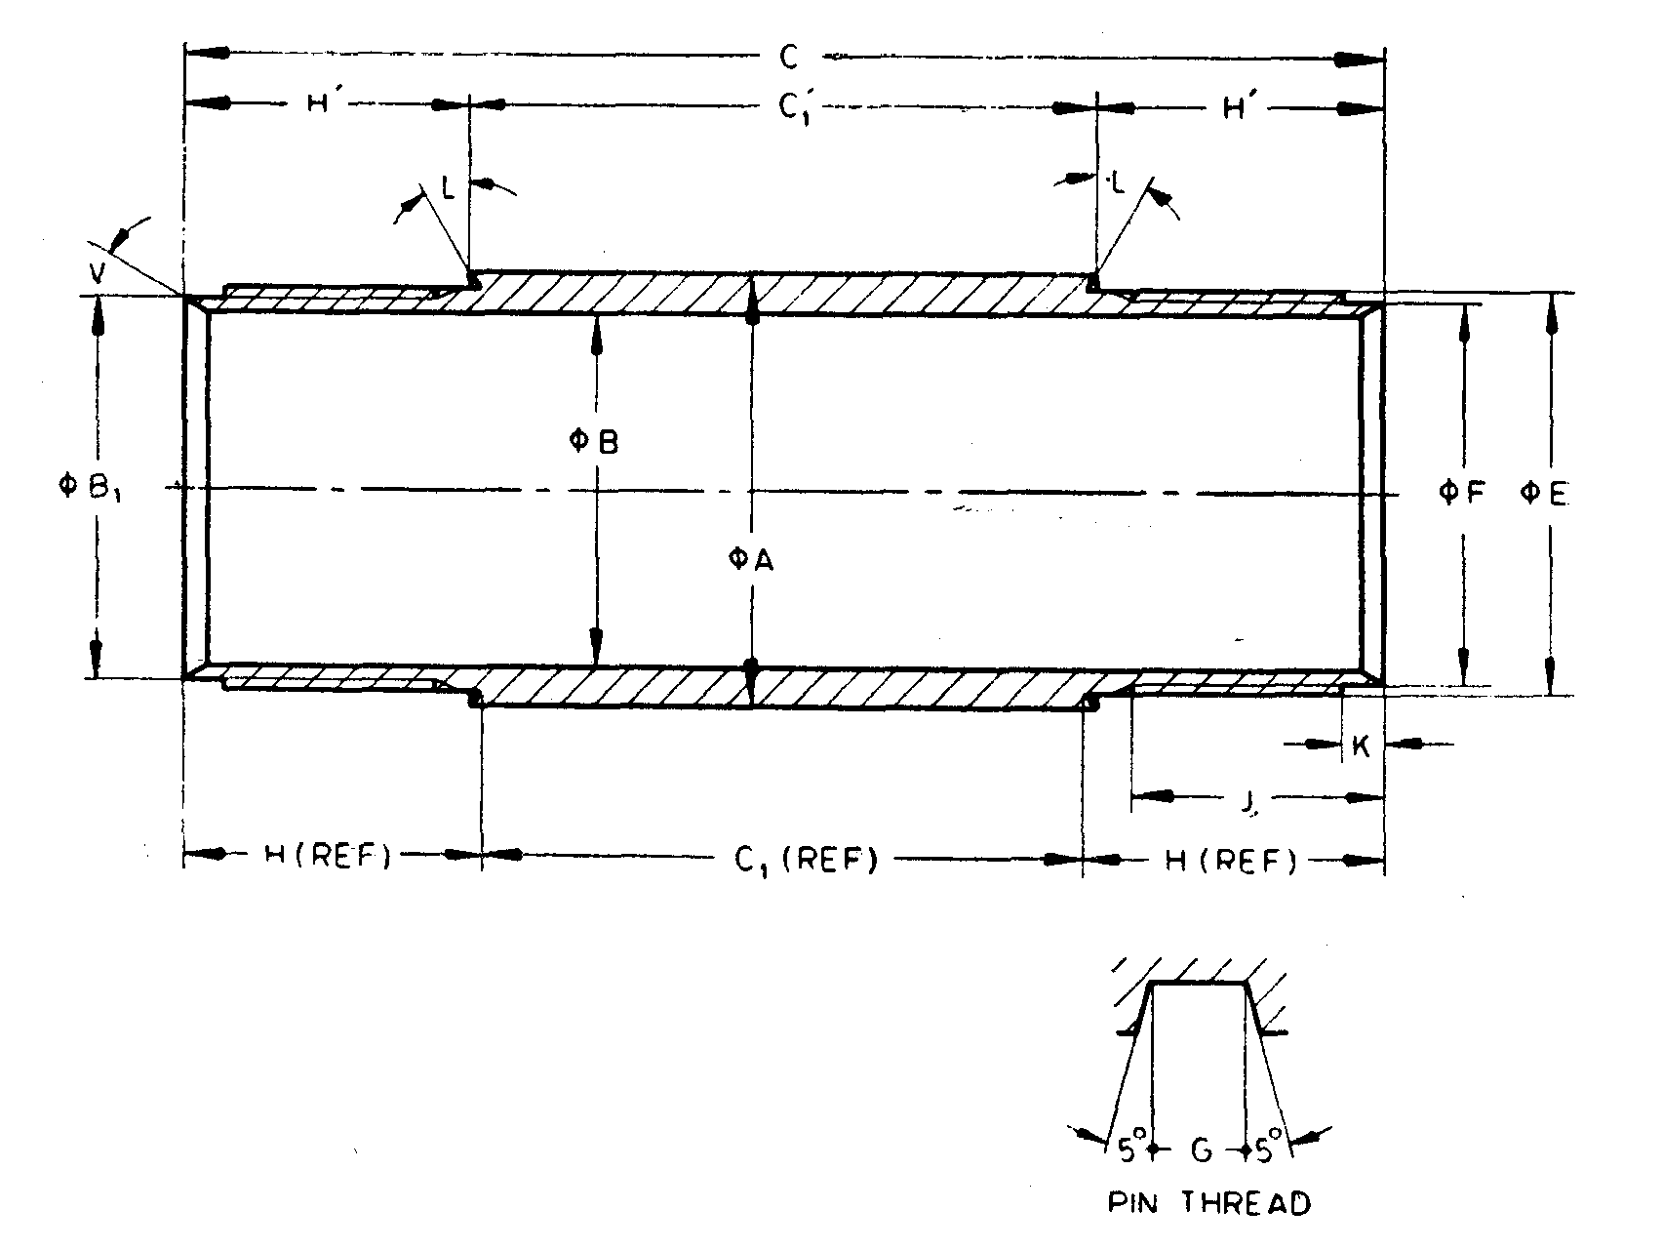

NOTE— Dimensions shown apply to both ends.

Fig. 18 'X' Design Flush Coupled Casings — Casing Coupling

All dimensions are in millimetres.

|  |  |  |  |  |  |  |  |  |  |  |  |  |
| --- | --- | --- | --- | --- | --- | --- | --- | --- | --- | --- | --- | --- |
| *Sl No.* | *Dimension* | | *RX* | *EX* | *AX* | *BX* | *NX* | *HX* | *PX* | *SX* | *UX* | *ZX* |
| (1) | (2) | | (3) | (4) | (5) | (6) | (7) | (8) | (9) | (10) | (11) | (12) |
|  | *A* | *Max* | 36.63 | 46.28 | 57.40 | 73.28 | 89.28 | 114.68 | 140.74 | 169.55 | 195.12 | 220.73 |
| *Min* | 36.50 | 46.02 | 57.15 | 73.03 | 88.90 | 114.30 | 138.66 | 167.01 | 192.23 | 217.42 |
|  | *B* | *Max* | 30.48 | 38.35 | 48.67 | 60.58 | 76.58 | 100.38 | 127.38 | 152.45 | 179.20 | 205.94 |
| *Min* | 30.23 | 38.10 | 48.41 | 60.33 | 76.20 | 100.00 | 122.30 | 147.70 | 176.20 | 201.60 |
|  | *B*1 | *Max* | 30.48 | 40.39 | 50.67 | 64.14 | 80.01 | 104.27 | 129.41 | 157.73 | 182.88 | 207.90 |
| *Min* | 30.23 | 39.75 | 50.04 | 63.50 | 79.38 | 103.63 | 128.78 | 157.10 | 182.25 | 207.26 |
|  | *C* | *—* | 101.60 | 127.00 | 177.80 | 196.85 | 209.55 | 215.90 | 228.60 | 254.00 | 279.40 | 304.80 |
|  | *C*1 | *Max* | 54.25 | 36.83 | 74.47 | 86.21 | 86.21 | 98.30 | 100.08 | 112.83 | 125.48 | 138.53 |
| *Min* | 53.75 | 36.32 | 73.96 | 85.70 | 85.70 | 97.79 | 99.57 | 112.32 | 124.97 | 138.02 |
|  | *C*1’ | *Max* | 54.25 | 38.31 | 76.40 | 89.07 | 88.10 | 101.89 | 101.76 | 114.60 | 127.77 | 140.33 |
| *Min* | 53.75 | 37.80 | 75.90 | 88.56 | 88.59 | 101.38 | 101.25 | 114.09 | 126.66 | 139.82 |
|  | *E* | *Max* | 34.21 | 43.61 | 53.95 | 68.22 | 84.10 | 108.31 | 133.45 | 161.75 | 187.45 | 212.45 |
| *Min* | 34.16 | 43.56 | 53.90 | 68.17 | 84.05 | 108.23 | 133.38 | 161.62 | 187.33 | 212.32 |
|  | *F* | *Max* | 32.69 | 42.04 | 52.35 | 65.84 | 81.71 | 105.89 | 131.06 | 159.36 | 184.56 | 209.55 |
| *Min* | 32.56 | 41.91 | 52.22 | 65.71 | 81.58 | 105.77 | 130.96 | 159.26 | 184.43 | 209.42 |
|  | *Thread pitch* | | 3.175 | 3.175 | 3.175 | 3.175 | 3.175 | 5.050 | 5.080 | 5.080 | 6.350 | 6.350 |
|  | *G* | *Max* | 1.63 | 1.63 | 1.63 | 1.60 | 1.60 | 2.59 | 2.57 | 2.57 | 3.18 | 3.18 |
| *Min* | 1.55 | 1.55 | 1.55 | 1.52 | 1.52 | 2.51 | 2.46 | 2.46 | 3.07 | 3.07 |
|  | *H* | *Max* | 24.05 | 45.47 | 52.07 | 55.75 | 61.98 | 59.18 | 64.64 | 70.97 | 77.32 | 83.52 |
| *Min* | 23.55 | 44.96 | 51.56 | 55.25 | 61.47 | 58.67 | 64.14 | 70.46 | 76.81 | 83.01 |
|  | *H’* | *Max* | 24.05 | 44.73 | 51.10 | 54.32 | 60.53 | 57.38 | 63.80 | 70.09 | 76.48 | 82.62 |
| *Min* | 23.55 | 44.22 | 50.69 | 53.82 | 60.02 | 56.87 | 63.30 | 69.58 | 75.97 | 82.11 |
|  | *J* | *Min* | 22.22 | 41.28 | 47.62 | 50.80 | 57.15 | 53.98 | 60.33 | 66.68 | 73.03 | 79.38 |
|  | *K* | *Max* | 3.43 | 5.03 | 5.03 | 503 | 5.03 | 5.03 | 5.03 | 5.03 | 5.03 | 5.03 |
| *Min* | 2.92 | 4.52 | 4.52 | 4.52 | 4.52 | 4.52 | 4.52 | 4.52 | 4.52 | 4.52 |
|  | *L* | *—* | 0o | 30o | 30o | 30o | 30o | 30o | 15o | 15o | 15o | 15o |
|  | *V* | *—* | 0 | 30 | 30 | 30 | 30 | 30 | 30 | 30 | 30 | 30 |

**SECTION 3 CORE BARRELS —'WF' DESIGN**

**16 'WF' DESIGN DOUBLE TUBE CORE BARREL** (**FOR BWF AND NWF**)

**16.1 Nomenclature**

Atypical assembly of double tube core barrel of BWF and NWF sizes is shown in Fig. 19 indicating the dimensions for checking:

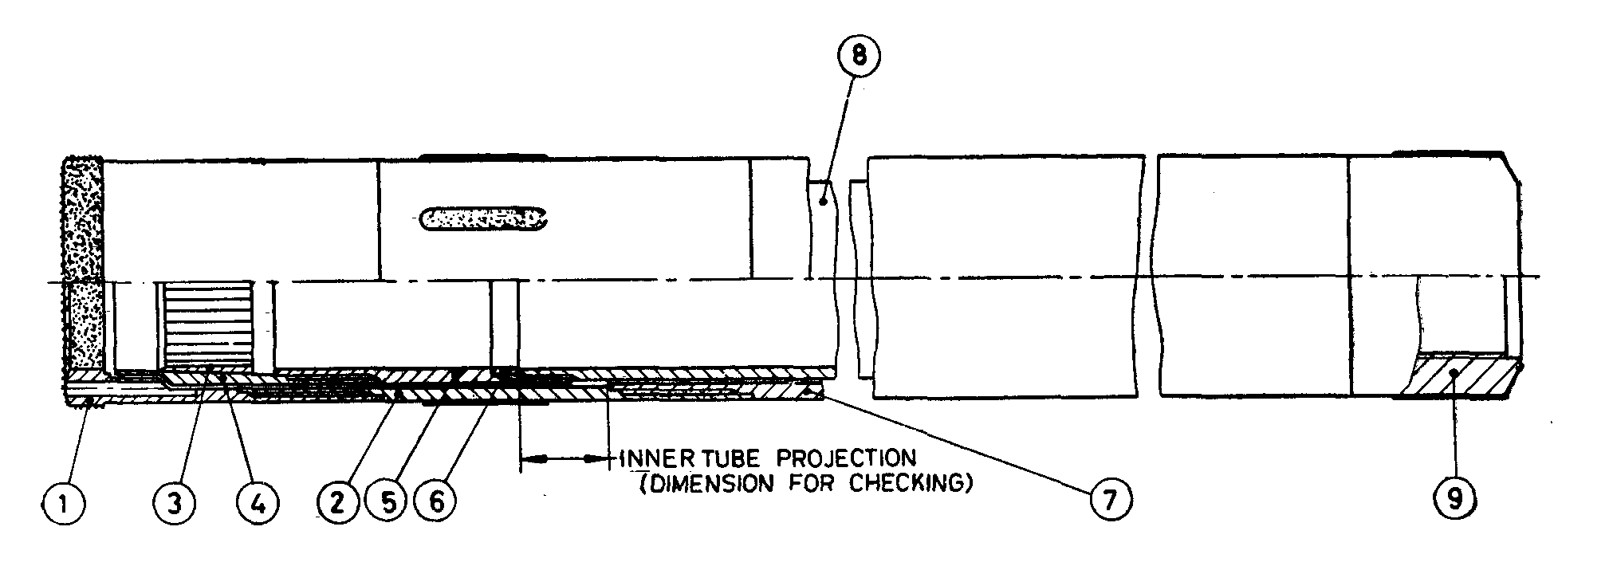

|  |  |
| --- | --- |
| *Key* | |
| 1 | Core bit |
| 2 | Reaming shell |
| 3 | Core lifter |
| 4 | Core lifter case |
| 5 | Inner tube extension |
| 6 | Inner tube extension spacer |
| 7 | Outer tube |
| 8 | Inner tube |
| 9 | Head |

Fig. 19 ATypical Assembly of Double Tube Core Barrel of bwf and nwf

All dimensions are in millimetres

|  |  |  |  |
| --- | --- | --- | --- |
| *Sl No.* | *Dimensions for Checking* | *BWF* | *NWF* |
| (1) | (2) | (3) | (4) |
|  | *Max* | 21.36 | 21.36 |
|  | *Min* | 19.13 | 19.13 |

**16.1.1** WF design core barrel shall have lengths of 1 500 mm and 3 000 mm (lengths refer to minimum core capacity).

**16.2 Detailed Dimensions**

**16.2.1** *'WF' Design Double Tube Core Barrel — Core Bit* (*see* Fig. 20)

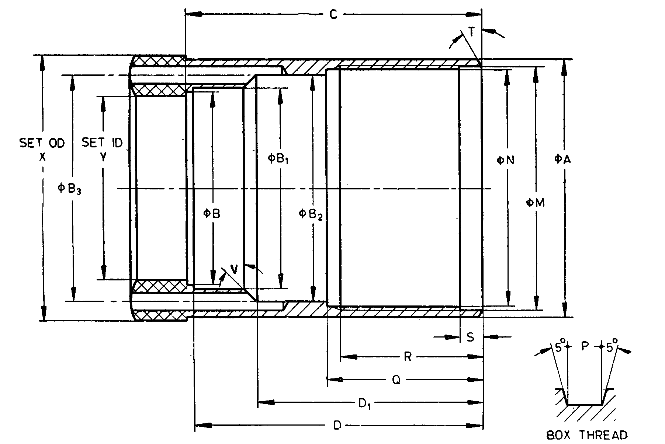

Fig. 20 'WF' Design Double Tube Core Barrel — Core Bit

All dimensions are in millimetres

|  |  |  |  |  |
| --- | --- | --- | --- | --- |
| *Sl No.* | *Dimension* | | *BWF* | *NWF* |
| (1) | (2) | | (3) | (4) |
|  | *A* | *Max* | 58.60 | 74.27 |
| *Min* | 58.50 | 74.17 |
|  | *B* | *Max* | 44.07 | 56.77 |
| *Min* | 43.69 | 56.39 |
|  | *B*1 | *Max* | 45.97 | 59.31 |
| *Min* | 45.85 | 59.18 |
|  | *B*2 | *Max* | 51.56 | 67.56 |
| *Min* | 51.44 | 67.44 |
|  | *B*3 | *Max* | 51.56 | 65.79 |
| *Min* | 51.41 | 65.53 |
|  | Hole Diameter | | 3.96 | 4.75 |
|  | *C* | *Max* | 67.06 | 76.58 |
| *Min* | 66.29 | 75.82 |
|  | *D* | *Max* | 65.53 | 75.06 |
| *Min* | 64.77 | 74.30 |
|  | *D*1 | *Max* | 51.18 | 59.44 |
| *Min* | 50.80 | 59.06 |
|  | *M* | *Max* | 55.55 | 71.43 |
| *Min* | 55.47 | 71.35 |
|  | *N* | *Max* | 54.25 | 70.13 |
| *Min* | 54.20 | 70.08 |
|  | Thread pitch | | 3.175 | 3.175 |
|  | *P* | *Max* | 1.63 | 1.63 |
| *Min* | 1.55 | 1.55 |
|  | *Q* | *Max* | 35.05 | 38.23 |
| *Min* | 34.92 | 38.10 |
|  | *R* | *Max* | 32.25 | 35.42 |
| *Min* | 31.75 | 34.92 |
|  | *S* | *Max* | 5.00 | 5.00 |
| *Min* | 4.50 | 4.50 |
|  | *T* | — | 15o | 15o |
|  | *V* | — | 45o | 45o |
|  | *X* | *Max* | 59.69 | 75.44 |
| *Min* | 59.44 | 75.18 |
|  | *Y* | *Max* | 42.16 | 54.86 |
| *Min* | 41.91 | 54.61 |

**16.2.2** *'WF' Design Double Tube Core Barrel* — *Reaming Shell* (*see* Fig. 21)

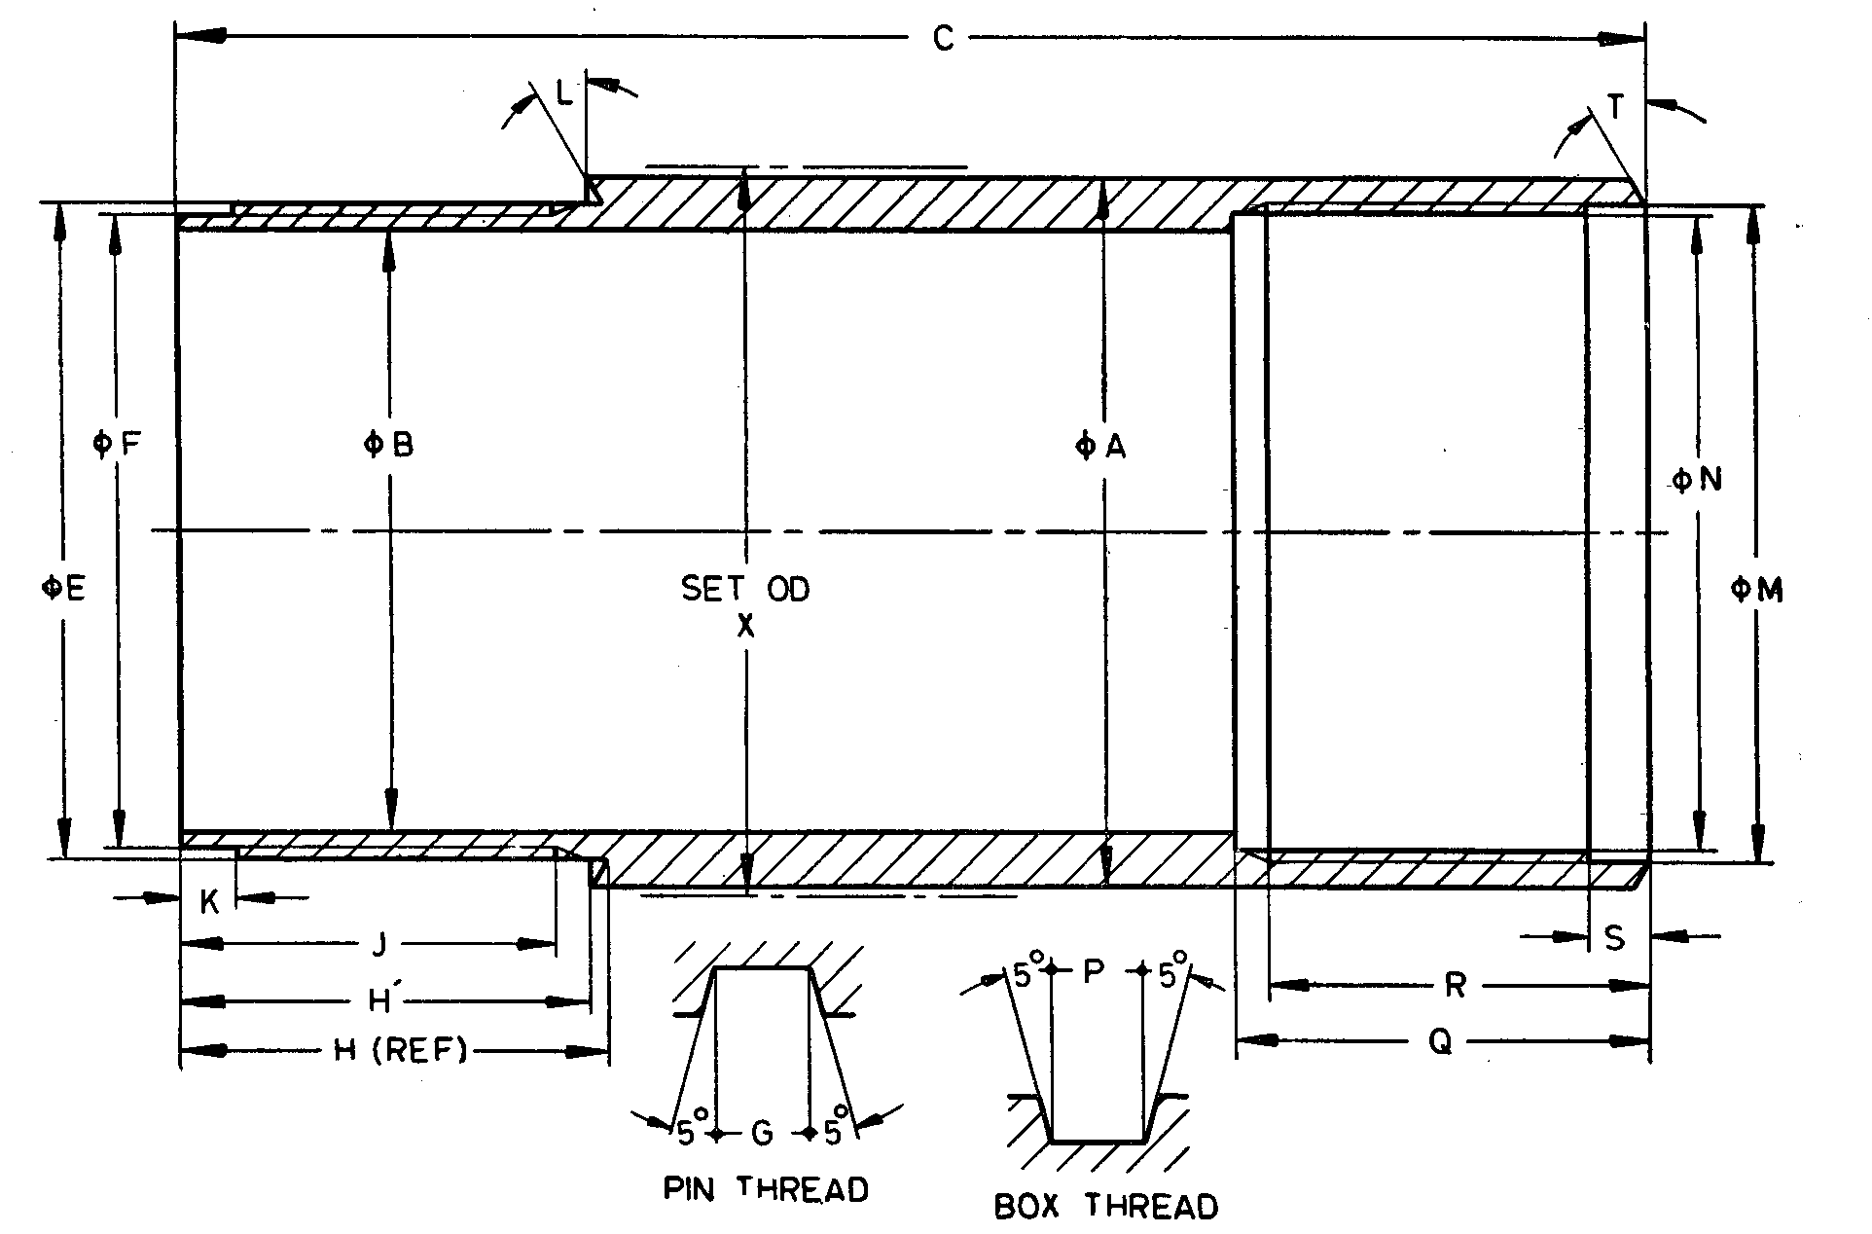

Fig. 21 'WF' Design Double Tube Core Barrel — Reaming Shell

All dimensions are in millimetres

|  |  |  |  |  |
| --- | --- | --- | --- | --- |
| *Sl No.* | *Dimension* | | *BWF* | *NWF* |
| (1) | (2) | | (3) | (4) |
|  | *A* | *Max* | 58.93 | 74.55 |
| *Min* | 58.83 | 74.45 |
|  | *B* | *Max* | 51.23 | 67.06 |
| *Min* | 51.10 | 66.93 |
|  | *C* | *Max* | 123.95 | 140.08 |
| *Min* | 123.19 | 139.32 |
|  | *E* | *Max* | 55.42 | 71.30 |
| *Min* | 55.37 | 71.25 |
|  | *F* | *Max* | 54.15 | 70.03 |
| *Min* | 54.08 | 69.95 |
|  | Hole Diameter | | 3.175 | 3.175 |
|  | *G* | *Max* | 1.63 | 1.63 |
| *Min* | 1.55 | 1.55 |
|  | *H* | *Max* | 34.92 | 38.10 |
| *Min* | 34.80 | 37.97 |
|  | *H’* | *Max* | 34.45 | 37.67 |
| *Min* | 34.33 | 37.54 |
|  | *J* | *Min* | 31.75 | 34.92 |
|  | *K* | *Max* | 5.00 | 5.00 |
| *Min* | 4.00 | 4.50 |
|  | *L* | — | 15o | 15o |
|  | *M* | *Max* | 55.85 | 71.73 |
| *Min* | 55.78 | 71.65 |
|  | *N* | *Max* | 54.25 | 70.13 |
| *Min* | 54.20 | 70.08 |
|  | Thread pitch | | 3.175 | 3.175 |
|  | *P* | *Max* | 1.63 | 1.63 |
| *Min* | 1.55 | 1.55 |
|  | *Q* | *Max* | 35.05 | 38.23 |
| *Min* | 34.92 | 38.10 |
|  | *R* | *Max* | 32.25 | 35.42 |
| *Min* | 31.75 | 34.92 |
|  | *S* | *Max* | 5.00 | 5.00 |
| *Min* | 4.50 | 4.50 |
|  | *T* | *—* | 15o | 15o |
|  | *X* | *Max* | 60.07 | 75.82 |
| *Min* | 59.82 | 75.56 |

**16.2.3** *'WF' Design Double Tube Core Barrel* — *Core Lifter* (*see* Fig. 22)

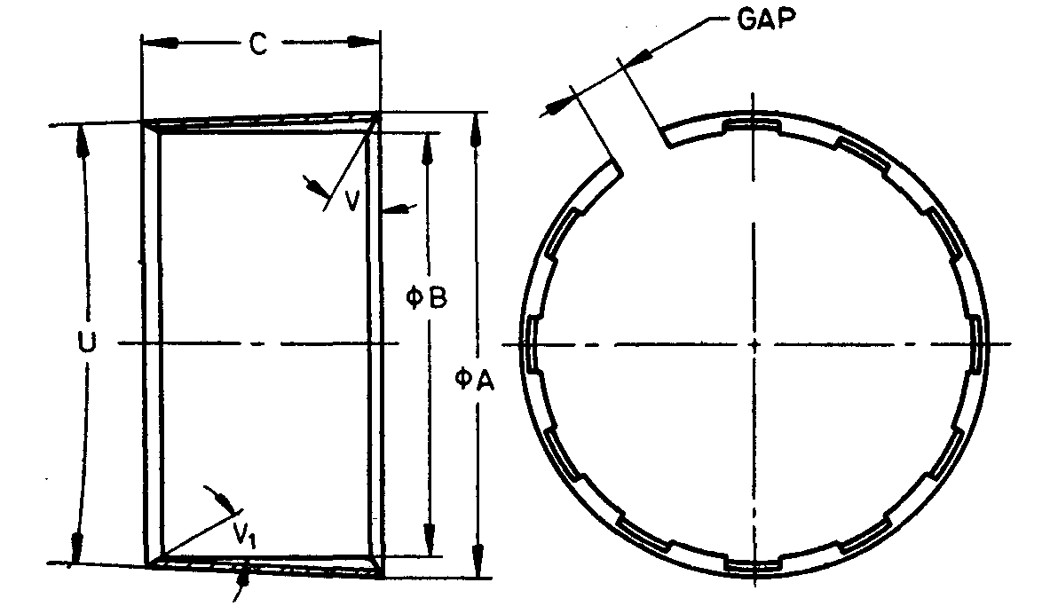

NOTES

**1** Width of gap, entry angle and number of flutes are at the discretion of manufacturer.  
**2** Core barrels with external flutes, if required by purchaser, shall conform to dimensions specified in this clause.

Fig. 22 'WF' Design Double Tube Core Barrel — Core Lifter

All dimensions are in millimetres.

|  |  |  |  |  |
| --- | --- | --- | --- | --- |
| *Sl No.* | *Dimension* | | *BWF\** | *NWF\** |
| (1) | (2) | | (3) | (4) |
|  | *A* | *Max* | 45.03 | 60.91 |
| *Min* | 44.93 | 60.81 |
|  | *B* | *Max* | 41.53 | 54.23 |
| *Min* | 41.43 | 54.13 |
|  | *C* | *Max* | 22.61 | 35.31 |
| *Min* | 21.84 | 34.54 |
|  | *U* | *Max* | 5o 15’ | 5o 15’ |
| *Min* | 4o 45’ | 4o 45’ |
|  | *V* | *—* | 0o | 0o |
|  | *V*1 | *—* | Optional | |
| *These items are interchangeable with 'WW design core barrels. | | | | |

**16.2.4** *'WF' Design Double Tube Core Barrel* — *Inner Tube Extension Spacer* (*see* Fig. 23)

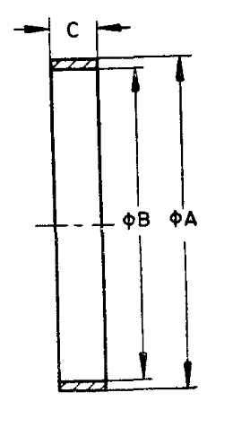

Fig. 23 'WF' Design Double Tube Core Barrel — Inner Tube Extension Spacer

All dimensions are in millimetres

|  |  |  |  |  |
| --- | --- | --- | --- | --- |
| *Sl No.* | *Dimension* | | *BWF* | *NWF* |
| (1) | (2) | | (3) | (4) |
|  | *A* | *Max* | 46.05 | 61.93 |
| *Min* | 45.97 | 61.85 |
|  | *B* | *Max* | 43.43 | 56.26 |
| *Min* | 43.31 | 56.01 |
|  | *C* | *Max* | 6.48 | 6.48 |
| *Min* | 6.22 | 6.22 |

**16.2.5** *'WF' Design Double Tube Core Barrel* — *Core Lifter Case* (*see* Fig. 24)

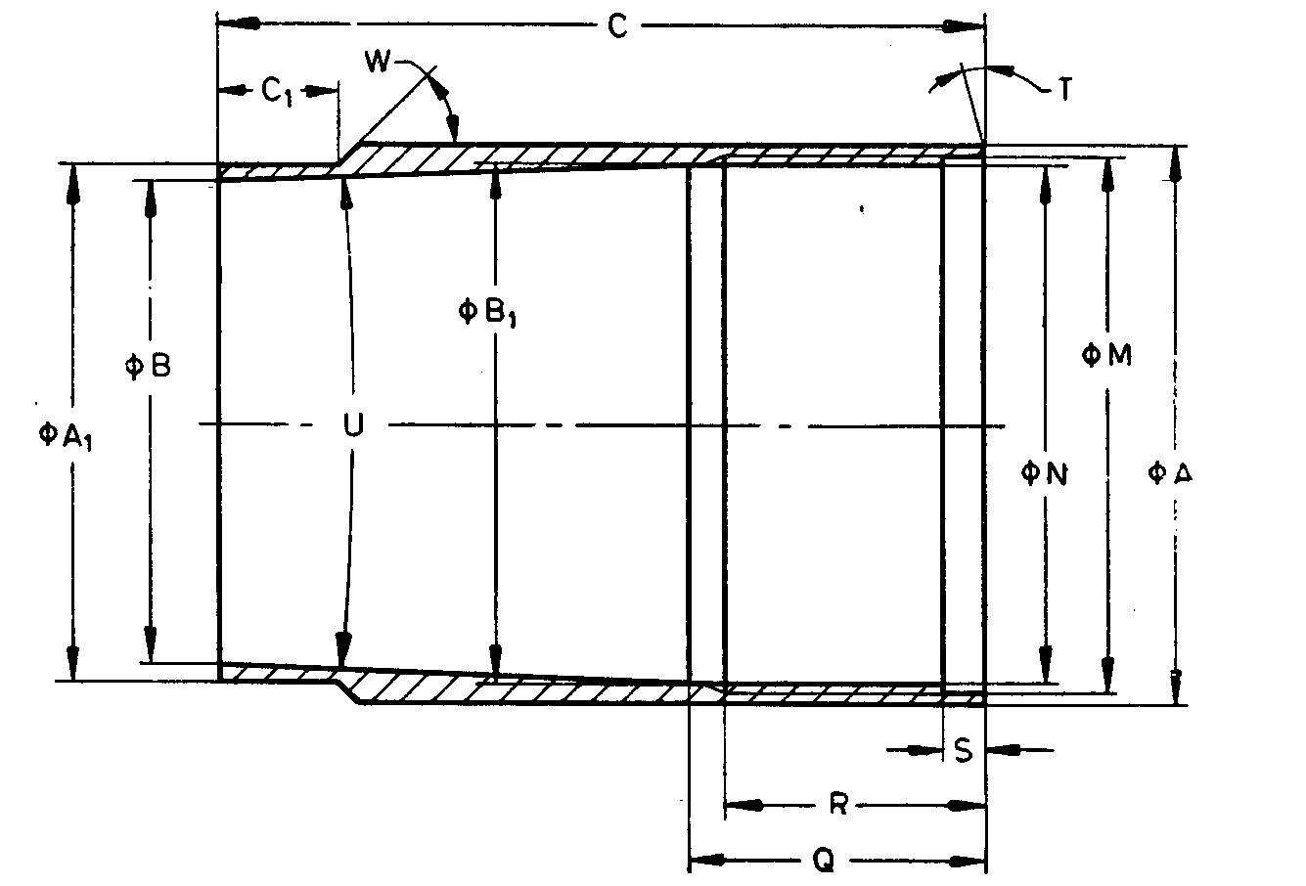

Fig. 24 'WF' Design Double Tube Core Barrel — Core Lifter Case

All dimensions are in millimetres

|  |  |  |  |  |
| --- | --- | --- | --- | --- |
| *Sl No.* | *Dimension* | | *BWF* | *NWF* |
| (1) | (2) | | (3) | (4) |
|  | *A* | *Max* | 49.53 | 65.35 |
| *Min* | 49.45 | 65.28 |
|  | *A*1 | *Max* | 45.72 | 59.06 |
| *Min* | 45.59 | 58.93 |
|  | *B* | *Max* | 43.18 | 50.80 |
|  | *C* | *Max* | 66.93 | 82.80 |
| *Min* | 66.42 | 82.30 |
|  | *C*1 | *Max* | 10.82 | 10.82 |
| *Min* | 10.57 | 10.57 |
|  | *M* | *Max* | 47.42 | 63.35 |
| *Min* | 47.35 | 63.27 |
|  | *N* | *Max* | 46.13 | 62.00 |
| *Min* | 46.08 | 61.95 |
|  | Thread pitch | | 3.175 | 3.175 |
|  | *P* | *Max* | 1.65 | 1.65 |
| *Min* | 1.57 | 1.57 |
|  | *Q* | *Max* | 25.78 | 28.70 |
| *Min* | 25.02 | 28.19 |
|  | *R* | *Max* | 22.72 | 25.90 |
| *Min* | 22.22 | 25.40 |
|  | *S* | *Max* | 3.43 | 3.43 |
| *Min* | 2.92 | 2.92 |
|  | *T* |  | 0° | 0° |
|  | *U* | *Max* | 5°15' | 5°15' |
| *Min* | 5°0' | 5°0' |
|  | *W* |  | 45° | 45° |
|  | *B*1 | *Max* | 46.13 | 62.00 |
| *Min* | 46.05 | 61.93 |

**16.2.6** '*WF*' *Design Double Tube Core Barrel — Inner Tube Extension* (*see* Fig. 25)

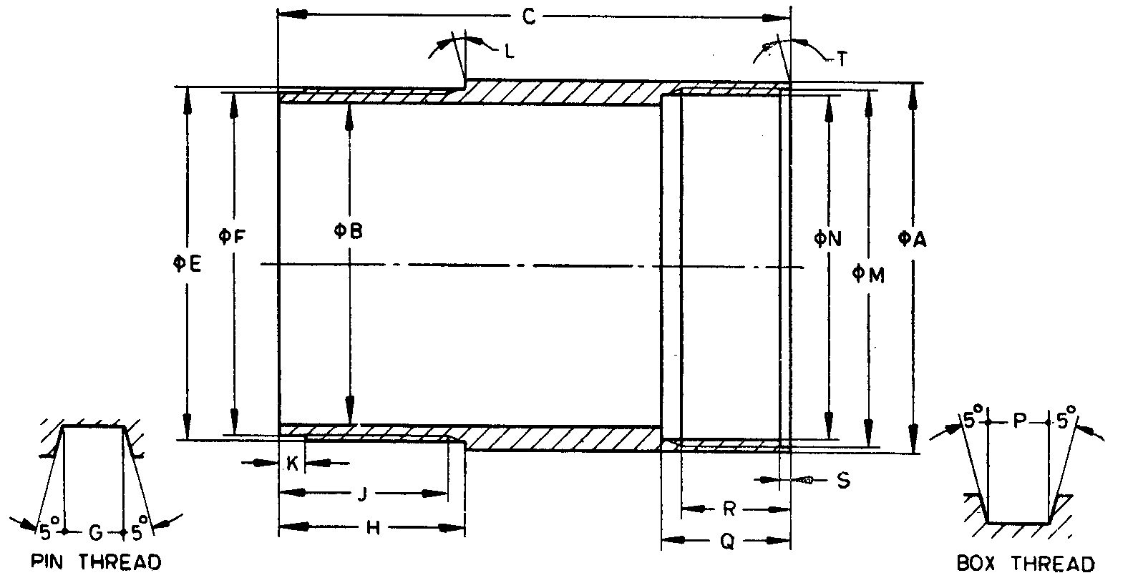

Fig. 25 ‘WF' Design Double Tube Core Barrel — Inner Tube Extension

All dimensions are in millimetres

|  |  |  |  |  |
| --- | --- | --- | --- | --- |
| *Sl No.* | *Dimension* | | *BWF* | *NWF* |
| (1) | (2) | (3) | (4) | (5) |
|  | *A* | *Max* | 49.53 | 65.35 |
| *Min* | 49.45 | 65.28 |
|  | *B* | *Max* | 43.31 | 56.01 |
| *Min* | 43.18 | 55.88 |
|  | *C* | *Max* | 68.83 | 78.36 |
| *Min* | 68.20 | 77.72 |
|  | *E* | *Max* | 47.29 | 63.22 |
| *Min* | 47.24 | 63.17 |
|  | *F* | *Max* | 46.02 | 61.90 |
| *Min* | 45.95 | 61.82 |
|  | Thread pitch | | 3.175 | 3.175 |
|  | *G* | *Max* | 1.65 | 1.65 |
| *Min* | 1.57 | 1.57 |
|  | *H* | *Max* | 25.02 | 28.19 |
| *Min* | 24.76 | 27.94 |
|  | *J* | *Min* | 22.86 | 26.04 |
|  | *K* | *Max* | 3.56 | 3.56 |
| *Min* | 3.18 | 3.18 |
|  | *L* | *—* | 5° | 0° |
|  | *M* | *Max* | 47.73 | 63.60 |
| *Min* | 47.65 | 63.53 |
|  | *N* | *Max* | 46.10 | 61.98 |
| *Min* | 46.05 | 61.93 |
|  | Thread pitch | | 3.175 | 3.175 |
|  | *P* | *Max* | 1.63 | 1.63 |
| *Min* | 1.55 | 1.55 |
|  | *Q* | *Max* | 17.32 | 22.10 |
| *Min* | 17.07 | 21.84 |
|  | *R* | *Max* | 14.47 | 16.75 |
| *Min* | 13.97 | 16.26 |
|  | *S* | *Max* | 1.70 | 1.70 |
| *Min* | 1.45 | 1.45 |
|  | *T* | *—* | 0° | 0° |

**16.2.7** '*WF*' *Design Double Tube Core Barrel* — *Outer Tube* (*see* Fig. 26)

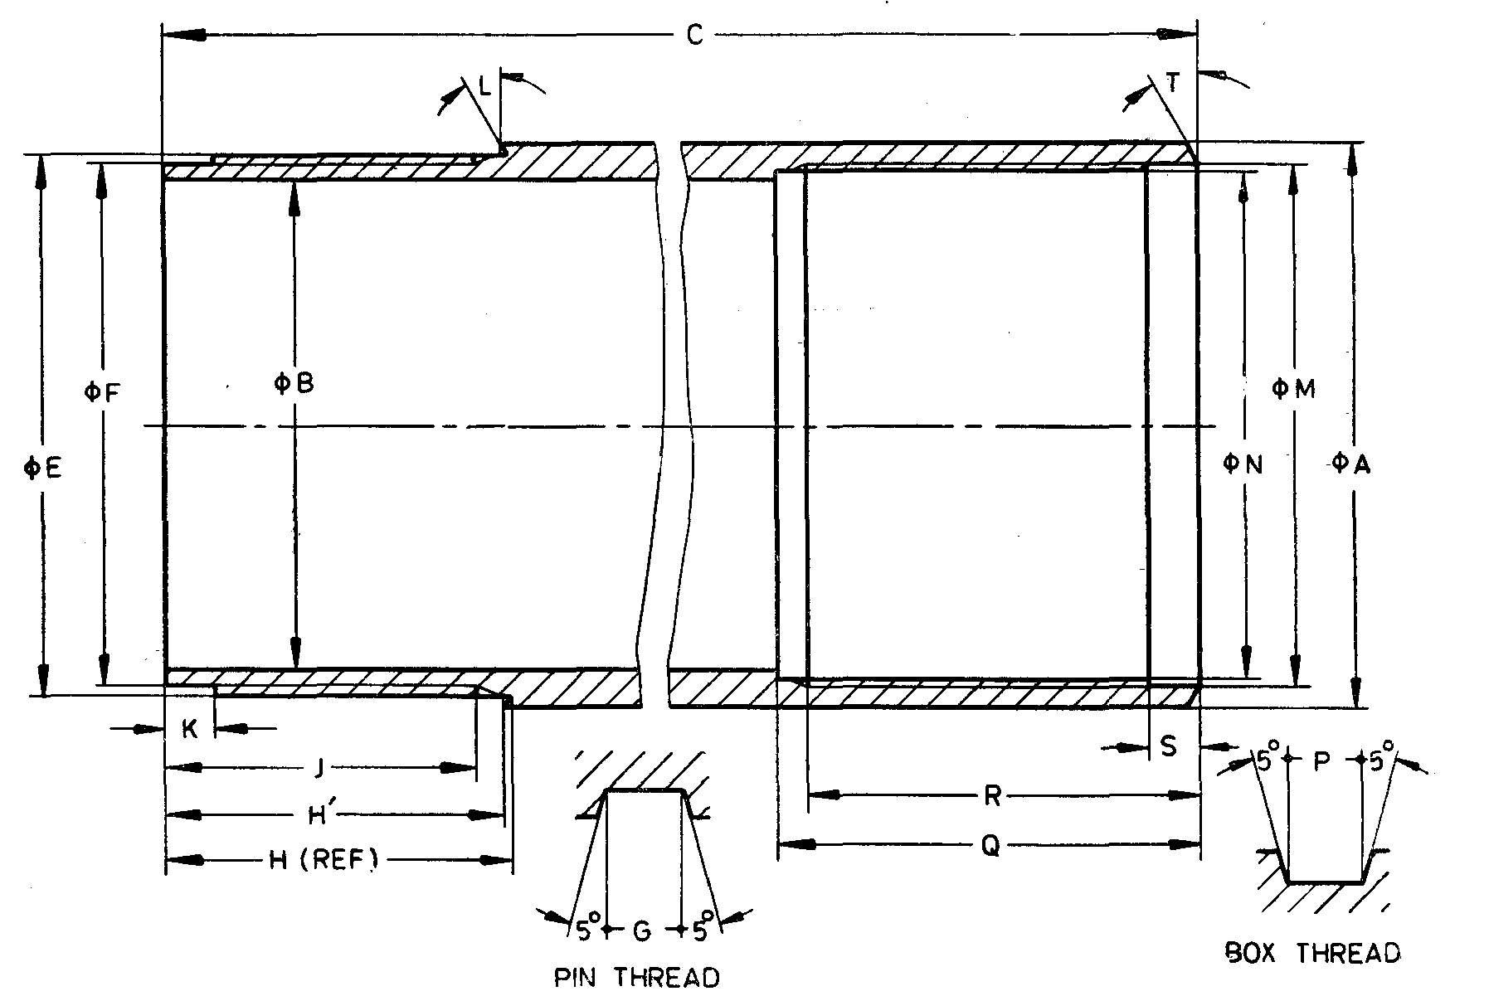

Fig. 26 'WF' Design Double Tube Core Barrel — Outer Tube

All dimensions are in millimetres

|  |  |  |  |  |
| --- | --- | --- | --- | --- |
| *Sl No.* | *Dimension* | | *BWF\** | *NWF\** |
| (1) | (2) | (3) | (4) | (5) |
|  | *A* | *Max* | 58.19 | 74.07 |
| *Min* | 57.94 | 73.81 |
|  | *B* | *Max* | 50.80 | 66.68 |
| *Min* | 50.55 | 66.42 |
|  | *C* | *Max* | 3 245.99 | 3 255.52 |
| *Min* | 3 245.21 | 3 254.73 |
|  | *E* | *Max* | 55.73 | 71.60 |
| *Min* | 55.68 | 71.55 |
|  | *F* | *Max* | 54.15 | 70.03 |
| *Min* | 54.05 | 69.93 |
|  | Thread pitch | | 3.175 | 3.175 |
|  | *G* | *Max* | 1.63 | 1.63 |
| *Min* | 1.55 | 1.55 |
|  | *H* | *Max* | 34.92 | 38.10 |
| *Min* | 34.80 | 37.97 |
|  | *H'* | *Max* | 34.60 | 37.78 |
| *Min* | 34.48 | 37.65 |
|  | *J* | *Min* | 31.75 | 34.92 |
|  | *K* | *Max* | 5.00 | 5.00 |
| *Min* | 4.50 | 4.50 |
|  | *L* | *Min* | 15° | 15° |
|  | *M* | *Max* | 54.05 | 69.93 |
| *Min* | 54.00 | 69.88 |
|  | *N* | *Max* | 52.45 | 68.33 |
| *Min* | 52.40 | 68.28 |
|  | Thread pitch | | 3.175 | 3.175 |
|  | *P* | *Max* | 1.63 | 1.63 |
| *Min* | 1.55 | 1.55 |
|  | *Q* | *Max* | 43.35 | 49.70 |
| *Min* | 42.85 | 49.20 |
|  | *R* | *Max* | 40.17 | 46.52 |
| *Min* | 39.67 | 46.02 |
|  | *S* | *Max* | 5.00 | 5.00 |
| *Min* | 4.50 | 4.50 |
|  | *T* | *—* | 30° | 30° |
| *These items are interchangeable with the ‘WG’ design core barrels. | | | | |

**16.2.8** '*WF*' *Design Double Tube Core Barrel — Inner Tube* (*see* Fig. 27)

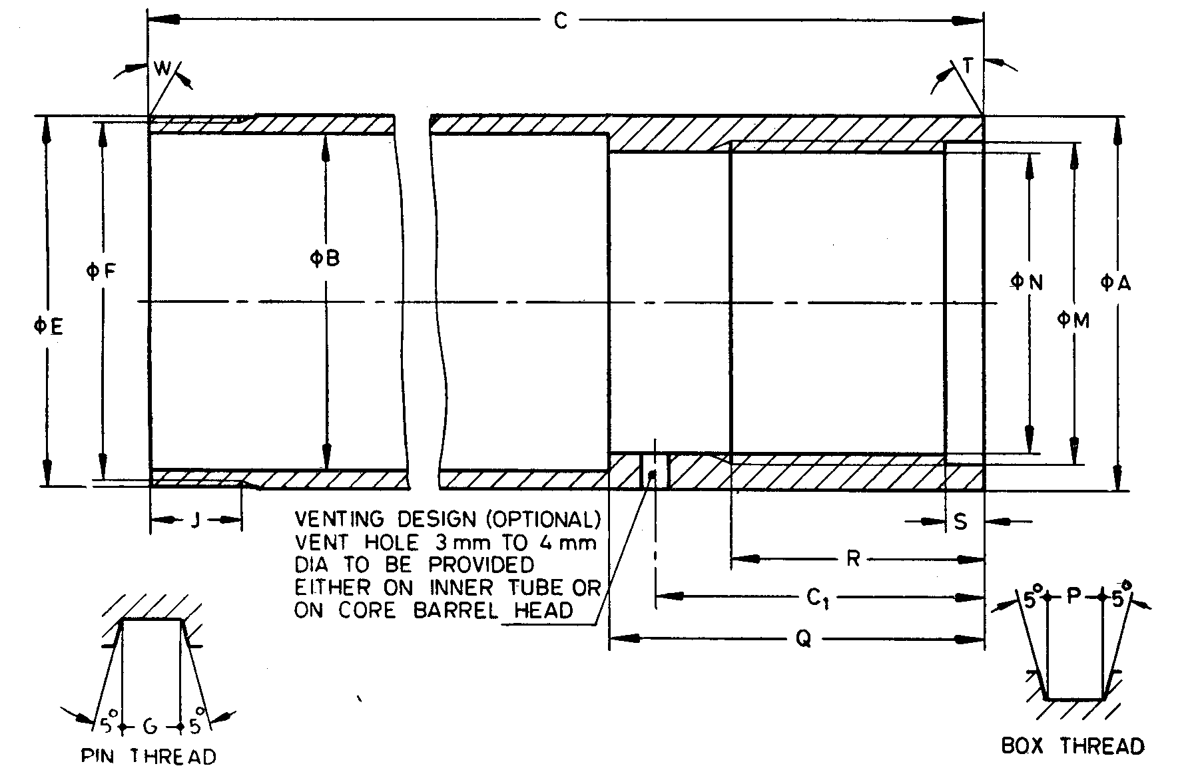

NOTES

**1** Dimension *C*1 is applicable only if vent hole is provided on inner tube.  
**2** Top end of inner tube need not be integral. Method of manufacture optional.

Fig. 27 'WF' Design Double Tube Core Barrel — Inner Tube

All dimensions are in millimetres

|  |  |  |  |  |  |
| --- | --- | --- | --- | --- | --- |
| *Sl No.* | *Dimension* | | | *BWF\** | *NWF\** |
| (1) | (2) | | | (3) | (4) |
|  | *A* | *Max* | 47.88 | | 63.75 | |
| *Min* | 47.62 | | 63.50 | |
|  | *B* | *Max* | 43.64 | | 57.15 | |
| *Min* | 43.38 | | 56.90 | |
|  | *C* | *Max* | 3 096.01 | | 3 105.53 | |
| *Min* | 3 095.22 | | 3 104.74 | |
|  | *C*1 | *Max* | 42.04 | | 51.56 | |
| *Min* | 40.51 | | 50.04 | |
|  | *E* | *Max* | 47.60 | | 63.47 | |
| *Min* | 47.55 | | 63.42 | |
|  | *F* | *Max* | 46.00 | | 61.87 | |
| *Min* | 45.87 | | 61.75 | |
|  | Thread pitch | | | 3.175 | 3.175 |
|  | *G* | *Max* | 1.63 | | 1.63 | |
| *Min* | 1.55 | | 1.55 | |
|  | *J* | *Max* | 11.23 | | 16.00 | |
| *Min* | 10.97 | | 15.75 | |
|  | *M* | *Max* | 41.35 | | 57.23 | |
| *Min* | 41.30 | | 57.18 | |
|  | *N* | *Max* | 38.96 | | 54.84 | |
| *Min* | 38.91 | | 54.79 | |
|  | Thread pitch | | | 3.175 | 3.175 |
|  | *P* | *Max* | 1.63 | | 1.63 | |
| *Min* | 1.55 | | 1.55 | |
|  | *Q* | *Max* | 48.01 | | 57.53 | |
| *Min* | 47.24 | | 56.77 | |
|  | *R* | *Max* | 32.25 | | 32.25 | |
| *Min* | 31.75 | | 31.75 | |
|  | *S* | *Max* | 5.00 | | 5.00 | |
| *Min* | 4.50 | | 4.50 | |
|  | *T* | *—* | 5° | | 0° | |
|  | *W* | *—* | 0° | | 0° | |
| *These items are interchangeable with the 'WM' design core barrels. | | | | | |

**16.2.9** '*WF* ' *Design Double Tube Core Barrel — Head* (*see* Fig. 28)

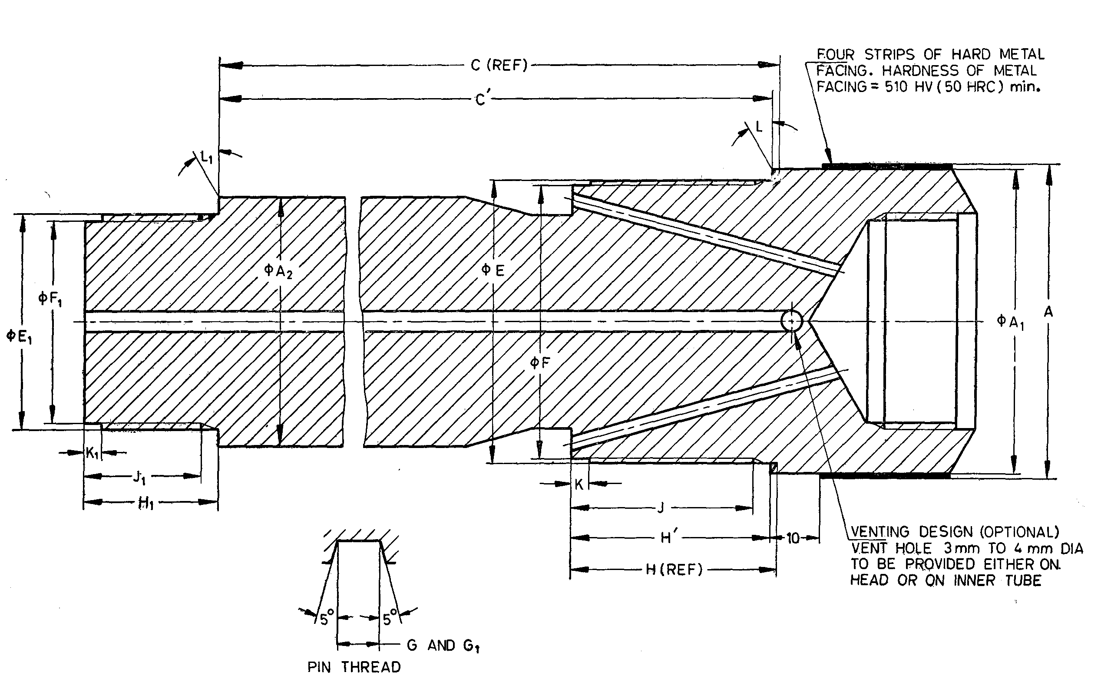

NOTE — The hardness of metal facing in *HRC* is approximate value.

Fig. 28 'WF ' Design Double Tube Core Barrel — Head

All dimensions are in millimetres

|  |  |  |  |  |
| --- | --- | --- | --- | --- |
| *Sl No.* | *Dimension* | | *BWF\** | *NWF\** |
| (1) | (2) | (3) | (4) | (5) |
|  | *A* | *Max* | 58.93 | 74.55 |
| *Min* | 58.81 | 74.43 |
|  | *A*1 | *Max* | 58.06 | 73.94 |
| *Min* | 57.81 | 73.69 |
|  | *A*2 | *Max* | 47.88 | 63.75 |
| *Min* | 47.62 | 63.50 |
|  | *C* | *Max* | 170.54 | 170.54 |
| *Min* | 169.90 | 169.90 |
|  | *C'* | *Max* | 169.38 | 169.38 |
| *Min* | 168.74 | 168.74 |
|  | *E* | *Max* | 53.95 | 69.82 |
| *Min* | 53.90 | 69.77 |
|  | *F* | *Max* | 52.35 | 68.22 |
| *Min* | 52.22 | 68.10 |
|  | Thread pitch | | 3.175 | 3.175 |
|  | *G* | *Max* | 1.63 | 1.63 |
| *Min* | 1.55 | 1.55 |
|  | *H* | *Max* | 39.27 | 45.62 |
| *Min* | 38.89 | 45.24 |
|  | *H'* | *Max* | 38.11 | 44.46 |
| *Min* | 37.73 | 44.08 |
|  | *J* | *Min* | 34.92 | 41.28 |
|  | *K* | *Max* | 3.43 | 3.43 |
| *Min* | 2.92 | 2.92 |
|  | *L* | *Min* | 30° | 30° |
|  | *E*1 | *Max* | 41.25 | 57.12 |
| *Min* | 41.20 | 57.07 |
|  | *F*1 | *Max* | 38.86 | 54.74 |
| *Min* | 38.74 | 54.61 |
|  | Thread pitch | | 3.175 | 3.175 |
|  | *G*1 | *Max* | 1.63 | 1.63 |
| *Min* | 1.55 | 1.55 |
|  | *H*1 | *Max* | 25.40 | 28.58 |
| *Min* | 25.02 | 28.19 |
|  | *J*1 | *Min* | 22.22 | 25.40 |
|  | *K*1 | *Max* | 3.43 | 3.43 |
|  | *Min* | 2.92 | 2.92 |
|  | *L*1 | *Min* | 0° | 0° |
|  | Rod thread connection | | BW | NW |
| *These items are interchangeable with the ‘WM’ design core barrels. | | | | |

**17 'WF' DESIGN DOUBLE TUBE CORE BARREL** (**FOR HWF, PWF, SWF, UWF, AND ZWF**)

**17.1 Nomenclature**

A typical assembly of double tube core barrel of HWF, PWF, SWF, UWF and ZWF size is shown below (*see* Fig. 29) indicating the dimensions for checking:

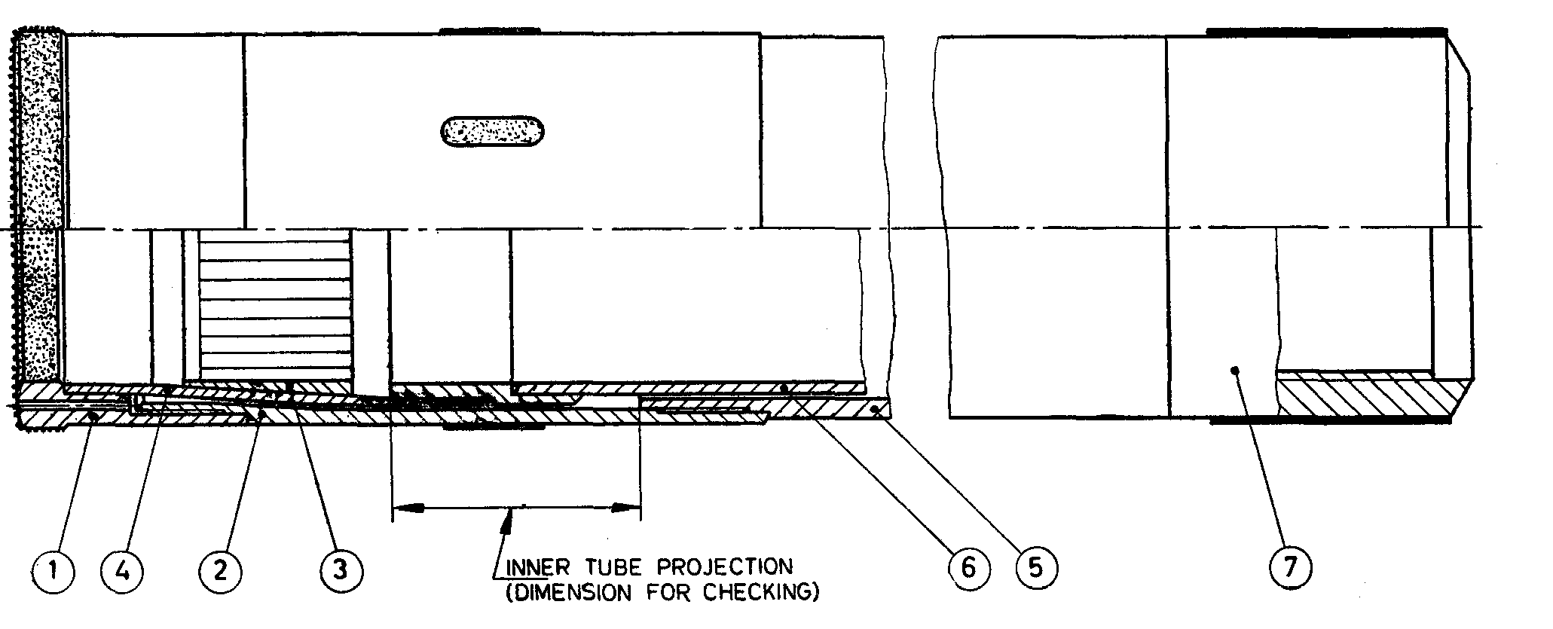

|  |  |
| --- | --- |
| *Key* | |
| 1 | Core bit for use with shell |
| or 1 | Core bit without shell |
| 2 | Reaming shell |
| 3 | Cure Lifter |
| 4 | Core lifter case |
| 5 | Outer tube |
| 6 | Inner tube |
| 7 | Head |

Fig. 29 'WF' Design Double Tube Core Barrel (For HWF, PWF, SWF, UWF, and ZWF)

All dimensions are in millimetres

|  |  |  |  |  |  |  |
| --- | --- | --- | --- | --- | --- | --- |
| *Sl No.* | *Dimensions for  Checking,* | *HWF* | *PWF* | *SWF* | *UWF* | *ZWF* |
| (1) | (2) | (3) | (4) | (5) | (6) | (7) |
|  | Core barrel diameter (confirm from member) , *Max* | 61.11 | 83.31 | 86.28 | 86.36 | 86.26 |
| *Min* | 59.16 | 80.98 | 83.85 | 83.64 | 83.64 |
|  | Core barrel length  (length refer to  core capacity) | 1 500 or 3 000 | | | | |

**17.1.1** Unless specified by the purchaser, blank core bit with blank reaming shell shall not be  
supplied with the core barrel.

**17.1.2** Core bit for use with shell is to be supplied un less otherwise specified.

**17.2 Detailed Dimensions**

**17.2.1** *'WF' Design Double Tube Core Barrel* — *Short Core Bit* (*see* Fig. 30)

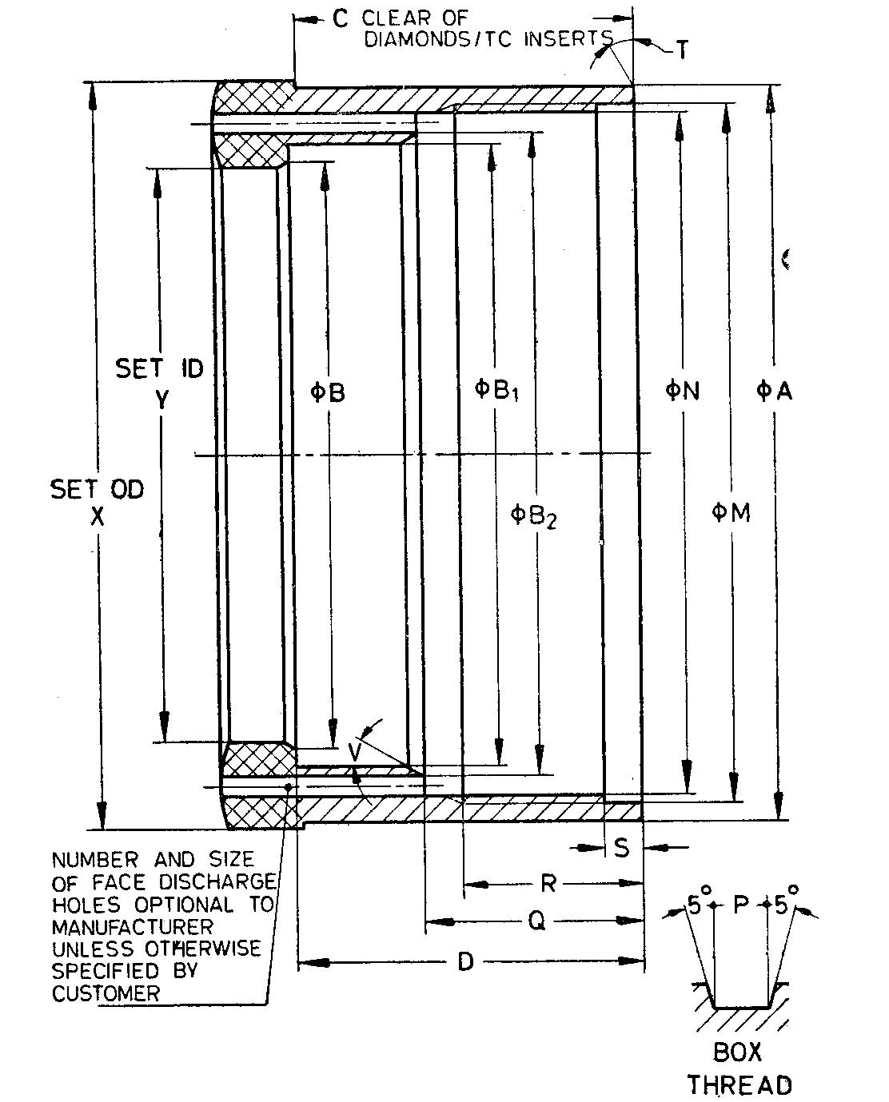

NOTE — Bit design may incorporate provision for the use of a bit breaker.

Fig. 30 'WF' Design Double Tube Core Barrel — Short Core Bit

All dimensions are in millimetres

|  |  |  |  |  |  |  |  |
| --- | --- | --- | --- | --- | --- | --- | --- |
| *Sl No.* | *Dimension* | | *HWF* | *PWF* | *SWF* | *UWF* | *ZWF* |
| (1) | (2) | | (3) | (4) | (5) | (6) | (7) |
|  | *A* | *Max* | 97.59 | 117.50 | 142.75 | 171.32 | 196.72 |
| *Min* | 97.49 | 117.37 | 142.62 | 171.20 | 196.60 |
|  | *B* | *Max* | 77.93 | 94.74 | 115.19 | 142.24 | 167.64 |
| *Min* | 77.83 | 94.62 | 115.06 | 142.11 | 167.51 |
|  | *B*1 | *Max* | 82.68 | 99.82 | 120.45 | 149.86 | 175.26 |
| *Min* | 82.55 | 99.70 | 120.32 | 149.71 | 175.11 |
|  | *B*2 | *Max* | 85.09 | 102.87 | 123.95 | 154.94 | 180.34 |
| *Min* | 84.58 | 102.36 | 123.44 | 154.43 | 179.83 |
|  | *C* | *Min* | 44.45 | 53.98 | 53.98 | 53.98 | 53.98 |
|  | *D* | *Max* | 45.47 | 54.74 | 54.74 | 54.74 | 54.74 |
| *Min* | 47.70 | 53.98 | 53.98 | 53.98 | 53.98 |
|  | *M* | *Max* | 92.56 | 113.46 | 137.69 | 165.74 | 191.14 |
| *Min* | 92.48 | 113.36 | 137.59 | 165.61 | 191.01 |
|  | *N* | *Max* | 90.96 | 111.05 | 135.28 | 163.32 | 188.72 |
| *Min* | 90.88 | 110.97 | 135.20 | 163.22 | 188.62 |
|  | Thread pitch | | 5.080 | 5.080 | 5.080 | 5.080 | 5.080 |
|  | *P* | *Max* | 2.59 | 2.57 | 2.57 | 2.57 | 2.570 |
| *Min* | 2.51 | 2.46 | 2.46 | 2.46 | 2.46 |
|  | *Q* | *Max* | 28.70 | 41.40 | 41.40 | 41.40 | 41.40 |
| *Min* | 28.45 | 41.15 | 41.15 | 41.15 | 41.15 |
|  | *R* | *Max* | 24.30 | 38.60 | 38.60 | 38.60 | 38.60 |
| *Min* | 23.80 | 38.10 | 38.10 | 38.10 | 38.10 |
|  | *S* | *Max* | 5.00 | 5.00 | 5.00 | 5.00 | 5.00 |
| *Min* | 4.50 | 4.50 | 4.50 | 4.50 | 4.50 |
|  | *T* |  | 0° | 0° | 0° | 0° | 0° |
|  | *V* |  | 30° | 30° | 30° | 30° | 30° |
|  | *X* | *Max* | 98.98 | 120.27 | 145.67 | 174.12 | 199.52 |
| *Min* | 98.60 | 119.76 | 145.16 | 173.36 | 198.76 |
|  | *Y* | *Max* | 76.33 | 92.33 | 112.95 | 140.08 | 165.48 |
| *Min* | 76.07 | 91.95 | 112.57 | 139.57 | 164.97 |

NOTES

**1** Unless specified otherwise, short core bit shall be supplied.

**2** Short core bit shall be used with reaming shell.

**17.2.2** *'WF' Design Double Tube Core Barrel — Long Core Bit* (*see* Fig. 31)

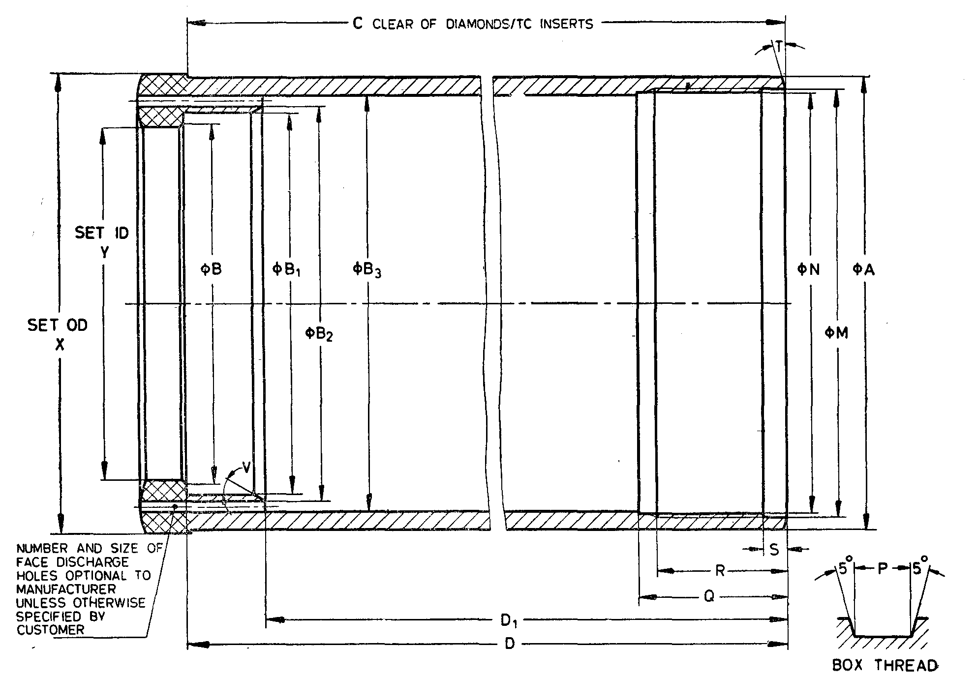

NOTE — Bit design may incorporate provision for the use of a bit breaker.

Fig. 31 'WF' Design Double Tube Core Barrel — Long Core Bit

All dimensions are in millimetres

|  |  |  |  |  |  |  |  |  |
| --- | --- | --- | --- | --- | --- | --- | --- | --- |
| *Sl No.* | *Dimension* | | *HWF* | *PWF* | *SWF* | *UWF* | *ZWF* | |
| (1) | (2) | | (3) | (4) | (5) | (6) | (7) | |
|  | *A* | *Max* | 97.59 | 117.50 | 142.75 | 171.32 | 196.72 |
| *Min* | 97.49 | 117.37 | 142.62 | 171.20 | 196.60 |
|  | *B* | *Max* | 77.93 | 94.74 | 115.19 | 142.24 | 167.64 |
| *Min* | 77.83 | 94.62 | 115.06 | 142.11 | 167.51 |
|  | *B*1 | *Max* | 82.68 | 99.82 | 120.45 | 149.86 | 175.26 |
| *Min* | 82.55 | 99.70 | 120.32 | 149.71 | 175.11 |
|  | *B*2 | *Max* | 85.09 | 102.87 | 123.95 | 154.94 | 180.34 |
| *Min* | 84.58 | 102.36 | 123.44 | 154.43 | 179.83 |
|  | *B*3 | *Max* | 89.92 | 108.36 | 132.84 | 162.28 | 187.68 |
| *Min* | 89.66 | 108.10 | 132.59 | 162.03 | 187.43 |
|  | *C* | *Min* | 174.75 | 223.01 | 235.71 | 248.41 | 248.41 |
|  | *D* | *Max* | 175.39 | 223.39 | 236.09 | 248.79 | 248.79 |
| *Min* | 174.62 | 222.63 | 235.33 | 248.03 | 248.03 |
|  | *D*1 | *Max* | 158.88 | 210.59 | 223.29 | 235.99 | 235.99 |
| *Min* | 158.75 | 210.34 | 223.04 | 235.74 | 235.74 |
|  | *M* | *Max* | 92.56 | 111.94 | 136.19 | 165.33 | 190.73 |
| *Min* | 92.48 | 111.84 | 136.09 | 165.20 | 190.60 |
|  | *N* | *Max* | 90.96 | 109.52 | 133.78 | 162.92 | 188.32 |
| *Min* | 90.88 | 109.45 | 133.71 | 162.81 | 188.21 |
|  | Thread pitch | | 5.080 | 5.080 | 5.080 | 5.080 | 5.080 | |
|  | *P* | *Max* | 2.59 | 2.57 | 2.57 | 2.57 | 2.570 |
| *Min* | 2.51 | 2.46 | 2.46 | 2.46 | 2.46 |
|  | *Q* | *Max* | 32.23 | 57.40 | 57.40 | 63.75 | 63.75 |
| *Min* | 32.11 | 57.15 | 57.15 | 63.50 | 63.50 |
|  | *R* | *Max* | 28.26 | 51.30 | 51.30 | 57.65 | 57.65 |
| *Min* | 27.76 | 50.80 | 50.80 | 57.15 | 57.15 |
|  | *S* | *Max* | 5.00 | 5.00 | 5.00 | 5.00 | 5.00 |
| *Min* | 4.50 | 4.50 | 4.50 | 4.50 | 4.50 |
|  | *T* |  | 15° | 15° | 15° | 15° | 15° |
|  | *V* |  | 30° | 30° | 30° | 30° | 30° |
|  | *X* | *Max* | 99.36 | 120.78 | 146.18 | 174.75 | 200.15 |
| *Min* | 98.98 | 120.40 | 145.80 | 174.24 | 199.64 |
|  | *Y* | *Max* | 76.33 | 92.33 | 112.95 | 140.08 | 165.48 |
| *Min* | 76.07 | 91.95 | 112.57 | 139.57 | 164.97 |

NOTES

**1** Long core bit to be supplied on specific order.  
**2** Long core bits shall be used without reaming shell.

**17.2.3** *'WF' Design Double Tube Core Barrel — Core Lifter Case* (*see* Fig. 32)

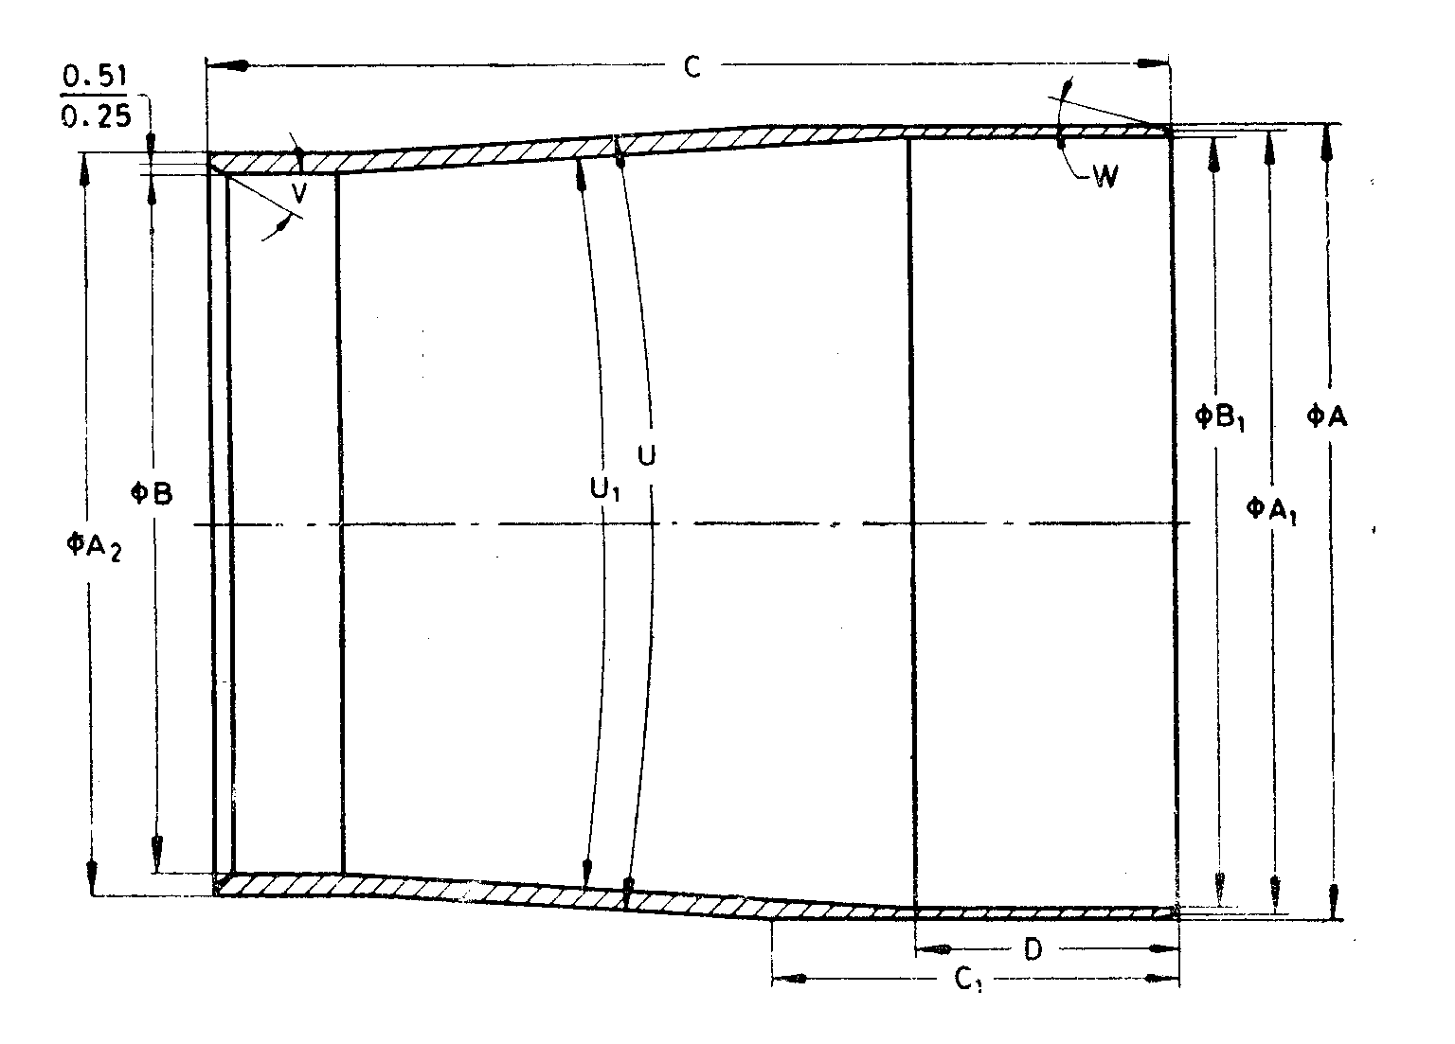

Fig. 32 'WF' Design Double Tube Core Barrel — Core Lifter Case

All dimensions are in millimetres

|  |  |  |  |  |  |  |  |  |
| --- | --- | --- | --- | --- | --- | --- | --- | --- |
| *Sl No.* | *Dimension* | | *HWF* | *PWF* | | *SWF* | *UWF* | *ZWF* |
| (1) | (2) | | (3) | (4) | | (5) | (6) | (7) |
|  | *A* | *Max* | 87.76 | 105.64 | 129.72 | | 157.51 | 182.91 |
| *Min* | 87.66 | 105.54 | 129.62 | | 157.38 | 182.78 |
|  | *A*1 | *Max* | — | 104.14 | 126.36 | | 154.94 | 180.34 |
| *Min* | — | 103.89 | 126.11 | | 154.69 | 180.09 |
|  | *A*2 | *Max* | 82.22 | 99.44 | 120.07 | | 149.45 | 174.85 |
| *Min* | 82.12 | 99.31 | 119.94 | | 149.33 | 174.73 |
|  | *B* | *Max* | 77.93 | 94.82 | 115.27 | | 142.34 | 167.74 |
| *Min* | 77.83 | 94.69 | 115.14 | | 142.19 | 167.59 |
|  | *B*1 | *Max* | 85.47 | 100.48 | 122.66 | | 151.05 | 176.45 |
| *Min* | 85.42 | 100.38 | 122.56 | | 150.93 | 176.33 |
|  | *C* | *Max* | 106.35 | 119.05 | 131.75 | | 138.10 | 138.10 |
| *Min* | 106.17 | 118.87 | 131.57 | | 137.92 | 137.92 |
|  | *C*1 | *Max* | 44.70 | 35.18 | 38.35 | | 38.35 | 38.35 |
| *Min* | 44.20 | 34.67 | 37.85 | | 37.85 | 37.85 |
|  | *D* | *Max* | 28.83 | 35.18 | 38.35 | | 38.35 | 38.35 |
| *Min* | 28.32 | 34.67 | 37.85 | | 37.85 | 37.85 |
|  | *U* | *Max* | 7°15' | 7°15' | 7°15' | | 7°15' | 7°15' |
| *Min* | 6°45' | 6°45' | 6°45' | | 6°45' | 6°45' |
|  | *U*1 | *Max* | 7°15' | 7°15' | 7°15' | | 7°15' | 7°15' |
| *Min* | 6°45' | 6°45' | 6°45' | | 6°45' | 6°45' |
|  | *V* | *—* | 30° | 30° | 30° | | 30° | 30° |
|  | *W* | *—* | — | 15° | 15° | | 15° | 15° |

**17.2.4** *'WP' Design Double Tube Core Barrel* — *Core Lifter* (*see* Fig. 33)

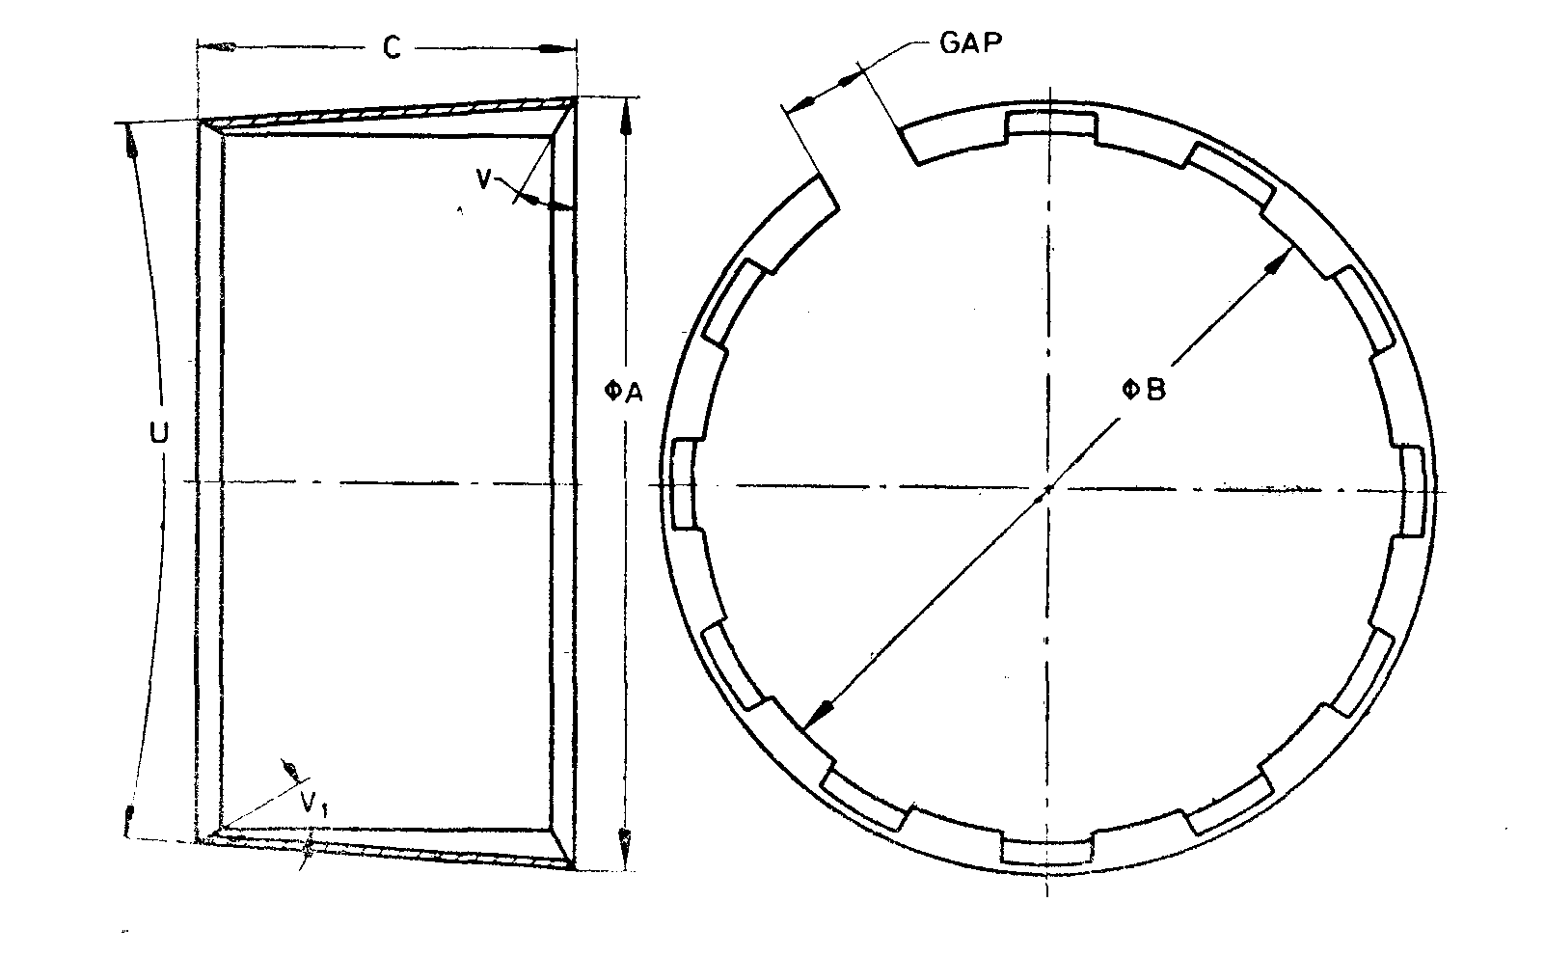

NOTES

**1** Width of gap, entry angle and number of flutes are at the discretion of manufacturer.  
**2** Core lifters with external flutes, if required by purchaser, shall conform to dimensions specified in this clause.

Fig. 33 'WP' Design Double Tube Core Barrel — Core Lifter

All dimensions are in millimetres

|  |  |  |  |  |  |  |  |  |
| --- | --- | --- | --- | --- | --- | --- | --- | --- |
| *Sl No.* | *Dimension* | | *HWF* | | *PWF* | *SWF* | *UWF* | *ZWF* |
| (1) | (2) | | (3) | | (4) | (5) | (6) | (7) |
|  | *A* | *Max* | | 83.97 | 99.31 | 120.90 | 149.30 | 174.70 |
| *Min* | | 83.87 | 99.16 | 120.75 | 149.10 | 174.50 |
|  | *B* | *Max* | | 75.69 | 91.64 | 112.27 | 139.27 | 164.67 |
| *Min* | | 75.56 | 91.52 | 112.14 | 139.14 | 164.54 |
|  | *C* | *Max* | | 41.66 | 41.66 | 48.01 | 54.36 | 54.36 |
| *Min* | | 40.89 | 40.89 | 47.24 | 53.59 | 53.59 |
|  | *U* | *Max* | | 7°15' | 7°15' | 7°15' | 7°15' | 7°15' |
| *Min* | | 6°45' | 6°45' | 6°45' | 6°45' | 6°45' |
|  | *V* | *—* | | 0° | 0° | 0° | 0° | 0° |
|  | *V*1 |  | | Optional | | | | | |

**17.2.5** *'WF' Design Double Tube Core Barrel* — *Outer Tube* (*see* Fig. 34)

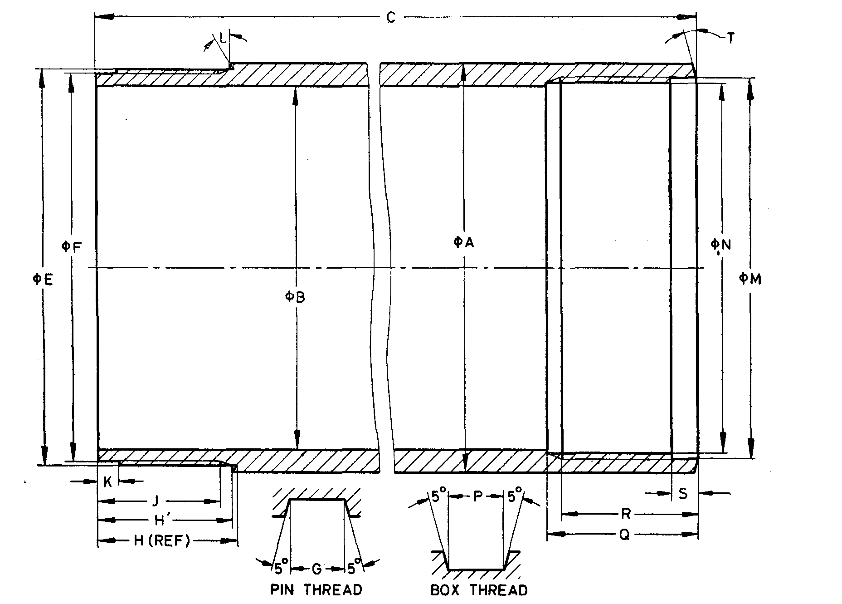

Fig. 34 'WF' Design Double Tube Core Barrel — Outer Tube

All dimensions are in millimetres

|  |  |  |  |  |  |  |  |
| --- | --- | --- | --- | --- | --- | --- | --- |
| *Sl No.* | *Dimension* | | *HWF* | *PWF* | *SWF* | *UWF* | *ZWF* |
| (1) | (2) | (3) | (4) | (5) | (6) | (7) | (8) |
|  | *A* | *Max* | 95.63 | 114.68 | 140.74 | 169.54 | 195.12 |
| *Min* | 65.25 | 114.30 | 138.66 | 167.00 | 192.23 |
|  | *B* | *Max* | 85.85 | 105.03 | 127.36 | 155.98 | 181.38 |
| *Min* | 85.34 | 10.45 | 126.64 | 151.17 | 180.57 |
|  | *C* | *Max* | 3143.48 | 3164.66 | 3151.96 | 3171.82 | 3171.82 |
| *Min* | 3142.69 | 3163.87 | 3151.17 | 3171.04 | 3171.04 |
|  | *E* | *Max* | 92.41 | 111.76 | 136.02 | 165.10 | 190.50 |
| *Min* | 92.33 | 111.68 | 135.94 | 165.00 | 190.40 |
|  | *F* | *Max* | 90.80 | 109.37 | 133.63 | 162.71 | 188.11 |
| *Min* | 30.70 | 109.27 | 133.53 | 162.59 | 187.99 |
|  | Thread pitch | | 5.080 | 5.080 | 5.080 | 5.080 | 5.080 |
|  | *G* | *Max* | 2.59 | 2.57 | 2.57 | 2.57 | 2.57 |
| *Min* | 2.51 | 2.46 | 2.46 | 2.46 | 2.46 |
|  | *H* | *Max* | 32.16 | 51.56 | 51.71 | 57.99 | 57.90 |
| *Min* | 32.03 | 51.18 | 51.33 | 57.61 | 57.61 |
|  | *H'* | *Max* | 31.75 | 51.19 | 51.21 | 57.56 | 57.56 |
| *Min* | 31.62 | 50.81 | 50.83 | 57.18 | 57.18 |
|  | *J* | *Min* | 28.58 | 47.62 | 47.62 | 53.98 | 53.98 |
|  | *K* | *Max* | 5.00 | 5.00 | 5.00 | 5.00 | 5.00 |
| *Min* | 4.50 | 4.50 | 4.50 | 4.50 | 4.50 |
|  | *L* |  | 15° | 15° | 15° | 15° | 15° |
|  | *M* | *Max* | 89.05 | 107.85 | 130.07 | 158.75 | 184.15 |
| *Min* | 88.95 | 107.75 | 129.97 | 158.62 | 184.02 |
|  | *N* | *Max* | 86.64 | 105.44 | 127.66 | 156.34 | 181.74 |
| *Min* | 86.56 | 105.36 | 127.58 | 156.24 | 181.64 |
|  | Thread pitch | | 5.080 | 5.080 | 5.080 | 5.080 | 5.080 |
|  | *P* | *Max* | 2.59 | 2.57 | 2.57 | 2.57 | 2.57 |
| *Min* | 2.51 | 2.46 | 2.46 | 2.46 | 2.46 |
|  | *Q* | *Max* | 35.42 | 57.65 | 57.65 | 64.00 | 64.00 |
| *Min* | 34.92 | 57.15 | 57.15 | 63.50 | 63.50 |
|  | *R* | *Max* | 32.25 | 51.30 | 51.30 | 57.65 | 57.65 |
| *Min* | 31.75 | 50.80 | 50.80 | 57.15 | 57.15 |
|  | *S* | *Max* | 6.05 | 6.60 | 6.60 | 6.60 | 6.60 |
| *Min* | 5.54 | 6.10 | 6.10 | 6.10 | 6.10 |
|  | *T* | — | 15° | 15° | 15° | 15° | 15° |

**17.2.6** '*WF' Design Double Tube Core Barrel* — *Inner Tube* (*see* Fig. 35)

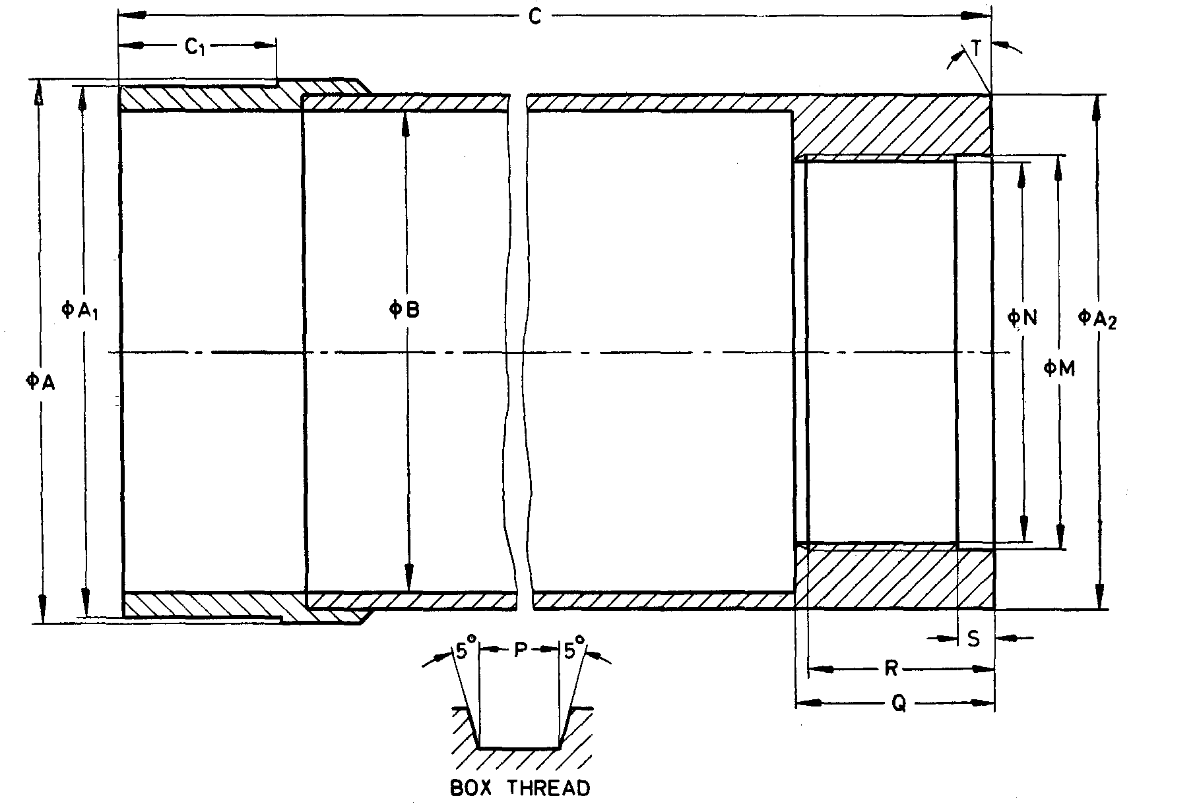

Fig. 35 'WF' Design Double Tube Core Barrel — Inner Tube

All dimensions are in millimetres

|  |  |  |  |  |  |  |  |
| --- | --- | --- | --- | --- | --- | --- | --- |
| *Sl No.* | *Dimension* | | *HWF* | *PWF* | *SWF* | *UWF* | *ZWF* |
| (1) | (2) | (3) | (4) | (5) | (6) | (7) | (8) |
|  | *A* | *Max* | 87.76 | 104.14 | 126.36 | 154.94 | 180.34 |
| *Min* | 87.66 | 104.01 | 126.24 | 154.81 | 180.21 |
|  | *A*1 | *Max* | 85.34 | 100.33 | 122.50 | 150.88 | 176.28 |
| *Min* | 85.27 | 100.25 | 122.43 | 150.77 | 176.17 |
|  | *A*2 | *Max* | 82.93 | 98.63 | 120.95 | 149.63 | 175.03 |
| *Min* | 82.55 | 98.22 | 120.35 | 148.82 | 174.22 |
|  | *B* | *Max* | 77.90 | 93.85 | 114.60 | 143.28 | 168.68 |
| *Min* | 77.39 | 93.45 | 114.00 | 142.47 | 167.87 |
|  | *C* | *Max* | 3 069.29 | 3 071.01 | 3 058.31 | 3 058.31 | 3 057.31 |
| *Min* | 3 068.50 | 3 070.22 | 3 057.52 | 3 057.52 | 3 057.52 |
|  | *C*1 | *Max* | 25.40 | 31.75 | 34.92 | 34.92 | 34.92 |
| *Min* | 25.27 | 31.62 | 34.80 | 34.80 | 34.80 |
|  | *M* | *Max* | 63.65 | 76.35 | 76.35 | 120.85 | 146.25 |
| *Min* | 63.55 | 76.25 | 76.25 | 120.73 | 146.13 |
|  | *N* | *Max* | 61.52 | 73.91 | 73.91 | 118.44 | 143.84 |
| *Min* | 61.44 | 73.86 | 73.86 | 118.34 | 143.74 |
|  | Thread Pitch | | 5.08 | 5.08 | 5.08 | 5.08 | 5.08 |
|  | *P* | *Max* | 2.59 | 2.57 | 2.57 | 2.57 | 2.57 |
| *Min* | 2.51 | 2.46 | 2.46 | 2.46 | 2.46 |
|  | *Q* | *Max* | 31.88 | 47.88 | 47.88 | 54.23 | 54.23 |
| *Min* | 31.75 | 47.37 | 47.37 | 53.72 | 53.72 |
|  | *R* | *Max* | 32.25 | 47.87 | 47.87 | 54.22 | 54.22 |
| *Min* | 31.75 | 47.37 | 47.37 | 53.72 | 53.72 |
|  | *S* | *Max* | 5.79 | 5.79 | 5.79 | 5.79 | 5.79 |
| *Min* | 5.28 | 5.28 | 5.28 | 5.28 | 5.28 |
|  | *T* | *—* | 0° | 0° | 0° | 0° | 0° |

**17.2.7** *'WF' Design Double Tube Core Barrel — Head* (*see* Fig. 36)

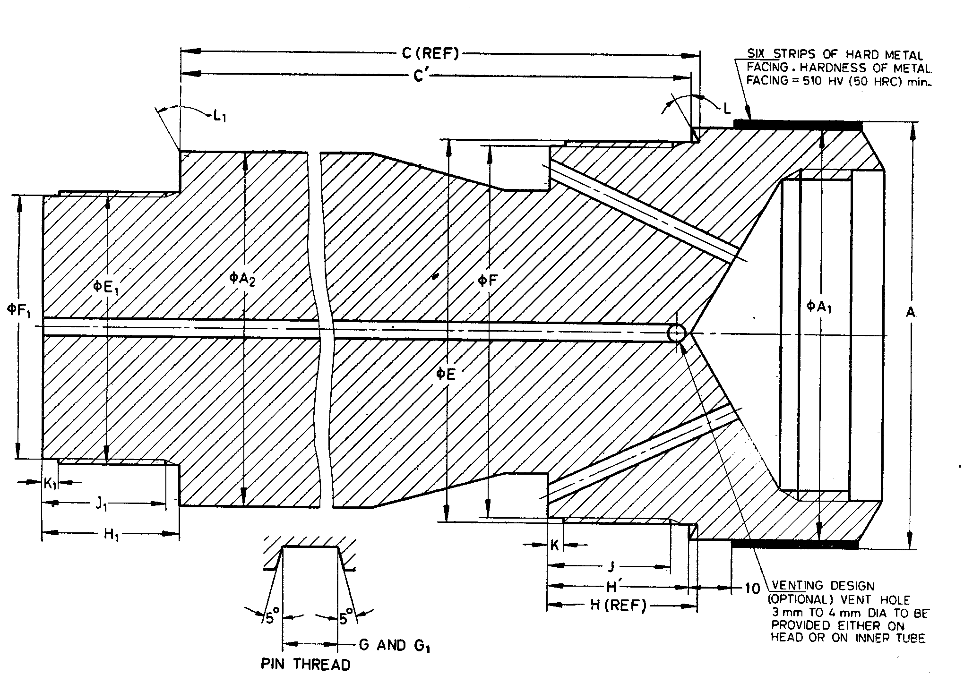

NOTE— Hardness of metal facing in *HRC* is approximate value.

Fig. 36 'WF' Design Double Tube Core Barrel — Head

All dimensions are in millimetres

|  |  |  |  |  |  |  |  |  |
| --- | --- | --- | --- | --- | --- | --- | --- | --- |
| *Sl No.* | *Dimension* | | *HWF* | *PWF* | *SWF* | *UWF* | *ZWF* | |
| (1) | (2) | | (3) | (4) | (5) | (6) | (7) | |
|  | *A* | *Max* | 97.78 | 118.77 | 143.96 | 171.92 | 197.11 | |
| *Min* | 97.65 | 118.65 | 143.84 | 170.80 | 196.99 | |
|  | *A*1 | *Max* | 95.45 | 114.68 | 140.08 | 168.66 | 194.06 | |
| *Min* | 95.07 | 114.30 | 139.70 | 168.28 | 193.68 | |
|  | *A*2 | *Max* | 82.55 | 98.63 | 120.95 | 149.63 | 175.03 | |
|  | *C* | *Max* | 134.52 | 176.17 | 179.15 | 199.09 | 199.09 | |
| *Min* | 134.14 | 175.41 | 178.38 | 197.94 | 197.94 | |
|  | *C* | *Max* | 133.66 | 175.25 | 177.81 | 197.75 | 197.75 | |
| *Min* | 133.28 | 174.49 | 177.64 | 196.60 | 196.60 | |
|  | *E* | *Max* | 88.90 | 107.67 | 129.90 | 158.52 | 183.92 | |
| *Min* | 88.82 | 107.59 | 129.82 | 158.42 | 183.82 | |
|  | *F* | *Max* | 86.51 | 105.28 | 127.51 | 156.13 | 181.53 | |
| *Min* | 86.41 | 105.18 | 127.41 | 156.01 | 181.41 | |
|  | Thread pitch | | 5.080 | 5.080 | 5.080 | 5.080 | 5.080 | |
|  | *G* | *Max* | 2.59 | 2.57 | 2.57 | 2.57 | 2.57 |
| *Min* | 2.51 | 2.46 | 2.46 | 2.46 | 2.46 |
|  | *H* | *Max* | 32.61 | 51.71 | 51.71 | 58.47 | 58.47 |
| *Min* | 32.23 | 51.33 | 51.33 | 58.09 | 58.09 |
|  | *H’* | *Max* | 31.75 | 50.79 | 50.37 | 57.13 | 57.13 |
| *Min* | 31.37 | 50.41 | 49.99 | 56.75 | 56.75 |
|  | *J* | *Min* | 28.58 | 47.62 | 47.62 | 53.98 | 53.98 |
|  | *K* | *Max* | 3.43 | 5.00 | 5.00 | 5.00 | 5.00 |
| *Min* | 2.92 | 4.50 | 4.50 | 4.50 | 4.50 |
|  | *L* |  | 15° | 15° | 15° | 15° | 15° |
|  | *E*1 | *Max* | 63.50 | 76.20 | 76.20 | 120.65 | 146.08 |
| *Min* | 63.45 | 76.15 | 76.15 | 120.57 | 145.97 |
|  | *F*1 | *Max* | 61.39 | 73.81 | 73.81 | 118.26 | 143.66 |
| *Min* | 61.29 | 73.71 | 73.71 | 118.16 | 143.56 |
|  | Thread Pitch | | 5.080 | 5.080 | 5.080 | 5.080 | 5.080 |
|  | *G*1 | *Max* | 2.59 | 2.57 | 2.57 | 2.57 | 2.57 |
| *Min* | 2.51 | 2.46 | 2.46 | 2.46 | 2.46 |
|  | *H*1 | *Max* | 31.75 | 47.62 | 47.62 | 53.98 | 53.98 |
| *Min* | 31.37 | 47.24 | 47.24 | 53.59 | 53.59 |
|  | *J*1 | *Min* | 28.58 | 44.45 | 44.45 | 50.80 | 50.80 |
|  | *K*1 | *Max* | 3.43 | 5.00 | 5.00 | 5.00 | 5.00 |
| *Min* | 2.92 | 4.50 | 4.50 | 4.50 | 4.5 |
|  | *L*1 |  | 0° | 0° | 0° | 0° | 0° |
|  | Drill rod connection | | HW | * | * | * | * |
| *Threads for drill rod connection shall be according to established practices. | | | | | | | |

**17.2.8** '*WF' Design Double Tube Core Barrel* — *Reaming Shell* (*see* Fig. 37)

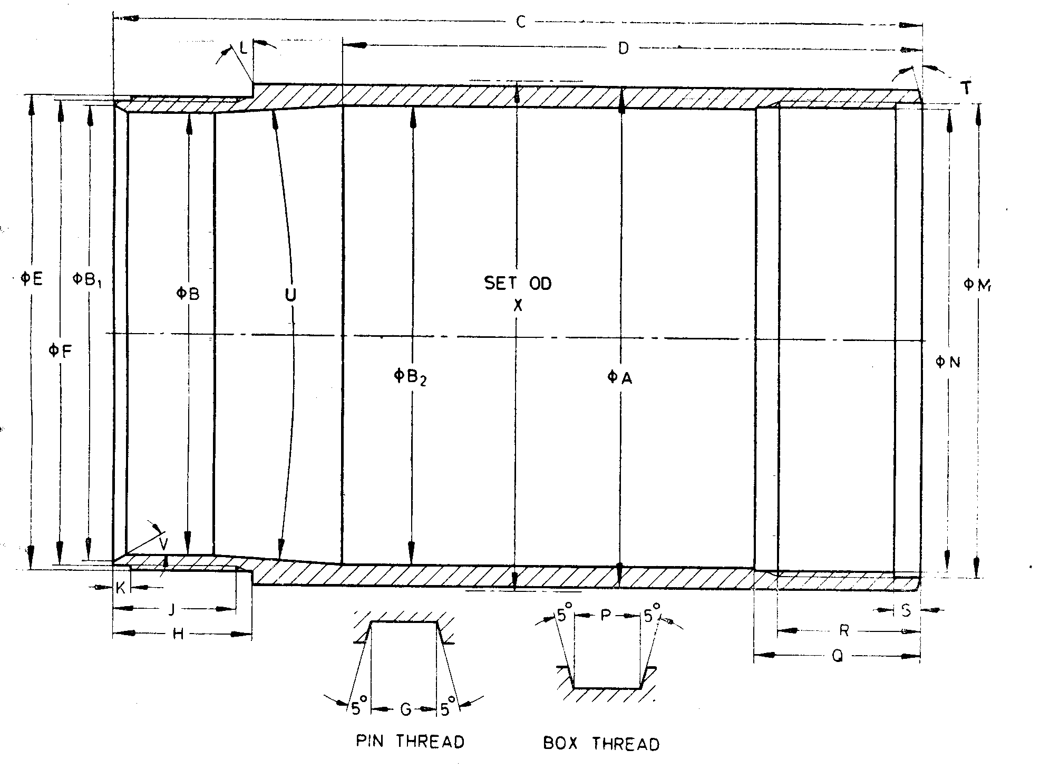

Fig. 37 'WF' Design Double Tube Core Barrel — Reaming Shell

All dimensions are in millimetres

|  |  |  |  |  |  |  |  |
| --- | --- | --- | --- | --- | --- | --- | --- |
| *Sl No.* | *Dimension* | | *HWF* | *PWF* | *SWF* | *UWF* | *ZWF* |
| (1) | (2) | (3) | (4) | (5) | (6) | (7) | (8) |
|  | *A* | *Max* | 97.59 | 117.50 | 142.75 | 171.32 | 196.72 |
| *Min* | 97.49 | 117.37 | 142.62 | 171.20 | 196.60 |
|  | *B* | *Max* | 86.64 | 104.90 | 127.13 | 155.70 | 181.10 |
| *Min* | 86.51 | 104.78 | 127.00 | 155.58 | 180.98 |
|  | *B*1 | *Max* | 89.28 | 109.09 | 133.73 | 161.42 | 186.82 |
| *Min* | 88.52 | 108.33 | 132.97 | 160.66 | 186.06 |
|  | *B*2 | *Max* | 89.92 | 108.36 | 132.84 | 162.28 | 187.68 |
| *Min* | 89.56 | 108.10 | 132.59 | 162.03 | 187.43 |
|  | *C* | *Max* | 157.15 | 207.01 | 219.71 | 232.41 | 232.41 |
| *Min* | 156.97 | 206.88 | 219.58 | 232.28 | 232.28 |
|  | *D* | *Max* | 112.83 | 143.00 | 143.89 | 146.94 | 146.94 |
| *Min* | 112.70 | 142.75 | 143.64 | 146.68 | 146.68 |
|  | *E* | *Max* | 92.41 | 113.28 | 137.52 | 165.51 | 190.91 |
| *Min* | 92.33 | 113.21 | 137.44 | 165.40 | 190.80 |
|  | *F* | *Max* | 90.80 | 110.90 | 135.13 | 163.12 | 188.52 |
| *Min* | 90.70 | 110.79 | 135.03 | 162.99 | 188.39 |
|  | Thread pitch | | 5.080 | 5.080 | 5.080 | 5.080 | 5.080 |
|  | *G* | *Max* | 2.59 | 2.57 | 2.57 | 2.57 | 2.57 |
| *Min* | 2.51 | 2.46 | 2.46 | 2.46 | 2.46 |
|  | *H* | *Max* | 26.97 | 38.23 | 38.23 | 38.23 | 38.23 |
| *Min* | 26.85 | 38.10 | 38.10 | 38.10 | 38.10 |
|  | *J* | *Min* | 23.80 | 34.92 | 34.92 | 34.92 | 34.92 |
|  | *K* | *Max* | 3.43 | 5.00 | 5.00 | 5.00 | 5.00 |
| *Min* | 2.92 | 4.50 | 4.50 | 4.50 | 4.50 |
|  | *L* | — | 0° | 0° | 0° | 0° | 0° |
|  | *M* | *Max* | 92.58 | 111.94 | 136.19 | 165.33 | 190.73 |
| *Min* | 92.48 | 111.84 | 136.09 | 165.20 | 190.60 |
|  | *N* | *Max* | 90.96 | 109.52 | 133.78 | 162.92 | 188.32 |
| *Min* | 90.88 | 109.45 | 133.71 | 162.81 | 188.21 |
|  | Thread pitch | | 5.08 | 5.08 | 5.08 | 5.08 | 5.08 |
|  | *P* | *Max* | 2.59 | 2.57 | 2.57 | 2.57 | 2.57 |
| *Min* | 2.50 | 2.46 | 2.46 | 2.46 | 2.46 |
|  | *Q* | *Max* | 32.23 | 57.40 | 57.40 | 63.75 | 63.75 |
| *Min* | 32.13 | 57.15 | 57.15 | 63.50 | 63.50 |
|  | *R* | *Max* | 28.26 | 51.30 | 51.30 | 57.65 | 57.65 |
| *Min* | 27.76 | 50.80 | 50.80 | 57.15 | 57.15 |
|  | *S* | *Max* | 5.00 | 5.00 | 5.00 | 5.00 | 5.00 |
| *Min* | 4.50 | 4.50 | 4.50 | 4.50 | 4.50 |
|  | *T* | *Max* | 15° | 15° | 15° | 15° | 15° |
|  | *V* | *Min* | 30° | 30° | 30° | 30° | 30° |
|  | *U* | *Max* | 7°15' | 7°15' | 7°15' | 7°15' | 7°15' |
| *Min* | 6°45' | 6°45' | 6°45' | 6°45' | 6°45' |
|  | *X* | *Max* | 99.36 | 120.78 | 146.18 | 174.75 | 200.15 |
| *Min* | 99.11 | 120.40 | 145.80 | 174.24 | 199.64 |

**SECTION 4 CORE BARRELS — 'WG' DESIGN**

**18 'WG' DESIGN SINGLE TUBE CORE BARRELS**

**18.1 Nomenclature**

A typical assembly of single tube core barrels is shown below (*see* Fig. 38):

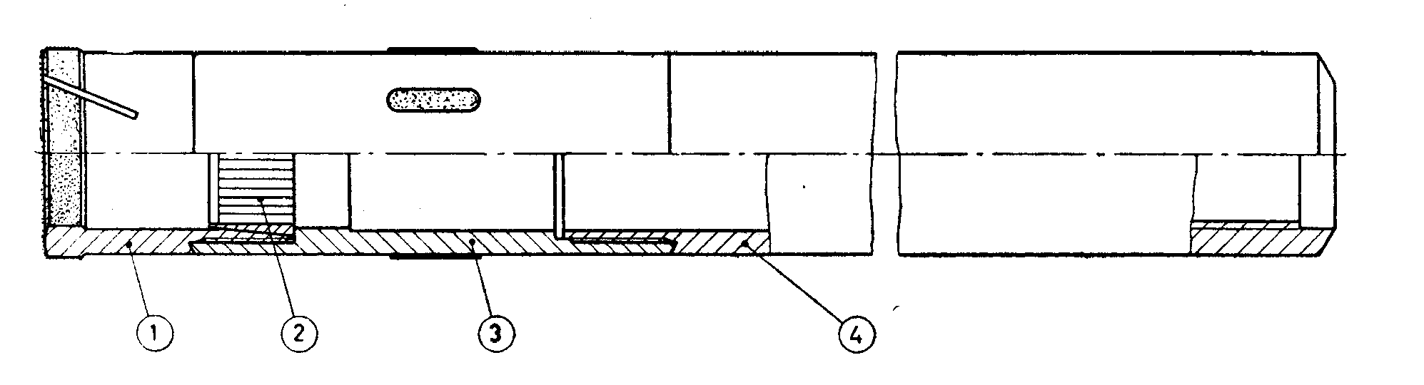

|  |  |
| --- | --- |
| *Key* | |
| 1 | Core bit |
| 2 | Core lifter |
| 3 | Reaming shell |
| 4 | Tube |

Fig. 38 'WG' Design Single Tube Core Barrels

**18.1.1** Bits and core lifters are interchangeable with double tube barrels.

**18.1.2** 'WG ' design core barrel shall have lengths of 1 500 mm, 3 000 mm and 6 000 mm.

**18.2 Detailed Dimensions**

**18.2.1** *'WG' Design Single Tube Core Barrel — Bevel Wall Core Bit* (*see* Fig. 39)

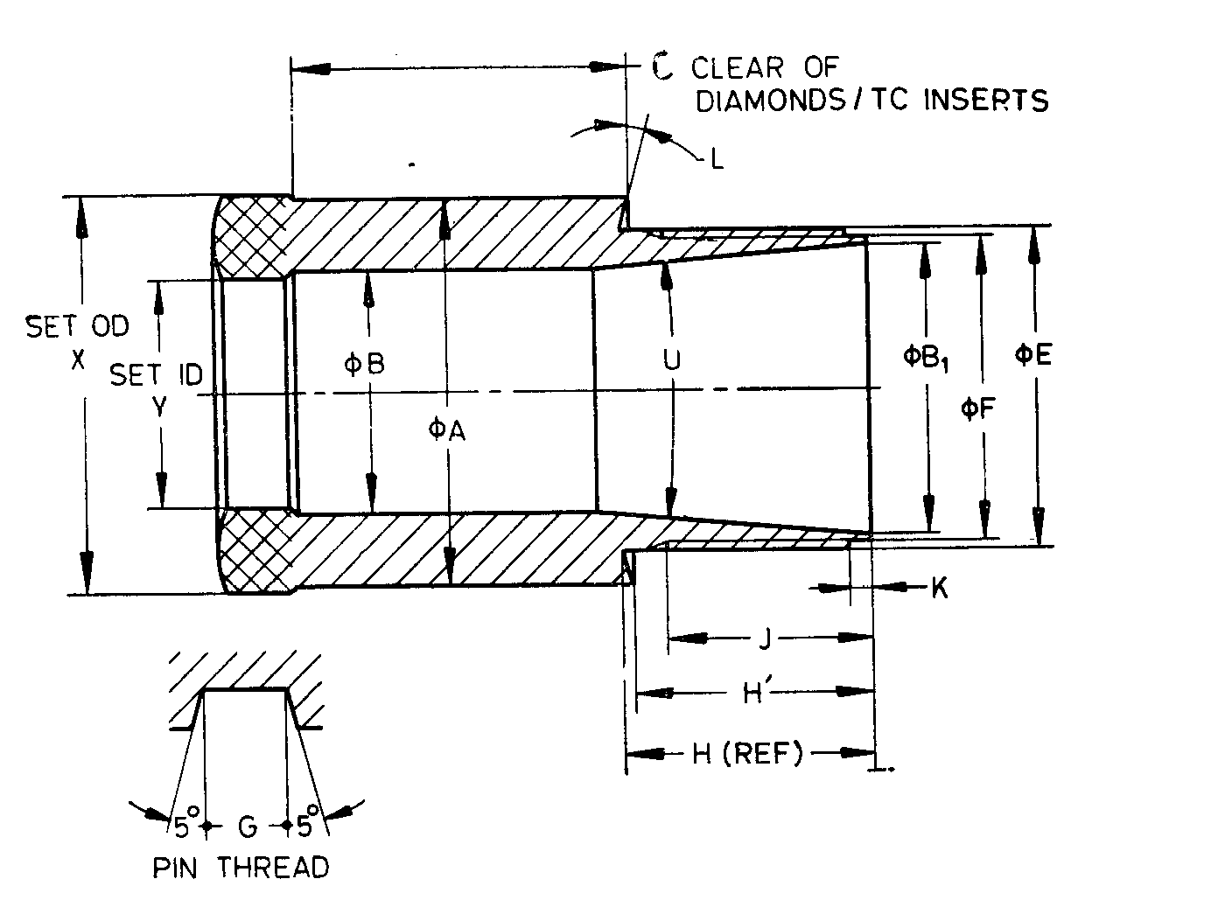

Fig. 39 'WG' Design Single Tube Core Barrel — Bevel Wall Core Bit

All dimensions are in millimetres

|  |  |  |  |  |  |  |  |
| --- | --- | --- | --- | --- | --- | --- | --- |
| *Sl No.* | *Dimension* | | *EWG* | *AWG* | *BWG* | *NWG* | *HWG* |
| (1) | (2) | | (3) | (4) | (5) | (6) | (7) |
|  | *A* | *Max* | 36.63 | 46.66 | 58.47 | 74.09 | 97.59 |
| *Min* | 36.53 | 46.56 | 58.37 | 73.99 | 97.48 |
|  | *B* | *Max* | 22.96 | 31.85 | 44.04 | 57.00 | 79.35 |
| *Min* | 22.86 | 31.75 | 43.94 | 56.90 | 79.25 |
|  | *B*1 | *Max* | 27.43 | 36.96 | 48.46 | 64.34 | 88.90 |
| *Min* | 27.33 | 36.86 | 48.36 | 64.24 | 88.77 |
|  | *C* | *Min* | 31.75 | 31.75 | 31.75 | 34.92 | 38.10 |
|  | *E* | *Max* | 30.12 | 39.65 | 51.56 | 67.44 | 38.40 |
| *Min* | 30.07 | 39.60 | 51.51 | 67.39 | 92.35 |
|  | *F* | *Max* | 28.55 | 38.07 | 49.96 | 65.84 | 90.80 |
| *Min* | 28.42 | 37.95 | 49.83 | 65.71 | 90.68 |
|  | Thread pitch | | 3.175 | 3.175 | 3.175 | 3.175 | 5.080 |
|  | *G* | *Max* | 1.63 | 1.63 | 1.63 | 1.63 | 2.59 |
| *Min* | 1.55 | 1.55 | 1.55 | 1.55 | 2.51 |
|  | *H* | *Max* | 22.48 | 25.65 | 28.83 | 32.00 | 35.18 |
| *Min* | 21.97 | 25.15 | 28.32 | 31.50 | 34.67 |
|  | *H'* | *Max* | 22.48 | 25.65 | 28.83 | 32.00 | 35.18 |
| *Min* | 21.97 | 25.15 | 28.32 | 31.50 | 34.67 |
|  | *J* | *Min* | 19.05 | 22.22 | 25.40 | 28.58 | 31.75 |
|  | *K* | *Max* | 1.83 | 1.83 | 1.83 | 1.83 | 1.83 |
| *Min* | 1.32 | 1.32 | 1.32 | 1.32 | 1.32 |
|  | *L* |  | 0° | 0° | 0° | 0° | 0° |
|  | *U* | *Max* | 10°15' | 10°15' | 10°15' | 10°15' | 10°15' |
| *Min* | 9°45' | 9°45' | 9°45' | 9°45' | 9°45' |
|  | *X* | *Max* | 37.46 | 47.75 | 59.69 | 75.44 | 98.98 |
| *Min* | 37.21 | 47.50 | 59.44 | 75.18 | 98.60 |
|  | *Y* | *Max* | 21.59 | 30.23 | 42.16 | 54.86 | 76.33 |
| *Min* | 21.34 | 29.97 | 41.91 | 54.61 | 76.07 |

**18.2.2** *'WG' Design Single Tube Core Barrel* — Core Lifter (*see* Fig. 40)

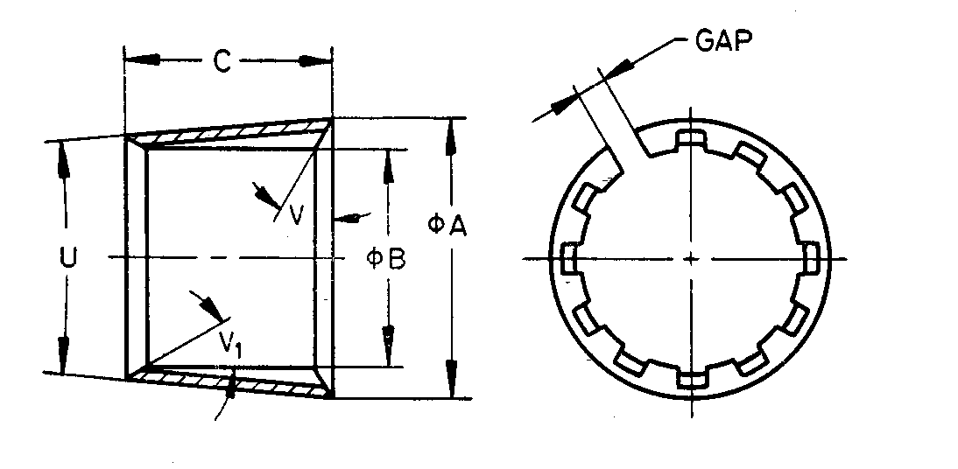

NOTES

**1** Width of gap, entry angle and number of flutes are at the discretion of manufacturer.  
**2** Core barrels with external flutes, If required by purchaser, shall conform to dimensions specified in this clause.

Fig. 40 'WG' Design Single Tube Core Barrel — Core Lifter

All dimensions are in millimetres

|  |  |  |  |  |  |  |  |
| --- | --- | --- | --- | --- | --- | --- | --- |
| *Sl No.* | *Dimension* | | *EWG* | *AWG* | *BWG* | *NWG* | *HWG* |
| (1) | (2) | | (3) | (4) | (5) | (6) | (7) |
|  | *A* | *Max* | 26.31 | 35.84 | 47.34 | 63.22 | 87.35 |
| *Min* | 26.21 | 35.74 | 47.24 | 63.12 | 57.25 |
|  | *B* | *Max* | 21.08 | 29.72 | 41.53 | 54.23 | 75.7 |
| *Min* | 20.98 | 29.62 | 41.43 | 54.13 | 75.59 |
|  | *C* | *Max* | 19.43 | 22.6 | 24.18 | 32.13 | 51.18 |
| *Min* | 18.67 | 21.84 | 23.42 | 31.37 | 50.42 |
|  | *U* | *Max* | 10°15' | 10°15' | 10°15' | 10°15' | 7°15' |
| *Min* | 9°45' | 9°45' | 9°45' | 9°45' | 6°45' |
|  | *V* |  | 0° | 0° | 0° | 0° | 0° |
|  | *V1* | Optional | | | | | | |

**18.2.3** *'WG' Design Single Tube Core Barrel — Tube* (*see* Fig. 41)

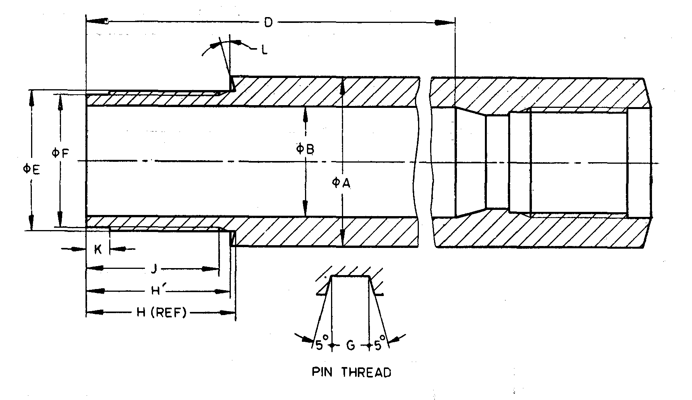

Fig. 41 'WG' Design Single Tube Core Barrel — Tube

All dimensions are in millimetres

|  |  |  |  |  |  |  |  |
| --- | --- | --- | --- | --- | --- | --- | --- |
| *Sl No.* | *Dimension* | | *EWG* | *AWG* | *BWG* | *NWG* | *HWG* |
| (1) | (2) | | (3) | (4) | (5) | (6) | (7) |
|  | *A* | *Max* | 36.63 | 46.28 | 58.19 | 74.07 | 95.63 |
| *Min* | 36.50 | 46.02 | 57.94 | 73.81 | 95.25 |
|  | *B* | *Max* | 23.80 | 32.54 | 44.45 | 57.15 | 79.50 |
| *Min* | 23.67 | 32.28 | 44.20 | 56.90 | 78.99 |
|  | *D* | *Min* | 3003.55 | 3003.55 | 3003.55 | 3003.55 | 3000.38 |
|  | *E* | *Max* | 30.12 | 39.65 | 51.56 | 67.43 | 88.87 |
| *Min* | 30.07 | 39.60 | 51.51 | 67.39 | 88.82 |
|  | *F* | *Max* | 28.55 | 38.07 | 49.96 | 65.84 | 87.27 |
| *Min* | 28.42 | 37.95 | 49.83 | 65.71 | 87.15 |
|  | Thread pitch | | 3.175 | 3.175 | 3.175 | 3.175 | 5.080 |
|  | *G* | *Max* | 1.63 | 1.63 | 1.63 | 1.63 | 2.59 |
| *Min* | 1.55 | 1.55 | 1.55 | 1.55 | 2.51 |
|  | *H* | *Max* | 31.75 | 31.75 | 34.92 | 38.10 | 41.28 |
| *Min* | 31.62 | 31.62 | 34.80 | 37.57 | 41.15 |
|  | *H'* | *Max* | 30.88 | 30.88 | 34.05 | 37.23 | 40.40 |
| *Min* | 30.75 | 30.75 | 33.93 | 37.10 | 40.27 |
|  | *J* | *Min* | 28.58 | 28.58 | 31.75 | 34.92 | 37.29 |
|  | *K* | *Max* | 5.00 | 5.00 | 5.00 | 5.00 | 6.60 |
| *Min* | 4.50 | 4.50 | 4.50 | 4.50 | 6.10 |
|  | *L* |  | 15° | 15° | 15° | 15° | 15° |
|  | Rod thread connection | | EW | AW | BW | NW | HW |

**18.2.4** *'WG' Design Single Tube Core Barrel — Reaming Shell* (*see* Fig. 42)

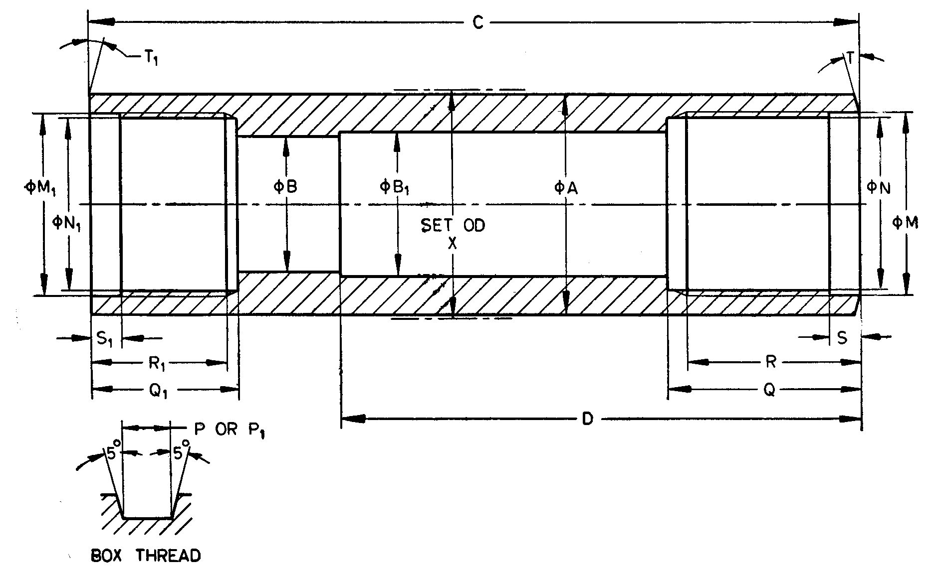

Fig. 42 'WG' Design Single Tube Core Barrel — Reaming Shell

All dimensions are in millimetres

|  |  |  |  |  |  |  |  |
| --- | --- | --- | --- | --- | --- | --- | --- |
| *Sl No.* | *Dimension* | | *EWG* | *AWG* | *BWG* | *NWG* | *HWG* |
| (1) | (2) | (3) | (4) | (5) | (6) | (7) | (8) |
|  | *A* | *Max* | 36.63 | 46.66 | 58.47 | 74.09 | 97.59 |
| *Min* | 36.53 | 46.56 | 58.37 | 73.99 | 97.49 |
|  | *B* | *Max* | 22.78 | 31.47 | 43.38 | 56.08 | 77.88 |
| *Min* | 22.68 | 31.37 | 43.28 | 55.98 | 77.77 |
|  | *B*1 | *Max* | 23.80 | 32.54 | 44.45 | 57.15 | 79.50 |
| *Min* | 23.67 | 32.28 | 44.20 | 56.90 | 78.99 |
|  | *C* | *Max* | 127.25 | 130.43 | 138.35 | 146.60 | 152.65 |
| *Min* | 126.75 | 129.92 | 137.85 | 145.80 | 152.15 |
|  | *D* | *Max* | 85.98 | 89.15 | 93.90 | 98.68 | 101.85 |
| *Min* | 85.34 | 88.52 | 93.27 | 98.04 | 101.22 |
|  | *M* | *Max* | 30.23 | 39.75 | 51.66 | 67.54 | 89.09 |
| *Min* | 30.18 | 39.70 | 51.61 | 67.49 | 88.98 |
|  | *N* | *Max* | 28.65 | 38.18 | 50.06 | 65.94 | 87.43 |
| *Min* | 28.60 | 38.12 | 50.01 | 65.89 | 87.35 |
|  | Thread pitch | | 3.175 | 3.175 | 3.175 | 3.175 | 5.080 |
|  | *P* | *Max* | 1.63 | 1.63 | 1.63 | 1.63 | 2.59 |
| *Min* | 1.55 | 1.55 | 1.55 | 1.55 | 2.51 |
|  | *Q* | *Max* | 31.88 | 31.88 | 35.05 | 35.05 | 41.40 |
| *Min* | 31.75 | 31.75 | 34.92 | 34.92 | 41.28 |
|  | *R* | *Max* | 29.08 | 29.08 | 32.25 | 32.25 | 38.60 |
| *Min* | 28.58 | 28.58 | 31.75 | 31.75 | 38.10 |
|  | *S* | *Max* | 5.00 | 5.00 | 5.00 | 5.00 | 6.05 |
| *Min* | 4.50 | 4.50 | 4.50 | 4.50 | 5.54 |
|  | *T* | *—* | 15° | 15° | 15° | 15° | 15° |
|  | *M*1 | *Max* | 30.23 | 39.75 | 51.66 | 51.66 | 92.53 |
| *Min* | 30.18 | 39.70 | 51.61 | 51.61 | 92.48 |
|  | *N*1 | *Max* | 28.65 | 38.18 | 50.06 | 50.06 | 90.93 |
| *Min* | 28.60 | 38.12 | 50.01 | 50.01 | 90.88 |
|  | Thread pitch | | 3.175 | 3.175 | 3.175 | 3.175 | 5.080 |
|  | *P*1 | *Max* | 1.63 | 1.63 | 1.63 | 1.63 | 2.59 |
| *Min* | 1.55 | 1.55 | 1.55 | 1.55 | 2.51 |
|  | *Q*1 | *Max* | 23.93 | 27.10 | 31.88 | 36.63 | 39.24 |
| *Min* | 23.80 | 26.97 | 31.75 | 36.50 | 38.86 |
|  | *R*1 | *Max* | 22.70 | 25.90 | 29.08 | 33.82 | 35.42 |
| *Min* | 22.20 | 25.40 | 28.58 | 33.32 | 34.92 |
|  | *S*1 | *Max* | 5.00 | 5.00 | 5.00 | 5.00 | 6.05 |
| *Min* | 4.50 | 4.50 | 4.50 | 4.50 | 5.54 |
|  | *T*1 | *—* | 0° | 0° | 0° | 0° | 0° |
|  | *X* | *Max* | 37.85 | 48.13 | 60.07 | 75.82 | 99.36 |
| *Min* | 37.59 | 47.88 | 59.82 | 75.56 | 99.11 |

**19 'WG' DESIGN DOUBLE TUBE CORE BARRELS**

**19.1 Nomenclature**

Atypical assembly of double tube core barrel is shown below (*see* Fig. 43):

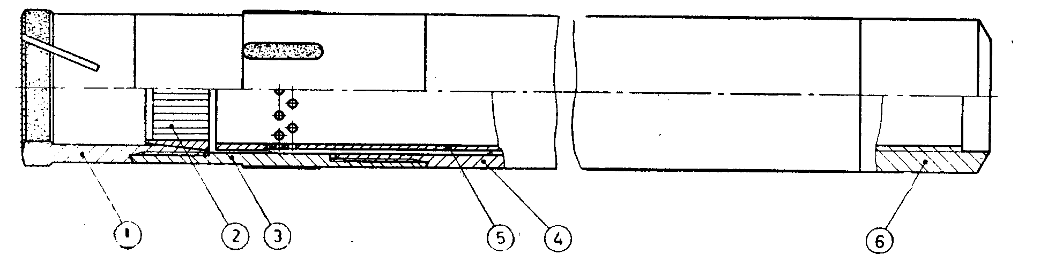

|  |  |
| --- | --- |
| Key | |
| 1 | Core bit |
| 2 | Core lifter |
| 3 | Lifter case |
| 4 | Outer case |
| 5 | Inner tube |
| 6 | Head-rigid or swivel |

Fig. 43 'WG' Design Double Tube Core Barrels

**19.1.1** Bits and core lifters of single tube core barrel and double tube core barrel are interchangeable (for dimensions *see* **18.2.1** and **18.2.2**).

**19.1.2** ' WG ' Design double tube core barrels shall have lengths of 1 500 mm, 3 000 mm and 6 000 mm (lengths refers to core capacity).

**19.2 Detailed Dimensions**

**19.2.1** *'WG' Design Double Tube Core Barrel* — *Outer Tube* (*see* Fig. 44)

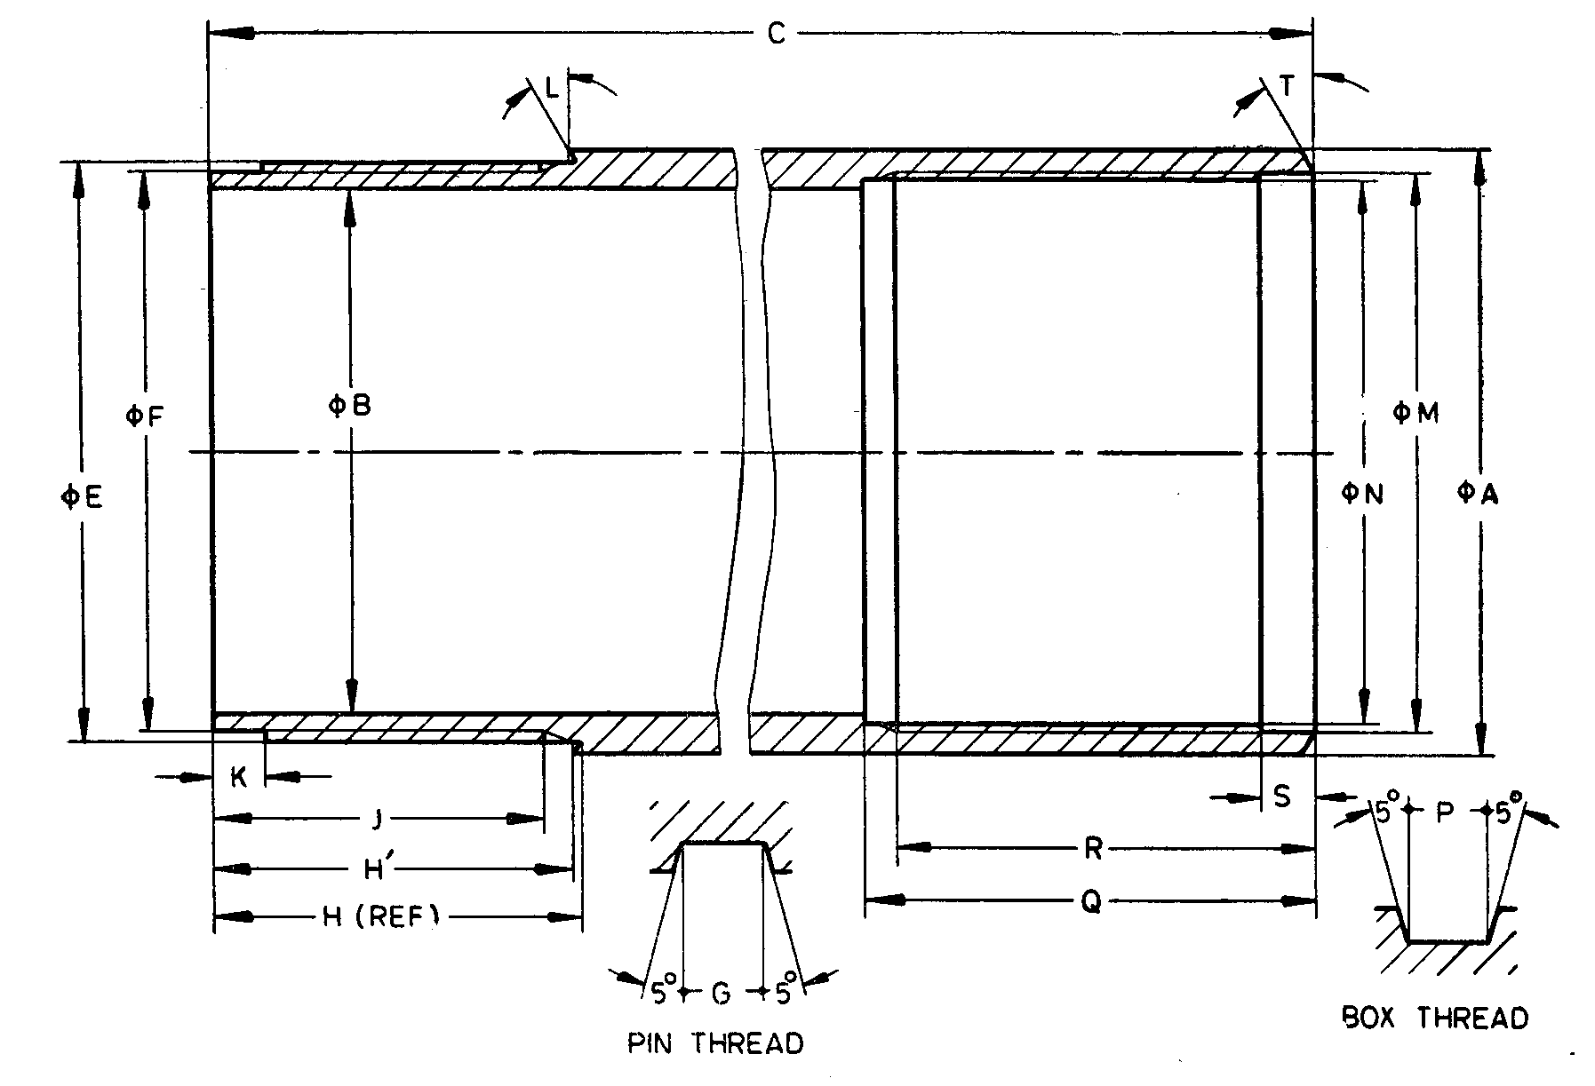

Fig. 44 'WG' Design Double Tube Core Barrel — Outer Tube

All dimensions are in millimetres

|  |  |  |  |  |  |  |  |
| --- | --- | --- | --- | --- | --- | --- | --- |
| *Sl No.* | *Dimension* | | *EWG* | *AWG* | *BWG* | *NWG* | *HWG* |
| (1) | (2) | | (3) | (4) | (5) | (6) | (7) |
|  | *A* | *Max* | 36.63 | 46.28 | 58.19 | 74.07 | 95.63 |
| *Min* | 36.50 | 46.02 | 57.94 | 73.81 | 95.25 |
|  | *B* | *Max* | 30.15 | 38.89 | 50.80 | 66.68 | 85.85 |
| *Min* | 30.02 | 38.63 | 50.55 | 66.42 | 85.34 |
|  | *C* | *Max* | 3 147.03 | 3 241.22 | 3 245.99 | 3 255.52 | 3 143.48 |
| *Min* | 3 146.22 | 3 240.43 | 3 245.21 | 3 254.73 | 3 142.69 |
|  | *E* | *Max* | 34.49 | 43.84 | 55.73 | 71.60 | 92.40 |
| *Min* | 34.44 | 43.81 | 55.68 | 71.55 | 92.33 |
|  | *F* | *Max* | 32.92 | 42.29 | 54.15 | 70.03 | 90.80 |
| *Min* | 32.82 | 42.19 | 54.05 | 69.93 | 90.70 |
|  | Thread pitch | | 3.175 | 3.175 | 3.175 | 3.175 | 5.080 |
|  | *G* | *Max* | 1.63 | 1.63 | 1.63 | 1.63 | 2.59 |
| *Min* | 1.55 | 1.55 | 1.55 | 1.55 | 2.51 |
|  | *H* | *Max* (Ref) | 31.75 | 31.75 | 34.92 | 38.10 | 32.13 |
| *Min* (Ref) | 31.62 | 31.62 | 34.80 | 37.97 | 32.03 |
|  | *H'* | *Max* | 31.47 | 31.44 | 34.60 | 37.78 | 31.72 |
| *Min* | 31.34 | 31.31 | 34.48 | 37.65 | 31.62 |
|  | *J* | *Min* | 28.58 | 28.58 | 31.75 | 34.92 | 28.58 |
|  | *K* | *Max* | 5.00 | 5.00 | 5.00 | 5.00 | 5.00 |
| *Min* | 4.50 | 4.50 | 4.50 | 4.50 | 4.50 |
|  | *L* |  | 15° | 15° | 15° | 15° | 15° |
|  | *M* | *Max* | 31.83 | 42.14 | 54.05 | 69.93 | 89.05 |
| *Min* | 31.78 | 42.09 | 54.00 | 69.88 | 88.95 |
|  | *N* | *Max* | 30.23 | 40.54 | 52.45 | 68.33 | 86.64 |
| *Min* | 30.18 | 40.49 | 52.40 | 68.28 | 86.56 |
|  | Thread pitch | | 3.175 | 3.175 | 3.175 | 3.175 | 5.080 |
|  | *F* | *Max* | 1.63 | 1.63 | 1.63 | 1.63 | 2.59 |
| *Min* | 1.55 | 1.55 | 1.55 | 1.55 | 2.51 |
|  | *Q* | *Max* | 30.65 | 37.00 | 43.35 | 49.70 | 35.42 |
| *Min* | 30.15 | 36.50 | 42.85 | 47.20 | 34.92 |
|  | *R* | *Max* | 27.47 | 33.82 | 40.17 | 46.52 | 32.28 |
| *Min* | 26.97 | 33.32 | 39.67 | 46.02 | 31.75 |
|  | *S* | *Max* | 5.00 | 5.00 | 5.00 | 5.00 | 6.05 |
| *Min* | 4.50 | 4.50 | 4.50 | 4.50 | 5.54 |
|  | *T* | — | 30° | 30° | 30° | 30° | 15° |

**19.2.2** *'WG' Design Double Tube Core Barrel* — *Inner Tube* (*see* Fig. 45)

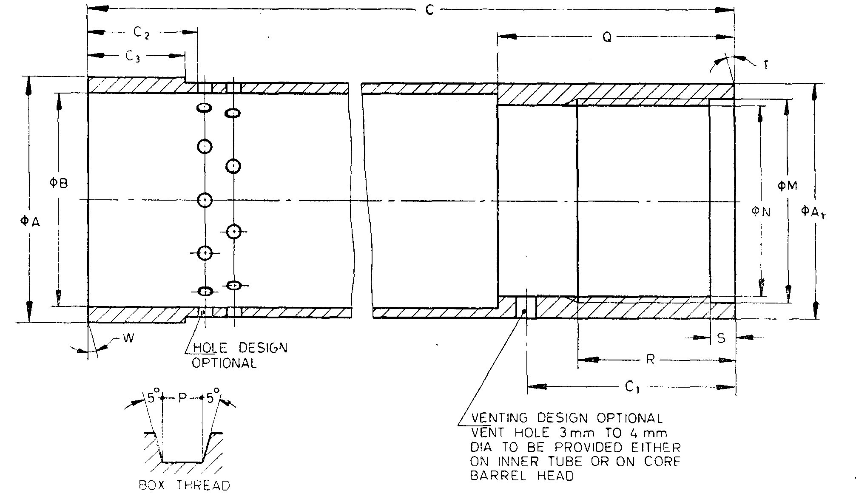

NOTES

**1** Ends of inner tube need not be integral. Method of manufacture optional.  
**2** Dimension *C*1 is applicable only if hole is provided on inner tube.

Fig. 45 'WG' Design Double Tube Core Barrel — Inner Tube

All dimensions are in millimetres

|  |  |  |  |  |  |  |  |
| --- | --- | --- | --- | --- | --- | --- | --- |
| *Sl No.* | *Dimension* | | *EWG* | *AWG* | *BWG* | *NWG* | *HWG* |
| (1) | (2) | | (3) | (4) | (5) | (6) | (7) |
| i) | *A* | *Max* | 28.45 | 37.97 | 49.78 | 65.66 | 85.34 |
| *Min* | 28.32 | 37.85 | 49.66 | 65.53 | 85.22 |
| ii) | *A*1 | *Max* | 27.10 | 35.97 | 47.88 | 63.75 | 82.93 |
| *Min* | 26.97 | 35.71 | 47.62 | 63.50 | 82.55 |
| iii) | *B* | *Max* | 23.80 | 31.75 | 43.64 | 57.15 | 77.90 |
| *Min* | 23.67 | 31.50 | 43.39 | 56.90 | 77.39 |
| iv) | *C* | *Max* | 3 109.11 | 3 117.04 | 3 121.81 | 3 131.34 | 3 078.96 |
| *Min* | 3 108.32 | 3 116.25 | 3 121.02 | 3 130.55 | 3 078.18 |
| v) | *C*1 | *Max* | 29.34 | 37.26 | 42.04 | 51.56 | 35.69 |
| *Min* | 27.81 | 35.74 | 40.51 | 50.04 | 34.16 |
| vi) | *C*1 | *Min* | 19.05 | 19.05 | 22.22 | 25.40 | 26.97 |
| vii) | *C*3 | *Max* | 16.26 | 16.26 | 19.43 | 52.61 | 25.78 |
| *Min* | 15.88 | 15.88 | 19.05 | 22.22 | 25.40 |
| viii) | *M* | *Max* | 20.70 | 29.44 | 41.35 | 57.23 | 63.63 |
| *Min* | 20.65 | 29.39 | 41.30 | 57.18 | 63.55 |
| ix) | *N* | *Max* | 19.13 | 27.05 | 38.96 | 54.84 | 61.49 |
| *Min* | 19.08 | 27.00 | 38.91 | 54.79 | 61.44 |
| x) | Thread pitch | | 3.175 | 3.175 | 3.175 | 3.175 | 5.080 |
| xi) | *P* | *Max* | 1.63 | 1.63 | 1.63 | 1.63 | 2.59 |
| *Min* | 1.55 | 1.55 | 1.55 | 1.55 | 2.51 |
| xii) | *Q* | *Max* | 35.05 | 42.98 | 47.75 | 57.28 | 41.40 |
| *Min* | 34.80 | 42.73 | 47.50 | 57.02 | 41.15 |
| xiii) | *R* | *Min* | 22.22 | 31.75 | 31.75 | 31.75 | 31.75 |
| xiv) | *S* | *Max* | 5.00 | 5.00 | 5.00 | 5.00 | 6.05 |
| *Min* | 4.50 | 4.50 | 4.50 | 4.50 | 5.54 |
| xv) | *T* | *—* | 0° | 0° | 0° | 0° | 0° |
| xvi) | Holes (minimum total area) mm2 | | 142.58 | 185.81 | 238.71 | 325.16 | 419.35 |
| xvii) | *W* | *—* | 0° | 0° | 0° | 0° | 0° |

**19.2.3** *'WG' Design Double Tube Core Barrel* — *Head* (*see* Fig. 46)

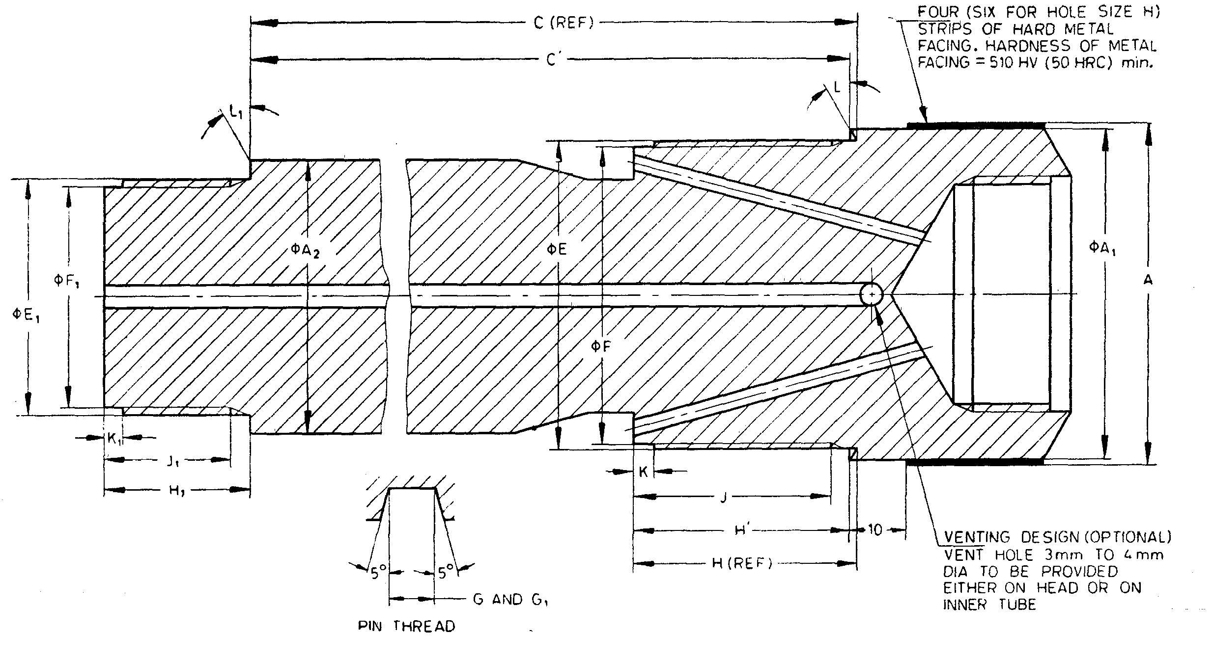

NOTE— The hardness of metal strip in *HRC* is approximate value.

Fig. 46 'WG' Design Double Tube Core Barrel — Head

All dimensions are in millimetres

|  |  |  |  |  |  |  |  |
| --- | --- | --- | --- | --- | --- | --- | --- |
| *Sl No.* | *Dimension* | | *EWG1)* | *AWG1)* | *BWG2)* | *NWG2)* | *HWG3)* |
| (1) | (2) | | (3) | (4) | (5) | (6) | (7) |
| i) | *A* | *Max* | 36.90 | 47.12 | 58.93 | 74.55 | 97.78 |
| *Min* | 36.73 | 47.00 | 58.81 | 74.43 | 57.66 |
| ii) | *A*1 | *Max* | 36.63 | 46.15 | 58.06 | 73.94 | 95.45 |
| *Min* | 36.37 | 45.90 | 57.81 | 73.69 | 95.07 |
| iii) | *A*2 | *Max* | 27.10 | 35.97 | 47.88 | 63.75 | 82.55 |
| *Min* | 26.97 | 35.71 | 47.62 | 63.50 | 82.17 |
| iv) | *C* | *Max* | 84.23 | 170.54 | 170.54 | 170.54 | 134.52 |
| *Min* | 83.59 | 169.90 | 169.90 | 169.90 | 134.14 |
| v) | *C'* | *Max* | 82.84 | 169.39 | 169.38 | 169.38 | 133.66 |
| *Min* | 82.20 | 168.75 | 168.74 | 168.74 | 133.28 |
| vi) | *E* | *Max* | 31.72 | 42.04 | 53.95 | 69.82 | 88.90 |
| *Min* | 31.67 | 41.99 | 53.90 | 69.77 | 88.82 |
| vii) | *F* | *Max* | 30.12 | 40.44 | 52.35 | 68.22 | 86.51 |
| *Min* | 30.00 | 40.31 | 52.22 | 68.10 | 86.41 |
| viii) | Thread pitch | | 3.175 | 3.175 | 3.175 | 3.175 | 5.080 |
| ix) | *G* | *Max* | 1.63 | 1.63 | 1.63 | 1.63 | 2.59 |
| *Min* | 1.55 | 1.55 | 1.55 | 1.55 | 2.51 |
| x) | *H* | *Max* | 26.77 | 32.92 | 39.27 | 45.62 | 32.61 |
| *Min* | 26.39 | 32.54 | 38.89 | 45.24 | 32.23 |
| xi) | *H'* | *Max* | 25.38 | 31.77 | 38.11 | 44.46 | 31.75 |
| *Min* | 25.00 | 31.39 | 37.73 | 44.08 | 31.37 |
| xii) | *J* | *Min* | 22.22 | 28.58 | 34.92 | 41.28 | 28.58 |
| xiii) | *K* | *Max* | 3.43 | 3.43 | 3.43 | 3.43 | 36.43 |
|  | *Min* | 2.52 | 2.92 | 2.92 | 2.92 | 2.92 |
| xiv) | *L* | — | 30° | 30° | 30° | 30° | 15° |
| xv) | *E*1 | *Max* | 20.60 | 29.34 | 41.25 | 57.12 | 63.50 |
|  | *Min* | 20.55 | 29.29 | 41.20 | 57.07 | 63.45 |
| xvi) | *F*1 | *Max* | 19.02 | 26.95 | 38.86 | 54.74 | 61.39 |
|  | *Min* | 18.90 | 26.82 | 38.74 | 54.61 | 61.29 |
| xvii) | Thread pitch | | 3.175 | 3.175 | 3.175 | 3.175 | 5.08 |
| xviii) | *G*1 | *Max* | 1.63 | 1.63 | 1.63 | 1.63 | 2.59 |
|  | *Min* | 1.55 | 1.55 | 1.55 | 1.55 | 2.51 |
| xix) | *H*1 | *Max* | 19.05 | 22.22 | 25.4 | 28.58 | 31.75 |
|  | *Min* | 18.67 | 21.84 | 25.02 | 28.19 | 31.37 |
| xx) | *J*1 | *Min* | 15.88 | 19.05 | 22.22 | 25.4 | 28.58 |
| xxi) | *K*1 | *Max* | 3.43 | 3.43 | 3.43 | 3.43 | 3.43 |
|  | *Min* | 2.92 | 2.92 | 2.92 | 2.92 | 2.92 |
| xxii) | *L*1 | — | 0° | 0° | 0° | 0° | 0° |
| xxiii) | Rod thread connection | | EW | AW | BW | NW | HW |
| 1)These items interchange with the 'WIVI' design core barrels. 2) These items interchange with the 'WM', 'WT' and 'WTM' design core barrels. 3) This item is interchangeable with the 'WF' design core barrel. | | | | | | | |

**19.2.4** *'WG' Design Double Tube Core Barrel* — *Reaming Shell* (*see* Fig. 47)

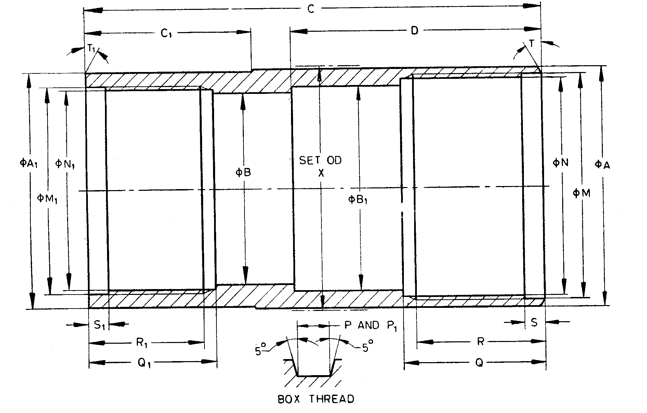

Fig. 47 'WG' Design Double Tube Core Barrel — Reaming Shell

All dimensions are in millimetres

|  |  |  |  |  |  |  |  |  |
| --- | --- | --- | --- | --- | --- | --- | --- | --- |
| *Sl No.* | *Dimension* | | *EWG* | *AWG* | *BWG* | *NWG* | *HWG* | |
| (1) | (2) | | (3) | (4) | (5) | (6) | (7) | |
| i) | *A* | *Max* | 37.01 | 47.04 | 58.85 | 74.57 | 97.97 | |
| *Min* | 36.91 | 46.94 | 58.75 | 74.47 | 97.87 | |
| ii) | *A*1 | *Max* | 36.63 | 46.66 | 58.47 | 74.09 | 97.59 | |
| *Min* | 36.53 | 46.56 | 58.37 | 73.99 | 97.48 | |
| iii) | *B* | *Max* | 28.65 | 38.18 | 50.06 | 65.94 | 85.60 | |
| *Min* | 28.60 | 38.13 | 50.01 | 65.89 | 85.47 | |
| iv) | *B*1 | *Max* | 30.15 | 38.89 | 50.80 | 66.68 | 87.38 | |
| *Min* | 30.02 | 38.76 | 50.67 | 66.55 | 87.25 | |
| v) | *C* | *Max* | 101.85 | 105.03 | 112.95 | 120.90 | 139.70 | |
| *Min* | 101.35 | 104.52 | 112.45 | 120.40 | 139.19 | |
| vi) | *C*1 | *Max* | 33.45 | 36.63 | 41.40 | 46.15 | 47.75 | |
| *Min* | 33.32 | 36.50 | 41.28 | 46.02 | 47.62 | |
| vii) | *D* | *Max* | 62.03 | 62.03 | 62.03 | 62.03 | 76.33 | |
| *Min* | 61.90 | 61.90 | 61.90 | 61.90 | 76.20 | |
| viii) | *M*1 | *Max* | 34.59 | 43.97 | 55.83 | 71.70 | 92.53 | |
| *Min* | 34.54 | 43.92 | 55.78 | 71.65 | 92.48 | |
| ix) | *N*1 | *Max* | 33.02 | 42.39 | 54.25 | 70.13 | 90.93 | |
| *Min* | 32.97 | 42.34 | 54.20 | 70.08 | 90.88 | |
| x) | Thread pitch | | 3.175 | 3.175 | 3.175 | 3.175 | 5.080 | |
| xi) | *P*1 | *Max* | 1.63 | 1.63 | 1.63 | 1.63 | 2.59 | |
| *Min* | 1.55 | 1.55 | 1.55 | 1.55 | 2.51 | |
| xii) | *Q*1 | *Max* | 31.88 | 31.88 | 35.05 | 38.23 | 32.23 | |
| *Min* | 31.75 | 31.75 | 34.92 | 38.10 | 32.13 | |
| xiii) | *R*1 | *Max* | 29.08 | 29.08 | 32.25 | 35.42 | 30.65 | |
| *Min* | 28.58 | 28.58 | 31.75 | 34.92 | 30.15 | |
| xiv) | *S*1 | *Max* | 5.00 | 5.00 | 5.00 | 5.00 | 6.05 | |
| *Min* | 4.50 | 4.50 | 4.50 | 4.50 | 5.54 | |
| xv) | *T*1 |  | 15° | 15° | 15° | 15° | 15° | |
| xvi) | *M*1 | *Max* | 30.23 | 39.75 | 51.66 | 67.54 | 92.53 | |
| *Min* | 30.18 | 39.70 | 51.61 | 67.49 | 92.48 | |
| xvii) | *N*1 | *Max* | 28.65 | 38.18 | 50.06 | 65.94 | 90.93 | |
| *Min* | 28.36 | 38.12 | 50.01 | 65.89 | 90.88 | |
| xviii) | Thread pitch | | 3.175 | 3.175 | 3.175 | 3.175 | 5.080 | |
| xix) | *P*1 | *Max* | 1.63 | 1.63 | 1.63 | 1.63 | 2.59 | |
| *Min* | 1.55 | 1.55 | 1.55 | 1.55 | 2.51 | |
| xx) | *Q*1 | *Max* | This length does not exist owing to bores 'B' and 'N' being identical | | | | | 39.24 | |
| *Min* |  | |
| xxi) | *R*1 | *Max* | 22.70 | 25.90 | 29.08 | 33.82 | 35.42 | |
| *Min* | 22.20 | 25.40 | 28.58 | 33.32 | 34.92 | |
| xxii) | *S*1 | *Max* | 5.00 | 5.00 | 5.00 | 5.00 | 6.05 | |
| *Min* | 4.50 | 4.50 | 4.50 | 4.50 | 5.54 | |
| xxiii) | *T*1 |  | 0° | 0° | 0° | 0° | 0° | |
| xxiv) | *X* | *Max* | 37.85 | 48.13 | 60.07 | 75.82 | 99.36 | |
| *Min* | 37.59 | 47.88 | 59.82 | 75.56 | 99.11 | |

**SECTION 5 CORE BARRELS — 'WM' DESIGN**

**20 'WM' DESIGN DOUBLE TUBE CORE BARRELS**

**20.1 Nomenclature**

A typical assembly of swivel type double tube core barrel of ' WM ' design is shown below:

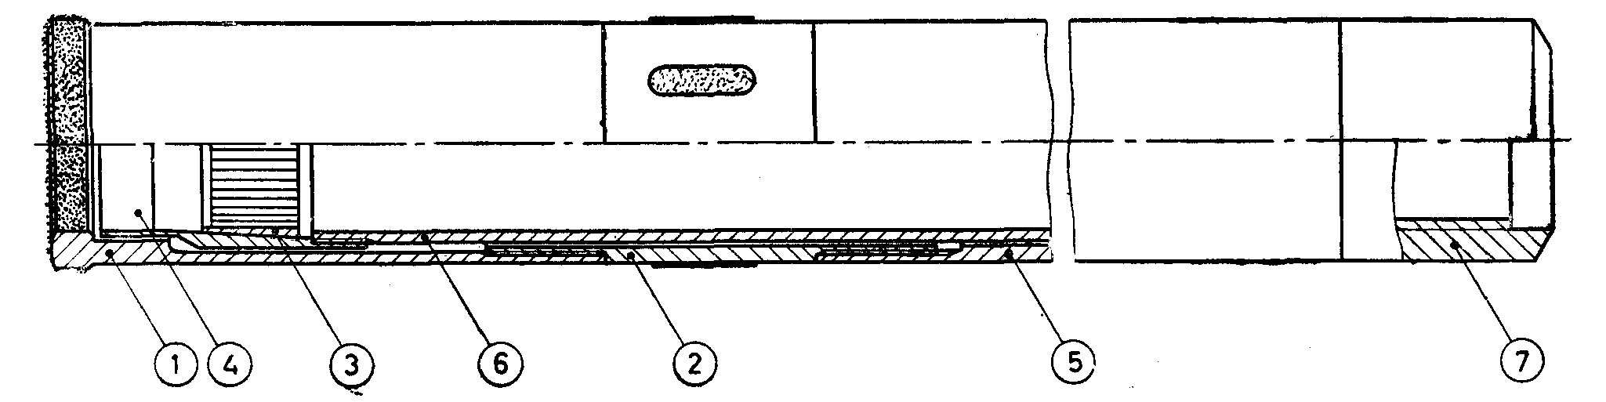

|  |  |
| --- | --- |
| *Key* | |
| 1 | Core bit |
| 2 | Reaming shell |
| 3 | Core lifter |
| 4 | Lifter case |
| 5 | Outer case |
| 6 | Inner tube |
| 7 | Head thread only |

'WM' Design Double Tube Core Barrels

**20.1.1** 'WM' design double tube core barrels shall have lengths of 1.5 m, 3.0 m and 6.0 m (lengths refer to core capacity).

**20.2 Detailed Dimensions**

**20.2.1** *'WM' Design Double Tube Core Barrel — Core Bit* (*see* Fig. 48)

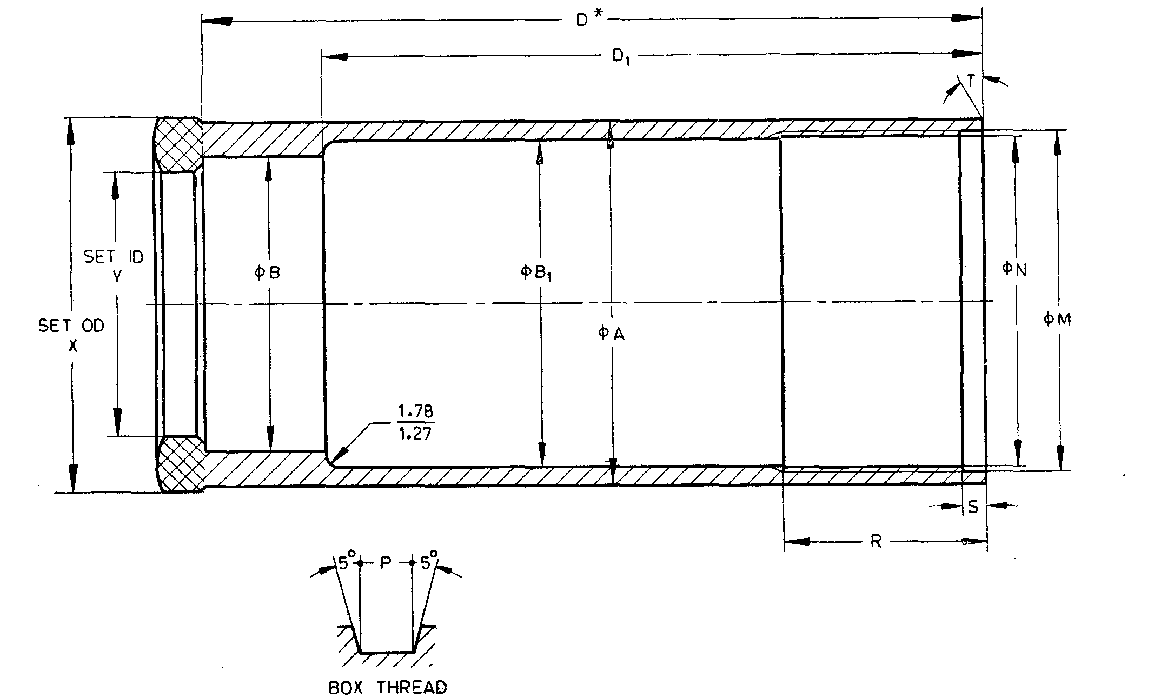

*Dimension from RH end to bottom of counter bore (⌀ B).

Fig. 48 'WM' Design Double Tube Core Barrel — Core Bit

All dimensions are in millimetres

|  |  |  |  |  |  |  |
| --- | --- | --- | --- | --- | --- | --- |
| *Sl No.* | *Dimension* | | *EWM* | *AWM* | *BWM* | *NWM* |
| (1) | (2) | | (3) | (4) | (5) | (6) |
| i) | *A* | *Max* | 36.09 | 46.15 | 57.94 | 73.86 |
| *Min* | 35.97 | 46.02 | 57.61 | 73.74 |
| ii) | *B* | *Max* | 27.10 | 35.31 | 46.81 | 61.24 |
| *Min* | 26.97 | 35.18 | 46.69 | 61.11 |
| iii) | *B*1 | *Max* | 31.80 | 40.49 | 52.40 | 68.38 |
| *Min* | 31.67 | 40.36 | 52.27 | 68.25 |
| iv) | *D* | *Max* | 124.48 | 124.48 | 122.94 | 153.16 |
| *Min* | 123.70 | 123.70 | 122.17 | 152.40 |
| v) | *D* | *Max* | 104.09 | 104.09 | 104.09 | 132.60 |
| *Min* | 103.84 | 103.84 | 103.84 | 132.41 |
| vi) | *M* | *Max* | 33.40 | 42.14 | 54.05 | 70.71 |
| *Min* | 33.35 | 42.09 | 54.00 | 70.66 |
| vii) | *N* | *Max* | 31.83 | 40.54 | 52.45 | 69.11 |
| *Min* | 31.78 | 40.49 | 52.40 | 69.08 |
| viii) | Thread pitch | | 3.175 | 3.175 | 3.175 | 3.175 |
| ix) | *P* | *Max* | 3.175 | 1.63 | 1.63 | 1.63 |
| *Min* | 1.55 | 1.55 | 1.55 | 1.55 |
| x) | *R* | *Max* | 32.25 | 32.25 | 32.25 | 35.42 |
| *Min* | 31.75 | 31.75 | 31.75 | 34.92 |
| xi) | *S* | *Max* | 3.43 | 3.43 | 3.43 | 3.43 |
| *Min* | 2.92 | 2.92 | 2.92 | 2.92 |
| xii) | *T* |  | 0° | 0° | 0° | 0° |
| xiii) | *X* | *Max* | 37.46 | 47.75 | 59.68 | 75.44 |
| *Min* | 37.21 | 47.50 | 59.44 | 75.18 |
| xiv) | *Y* | *Max* | 21.69 | 30.23 | 42.16 | 54.86 |
| *Min* | 21.24 | 29.97 | 41.91 | 54.61 |

**20.2.2** *'WM' Design Double Tube Core Barrel — Core Lifter Case* (*see* Fig. 49)

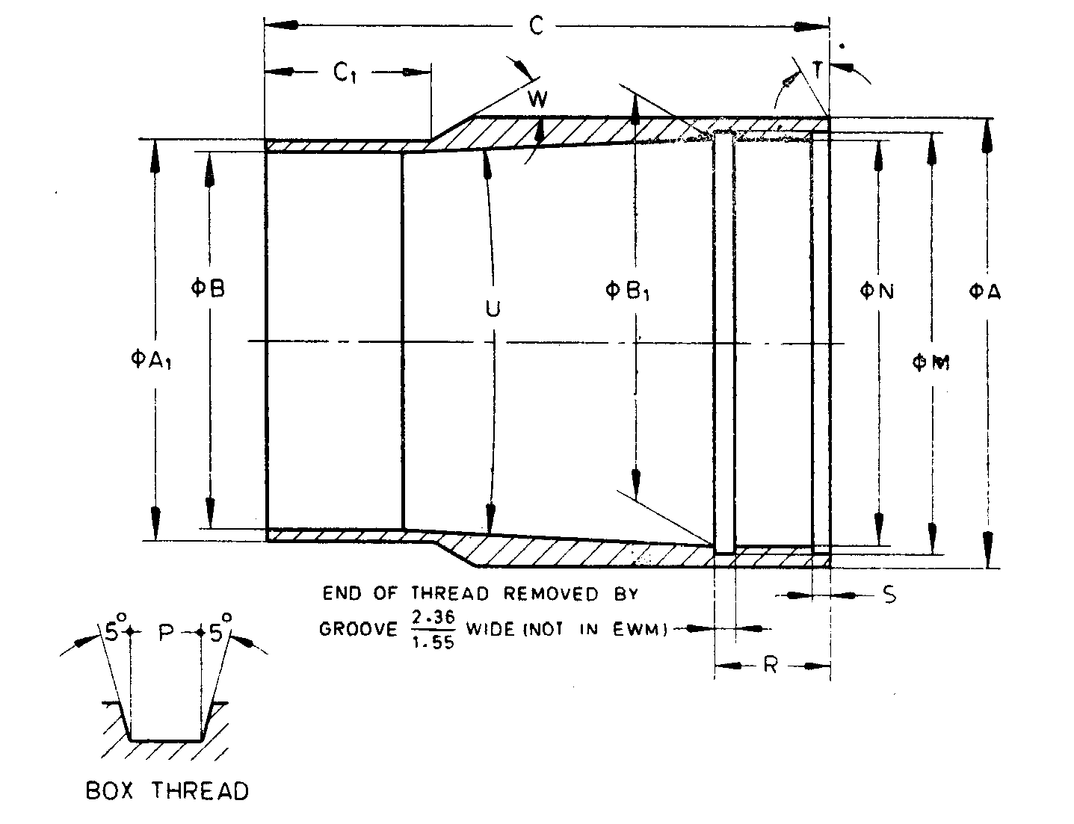

NOTE — This thread form does not apply to EWM size (*see* note below the tables).

Fig. 49 'WM' Design Double Tube Core Barrel — Core Lifter Case

All dimensions are in millimetres

|  |  |  |  |  |  |  |
| --- | --- | --- | --- | --- | --- | --- |
| *Sl No.* | *Dimension* | | *EWM* | *AWM* | *BWM* | *NWM* |
| (1) | (2) | | (3) | (4) | (5) | (6) |
| i) | *A* | *Max* | 30.15 | 38.89 | 50.80 | 66.68 |
|  | *Min* | 30.02 | 38.76 | 50.67 | 66.55 |
| ii) | *A*1 | *Max* | 25.45 | 33.55 | 45.29 | 59.56 |
|  | *Min* | 25.32 | 33.43 | 45.16 | 59.44 |
| iii) | *B* | *Max* | 23.09 | 31.19 | 42.90 | 57.20 |
|  | *Min* | 22.96 | 31.06 | 42.77 | 57.07 |
| iv) | *B*1 | *Max* | 26.24 | 34.16 | 46.08 | 61.95 |
|  | *Min* | 26.19 | 34.11 | 46.02 | 61.90 |
| v) | *C* | *Max* | 68.33 | 65.15 | 63.58 | 87.38 |
|  | *Min* | 68.20 | 65.02 | 63.45 | 87.25 |
| vi) | *C*1 | *Max* | 20.78 | 20.78 | 19.18 | 20.78 |
|  | *Min* | 20.52 | 20.52 | 18.92 | 20.52 |
| vii) | *M* | *Max* | 26.37 | 35.79 | 47.70 | 63.58 |
|  | *Min* | 26.21 | 35.74 | 47.65 | 63.53 |
| viii) | *N* | *Max* | 24.76 | 34.19 | 46.10 | 61.98 |
|  | *Min* | 24.71 | 34.14 | 46.05 | 61.93 |
| ix) | Thread pitch | | * | 3.175 | 3.175 | 3.175 |
| x) | *P* | *Max thread* | * | 1.63 | 1.63 | 1.63 |
|  | *Min thread* | * | 1.55 | 1.55 | 1.55 |
| xi) | *R* | *Max* | 11.23 | 12.83 | 12.83 | 16.00 |
|  | *Min* | 10.97 | 12.57 | 12.57 | 15.75 |
| xii) | *S* | *Max* | 1.70 | 1.70 | 1.70 | 1.70 |
|  | *Min* | 1.45 | 1.45 | 1.45 | 1.45 |
| xiii) | *T* | — | 0° | 0° | 0° | 0° |
| xiv) | *U* | *Max* | 5°15' | 5°15' | 5°15' | 5°15' |
| xv) | *Min* | 4°45' | 4°45' | 4°45' | 4°45' |
| xvi) | *W* | — | 30° | 30° | 30° | 30° |
| *The thread dimension for the EWM shall be according to established practices. | | | | | | |

**20.2.3** *'WM' Design Double Tube Core Barrel — Core Lifter* (*see* Fig. 50)

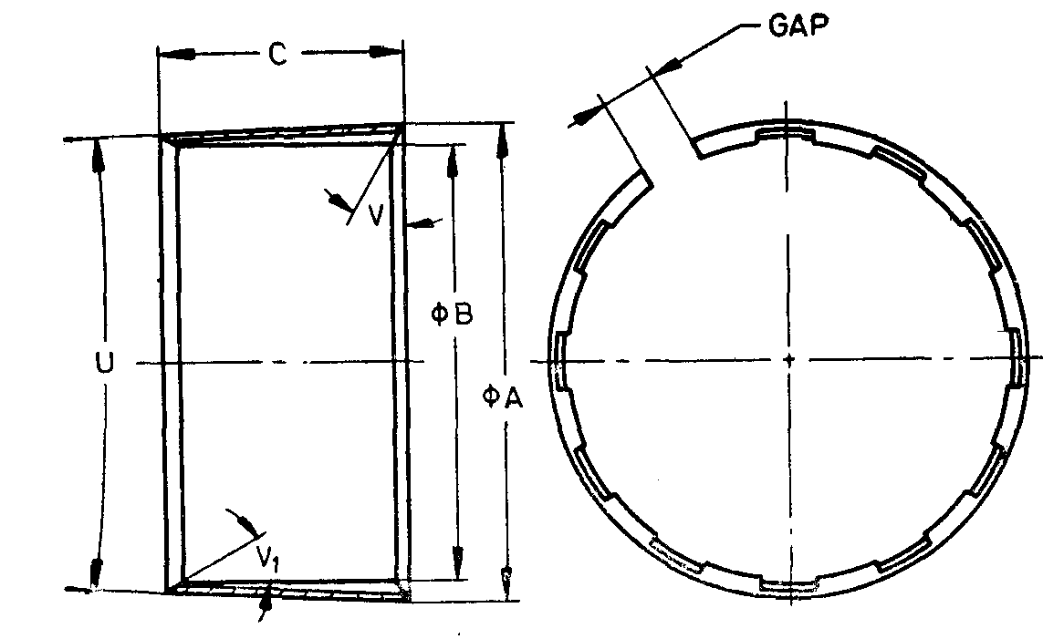

NOTES

**1** Width of gap, entry angle and number of flutes are at the discretion of manufacturer.  
**2** Core lifter with external flutes if required by purchaser, shall conform to dimensions specified in this clause.

Fig. 50 'WM' Design Double Tube Core Barrel — Core Lifter

All dimensions are in millimetres

|  |  |  |  |  |  |  |
| --- | --- | --- | --- | --- | --- | --- |
| *Sl No.* | *Dimension* | | *EWM* | *AWM* | *BWM* | *NWM* |
| (1) | (2) | | (3) | (4) | (5) | (6) |
| i) | *A* | *Max* | 25.32 | 33.25 | 45.03 | 60.91 |
|  | *Min* | 25.22 | 33.15 | 44.93 | 90.81 |
| ii) | *B* | *Max* | 21.08 | 29.72 | 41.53 | 54.23 |
|  | *Min* | 20.98 | 29.62 | 41.43 | 54.13 |
| iii) | *C* | *Max* | 19.43 | 22.61 | 22.61 | 35.31 |
|  | *Min* | 18.67 | 21.84 | 21.84 | 34.54 |
| iv) | *U* | *Max* | 5°15' | 5°15' | 5°15' | 5°15' |
|  | *Min* | 4°45' | 4°45' | 4°45' | 4°43' |
| v) | *V* | — | 0° | 0° | 0° | 0° |
| vi) | *V*1 | — | Optional | | | |

**20.2.4** *'WM' Design Double Tube Core Barrel — Outer Tube* (*see* Fig. 51)

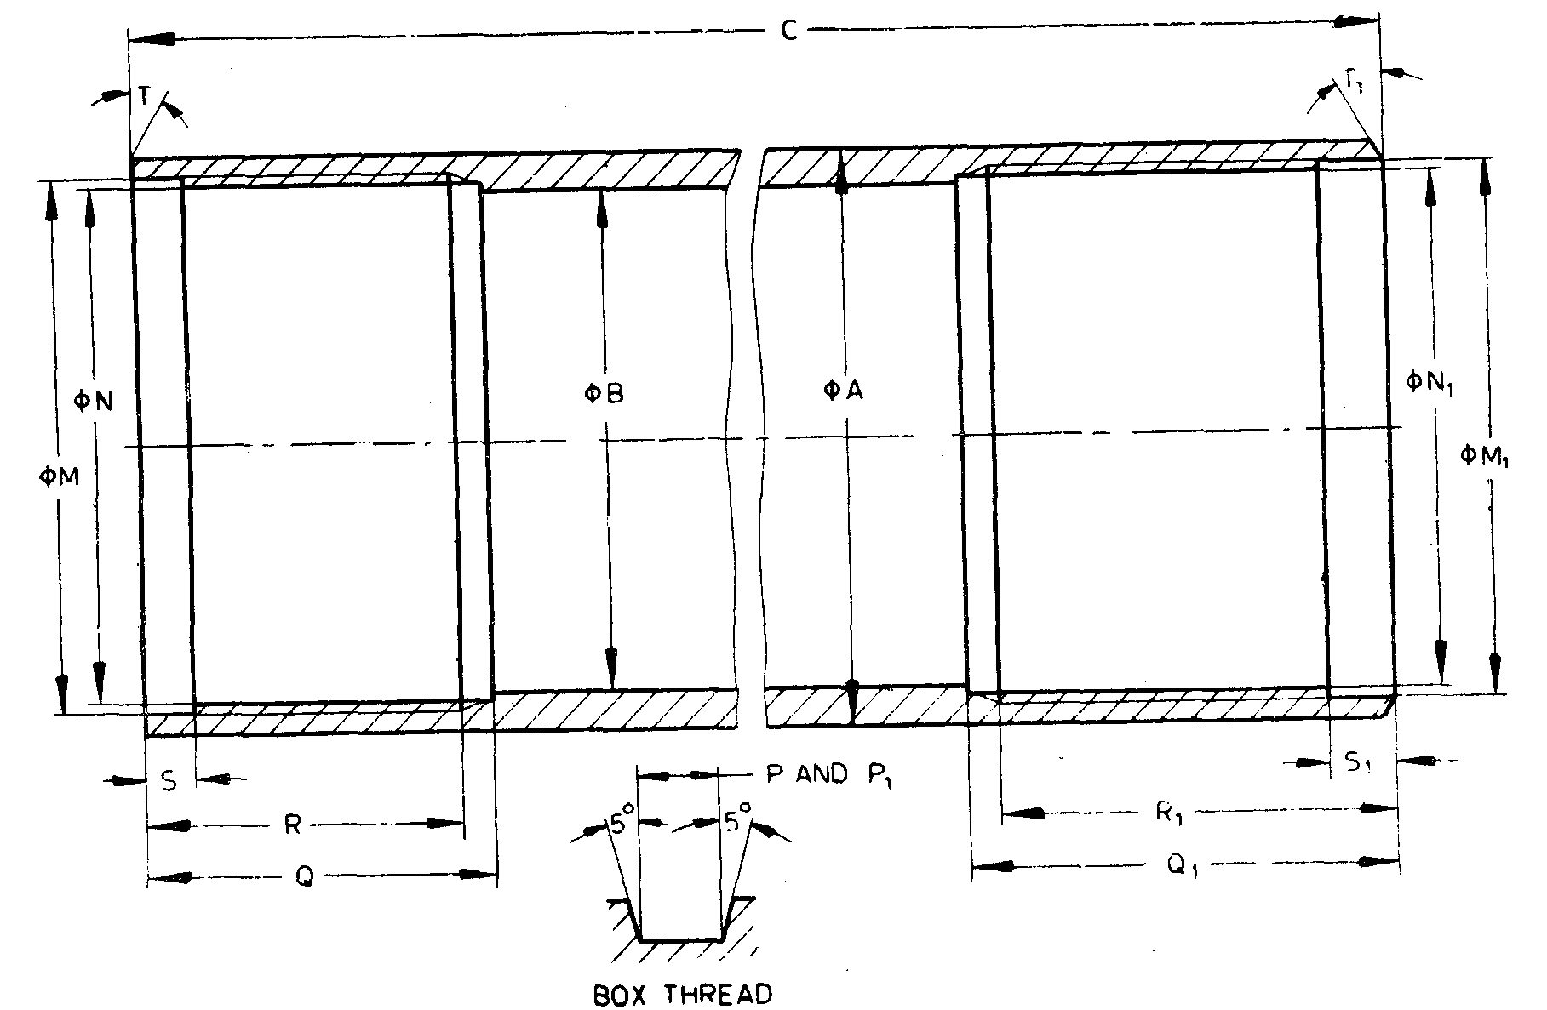

Fig. 51 'WM' Design Double Tube Core Barrel — Outer Tube

All dimensions are in millimetres.

|  |  |  |  |  |  |  |
| --- | --- | --- | --- | --- | --- | --- |
| *Sl No.* | *Dimension* | *EWM* | | *AWM* | *BWM* | *NWM* |
| (1) | (2) | (3) | | (4) | (5) | (6) |
| i) | *A* | *Max* | 36.63 | 46.28 | 58.19 | 74.07 |
|  | *Min* | 36.50 | 46.02 | 57.94 | 73.81 |
| ii) | *B* | *Max* | 30.15 | 38.89 | 50.80 | 66.68 |
|  | *Min* | 30.05 | 38.63 | 50.55 | 66.42 |
| iii) | *C* | *Max* | 3 053.18 | 3 142.84 | 3 147.59 | 3 148.00 |
|  | *Min* | 3 052.34 | 3 142.06 | 3 146.81 | 3 147.21 |
| iv) | *M* | *Max* | 33.40 | 42.14 | 54.05 | 70.71 |
|  | *Min* | 33.35 | 42.09 | 54.00 | 70.66 |
| v) | *N* | *Max* | 31.83 | 40.54 | 52.45 | 69.11 |
|  | *Min* | 31.78 | 40.49 | 52.40 | 69.06 |
| vi) | Thread pitch | 3.175 | | 3.175 | 3.175 | 3.175 |
| vii) | *P* | *Max* | 1.63 | 1.63 | 1.63 | 1.63 |
|  | *Min* | 1.55 | 1.55 | 1.55 | 1.55 |
| viii) | *Q* | *Max* | 35.42 | 35.42 | 35.42 | 38.60 |
|  | *Min* | 34.92 | 34.92 | 34.92 | 38.10 |
| ix) | *R* | *Max* | 32.25 | 32.25 | 32.25 | 35.42 |
|  | *Min* | 31.75 | 31.75 | 31.75 | 34.92 |
| x) | *S* | *Max* | 5.00 | 5.00 | 5.00 | 5.00 |
|  | *Min* | 4.50 | 4.50 | 4.50 | 4.50 |
| xi) | *T* | - | 0° | 0° | 0° | 0° |
| xii) | *M*1 | *Max* | 31.83 | 42.14 | 54.05 | 69.93 |
|  | *Min* | 31.78 | 42.09 | 54.00 | 69.88 |
| xiii) | *N*1 | *Max* | 30.23 | 40.54 | 52.45 | 68.33 |
|  | *Min* | 30.18 | 40.49 | 54.40 | 68.28 |
| xiv) | Thread pitch | 3.175 | | 3.175 | 3.175 | 3.175 |
| xv) | *P*1 | *Max* | 1.63 | 1.63 | 1.63 | 1.63 |
|  | *Min* | 1.55 | 1.55 | 1.55 | 1.55 |
| xvi) | *Q*1 | *Max* | 30.65 | 37.00 |  |  |
|  | *Min* | 30.15 | 36.50 | 42.85 | 49.20 |
| xvii) | *R*1 |  | 42.88 | 55.58 | 55.58 | 55.58 |
| xviii) | *S*1 | *Max* | 6.60 | 6.60 | 6.60 | 6.60 |
|  | *Min* | 6.10 | 6.10 | 6.00 | 6.10 |
| xix) | *T*1 |  | 30° | 30° | 30° | 30° |

**20.2.5** *'WM' Design Double Tube Core Barrel — Inner Tube* (*see* Fig. 52)

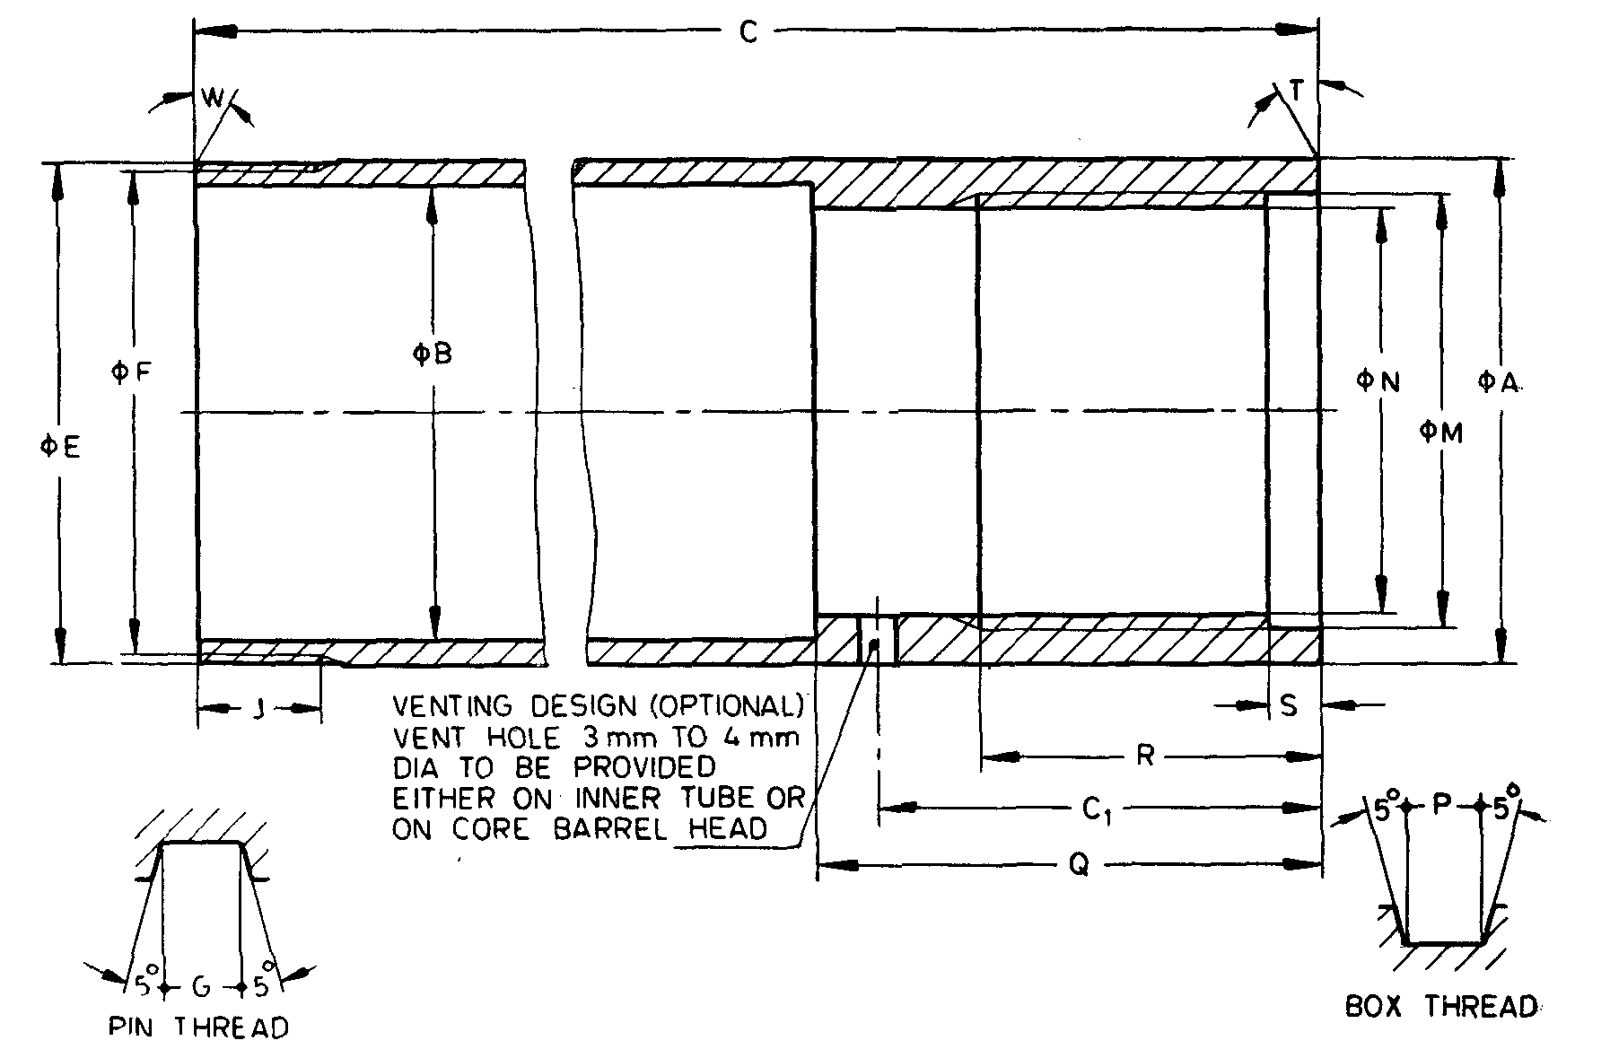

NOTES

**1** Dimension *C*1 is applicable only if vent hole is provided on inner tube.  
**2** Top end of inner tube need not be integral method of manufacture optional.

Fig. 52 'WM' Design Double Tube Core Barrel — Inner Tube

All dimensions are in millimetres.

|  |  |  |  |  |  |  |
| --- | --- | --- | --- | --- | --- | --- |
| *Sl No.* | *Dimension* | | *EWM* | *AWM* | *BWM* | *NWM* |
| (1) | (2) | | (3) | (4) | (5) | (6) |
| i) | *A* | *Max* | 27.10 | 35.97 | 47.88 | 63.75 |
| *Min* | 26.97 | 35.71 | 47.62 | 63.50 |
| ii) | *B* | *Max* | 23.80 | 31.75 | 43.64 | 57.15 |
| *Min* | 23.67 | 31.50 | 43.38 | 56.90 |
| iii) | *C* | *Max* | 3 083.31 | 3 091.26 | 3 096.01 | 3 105.53 |
| *Min* | 3 082.52 | 3 090.44 | 3 095.22 | 3 104.74 |
| iv) | *C*1 | *Max* | 29.34 | 37.26 | 42.04 | 51.56 |
| *Min* | 27.81 | 35.74 | 40.51 | 50.04 |
| v) | *E* | *Max* | 26.16 | 35.69 | 47.60 | 63.47 |
| *Min* | 26.01 | 35.64 | 47.55 | 63.42 |
| vi) | *F* | *Max* | * | 34.09 | 46.00 | 61.87 |
| *Min* | * | 33.96 | 45.87 | 61.75 |
| vii) | Thread pitch | | * | 3.175 | 3.175 | 3.175 |
| viii) | *G* | *Max* | * | 1.63 | 1.63 | 1.63 |
| *Min* | * | 1.55 | 1.55 | 1.55 |
| ix) | *J* | *Max* | 11.23 | 11.23 | 11.23 | 16.00 |
| *Min* | 10.97 | 10.97 | 10.97 | 15.75 |
| x) | *M* | *Max* | 20.70 | 29.44 | 41.35 | 57.23 |
| *Min* | 20.65 | 29.39 | 41.30 | 57.18 |
| xi) | *N* | *Max* | 19.13 | 27.05 | 38.96 | 54.84 |
| *Min* | 19.08 | 27.00 | 38.91 | 54.79 |
| xii) | Thread pitch | | 3.175 | 3.175 | 3.175 | 3.175 |
| xiii) | *P* | *Max* | 1.63 | 1.63 | 1.63 | 1.63 |
| *Min* | 1.55 | 1.55 | 1.55 | 1.55 |
| xiv) | *Q* | *Max* | 35.31 | 43.23 | 48.01 | 57.53 |
| *Min* | 34.54 | 42.47 | 47.24 | 56.77 |
| xv) | *R* | *Max* | 22.72 | 32.25 | 32.25 | 32.28 |
| *Min* | 22.22 | 31.75 | 31.75 | 31.75 |
| xvi) | *S* | *Max* | 5.00 | 5.00 | 5.00 | 5.00 |
| *Min* | 4.50 | 4.50 | 4.50 | 4.50 |
| xvii) | *T* | — | 0° | 0° | 0° | 0° |
| xviii) | *W* | — | 0° | 0° | 0° | 0° |
| *The thread dimensions for the EWM shall be according to established practices. | | | | | | |

**20.2.6** *'WM' Design Double Core Barrel — Head* (*see* Fig. 53)

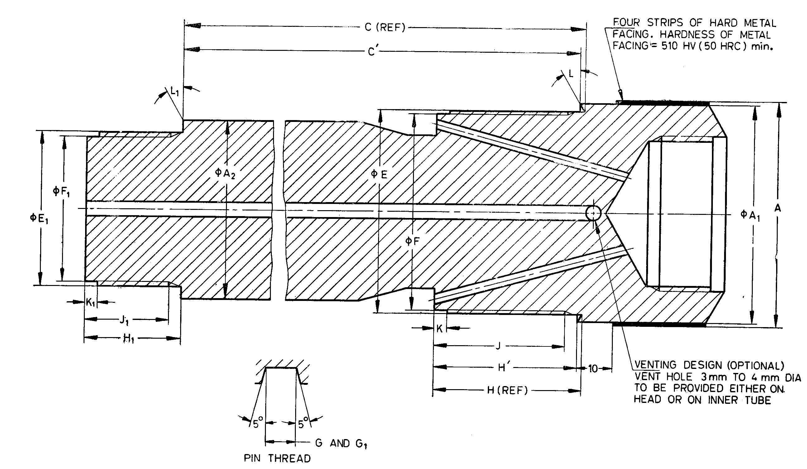

NOTE — The hardness of metal facing in HRC is approximate value

Fig. 53 'WM' Design Double Core Barrel — Head

All dimensions are in millimetres.

|  |  |  |  |  |  |  |
| --- | --- | --- | --- | --- | --- | --- |
| *Sl No.* | *Dimension* | | *\*EWM* | *\*AWM* | *\*BWM†* | *\*NWM†* |
| (1) | (2) | | (3) | (4) | (5) | (6) |
| i) | *A* | *Max* | 36.90 | 47.12 | 58.93 | 74.55 |
| *Min* | 36.78 | 47.00 | 58.81 | 74.42 |
| ii) | *A*1 | *Max* | 36.63 | 46.15 | 58.06 | 73.94 |
| *Min* | 36.37 | 45.90 | 57.81 | 73.69 |
| iii) | *A*2 | *Max* | 27.10 | 35.97 | 47.88 | 63.75 |
| *Min* | 26.97 | 35.71 | 47.63 | 63.50 |
| iv) | *C* | *Max* | 84.23 | 170.54 | 170.54 | 170.54 |
| *Min* | 83.59 | 169.90 | 169.90 | 169.90 |
| v) | *C'* | *Max* | 82.84 | 169.39 | 169.38 | 169.38 |
| *Min* | 82.20 | 168.75 | 168.74 | 168.74 |
| vi) | *E* | *Max* | 31.72 | 42.04 | 53.95 | 69.82 |
| *Min* | 31.67 | 41.99 | 53.90 | 69.77 |
| vii) | *F* | *Max* | 30.12 | 40.44 | 52.35 | 68.22 |
| *Min* | 30.00 | 40.31 | 52.22 | 68.10 |
| viii) | Thread pitch | | 3.175 | 3.175 | 3.175 | 3.175 |
| ix) | *G* | *Max* | 1.63 | 1.63 | 1.63 | 1.63 |
| *Min* | 1.55 | 1.55 | 1.55 | 1.55 |
| x) | *H* | *Max* | 26.77 | 32.92 | 39.27 | 45.62 |
| *Min* | 26.39 | 32.54 | 38.89 | 45.24 |
| xi) | *H'* | *Max* | 25.28 | 31.77 | 38.11 | 44.46 |
| *Min* | 25.00 | 31.29 | 37.73 | 44.08 |
| xii) | *J* | *Min* | 22.22 | 28.58 | 34.92 | 41.28 |
| xiii) | *K* | *Max* | 3.43 | 3.43 | 3.43 | 3.43 |
| *Min* | 2.92 | 2.92 | 2.92 | 2.92 |
| xiv) | *L* |  | 30° | 30° | 30° | 30° |
| xv) | *E*1 | *Max* | 20.60 | 29.34 | 41.25 | 57.12 |
| *Min* | 20.55 | 29.29 | 41.20 | 57.07 |
| xvi) | *F*1 | *Max* | 19.02 | 26.95 | 38.86 | 54.74 |
| *Min* | 18.90 | 26.82 | 38.74 | 54.61 |
| xvii) | Thread pitch | | 3.175 | 3.175 | 3.175 | 3.175 |
| xviii) | *G*1 | *Max* | 1.63 | 1.63 | 1.63 | 1.63 |
| *Min* | 1.55 | 1.55 | 1.55 | 1.55 |
| xix) | *H*1 | *Max* | 19.05 | 22.22 | 25.40 | 28.58 |
| *Min* | 18.67 | 21.84 | 25.02 | 28.19 |
| xx) | *J*1 |  | 15.88 | 19.05 | 22.22 | 25.40 |
| xxi) | *K*1 | *Max* | 3.43 | 3.43 | 3.43 | 3.43 |
| *Min* | 2.92 | 2.92 | 2.92 | 2.92 |
| xxii) | *L*1 | — | 0° | 0° | 0 | 0° |
| Road thread connection | | EW | AW | BW | NW |
| *These items are interchangeable with the ‘WG’ design core barrels.  †These items are interchangeable with the ‘WT’ design core barrels. | | | | | | |

**20.2.7** *'WM' Design Double Tube Core Barrel — Reaming Shell* (*see* Fig. 54)

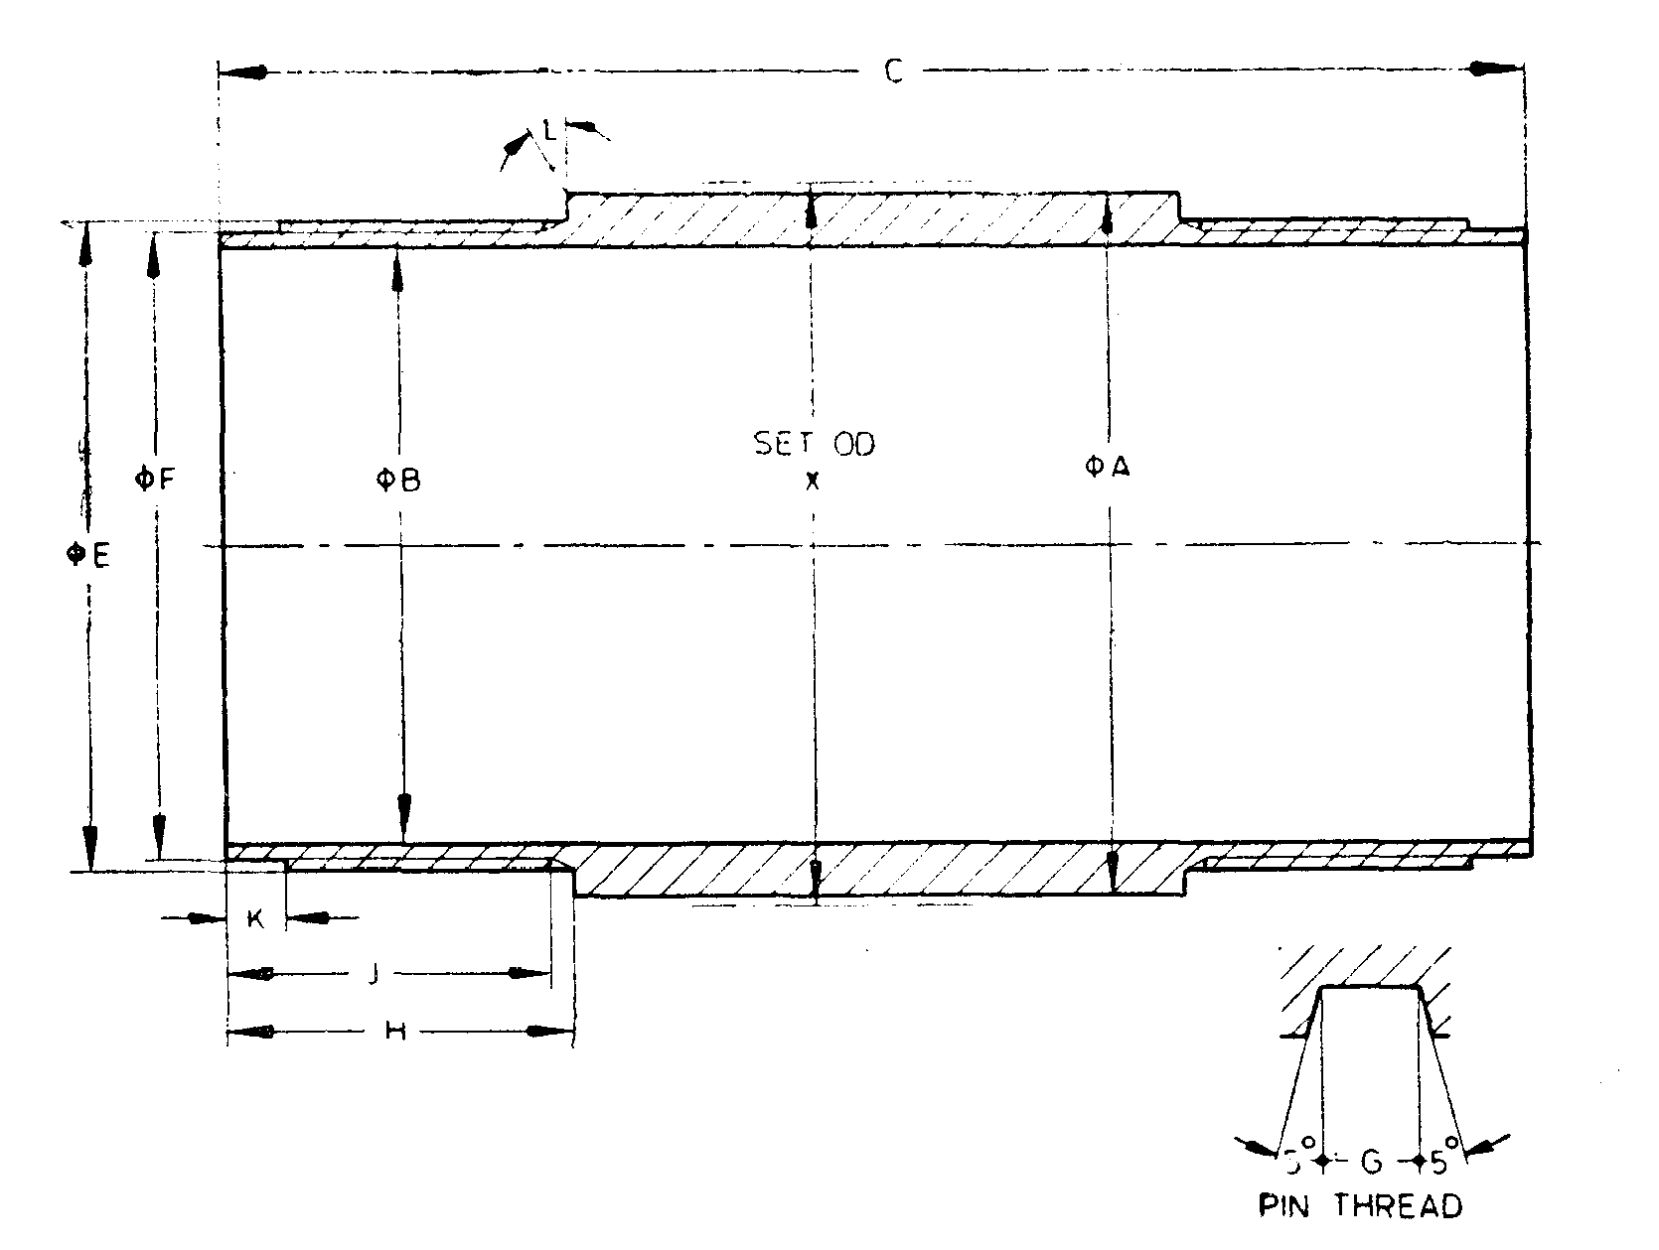

NOTE — Dimensions shown apply to both ends.

Fig. 54 'WM' Design Double Tube Core Barrel — Reaming Shell

All dimensions are in millimetres.

|  |  |  |  |  |  |  |
| --- | --- | --- | --- | --- | --- | --- |
| *Sl No.* | *Dimension* | | *EWM* | *AWM* | *BWM* | *NWM* |
| (1) | (2) | | (3) | (4) | (5) | (6) |
| i) | *A* | *Max* | 36.37 | 46.66 | 58.47 | 74.09 |
|  | *Min* | 36.27 | 46.56 | 58.37 | 73.99 |
| ii) | *B* | *Max* | 29.44 | 38.18 | 50.04 | 65.99 |
|  | *Min* | 29.31 | 38.05 | 49.91 | 65.86 |
| iii) | *C* | *Max* | 108.20 | 108.20 | 108.20 | 114.55 |
|  | *Min* | 107.70 | 107.70 | 107.70 | 114.05 |
| iv) | *E* | *Max* | 33.30 | 42.04 | 53.95 | 70.61 |
|  | *Min* | 33.25 | 41.99 | 53.90 | 70.56 |
| v) | *F* | *Max* | 31.72 | 40.44 | 52.35 | 69.01 |
|  | *Min* | 31.60 | 40.31 | 52.22 | 68.88 |
| vi) | Thread pitch | | 3.175 | 3.175 | 3.175 | 3.175 |
| vii) | *G* | *Max* | 1.63 | 1.63 | 1.63 | 1.63 |
|  | *Min* | 1.55 | 1.55 | 1.55 | 1.55 |
| viii) | *H* | *Max* | 28.83 | 28.83 | 28.83 | 32.00 |
|  | *Min* | 28.32 | 28.32 | 28.32 | 31.50 |
| ix) | *J* | *Min* | 26.97 | 26.97 | 26.97 | 30.15 |
| x) | *K* | *Max* | 5.00 | 5.00 | 5.00 | 5.00 |
|  | *Min* | 4.50 | 4.50 | 4.50 | 4.50 |
| xi) | *L* | *—* | 0° | 0° | 0° | 0° |
| xii) | *X* | *Max* | 37.85 | 48.13 | 60.07 | 75.82 |
|  | *Min* | 37.59 | 47.88 | 59.82 | 75.56 |

**SECTION 6 CORE BARRELS — 'WT' DESIGN**

**21 'WT' DESIGN SINGLE TUBE CORE BARREL (BWT, NWT AND HWT SIZES**)

**21.1 Nomenclature**

A typical assembly of single tube core barrel of BWT, NWT and HWT sizes is shown below (*see* Fig. 55):

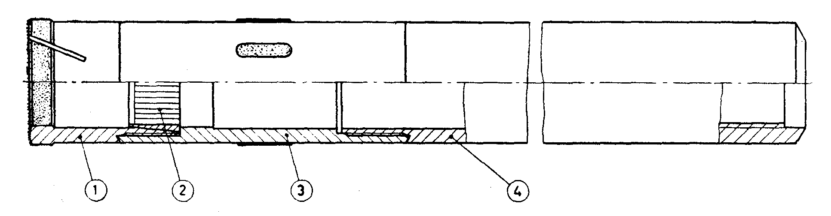

|  |  |
| --- | --- |
| *Key* |  |
| 1 | Core bit |
| 2 | Core Lifter |
| 3 | Reaming shell |
| 4 | Tube |

Fig. 55 'WT' Design Single Tube Core Barrel (BWT, NWT and HWT Sizes)

**21.1.1** Bits and core lifters of single tube core lifters are interchangeable with bits and core lifters of double tube core barrels (for dimensions *see* **22.1.2.1** and **22.1.2.2**).

**21.1.2** Standard 'WT' design core barrels shall have lengths of 1 500 mm, 3 000 mm, 6 000 mm, and 6 000 mm (lengths refer to core capacity).

**21.2 Detailed Dimensions**

**21.2.1** *'WT' Design Single Tube Core Barrel* — *Tube* (*see* Fig. 56)

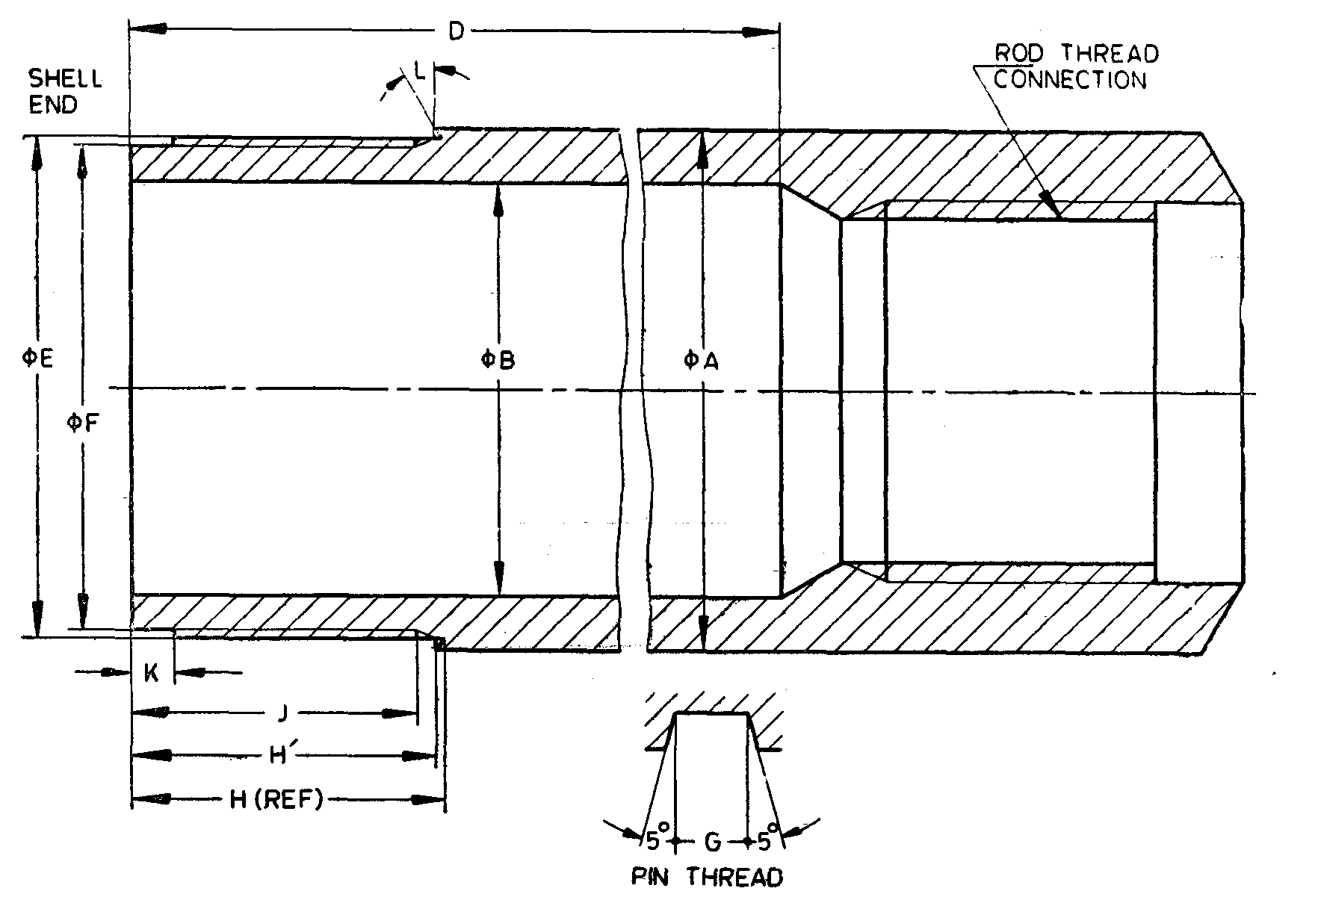

Fig. 56 'WT' Design Single Tube Core Barrel — Tube

All dimensions are in miliimetres.

|  |  |  |  |  |  |
| --- | --- | --- | --- | --- | --- |
| *Sl No.* | *Dimension* | | *BWT* | *NWT* | *HWT* |
| (1) | (2) | | (3) | (4) | (5) |
| i) | *A* | *Max* | 58.98 | 74.07 | 97.21 |
|  | *Min* | 58.72 | 73.81 | 96.82 |
| ii) | *B* | *Max* | 46.84 | 61.90 | 84.12 |
|  | *Min* | 46.58 | 61.65 | 83.62 |
| iii) | *D* | *Min* | 2 981.32 | 2 981.32 | 2 981.32 |
| iv) | *E* | *Max* | 56.24 | 71.60 | 94.49 |
|  | *Min* | 56.18 | 71.55 | 94.44 |
| v) | *F* | *Max* | 54.66 | 70.03 | 92.91 |
|  | *Min* | 54.58 | 69.95 | 92.79 |
| vi) | Thread pitch | | 3.175 | 3.175 | 5.080 |
| vii) | *G* | *Max* | 1.63 | 1.63 | 2.59 |
|  | *Min* | 1.55 | 1.55 | 2.51 |
| viii) | *H* | *Max* | 35.28 | 38.43 | 44.81 |
|  | *Min* | 35.15 | 38.30 | 44.68 |
| ix) | *H'* | *Max* | 34.93 | 38.11 | 44.47 |
|  | *Min* | 34.80 | 37.98 | 44.34 |
| x) | *L* | *Min* | 31.75 | 34.92 | 41.28 |
| xi) | *K* | *Max* | 5.00 | 5.00 | 5.79 |
|  | *Min* | 4.50 | 4.50 | 5.28 |
| xii) | *L* | — | 15° | 15° | 15° |
| xiii) | Road thread connection | | BW | NW | HW |

**21.2.2** *'WT' Design Single Tube Core Barrel — Reaming Shell* (*see* Fig. 57)

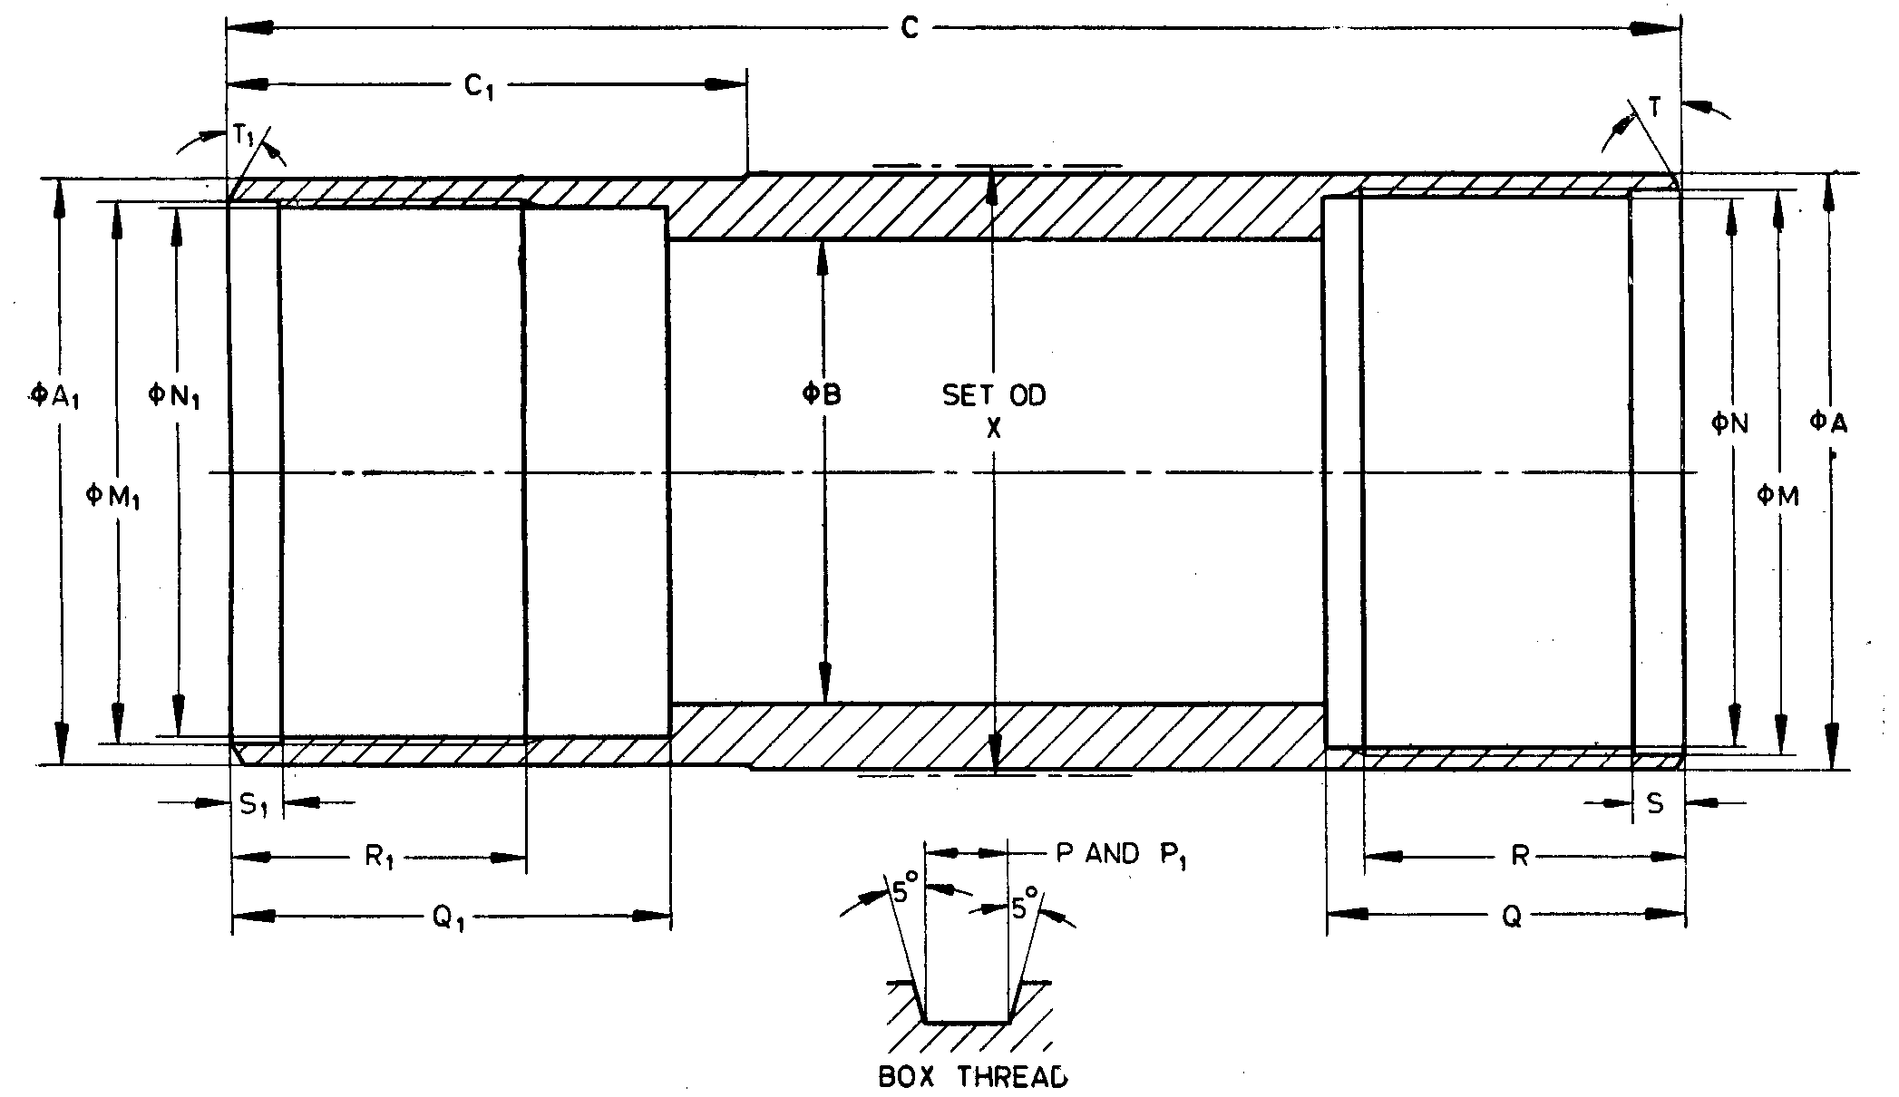

Fig. 57 'WT' Design Single Tube Core Barrel — Reaming Shell

All dimensions are in millimetres.

|  |  |  |  |  |  |
| --- | --- | --- | --- | --- | --- |
| *Sl No.* | *Dimension* | | *BWT* | *NWT* | *HWT* |
| (1) | (2) | | (3) | (4) | (5) |
| i) | *A* | *Max* | 58.93 | 74.55 | 97.94 |
|  | *Min* | 58.83 | 74.45 | 94.84 |
| ii) | *A*1 | *Max* | 58.60 | 74.27 | 97.71 |
|  | *Min* | 58.50 | 74.17 | 94.61 |
| iii) | *B* | *Max* | 46.08 | 60.38 | 82.60 |
|  | *Min* | 45.97 | 60.27 | 82.50 |
| iv) | *C* | *Max* | 168.91 | 175.26 | 191.14 |
|  | *Min* | 168.28 | 174.62 | 190.50 |
| v) | *C*1 | *Max* | 51.18 | 54.36 | 63.88 |
|  | *Min* | 50.42 | 53.59 | 63.12 |
| vi) | *M* | *Max* | 56.34 | 71.70 | 94.59 |
|  | *Min* | 56.29 | 71.65 | 94.54 |
| vii) | *N* | *Max* | 54.76 | 70.13 | 93.01 |
|  | *Min* | 54.71 | 70.08 | 92.96 |
| viii) | Thread pitch | | 3.175 | 3.175 | 5.080 |
| ix) | *P* | *Max* | 1.63 | 1.63 | 2.59 |
|  | *Min* | 1.55 | 1.55 | 2.51 |
| x) | *Q* | *Max* | 35.41 | 38.56 | 44.93 |
|  | *Min* | 35.28 | 38.43 | 44.81 |
| xi) | *R* | *Max* | 32.25 | 35.42 | 41.78 |
|  | *Min* | 31.75 | 34.92 | 41.28 |
| xii) | *S* | *Max* | 5.00 | 5.00 | 5.79 |
|  | *Min* | 4.50 | 4.50 | 5.20 |
| xiii) | *T* | *—* | 15° | 15° | 15° |
| xiv) | *M*1 | *Max* | 53.98 | 69.24 | 92.46 |
|  | *Min* | 53.92 | 69.19 | 92.41 |
| xv) | *N*1 | *Max* | 52.45 | 67.72 | 90.93 |
|  | *Min* | 52.40 | 67.67 | 90.88 |
| xvi) | Thread pitch | | 3.175 | 3.175 | 5.08 |
| xvii) | *P*1 | *Max* | 1.63 | 1.63 | 2.59 |
|  | *Min* | 1.55 | 1.55 | 2.51 |
| xviii) | *Q*1 | *Max* | 42.85 | 46.02 | 54.25 |
|  | *Min* | 42.34 | 45.52 | 53.75 |
| xix) | *R*1 | *Max* | 29.08 | 32.25 | 38.60 |
|  | *Min* | 28.58 | 31.75 | 38.10 |
| xx) | *S*1 | *Max* | 5.00 | 5.00 | 5.79 |
|  | *Min* | 4.50 | 4.50 | 5.28 |
| xxi) | *T*1 | — | 15° | 15° | 15° |
| xxii) | *X* | *Max* | 60.07 | 75.82 | 99.36 |
|  | *Min* | 59.82 | 75.56 | 99.11 |

**22 'WT' DESIGN DOUBLE TUBE CORE BARREL**

**22.1 'WT Design Double Tube Core Barrel (For BWT, NWT and HWT Sizes)**

**22.1.1** *Nomenclature*

A typical assembly of double tube core barrel of BWT, NWT and HWT sizes is shown below (*see* Fig. 58):

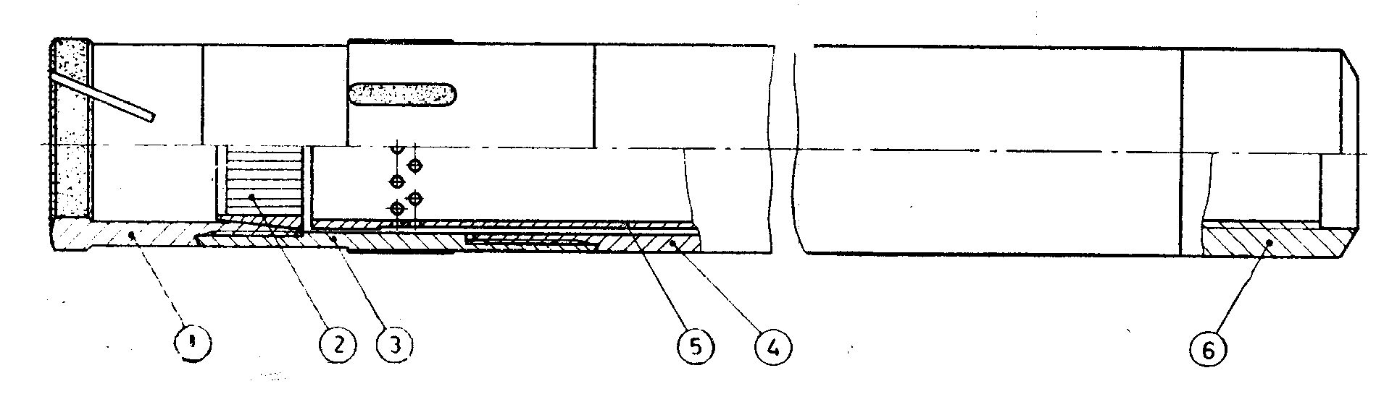

|  |  |
| --- | --- |
| *Key* |  |
| 1 | Core bit |
| 2 | Core lifter |
| 3 | Reaming shell |
| 4 | Outer tube |
| 5 | Inner tube |
| 6 | Head rigid or swivel |

Fig. 58 'WT’ Design Double Tube Core Barrel (For BWT, NWT and HWT Sizes)

**22.1.1.1** Bits and core lifters of double tube core barrels are interchangeable with single tube core barrels.

**22.1.1.2** 'WT' design double tube core barrels for BWT, NWT, and HWT sizes shall have  
lengths of 1 500 mm, 3 000 mm, and 6 000 mm (lengths refers to core capacity).

**22.1.2** *Detailed Dimensions*

**22.1.2.1** *'WT' Design Double Tube Core Barrel — Bewel Wall Core Bit* (*see* Fig. 59)

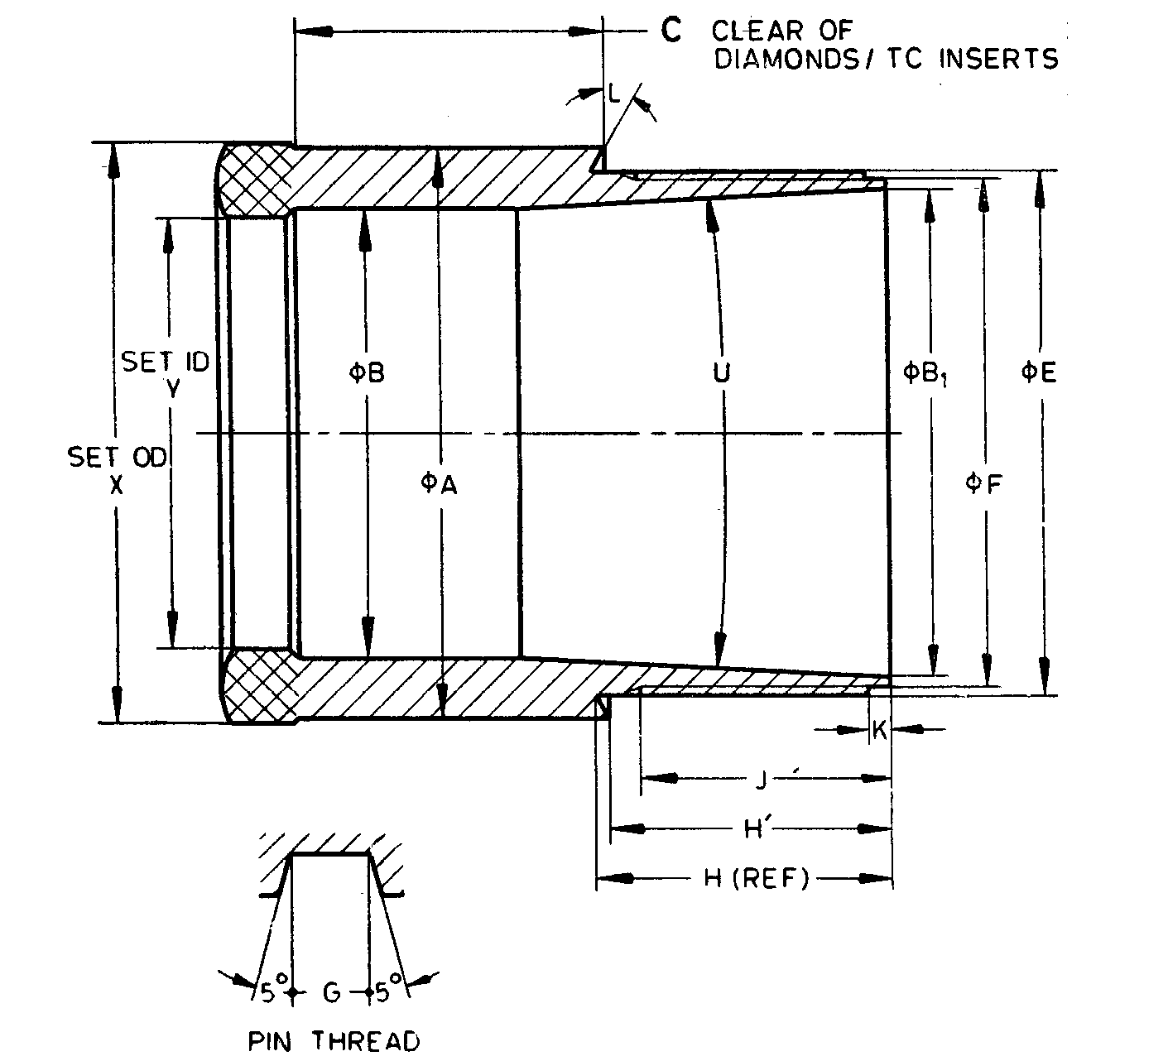

Fig. 59 'WT' Design Double Tube Core Barrel — Bewel Wall Core Bit

All dimensions are in millimetres.

|  |  |  |  |  |  |
| --- | --- | --- | --- | --- | --- |
| *Sl No.* | *Dimension* | | *BWT* | *NWT* | *HWT* |
| (1) | (2) | | (3) | (4) | (5) |
| i) | *A* | *Max* | 58.60 | 74.27 | 97.71 |
|  | *Min* | 58.50 | 74.17 | 97.61 |
| ii) | *B* | *Max* | 46.23 | 60.53 | 82.73 |
|  | *Min* | 45.97 | 60.27 | 82.47 |
| iii) | *B*1 | *Max* | 50.39 | 65.74 | 88.75 |
|  | *Min* | 50.29 | 65.63 | 89.65 |
| iv) | *C* | *Min* | 31.75 | 34.93 | 38.10 |
| v) | *E* | *Max* | 53.87 | 69.14 | 92.35 |
|  | *Min* | 53.82 | 69.09 | 92.30 |
| vi) | *F* | *Max* | 52.35 | 67.61 | 90.83 |
|  | *Min* | 52.27 | 67.54 | 90.75 |
| vii) | Thread pitch | | 3.175 | 3.175 | 5.080 |
| viii) | *G* | *Max* | 1.63 | 1.63 | 2.59 |
|  | *Min* | 1.55 | 1.55 | 2.51 |
| ix) | *H* | *Max* | 29.46 | 32.69 | 39.07 |
|  | *Min* | 28.96 | 32.18 | 38.56 |
| x) | *H'* | *Max* | 28.83 | 32.01 | 38.35 |
| xi) | *Min* | 28.33 | 31.50 | 37.84 |
|  | *J* | *Min* | 25.40 | 28.58 | 34.93 |
| xii) | *K* | *Max* | 1.83 | 1.83 | 1.83 |
|  | *Min* | 1.32 | 1.32 | 1.32 |
| xiii) | *L* | *—* | 15° | 15° | 15° |
| xiv) | *U* | *Max* | 6°15' | 6°15' | 6°15' |
|  | *Min* | 5°45' | 5°45' | 5°45' |
| xv) | *X* | *Max* | 59.69 | 75.44 | 98.98 |
|  | *Min* | 59.44 | 75.18 | 98.60 |
| xvi) | *Y* | *Max* | 44.58 | 58.88 | 81.08 |
|  | *Min* | 44.32 | 58.62 | 80.82 |

**22.1.2.2** *'W T' Design Double Tube Core Barrel — Core Lifter* (*see* Fig. 60)

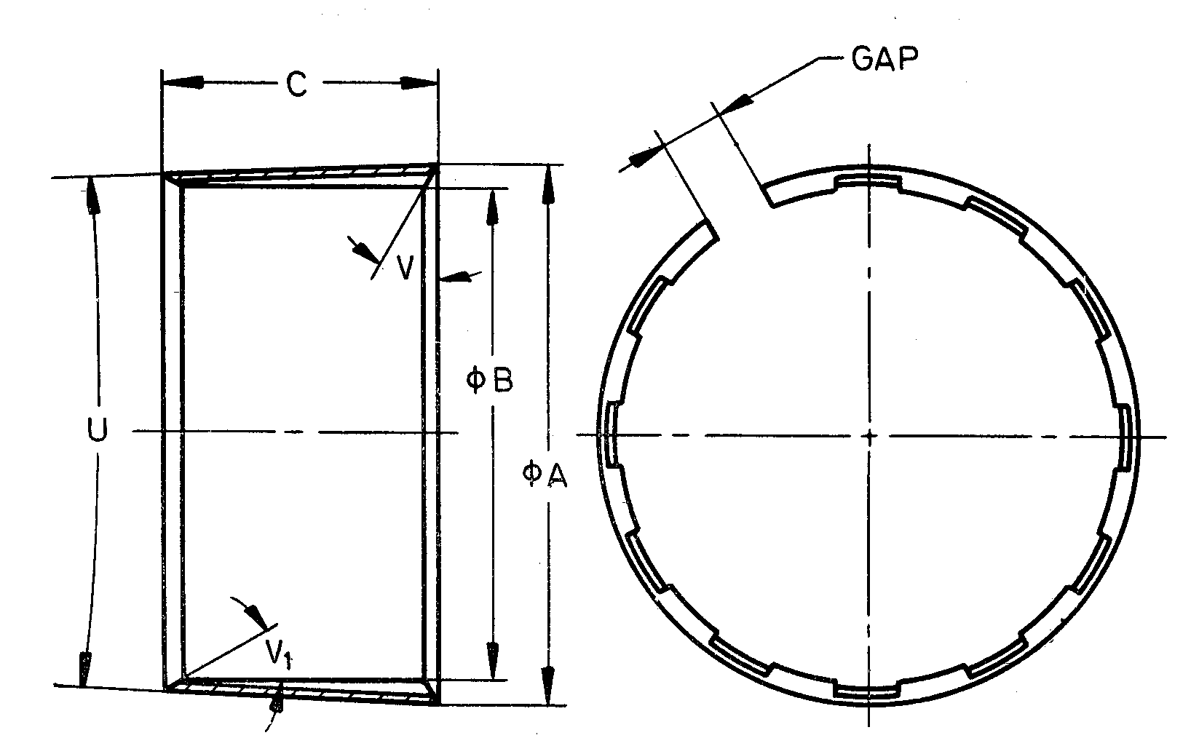

NOTES

**1** Width of gap, entry angle and number of flutes are at the discretion of manufacturer.  
**2** The core lifter with external flutes, if required by purchaser, shall conform to dimensions specified in this clause.

Fig. 60 'WT' Design Double Tube Core Barrel — Core Lifter

All dimensions are in millimetres.

|  |  |  |  |  |  |
| --- | --- | --- | --- | --- | --- |
| *Sl No.* | *Dimension* | | *BWT* | *NWT* | *HWT* |
| (1) | (2) | | (3) | (4) | (5) |
| i) | *A* | *Max* | 50.39 | 65.74 | 88.75 |
| *Min* | 50.29 | 65.63 | 88.65 |
| ii) | *B* | *Max* | 43.94 | 58.24 | 80.31 |
| *Min* | 43.84 | 58.14 | 80.21 |
| iii) | *C* | *Max* | 30.53 | 38.48 | 51.18 |
| *Min* | 29.77 | 37.72 | 50.42 |
| iv) | *U* | *Max* | 6°15' | 6°15' | 5°15' |
| *Min* | 5°45' | 5°45' | 4°45' |
| v) | *V* | *—* | 10° | 10° | 10° |
| vi) | *V*1 | *—* | Optional | | |

**22.1.2.3** *'WT' Design Double Tube Core Barrel — Outer Tube* (*see* Fig. 61)

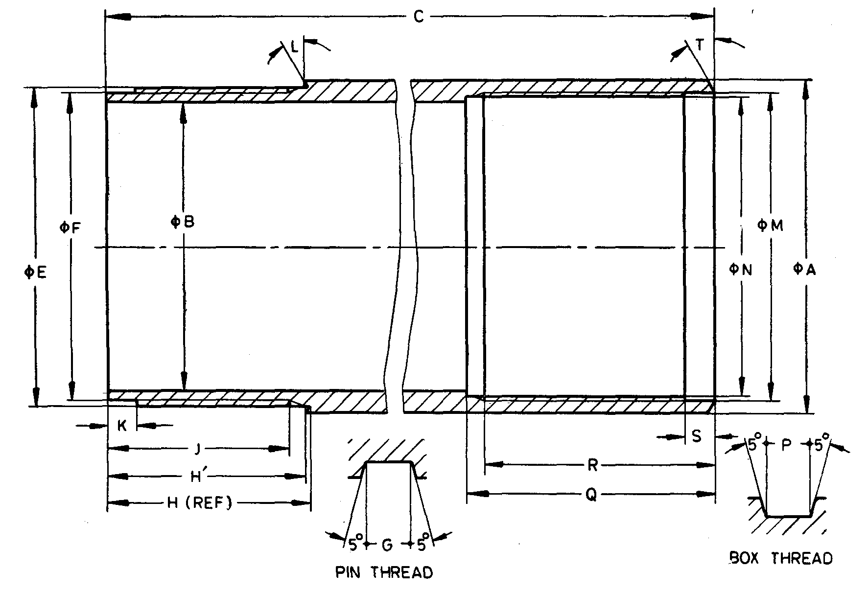.

Fig. 61 'WT' Design Double Tube Core Barrel — Outer Tube

All dimensions are in millimetres.

|  |  |  |  |  |  |
| --- | --- | --- | --- | --- | --- |
| *Sl No.* | *Dimension* | | *BWT* | *NWT* | *HWT* |
| (1) | (2) | | (3) | (4) | (5) |
| i) | *A* | *Max* | 58.98 | 74.07 | 97.21 |
| *Min* | 58.72 | 73.81 | 96.82 |
| ii) | *B* | *Max* | 51.59 | 66.68 | 88.90 |
| *Min* | 51.33 | 66.42 | 88.39 |
| iii) | *C* | *Max* | 3 211.09 | 3 211.09 | 3 180.46 |
| *Min* | 3 210.33 | 3 210.33 | 3 179.70 |
| iv) | *E* | *Max* | 56.24 | 71.60 | 94.49 |
| *Min* | 56.18 | 71.55 | 94.44 |
| v) | *F* | *Max* | 54.66 | 70.03 | 92.91 |
| *Min* | 54.58 | 69.95 | 92.79 |
| vi) | Thread pitch | | 3.175 | 3.175 | 5.080 |
| vii) | *G* | *Max* | 1.63 | 1.63 | 2.59 |
| *Min* | 1.55 | 1.56 | 2.51 |
| viii) | *H* | *Max* | 35.28 | 38.43 | 44.81 |
| *Min* | 35.15 | 38.30 | 44.68 |
| ix) | *H'* | *Max* | 34.93 | 38.11 | 44.47 |
| *Min* | 34.80 | 37.96 | 44.34 |
| x) | *J* | *Min* | 31.75 | 34.93 | 41.28 |
| xi) | *K* | *Max* | 5.00 | 5.00 | 5.79 |
| *Min* | 4.50 | 4.50 | 5.28 |
| xii) | *L* |  | 15° | 15° | 15° |
| xiii) | *M* | *Max* | 54.05 | 69.93 | 91.31 |
| *Min* | 54.00 | 69.88 | 91.26 |
| xiv) | *N* | *Max* | 52.45 | 68.33 | 89.71 |
| *Min* | 52.40 | 68.28 | 89.66 |
| xv) | Thread pitch | | 3.175 | 3.175 | 5.080 |
| xvi) | *P* | *Max* | 1.63 | 1.63 | 2.59 |
| *Min* | 1.55 | 1.55 | 2.51 |
| xvii) | *Q* | *Max* | 43.35 | 49.70 | 48.91 |
| *Min* | 42.85 | 49.20 | 48.41 |
| xviii) | *R* | *Max* | 40.17 | 46.52 | 45.74 |
| *Min* | 39.67 | 46.02 | 45.24 |
| xix) | *S* | *Max* | 5.00 | 5.00 | 5.79 |
| *Min* | 4.50 | 4.50 | 5.28 |
| xx) | *T* |  | 30° | 30° | 15° |

**22.1.2.4** *'WT ' Design Double Tube Core Barrel — Inner Tube* (*see* Fig. 62)

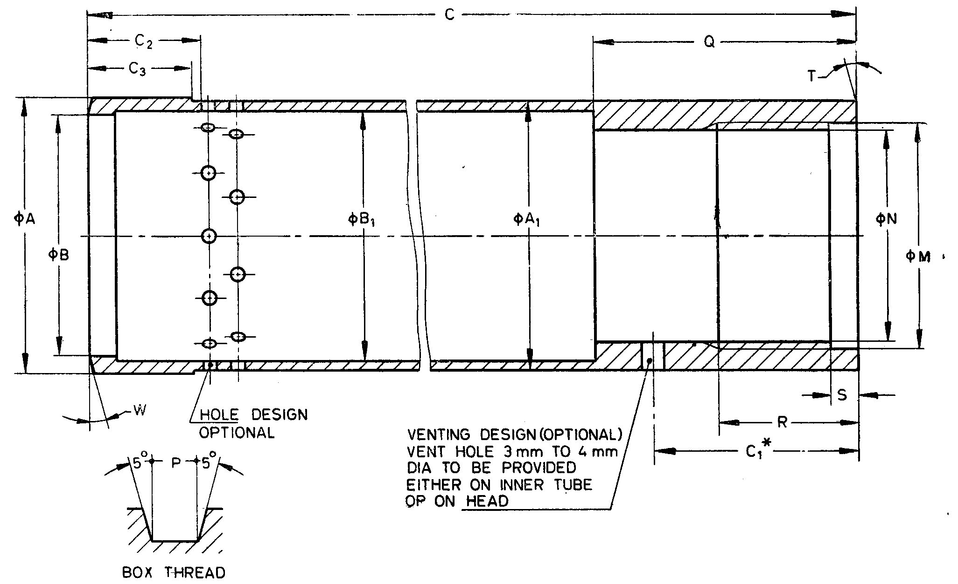

*Dimension *C*1 is applicable only if vent hole is provided on inner tube.

Fig. 62 'WT ' Design Double Tube Core Barrel — Inner Tube

All dimensions are in millimetres.

|  |  |  |  |  |  |
| --- | --- | --- | --- | --- | --- |
| *Sl No.* | *Dimension* | | *BWT* | *NWT* | *HWT* |
| (1) | (2) | | (3) | (4) | (5) |
| i) | *A* | *Max* | 50.50 | 65.30 | 87.53 |
| *Min* | 50.42 | 65.23 | 87.45 |
| ii) | *A*1 | *Max* | 49.45 | 63.75 | 85.98 |
| *Min* | 49.20 | 63.50 | 85.73 |
| iii) | *B* | *Max* | 46.02 | 60.33 | 82.55 |
| *Min* | 45.90 | 60.20 | 82.42 |
| iv) | *B*1 | *Max* | 46.02 | 60.33 | 82.55 |
| *Min* | 45.77 | 60.07 | 82.04 |
| v) | *C* | *Max* | 3 108.33 | 3 108.33 | 3 114.68 |
| *Min* | 3 107.69 | 3 107.69 | 3 114.04 |
| vi) | *C*1 | *Max* | 37.26 | 40.44 | 43.61 |
| *Min* | 35.74 | 38.91 | 42.09 |
| vii) | *C*2 | *Min* | 20.62 | 23.80 | 26.97 |
| *Max* | 19.43 | 22.61 | 25.78 |
| *Min* | 19.05 | 22.23 | 25.40 |
| viii) | *M* | *Max* | 41.35 | 57.23 | 63.60 |
| *Min* | 41.30 | 57.18 | 63.55 |
| ix) | *N* | *Max* | 38.96 | 54.84 | 61.49 |
| *Min* | 38.91 | 54.79 | 61.44 |
| x) | Thread pitch | | 3.175 | 3.175 | 5.080 |
| xi) | *P* | *Max* | 1.63 | 1.63 | 2.59 |
| *Min* | 1.55 | 1.55 | 2.51 |
| xii) | *Q* | *Max* | 47.75 | 50.93 | 54.10 |
| *Min* | 47.50 | 50.67 | 53.85 |
| xiii) | *R* | *Max* | 25.90 | 29.08 | 32.25 |
| *Min* | 25.40 | 28.58 | 31.75 |
| xiv) | *S* | *Max* | 5.00 | 5.00 | 5.79 |
| *Min* | 4.50 | 4.50 | 5.28 |
| xv) | *T* | *—* | 0° | 0° | 0° |
| xvi) | Holes (minimum total area), mm2 | | 238.7 | 325.16 | 419.35 |
| xvii) | *W* | | 10° | 10° | 10° |

**22.1.2.5** *'WT' Design Double Tube Core Barrel — Reaming Shell* (*see* Fig. 63)

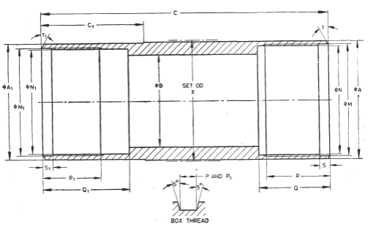

Fig. 63 'WT' Design Double Tube Core Barrel — Reaming Shell

All dimensions are in millimetres.

|  |  |  |  |  |  |
| --- | --- | --- | --- | --- | --- |
| *Sl No.* | *Dimension* | | *BWT* | *NWT* | *HWT* |
| (1) | (2) | | (3) | (4) | (5) |
| i) | *A* | *Max* | 58.93 | 74.55 | 97.94 |
|  | *Min* | 58.83 | 74.45 | 97.84 |
| ii) | *A*1 | *Max* | 58.60 | 74.27 | 97.71 |
|  | *Min* | 58.50 | 74.17 | 97.61 |
| iii) | *B* | *Max* | 50.77 | 65.58 | 87.81 |
|  | *Min* | 50.67 | 65.48 | 87.71 |
| iv) | *C* | *Max* | 143.56 | 149.86 | 165.76 |
|  | *Min* | 143.05 | 149.35 | 165.25 |
| v) | *C*1 | *Max* | 51.18 | 54.36 | 63.88 |
|  | *Min* | 50.42 | 53.59 | 63.12 |
| vi) | *M* | *Max* | 56.34 | 71.70 | 94.59 |
|  | *Min* | 56.29 | 71.65 | 94.54 |
| vii) | *N* | *Max* | 54.76 | 70.13 | 93.01 |
|  | *Min* | 54.71 | 70.08 | 92.96 |
| viii) | Thread pitch | | 3.175 | 3.175 | 5.080 |
| ix) | *P* | *Max* | 1.63 | 1.63 | 2.590 |
|  | *Min* | 1.55 | 1.55 | 2.51 |
| x) | *Q* | *Max* | 35.40 | 38.56 | 44.93 |
|  | *Min* | 35.28 | 38.43 | 44.81 |
| xi) | *R* | *Max* | 32.25 | 35.03 | 41.78 |
|  | *Min* | 31.75 | 34.95 | 41.28 |
| xii) | *S* | *Max* | 5.00 | 5.00 | 5.79 |
|  | *Min* | 4.50 | 4.50 | 5.28 |
| xiii) | *T* |  | 15° | 15° | 15° |
| xiv) | *M*1 | *Max* | 53.98 | 69.24 | 92.46 |
|  | *Min* | 53.92 | 69.19 | 92.41 |
| xv) | *N*1 | *Max* | 52.45 | 67.72 | 90.93 |
|  | *Min* | 52.40 | 67.67 | 90.88 |
| xvi) | Thread pitch | | 3.175 | 3.175 | 5.080 |
| xvii) | *P*1 | *Max* | 1.63 | 1.63 | 2.59 |
|  | *Min* | 1.55 | 1.55 | 2.51 |
| xviii) | *Q*1 | *Max* | 42.35 | 46.02 | 54.25 |
|  | *Min* | 42.34 | 45.52 | 53.75 |
| xix) | *R*1 | *Max* | 29.08 | 32.25 | 38.60 |
|  | *Min* | 28.58 | 31.75 | 38.10 |
| xx) | *S*1 | *Max* | 5.00 | 5.00 | 5.79 |
|  | *Min* | 4.50 | 4.50 | 5.28 |
| xxi) | *T*1 |  | 15° | 15° | 15° |
| xxii) | *X* | *Max* | 60.07 | 75.82 | 99.36 |
|  | *Min* | 59.82 | 75.56 | 99.11 |

**22.1.2.6** *'WT' Design Double Tube Core Barrel — Head* (*see* Fig. 64)

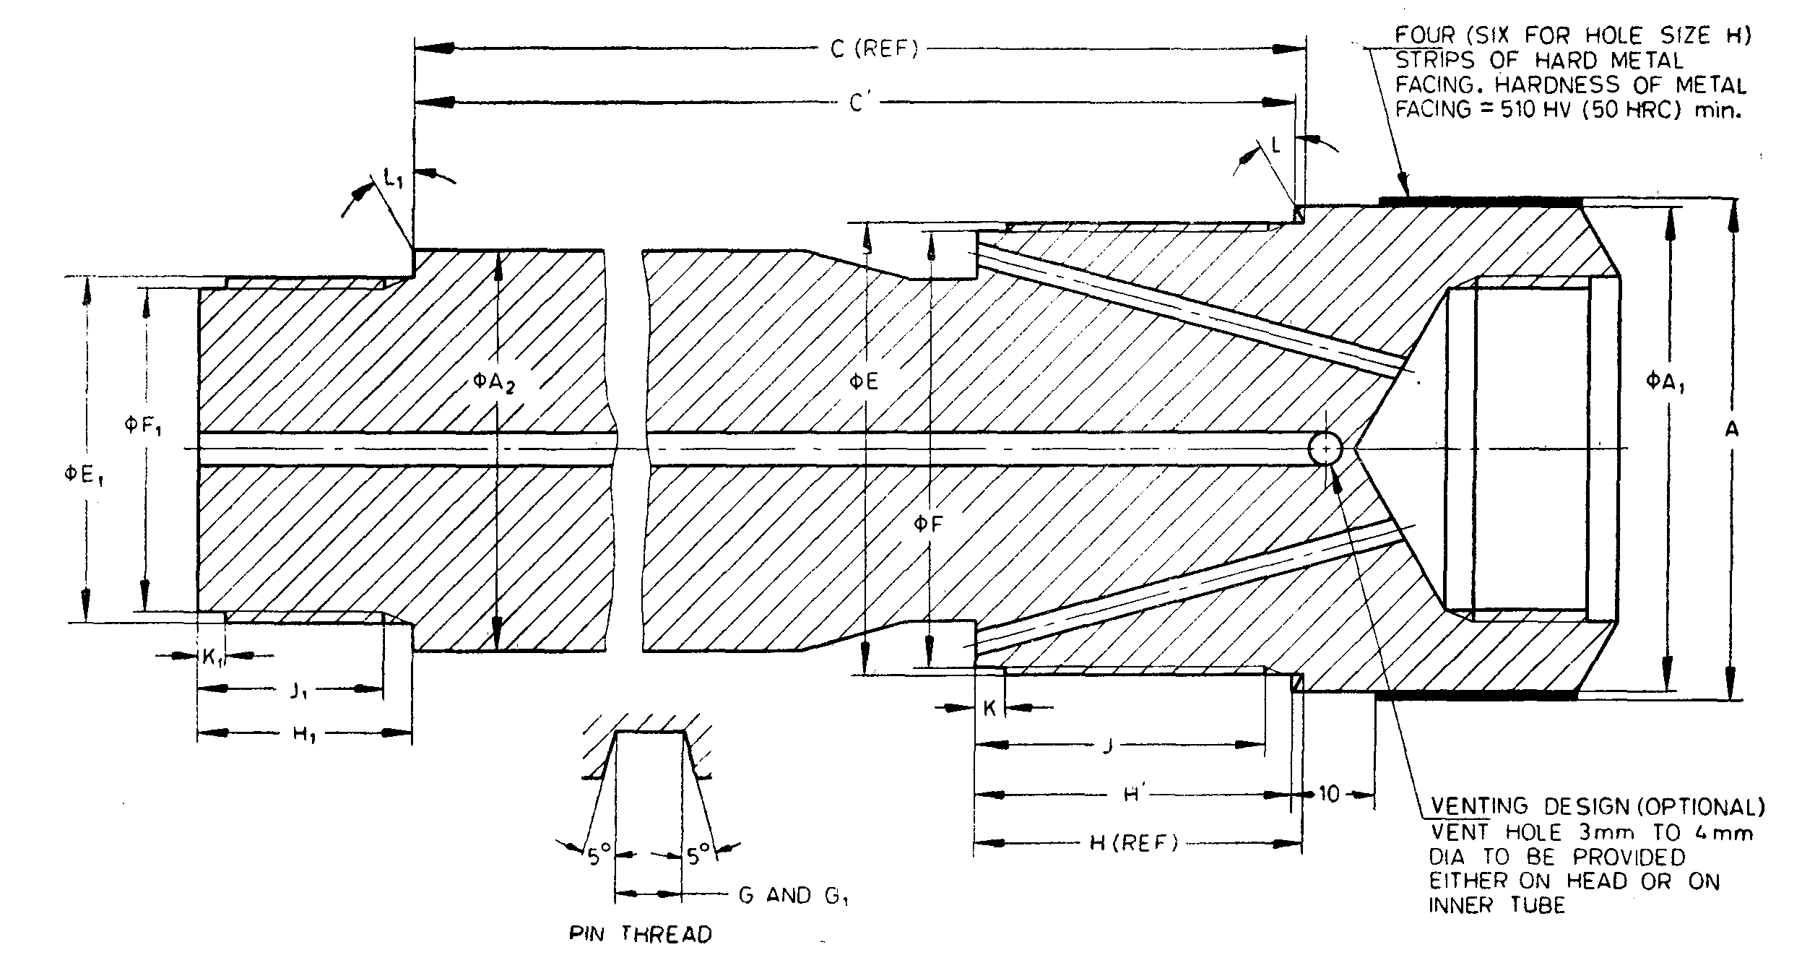

NOTE— The hardness of metal strip in *HRC* is approximate value.

Fig. 64 'WT' Design Double Tube Core Barrel — Head

All dimensions are in millimetres.

|  |  |  |  |  |  |
| --- | --- | --- | --- | --- | --- |
| *Sl No.* | *Dimension* | | *\*BWT* | *\*NWT* | *HWT* |
| (1) | (2) | | (3) | (4) | (5) |
| i) | *A* | *Max* | 58.93 | 74.55 | 97.78 |
|  | *Min* | 58.81 | 74.43 | 97.66 |
| ii) | *A*1 | *Max* | 58.06 | 73.94 | 97.03 |
|  | *Min* | 57.81 | 73.69 | 96.65 |
| iii) | *A*2 | *Max* | 47.88 | 63.75 | 85.98 |
|  | *Min* | 47.63 | 63.50 | 85.73 |
| iv) | *C* | *Max* | 170.54 | 170.54 | 134.42 |
|  | *Min* | 169.90 | 169.90 | 133.78 |
| v) | *C'* | *Max* | 169.38 | 169.38 | 133.66 |
|  | *Min* | 168.74 | 168.74 | 133.02 |
| vi) | *E* | *Max* | 53.95 | 69.82 | 91.21 |
|  | *Min* | 53.90 | 69.77 | 91.16 |
| vii) | *F* | *Max* | 52.35 | 68.22 | 89.61 |
|  | *Min* | 52.22 | 68.10 | 89.48 |
| viii) | Thread pitch | | 3.175 | 3.175 | 5.080 |
| ix) | *G* | *Max* | 1.63 | 1.63 | 2.59 |
|  | *Min* | 1.55 | 1.55 | 2.51 |
| x) | *H* | *Max* | 39.27 | 45.62 | 45.21 |
|  | *Min* | 38.89 | 45.24 | 44.83 |
| xi) | *H'* | *Max* | 38.11 | 44.46 | 44.45 |
|  | *Min* | 37.73 | 44.08 | 44.07 |
| xii) | *J* |  | 34.93 | 41.28 | 41.28 |
| xiii) | *K* | *Max* | 3.43 | 3.43 | 3.43 |
|  | *Min* | 2.92 | 2.92 | 2.92 |
| xiv) | *L* |  | 30° | 30° | 15° |
| xv) | *E*1 | *Max* | 41.25 | 57.12 | 63.50 |
|  | *Min* | 41.20 | 57.07 | 63.45 |
| xvi) | *F*1 | *Max* | 38.86 | 54.74 | 61.39 |
|  | *Min* | 38.74 | 54.61 | 61.26 |
| xvii) | Thread pitch | | 3.175 | 3.175 | 5.080 |
| xviii) | *G*1 | *Max* | 1.63 | 1.63 | 2.59 |
|  | *Min* | 1.55 | 1.55 | 2.51 |
| xix) | *H*1 | *Max* | 25.40 | 28.58 | 31.75 |
|  | *Min* | 25.02 | 28.19 | 31.37 |
| xx) | *J*1 | *Min* | 22.23 | 25.40 | 28.58 |
| xxi) | *K*1 | *Max* | 3.43 | 3.43 | 3.43 |
|  | *Min* | 2.92 | 2.92 | 2.92 |
| xxii) | *L*1 |  | 0° | 0° | 0° |
| xxiii) | Rod thread connections | | BW | NW | HW |
| *These items are interchangeable with BWM and NWM. | | | | | |

**22.2 'WT' Design Double Tube Core Barrel (for RWT, EWT and AWT Sizes)**

**22.2.1** *Nomenclature*

A typical assembly of double tube core barrel of RWT, EWT and AWT sizes is shown below (*see* Fig. 65):

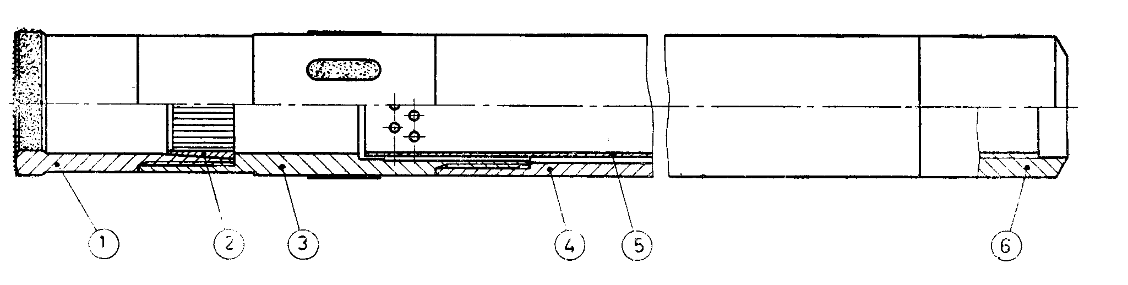

|  |  |
| --- | --- |
| *Key* |  |
| 1 | Core bit belvel wall |
| or 1 | Core bit straight wall |
| 2 | Core lifter |
| 3 | Reaming shell |
| 4 | Outer tube |
| 5 | Inner tube |
| 6 | Head-rigid type |

Fig. 65 'WT' Design Double Tube Core Barrel (for RWT, EWT and AWT Sizes)

**22.2.1.1** No core lifter is used with straight walled bits.

**22.2.1.2** 'WT'design double tube core barrels of RWT, EWT and AWT sizes shall have

lengths of 1 500 mm, 3 000 mm, and 6 000 mm (lengths refer to core capacity).

**22.2.1.3** Unless otherwise specified bevel wall core bit shall be supplied.

**22.2.2** *Detailed Dimensions*

**22.2.2.1** *'WT' Design Double Tube Core Barrel — Bevel Wall Core Bit* (*see* Fig. 66)

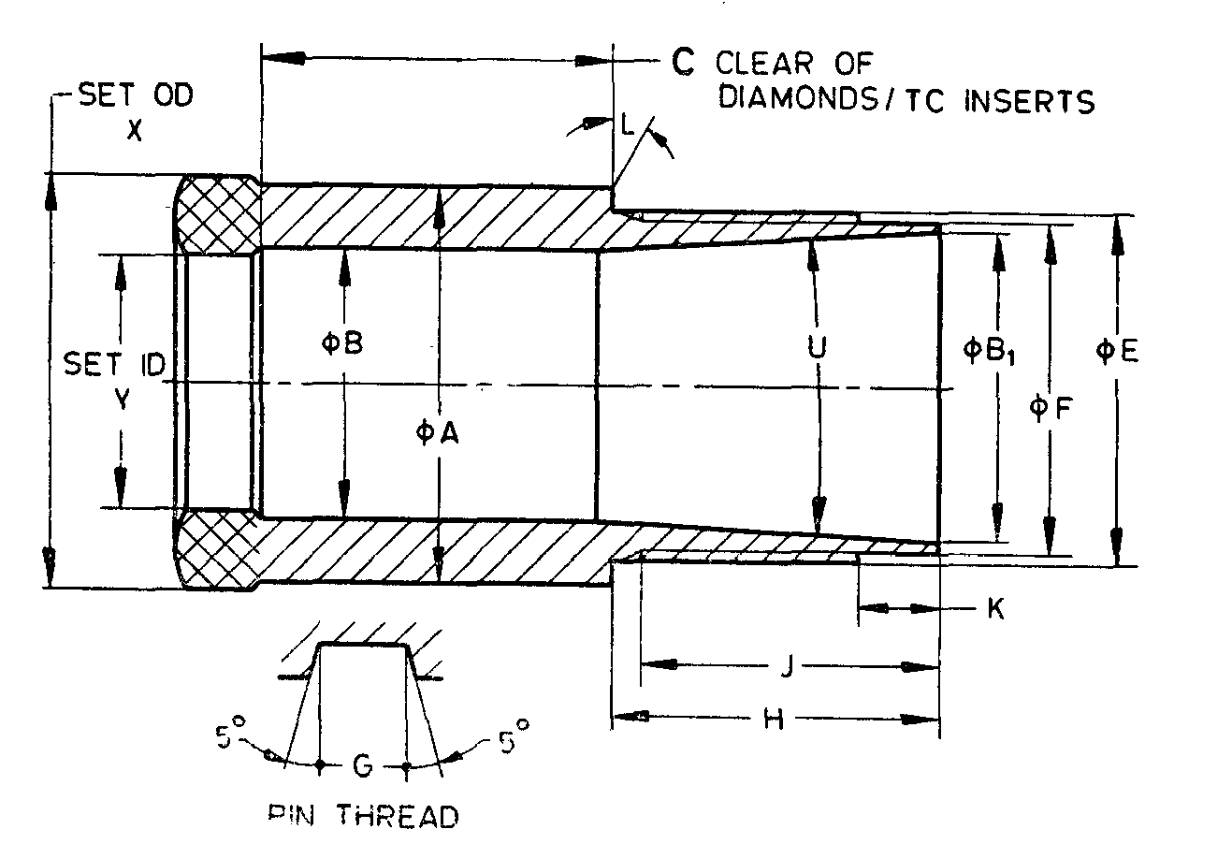

Fig. 66 'WT' Design Double Tube Core Barrel — Bevel Wall Core Bit

All dimensions are in millimetres.

|  |  |  |  |  |  |
| --- | --- | --- | --- | --- | --- |
| *Sl No.* | *Dimension* | | *RWT* | *EWT* | *AWT* |
| (1) | (2) | (3) | (4) | (5) | (6) |
| i) | *A* | *Max* | 28.75 | 36.25 | 46.66 |
|  | *Min* | 28.65 | 39.14 | 46.56 |
| ii) | *B* | *Max* | 19.81 | 24.76 | 34.32 |
|  | *Min* | 19.43 | 24.51 | 34.06 |
| iii) | *B*1 | *Max* | 22.58 | 28.60 | 38.91 |
|  | *Min* | 22.53 | 28.50 | 38.81 |
| iv) | *C* | *Min* | 28.58 | 31.75 | 31.75 |
| v) | *E* | *Max* | 24.56 | 31.72 | 42.04 |
|  | *Min* | 24.51 | 31.67 | 41.99 |
| vi) | *F* | *Max* | 23.37 | 30.12 | 40.44 |
|  | *Min* | 23.32 | 30.05 | 40.34 |
| vii) | Thread pitch | | 3.175 | 3.175 | 3.175 |
| viii) | *G* | *Max* | 1.63 | 1.63 | 1.63 |
|  | *Min* | 1.55 | 1.55 | 1.55 |
| ix) | *H* | *Max* | 22.48 | 29.62 | 32.79 |
|  | *Min* | 21.97 | 29.11 | 32.28 |
| x) | *J* | *Min* | 19.84 | 26.97 | 30.15 |
| xi) | *K* | *Max* | 5.00 | 7.39 | 7.39 |
|  | *Min* | 4.50 | 6.88 | 6.88 |
| xii) | *L* | *—* | 0° | 0° | 0° |
| xiii) | *U* | *Max* | 8°15' | 7°15' | 7°15' |
|  | *Min* | 7°45' | 6°45' | 6°45' |
| xiv) | *X* | *Max* | 29.59 | 37.46 | 47.75 |
|  | *Min* | 29.34 | 37.21 | 47.50 |
| xv) | *Y* | *Max* | 18.80 | 23.11 | 32.66 |
|  | *Min* | 18.54 | 22.86 | 32.41 |

**22.2.2.2** *'WT' Design Double Tube Core Barrel — Straight Wall Core Bit* (*see* Fig. 67)

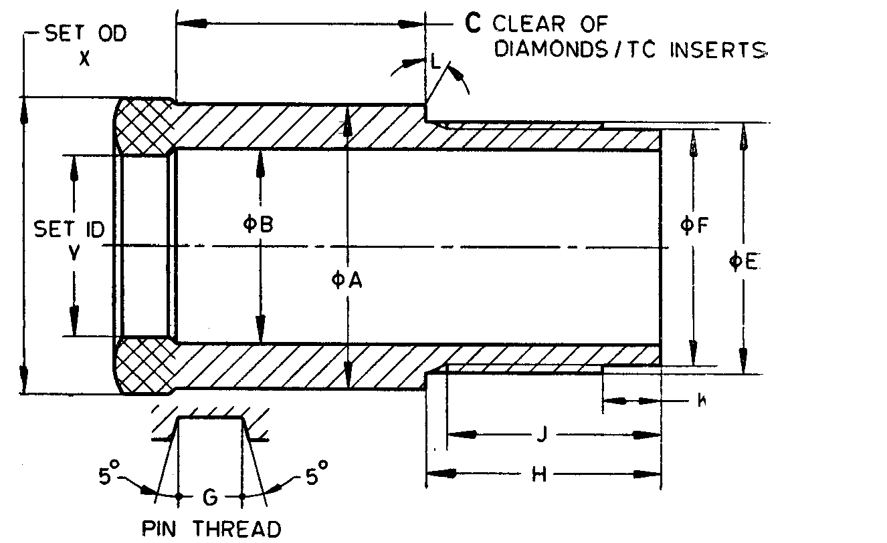

Fig. 67 'WT' Design Double Tube Core Barrel — Straight Wall Core Bit

All dimensions are in millimetires.

|  |  |  |  |  |  |
| --- | --- | --- | --- | --- | --- |
| *Sl No.* | *Dimension* | | *RWT* | *EWT* | *AWT* |
| (1) | (2) | | (3) | (4) | (5) |
| i) | *A* | *Max* | 28.75 | 36.25 | 46.66 |
| *Min* | 28.65 | 36.14 | 46.56 |
| ii) | *B* | *Max* | 19.81 | 24.76 | 34.32 |
|  | *Min* | 19.43 | 24.51 | 34.06 |
| iii) | *C* | *Min* | 28.58 | 31.75 | 31.75 |
| iv) | *E* | *Max* | 24.56 | 31.72 | 42.04 |
|  | *Min* | 24.51 | 31.67 | 41.99 |
| v) | *F* | *Max* | 23.37 | 30.12 | 40.44 |
|  | *Min* | 23.32 | 30.05 | 40.34 |
| vi) | Thread pitch | | 3.175 | 3.175 | 3.175 |
| vii) | *G* | *Max* | 1.63 | 1.63 | 1.63 |
|  | *Min* | 1.55 | 1.55 | 1.55 |
| viii) | *H* | *Max* | 27.20 | 29.62 | 32.79 |
|  | *Min* | 26.70 | 29.11 | 32.28 |
| ix) | *J* | *Min* | 24.59 | 26.97 | 30.15 |
| x) | *K* | *Max* | 6.60 | 7.39 | 7.39 |
|  | *Min* | 6.10 | 6.88 | 6.88 |
| xi) | *L* | *—* | 0° | 0° | 0° |
| xii) | *X* | *Max* | 29.59 | 37.46 | 47.75 |
|  | *Min* | 29.34 | 37.21 | 47.50 |
| xiii) | *Y* | *Max* | 18.80 | 23.11 | 32.66 |
|  | *Min* | 18.54 | 22.86 | 32.41 |

**22.2.2.3** *'WT' Design Double Tube Core Barrel — Core Lifters* (*see* Fig. 68)

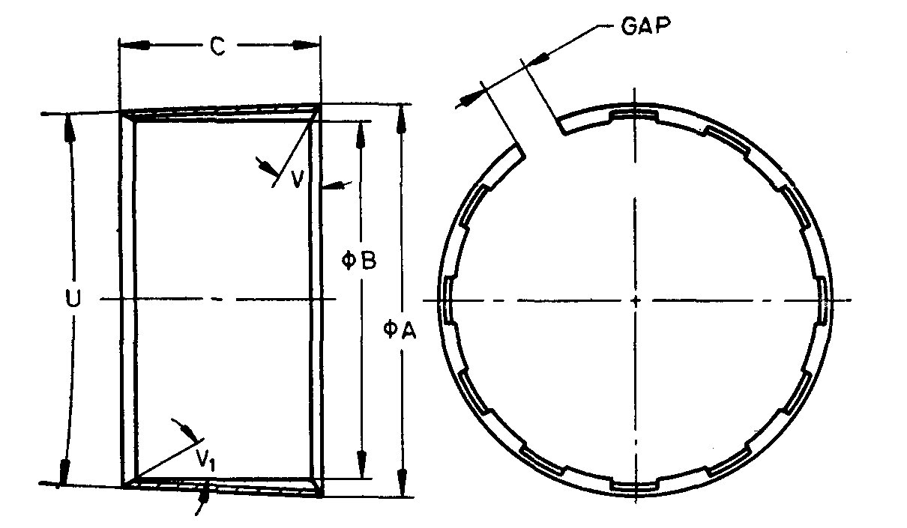

NOTES

**1** Width of gap, entry angle and number of flutes are at the discretion of manufacturer.  
**2** Core lifters with external flutes, it required by purchaser, shall conform to the dimensions specified in this clause.

Fig. 68 'WT' Design Double Tube Core Barrel — Core Lifters

All dimensions are in millimetres.

|  |  |  |  |  |  |
| --- | --- | --- | --- | --- | --- |
| *Sl No.* | *Dimension* | | *BWT* | *NWT* | *HWT* |
| (1) | (2) | | (3) | (4) | (5) |
| i) | *A* | *Max* | 22.91 | 27.58 | 37.80 |
|  | *Min* | 22.81 | 27.48 | 37.69 |
| ii) | *B* | *Max* | 18.29 | 22.61 | 32.16 |
|  | *Min* | 18.19 | 22.50 | 32.05 |
| iii) | *C* | *Max* | 16.26 | 19.43 | 22.61 |
|  | *Min* | 15.49 | 18.67 | 21.84 |
| iv) | *U* | *Max* | 8°15' | 7°15' | 7°15' |
|  | *Min* | 7°45' | 6°45' | 6°45' |
| v) | *V* | *—* | 0° | 0° | 0° |
| vi) | *V*1 | *—* | Optional | | |

**22.2.2.4** *'WT' Design Double Core Barrel — Outer Tube* (*see* Fig. 69)

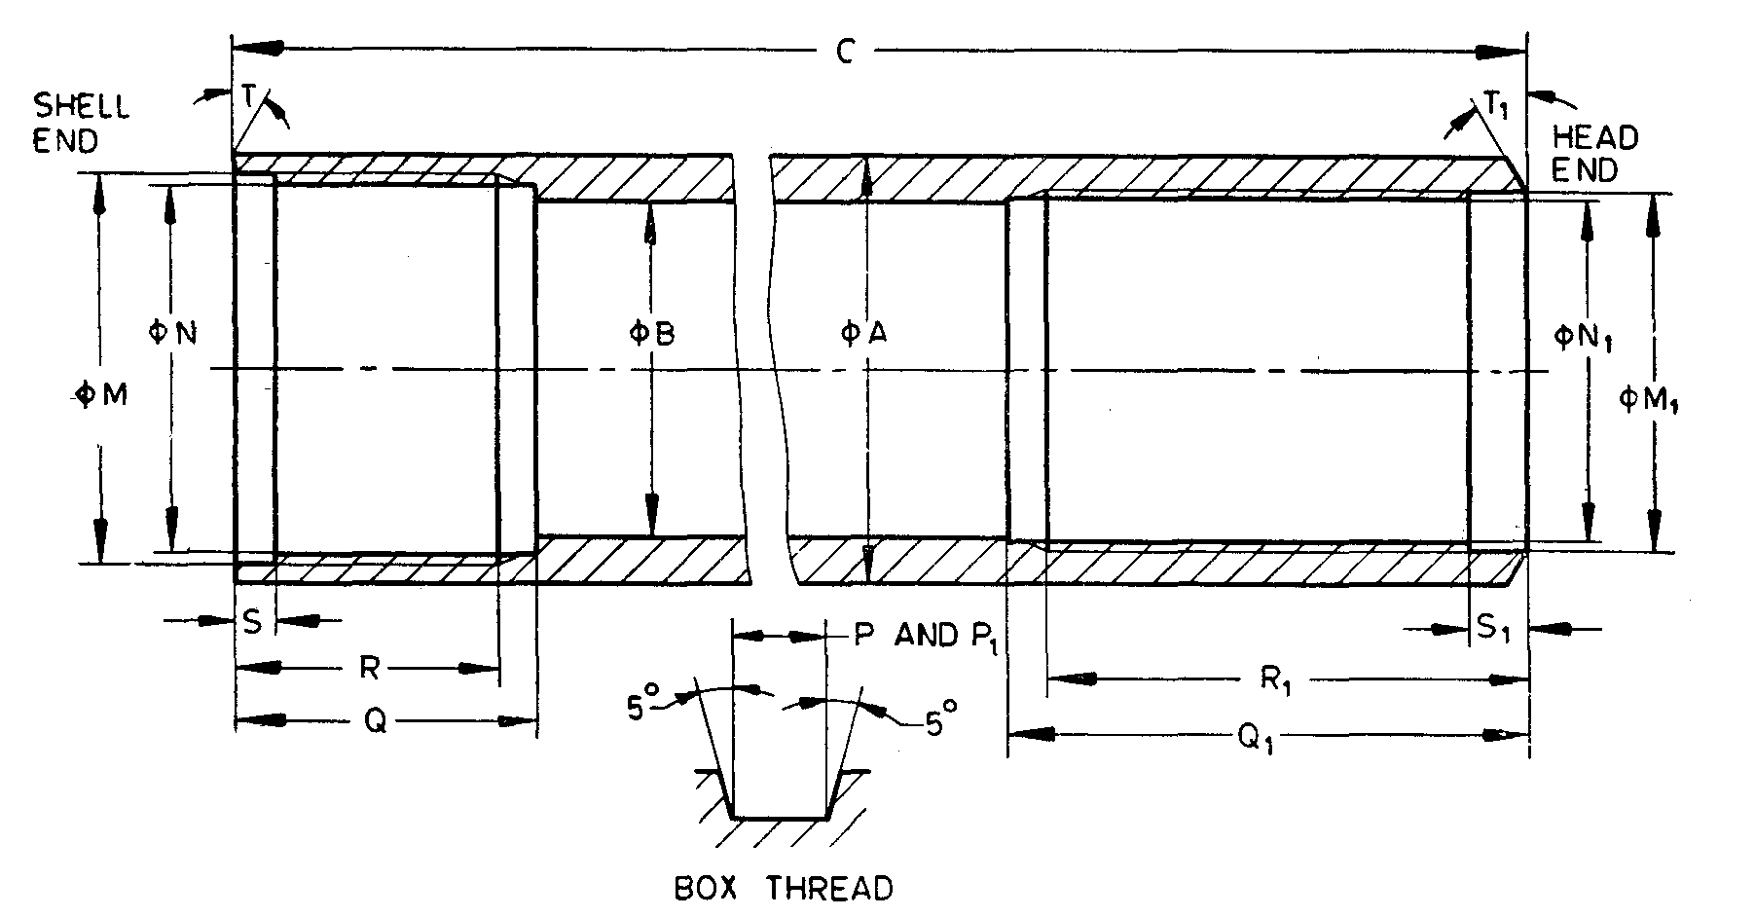

Fig. 69 'WT' Design Double Core Barrel — Outer Tube

All dimensions are in millimetres.

|  |  |  |  |  |  |
| --- | --- | --- | --- | --- | --- |
| *Sl No.* | *Dimension* | | *RWT* | *EWT* | *AWT* |
| (1) | (2) | | (3) | (4) | (5) |
| i) | *A* | *Max* | 28.70 | 36.63 | 47.07 |
|  | *Min* | 28.58 | 36.50 | 46.81 |
| ii) | *B* | *Max* | 22.61 | 28.96 | 38.89 |
|  | *Min* | 22.48 | 28.83 | 38.63 |
| iii) | *C* | *Max* | 3 063.06 | 3 035.68 | 3 048.38 |
|  | *Min* | 3 062.27 | 3 034.89 | 3 047.59 |
| iv) | *M* | *Max* | 24.66 | 33.40 | 42.96 |
|  | *Min* | 24.61 | 33.35 | 42.88 |
| v) | *N* | *Max* | 23.47 | 31.83 | 41.35 |
|  | *Min* | 23.42 | 31.78 | 41.30 |
| vi) | Thread pitch | | 3.175 | 3.175 | 3.175 |
| vii) | *P* | *Max* | 1.63 | 1.63 | 1.63 |
|  | *Min* | 1.55 | 1.55 | 1.55 |
| viii) | *Q* | *Max* | 19.05 | 25.60 | 31.95 |
|  | *Min* | 18.64 | 25.40 | 31.75 |
| ix) | *R* | *Max* | 16.38 | 22.72 | 29.08 |
|  | *Min* | 15.88 | 22.22 | 28.58 |
| x) | *S* | *Max* | 3.43 | 3.43 | 3.43 |
|  | *Min* | 2.92 | 2.92 | 2.92 |
| xi) | *T* |  | 0° | 0° | 0° |
| xii) | *M*1 | *Max* | 24.66 | 31.01 | 41.35 |
|  | *Min* | 24.61 | 30.96 | 41.30 |
| xiii) | *N*1 | *Max* | 23.47 | 29.44 | 39.75 |
|  | *Min* | 23.42 | 29.39 | 39.70 |
| xiv) | Thread pitch | | 3.175 | 3.175 | 3.175 |
| xv) | *P*1 | *Max* | 1.63 | 1.63 | 1.63 |
|  | *Min* | 1.55 | 1.55 | 1.55 |
| xvi) | *Q*1 | *Max* | 30.65 | 44.95 | 51.30 |
|  | *Min* | 30.15 | 44.45 | 50.80 |
| xvii) | *R*1 | *Max* | 27.47 | 41.78 | 48.12 |
|  | *Min* | 26.97 | 41.28 | 47.62 |
| xviii) | *S*1 | *Max* | 4.22 | 5.00 | 5.00 |
|  | *Min* | 3.71 | 4.50 | 4.50 |
| xix) | *T*1 | *—* | 30° | 30° | 30° |

**21.2.2.5** *'WT' Design Double Tube Core Barrel — Inner Tube* (*see* Fig. 70)

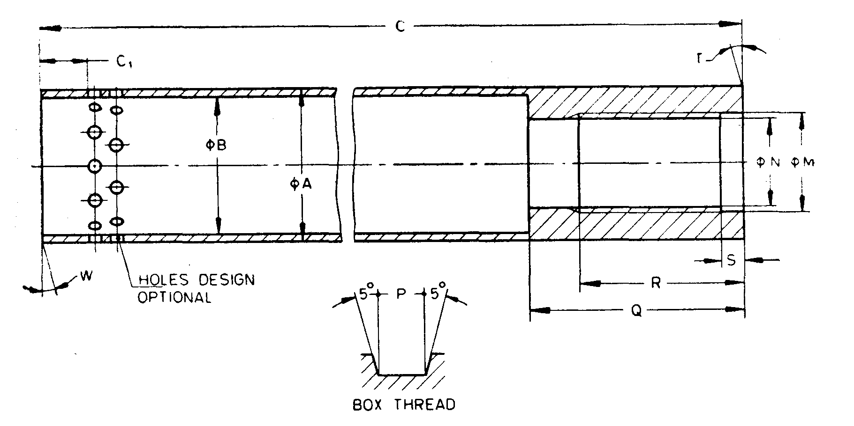

Fig. 70 'WT' Design Double Tube Core Barrel — Inner Tube

All dimensions are in millimetres

|  |  |  |  |  |  |
| --- | --- | --- | --- | --- | --- |
| *Sl No.* | *Dimension* | | *RWT* | *EWT* | *AWT* |
| (1) | (2) | | (3) | (4) | (5) |
| i) | *A* | *Max* | 21.16 | 27.10 | 36.63 |
|  | *Min* | 21.03 | 26.97 | 36.50 |
| ii) | *B* | *Max* | 19.43 | 24.59 | 34.11 |
|  | *Min* | 19.33 | 24.46 | 33.86 |
| iii) | *C* | *Max* | 3 016.25 | 3 009.90 | 3 014.65 |
|  | *Min* | 3 015.46 | 3 009.09 | 3 013.89 |
| iv) | *C1* | *Min* | 6.73 | 8.33 | 8.33 |
| v) | *M* | *Max* | * | 17.53 | 25.48 |
|  | *Min* | * | 17.48 | 25.43 |
| vi) | *N* | *Max* | * | 15.95 | 23.88 |
|  | *Min* | * | 15.90 | 23.83 |
| vii) | Thread pitch | | * | 3.175 | 3.175 |
| viii) | *P* | *Max* | * | 1.63 | 1.63 |
|  | *Min* | * | 1.55 | 1.55 |
| ix) | *Q* | *Max* | 12.83 | 38.23 | 50.93 |
|  | *Min* | 12.57 | 37.97 | 50.67 |
| x) | *R* | *Max* | * | 29.08 | 29.08 |
|  | *Min* | * | 28.58 | 28.58 |
| xi) | *S* | *Max* | 3.43 | 3.81 | 3.81 |
|  | *Min* | 2.92 | 3.30 | 3.30 |
| xii) | *T* |  | 0° | 0° | 0° |
|  | Holes (mimimum total area), mm2 | | 81.92 | 142.55 | 185.76 |
| xiii) | *W* | *—* | 0° | 0° | 0° |
| *The thread dimensions for RWT sizes shall be according to established practices. | | | | | |

**22.2.2.6** *'WT' Design Double Tube Core Barrel — Head* (*see* Fig. 71)

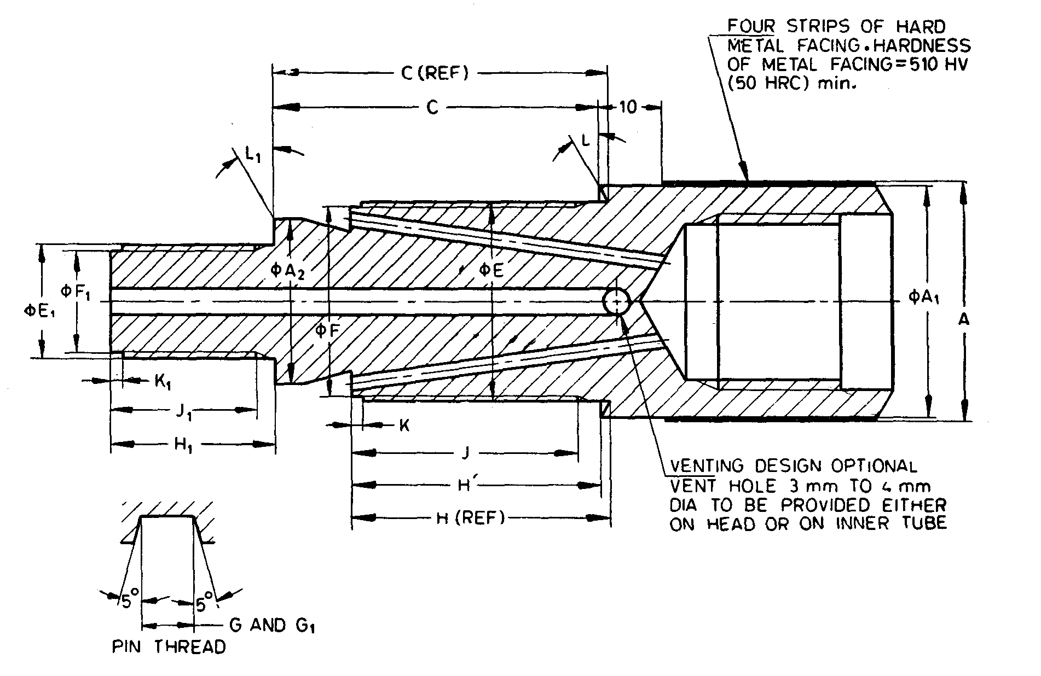

NOTE — The hardness of metal facing in *HRC* is approximate value.

Fig. 71 'WT' Design Double Tube Core Barrel — Head

All dimensions are in millimetres.

|  |  |  |  |  |  |
| --- | --- | --- | --- | --- | --- |
| *Sl No.* | *Dimension* | | *RWT* | *EWT* | *AWT* |
| (1) | (2) | | (3) | (4) | (5) |
| i) | *A* | *Max* | 29.10 | 36.90 | 47.12 | |
|  | *Min* | 28.98 | 36.78 | 47.00 | |
| ii) | *A*1 | *Max* | 28.70 | 36.63 | 47.07 | |
|  | *Min* | 28.45 | 36.37 | 46.81 | |
| iii) | *A*2 | *Max* | 21.16 | 25.53 | 35.05 | |
|  | *Min* | 21.03 | 25.40 | 34.92 | |
| iv) | *C* | *Max* | 34.82 | 51.16 | 59.11 | |
|  | *Min* | 34.44 | 50.77 | 58.72 | |
| v) | *C'* | *Max* | 33.65 | 49.54 | 57.46 | |
|  | *Min* | 33.27 | 49.15 | 57.07 | |
| vi) | *E* | *Max* | 24.56 | 30.91 | 41.25 | |
|  | *Min* | 24.51 | 30.86 | 41.20 | |
| vii) | *F* | *Max* | 23.37 | 29.34 | 39.65 | |
|  | *Min* | 23.32 | 29.29 | 39.60 | |
| viii) | Thread pitch | | 3.175 | 3.175 | 3.175 |
| ix) | *G* | *Max* | 1.63 | 1.63 | 1.63 | |
|  | *Min* | 1.55 | 1.55 | 1.55 | |
| x) | *H* | *Max* | 26.57 | 39.73 | 46.10 | |
|  | *Min* | 26.19 | 39.34 | 45.72 | |
| xi) | *H'* | *Max* | 25.40 | 38.11 | 44.45 | |
|  | *Min* | 25.02 | 37.72 | 44.07 | |
| xii) | *J* | *—* | 23.01 | 34.92 | 41.28 | |
|  | *K* | *Max* | 1.70 | 1.70 | 1.70 | |
| xiii) | *Min* | 1.45 | 1.45 | 1.45 | |
| xiv) | *L* | *—* | 30° | 30° | 30° | |
| xv) | *E*1 | *Max* | * | 17.42 | 25.37 | |
|  | *Min* | * | 17.37 | 25.32 | |
| xvi) | *F*1 | *Max* | * | 15.85 | 23.77 | |
|  | *Min* | * | 15.80 | 23.72 | |
| xvii) | Thread pitch | | * | 3.175 | 3.175 |
| xviii) | *G*1 | *Max* | * | 1.63 | 1.63 | |
|  | *Min* | * | 1.55 | 1.55 | |
| xix) | *H*1 | *Max* | 12.70 | 25.40 | 25.40 | |
|  | *Min* | 12.32 | 25.02 | 25.02 | |
| xx) | *J*1 | *Max* | 10.16 | 22.22 | 22.22 | |
| xxi) | *K*1 | *Max* | 1.70 | 1.70 | 1.70 | |
|  | *Min* | 1.45 | 1.45 | 1.45 | |
| xxii) | *L*1 | *—* | 0° | 0° | 0° | |
| xxiii) | Rod thread connections | | RW | EW | AW |
| *The thread dimensions for RWT size shall be according to established practices. | | | | | |

**22.2.2.7** *'WT' design double tube core barrel — reaming shell* (*see* Fig. 72)

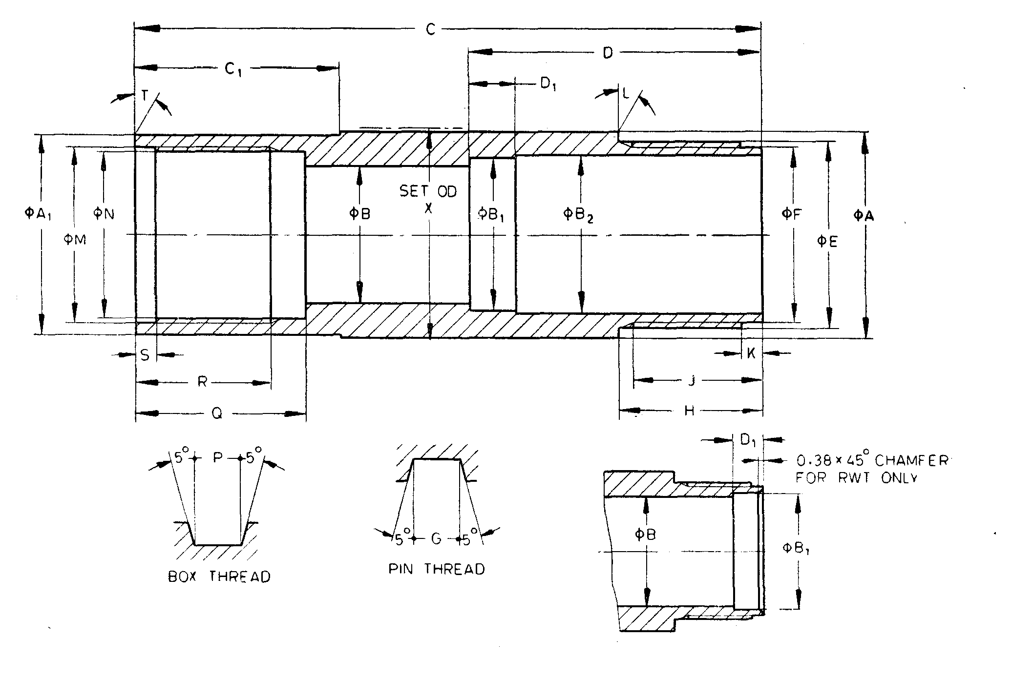

Fig. 72 'WT' design double tube core barrel — reaming shell

All dimensions are in millimetres.

|  |  |  |  |  |  |  |
| --- | --- | --- | --- | --- | --- | --- |
| *Sl No.* | *Dimension* | | *RWT* | | *EWT* | *AWT* |
| (1) | (2) | | (3) | | (4) | (5) |
| i) | *A* | *Max* | 28.75 | 36.96 | | 47.14 |
|  | *Min* | 28.65 | 36.86 | | 47.01 |
| ii) | *A*1 | *Max* | 28.75 | 36.25 | | 46.66 |
|  | *Min* | 28.65 | 36.14 | | 46.56 |
| iii) | *B* | *Max* | 19.81 | 24.76 | | 34.32 |
|  | *Min* | 19.43 | 24.51 | | 34.06 |
| iv) | *B*1 | *Max* | 21.46 | 27.51 | | 37.03 |
|  | *Min* | 21.33 | 27.25 | | 36.78 |
| v) | *B*2 | *Max* | — | 28.63 | | 37.82 |
|  | *Min* | 28.52 | | 37.69 |
| vi) | *C* | *Max* | 92.58 | 111.63 | | 133.86 |
|  | *Min* | 92.08 | 111.12 | | 133.35 |
| vii) | *C*1 | *Max* | — | 36.36 | | 39.80 |
|  | *Min* | 36.50 | | 39.67 |
| viii) | *D* | *Max* | — | 51.97 | | 58.32 |
|  | *Min* | 51.59 | | 57.94 |
| ix) | *D*1 | *Max* | 5.21 | 8.26 | | 8.26 |
|  | *Min* | 4.83 | 7.87 | | 7.87 |
| x) | *E* | *Max* | 24.56 | 33.30 | | 42.82 |
|  | *Min* | 24.51 | 33.25 | | 42.77 |
| xi) | *F* | *Max* | 23.37 | 31.72 | | 41.25 |
|  | *Min* | 23.32 | 31.67 | | 41.20 |
| xii) | Thread pitch | | 3.175 | | 3.175 | 3.175 |
| xiii) | *G* | *Max* | 1.63 | 1.63 | | 1.63 |
|  | *Min* | 1.55 | 1.55 | | 1.55 |
| xiv) | *H* | *Max* | 16.08 | 25.40 | | 31.75 |
|  | *Min* | 15.88 | 25.20 | | 31.55 |
| xv) | *J* | *—* | 13.49 | 23.01 | | 28.58 |
| xvi) | *K* | *Max* | 1.83 | 3.43 | | 3.43 |
|  | *Min* | 1.32 | 2.92 | | 2.92 |
| xvii) | *L* | *—* | 0° | 0° | | 0° |
| xviii) | *M* | *Max* | 24.66 | 31.83 | | 42.14 |
|  | *Min* | 24.61 | 31.78 | | 42.09 |
| xix) | *N* | *Max* | 23.47 | 30.23 | | 40.54 |
|  | *Min* | 23.42 | 30.18 | | 40.49 |
| xx) | Thread pitch | | 3.175 | | 3.175 | 3.175 |
| xxi) | *P* | *Max* | 1.63 | 1.63 | | 1.63 |
|  | *Min* | 1.55 | 1.55 | | 1.55 |
| xxii) | *Q* | *Max* | 28.70 | 30.28 | | 33.45 |
|  | *Min* | 28.58 | 30.15 | | 33.32 |
| xxiii) | *R* | *Max* | 22.72 | 24.30 | | 27.47 |
|  | *Min* | 22.22 | 23.80 | | 26.97 |
| xxiv) | *S* | *Max* | 3.43 | 3.43 | | 3.43 |
|  | *Min* | 2.92 | 2.92 | | 2.92 |
| xxv) | *T* | *—* | 0° | 0° | | 0° |
| xxvi) | *X* | *Max* | 29.97 | 37.85 | | 48.13 |
|  | *Min* | 29.72 | 37.59 | | 47.88 |

**ANNEX A**

(*Foreword*)

**COMMITTEE COMPOSITION**

**Diamond Core and Waterwell Drilling Sectional Committee, MED 21**

|  |  |
| --- | --- |
| *Organization* | *Members* |
| Geological Survey of India, New Delhi | Shri Ajay Agarwal (***Chairperson***) |
| Aqseptence Group (India) Pvt. Ltd.(Formaly Known as Johanson Screens India Pvt. Ltd.) Gujarat | Shri Shiv Narayan Singh  Shri Shiven Amin (*Alternate*) |
| Atlas Copco (I) Ltd. Pune | Shri Shudhanshu Nigam  Shri S. Datta Majumdar (*Alternate*) |
| Central Ground Water Board, Faridabad | Shri C. B. Singh  Shri Amit Kumar Singh (*Alternate*) |
| Central Mine Planning and Design Institute, Ranchi | Shri Anil Savanur  Shri A.V. Ramakrishna (*Alternate*) |
| Epiroc Mining India Limited, Nashik | Shri Sujeet Kumar  Shri Chandan Ghosh (*Alternate*) |
| Geological Survey of India | Shri Anup Kumar Johri  Shri C. B. Tiwari (*Young Professional* I)  Shri S. Shankar (*Young Professional* II) |
| Indian Institute of Technology, Kanpur | Prof J. Ramkumar  Prof Sudhanshu Shekhar Singh (*Alternate*) |
| Indian Institute of Technology Kharagpur, Kharagpur | Prof Khanindra Pathak  Shrimati Sunita Mishra (*Alternate*) |
| Indian Institute of Technology, Roorkee | Prof B.K. Gandhi  Shri Varun Kumar Sharma (*Alternate*) |
| Indian Pump Manufacturers Association, Mumbai | Shri Utkarsh A. Chhaya |
| Indian Institute of Technology (ISM), Dhanbad | Mohammed Hamid Siddique  Shri Pawan Gupta (*Alternate* I)  Shri Vinay Kumar Rajak (*Alternate* II) |
| Kores (India) Ltd, Mumbai | Shri Sandeep Dholi |
| Mining Associates Pvt Ltd, West Bengal | Shri Ram Babu Bansal |
| Rites Ltd, Gurgaon | Shri S. Kunal |
| Rockdrill (India), Jodhpur | Shri Kamal Kishor Gupta  Shri Ravindra Ku. Gupta (*Alternate*) |
| Sandvik Smith Asia Limited, Medak | Shri Rangayya Naidu  Shri N. Bhaskara Reddy (*Alternate*) |
| In Personal Capacity (*90 Mayur Vihar, Sec 48,*  *Chandigarh*) | Shri Mahesh Chandra Jindal |
| In Personal Capacity (*F-401, Maruti Sadan,*  *Begumpet, Hydrabad*) | Shri A. B. Anand |
| In Personal Capacity (*D-5/10, Rail Vihar, Indirapuram, Ghaziabad*) | Shri P. C. Dewli |
| BIS Directorate General | Shri K. V. Rao, Scientist ‘F’/Senior Director and Head (Mechanical Engineering) [Representing General (*Ex-officio*)] |

*Member Secretary*

Shri Shubham Yadav

Scientist ‘C’/Deputy Director

(Mechanical Engineering), BIS