**Doc: FAD 08(25278)F**

**IS 5055 : 2024**

***भारतीय मानक***

***Indian Standard***

**लेसीथीन, खाद्य ग्रेड *— विशिष्टि***

*( दूसरा पुनरीक्षण )*

**Lecithin, Food Grade — Specification**

*( Second Revision )*

ICS No. 67.220.20

© BIS 2024

**B U R E A U O F I N D I A N S T A N D A R D S**

MANAK BHAVAN, 9 BAHADUR SHAH ZAFAR MARG

NEW DELHI 110002

**November 2024** **Price Group**

Food Additives Sectional Committee, FAD 08

FOREWORD

This Indian Standard (Second Revision) was adopted by the Bureau of Indian Standards, after the draft finalized by the Food Additives Sectional Committee had been approved by the Food and Agriculture Division Council.

Food additives are added to improve the appearance, flavour, texture or storage properties, etc of the processed foods. As certain impurities in these substances have been found to be harmful, it is necessary to have a strict quality control of these food additives. A series of standards have, therefore, been prepared to cover purity and identification of these substances. These standards would help in checking purity, which requires to be checked at the stage of manufacture, for it is extremely difficult to detect the impurity once these substances have been added to the processed foods. Besides, these standards are intended to guide the indigenous manufacturers in making their product conform to specifications that are accepted by scientists, health authorities and national/ international bodies.

Lecithin, widely used as anti-oxidant and emulsifier, is permitted under the *Food Safety and Standards* (*Food Products Standards and Food Additives*) *Regulation*, 2011.

Chemical names and formulae:

The recognized chemical names are lecithin, phospholutein, phosphatides, and phospholipids. Food grade lecithin is a complex mixture of acetone insoluble phosphatides consisting chiefly of phosphatidyl choline, phosphatidyl ethanolamine, phosphatidic acid, and phosphatidyl inositol combined with various amounts of other substances, such as triglycerides, fatty acid and carbohydrates. Formulae for various phosphatides are given below:

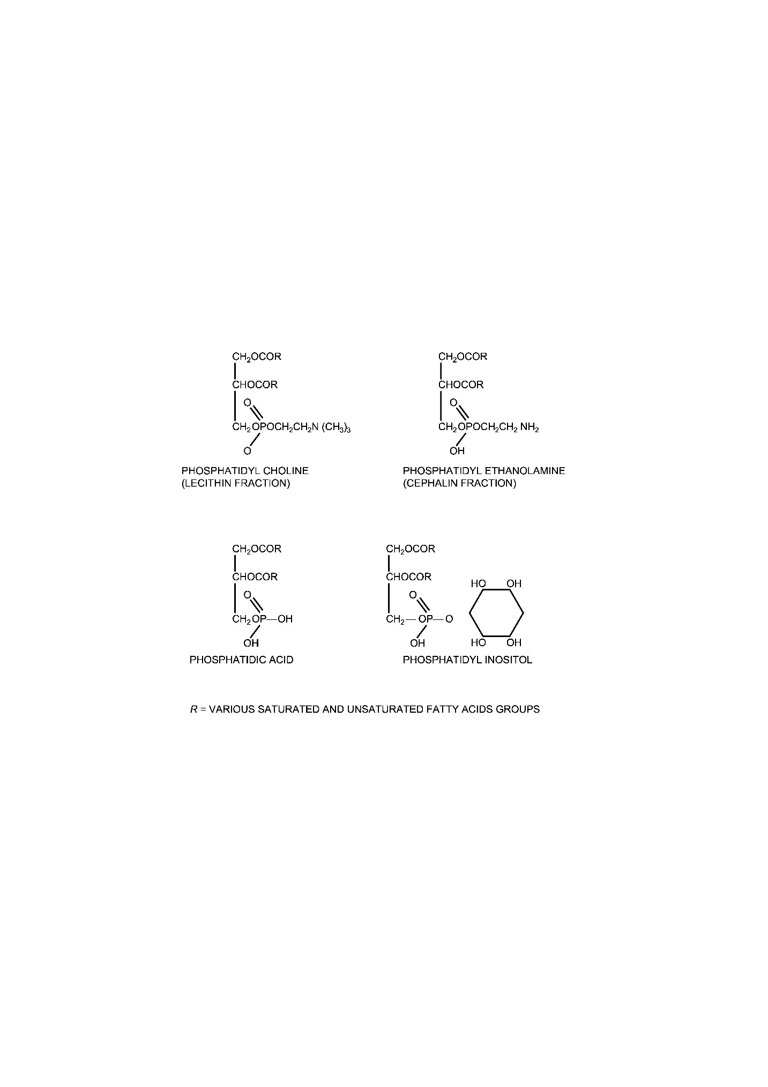

This standard was first published in 1969. In the preparation of this standard, considerable amount of assistance was derived from food chemical codex (FCC), Third Edition, National Academy of Sciences, National Research Council, Washington DC, USA.

It was first revised in 1996 to upgrade the standard by increasing the purity limit; to incorporate the requirement of solubility, heavy metals and peroxide value, and their methods of test; to provide information whether it is of animal origin or vegetable origin or both and the expiry date under marking clause.

In this revision, the following major changes have been made:

1. The requirement of lead has been aligned with JECFA Monograph (2007);
2. The requirement for heavy metals has been removed as the limit of lead (contaminant in food colours) is already covered through the standard;
3. The word ‘benzene insoluble matter’ has been replaced by ‘toluene insoluble matter’ and corresponding test method has been aligned with JECFA Monograph (2007); and
4. The marking requirements have been updated.

For the purpose of deciding whether a particular requirement of this standard is complied with, the final value, observed or calculated, expressing the result of a test or analysis, shall be rounded off In accordance with IS 2 : 2022 ‘Rules for rounding off numerical values (*second revision*)’. The number of significant places retained In the rounded off value should be the same as that of the specified value of this standard.

*Indian Standard*

LECITHIN, FOOD GRADE — SPECIFICATION

*( Second Revision )*

**1 SCOPE**

This standard prescribes the requirements and the methods of sampling and tests for lecithin, food grade.

**2 REFERENCES**

The standards given below contain provisions which through reference in this text, constitute provision of this standard. At the time of publication, the editions indicated were valid. All standards are subject to revision and parties to agreements based on this standard are encouraged to investigate the possibility of applying the most recent edition of these standards:

|  |  |
| --- | --- |
| *IS No.* | *Title* |
| IS 1070 : 2023 | Reagent grade water — Specification (*fourth revision*) |
| IS 1699 : 2024 | Food colours — Methods of sampling and test (*third revision*) |

**3 DESCRIPTION**

**3.1** The material is a viscous semi-liquid with a characteristic odour. It is light yellow to brown depending upon whether it is bleached or unbleached. Lecithin is obtained from egg or edible vegetable oilseeds by suitable dehydration or solvent extraction using food grade solvents. It may also be obtained from animal sources. Edible products, such as cocoa butter and vegetable oils may be added to improve functional and flavour characteristics.

**3.2** The material is insoluble in water but characteristically hydrated with swelling. It is insoluble in acetone but insoluble in chloroform and toluene. The lecithin fraction is soluble while cephalin fraction is insoluble in ethanol.

NOTE — The solubility is intended only as information regarding approximate solubility and is not to be considered as a quality requirement and is of minor significance as a means of identification or determination of purity.

**4 REQUIREMENTS**

**4.1 Identification**

**4.1.1** *Yellow Precipitate with Ammonium Molybdate*

Ignite 1 g of the material with 2 g of anhydrous sodium carbonate. Cool and dissolve the residue in 5 ml of water and 5 ml of nitric acid. Add 5 ml of ammonium molybdate and heat to boiling. A yellow precipitate shall be formed.

**4.1.2** *Blue Precipitate with Ferrous Sulphate*

Fuse about 0.5 g of the material with about 0.05 g of sodium in a soft glass tube, and heat to redness. Plunge while hot into about 10 ml of distilled water, heat to boiling and filter. Add a few crystals of ferrous sulphate to the filtrate, boil and add dilute sulphuric acid until just acidic. Allow to stand for 15 min, filter and wash. A blue precipitate shall be formed.

**4.1.3** Reflux 1 g of lecithin for 1 h with 25 ml of 0.5 N ethanolic potassium hydroxide. When cooled to 0 °C, precipitate of potassium soap shall be obtained.

**4.2 Gossypol Test**

The total gossypol content in cottonseed lecithin shall not exceed 5 percent by mass. The method for determination of gossypol is given in Annex A.

**4.3** The material shall also conform to the requirements given in Table 1.

**Table 1 Requirements for Lecithin, Food Grade**

(*Clauses* 4.3 *and* 8.1)

|  |  |  |  |
| --- | --- | --- | --- |
| **Sl No.** | **Characteristic** | **Requirements** | **Method of Test, Ref to** |
| (1) | (2) | (3) | (4) |
| i) | Purity as acetone insoluble residue, percent by mass, *Min* | 62 | Annex B |
| ii) | Moisture, percent by mass, *Max* | 2 | Annex C |
| iii) | Toluene insoluble matter, percent by mass, *Max* | 0.3 | Annex D |
| iv) | Acid value, *Max* | 35 | Annex E |
| v) | Arsenic (as As), mg/kg, *Max* | 3 | IS 1699 |
| vi) | Lead (as Pb), mg/kg, *Max* | 2 | IS 1699 |
| vii) | Peroxide value, percent by mass, *Max* | 10 | Annex F |

**5 PACKING**

The material shall be filled in amber coloured glass containers, or any other well-closed containers, or suitable bag with inner lining of food grade material, with as little air space as possible. The containers shall be such as to preclude contamination of the contents with metals or other impurities.

**6 MARKING**

**6.1** Each container shall be legibly and indelibly marked with the following information:

1. Name of the material, including the words ‘Food Grade’;
2. Name and address of the manufacturer;
3. Net content, when packed;
4. Batch or code number;
5. Date of manufacture;
6. Instructions for storage;
7. Expiry date; and
8. Any other requirements as specified under the *Legal Metrology* (*Packaged Commodities*) *Rules*, 2011 and *Food Safety and Standards* (*Labelling and Display*) *Regulations*, 2020.

**6.2** **BIS Certification Marking**

The product(s) conforming to the requirements of this standard may be certified as per the conformity assessment schemes under the provisions of the *Bureau of Indian Standards Act*, 2016 and the Rules and Regulations framed thereunder, and the products may be marked with the Standard Mark.

**7 SAMPLING**

Representative samples of the material shall be drawn according to the method prescribed in IS 1699.

**8 TESTS**

**8.1** Tests shall be carried out by the methods as specified in col (4) of Table 1.

**8.2 Quality of Reagents**

Unless specified otherwise, pure chemicals and distilled water (*see* IS 1070) shall be employed in tests.

NOTE — ‘Pure chemicals’ shall mean chemicals that do not contain impurities which affect the experimental results.

**ANNEX A**

(*Clause* 4.2)

**DETERMINATION OF TOTAL GOSSYPOL**

**A-1 PRINCIPLE**

The term ‘total gossypol’ designates ‘free gossypol’, ‘bound gossypol’ and closely related pigments which after hydrolysis and reaction with an organic amine (*p*-anisidine or aniline) give a product identical spectrophotometrically with that obtained from pure gossypol and the same reagent. In this method, total gossypol is completely removed from lecithin in a 30 min extraction during which gossypol is complexed with neutralized 3-amino-l-propanol in dimethyl formamide. The difference in absorption of aliquot portions of the extract before and after reaction with aniline serves as a measure of the total gossypol content, and allows proper correction for the background absorption of the extracts.

**A-2 APPARATUS**

**A-2.1 Photoelectric Colorimeter** —with a filter having a maximum transmittance in the vicinity of 440 nm or a spectrophotometer isolating a band at 440 nm.

**A-2.2 Pipette, Volumetric** —1 ml, 2 ml, 4 ml, 6 ml, 8 ml and 10 ml

**A-2.3 Flasks, Volumetric** —25 ml, 50 ml and 100 ml

**A-2.4 Insulated Water Bath**

Thermostatically controlled to ± 1 °C and capable of keeping the water at a gentle boil. The water-bath should be equipped with clamps to securely hold the volumetric flasks immersed in water.

**A-3 REAGENTS**

**A-3.1 Iso-propyl Alcohol-Hexane Mixture**

Mix 60 volumes of reagent grade iso-propyl alcohol and 40 volumes of commercial hexane.

**A-3.2 Complexing Reagent**

Pipette 2 ml of 3-amino-l-propanol and 10 ml of glacial acetic acid into a 100 ml volumetric flask, cool to room temperature, and dilute to volume with dimethyl formamide (N-N dimethyl formamide, redistilled between 152 °C to 153 °C). This reagent is stable for one week after preparation.

NOTE — 3-amino-1-propanol may be redistilled if coloured. Its boiling point is 188 °C, and it may be conveniently distilled under water pump vacuum.

**A-3.3 Aniline**

Reagent grade, redistilled over zinc dust. Store in a refrigerator and redistill when the absorbance of the reagent blank exceeds 0.022.

**A-4 STANDARD GOSSYPOL SOLUTIONS**

**A-4.1** Weigh accurately 25 mg of pure gossypol or 27.9 mg of pure gossypol acetate, dissolve in and make up to 50 ml volume with the complexing reagent. If exactly 25 mg of pure gossypol is used, the solution shall contain 0.5 mg/ml.

**A-4.2 Calibration Curve**

Pipette 2 ml, 4 ml, 6 ml, 8 ml and 10 ml of standard gossypol solution into 50 ml volumetric flasks.

**A-4.3** To each standard add sufficient complexing reagent to make up the total volume to 10 ml. Use 10 ml of the complexing reagent as a blank.

**A-4.4** Heat the flask containing the standards and the blank in a boiling water bath (100 °C) for 30 min, cool and dilute to volume with the iso-propyl alcohol-hexane mixture.

**A-4.5** Pipette in duplicate 2 ml aliquots of each diluted standard and of the blank into 25 ml volumetric flaks. Dilute one set of aliquots to volume with the iso-propyl alcohol-hexane mixture and reserve as reference solutions.

**A-4.6** To the other set of aliquots, add 2 ml of aniline. Heat in boiling water-bath for 30 min, cool to room temperature and dilute to volume with iso-propyl alcohol-hexane mixture Allow the flask to stand at room temperature for 1 h after dilution and mixing.

**A-4.7** With a spectrophotometer, determine the absorbance of the reagent blank at 440 nm using the dilute blank aliquot without aniline as a reference solution.

**A-4.8** Determine the absorbance of each gossypol standard reacted with aniline, using the appropriate diluted standard as a reference solution. Subtract the absorbance of the reagent blank from that of each standard to obtain the corrected absorbance.

**A-4.9** Calculate the calibration factor by dividing the number of milligrams of gossypol in the 2 ml aliquot of each standard by the appropriate corrected absorbance. Average the factors for all the gossypol standards. When a photo-electric colorimeter is used, the factors shall probably vary with each concentration of gossypol in which case a calibration curve should be plotted and used.

**A-5 SAMPLE PREPARATION**

Heat the sample to approximately 50 °C, mix well and filter store at 0 °C, if analysis is not done immediately, the analytical sample should contain from 1 mg to 5 mg of gossypol. For maximum precision, the aliquot used should contain 0.1 mg of gossypol.

**A-6 PROCEDURE**

**A-6.1** Weigh sufficient quantity of the sample material as directed in **A-4.1** into a 50 ml volumetric flask. Add 10 ml of the complexing reagent.

**A-6.2** Use 10 ml of the complexing reagent as the reagent blank.

**A-6.3** Heat both the sample and the blank in a boiling water-bath for 30 min, cool to room temperature, dilute to volume with iso-propyl alcohol hexane mixture and mix. Filter through Whatman No. 1 or equivalent filter paper and collect the filtrate in a small glass stoppered flask.

**A-6.4** Pipette duplicate aliquots (*see* **A-4.5**) of the filtered extract and of the reagent blank into 25 ml volumetric flasks.

**A-6.5** Dilute one of the aliquots to volume with the iso-propyl alcohol hexane mixture and reserve as reference solutions.

**A-6.6** To the other aliquot, add 2 ml of aniline, develop the colour and determine the corrected absorbance at 440 nm as outlined in **A-4.7** and **A-4.8**.

**A-7 CALCULATION**

Determine the gossypol (in milligrams) in the sample aliquot by means of the calibration curve on the calibration factor.

Total gossypol, percent by mass = $\frac{5 × mg gossypol in sample aliquot}{Mass of sample in g × Volume of aliquot used for analysis}$

**ANNEX B**

[*Table* 1, *Sl No.* (i)]

**DETERMINATION OF PURITY**

**B-1 REAGENTS**

**B-1.1 Purification of Phosphatide**

Dissolve 5 g of phosphatides from previous acetone insoluble matter determination in 10 ml of petroleum ether and add 25 ml of acetone to the solution. Transfer approximately equal portions of the precipitate to each of two 40 ml centrifuge tubes using additional portions of acetone to facilitate the transfer. Stir thoroughly, dilute to 40 ml with acetone, stir again, chill for 15 min in an ice-bath, stir again, and then centrifuge for 5 min. Decant the acetone, crush the solids with a stirring rod, refill the tube with acetone, stir, chill, centrifuge and decant as before. The solids after the second centrifugation require no further purification and may be used for preparing the phosphatide acetone solution. 5 g of the purified phosphatides are required to saturate about 16 litre of acetone.

**B-1.2 Phosphatide Acetone Solution**

Add a quantity of purified phosphatides to sufficient acetone previously cooled to a temperature of about 5 °C to form a saturated solution and maintain the mixture at this temperature for 2 h shaking it vigorously at 15 min intervals. Decant the solution through a rapid filter paper avoiding the transfer of any undissolved solids to the paper and conducting the filtration under refrigerated conditions (not above 5 °C).

**B-2 PROCEDURE**

Soften a portion of the material by warming it in a water bath at a temperature not exceeding 60 °C and then mixing it thoroughly. Transfer 2 g of a well-mixed sample accurately weighed into a 40 ml centrifuge tube previously tared with a glass stirring rod. Add 15 ml of phosphatide acetone solution from a burette. Warm the mixture in a water bath until the lecithin melts, but avoid evaporation of the acetone. Stir until the sample is completely disintegrated and dispersed, and then transfer the tube into an ice-bath. Stir for 5 min, remove from the ice-bath, and add about one-half of the required volume of phosphatide acetone solution, previously chilled for 5 min in an ice-bath. Stir the mixture to complete dispersion of the sample, dilute to 40 ml with chilled phosphatide acetone solution (5 °C), again stir and return the tube and contents to the ice-bath for 15 min. At the end of the 15 min chilling period, stir again while still in the ice-bath, remove the stirring rod, temporarily supporting it in a vertical upside down position and centrifuge the mixture immediately at about 2 000 rev/min for 5 min. Decant the supernatant liquid from the centrifuge tube, crush the centrifuged solids with the same stirring rod previously used, and refill the tube to the 40 ml mark with chilled (5 °C) phosphatide acetone solution, and repeat the chilling, stirring, centrifugation, and decantation procedure previously followed. After the second centrifugation and decantation of the supernatant acetone, again crush the solids with the assigned stirring rod, and place the tube and its contents in a horizontal position at room temperature until the excess acetone has evaporated. Mix the residue again. Dry the centrifuge tube and its contents at l05 °C for 45 min in a forced draft oven, cool and weigh.

**B-3 CALCULATION**

Acetone insoluble residue, percent by mass =

where

|  |  |  |
| --- | --- | --- |
| *R* | = | mass of the residue; |
| *B* | = | toluene insoluble matter (*see* **D-2**); and |
| *S* | = | mass of the sample. |

**ANNEXC**

[*Table* 1, *Sl No.* (ii)]

**DETERMINATION OF MOISTURE**

**C-1 APPARATUS**

**C-1.1 Oven** —maintained at (105 ± 1) °C

**C-1.2 Weighing Bottle** —glass stoppered, shallow

**C-2 PROCEDURE**

Weigh accurately about 10 g of the well mixed sample in the tared weighing bottle. Distribute the sample as evenly as practicable to a depth of about 5 mm. Place the bottle containing the sample (uncovered) in the oven maintained at (105 ± 1) °C. Remove the bottle from the oven after 1 h, close the bottle promptly and allow it to come to room temperature in a desiccator. Weigh it.

Calculate loss on drying, percent by mass.

**ANNEX D**

[*Table* 1, *Sl No*. (iii)]

**DETERMINATION OF TOLUENE INSOLUBLE MATTER**

**D-1 PROCEDURE**

Weigh 10 g of the well-mixed sample into a 250 ml flask. Add 100 ml of toluene and shake until dissolved. Filter through a tared filter funnel G3 or equivalent with a porosity of 16 µm to 40 µm. Wash the flask with 25 ml portions of toluene and pour the washings through the funnel. Place the funnel in a forced-draft oven and dry at 105 oC for 1 h. Weigh the dried funnel.

**D-2 CALCULATION**

Toluene insoluble residue, percent by mass = $\frac{M_{1} × 100}{M}$

where

*M*1 = mass, in g, of the residue; and

*M* = mass, in g, of the sample taken.

**ANNEX E**

[*Table* 1, *Sl No.* (iv)]

**DETERMINATION OF ACID VALUE**

**E-1 PROCEDURE**

Soften a portion of the material by warming it in a water-bath at a temperature not exceeding 60 °C and then mix it thoroughly. Transfer about 2 g of the well-mixed sample into a 250 ml wide-mouth Erlenmeyer flask, and dissolve it in 50 ml of petroleum ether. To this solution, add 50 ml of alcohol, previously neutralized to phenolphthalein with 0.1 N sodium hydroxide, and mix well. Add phenolphthalein and titrate with 0.1 N sodium hydroxide to a pink end point which persists for 5 s.

**E-2 CALCULATION**

Calculate the number of milligrams of potassium hydroxide required to neutralize the acids in one gram of the sample by multiplying the number of millilitres of 0.1 N sodium hydroxide consumed in the titration by 5.6 and dividing the result by the weight of the sample.

**ANNEX F**

[*Table* 1, *Sl No.* (vii)]

**DETERMINATION OF THE PEROXIDE VALUE**

**F-1 PRINCIPLE**

Oxidation of potassium iodide by the peroxides of lecithin and titration of the iodine liberated using standard sodium thiosulphate solution.

**F-2 APPARATUS**

**F-2.1 Analytical Balance**

**F-2.2 Apparatus** — as shown in Fig. 1

**F-3 REAGENTS**

**F-3.1 Acetic Acid Glacial**

**F-3.2 Chloroform**

**F-3.3 Potassium Iodide**

**F-3.4 Sodium Thiosulphate** (0.1 mol/l or 0.01 mol/l)

**F-3.5 Starch Solution** (approximately 1 percent *m*/*v*)

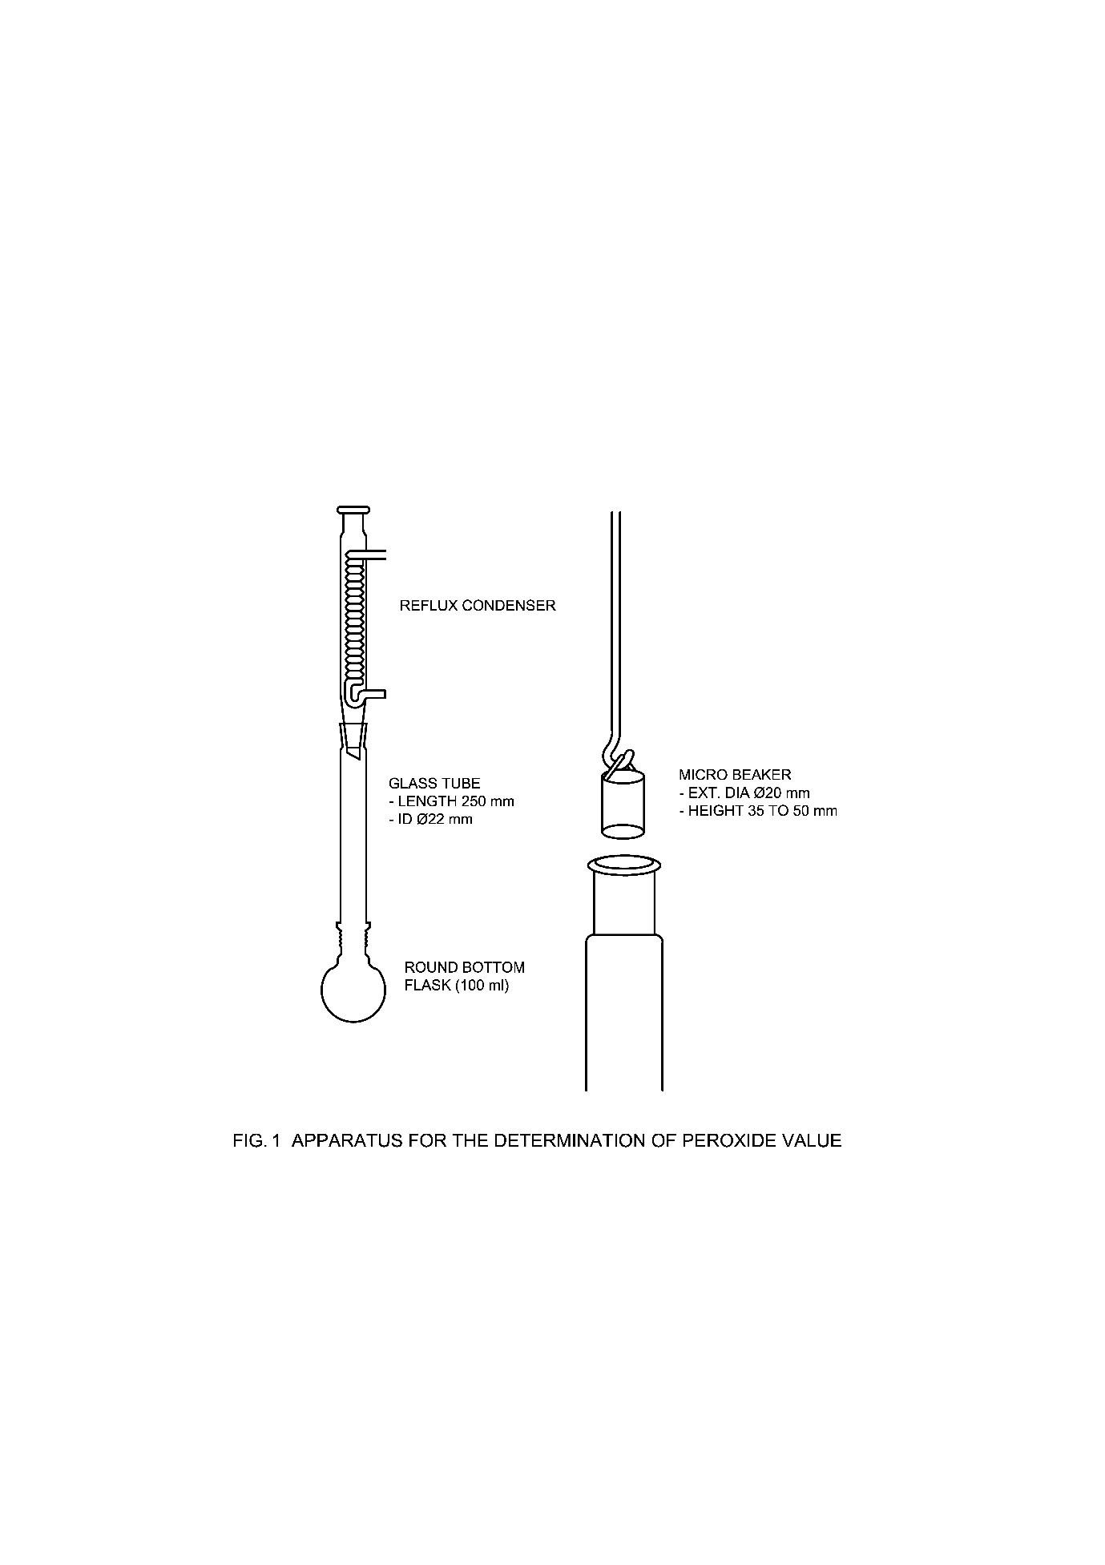

Fig. 1 Apparatus for the Determination of Peroxide Value

**F-4 PROCEDURE**

**F-4.1** Place 10 ml of glacial acetic acid and 10 ml of chloroform in the 100 ml flask. Fit the glass tube and reflux condenser and gently boll the mixture for 2 min to expel all dissolved air. Dissolve 1 g of potassium iodide in 13 ml of water and add this solution to the mixture in the flask taking care that the boiling is not interrupted.

**F-4.2** If a yellow colour appears at this stage the determination must be rejected and repeated using fresh reagents.

**F-4.3** Accurately weigh, to the nearest mg, about 1 g of the sample and, after a further 2 min of boiling, add the weighed sample to the contents of the flask again taking care that the boiling remains continuous. For this purpose, the sample should be contained in a micro-beaker which may be lowered through the glass tube with a glass rod. The bottom of which has been suitably shaped as shown in the diagram. The condenser may be removed for a short time. Continue boiling for three to 4 min. Stop heating and immediately disconnect the condenser. Quickly add 50 ml of water through the glass tube. Remove the glass tube and cool the flask to room temperature under the water tap. Titrate with sodium thiosulphate until the aqueous layer becomes pale yellow. Add 1 ml of starch solution and continue the titration until the blue colour is discharged. Shake the flask well during the titration to ensure the complete extraction of iodine from the non-aqueous layer.

**F-4.4** Obtain a blank titration value by repeating the complete procedure (**F-4.1** to **F-4.3**) but without adding the sample.

**F-5 CALCULATION**

The peroxide value of the sample, in milli-equivalents per kilogram is given by:



where

|  |  |  |
| --- | --- | --- |
| *a* | = | concentration of sodium thiosulphate solution in mol/l; |
| *V*1 | = | volume in ml of thiosulphate solution required for the titration of the sample; |
| *V*2 | = | volume in ml of thiosulphate solution required for the titration at blank; and |
| *m*0 | = | initial mass in grams of the sample taken. |

NOTES

**1** The choice of the concentration of the sodium thiosulphate used depends on the anticipated titration value. Less than 0.5 ml of 0.1 mol/l sodium thiosulphate is required, repeat the determination using 0.01 mol/l sodium thiosulphate.

**2** The determination should not be carried out in strong light.