**Doc. No. FAD 18 (24917) F**

**IS 12190 : 2024**

*भारतीय मानक*

**भेड़ के रक्ततस्राव के लिए बेड़ियां — विशिष्टि**

*( पहला पुनरीक्षण )*

*Indian Standard*

**Sheep Bleeding Shackles — Specification**

*( First Revision )*

ICS 65.040.20

© BIS 2024

**BUREAU OF INDIAN STANDARDS**

MANAK BHAVAN, 9 BAHADUR SHAH ZAFAR MARG

NEW DELHI 110002

**July 2024 Price Group**

Slaughter House and Meat Industry Sectional Committee, FAD 18

FOREWORD

This Indian Standard (First Revision) was adopted by the Bureau of Indian Standards, after the draft finalized by the Slaughter House and Meat Industry Sectional Committee had been approved by the Food and Agriculture Division Council.

Bleeding shackles is an essential tool used in slaughterhouses during the processing of sheep. Bleeding shackles are used for bleeding the stunned sheep in an abattoir. It is used to fasten hind legs of sheep for hanging on conveyor rail for slaughtering and bloodletting. It is used with other sheep slaughtering equipment as well as slaughtering and meat processing machines.

In order to provide guidance to manufacturers and facilitate quality manufacturing of sheep bleeding shackles, this standard was first published in 1987. In this first revision of the standard, the raw material requirements for the flat section and shackle rod have been modified as per current technological advancement and industrial practices. Also, the standard has been brought out in the latest style and format of the Indian Standards.

The composition of the Committee responsible for the formulation of this standard is given in Annex B.

For the purpose of deciding whether a particular requirement of this standard is complied with, the final value, observed or calculated, expressing the result of a test or analysis, shall be rounded off in accordance with IS 2 : 2022 ‘Rules for rounding off numerical values (*second revision*)’. The number of significant places retained in the rounded off value should be the same as that of the specified value in this standard.

*Indian Standard*

SHEEP BLEEDING SHACKLES — SPECIFICATION

( *First Revision )*

**1 SCOPE**

This standard prescribes the material, dimensions and other requirements for sheep bleeding shackles. These sheep bleeding shackles are suitable for semi-automatic type of abattoirs.

**2 REFERENCES**

The standards given below contain provisions which through reference in this text, constitute provision of this standard. At the time of publication, the editions indicated were valid. All standards are subject to revision and parties to agreements based on this standard are encouraged to investigate the possibility of applying the most recent edition of these standards:

|  |  |
| --- | --- |
| *IS No.* | *Title* |
| IS 2062 : 2011 | Hot rolled medium and high tensile structural steel — Specification (*seventh revision*) |
| IS 4905 : 2015 | Random sampling and randomization procedures (*first revision*) |
| IS 6628 : 2024 | Slide rails for use in abattoirs — Specification (*first revision*) |
| IS 6911 : 2017 | Stainless steel plate, sheet and strip — Specification (*second revision*) |

**3 DESCRIPTION**

The sheep bleeding shackles shall consist of the shackle rod attached to a flat section with swiveling arrangements to suit the sliding rails. The word shackle means a ring or other fastening for securing the wrist or ankle, etc; in order to confine or restrain the sheep.

**4 MATERIAL OF CONSTRUCTION REQUIREMENTS**

The flat section and the shackle rod shall be made of mild steel as per IS 2062 or stainless steel of designation SS 304 (Austenitic X04Cr19Ni9) or SS 316 (Austenitic X04Cr17Ni12Mo2) conforming to IS 6911.

**5 SHAPE AND DIMENSIONS REQUIREMENTS**

**5.1** The shape and dimensions of the sheep bleeding shackles is given in Fig. 1 for guidance.

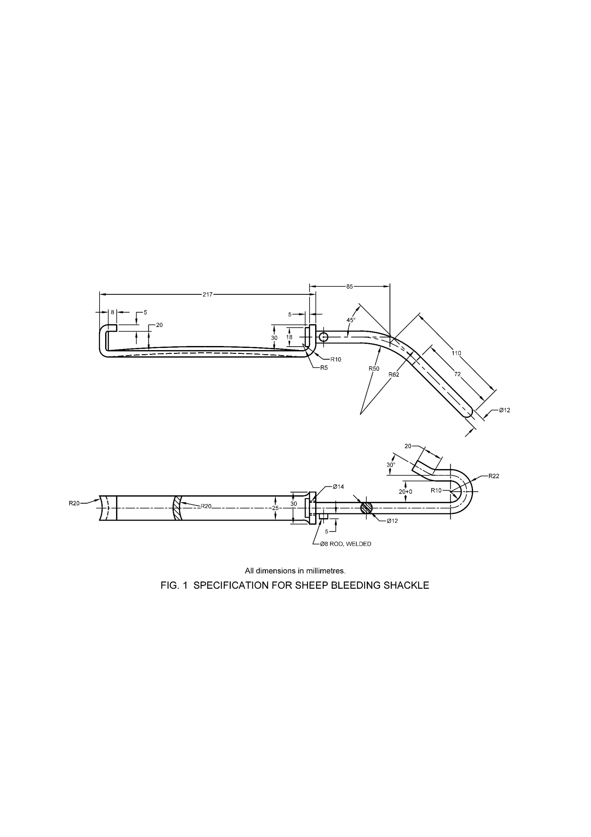

All dimensions in millimetres.

Fig. 1 Sheep Bleeding Shackle

**5.1.1** The tolerance for various dimensions given in Fig. 1 shall be ± 5 percent.

**6 CONSTRUCTIONAL REQUIREMENTS**

**6.1** The shape at the shackle end shall be as given in Fig. 1 and the end shall be rounded smoothly.

**6.2** The shackle shall not lose its original shape when a mass of 100 kg is applied.

**6.3** The shackle shall rotate freely on the flat section.

**6.4** The flat section shall be selected taking into consideration, the dimensions of the overhead rail system (*see* IS 6628). The flat section shall make minimum contact on the rail to ensure easy mobility.

**7 WORKMANSHIP AND FINISHING REQUIREMENTS**

**7.1** The sheep bleeding shackle shall be free from flaws, burrs, pits and sharp edges.

**7.2** The welding shall be smooth and satisfactory in all respects. It shall not be porous or brittle.

**7.3** The components of bleeding shackle when constructed of mild steel shall be hot dip galvanized before assembly for protection from rust and corrosion.

**8 MARKING**

**8.1** Each sheep bleeding shackle shall be marked with the following information at a convenient place.

1. Manufacturer’s name or trade-mark, if any;
2. Year of Manufacture; and
3. Batch or code number.

**8.1.1** The marking shall be done at an appropriate and visible place.

**8.2 BIS Certification Marking**

The product(s) conforming to the requirements of this standard may be certified as per the conformity assessment schemes under the provisions of the *Bureau of Indian Standards Act*, 2016 and the Rules and Regulations framed thereunder, and the products may be marked with the Standard Mark.

**9 PACKING**

The sheep bleeding shackles shall be packed for safe handling between the manufacturer and the purchaser.

**10 SAMPLING**

The method for drawing representative samples of sheep bleeding shackles and the criteria for conformity shall be as given in Annex A.

**ANNEX A**

(*Clause* 10)

**SAMPLING OF BLEEDING SHACKLES**

**A-1 SCALE OF SAMPLING**

**A-1.1 Lot**

In any consignment of the sheep bleeding shackle of the same type, shape, size and belonging to the same batch of manufacture, shall be grouped together to constitute a lot.

**A-1.2** For ascertaining the conformity of the material to the requirements of this specification, Samples shall be tested from each lot separately.

**A-1.3** The number of sheep bleeding shackle to be selected from a lot shall depend on the size of the lot and shall be according to col (2) and col (3) of Table 1.

**Table 1 Scale of Sampling and Permissible Number of Defectives**

(*Clauses* A-1.3, A-2.1 *and* A-2.2)

|  |  |  |  |  |
| --- | --- | --- | --- | --- |
| Sl No. | Number of Sheep Bleeding  Shackles in the Lot | For Visual and Dimensional Requirements | | Number of Sheep Bleeding  Shackles as the Sub-sample for Bend Test |
|  |  | Number of Hooks  to be Selected | Permissible Number of Defectives |  |
| (1) | (2) | (3) | (4) | (5) |
|  | Up to 100 | 5 | 0 | 2 |
|  | 101 to 300 | 13 | 1 | 2 |
|  | 301 to 500 | 32 | 3 | 3 |
|  | 501 to 1 000 | 50 | 5 | 5 |
|  | 1 001 and above | 80 | 7 | 8 |

These sheep bleeding shackles shall be selected at random from the lot. In order to ensure the randomness of selection, procedures given in IS 4905 shall be followed.

**A-2 NUMBER OF TESTS AND CRITERIA FOR CONFORMITY**

**A-2.1** All the sheep bleeding shackles selected according to **A-1.3** shall be examined for all the visual and dimensional requirements (*see* **5**, **6.1**, **6.3**, **6.4** and **7**). A shackle failing to satisfy any one or more of these requirements shall be considered as defective. The lot shall be considered as conforming to these requirements if the number of defectives found in the sample is less than or equal to the corresponding number of permissible number of defectives given in col (4) of Table 1.

**A-2.2** The lot having been found satisfactory according to **A-2.1** shall be further subjected to bend test given in **6.2**. For this purpose, a sub-sample of size given in col (5) of Table 1 shall be taken from the lot. These hooks may be selected from those already examined according to **A-2.1** and found satisfactory. The lot shall be declared as conforming to the requirements of this specification if none of the shackles subjected to the bend test fails to satisfy the requirements of this test.

**ANNEX B**

(*Foreword*)

**COMMITTEE COMPOSITION**

Slaughter House and Meat Industry Sectional Committee, FAD 18

| *Organization* |  | *Representative(s)* |
| --- | --- | --- |
| ICAR - National Research Center on Meat, Hyderabad |  | Dr S. B. Barbuddhe **(*Chairperson*)** |
| All India Meat and Livestock Exporters Association, Mumbai |  | Dr N. Kondaiah |
| Animal Welfare Board of India, Balabhgarh |  | Dr Sujit Kumar Dutta  Shrimati Prachi Jain (*Alternate*) |
| Association of Meat Scientists and Technologists (AMST), Chennai |  | Dr V. Appa Rao |
| Confederation of Indian Food & Trade Industry & Industry, New Delhi |  | Shri Kannan B.  Ms Varsha Yadav (*Alternate*) |
| CSIR - Central Food Technological Research Institute, Mysuru |  | Dr Tanaji Kudre |
| CSIR - Central Leather Research Institute, Chennai |  | Dr T. S. Uma |
| Deonar Slaughterhouse, Mumbai |  | Dr Kalimpasha Ahmedkhan Pathan |
| Food Safety and Standards Authority of India, New Delhi |  | Ms Geetika  Ms Nidhi Somia Lakra (*Alternate*) |
| Greater Hyderabad Municipal Corporation, Hyderabad |  | Dr Abdul Wakil  Dr K. Chakrapani Reddy (*Alternate*) |
| ICAR - Indian Veterinary Research Institute, **Bareilly** |  | Dr A. R. Sen  Dr Suman Talukder (*Alternate*) |
| ICAR - National Research Center on Meat, Hyderabad |  | Dr M. Muthukumar  Dr B. M. Naveena (*Alternate*) |
| ICAR - National Research Centre for Pig, Guwahati |  | Dr R. Thomas |
| Indian Meat Science Association, Hyderabad |  | Dr Girish Patil S.  Dr Rajiv Ranjan Kumar (*Alternate*) |
| Indian Poultry Science Association, **Bareilly** |  | Dr Jaydeep Rokade |
| Indian Stainless Steel Development Association (ISSDA), Gurugram |  | Shri Rohit Kumar |
| Kerala Veterinary and Animal Sciences University, Thrissur |  | Dr Vasudevan V. N.  Ms Renuka Nayar (*Alternate*) |
| Ministry of Food Processing Industries, Delhi |  | Dr G. Srinivasan |
| Municipal Corporation of Delhi, New Delhi |  | Dr V. K. Singh  Dr Akhilesh Kamal (*Alternate*) |
| People for Ethical Treatment of Animals, Mumbai |  | Dr Kiran Ahuja  Dr Bandhanpreet Kaur (*Alternate*) |
| Rajiv Gandhi Institute of Veterinary Education and Research (RIVER), Pondicherry |  | Dr P. K. Mandal  Dr V. J. Ajay (*Alternate*) |
| Tamil Nadu Vet & Animal Sciences University, Chennai |  | Dr R. Narendra Babu  Dr S. Ezhilvelan (*Alternate*) |
| Voluntary Organisation in Interest of Consumer Education (VOICE), New Delhi |  | Shri M. A. U. Khan  Dr Rajiv Jha (*Alternate*) |
| BIS Directorate General |  | Shrimati Suneeti Toteja, Scientist ‘E’/ Director and Head (Food and Agriculture) [Representing Director General (*Ex-officio*)] |

*Member Secretary*

Shri Debasish Mahalik

Scientist ‘C’/Deputy Director

(Food and Agriculture), BIS

Panel for Equipment Related Slaughter House and Meat Industry FAD 18/P 4

|  |  |
| --- | --- |
| *Organization* | *Representative(s)* |
| Tamil Nadu Vet & Animal Sciences University, Chennai | Dr R. Narendra Babu **(*Convener*)**  Dr S. Ezhilvelan |
| ICAR - Indian Veterinary Research Institute, **Bareilly** | Dr Ravikant Agarwal |
| National Research Centre for Pig, Guwahati | Dr R. Thomas |