**FAD 11 (24864) F**

IS 10684 : 2024

***भारतीय मानक***

**ट्री प्रूनर — विशिष्टि**

*( पहला पुनरीक्षण )*

**Indian Standard**

**Tree Pruner — Specification**

*( First Revision )*

ICS 65.060.70

© BIS 2024

**B U R E A U O F I N D I A N S T A N D A R D S**

MANAK BHAVAN, 9 BAHADUR SHAH ZAFAR MARG

NEW DELHI 110002

*September*, 2024 **Price Group**

Agricultural Machinery and Equipment Sectional Committee, FAD 11

FOREWORD

This Indian Standard (First Revision) was adopted by the Bureau of Indian Standards, after the draft finalized by the Agricultural Machinery and Equipment Sectional Committee had been approved by the Food and Agriculture Division Council.

A tree pruner is a hand tool used for removing unwanted branches/twigs of the tree for giving proper framework and aeration to the tree. Tree pruner can be used to remove the unwanted branches/twigs more conveniently with less effort and saving time. Nowadays long reach tree pruner is used to cut branches which are beyond the reach of human hand and is thus a more powerful tool for the modern gardener. The long reach tree pruner is fixed on the top of a bracket which is fixed with lightweight aluminium or fibre glass pipe, and the blade is actuated by a nylon strip/rope which returns to the original position with the help of tension spring. Height can be extended through telescopic pipe (optional) which is used for cutting of green limbs from far away branches of tree without using ladder. It can cut the branches at different angles also.

This standard was first published in 1983. The revision of this standard incorporates the following changes:

1. Types of tree pruner are briefly explained with the help of graphical representation and dimensional figures for guidance of users;
2. Details of long reach tree pruner has been added;
3. Hardness, size and dimensions of tree pruner has been modified as per current manufacturing practices; and
4. Raw material requirements of the tree pruner have been updated as per the current manufacturing practices.

The figures in the standard are given only for typical illustration and should not be considered as suggestive of any standard design.

In revision of this standard, considerable assistance has been derived from the technical information provided by Agricultural Machinery Manufacturers Association, Pune, India.

The composition of the Committee responsible for the formulation of this standard is given in Annex B.

For the purpose of deciding whether a particular requirement of this standard is complied with, the final value, observed or calculated expressing the result of a test or analysis, shall be rounded off in accordance with   
IS 2 : 2022 ‘Rules for rounding off numerical values (*second revision*)’. The number of significant places retained in the rounded off value should be the same as that of the specified value in this standard.

*Indian Standard*

TREE PRUNER — SPECIFICATION

*( First Revision )*

**1 SCOPE**

This standard specifies material, dimensional and other requirements for tree pruner.

**2 REFERENCES**

The standards listed in Annex A contain provisions which, through reference in this text, constitute provisions of this standard. At the time of publication, the editions indicated were valid. All standards are subject to revision and parties to agreements based on this standard are encouraged to investigate the possibility of applying the most recent edition of these standards.

**3 TYPES**

**3.1 Tree Pruner**

A simple gardening equipment used by gardner/farmer to cut unwanted branches/twigs which are in reach of the human hand. The various parts of the tree pruner are given in Fig. 1 to Fig. 7.

**3.2 Long Reach Tree Pruner**

A tree prunerused to cut branches/twigs which are beyond the reach of human hand. The various parts of the long reach tree pruner are given in Fig. 8 and Fig. 9.

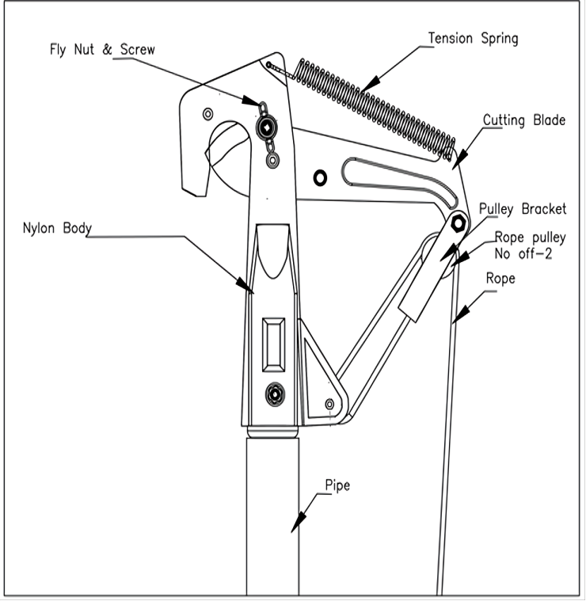

Fig. 1 Typical Example of Tree Pruner AssemblyA diagram of a curved object

Description automatically generated

Fig. 2 Typical Dimensions of Cutting Saw for Tree Pruner

(All dimensions are in mm unless stated otherwise)

Fig. 3 Typical Dimensions of Cutting Blade for Tree Pruner

(All dimensions are in millimetres unless stated otherwise)

**4 MATERIALS**

**4.1 Blade**

The blade of the tree pruner shall be manufactured from carbon steel [*see* IS 1570 (Part 2/Sec 1)] or stainless steel (*see* IS 6911).

**4.1.1** The chemical composition of the carbon steel shall be as follows:

|  |  |  |  |
| --- | --- | --- | --- |
|  | Carbon | — | 0.7 percent to 0.9 percent; |
|  | Silicon | — | 0.1 percent to 0.4 percent; |
|  | Manganese | — | 0.5 percent to 1.0 percent; |
|  | Sulphur | — | 0.05 percent, *Max*; and |
|  | Phosphorus | — | 0.05 percent, *Max*. |

**4.1.1.1** Some of the examples of carbon steels that may be used are C70, C80 and C85 [*see* IS 1570 (Part 2/Sec 1)].

**4.1.2** The chemical composition of stainless steel (*see* IS 6911) as:

|  |  |  |  |
| --- | --- | --- | --- |
|  | Carbon | — | 0.26 percent to 0.4 percent; |
|  | Silicon | — | 1.0 percent, *Max*; |
|  | Manganese | — | 0.6 percent to 1.0 percent; |
|  | Sulphur | — | 0.03 percent, *Max*; |
|  | Phosphorus | — | 0.03 percent, *Max*; and |
|  | Chromium | — | 12 percent to 14 percent. |

**4.2 Body Links**

For body links mild steel (*see* IS 2062) should be used.

**4.3 Main Body**

The following material shall be used for body:

1. Nylon 6 (*see* IS 13463); or
2. Teak wood body with steel bracket.

**4.4 Spring**

Spring steel wire [*see* IS 4454 (Part 1)] should be used.

**4.5 Pipe**

Pipe shall be made of aluminium alloy (*see* IS 1285) or light weight fibre glass.

**4.6 Cutting Saw**

The saw shall be manufactured from a suitable steel having a carbon content of not less than 0.7 percent. Suitable steels that may be used for this purpose are C70, C75, C80, C85 [*see* IS 1570 (Part 2/Sec 1)]. It should be hardened and tempered.

**4.6 Rope**

It shall be made of nylon (*see* IS 13643).

**5 HARDNESS**

The blade shall be heat-treated to have a hardness in range of 48 to 55 HRC [*see* IS 1586 (Part 1)].

**6 SIZE**

**6.1** The size (total length) shall be declared by the manufacturer. The size shall not differ by more than ± 15 mm from the declared value.

**6.2** Sizes of various types of tree pruners for guidance of the user have been provided in Table 1.

Fig. 4 Typical Dimensions of Body of Tree Pruner

(All dimensions are in millimetres unless stated otherwise)

**Table 1 Sizes of Various Types of Tree Pruners**

(*Clause* 6.2)

|  |  |  |  |
| --- | --- | --- | --- |
| **Sl No.** | **Type** | **Length,**  (mm) | Reference Figures |
|  |  |  |  |
|  | Length (L1) of wooden body tree pruner without saw and handle, without top of the blade | 445 | *see* Fig. 6A |
|  | Length (L2) of wooden body tree pruner with saw, without handle | 780 | *see* Fig. 6B |
|  | Length (L3) of wooden body tree pruner without saw and handle, with top of the blade | 530 | *see* Fig. 6A |
|  | Length (L) of wooden body tree pruner with saw | 2 760 to 2 810 | *see* Fig. 6C |
|  | Length (L) of wooden body tree pruner without saw | 2 425 to 2 475 | — |
|  | Length (L) of plastic body tree pruner with saw | 2 530 to 2 580 | *see* Fig. 5A |
|  | Length (L) of plastic body tree pruner without saw | 2 200 to 2 250 | *see* Fig. 5B |
| NOTE — The tolerance on various dimensions, unless specified otherwise, shall be ± 3 mm. | | | |

**7 DIMENSIONS**

**7.1** The dimensions of various components such as body, cutting saw and blade are given in given in Fig. 2, Fig. 3 and Fig. 4 for guidance of users. The tolerance on various dimensions, unless specified otherwise, shall be ± 5 percent.

**7.2** Dimensions of aluminium and fibre glass handle (*see* Fig. 6C and Fig. 7) which is attached to tree pruners are given in Table 2.

**Table 2 Dimension for Aluminium and Fibre Glass Handle**

(*Clause* 7.2)

|  |  |  |  |
| --- | --- | --- | --- |
| **Sl No.** | **Handle Type** | **Length**  (mm) | **Diameter**  (mm) |
| (1) | (2) | (3) | (4) |
| i) | Aluminium pipe | 2 000 to 2 050 | 25 to 30 |
| ii) | Fibre glass pipe | 2 000 to 2 050 | 26.5 to 32 |

**7.3** The diameter of wire for tension spring shall be minimum 1.4 mm for plastic body and 1.75 mm for wooden body. The spring shall have 25 and 27 coils respectively.

**7.4** Details of long reach tree pruner are given in Fig. 8.

**7.5** There shall be an operating nylon strip of 1.0 mm thick, 6.0 mm wide and of length as required for long reach tree pruner as shown in Fig. 8 and Fig. 9. The tolerance on various dimensions, unless specified otherwise, shall be ± 3 percent.

|  |  |
| --- | --- |
|  |  |
| Fig. 5A Tree Pruner (Plastic Body)  With Cutting Saw | Fig. 5B Tree Pruner (Plastic Body) Without Cutting Saw |

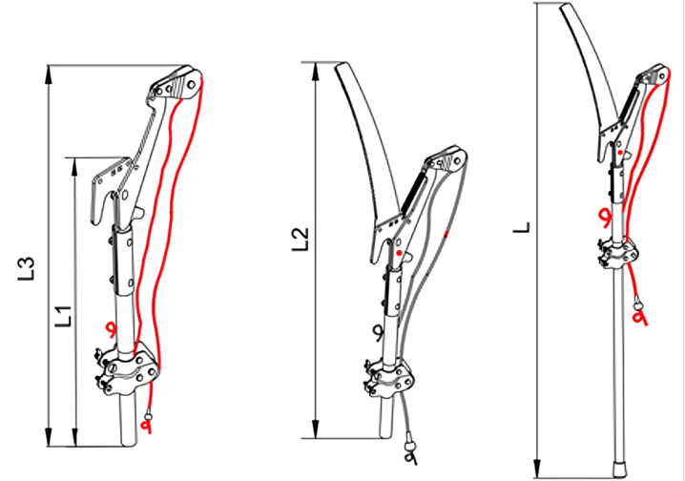

Fig. 6C Tree Pruner (Wooden Body) With Cutting Saw Attached With Aluminium/Fibre Glass Handle

Fig. 6B Tree Pruner (Wooden Body) With Cutting Saw

Fig. 6A Tree Pruner (Wooden Body) Without Cutting Saw

Fig. 7 Complete Tree Pruner (Wooden Body) Attached With Optional Aluminium or Light Weight Fibre Glass Handle

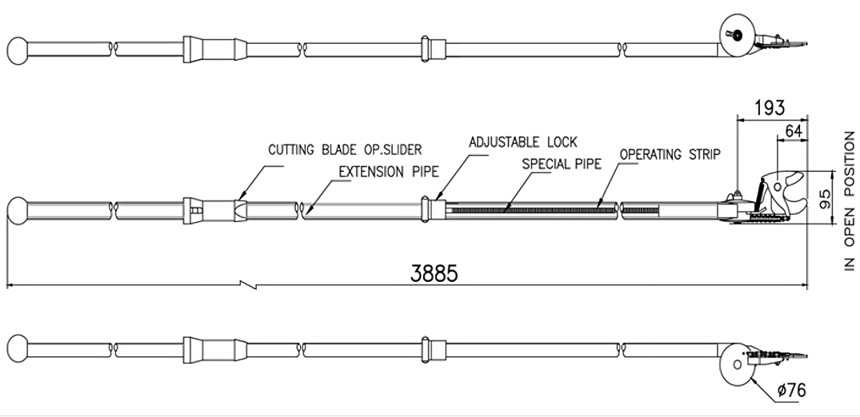

Fig. 8 Typical Example of Long Reach Tree Pruner Attached With Telescopic Aluminium or Light Weight Fibre Glass Pipe

(All dimensions are in millimetres unless stated otherwise)

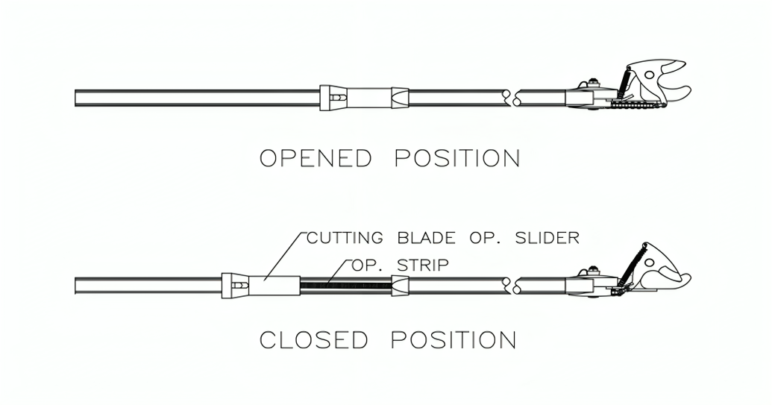

Fig. 9 Typical Example of Long Reach Tree Pruner With Closed And Open Position of Cutting Blade

**8 OTHER REQUIREMENTS**

**8.1** The blade of the pruner shall be made of sheet metal which shall be hardened and tempered. The edges are sufficiently sharpened by suitable grinding operation.

**8.2** The blade shall be fitted in the body so that it can freely move when pulled with rope. The blade shall come back inside the body by the spring action.

**8.3** In the closed position the cutting edge of the blade shall remain inside the body and shall not protrude.

**8.4** A circular ring shall be provided for tying the rope with the pruner.

**8.5** A hole shall be provided for proper fixing up of the handle with the socket of the body.

**8.6** Apart from cutting blade a powerful hardened and tempered cutting saw shall be provided optionally as per requirement of the customer to cut higher diameter of branches easily and effectively.

**8.7** Long reach tree pruner is a new kind of pruner that cuts the branches easily and effortlessly. It can be extended optionally as per requirement of the customer up to 4 m, Fig. 6 shows the closed and open position of cutting blade.

**8.8** Cutting capacity of the pruner should be to cut branches of diameter 10 mm to 22 mm.

**9 TESTS**

**9.1** The pruner shall be tested by cutting not less than 20 samples of grafts, not exceeding 15 mm in diameter of citrus, guava, mango or apple suitably prepared in green condition. The cut on the bark shall be clean.

**9.2** The pruner with saw attachment shall be tested by cutting not less than 6 samples of hardwood, not exceeding 25 mm in diameter.

**10 WORKMANSHIP AND FINISH**

**10.1** The cutting surface of the blade shall be ground in a direction, preferably, at right angle to the cutting edge. The blade shall be puffed to give a fine finish. The cutting edge shall be sharp enough for immediate use. All the sharp edges, except the cutting edge shall be rounded.

**10.2** The blade shall be free from cracks, seams, pits, burrs and other visual defects.

**11 PACKING AND MARKING**

**11.1 Marking**

Each tree pruner shall be marked with the following particulars:

1. Manufacturer’s name or recognized trademark, if any;
2. Size;
3. Batch or code number; and
4. Any other markings required under the *Legal Metrology* (*Packaged Commodities*) *Rules*,2011and any other statutory requirement.

**11.2 Packing**

Because of highly sharp edges the exposed metallic parts shall be packed with proper thick paper or plastic sheet, such as blister type or pouch type of packing to prevent any accidental damage of the product or injury to any human being.

**11.3 BIS Certification Marking**

The product(s) conforming to the requirements of this standard may be certified as per the conformity assessment schemes under the provisions of the *Bureau of Indian Standards Act*, 2016 and the Rules and Regulations framed thereunder, and the products may be marked with the Standard Mark.

**12 SAMPLING FOR LOT ACCEPTANCE**

Unless otherwise agreed to between the purchaser and the supplier, sampling of the pruner for lot acceptance shall be as per IS 7201 (Part 1).

**ANNEX A**

(*Clause* 2)

**LIST OF REFERRED STANDARDS**

|  |  |
| --- | --- |
| *IS No.* | *Title* |
| IS 1285 : 2023 | Wrought aluminium and aluminium alloys — Extruded round tube and hollow sections for general engineering purposes — Specification (*fourth revision*) |
| IS 1570 (Part 2/ Sec 1) : 1979 | Schedules for wrought steels: Part 2 Carbon steels (unalloyed steels), Section 1 Wrought products (other than wires) with specified chemical composition and related properties (*first revision*) |
| IS 1586 (Part 1) 2018/ISO 6508-1 : 2016 | Metallic materials — Rockwell hardness test: Part 1 test method (*fifth revision*) |
| IS 2062 : 2011 | Hot rolled medium and high tensile structural steel — Specification (*seventh revision*) |
| IS 4454 (Part 1) : 2001 | Steel wire for mechanical springs — Specification: Part 1 Cold drawn unalloyed steel wire (*third revision*) |
|  |  |
| IS 7201 (Part 1) : 1987 | Methods of sampling for agricultural machinery and equipment: Part 1 Hand-tools and hand-operated/animal drawn equipment (*first revision*) |
| IS 13463 : 2022 | Polyamide 6 materials for moulding and extrusion — Specification (*first revision*) |
|  |  |

**ANNEX B**

(*Foreword*)

**COMMITTEE COMPOSITION**

Agricultural Machinery and Equipment Sectional Committee, FAD 11

| *Organization* | *Representative(s)* |
| --- | --- |
| ICAR - Central Institute of Agricultural Engineering, Bhopal | Dr C. R. Mehta **(*Chairperson*)** |
| Agricultural Machinery Manufacturers Association (AMMA-India), Gandhinagar | Dr Surendra Singh  Shri Mitul Panchal (*Alternate*) |
|  |  |
| All India Farmers Alliance, New Delhi | Dr Rajaram Tripathi  Shrimati Apurva Tripathi (*Alternate*) |
| Aspee Agro Equipment Private Limited, Mumbai | Shri Jatin S. Patel  Shri Gangadhar Varpe (*Alternate*) |
| Automotive Research Association of India, Pune | Shri A. Akbar Badusha  Shri Girish Tanawade (*Alternate* I)  Shri Gangaram Auti (*Alternate* II) |
| CCS Haryana Agricultural University, Hisar | Dr Vijaya Rani |
| Central Farm Machinery Training and Testing Institute, Budni | Shri Anil Kumar Upadhyay  Shri Babul Nath Dixit (*Alternate* I)  Shri Parth Lodh (*Alternate* II) |
| CLAAS India Private Limited, Chandigarh | Shri Krishna Prabhakar Singh |
| CNH Industrial India Private Limited, Pune | Shri Santhosh Rao  Shri Sujit Hinge (*Alternate*) |
| Consumer Guidance Society of India, Mumbai | Shri Sitaram Dixit |
| Dasmesh Mechanical Works Private Limited, Malerkotla | Shri Sarbjeet Singh Panesar  Shri Gurdeep Singh Panesar (*Alternate*) |
| ICAR - All India Coordinated Research Project on Ergonomics and Safety in Agriculture, Bhopal | Dr Sukhbir Singh  Dr Rahul R. Potdar (*Alternate* I)  Shrimati Sweeti Kumari (*Alternate* II) |
| ICAR - All India Coordinated Research Project on Farm Implements and Machinery, Bhopal | Dr K. N. Agrawal |
| ICAR - All India Coordinated Research Project on Mechanization of Animal Husbandary, Bhopal | Dr S. P. Singh |
| ICAR - Central Institute of Agricultural Engineering, Bhopal | Dr V. P. Chaudhary  Dr U. R. Badegaonkar (*Alternate* I)  Dr Dilip Jat (*Alternate* II) |
| Indian Council of Agricultural Research, New Delhi | Dr Panna Lal Singh |
| John Deere India Private Limited, Pune | Shri Anand Raj  Shri Chandrashekhar Deshmukh (*Alternate* I)  Shri Pratik Duraphe (*Alternate* II) |
| Kerala Agro Machinery Corporation Ltd (KAMCO), Athani | Shri A. Unnikrishnan  Shri P. C. Sajimon (*Alternate*) |
| KisanKraft Limited, Bangaluru | Shri Ravindra Agarwal  Shri Ankit Chitalia (*Alternate* I)  Shri Sunil Prasad (*Alternate* II) |
| Kubota Agricultural Machinery India Private Limited, Faridabad | Shri Ashok Kumar  Shri Ashish Kumar Mallarh (*Alternate*) |
| Maharana Pratap University of Agricultural and Technology, Udaipur | Dr Sanwal Singh Meena |
| Mahatma Phule Krishi Vidyapeeth, Rahuri | Dr Sachin Madhukar Nalawade  Shri Vikram Parasharam Kad (*Alternate* I)  Dr Avdhut Ashok Walun (*Alternate* II) |
| Mahindra and Mahindra Limited, Mumbai | Shri Pradeep Shinde |
| Ministry of Agriculture, Department of Agriculture, New Delhi | Dr V. N. Kale  Shri Arvind N. Meshram (*Alternate*) |
| National Innovation Foundation, New Delhi | Shri Rakesh Maheshwari  Shri Mahesh Patel (*Alternate*) |
| National Institute of Plant Health Management, Hyderabad | Dr Vidhu Kampurath P.  Shri Mutyala Udaya (*Alternate*) |
| North Eastern Region Farm Machinery Training and Testing Institute, Biswanath Chariali | Dr P. P. Rao  Shri S. G. Pawar (*Alternate* I)  Shri Khagendra Bora (*Alternate* II) |
| Northern Region Farm Machinery Training and Testing Institute, Hisar | Dr Mukesh Jain  Shri Sanjay Kumar (*Alternate*) |
| Power Tillers Manufacturers Association, Kolkata | Shri A. R. Ganesh Kumar |
| Punjab Agricultural University, Ludhiana | Dr Mahesh Kumar Narang  Dr Rajesh Goyal (*Alternate* I)  Shri Apoorv Prakash (*Alternate* II) |
| Southern Region Farm Machinery Training and Testing Institute, Anantpur | Dr B. M. Nandede |
| Tamil Nadu Agricultural University, Coimbatore | Dr R. Kavitha  Dr A. Surendra Kumar (*Alternate* I)  Dr A. P. Mohan kumar (*Alternate* II) |
| Tirth Agro Technology Private Limited 'Shaktiman', Rajkot | Shri Parag Devidas Badgujar  Shri V. Audhi Narayan Reddy (*Alternate*) |
| Tractor and Mechanization Association, New Delhi | Shri Philip Koshy  Shri Veenit Negi (*Alternate* I)  Shrimati Devyani (*Alternate* II) |
| Tube Investments Clean Mobility Private Limited, Chennai | Shri Abhishek Sinha  Shri S. O. Tyagi (*Alternate*) |
| Voluntary Organisation in Interest of Consumer Education (VOICE), New Delhi | Shri B. K. Mukhopadhyay |
| In Personal Capacity (*201, Memnon Tower, Omaxe The Nile, Sector 49, Sohna Road, Gurugram - 122018*) | Shri Vivek Gupta |
| BIS Directorate General | Shrimati Suneeti Toteja, Scientist ‘F’/Senior Director and Head (Food and Agriculture) [Representing Director General (*Ex-officio*)] |

*Member Secretary*

Shri Vikrant Chauhan

Scientist ‘B’/Assistant Director

(Food and Agriculture), BIS

Panel to Formulate and Review Indian Standards on Gardening and Forestry Tools and Agricultural Implements, FAD 11/P 3

| *Organization* | *Representative(s)* |
| --- | --- |
| Agricultural Machinery Manufacturers Association (AMMA-India), Gandhinagar | Dr Surendra Singh **(*Convenor*)** |
| ASPEE Agro Equipment Private Limited, Mumbai | Shri Jatin S. Patel  Shri Gangadhar Varpe (*Alternate*) |
| Falcon Garden Tools Private Limited, Ludhiana | Shri Gurchintan Singh Dua |
| ICAR - Central Institute of Agricultural Engineering, Bhopal | Dr Dilip Jat |
| John Deere India Private Limited, Pune | Shri Chandrashekhar Deshmukh |
| Mahatma Phule Krishi Vidyapeeth, Rahuri | Dr Sachin Madhukar Nalawade |