FAD 11(22336) F

IS 11082 : 2024

**भारतीय मानक**

**गीली भूमि पर खेती के लिए कृषि ट्रैक्टर — तकनीकी अपेक्षाएँ**

*( पहला पुनरीक्षण )*

**Indian Standard**

**Agricultural Tractors for Use in Wet Land Cultivation — Technical Requirements**

*( First Revision )*

ICS 65.060.10

© BIS 2024

**B U R E A U O F I N D I A N S T A N D A R D S**

MANAK BHAVAN, 9 BAHADUR SHAH ZAFAR MARG

NEW DELHI 110002

Agricultural Machinery and Equipment Sectional Committee, FAD 11

FOREWORD

This Indian Standard (First Revision) was adopted by the Bureau of Indian Standards, after the draft finalized by the Agricultural Machinery and Equipment Sectional Committee had been approved by the Food and Agriculture Division Council.

Wet land cultivation, popularly known as puddling, is an important tillage operation in cultivation of transplanted paddy. The agricultural tractors are increasingly used for wet land cultivation and the success of mechanized paddy cultivation with these tractors depends upon efficiency of waterproofing functions of critical assemblies. Therefore, in 1984 the standard was published with the title ‘Agricultural tractors for wet land cultivation — Technical requirements’ to provide guidance to the manufacturers as well as users.

The revision of this standard incorporates water proofing test to measure the suitability of tractor for wetland cultivation. Apart from this, the standard has been brought out in the latest style and format of Indian Standards and reference of the Indian Standards wherever applicable have been updated.

In revision of this standard, assistance has been derived from OECD Code 2 ‘OECD standard code for the official testing of agricultural and forestry tractor performance’.

The composition of the committee responsible for the formulation of this standard is given in Annex A.

For the purpose of deciding whether a particular requirement of this standard is complied with, the final value, observed or calculated, expressing the result of a test or analysis, shall be rounded off in accordance with   
IS 2 : 2022 ‘Rules for rounding off numerical values (*second revision*)’. The number of significant places retained in the rounded off value should be the same as that of the specified value in this standard.

*Indian Standard*

AGRICULTURAL TRACTORS FOR USE IN WET LAND CULTIVATION — TECHNICAL REQUIREMENTS

*( First Revision )*

**1 SCOPE**

This standard specifies the technical requirements for the use of agricultural tractors in wetland cultivation (puddling operation) and also covers the water proofing test.

**2 REFERENCES**

The standards given below contain provisions which, through reference in this text, constitute provisions of this standard. At the time of publication, the editions indicated were valid. All standards are subject to revision and parties to agreements based on this standard are encouraged to investigate the possibility of applying the most recent edition of these standards:

|  |  |
| --- | --- |
| *IS No./Other Standard* | *Title* |
| IS 11081 : 1993 | Agricultural tractors — Half cage wheel — Specification (*first revision*) |
| IS 10500 : 2012 | Drinking water — Specification (*second revision*) |
| ISO 4251-1 : 2019 | Code designated diagonal tyres (ply rating marked series) for agricultural tractors, trailers and machines — Part 1: Tyre designation and dimensions, and approved rim contours |

**3 TERMINOLOGY**

For the purpose of this standard, the following definition shall apply.

**3.1 Agricultural Tractors** — A self-propelled wheeled vehicle having two axles, or a track-laying or semi-track-laying machine, more particularly designed to pull, push, carry and operate implements and machines used for agricultural work (including forestry work).

**3.2 Cage Wheel** — A wheel or an attachment to a wheel with space crossbars for reducing ground pressure and/or improving traction of a tractor or power tiller, generally used in wet-land seed-bed preparation (*see* Fig. 1).

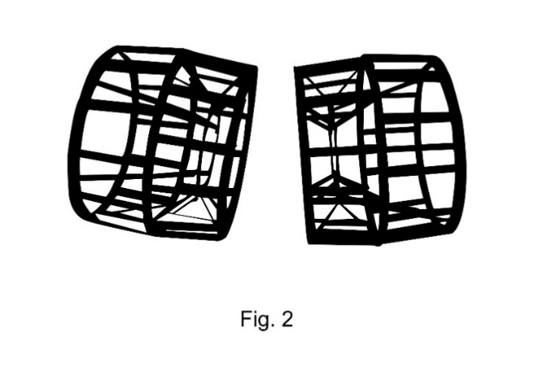

Fig. 1 Cage Wheel

.

**3.2.1** *Half Cage Wheel* — A cage wheel which is used in conjunction with pneumatic wheel.

**3.2.2** *Full Cage Wheel* — The cage wheel used in place of pneumatic wheels (tyres).

**3.3 Puddling** — The mechanical manipulation of soil in presence of standing water in the field to create an impervious hard pan below the puddle zone so as to prevent loss of water through leaching and facilitate the transplanting of paddy seedlings by making the soil softer.

**4 CONSTRUCTIONAL REQUIREMENTS**

**4.1** As the tractor is required to be operated under wet conditions, pre-treatment to sheet metal should be adequate to prevent corrosion.

**4.2** The tractor should have independent braking system.

**4.3** The tractor may be equipped with differential lock.

**4.4** Adequate provision should be made for the drainage of water near footrest and operator’s workplace.

**4.5** Outside part should be such that they are not affected during the water cleaning of the tractor as normally tractor requires thorough cleaning with water after puddling operation.

**4.6** Where choice for fitting tyre is available, it is advisable to use tyres having broader contact area.

**4.7** Exhaust system of the tractor should be appropriately positioned to prevent ingress of water and mud during operation.

**4.8** Provision for fitting half cage wheel and full cage wheel shall be ~~made~~ provided. The half cage wheel shall conform to the requirements given in IS 11081.

**4.9** The sealing of the critical components should be effective. The following critical components and systems should be free from entry of water, dust and mud:

1. Lubricating oil in the engine sump, transmission, hydraulic housings, final drive housings and steering box;
2. Brake assembly;
3. Clutch assembly 0;
4. Rear axle assembly;
5. Front axle assembly including stub axle, front wheel hubs, king pin and centre (pivot) pin assembly;
6. Starter motor and dynamo; and
7. Electrical components, such as magneto, battery, and cut out.

**4.10** Provision should be made to plug various weep holes or inspection holes provided in the transmission housing, clutch housing, rear axle housing, etc.

**5 OPERATING REQUIREMENTS**

**5.1** All the necessary instructions provided by the manufacturers for preparing the tractor for wet land operation should be strictly followed.

**5.2** Necessary servicing and periodic maintenance during and after the use of tractor for wet land operation should be conducted in accordance with the printed literature provided by manufacturers.

**5.3** Taper plugs used for plugging the weep holes or inspection holes should be opened to allow the water to drain out at suitable intervals as recommended by the manufacturers.

**5.4** While using cage wheels, for reasons of safety and obtaining good quality puddle, a suitable implement like puddler, disc harrow, rotavator may be used.

**6 LITERATURE**

**6.1** The operator’s manual or other printed literature supplied with tractor should include necessary instructions for preparation, safe operation, and the maintenance of the tractor for wet land operation.

**6.2** The manufacturers should also provide the information with respect to front axle reaction in terms of the front mass for various usage of the wet land cultivation, that is for half cage wheel or full cage wheel to ensure stability and steerability of the tractor. The mass can be varied by the user depending upon the need.

**7 WATER PROOFING TEST**

**7.1** The waterproofing test is applied to wheeled or track-laying tractors to be used in the paddy field for puddling.

**7.2** The primary purpose is to verify the waterproofing functions of the wheel axles, the brake assembly and the clutch assembly.

**7.3** Verification can however be extended at the request of the manufacturer to other parts of tractors such as engine sump, hydraulic/transmission case and self-starter that could be damaged by water penetration.

**7.4** The tractor is classed as ‘waterproof tractor’, if after the test described below, there is no water penetration into axle, brake, clutch system, or any other part submitted to the verification.

**7.5 Test Conditions**

**7.5.1** *Test Bed*

The test shall be conducted in a cistern (*see* Fig. 2). The tractor shall be set on the roller bed (or on a similar device) where the tractor remains safely fixed during the test. For two-wheel-drive tractors the front axle shall be driven by external means (*see* Fig. 2) at the same equivalent ground speed as the rear axle.

**7.5.2** *Water Level*

The water level shall be adjusted to the height of the center line of the front axle (wheeled tractor) or the driven sprockets (track-laying tractor) with the tractor in a horizontal position, as if driving on a road. However, if the center line is higher than 400 mm above ground level (in accordance with ISO 4251-1) the water level shall only be raised to 400 mm above the ground level.

Potable water (*see* IS 10500) shall be used in the cistern.

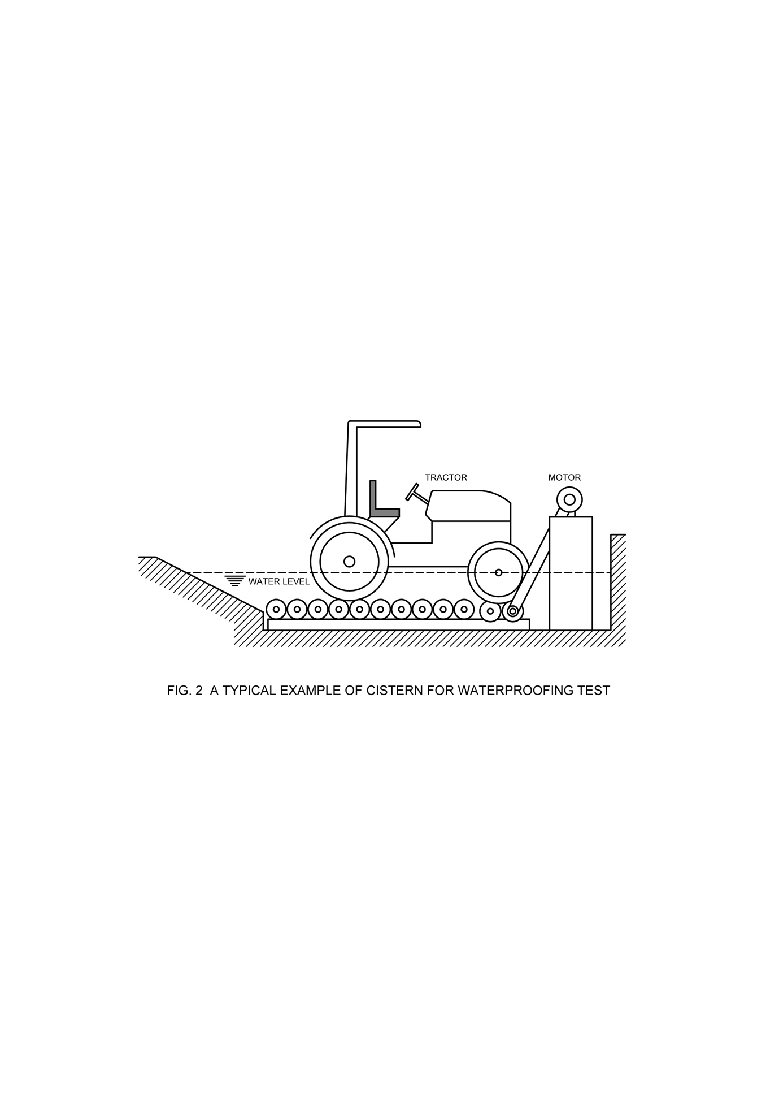

Fig 2. A Typical Example of Cistern for Waterproofing Test

**7.6 Test Procedures**

**7.6.1** *General Provisions*

**7.6.1.1** The tractor shall be in the gear giving the nominal forward speed nearest to 6 km/h and operated continuously at rated speed for 2 h. The tractor shall then (immediately) be removed from the cistern and any excess water shall be wiped off the outside of the axles, clutch and brake assemblies with a rag. The tractor shall be left in a place free from rain or snow for at least 12 h before being finally checked.

**7.6.1.2** The axles (including center pivot), clutch housing, the brake assembly and any other part also optionally submitted for test shall then be disassembled and any evidence of water penetration into them shall be stated in the test report.

**7.6.2** *Unsuccessful Test*

If the test fails, the manufacturer may ask for a repeat test of the same tractor but only once. The tractor when re-tested, shall be equipped with the same components after the seals have been changed and/or re-fixed in conformity with manufacturing specifications.

**7.7 Checking Methods**

**7.7.1** *Non-Lubricating Parts*

‘Dry’ type clutch housings, and similar ‘dry’ tractor components such as dry brakes, shall be checked inside (visually) for water ingress as indicated by actual water or rust from oxidation.

**7.7.2** *Oiled Parts*

For the tractor’s parts running in oil and under test, the oil in the housing shall be checked using one or more of the following alternative methods.

**7.7.2.1** *Visual method*

Distinct emulsification and/or color change of the oil shall be regarded as proof of water-ingress.

**7.7.2.2** *Crackling method*

When water ingress is not visually distinct, the presence of water in the lubricant shall be checked by putting a heated electric soldering iron into the oil. The presence of water crackling shall be regarded as waterproofing failure; conversely, no crackling shall be regarded as waterproofing.

**7.7.2.3** *Other methods*

Other physical (for example, centrifugation) or chemical (for example, Karl-Fisher) methods to check if there is water in the oil is accepted or not.

**ANNEX A**

(*Foreword*)

**COMMITTEE COMPOSITION**

Agricultural Machinery and Equipment Sectional Committee, FAD 11

| *Organization* | *Representative(s)* |
| --- | --- |
| ICAR - Central Institute of Agricultural Engineering, Bhopal | Dr C. R. MEHTA **(*Chairperson*)** |
| Agricultural Machinery Manufacturers Association (AMMA-India), Gandhinagar | Dr Surendra Singh  Shri Mitul Panchal (*Alternate*) |
| All India Farmers Alliance, New Delhi | Dr Rajaram Tripathi  Shrimati Apurva Tripathi (*Alternate*) |
| ASPEE Agro Equipment Private Limited, Mumbai | Shri Jatin S. Patel  Shri Gangadhar Varpe (*Alternate*) |
| Automotive Research Association of India, Pune | Shri A. Akbar Badusha  Shri Girish Tanawade (*Alternate* I)  Shri Gangaram Auti (*Alternate* II) |
| CCS Haryana Agricultural University, Hisar | Dr Vijaya Rani |
| Central Farm Machinery Training and Testing Institute, Budni | Shri Anil Kumar Upadhyay  Shri Babul Nath Dixit (*Alternate* I)  Shri Parth Lodh (*Alternate* II) |
| CLAAS India Private Limited, Chandigarh | Shri Krishna Prabhakar Singh |
| CNH Industrial India Private Limited, Pune | Shri Santhosh Rao  Shri Sujit Hinge (*Alternate*) |
| Consumer Guidance Society of India, Mumbai | Shri Sitaram Dixit |
| Dasmesh Mechanical Works Private Limited, Malerkotla | Shri Sarbjeet Singh Panesar  Shri Gurdeep Singh Panesar (*Alternate*) |
| ICAR - All India Coordinated Research Project on Ergonomics and Safety in Agriculture, Bhopal | Dr Sukhbir Singh  Dr Rahul R. Potdar (*Alternate* I)  Shrimati Sweeti Kumari (*Alternate* II) |
| ICAR - All India Coordinated Research Project on Farm Implements and Machinery, Bhopal | Dr K. N. AGRAWAL |
| ICAR - All India Coordinated Research Project on Mechanization of Animal Husbandry, Bhopal | Dr S. P. Singh |
| ICAR - Central Institute of Agricultural Engineering, Bhopal | Dr V. P. Chaudhary  Dr U. R. Badegaonkar (*Alternate* I)  Dr Dilip Jat (*Alternate* II) |
| Indian Council of Agricultural Research, New Delhi | Dr Panna Lal Singh (*Alternate*) |
| John Deere India Private Limited, Pune | Shri Anand Raj  Shri Chandrashekhar Deshmukh (*Alternate* I)  Shri Pratik Duraphe (*Alternate* II) |
| Kerala Agro Machinery Corporation Ltd (KAMCO), Athani | Shri A. Unnikrishnan  Shri P. C. Sajimon (*Alternate*) |
| Kisan Kraft Limited, Bangaluru | Shri Ravindra Agarwal  Shri Ankit Chitalia (*Alternate* I)  Shri Sunil Prasad (*Alternate* II) |
| Kubota Agricultural Machinery India Private Limited, Faridabad | Shri Ashok Kumar  Shri Ashish Kumar Mallarh (*Alternate*) |
| Maharana Pratap University of Agricultural and Technology, Udaipur | Dr Sanwal Singh Meena |
| Mahatma Phule Krishi Vidyapeeth, Rahuri | Dr Sachin Madhukar Nalawade  Shri Vikram Parasharam Kad (*Alternate* I)  Dr Avdhut Ashok Walun (*Alternate* II) |
| Mahindra and Mahindra Limited, Mumbai | Shri Pradeep Shinde (*Alternate*) |
| Ministry of Agriculture, Department of Agriculture, New Delhi | Dr V. N. Kale  Shri Arvind N. Meshram (*Alternate*) |
| National Innovation Foundation, New Delhi | Shri Rakesh Maheshwari  Shri Mahesh Patel (*Alternate*) |
| National Institute of Plant Health Management, Hyderabad | Dr Vidhu Kampurath P.  Shri Mutyala Udaya (*Alternate*) |
| North Eastern Region Farm Machinery Training and Testing Institute, Biswanath Chariali | Dr P. P. Rao  Shri S. G. Pawar (*Alternate* I)  Shri Khagendra Bora (*Alternate* II) |
| Northern Region Farm Machinery Training and Testing Institute, Hisar | Dr Mukesh Jain  Shri Sanjay Kumar (*Alternate*) |
| Power Tillers Manufacturers Association, Kolkata | Shri A. R. Ganesh Kumar |
| Punjab Agricultural University, Ludhiana | Dr Mahesh Kumar Narang  Dr Rajesh Goyal (*Alternate* I)  Shri Apoorv Prakash (*Alternate* II) |
| Southern Region Farm Machinery Training and Testing Institute, Anantpur | Dr B. M. Nandede |
| Tamil Nadu Agricultural University, Coimbatore | Dr R. Kavitha  Dr A. Surendra Kumar (*Alternate* I)  Dr A. P. Mohan kumar (*Alternate* II) |
| Tirth Agro Technology Pvt. Ltd. 'Shaktiman', Rajkot | Shri Parag Devidas Badgujar  Shri V. Audhi Narayan Reddy (*Alternate*) |
| Tractor and Mechanization Association, New Delhi | Shri Philip Koshy  Shri Veenit Negi (*Alternate* I)  Shrimati Devyani (*Alternate* II) |
| Tube Investments Clean Mobility Private Limited, Chennai | Shri Abhishek Sinha  Shri S. O. Tyagi (*Alternate*) |
| Voluntary Organisation in Interest of Consumer Education (VOICE), New Delhi | Shri B. K. Mukhopadhyay |
| In Personal Capacity | Shri Vivek Gupta |
| BIS Directorate General | Shrimati Suneeti Toteja, Scientist ‘F’/Senior Director and Head (Food and Agriculture) [Representing Director General (*Ex-officio*)] |

*Member Secretary*

Shri Vikrant Chauhan

Scientist ‘B’/Assistant Director

(Food and Agriculture), BIS

Panel to Formulate and Review Indian Standards on Tractors, FAD11/P 5

| *Organization* | *Representative(s)* |
| --- | --- |
| ICAR - Central Institute of Agricultural Engineering, Bhopal | Dr C. R. MEHTA **(*Convenor*)** |
| Automotive Research Association of India, Pune | Shri Girish Tanawade |
| CNH Industrial India Private Limited, Pune | Shri Himanshu Mishra |
| Central Farm Machinery Training and Testing Institute, Budni | Shri A. K. Upadhyay |
| John Deere India Private Limited, Pune | Shri Mansingh Jagdale |
| Kubota Agricultural Machinery India Private Limited, Faridabad | Shri Ashish Kumar Mallarh |
| Mahindra and Mahindra Limited, Mumbai | Shri Pradeep Shinde |
| Tractor and Mechanization Association, New Delhi | Shri Veenit Negi |
| Tube Investments Clean Mobility Private Limited, Chennai | Shri Abhishek Sinha |
| In Personal Capacity (*201, Memnon Tower, Omaxe The Nile, Sector 49, Sohna Road, Gurugram - 122018*) | Shri Vivek Gupta |