*भारतीय मानक*

**IS 4912 : 2024**

***Indian Standard***

**फ्लोर एवं वॉल ओपनिंग, ओपन-साइड फ्लोर, सीढ़ीमार्ग एवं गार्डरेल प्रणालियों की अस्थायी सुरक्षा हेतु सुरक्षात्मक अपक्षाएँ**

(*दूसरा पुनरीक्षण*)

**Safety Requirements for Temporary Protection of Floor and Wall Openings, Open-side Floors, Staircases and Guardrail Systems**

(*Second Revision*)

ICS No. 13.340.60

© BIS 2024



भारतीय मानक ब्यूरो

BUREAU OF INDIAN STANDARDS

मानक भवन, 9, बहादुरशाह ज़फर मार्ग, नई दिल्ली — 110002

MANAK BHAVAN, 9, BAHADUR SHAH ZAFAR MARG NEW DELHI-110002

[www.bis.gov.in](http://www.bis.gov.in) [www.standardsbis.in](http://www.standardsbis.in)

*January* 2024

**Price Group XX**

Safety in Construction Sectional Committee, CED 45

FOREWORD

This Indian Standard (Second Revision) was adopted by the Bureau of Indian Standards, after the draft finalized by the Safety in Construction Sectional Committee had been approved by the Civil Engineering Division Council.

This standard was first published in 1968 and subsequently revised in 1978. The present revision has been taken up based on the experience gained with the use of this standard and the technological improvement in the country. Work at height poses a major risk in construction project specifically in the areas related to floor openings, wall openings, building periphery and leading edges. This revised standard set forth the safety requirement in above mentioned workplace situations.

In this revision, the following major modifications have been made:

1. The safety procedures to be followed during the temporary removal of safety protection systems for enabling works have been included;
2. This standard is applicable only for managing risks for projects under construction. For permanent installations, safety requirements shall be meeting the requirements of National Building Code of India;
3. Annex A provides Application of Hierarchy of Control – Fall Hazard; and
4. Title of the standard has been modified to reflect the actual coverage.

The formulation of this standard due weightage has been given to international coordination among the standards and practices prevailing in different countries in addition to relating it to the practices in the field in this country. This has been met by deriving assistance from the following publications:

1. ANSI/ASSE A1264.1-2017 ‘Safety requirement for workplace walking/working surfaces and their access; workplace, floor, wall and roof openings; stairs and guardrails/handrails systems’.
2. ‘Code of practice for working safety at Heights’ – Workplace safety and health council in collaboration with Ministry of Man Power, Singapore.
3. BS EN 13374:2013+A1:2018 ‘Temporary edge protection systems. Product specification. Test methods ’.
4. ISO 45001 : 2018 ‘Occupational health and safety management systems — Requirements with guidance for use’.
5. IS 15883 (Part 5) : 2013 ‘Construction project management — Guidelines: Part 5 Health and safety management’.

The composition of the Committee responsible for the formulation of this standard is given in Annex B.

For the purpose of deciding whether a particular requirement of this standard, is complied with, the final value, observed or calculated, expressing the result of a test or analysis, shall be rounded off in accordance with IS 2 : 2022 ‘Rules for rounding off numerical values (*second revision*)’. The number of significant places retained in the rounded off value should be the same as that of the specified value in this standard.

*Indian Standard*

SAFETY REQUIREMENTS FOR TEMPORARY PROTECTION OF FLOOR AND WALL OPENINGS, OPEN-SIDE FLOORS, STAIRCASES AND GUARDRAIL SYSTEMS

*( Second Revision )*

**1 SCOPE**

**1.1** This standard sets forth safety requirements in workplace situations in all construction project sites including buildings for protecting persons in areas/places where danger exists of persons or objects falling from elevated walking and work surfaces such as the floor, roof, wall openings, ramps, stairways, and roofs.

**1.2** The following are excluded from this standard:

1. Buildings that are completed and other permanent structures;
2. Mobile elevated working platforms (MEWP);
3. Scaffolds used in the construction and ladders;
4. Installation of formwork; and
5. Demolition of buildings and structures.

**2 REFERENCE**

This standard given below contain provision which, through reference in the text, constitute provisions of this standard. At the time of publication, the edition indicated was valid. All standards are subject to revision and parties to agreements based on this standard are encouraged to investigate the possibility of applying the most recent edition of this standard:

|  |  |
| --- | --- |
| *IS No.* | *Title* |
| IS 11057 : 1984 | Specification for industrial safety nets |

**3 TERMINOLOGY**

For the purpose of this standard, the following definitions shall apply.

**3.1 Authority**

Governmental agency or the employer/owner in the absence of governmental jurisdiction.

**3.2 Exposed Edge**

The edge of a walking/working surface at which an immediate downward change in elevation occurs.

**3.3 Flight**

A series of stair risers, including a single stair riser, between landings.

**3.4 Floor Opening Guard/Cover**

A member made up of steel mesh or fabricated grill to act as a cover/guard to protect the fall of material or persons inside the floor opening.

**3.5 Floor Opening**

A void in a floor, resulting in a change in elevation/level, into which persons may trip or fall or into which objects in use may fall.

**3.6 Guardrail System**

A barrier or an arrangement of barriers located at or near the open edges of elevated walking and working surfaces that are intended to prevent falls from that surface such as exposed edges of an open-sided floor opening, wall opening, ramp, stairways.

**3.7 Handrail**

Horizontal or sloping rail grasped by hand for guidance and support on edges of a floor, stairways or on openings, etc.

**3.8 Landing**

The platform between flights of stairs, or the walking/working surface immediately or after a stairway, such as a platform, floor, or roof.

**3.9 Ramp**

Any inclined walking/working surface with a slope greater than 1 : 20 (5 percent) is considered a ramp.

**3.10 Roof Opening**

A void in a roof, resulting in a change of elevation into which persons may fall or into which objects in use may fall.

**3.11 Safety Gate**

A barrier to prevent unintended passage and falls through guardrail openings such as those necessary for the passage of persons or materials.

**3.12 Stairway**

One or more flights of stairs, including required handrails and guardrail systems and the required landings.

**3.13 Toe Board**

Vertical barrier at walking or work surface level, erected along the exposed edges of a walking or work surface to reduce the likelihood of objects falling over the edges.

**3.14 Wall Opening**

A void in any wall or partition, resulting in a change in elevation, into which a person can fall or into which objects may fall.

**3.15 Walking/Working Surface**

Any surface (including floors, roofs) walked upon by persons, used as a work area, or used to gain access to a work area.

**4** **PROTECTION OF FLOOR OPENINGS**

**4.1** Every floor opening, regardless of resulting elevation change, or through which persons can pass, or which may cause a person to trip or fall, shall be protected in such a manner to prevent a person from passing through that opening and falling. Where there is a risk of personal injury or property damage due to the fall of materials through the floor openings, these openings shall be protected in such a manner as to prevent objects from passing through the opening and falling.

**4.2** Signages indicating the presence of such risk and adequate lighting shall be provided near the opening protection. Typical signages for floor opening is given below (*see* Fig. 1).

Fig. 1 Typical Signage for Floor Opening

**4.3 Prevention of Fall of Person**

Where there is a risk of fall of a person through the floor opening the same shall be protected by one of the following:

**4.3.1** *Guardrail System*

1. All unprotected edges shall be protected using a guardrail system (*see* Fig. 2.) except at the entrance to a stairway;
2. The guardrails shall meet the design requirements of the guardrail system as specified in **7**.

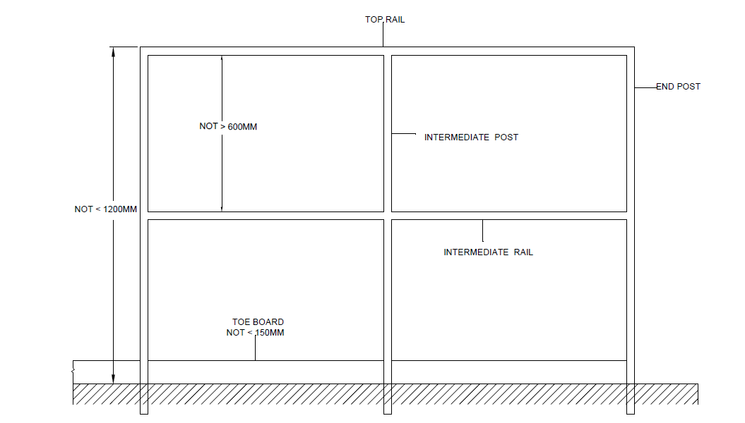

Fig. 2 Guardrail System

1. In case of entrance openings and any other interruptions in the guardrail, it shall be protected by a self-closing safety gate (*see* Fig. 3) meeting the requirements as specified in **7**;

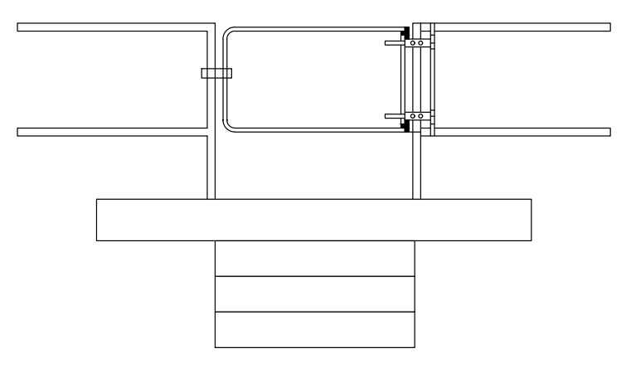

Fig. 3 Self-closing Safety Gate

**4.3.2** *Floor Opening Cover*

1. If field or operating conditions do not permit use of guardrail system, such openings or holes shall be provided with a Floor opening cover
2. Floor opening covers may be of any material that meets the strength requirements of the surrounding floor (*see* Fig. 4).

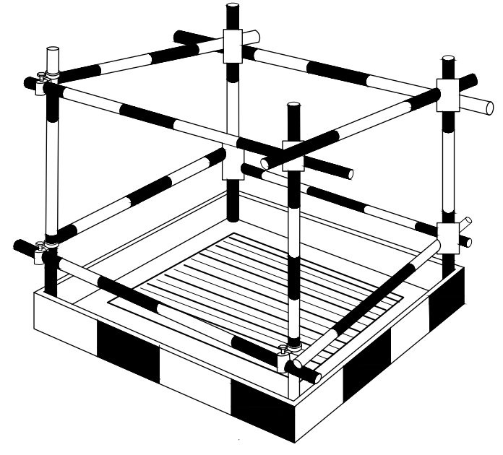

Fig. 4 Guardrail or Cover For Floor Opening For Personnel Fall Protection Floor Opening Cover

**4.3.3** *Other Protection Methods*

1. For openings sizes below 1 000 mm, hinged floor opening cover can be provided. This cover shall be of adequate strength meeting the strength requirements of surrounding floor and permanently attached thereto to leave only one side openable. When the opening is not in use, the cover shall be always kept closed;
2. In case of chute openings, where operating conditions necessitate the feeding of material into any chute opening, protection shall be provided to prevent a person from falling through the opening;
3. Every skylight and floor opening shall be guarded by a skylight screen or a fixed railing with toe guard on all exposed sides; and
4. Every floor opening onto which persons cannot accidentally walk (on account of fixed machinery, equipment, or walls) shall be protected by a cover that leaves no opening more than 25 mm wide. The cover shall be securely held in place to prevent tools or materials from falling through.

**4.4 Prevention of Falling Objects**

When there is a risk of objects falling through the opening and causing personal injury or property damage such openings shall be protected by one of the following methods

**4.5 Toe Board**

The guardrail system shall be provided with toe boards that leave no openings through which the objects in use or other debris may pass (*see* Fig. 5).

**4.6 Safety Net**

Safety net or other covers provided over the complete floor opening area to arrest the fall of materials (*see* Fig. 5) shall be as per IS 11057.

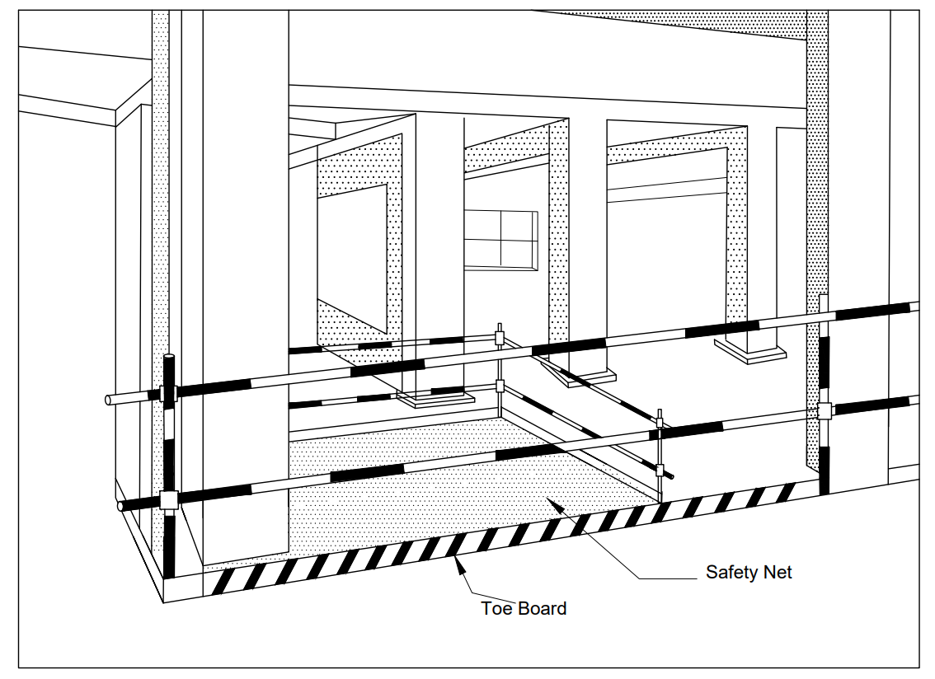

Fig. 5 Toe Board and Safety Net Protection

**5** **GUARDING OF WALL OPENINGS INCLUDING VERTICAL SHAFT OPENINGS**

**5.1 Prevention of Fall of Person**

Every wall opening which is greater than or equal to 1 200 mm in elevation and when there is a potential to fall from a walking surface greater than 750 mm above the surface directly below, through which persons may pass shall be guarded in such a manner as to prevent the person from passing through the opening and falling to the lower level.

**5.2** **Prevention of Falling Objects**

Where there is a risk of personal injury or property damage due to the fall of materials through the wall openings, these openings shall be protected in such a manner as to prevent objects from passing through the opening and falling especially for vertical shaft openings such as lift shafts, garbage chutes, communication shafts, etc, by one of the following:

1. *Guardrails* — The guardrail shall be provided at all exposed edges where there is a risk of a person falling. The guardrails shall meet the requirements as given in **7**. A standard pictorial signboard indicating the risk of falling from height shall be displayed at the entrance;
2. If field conditions prevent the use of a guardrail system, a removable guardrail otherwise meeting all the requirements of the guardrail system may be used if it is only removed when the opening is in use and replaced immediately thereafter, and sufficient precaution continue to be taken that person are not exposed to fall risk for the duration; and
3. For all wall openings, where there is a risk of objects falling through the opening and causing personal injury or property damage, such openings shall be protected by a securely fastened cover or toe boards that leave no openings through which the objects in use may pass.

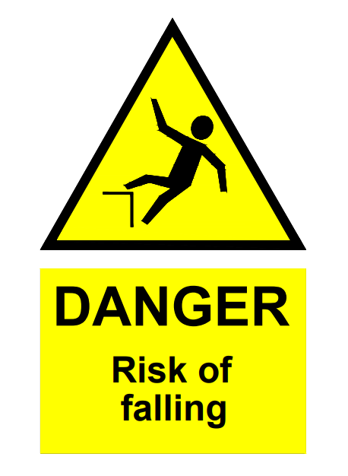**5.3** Signages indicating the presence of such risk and adequate lighting shall be provided near the wall and shaft opening protection. Typical signages for wall and shaft opening protection is given below (*see* Fig. 6).

Fig. 6 Typical Signage for Wall and Shaft Opening Protection

**5.4 Protection of Wall Openings (Shaft)**

During the construction stage of buildings, many shafts and openings are present such as for lifts, elevators, mechanical, electrical, and plumbing services, communication, and garbage disposal.

These openings shall be protected from the risk of fall of persons and objects till permanent doors or enclosures are installed.

**5.4.1** *Wall Openings* (*Shaft*)

In terms of protection systems, wall openings (shaft) can be broadly classified as:

1. Openings which start from the floor level, for example, lift shaft opening,
2. Openings which start above the floor level, for example, window openings, chute openings, service shafts, etc.

**5.4.1.1** *Openings which start from the floor level* (*see* Fig.7)

All entry to the shaft from floor level where there is a risk of a person falling through the opening shall be protected at the entrance to avoid any person from entering the shaft by using a hinged gate. Gates shall be at least 1.5 m in height and shall be provided with a lock arrangement to avoid inadvertent opening of the gate.

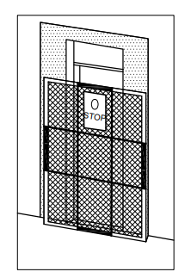

Fig. 7 Lift Shaft Opening Protection

Where there is a risk of objects falling through the opening and causing personal injury or property damage, such openings shall be protected by a securely fastened cover or toe boards in addition to the gates provided as per **7** which leave no openings through which the objects in use may pass. The toe board shall be of a minimum of 150 mm in height and securely fastened in place and meet other requirements as mentioned in **7**.

**5.4.1.2** *Opening which starts above the floor level*

1. For all wall openings that start above the floor level, where there is a risk of a person falling through the openings shall be protected using a guardrail system or gates to avoid the fall of the person;
2. The hinged gates/guardrails shall be provided in such a manner to prevent the sitting of persons on the wall at sill level (*see* Fig. 8). Adjustable jacks if fitted to the guard rail pipes facilitates easy installation and removal while providing effective protection;
3. At intermittent levels not exceeding 9 m, safety nets as per IS 11057 shall be provided with a schedule for regular cleaning and maintenance; and
4. Activities at multiple levels shall not be carried out inside shafts where there is a risk of falling objects from a higher level to lower levels.

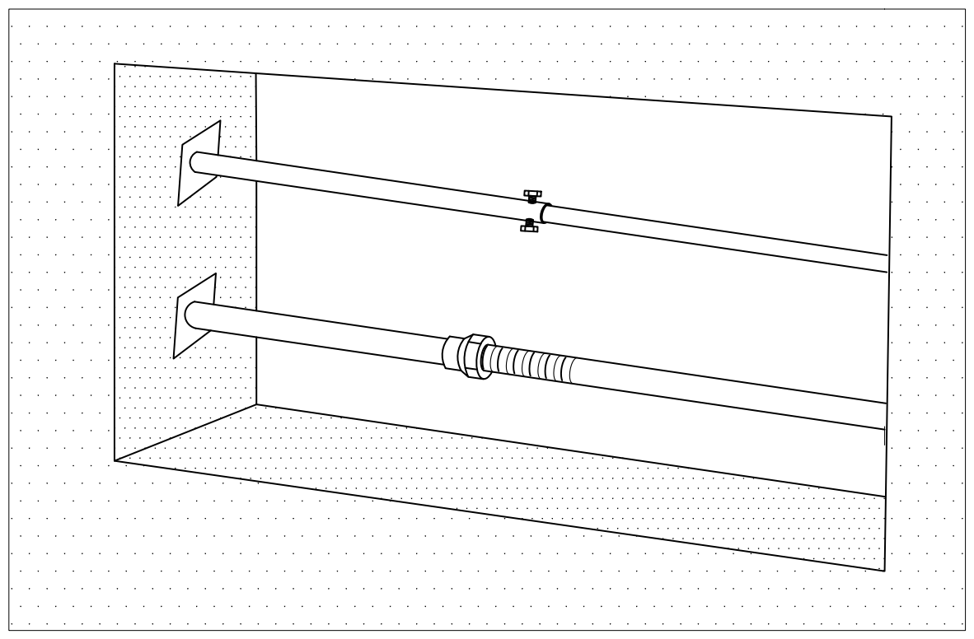

Fig. 8 Fall Protection For Openings in Service Shaft (Above Floor level)

**5.5 Requirements of Wall Opening Protection**

1. Wall opening barriers shall be designed for a load of at least 90 kg in any direction (except upward) at any point on the top rail or corresponding member; and
2. Grab handles shall be provided for the gates installed as wall opening barriers. The size, material, and anchoring of the grab handle shall be such that the completed structure is capable of withstanding a load of at least 90 kg applied in any direction at any point of the handle.

**6 GUARDING OF OPEN-SIDE FLOORS, ROOFS AND RAMPS**

**6.1** Every exposed edge on a floor, roof, or ramp, equal to or greater than 1.20 m in elevation, from which persons can pass and fall to the lower level shall be protected in such a manner to prevent a person from passing through the opening and falling. If required to prevent personal injury or property damage, these openings shall also be protected in such a manner as to prevent objects from passing through the opening and falling.

**6.2 Types of Temporary Floor Edge Protection Systems**

Types of temporary edge protection systems at various locations such as sloped roofs, exposed edges in RCC and steel buildings, and conventional and proprietary edge protection systems are given in the sketch shown in Fig. 9.



Fig. 9 Different Types of

Temporary Edge Protection

**6.3 Prevention of Fall of Person**

1. Every such open edge from which persons can fall shall be guarded by a guardrail system as specified in **7**. The guardrail shall be provided at all exposed edges, except at the entrance of the stairway, chute, or other openings;
2. Such entrance openings and any other interruptions in the guardrail shall be protected by a self-closing gate meeting the requirements of **7** and preventing unintended passage and fall through the opening at all times; and
3. If field conditions prevent the use of this protection, a removable guardrail otherwise meeting all the requirements of the guardrail system may be used if it is only removed when the opening is in use and replaced immediately thereafter.

**6.4 Prevention of Falling Objects**

Where there is a risk of objects falling through the opening and causing personal injury or property damage, such openings shall be protected by a safety net as per IS 11057, securely fastened cover or toe boards meeting the requirements of **7**, which leave no openings through which the objects in use may pass.

**6.5 Edge Protection for Steel Structure**

This is the most suitable type of edge protection for use on new steel structures. Edge protection uprights are secured into prefabricated brackets or sockets on the structural steelwork. The guardrail system, whenever possible, should be attached to the structural steelwork component at ground level and lifted to the required level thereafter. The structure should be of sufficient strength and rigidity to resist foreseeable forces exerted on the guardrail system.

**6.6 Use of Proprietary Systems for Edge Protection** (*see* Fig. 10)

Where it is intended to use proprietary temporary edge protection systems, following points shall be taken into consideration before selection of the system.

1. The situation in which the system is to be used (for example, whether the site is exposed and any significant topographic feature likely to affect the wind speed and direction);
2. The thickness of the slab (for example, when clamped to the edge of a concrete slab);
3. Width of the flanges (for example, when clamped to steel beams);
4. The slope of the roof (for example, when used on a sloping roof);
5. Whether the system will be modified (for example, fixing debris nets or advertising banners to it); and
6. Whether work will be carried out at the edge of the roof (for example, some sections may need to be removed temporarily).

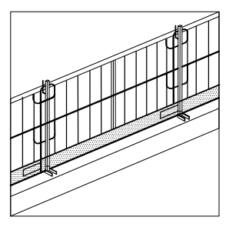

Fig. 10 Example of Proprietary Systems for Edge Protection

**7 DESIGN REQUIREMENTS FOR GUARDRAIL SYSTEMS** (*see* Fig. 11)

**7.1 Height of Guardrails**

1. A railing system shall consist of a top rail, mid rail or equivalent protection, and posts and shall have a minimum vertical height of 1.2 m from the walking/working surface to the upper surface of the top rail;
2. The top rail shall be smoothly surfaced throughout the length of the railing;
3. The mid rail shall be approximately halfway between the top rail and the walking surface. The vertical gap between the protection components shall not exceed 600 mm;
4. The ends of the rails shall not overhang the terminal posts, except where such overhang does not constitute a projection hazard; and
5. Spacing between guardrail system(s) and adjacent structure(s) shall not exceed 50 mm where a fall hazard exists.

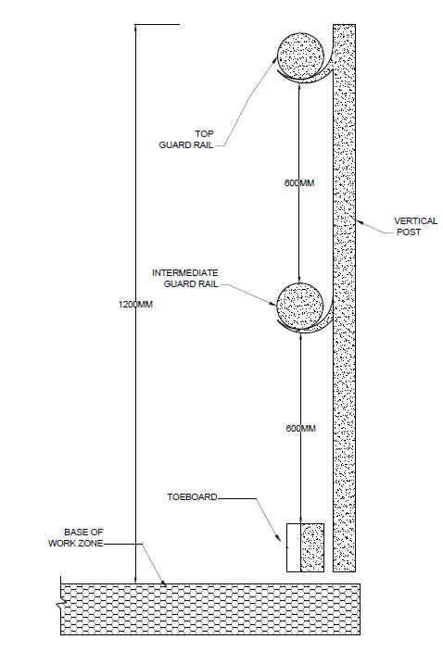

Fig. 11 Guardrails (Cross –Section)

**7.2 Guardrail System Load Requirements**

1. The top rail shall withstand a minimum concentrated load of 90 kg applied in any outwardly horizontal or downward direction, at the midpoint between posts without exceeding the maximum allowable deflection;
2. The mid rail, or equivalent protection designs, shall withstand a minimum concentrated outwardly horizontal load of 75 kg, applied at the midpoint between posts without exceeding the maximum allowable deflection;
3. Every post shall withstand a minimum concentrated load of 90 kg, applied in any direction, at the top of the post without exceeding the maximum allowable deflection;
4. In all cases, the maximum allowable deflection of the installed guardrail under each test load shall not exceed 75 mm; and
5. The materials selected for the components of the Guardrail system as per the design requirements shall be durable, and weather-resistant.

**7.3 Guardrail Opening Protection**

Safety gates or guardrail offsets shall be used as barriers to prevent unintended egress through guardrail openings.

**7.4 Toe Board**

1. Every exposed edge located where there is a risk of objects falling through the opening or over the edge and causing personal injury or property damage shall be protected by toe boards that leave no openings through which the objects in use may pass;
2. A toe board shall be of sufficient height to prevent the objects in use on the elevated walking and work surface from falling. A toe board shall be a minimum of 150 mm in height and securely fastened in place, with not more than 6 mm clearance above floor level, provided such clearance does not permit the objects in use to pass through the clearance elevation; and
3. A toe board shall be either solid or with openings. Openings in a toe board shall not exceed 25 mm in any dimension but shall be sufficient to prevent the objects in use from falling.

**8 STAIRWAY RAILINGS AND GUARDS**

Every flight of stairs having four or more risers shall be equipped with stair railings or handrails as specified below, the width of the stair being measured clear of all constructions except handrails:

1. On stairways less than 150 cm wide having both sides enclosed, at least one handrail, preferably on the right side descending;
2. On stairways, less than 150 cm wide, having one side open, at least one stair railing on the open side;
3. On stairways less than 150 cm wide having both sides open, one stair railing on each side;
4. On stairways more than 150 cm wide one handrail on each enclosed side and one stair railing on each open side; and
5. The height of handrails shall be not more than 85 cm measured vertically above the pitch line; a handrail is required for all stairs, or a ramp having a rise of more than 60 cm.

**9 INSPECTION, MAINTENANCE AND TRAINING**

**9.1** Guardrail systems, floor and wall opening protection, stairway railings, safety net installations, shaft gates and any components or systems thereof shall be inspected to ensure compliance with the requirements of this standard. Such inspection shall include examination for corrosion, degradation, damage, or any permanent deformation caused by exposure to loads or by environmental conditions or from normal wear in use.

**9.2** If any protection system component is noncompliant with the requirements of this standard, or exhibiting any permanent deformation, or exhibiting corrosion, degradation or any damage impairing protective capacity, shall be barricaded from use with warnings prohibiting use prominently displayed until remedial repairs or complete replacement of systems or components have been completed or until a structural and operational evaluation by a qualified professional determines that the component or system is functional within the requirements of this standard.

**9.3** Employers shall train employees and other users in the safe use and maintenance of guardrail systems, floor and wall opening protection, stairway railings, safety net installations, shaft gates and any components or systems thereof. Walking/working surfaces and stairways shall be kept free of contamination, liquids, debris and obstructions that may impede personnel movement or otherwise increase the risk of a fall.

**10 REMOVAL OF PROTECTIONS/BARRICADES/GATES/COVERS**

**10.1 Permit to Work System**

If any protection provided to protect floor openings, wall opening, shafts and floor edges is to be removed (for reasons such as carrying out finishing and other mechanical electrical and plumbing (MEP) works), permit to work (PTW) system shall be followed. The following points shall be taken into consideration during the implementation of the PTW system.

**10.1.1** The PTW system shall be commensurate with the scale, size, and scope of work being performed.

**10.1.2** PTW system shall include the following:

* 1. PTW is requested by the engineer performing the work (permittee) after taking necessary precautions.
  2. Typical checkpoints include:
  3. Whether the area been fenced/cordoned off to prevent the fall of persons,
  4. Whether warning sign has been displayed,
  5. Whether sufficient lighting is available, and
  6. During lunch and tea breaks, are enough safeguard provided.
  7. Safety arrangements provided at the work location shall be cross-checked and verified for their adequacy and effectiveness by permit issuer.
  8. Before issuing the permit, permit issuer confirms that the activity cannot be carried out without removing the protection and no alternative options are available.
  9. The engineer performing the work (permittee) shall place back all the removed protections after the completion of the activity and closes the permit.

**ANNEX A**

(*Foreword*)

**APPLICATION OF HIERARCHY OF CONTROL – FALL HAZARD**

**A-1** The following fall protection hierarchy or preferred order of control to eliminate or control fall hazards shall be considered during the selection, installation, maintenance and use of the temporary protection of floor and wall openings, open-side floors, staircases, and guardrail systems.

|  |  |
| --- | --- |
| Fall elimination or Substitution | Fall hazard may be eliminated by:  a) Not assigning or permitting any one to work at height who is not specifically required to do so; or  b) Fabricating entire barrier assemblies at ground or floor level and shifting them by cranes to the desired location for fixing them in place. |
| Fall prevention  (engineering controls) | Where elimination of fall hazards is not feasible, provide collective (‘Passive’) fall prevention, by means of edge protection comprising guard rails and toe boards, or other barriers, fully complying with approved design and erection. |
| Administrative controls | Utilize work practices or procedures that signal or warn an authorized person to avoid approaching a fall hazard. |
| Fall restraint  (personal protective equipment) | Provide Individual (‘Active’) fall prevention, by means of fall restraint, achieved by the person attaching a lanyard not longer than the distance to the unprotected edge from his/her harness to an anchor of capacity twice the weight of the person and tools. |
| Fall arrest  (personal protective equipment) | a) Provide collective (‘Passive’) fall arrest, by means of soft landing, in the form of:   1. safety nets as per IS 11057; or 2. airbags.   b) Individual (‘Active’) fall arrest, by means of full-body safety harness, ensuring the proper implementation of all co-requisites such as:   1. adequate fall clearance; 2. anchors of adequate capacity and numbers; 3. lifelines as needed; 4. proper fit; and 5. plan for prompt rescue, etc.   Double lanyard harness shall be used to facilitate 100 percent tie-off, with suitable anchor points available for their use. |

**ANNEX B**

(*Foreword*)

**COMMITTEE COMPOSITION**

Safety in Construction Sectional Committee, CED 45

| *Organization* | *Representative(s)* |
| --- | --- |
| In Personal Capacity (*132, Marigold Serene County, Telecom Nagar, Gachibouuli, Hyderabad*) | Shri M. P. Naidu **(*Chairperson*)** |
| AECOM India Private Limited, Gurugram | Shri Govindraj M. |
| Advanced Construction Technologies Private Limited, Chennai | Shri Mohan Ramanathan |
| Builders Association of India, Mumbai | Representative |
| Central Public Works Department, New Delhi | Shri Satya Narain Jaiswal  Shri Chandra Shekhar Azad (*Alternate*) |
| Centre for Workplace Safety and Health, Mysuru | Dr N. C. Balaji  Dr Gourav K. (*Alternate*) |
| CSIR – Central Building Research Institute, Roorkee | Dr Subhash Chand Bose Gurram  Dr Rajesh Deolia (*Alternate*) |
| CSIR – Central Road Research Institute, New Delhi | Shri G. K. Sahu  Dr Rajeev Goel (*Alternate*) |
| Delhi Development Authority, New Delhi | Shri D. C. Goel |
| Delhi Metro Rail Corporation Limited, Delhi | Shri Devendra Gill |
| EHS Cares, New Delhi | Shri A. K. Tripathi  Shri Anoop Pandey (*Alternate*) |
| Engineers India Limited, Gurugram | Shri Ravindra Kumar  Shri Debasish Ghosal (*Alternate*) |
| Hilti India Private Limited, New Delhi | Shri Shounak Mitra |
| Indian Building Congress, New Delhi | Representative |
| Indian Institute of Technology Madras, Chennai | Shri Nikhil Bugalia |
| L&T Limited, Chennai | Dr K. N. Sen  Shri M. Nachiappan (*Alternate*) |
| National Institute of Construction Management  and Research, Pune | Dr Anil Kashyap  Shri S. V. S Rajaprasad (*Alternate*) |
| National Safety Council, Navi Mumbai | Shri R. R. Deoghare  Shri Swapnil U. Pupulwad (*Alternate*) |
| NBCC (India) Limited, New Delhi | Representative |
| NTPC Limited, New Delhi | Shri Palash Chakrabortty  Ms Linda Skariah (*Alternate*) |
| STUP Consultants Private Limited, Mumbai | Shri Anbu Thomas Samuel  Shri Yogesh Gopinath (*Alternate*) |
| TATA Projects Limited, Noida | Shri Yogesh Saran Srivastava |
| The Institution of Engineers (India), Kolkata | Shri S. K. Singh |
| In Personal Capacity (*204, Sector-A Pocket C,*  *Vasant Kunj, New Delhi*) | Dr Vanita Ahuja |
| In Personal Capacity (*8A/60, W. E. A. Karol Bagh New Delhi*) | Shri Anil Kapoor |
| In Personal Capacity (*Grace Villa, Kadamankulam,*  *P.O, Thiruvalla*) | Shri Jose Kurian |
| In Personal Capacity (*F-29, Flat P1/02 Block 2,*  *Silver Estate, Sector 50, Noida*) | Shri Vinod Nakra |
| In Personal Capacity (*4581, Gomathi, Ganesa Temple Road, N. R. Mohalla, Mysuru*) | Prof N. Krishnamurthy |
| In Personal Capacity (*B-31*, *Manas Apartments, Mayur Vihar Phase-1, Delhi*) | Shri V. K. Sharma |
| BIS Directorate General | Shri Arunkumar S., Scientist ‘E’/Director and Head (Civil Engineering) [Representing Director General (*Ex-officio*)] |
| *Member Secretary*  Shri Prashant Yadav  Scientist ‘B’/Assistant Director  (Civil Engineering), BIS | |

Working Group for Revision of IS 4912, CED 45/WG1

| *Organization* | *Representative(s)* |
| --- | --- |
| L&T Limited, Chennai | Shri M. Nachiappan **(*Convener*)** |
| AECOM India Private Limited, Gurugram | Shri Govindraj M. |
| EHS Cares, New Delhi | Shri A. K. Tripathi |
| Indian Concrete Institute, Chennai | Shri K. P. Abraham |
| L&T Construction, Chennai | Dr K. N. Sen |
| National Institute of Construction Management and Research, Pune | Dr S. V. S Rajaprasad |
| In Personal Capacity (*132, Marigold Serene County, Telecom Nagar, Gachibouuli, Hyderabad*) | Shri M. P. Naidu |
| In Personal Capacity (*4581, Gomathi, Ganesa Temple Road, N. R. Mohalla, Mysuru*) | Prof N. Krishnamurthy |