**IS 6786 : 2024**

**Doc.No: TXD 14 (24696)**

***भारतीय मानक***

**वस्त्रादि — कार्ड गेज — विशिष्टि**

*( दूसरा पुनरीक्षण )*

*Indian Standard*

**Textiles** — **Card Gauges** — **Specification**

*( Second Revision )*

ICS 59.120.10

© BIS 2024

**B U R E A U OF I N D I A N S T A N D A R D S**

MANAK BHAWAN, 9 BAHADUR SHAH ZAFAR MARG

NEW DELHI 110002

**July 2024 Price Group**

Textile Machinery and Accessories Sectional Committee, TXD 14

FOREWORD

This Indian Standard (Second Revision) was adopted by the Bureau of Indian Standards, after the draft finalized by the Textile Machinery and Accessories Sectional Committee had been approved by the Textiles Division Council.

Card gauges are used in the carding process of spinning to measure the gap between the cylinder and the flats.

This standard was first published in 1972 and subsequently revised in 1987 to align dimensions, thickness and gauge number with ISO 2572 ‘Textile machinery and accessories — Card gauges’ issued by the International Organization for Standardization (ISO). The present revision has been made to incorporate the following changes:

1. Marking clause has been modified;
2. Sampling clause has been incorporated; and
3. Reference clause has been incorporated.

The composition of the Committee responsible for the formulation of this standard is given in Annex A.

For the purpose of deciding whether a particular requirement of this standard is complied with, the final value, observed or calculated, expressing the result of a test or analysis, shall be rounded off in accordance with IS 2 : 2022 ‘Rules for rounding off numerical values (*second revision*)’. The number of significant places retained in the rounded off value should be the same as that of the specified value in this standard.

*Indian Standard*

TEXTILES — CARD GAUGES — SPECIFICATION

*( Second Revision )*

**1 SCOPE**

This standard prescribes the requirements for two types of card gauges currently used to set the distance between the working elements of cards.

**2 REFERENCES**

The standards given below contain provisions which through reference in this text, constitute provisions of this standard. At the time of publication, the editions indicated were valid. All standards are subject to revision and parties to agreements based on this standard are encouraged to investigate the possibility of applying the most recent edition of these standards:

|  |  |
| --- | --- |
| *IS No.* | *Title* |
| IS 2500 (Part 1) : 2000/ ISO 2859-1 : 1999 | Sampling procedure for inspection by attributes: Part 1 Sampling schemes indexed by acceptance quality limit (AQL) for lot-by-lot inspection (*third revision*) |

**3 MATERIAL**

The gauges shall be made from suitable material so as to attain hardness of 55 HRC to 60 HRC.

**4 WORKMANSHIP AND FINISH**

The gauges shall have smooth scratch-resistant surface with ground and lapped finish. The gauges shall be flexible.

**5 TYPES**

The gauges shall be of two types as shown in Fig. 1 and Fig. 2. The dimensions of Type A gauges used for setting of elements, other than flats to the cylinder, shall be as given in Table 1. The dimensions of Type B gauges normally used for setting flats to the cylinder shall be as shown in Fig. 2.

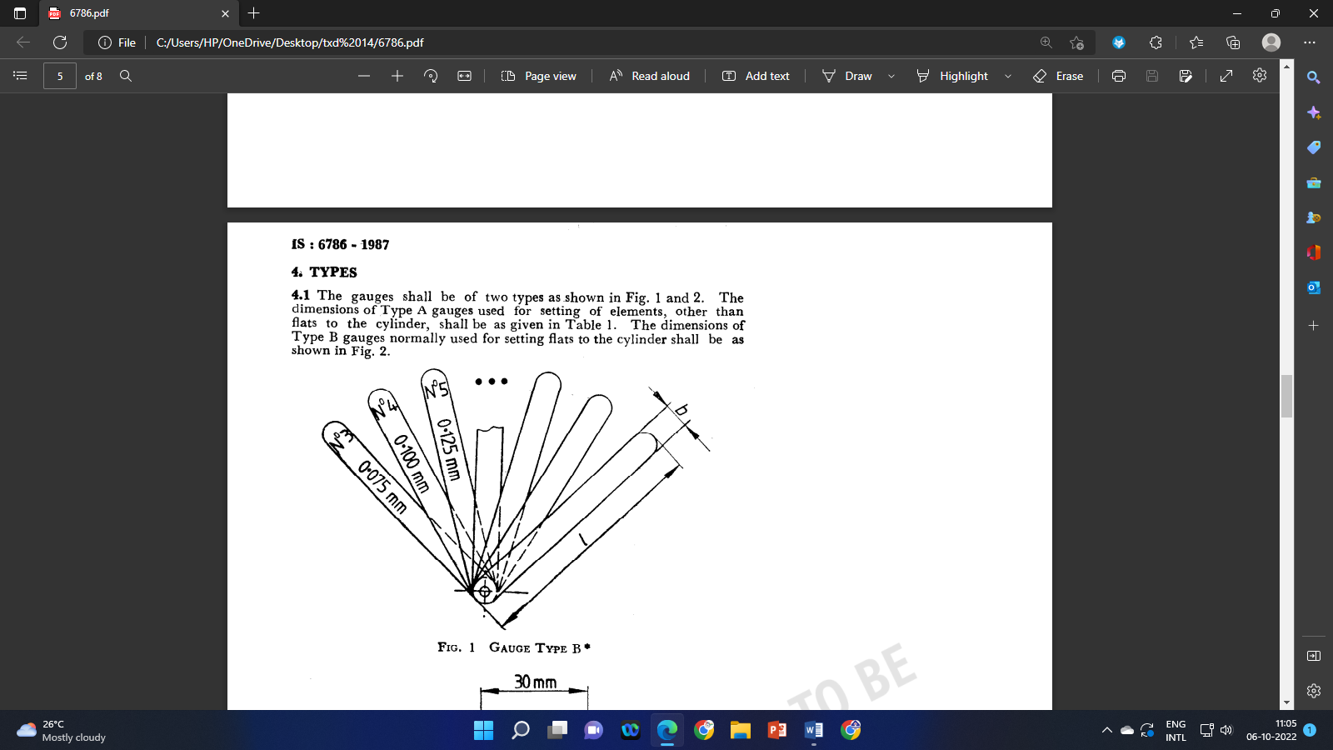

Fig. 1 Gauge Type A

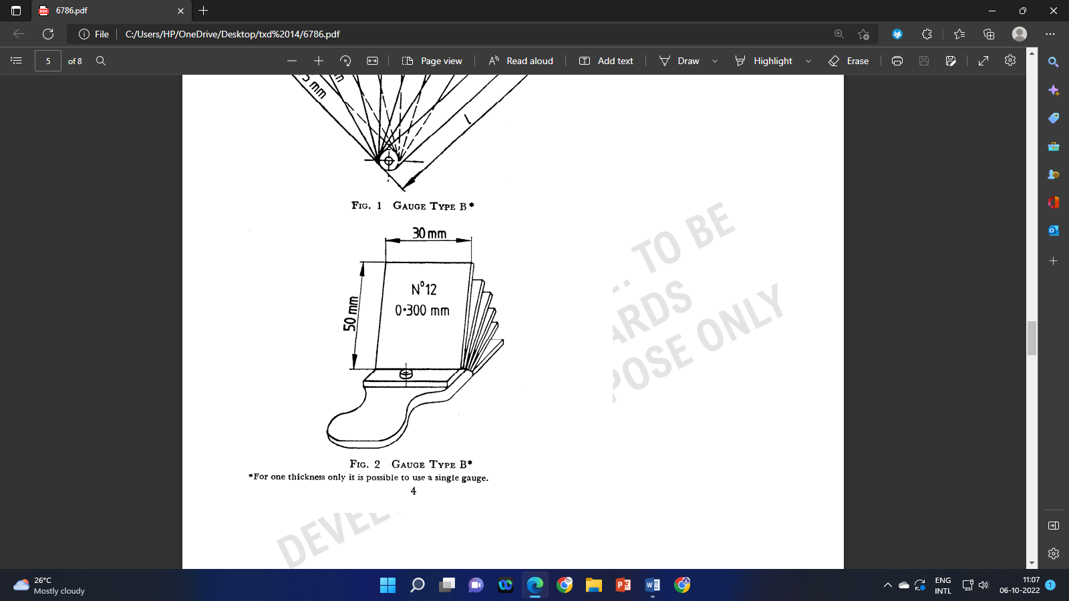

Fig. 2 Gauge Type B

**Table 1 Dimensions of Gauges Type A**

(*Clause* 5)

|  |  |  |
| --- | --- | --- |
| **Sl No.** | **b**  mm | **L**  mm |
| (1) | (2) | (3) |
| i) | 30 | 300  (240) |
| ii) | 45 | 300  400 |
| NOTE — The value in bracket to be avoided, as far as possible. | | |

**6 NUMBER, DIMENSIONS AND TOLERANCES**

The number of the gauge corresponds to the thickness of the gauge expressed in multiples of 0.025 mm (initially in 1/1 000 inch). The thickness of the gauges specified in co1 (2) of Table 2 shall be within the tolerances specified in co1 (3) of Table 2.

**Table 2 Number, Thickness and Tolerances of the Gauges**

(*Clause* 6)

| **Sl No.** | **Number** | **Thickness**  mm | **Tolerance**  mm |
| --- | --- | --- | --- |
| (1) | (2) | (3) | (4) |
| i) | 1 | 0.025 | ± 0.004 |
| ii) | 2 | 0.050 | ± 0.005 |
| iii) | 3 | 0.075 | ± 0.005 |
| iv) | 4 | 0.100 | ± 0.005 |
| v) | 5 | 0.125 | ± 0.005 |
| vi) | 6 | 0.150 | ± 0.005 |
| vii) | 7 | 0.175 | ± 0.005 |
| viii) | 8 | 0.200 | ± 0.005 |
| ix) | 9 | 0.225 | ± 0.005 |
| x) | 10 | 0.250 | ± 0.005 |
| xi) | 12 | 0.300 | ± 0.005 |
| xii) | 20 | 0.500 | ± 0.008 |
| xiii) | 40 | 1.000 | ± 0.010 |
| xiv) | 80 | 2.000 | ± 0.015 |
| xv) | 120 | 3.000 | ± 0.020 |
| xvi) | 200 | 5.000 | ± 0.025 |

**7 SAMPLING**

Unless otherwise agreed to between the buyer and the seller, to ascertain the conformity of product(s) to the requirements of this specification, or as specified in IS 2500 (Part 1) shall be followed.

**8 MARKING**

**8.1** The gauge shall be marked with the following:

1. Nominal size;
2. Gauge type and number of this standard;
3. Manufacturer's name or trade-mark; and
4. Serial number.

**8.2** **BIS Certification Marking**

The product(s) conforming to the requirements of this standard may be certified as per the conformity assessment schemes under the provisions of the *Bureau of Indian Standards Act*, 2016 and the Rules and Regulations framed thereunder, and the products may be marked with the Standard Mark.

**9 PACKING**

The gauges shall be coated with rust-preventive agent and wrapped in oil paper. Gauges shall be protected against climatic conditions by application of any anti-corrosive coating. Packing should be suitable to prevent damage in transit.



**ANNEX A**

(*Foreword*)

**COMMITTEE COMPOSITION**

Textile Machinery and Accessories Sectional Committee, TXD 14

| *Organization* |  | *Representative(s)* |
| --- | --- | --- |
| Central Manufacturing Technology Institute, Bengaluru |  | Dr Nagahanumaian (***Chairperson***) |
| ATE Enterprises Private Limited, New Delhi |  | Shri Abhijit Kulkarni  Shri Anil Kumar Sharma (*Alternate*) |
| Bajaj Industries Private Limited, Kolkata |  | Representative |
| Bhowmick Calculator, Kolkata |  | Shri Goutam Bhowmick  Shri Vivekananda Bhowmick (*Alternate*) |
| Bombay Textile Research Association, Mumbai |  | Shri Vijay Gawde  Shri R. A. Shaikh (*Alternate*) |
| Central Manufacturing Technology Institute, Bengaluru |  | Shri B. R. Mohanraj  Shri K. Saravanan (*Alternate*) |
| Confederation of Indian Textile Industry, New Delhi |  | Shrimati Chandrima Chatterjee  Shri Anmol Gupta (*Alternate*) |
| ICAR - Central Institute for Research on Cotton Technology, Mumbai |  | Dr N. Shanmugam  Dr T. Senthil Kumar (*Alternate*) |
| India ITME Society, Mumbai |  | Shri S. Senthil Kumar  Shrimati Seema Srivastava (*Alternate*) |
| Indian Jute Industries Research Association, Kolkata |  | Shrimati Saumita Choudhury  Shri Partha Sanyal (*Alternate*) |
| Indian Jute Mills Association, Kolkata |  | Shri Bhudipta Saha  Shri Tanmoy Singha (*Alternate*) |
| Indian Textile Accessories and Machinery Manufacturers Association, Mumbai |  | Shri N. D. Mhatre  Shri Chandresh Shah (*Alternate*) |
| Inspiron Engineering Private Limited, Ahmedabad |  | Shri Ankur Soni |
| Kusters Calico Machinery Limited, Karjan |  | Shri Devang Parikh  Shri Shubhasis Sur (*Alternate*) |
| Lagan Engineering Company Limited, Kolkata |  | Representative |
| Lakshmi Machine Works Limited, Coimbatore |  | Shrimati Kalpana A.  Shrimati Divya V. (*Alternate*) |
| Laxmi Shuttleless Looms Private Limited, Ahmedabad |  | Shri Ketan Sanghvi |
| Ludlow Jute Limited, Kolkata |  | Representative |
| Ministry of Heavy Industries and Public Enterprises, Department of Heavy Industry, New Delhi |  | Shri Sanjeev Gupta  Shri S. Sundar |
| National Safety Council, Navi Mumbai |  | Shri Lalit R. Gabhane  Shri R. R. Deoghare (*Alternate*) |
| Office of the Textile Commissioner, Mumbai |  | Shri N. K. Singh  Shri Narottam Kumar (*Alternate*) |
| Peass Industrial Engineers Private Limited, Navsari |  | Shri Ravi S. Rao  Shri Naimishkumar Ramanlal Tandel (*Alternate*) |
| Synthetic and Art Silk Mills Research Association, Mumbai |  | Dr Manisha Mathur  Shri Sanjay Saini (*Alternate*) |
| Technocraft Industries India Limited, Mumbai |  | Shri Ravinder Kumar  Shri R. Murali (*Alternate*) |
| Truetzschler India Private Limited, Ahmedabad |  | Shri Pravin Kandge  Shri Shiladitya Joshi (*Alternate*) |
| Veermata Jijabai Technological Institute, Mumbai |  | Dr Suranjana Gangopadhyay  Dr S. P. Borkar (*Alternate*) |
| BIS Directorate General |  | Shri J. K. Gupta, Scientist ‘E’/Director and Head (Textiles) [Representing Director General (*Ex-officio*)] |

*Member Secretary*

Shri Swapnil

Scientist ‘B’/Assistant Director

(Textiles), BIS