**IS 4778 : 2024**

**Doc No. TXD 39 (23318)**

भारतीय मानक

**वस्त्रादि — जूते के लिए सूती लेस — विशिष्टि**

(*दूसरा पुनरीक्षण* )

*Indian Standard*

**TEXTILES — COTTON LACES FOR FOOTWEAR — SPECIFICATION**

(*Second Revision*)

ICS 61.060

© BIS 2024

भारतीय मानक ब्यूरो

B U R E A U O F I N D I A N S T A N D A R D S

*मानक भवन,* 9 *बहादर शाह ज़फर मार्ग, नई दिल्ली -* 110002MANAK BHAVAN, 9 BAHADUR SHAH ZAFAR MARG

NEW DELHI 110002

[www.bis.gov.in](http://www.bis.gov.in) [www.standardsbis.in](http://www.standardsbis.in)

**June 2024 Price Group**

Technical Textiles for Clothtech Applications including Narrow Fabrics and Braids Sectional Committee, TXD 39

FOREWORD

This Indian Standard (Second Revision) was adopted by the Bureau of Indian Standards after the draft finalized by the Technical Textiles for Clothtech Applications including Narrow Fabrics and Braids Sectional Committee had been approved by the Textile Division Council.

This standard was first published in 1968 and subsequently revised in 1982. This revision has been made in the light of experience gained since its publication and to incorporate the following major changes:

1. Title of the standard has been modified;
2. Note for not using Sulphur dyes during dyeing is included;
3. BIS certification marking clause has been modified; and
4. References to Indian Standard given in Annex A has been updated.

This standard was first published in 1968 and for preparing this standard considerable assistance was derived from the following standards:

IND/TC/0303 Laces, fabric. Ministry of Defence.

V-L.51 Federal specification for laces, shoe; cotton Section IV (Part 5) of Federal standard stock catalog. United States of America.

Recommended use of the laces covered in the standard is as follows:

*Designation Laces for*

L 115/45 Safety boots for miners

L 100/45 Canvas boots

L 135/23 Football boots

L 100/23 Ankle derby boots

L 90/23 Cricket boots

L 60123 Shoes

L 145/36 Ski-boots (defence requirement)

L 115/36 Motor-cyclist shoes (defence requirement)

L 100/36 Sports shoes; boots (defence requirement)

L 60/36 Shoes (defence requirement)

L 60/25 -do-

NOTE — In the designation, the first number indicates the length of lace in centimetres and the second number indicates the minimum breaking load in kilogram force.

The composition of the Committee responsible for the formulation of this standard is given in Annex B.

For the purpose of deciding whether a particular requirement of this standard is complied with, the final value, observed or calculated expressing the result of a test or analysis, shall be rounded off in accordance with IS 2 : 2022 ‘Rules for rounding off numerical values (*second revision*)’. The number of significant places retained in the rounded off value should be the same as that of the specified value in this standard.

IS 4778 : 2024

*Indian Standard*

TEXTILES — COTTON LACES FOR FOOTWEAR — SPECIFICATION

*( Second Revision )*

**1 SCOPE**

This standard covers braided tubular cotton laces to be used for footwear.

**2 REFERENCES**

The standards given below contain provisions which, through reference in this text, constitute provisions of this standard. At the time of publication, the editions indicated were valid. All standards are subject to revision, and parties to agreements based on this standard are encouraged to investigate the possibility of applying the most recent edition of these standards:

|  |  |
| --- | --- |
| *IS No.* | *Title* |
| IS 171 : 1993 | Textiles — Ring spun grey cotton yarn for weaving — Specification (*fourth revision*) |
| IS 196 : 1966 | Atmospheric conditions for testing (*revised*) |
| IS 6359 : 2023 | Method for conditioning of textiles (*first revision*) |
| IS 1969 (Part 1) : 2018/ ISO 13934-1 : 2013 | Textiles — Tensile properties of fabrics: Part 1 Determination of maximum force and elongation at maximum force using the strip method (*fourth revision*) |
| IS/ISO 105-B02 : 2014 | Textiles — Tests for colour fastness: Part B02 Colour fastness to artificial light: Xenon arc fading lamp test |
| IS/ISO 105-C10 : 2006 | Textiles — Tests for colour fastness: Part C10 Colour fastness to washing with soap or soap and soda |

**3 MATERIALS**

**3.1 Yarn**

The cotton yarn used in the manufacture of laces should be conforming to Grade A or B of IS 171.

**3.2 Laces**

The colour of laces and tags shall be as specifies in the contract or order.

**3.2.1** *Dying*

The shoe laces shall be dyed to the required’ shade using suitable dyes.

**3.2.2** For black laces manufactured against defence orders.

NOTE — Sulphur dyes shall not be used.

**3.3 Tags**

Both ends of the lace shall be provided with tags of metal or plastic materials. The metal tags shall be coated with varnish or shall be of the same colour to match with the laces. In the case of laces required by defence (L 145/36, L 115/36) (L 100/36, L 60/36, L 63/25) metallic tags shall be used unless otherwise specified. The length of the tags shall be not less than 15 mm. The metallic tags shall not have rough joints, shall grip the lace firmly and the laces shall protrude about 2 mm out of the tip of the tag at either end.

Plastic tags shall be so fitted that the wrap over is heat-sealed, and the plastic materials fused and sealed so as to be an integral part of the lace. The plastic material used for tags shall be at least 0.15 mm thick.

**4 REQUIREMENTS**

**4.1** The requirements for shoe laces for general use are given in Table 1 while those for defence use in Table 2.

**Table 1 Requirements for Shoe Laces, General Use**

(*Clause* 4.1)

|  |  |  |  |  |  |  |  |
| --- | --- | --- | --- | --- | --- | --- | --- |
| **Sl No.** | **Requirements** | **Designation** | | | | | **Method of Test, Ref to** |
| 115/45 | 100/45 | 135/23 | 90/23 | 60/23 |  |
| (1) | (2) | (3) | (4) | (5) | (6) | (7) | (8) |
| i) | Length cm, *Min* | 115 | 100 | 135 | 90 | 60 | **A-2** |
| ii) | Breaking strength N (kgf), *Min* | 440(4) | 440(45) | 225(23) | 225(23) | 225(23) | IS 1969 |
| iii) | Colour fastness to:  a) Washing (for dyed laces); and  b) Light (for dyed laces). | 4 or better | | | | | IS/ISO 105-C10  IS/ISO 105-B02 |
| iv) | Slip resistance, N (kgf), *Min* | 12 (1.2) | | | | | **A-3** |
| v) | Gripping strength of metallic tags, N (kgf), *Min* | 128 (13) | | | | | **A-4** |
| NOTE — For laces of other lengths, the breaking strength shall be not less than that specified in the contract or order. | | | | | | | |

**Table 2 Requirements of Manufacturing Details for Shoe Laces for Defence Use**

(*Clause* 4.1)

| **Sl No.** | **Requirements** | **Designation** | | | | | | **Method of Test, Ref to** |
| --- | --- | --- | --- | --- | --- | --- | --- | --- |
| L115/45 | L145/36 | L115/36 | L100/36 | L 60/36 | L 60/25 |  |
| (1) | (2) | (3) | (4) | (5) | (6) | (7) | (8) | (9) |
| i) | Length, cm, *Min* | 115 | 145 | 115 | 100 | 60 | 60 | **A-2** |
| ii) | Breaking strength, N (kgf), *Min* | 440(45) | 355(36) | 325(36) | 355(36) | 355(3) | 245(25) | IS 1969 |
| iii) | Colour fastness, slip resistance and griping strength | Same as specified in Table 1 | | | | | | |
| iv) | Flat width and tolerances, mm | 8 ± 2 | | 7 ± 2 | | 3.5 ± 1 | | **A-5** |
| v) | Mass, g/pair including tags, *Min* | 11.5 | 12.5 | 10.0 | 9.0 | 6.0 | 3.0 | **A-6** |
| vi) | Manufacturing details: |  | | | | | | — |
| a) Total number of ends; | 96 | | | | | | — |
| b) Number of spindles; and | 16 or 32 | | 16, 32 or 48 | | 16 or 32 | | — |
| c) Ends/spindles. | 3 or 6 | | 6, 3 or 2 | | 6 or 3 | | — |
| vii) | Recommended approximate count of yarn | — 15 tex × 2 (2/240s) 30 tex × 2(2/20s) | | | | | | — |
| NOTE — If so specified in the contract or order, carbon-arc lamp may be used for determining colour fastness to light. | | | | | | | | |

**4.2** **Sealed Sample**

If in order to illustrate or specify colour, general appearance, feel and such other characteristics of the lace, a sample has been agreed upon and sealed, the supply shall be in conformity with the sample in such respects.

The custody of the sealed sample shall be a matter of prior agreement between the buyer and the seller

**5 PACKING**

Unless otherwise agreed between the buyer and seller, The laces shall be tied in pairs, then bundled or packed (in 50 pairs) in a manner acceptable to the purchaser. Only laces of the same designation, length and colour shall be packed together in the same bundle or package.

**6 MARKING**

**6.1** Each pair of laces shall be bound by a paper band bearing the following information:

1. Manufacturer’s name, initials or trademark;
2. Material (for example, cotton lace); and
3. Designation/length of lace (cm).

**6.2** Each bundle or package shall have a label securely attached bearing the following information:

1. Manufacturer’s name or trade-mar;
2. Designation/length of lace (cm);
3. Colour;
4. Number of pairs; and
5. Any other information as required by the law in force.

**6.3** **BIS Certification Marking**

The product(s) conforming to the requirements of this standard may be certified as per the conformity assessment schemes under the provisions of the *Bureau of Indian Standards Act*, 2016 and the Rules and Regulations framed thereunder, and the product(s) may be marked with the Standard Mark.

**7 SAMPLING**

**7.1** The quantity of laces of one definite type delivered to a buyer against a dispatch note shall constitute a lot.

**7.2** The sampling plan and criteria for conformity shall be as given in Table 3.

**Table 3 Sample Size and Criteria for Conformity**

(*Clause* 7.2)

|  |  |  |  |  |
| --- | --- | --- | --- | --- |
| **Sl No.** | **Number of Bundle in Lot** | **Number of Bundle to be Selected** | **Permissible Number of Defectives (Pair of Laces)** | |
| (1) | (2) | (3) | (4) | (5) |
|  | Up to 25 | 3 | 3 | 0 |
|  | 26 to 50 | 5 | 5 | 1 |
|  | 51 to 100 | 8 | 7 | 2 |
|  | 101 to 300 | 13 | 10 | 3 |
|  | 301 and above | 20 | 14 | 4 |

**7.3** Ten pairs of laces shall be selected from each bundle for examining-tags, length, flat width and mass.

**7.3.1** Two pairs of laces shall be selected from each bundle for testing breaking load, slip resistance and gripping strength of tags.

**7.3.2** For testing colour fastness, three test specimens of each colour for lot size of 100 bundles or less and five test specimens otherwise shall be prepared.



**ANNEX A**

(*Table* 1 *and Table* 2)

**METHODS OF TEST**

**A-1 CONDITIONING OF SPECIMENS AND ATMOSPHERIC CONDITIONS FOR TESTING**

**A-1.1** Prior to determination of mass and slip resistance, the test specimens shall be conditioned to moisture equilibrium in a standard atmosphere at (65 ± 2) percent RH and (27 ± 2) °C (*see* IS 196) for 48 h in accordance with IS 6359. For other determinations, the test specimens shall preferably be conditioned in the standard atmosphere for 48 h.

**A-1.2** The determination of mass and slip resistance shall be carried out in the standard atmosphere and all other tests shall preferably be carried out in the standard atmosphere.

**A-2 LENGTH**

**A-2.1** Measure the length of 2 tags on the test specimen to the nearest millimetre. Measure the length between the inner grips of the 2 tags by applying a tension of 28 ± 0.5 gf (274 ± 5 mN) on the lace. The sum of these two measurements shall be taken as the length of the lace in the test specimen.

**A-3 SLIP RESISTANCE**

**A-3.1 Apparatus**

A suitable power-driven tensile strength testing machine with a rate of traverse of (115 ± 12) mm/ min and a clamp with 5 kg weight for application of tension on the specimen.

**A-3.2** From a slip knot (*see* Fig. 1) with its knot in the centre of the specimen, clamp one end *A* of the specimen centrally in the upper jaw, then a clamp a 5 kg weight for a period of 10 s at *B*. Remove the 5 kg weight and clamp the free hanging length C of the specimen centrally in the pulling jaw. Operate the machine and record the highest load registered during the slipping of the first 50 mm of the lace through the slip knot. Continue to operate the machine until the knot is undone. Take the average of 6 results on each lace as the slip resistance.

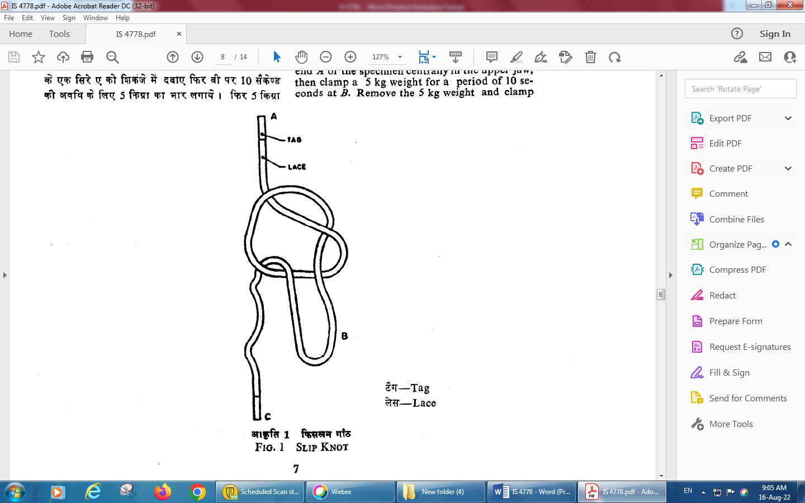

Fig. 1 Slip Knot

**A-4 GRIPPING STRENGTH OF TAGS**

**A-4.1 Apparatus**

a) A suitable power-driven tensile strength testing machine with a rate of traverse of 115 ± 12 mm/min; and

b) Slotted Plate (*see* Fig. 2).

A rigid metal plate of suitable dimensions with a vertical edge tapered slot along the length of the plate. In conjunction with the slotted plate, use the upper jaw of the testing machine to keep the slot at right-angle to the direction of application of load during the test.

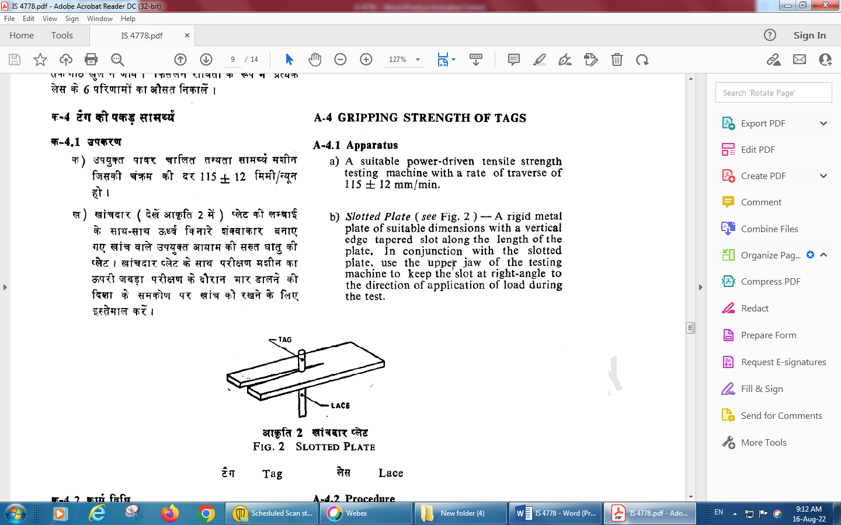

Fig. 2 Slotted Plate

**A-4.2 Procedure**

Move the conditioned test specimen with one of its tags uppermost horizontally along the slot until both sides of the base of the tag rest on the top of the slotted plate. Centre the plate so that longitudinal axis of the test specimen is along the axis of the application of the load. Apply by hand an initial tension sufficient to strengthen the lace. Clamp the free end of the straightened specimen in the pulling jaw so that the free distance between the upper grip and the pulling jaw is 100 mm at the start of the test. Operate the machine and record the highest load registered before the tag is pulled from the lace. Discard the result and test another specimen if:

a) the tag slips through the slot without being removed from the fabric lace; and/or

b) the tag buckles at the base or the tag is scrapped without being removed from the lace before the specified minimum gripping strength is reached.

Take the average of results of 10 specimens at the gripping strength of the tag.

**A-5 WIDTH**

Measure the width of the test specimen to the nearest millimetre after applying tension of 28 ± 0.5 gf (274 ± 5 mN) on the test specimen.

**A-6 MASS**

Take a conditioned pair of laces constituting the test specimen and weigh it to an accuracy of 0.5 g. Similarly, determine the mass of the other test specimens and take the average as the mass of a pair of laces.

**ANNEX B**

(*Foreword*)

**COMMITTEE COMPOSITION**

Technical Textiles for Clothtech Applications including Narrow Fabrics and Braids Sectional Committee, TXD 39

| *Organization* |  | *Representative*(*s*) |
| --- | --- | --- |
| Additional Controller CQA (General Stores), DGQA, Ministry of Defence |  | Shri A. Chowdhury **(*Chairperson*)** |
| ICAR - Central Institute for Research on Cotton Technology, Mumbai |  | Dr P. Jagajanantha |
| Federation of Indian Chambers of Commerce and Industry |  | Shri Anu Handa  Dr T. Senthilkumar (*Alternate*) |
| Indian Technical Textile Association, Mumbai |  | Dr Anup Rakshit  Shri Vikram Jain (*Alternate*) |
| M K U Limited, Kanpur |  | Shri Sumit Khandelwal  Shri Rajib Pal (*Alternate*) |
| Motilal Dulichand Pvt Ltd, Kanpur |  | Shri Shailendra Nath Misra  Shri Sudhir Shivhare *(Alternate*) |
| National Textile Corporation, New Delhi |  | Shri R. K. Yadav |
| Ordnance Parachute Factory, Kanpur |  | Shri V. M. Bagade  Shri S. Kondaiah (*Alternate*) |
| Office of Textiles Commissioner, Mumbai |  | Shri V. K. Kohli  Shri Humayun K. (*Alternate*) |
| SGS Limited, Gurugram |  | Ms Anitha Jeyaraj  Shri Gaurav Saraswat (*Alternate*) |
| S L Banthia Textiles Industries Pvt Ltd |  | Shri Santosh Kumar Banthia |
| Shipra International, Kanpur |  | Shri Abhishek Kumar Agrawal |
| Sky Industries Ltd, Navi Mumbai |  | Shri Kapil Mehrotra  Shri Michael (*Alternate*) |
| Synthetic and Art Silk Mills Research Association, Mumbai |  | Shri Sanjay Saini  Shri Premnath Surwase (*Alternate*) |
| Thanawala & Co, Mumbai |  | Shri Hemal Thanawala  Shri Vivan Thanawala (*Alternate*) |
| The Bombay Textile Research, Association, Mumbai |  | Shri Shaikh Riyaz Ahmed  Dr Prasanta Kumar Panda (*Alternate*) |
| U P Textile Technological Institute, Kanpur |  | Dr Prashant Vishnoi |
| Universal Yarn & Tex Pvt Ltd, Kanpur |  | Shri Rajiv K. Bhartiya |
| BIS Directorate General |  | Shri J. K. Gupta, Scientist ‘E’/Director and Head (Textiles) [Representing Director General (*Ex-officio*)] |

*Member Secretary*

Shri Tanishq Awasthi

Scientist ‘B’/Asistant Director

(Textiles), BIS