***भारतीय मानक***

***Indian Standard***

**TED 22 (23030) F**

**IS 8007 (Part 1): 2023**

***सड़क वाहन− ट्रैक्टरों और अर्ध-ट्रेलरों के बीच यांत्रिक युग्मन   
भाग* 1 *सामान्य कार्गो के लिए ट्रैक्टरों और अर्ध-ट्रेलरों के बीच अंतर्विनिमयता***

**[ISO 1726-1 : 2000,** संशोधित **]**

(दूसरा पुनरीक्षण*)*

**Road vehicles — Mechanical Coupling Between Tractors and Semi-trailers**

**Part 1 Interchangeability Between Tractors and Semi-trailers for General Cargo**

**[ISO 1726-1 : 2000, MOD]**

(*Second Revision*)

ICS 43.040.70

© BIS 2024

भारतीय मानक ब्यूरो

BUREAU OF INDIAN STANDARDS

मानक भवन, 9 बहादुर शाह ज़फर मार्ग, नई दिल्ली - 110002

MANAK BHAVAN, 9 BAHADUR SHAH ZAFAR MARG

NEW DELHI - 110002

[www.bis.gov.in](http://www.bis.org.in) [www.standardsbis.in](http://www.standardsbis.in)

**July 2024 Price Group**

Transport Tractors, Trailers and Industrial Trucks Sectional Committee, TED 22

FOREWORD

This Indian Standard (Part 1) (Second Revision) was adopted by the Bureau of Indian Standards, after the draft finalized by the Transport Tractors, Trailers and Industrial Trucks Sectional Committee had been approved by the Transport Engineering Division Council.

This standard was first published in 1976 which was based on ISO 1726 : 1973. Subsequent to the revision in the ISO 1726 : 2000, this standard was revised in 2004 to bring it in line with the revised ISO standard. This revision has been brought out to publish it as modified adoption of ISO 1726-1 : 2000.

This standard supersedes IS 8007 : 2004/IS0 1726 : 2000 'Road vehicles — Mechanical coupling between tractors and semi-trailers — Interchangeability (*first revision*)'.

The standard is being issued in two parts under general title ‘Road vehicles — Mechanical couplings between tractors and semi-trailers’, the other part is:

|  |
| --- |
| Part 2 Interchangeability between low-coupling tractors and high-volume semi-trailers |

Height of fifth wheel of laden tractor, of ISO 1726-1 has been modified in-order to bring them in line with Indian conditions.

The composition of the committee responsible for formulation of this standard is given in Annex B.

For the purpose of deciding whether a particular requirement of this standard is complied with, the final value, observed or calculated expressing the result of a test or analysis, shall be rounded off in accordance with IS 2 : 2022 ‘Rules for rounding off numerical values (*second revision*).’ The number of significant places retained in the rounded off value should be the same as that of the specified value in this standard.

*Indian Standard*

ROAD VEHICLES — MECHANICAL COUPLING BETWEEN TRACTORS AND SEMI-TRAILERS

**PART 1 INTERCHANGEABILITY BETWEEN TRACTORS AND SEMI-TRAILERS FOR GENERAL CARGO**

**[ISO 1726-1 : 2000, MOD]**

*( Second Revision )*

# SCOPE

This standard (Part 1) specifies dimensions to ensure interchangeability between a tractor vehicle and a coupled semi-trailer, the two together constituting an articulated vehicle. It specifies certain interchangeability dimensions, including those of the gooseneck contour, as well as operating dimensions related to angle values. The specifications permit the same semi-trailer to be used with either two- or three-axle tractors.

Annex A gives interface technical specifications for tractors designed for towing high-cube semi- trailers, including ISO containers having an external height of 2.9 m.

This standard covers articulated vehicles used in commercial cargo transport of the greatest possible variety. However, it may not be applicable to special combination types such as low-bed or tipper vehicles.

This standard does not provide limitations of maximum gross mass and overall dimensions, which are generally laid down by legislative requirements.

# REFERENCES

The standard given below contain provisions which, through reference in this standard, constitute provisions of this standard. At the time of publication, the edition indicated was valid. All standards are subject to revision, and parties to agreement based on this standard are encouraged to investigate the possibility of applying the most recent edition of this standard:

|  |  |
| --- | --- |
| *Other Standard* | *Title* |
| ISO 337 : 1981 | Road vehicles — 50 semi-trailer fifth wheel coupling pin — Basic and mounting interchangeability dimensions |

# INTERCHANGEABILITY DIMENSIONS

* 1. **Height of Fifth Wheel of Uncoupled Tractor**

The height ‘*h’* above GRP of the fifth wheel of an uncoupled tractor shall be *Max* 1 500 mm. In case of 90 mm, fifth wheel coupling height ‘*h*’ in uncoupled condition shall be *Max* 1 550 mm (*see* Fig. 1).

* 1. **Forward-Clearance-Zone Radius of Semi-Trailer**

The semi-trailer's forward-clearance- zone radius, *d* (*see* Fig. 2), shall not exceed 2 040 mm.

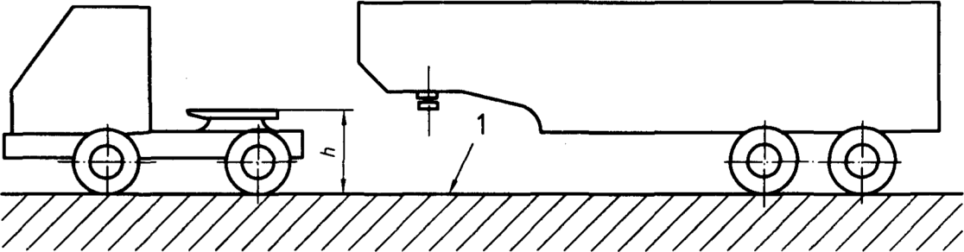

*Key*

1 GRP

Fig. 1 Height Of Fifth Wheel

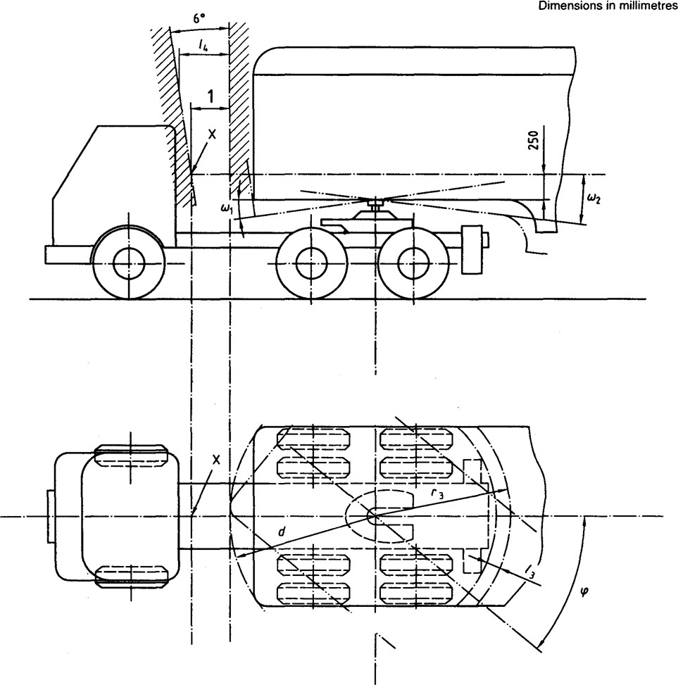

*Key*

1. *l*4 at point X = 80 mm, *Min*

All dimensions in millimeters.

Fig. 2 Free Space Between Tractor and Semi-Trailer

* 1. **Gooseneck Contour**

The gooseneck shall be located on the outside of a surface consisting of two planes and one surface of revolution interconnected without forming a step. These three parts of the total surface are shown in Fig. 3, 4 and 5 and defined as follows:

1. A plane horizontal and perpendicular to the axis of the coupling pin with a length of *l*2 (AB) and a width of that of the semi-trailer, limited by the intersection of;
2. A second plane of the same width, making an angle 𝛾 with the first plane, limited by the intersection of; and
3. A surface of revolution generated by rotating the vertical portion DE, situated at a radius, *r*3, from the axis of the coupling pin, and an arc of a circle of radius *r*2 (CD — C’D’), between the second plane and DE, such that no discontinuity arises.

The values adopted for these generator elements:

1. l2 = 750 mm;
2. 𝛾 = 4°;
3. r2 = 450 mm; and
4. r3 = 2300 mm.

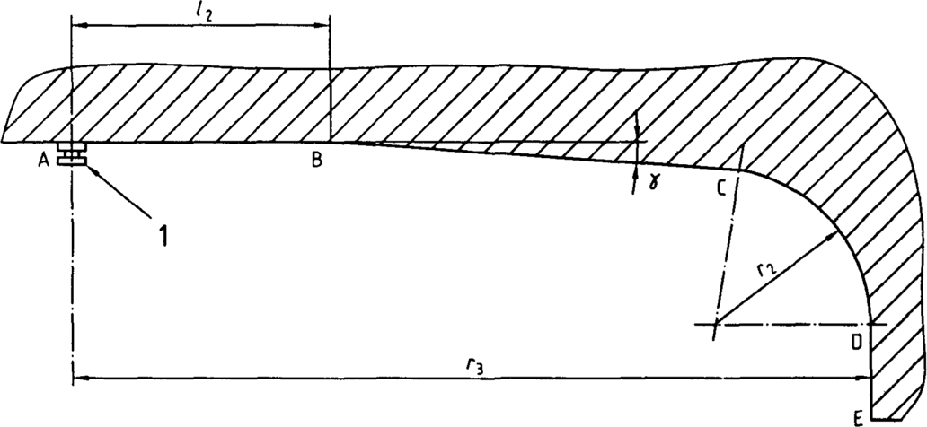The above dimensions allow the determination of the center of the circle of radius *r*2.

*Key*

1. Coupling pin (in accordance with ISO 337)
2. Centre profile
3. Outer profile

Fig. 3 Gooseneck Contour: Generator Elements

*Key*

1. Coupling pin (in accordance with ISO 337)
2. Centre profile
3. Outer profile

Fig. 4 Gooseneck Contour: Center and Outer Profiles

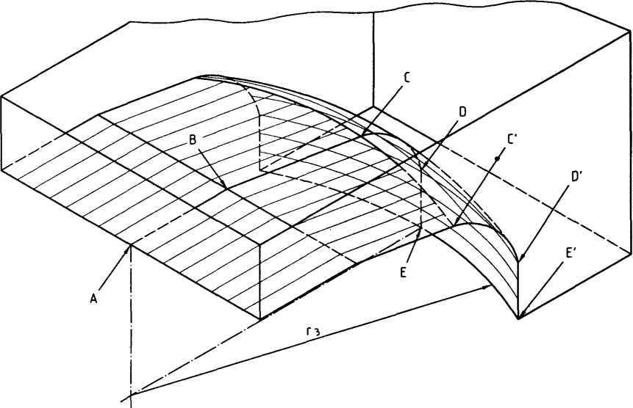

*Key*

1. Coupling pin (in accordance with ISO 337)
2. Centre profile
3. Outer profile

Fig. 5 Gooseneck Contour: Three-Dimensional View

# OPERATING DIMENSIONS

* 1. **Angles of Inclination of Semi-Trailer in Relation to Tractor**

The tractor shall be constructed so that tractor and semi-trailer components, except for those concerned with articulation, do not make contact with each other when the articulated vehicle is running in a straight line, and when the angle of inclination of the semi-trailer relative to the tractor does not exceed the following values (*see* Fig. 2):

ω1 = 6° towards the front; and

ω2 = 7° towards the rear.

For the purposes of the measurement of ω1 and ω2, the fifth wheel plate is assumed to be situated in a horizontal plane. The tractor shall be set at the attitude which corresponds to the design laden condition when the tractor is standing on a horizontal plane.

# Lateral Inclination

When the trailer is at a lateral inclination, δ (*see* Fig. 6), of a maximum of 3° relative to the tractor chassis, there shall be no contact between the tractor chassis and the semi-trailer.

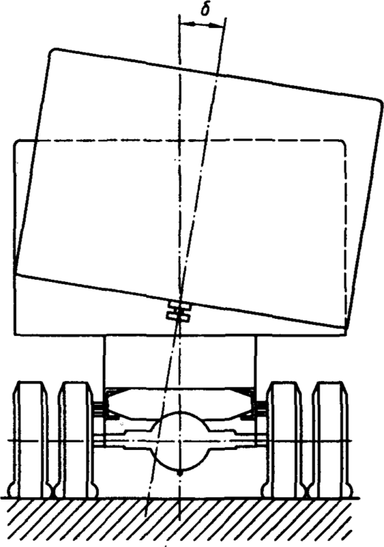Fig. 6 Lateral Inclination

# Free Space between Tractor and Semi-trailer

The free space between the tractor and semi-trailer is measured as follows (*see* Fig. 2):

1. *l*3 is the distance between two cylinders of revolution, both having the kingpin axis as their axis. One of these cylinders has the radius *r*3 (lower part of the gooseneck), the other cylinder is that of the smallest radius within which all points of the rear part of the tractor are located. The distance *l*3 shall be a minimum of 100 mm.
2. *l*4 is the horizontal clearance between a cylinder of revolution having as its axis the axis of the fifth wheel coupling and a conical surface of revolution having the same axis. The cylinder of revolution has the radius *d*. The conical surface is generated by a line making an angle of 6° from the vertical towards the front of the tractor. This line is positioned in such a way that the conical surface does not interfere with any point of the tractor located above the fifth-wheel coupling horizontal plane. A point, X, of this surface is positioned on the plane of symmetry of the semi-trailer at a height of 250 mm above the fifth wheel coupling face. At X, *l*4 shall be a minimum of 80 mm.

# DESIGNATION

Tractors and semi-trailers in compliance with the requirements of this standard (excluding Annex A) shall be designated:

Tractors and semi-trailers IS 8007-S.

Tractors and semi-trailers in compliance with Annex A shall be designated:

Tractors and semi-trailers IS 8007-A.

# BIS CERTIFICATION MARKING

The product(s) conforming to the requirements of this standard may be certified as per the conformity assessment schemes under the provisions of the *Bureau of Indian Standards Act*, 2016 and the Rules and Regulations framed thereunder, and the products may be marked with the Standard Mark.

# ANNEX A

(*Clauses* 1 *and* 5)

# INTERFACE SPECIFICATIONS FOR TRACTORS DESIGNED FOR TOWING HIGH-CUBE

**SEMI-TRAILERS**

For tractors designed to tow high-cube semi-trailers, including ISO containers having an external height of 2.9 m, the requirements instead of those stated in **3.2** are:

1. The height *h* above GRP of the fifth wheel of a laden tractor shall be in the range 1 025 mm to 1 100 mm;
2. The height *h* above GRP of the fifth wheel of an uncoupled tractor shall not exceed 1 150 mm.

Although three-axle tractors are not excluded from Annex A, it might be difficult to apply its specifications and at the same time comply with the angles of inclination and other requirements specified elsewhere in this standard. Any deviations from compliance should be carefully evaluated by those competent to do so in order to decide whether safe and satisfactory operation can be ensured.

**ANNEX A**

(*Foreword*)

**COMMITTEE COMPOSITION**

Transport Tractors, Trailers and Industrial Trucks Sectional Committee, TED 22

| *Organization* | *Representative(s)* |
| --- | --- |
| Automotive Research Association of India, Pune | Shri A. Akbar Badusha **(*Chairperson*)** |
| BEML Limited, Bengaluru | Shri Ramesh Raju  Shri Sethu Madhavan (*Alternate*) |
| Action Construction Equipment Limited, Palwal | Shri Chetan Gole  Shri Inderpal Singh Beniwal(*Alternate*) |
| All India Motor Transport Congress, New Delhi | Shri Naveen Gupta  Shri S. K. Mittal (*Alternate*) |
| Ashok Leyland Limited, Chennai | Shri Prasanna Venkatesh  Shri Faustino V. (*Alternate*) |
| Automotive Component Manufactures Association of India, New Delhi | Shri Uday Harite  Shri Jitender Rana *(Alternate)* |
| Automotive Research Association of India, Pune | Shri P. D. Betgeri  Shri Tusharkumar R. Kamble(*Alternate*) |
| Black Diamond Motors Private. Limited, Bilaspur | Shri Jacob Thomas  Shri Tanmay Ganguly *(Alternate)* |
| Brakes India Limited, Chennai | Shri P. venugopal  Shri G. Devendran(*Alternate*) |
| Central Institute of Road Transport, Pune | Shri S. N. Dhole  Shri S. N. Gutte(*Alternate*) |
| Department of Heavy Industry, New Delhi, Ministry of Heavy Industries and Public Enterprises, | Shri B. K. Mishra  Shri R. K. Jaiswal (*Alternate*) |
| Directorate General Factory Advice Service and Labour Institutes, Mumbai | Shri N. Varadharajan  Shri Karunesh Srivastava (*Alternate*) |
| Global Automotive Research Centre, Oragaram | Shri. A. S. Ramadhas  Shri V. M. Dhanasekkar (*Alternate*) |
| Godrej & Boyce Manufacturing Company Limited, Mumbai | Shri Vinay G. Kulkarni  Shri Anand Shankar Tawde(*Alternate*) |
| International Centre for Automotive Technology, Manesar | Shri Keshav Kumar Tripathi  Shri Gavendra Singh (*Alternate*) |
| JCB India Limited, New Delhi | Shri Saurabh Dalela  Shri Alok Gandhi (*Alternate*) |
| Josts Engineering Company Limited, Thane | Shri Pramod M. Pophale  Shri Santosh Saraf (*Alternate*) |
| KION India Private Limited, Pune | Shri Sunil K. Gupta  Shri Rizwan Khan (*Alternate*) |
| Knorr-Bremse Systems for Commercial Vehicles India Private Limited, Pune | Shri Arun Bisht  Shri Atul Ingole (*Alternate*) |
| Machine and Mill Stores Corporation Private Limited, Howrah | Shri Dipak Ghosh |
| Mahindra Trucks and Bus Division, Pune | Shri Nagaraju K.  Shri V. G. Kulkarni (*Alternate*) |
| Ministry of Labour and Employment Directorate, Mumbai | Dr R. N. Meena  Shri K. Durai (*Alternate*) |
| Ministry of Road Transport and Highways, New Delhi | Ms. Dharkat R. Luikang |
| National Automotive Test Tracks, Dhar | Shri Sagar Bendre  Shri J. K. Chakrabarty (*Alternate*) |
| Satrac Engineering Private Limited, Bangalore | Shri Santhana Krishnan S.  Shri Nithin Kumar (*Alternate*) |
| SDR Auto Private Limited, Chennai | Shri B. Ramesh  Shri Praveen Kumar (*Alternate*) |
| Tata International Vehicle Applications Private Limited, Pune | Shri Parikshit Abhimanyu Bhaskar  Shri Krishna Prasad (*Alternate*) |
| Tata Motors Limited, Pune | Shri Rahul Mohanrao Pathak  Shri Sunil Agarwal (*Alternate*) |
| Transport Engineering Solutions India Private Limited, Pune | Shri Manoj Varghese  Shri Anand Singh (*Alternate*) |
| Volvo Trucks, VE Commercial Vehicles Limited, Bengaluru | Shri Challapalli Nithin Roy  Shri Gedela Chaitanya (*Alternate*) |
| ZF Commercial Vehicle Control Systems India Limited, Pune | Shri S. Balachandran  Shri Kuldeep Singh (*Alternate*) |
| BIS Directorate General | Shri Deepak Aggarwal, Scientist ‘F’/ Director and Head (Transport Engineering) [Representing Director General (*Ex-officio*)] |

*Member Secretary*

Shri Mitra Sen Verma

Scientist ‘D’/Joint Director

(transport engineering), BIS