***भारतीय मानक***

***Indian Standard***

**IS 12271 : 2024**

**लैप्रोस्कोपिक ट्रोकर और कैनुला — विशिष्टि**

*( पहला पुनरीक्षण )*

**Laproscopic Trocar and Cannula — Specification**

( *First Revision )*

ICS 11.040.30

© BIS 2024

भारतीय मानक ब्यूरो

BUREAU OF INDIAN STANDARDS

मानक भवन, 9 बहादुर शाह ज़फर मार्ग, नई दिल्ली - 110002

MANAK BHAVAN, 9 BAHADUR SHAH ZAFAR MARG

NEW DELHI - 110002

[www.bis.gov.in](http://www.bis.org.in) [www.standardsbis.in](http://www.standardsbis.in)

**December 2024 Price Group X**

Obstetric and Gynaecological Instruments and Appliances Sectional Committee, MHD 03

FOREWORD

This Indian Standard (First Revision) was adopted by the Bureau of Indian Standards, after the draft finalized by the Obstetric and Gynaecological Instruments and Appliances Sectional Committee had been approved by the Medical Equipment and Hospital Planning Division Council.

This standard was first published in 1988. This revision of the standard has been brought out to align the standard with the latest style and format of Indian Standards.

The composition of the Committee responsible for the formulation of this standard is given in Annex A.

For the purpose of deciding whether a particular requirement of this standard is complied with the final value, observed or calculated, expressing the result of a test or analysis shall be rounded off in accordance with IS 2 : 2022 ‘Rules for rounding off numerical values (s*econd revision*)’. The number of significant places retained in the rounded off value should be same as that of the specified value in this standard.

*Indian Standard*

LAPROSCOPIC TROCAR AND CANNULA — SPECIFICATION

( *First Revision )*

**1 SCOPE**

This standard provides material, dimensions and other requirements for laparoscopic trocar and cannula used in gynaecology.

**2 REFERENCES**

The standards given below contain provisions which, through reference in this text, constitute provisions of this standard. At the time of publication, the editions indicated were valid. All standards are subject to revision, and parties to agreements based on this standard are encouraged to investigate the possibility of applying the most recent edition of these standards:

|  |  |
| --- | --- |
| *IS No.* | *Title* |
| IS 1068 : 1993 | Electroplated coatings of nickel plus chromium and copper plus nickel plus chromium — Specification (*third revision*) |
| IS 6603 : 2024 | Stainless steel semi-finished products, bars, wire rods, and bright bars — Specification *(second revision*) |
| IS 7531 : 1990 | Surgical instruments — Corrosion resistance of stainless steel surgical — |

**3 MATERIAL**

**3.1** Trocar and cannula shall be made from stainless steel of Designation X30Cr13 of IS 6603.

**3.2** Other components shall also be made of stainless steel of the same grade except the knob, spring and sliding shutter which shall be of bakelite and brass, respectively.

**4 SHAPE AND DIMENSIONS**

**4.1** The general shape and dimensions of laparoscopic trocar and cannula shall be as shown in Fig. 1, Fig. 2, Fig. 3 and Fig. 4.

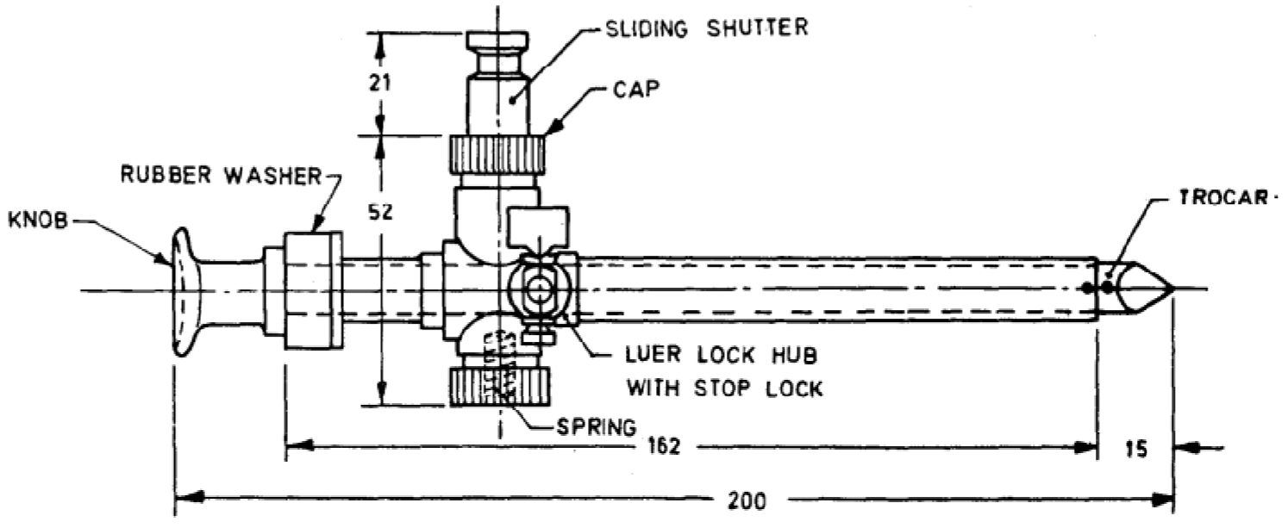

All dimensions in millimetres.

Fig. 1 Laproscopic Trocar and Cannula, Trocar Size 11 mm

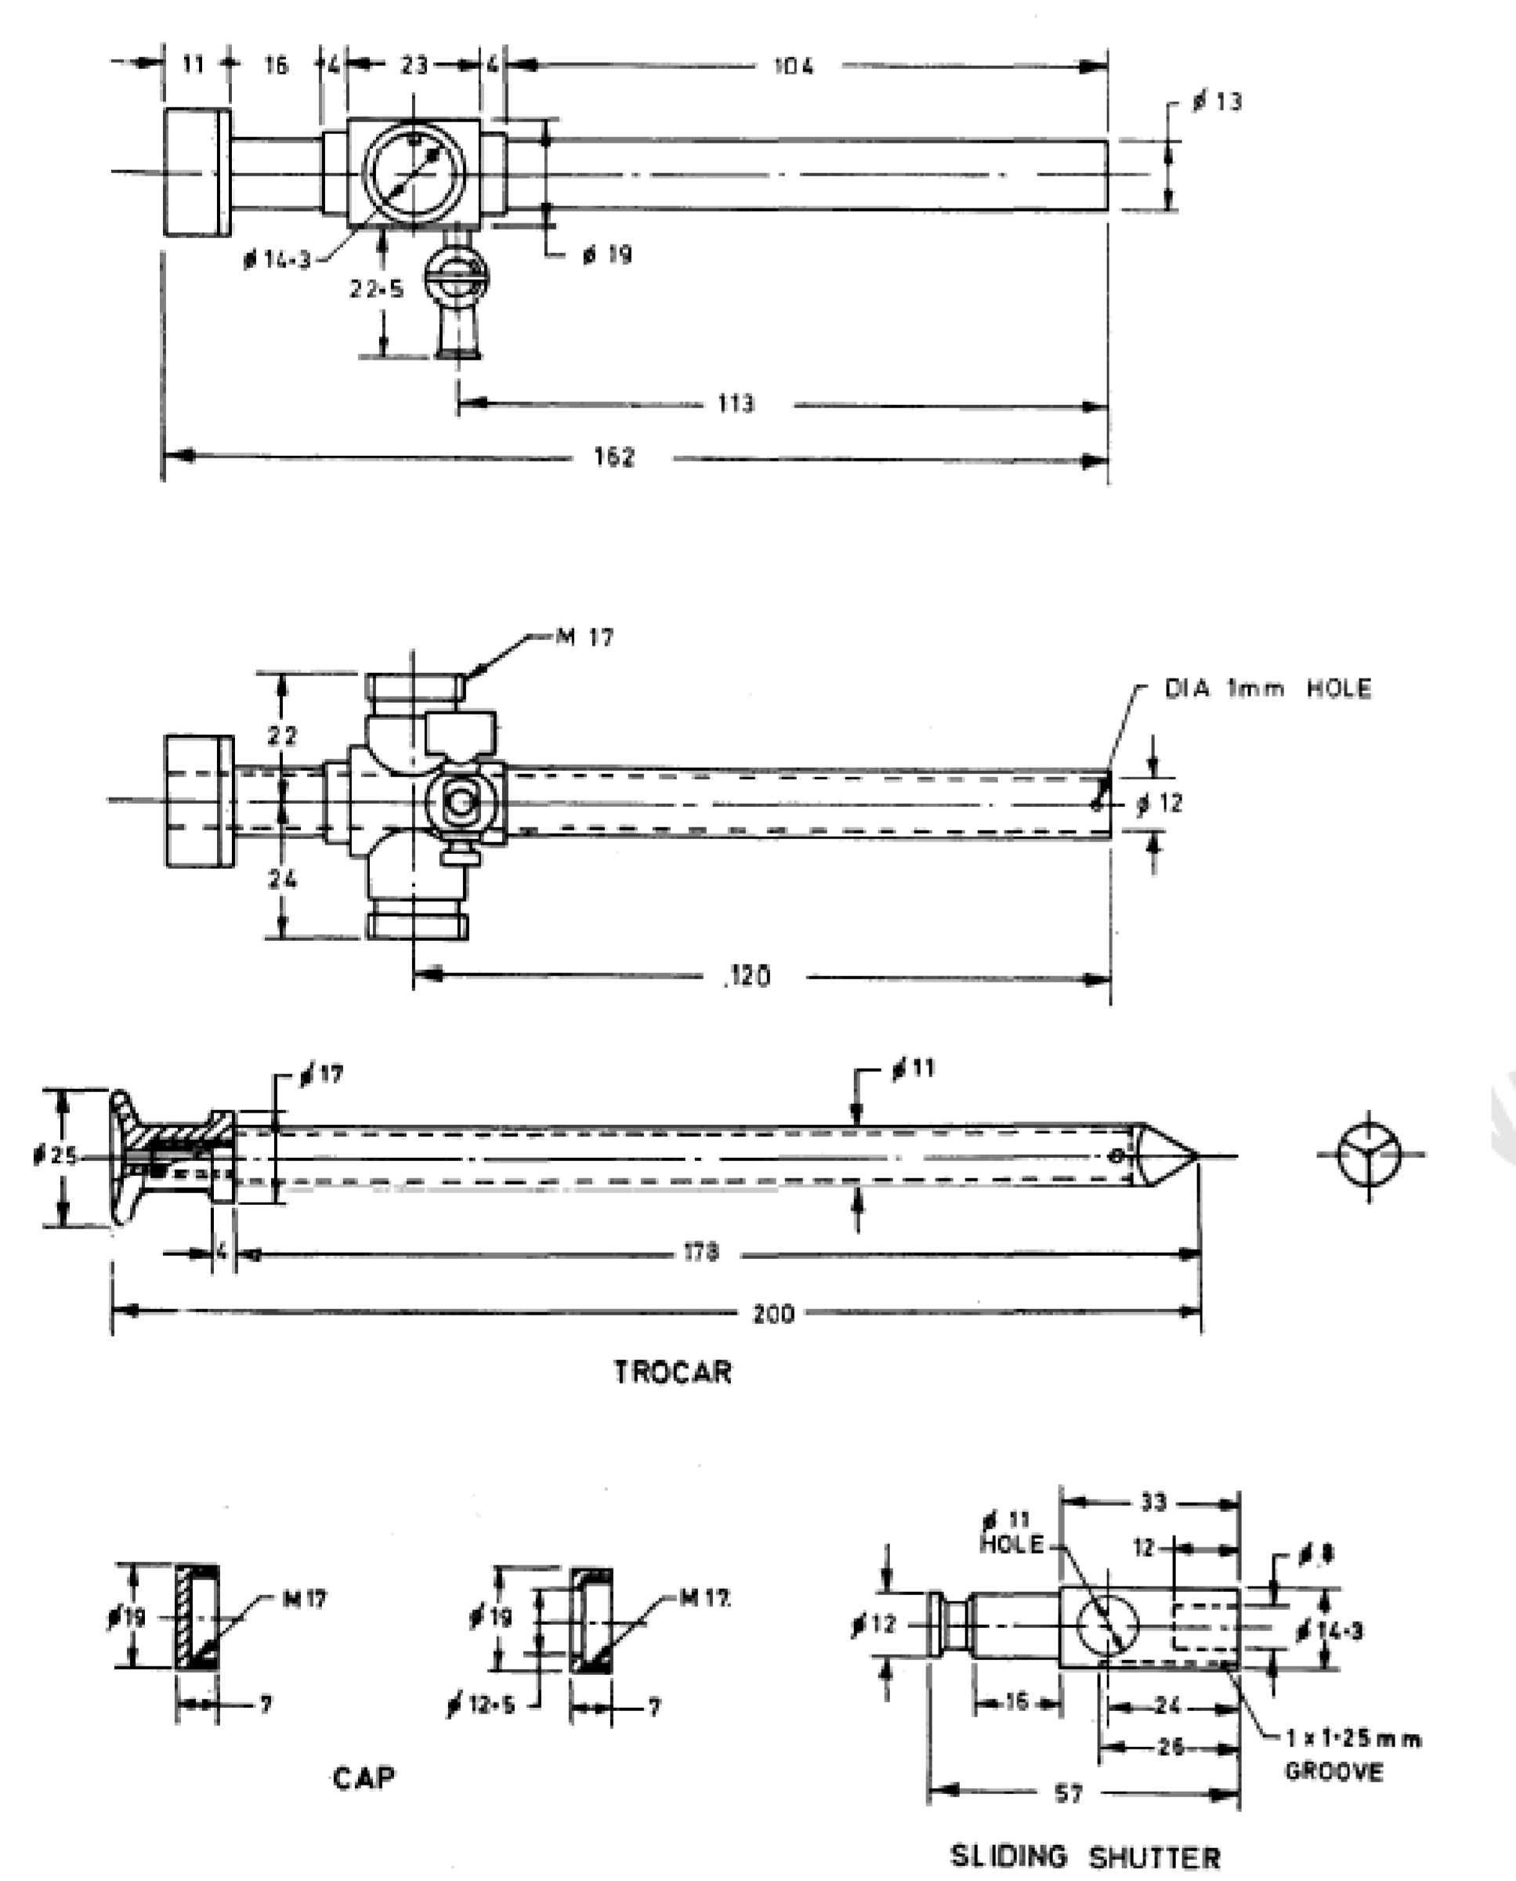

All dimensions in millimetres.

Fig. 2 Detailed Dimensions of Laproscopic Trocar and Cannula, Trocar Size 11 mm

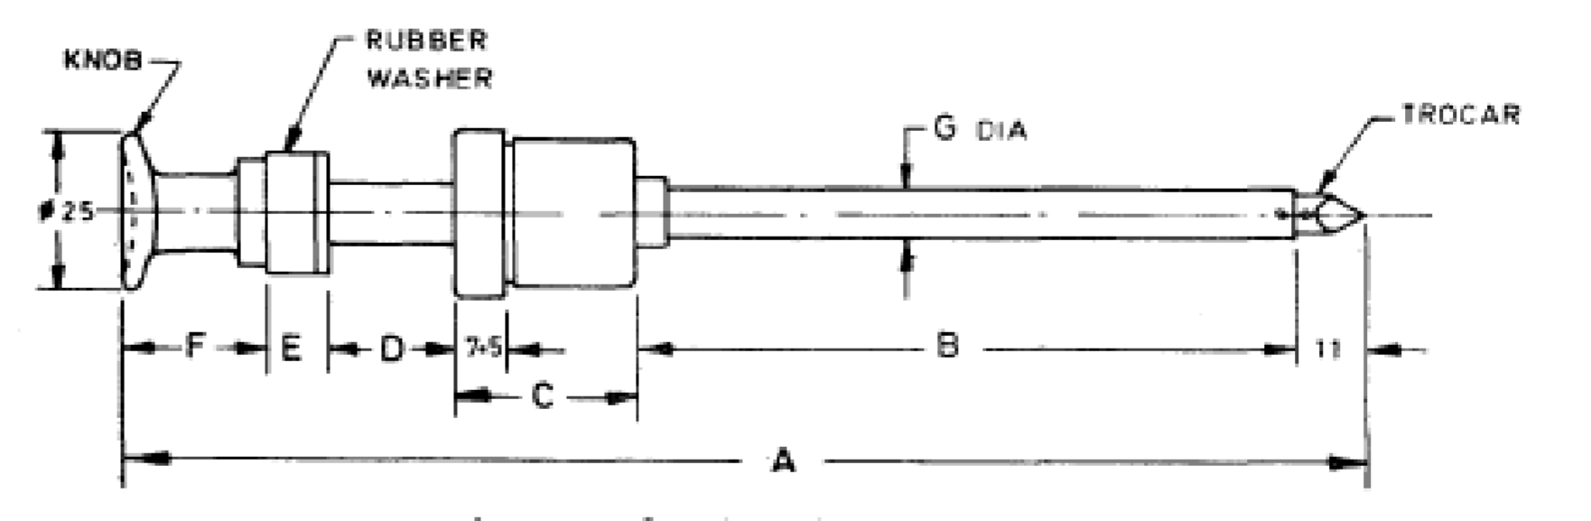

|  |  |  |  |  |  |  |
| --- | --- | --- | --- | --- | --- | --- |
| *A* | *B* | *C* | *D* | *E* | *F* | *G, Dia* |
| 188 | 100 | 27 | 19 | 10 | 21 | 7.5 |
| 124 | 65 | 17 | 12 | 6 | 14 | 5.9 |

All dimensions in millimetres

Fig. 3 Laproscopic Trocar and Cannula, Trocar Size 6.6 mm and 5 mm

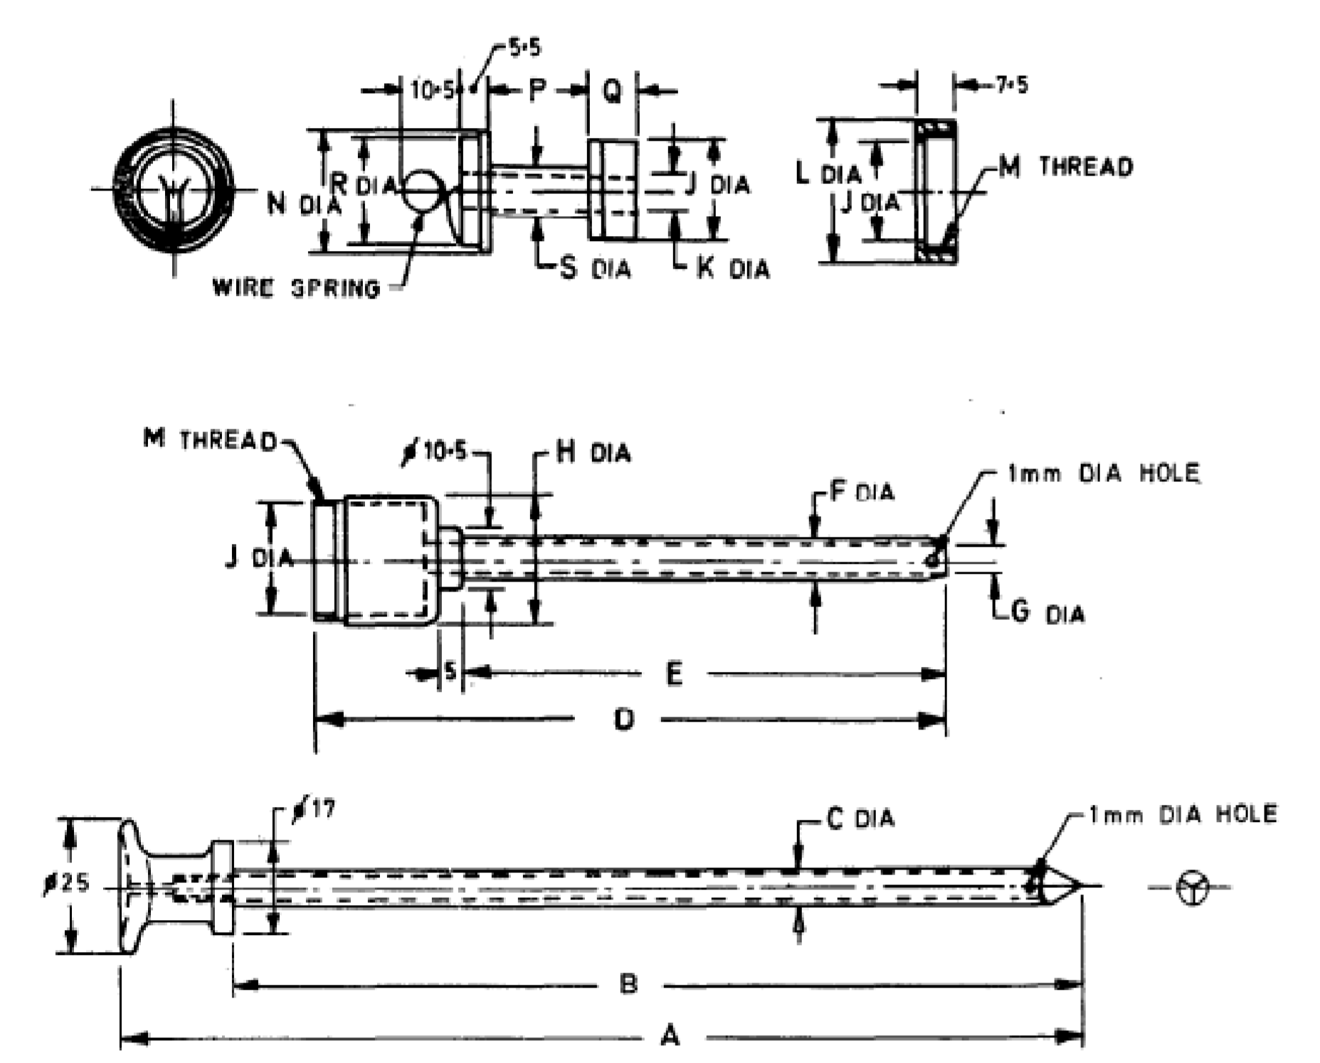

|  |  |  |  |  |  |  |  |  |  |  |  |  |  |  |  |  |  |
| --- | --- | --- | --- | --- | --- | --- | --- | --- | --- | --- | --- | --- | --- | --- | --- | --- | --- |
| *Sl No.* | *A* | *B* | *C Dia* | *D* | *E* | *F Dia* | *G Dia* | *H Dia* | *J*  *Dia* | *K Dia* | *L Dia* | *M*  *Thread* | *N Dia* | *P* | *Q* | *R Dia* | *S Dia* |
|  |  |  |  |  |  |  |  |  |  |  |  |  |  |  |  |  |  |
|  | 188 | 167 | 6.6 | 124 | 95 | 7.5 | 7 | 24 | 19 | 7 | 26.5 | 23 | 23 | 19 | 9.5 | 21 | 9 |
|  | 124 | 110 | 5 | 79 | 61 | 5.9 | 5.4 | 15.6 | 12.3 | 5.4 | 17.2 | 15 | 15 | 12.3 | 6 | 13.5 | 6 |

All dimensions in millimetres.

Fig. 4 Detailed Dimensions of Laproscopic Trocar and Cannula, Trqcar Size 6.6 mm And 5 mm

**4.2** Tolerances on dimensions shall be permitted as given below:

1. ± 0.1 mm on dimensions up to 10.0 mm;
2. ± 0.5 mm on dimensions above 10.0 mm and up to 25.0 mm;
3. ± 1.0 mm on dimensions above 25.0 mm and up to 50.0 mm;
4. ± 1.5 mm on dimensions above 50.0 mm and up to 100.0 mm; and
5. ± 2.0 mm on dimensions above 100.0 mm.

**5 REQUIREMENTS**

**5.1** The trocar and cannula shall be free from pits, burrs, cracks, scales and other surface defects.

**5.2** All edges shall be smoothly rounded off except the tip of the trocar which shall be triangular and sharp.

**5.3** The sliding shutter shall work smoothly and shall block the passage of the trocar tube after trocar rod is taken out and the stud is released.

**5.4** The brass parts shall be plated chromium over nickel conforming to service Grade No. 2 of IS 1068*.*

**5.5** The hub shall be of luer lock type and the opening and closing mechanism shall work smoothly and effectively.

**5.6** The working end of the trocar shall be hardened and tempered to give a hardness of 400 HV to 460 HV.

**6 TESTS**

**Corrosion Resistance Test**

The trocar and cannula after the removal of rubber, bakelite and brass components shall satisfy the boiling and autoclaving test as specified in IS 7531.

**7 MARKING**

**7.1** The product shall be legibly and indelibly marked with the following:

1. Manufacturer's name, initials or registered trade-mark;
2. Country of manufacture; and
3. The words ‘Stainless Steel’ or the letters ‘SS’

.

**7.2 BIS Certification Marking**

The product(s) conforming to the requirements of this standard may be certified as per the conformity assessment schemes under the provisions of the *Bureau of Indian Standards Act*, 2016 and the Rules and Regulations framed there under, and the products may be marked with the Standard Mark.

**8 PACKING**

**8.1** Each trocar and cannula shall be wrapped in moisture-proof paper or packed in polyethylene bags. The trocar and cannula shall then be packed in individual cartons and shall be provided with general instructions for maintenance and handling of the instrument.

**8.2** The trocar and cannula may also be packed as agreed to between the purchaser and the supplier.

**ANNEX A**

(*Foreword*)

**COMMITTEE COMPOSITION**

Obstetric and Gynaecological Instruments and Appliances Sectional Committee, MHD 03



| *Organization* |  | *Representative(s)* |
| --- | --- | --- |
| In Personal Capacity, Gurugram |  | Dr Suneeta Mittal **(*Chairperson*)** |
| Association Of Indian Medical Device Industry, New Delhi |  | Shri Pradeep Narkhede |
|  | SHRI ANKUR BHARGAVA (*Alternate* I) |
|  | Dr C. S. Prasad (*Alternate* II) |
| Central Drugs Standard Control Organization, New Delhi |  | Shri Aseem Sahu |
|  | Ms Shyamni Sasidharan (*Alternate* I) |
|  | Shri Aniruddh Negi (*Alternate* II) |
| Central Drugs Testing Laboratory, Mumbai |  | Dr C. Hariharan  Ms Sukhada Ajay Navratne (*Alternate*) |
| Chemco Plastic Industries Private Limited, Mumbai |  | Dr Gaurav Saraogi |
|  | Ms Rupande Sampat (*Alternate*) |
| Corporate Channel India Private Limited, Mumbai |  | Shri Vinod Kumat |
|  | Shri Ramnick Dagaria (*Alternate*) |
| HLL Lifecare Limited, Thiruvananthapuram |  | Ms SMITHA L. G. |
|  | Shri R. Mukund (*Alternate* I) |
|  | Shri Manikandan S. A. (*Alternate* Ii) |
| Indian Institute of Technology, Kanpur |  | Dr S. K. Guha |
| Indus Medicare Limited, Hyderabad |  | Shri P. J. Reddy |
|  | Dr Biswaranjan Mohanthy (*Alternate*) |
| Johnson And Johnson Private Limited, Mumbai |  | Shri Hemant Sonawane |
|  | Shri Bhuwandeep Singhla (*Alternate*) |
| Kalam Institute of Health Technology, Vishakhapatnam |  | Dr Arjun Thimmaiah |
|  | Shri Satyan Sharma (*Alternate* I) |
|  | Shri Mohan Ragul (*Alternate* II) |
| MHL Healthcare Limited, Muzaffarnagar |  | Dr Puneet Manocha |
|  | Shri Sudhansu Mishra (*Alternate*) |
| Office Of Development Commissioner (MSME), New Delhi |  | Dr Suvankar Santra |
| Pregna International Limited, Pune |  | Shri Ajit Raje |
|  | Shri Ranjit Gaikwad (*Alternate*) |
| Rubber Research Institute of India, Rubber Board, Kottayam |  | Shri Siby Varghese |
|  | Shri Shera Mathew (*Alternate*) |
| SMB Corporation of India, Mumbai |  | Shri Girish R. Shah |
|  |  | Shri Anupam Rai (*Alternate*) |
| TTK Healthcare Limited, Chennai |  | Shri Brij Balaji Singh |
|  |  | Shri John Selwyn Daniel (*Alternate*) |
| Vardhman Mahavir Medical College and Safdarjung Hospital, New Delhi |  | Dr Bindu Bajaj |
|  | Dr Jyotsna Suri (*Alternate*) |
| In Personal Capacity (*K-402, The Atrium, 22, Kalakshetra Road, Thiruvanmiyur – 600041*) |  | DR K. SIVAKUMAR |
| In Personal Capacity (*301, Bldg No. 52, Seawood estates, NRI complex, Sector 54/56/58, Nerul - 400706)* |  | Dr Amit Sen Gupta |
| In Personal Capacity (*E 219, GK-2, New Delhi 110048*) |  | Dr Malabika Roy |
| BIS Directorate General |  | Shri Chinmay Dwivedi, Scientist ‘E’/Director and Head (Medical Equipment and Hospital Planning) [Representative Director General (*Ex-officio*)] |

*Member Secretary*

Ms Gurpreet Kaur

Scientist ‘C’/Deputy Director

(Medical Equipment and Hospital Planning), BIS