***भारतीय मानक***

***Indian Standard***

**IS 6111 : 2024**

**सक्शन प्रकार का गर्भाशय क्यूरेट — विशिष्टि**

*( पहला* पुनरीक्षण )

**Suction Type Uterine Curette — Specification**

( First *Revision )*

ICS 11.040.30

© BIS 2024

भारतीय मानक ब्यूरो

BUREAU OF INDIAN STANDARDS

मानक भवन, 9 बहादुर शाह ज़फर मार्ग, नई दिल्ली - 110002

MANAK BHAVAN, 9 BAHADUR SHAH ZAFAR MARG

NEW DELHI - 110002

[www.bis.gov.in](http://www.bis.org.in) [www.standardsbis.in](http://www.standardsbis.in)

**December 2024 Price Group X**

Obstetric and Gynaecological Instruments and Appliances Sectional Committee, MHD 03

FOREWORD

This Indian Standard (First Revision) was adopted by the Bureau of Indian Standards, after the draft finalized by the Obstetric and Gynaecological Instruments and Appliances Sectional Committee had been approved by the Medical Equipment and Hospital Planning Division Council.

This standard was first published in 1971. This revision of the standard has been brought out to align the standard with the latest style and format of Indian Standards. This revision incorporates Amendment no. 1 issued in 1980.

The composition of the Committee responsible for the formulation of this standard is given in Annex A.

For the purpose of deciding whether a particular requirement of this standard is complied with the final value, observed or calculated, expressing the result of a test or analysis shall be rounded off in accordance with IS 2 : 2022 ‘Rules for rounding off numerical values (s*econd revision*)’. The number of significant places retained in the rounded off value should be same as that of the specified value in this standard.

*Indian Standard*

SUCTION TYPE UTERINE CURETTE — SPECIFICATION

( *First Revision )*

**1 SCOPE**

This standard covers the requirement of two sizes of blunt uterine curette (suction type).

**2 REFERENCES**

The standards given below contain provisions which, through reference in this text, constitute provisions of this standard. At the time of publication, the editions indicated were valid. All standards are subject to revision, and parties to agreements based on this standard are encouraged to investigate the possibility of applying the most recent edition of these standards:

|  |  |
| --- | --- |
| *IS No.* | *Title* |
| IS 1570 (Part 5) : 1985 | Schedules for wrought steels: Part 5 Stainless and heat-resisting steels (*second revision*) |
| IS 1068 : 1993 | Electroplated coatings of nickel plus chromium and copper plus nickel plus chromium — Specification (*third revision*) |
| IS 7531 : 1990 | Surgical instruments — Corrosion resistance of stainless-steel surgical instruments — Methods of tests (*first revision*) |

**3 MATERIAL**

The material shall be stainless steel conforming to designation X22Cr13 or X30Cr13 as per IS1570 (Part 5) or brass (with minimum of 60 percent copper).

**4 SHAPE AND DIMENSIONS**

The shape & dimensions shall be as shown in Fig. 1.

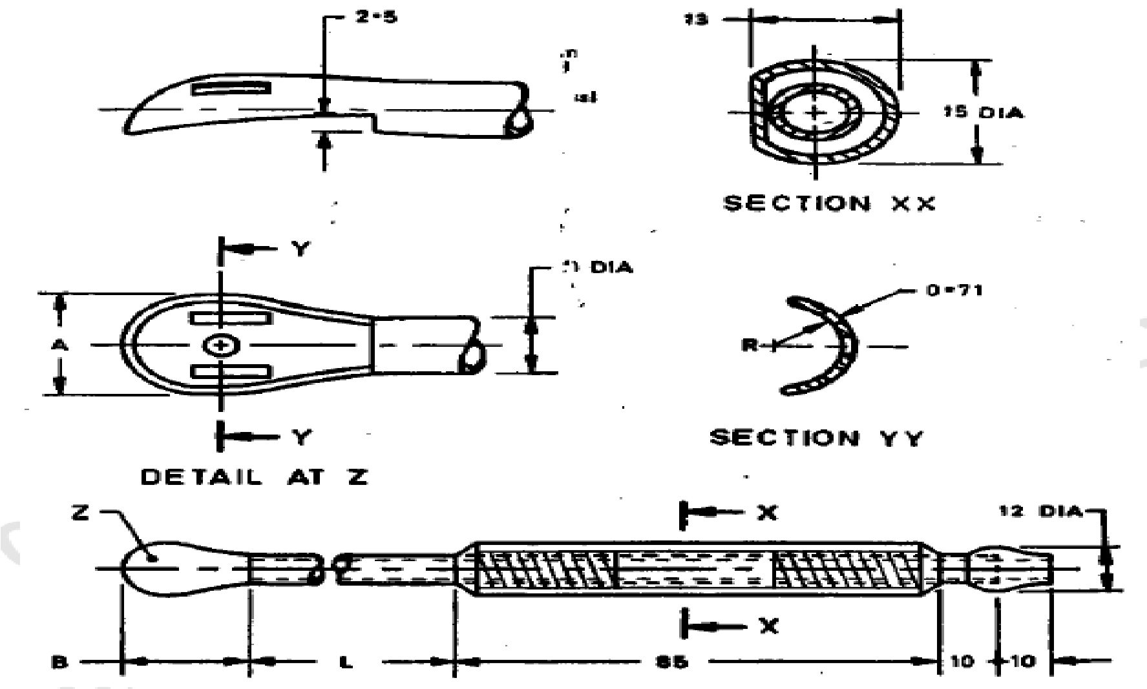

|  |  |  |  |  |  |  |
| --- | --- | --- | --- | --- | --- | --- |
| *Sl No.* | *Size* | *L* | *A* | *B* | *R* | *D DIA* |
|  |  |  |  |  |  |  |
|  | A | 150 | 14.0 | 22 | 14.0 | 8.0 |
|  | B | 130 | 8.0 | 17 | 8.0 | 5.0 |

All dimensions in millimetres.

Fig. 1 Curette, Uterine (Suction Type)

**5 WORKMANSHIP AND FINISH**

**5.1** The surface of the curette shall be free from pits, dents, burrs, scales, end other defects.

**5.2** All edges shall be smooth and rounded off.

**5.3** The fenestration on the spoon shall be neatly cut.

**5.4** The working edge of the spoon shall be blunt.

**5.5** The brazing and soldering shall be neat and joints shall be finished smooth.

**5.6** The edges of the flat surface of the handle shall not be sharp. The flat surface shall have suitable serrations to provide a good grip.

**5.7** The curette made of brass shall be plated chromium over nickel conforming to service condition no. 2 of IS 1068.

**5.8** If made of stainless steel, the curette shall be passivated and polished bright.

**6 HEAT TREATEMENT**

The instrument, if made of stainless steel, shall be hardened and tempered to 380 HV to 420 HV.

**7 TESTS**

**7.1** Clamp the curette in a vice at the middle of the shaft to long axis. Apply a force of 40 N gradually from the working end at a distance of 15 mm from the tip. On completion of the test, the curette shall show no sign of damage.

**7.2 Corrosion Resistance Test**

Test the sample in accordance with IS 7531. The sample shall show no sign of corrosion after the test.

**8 MARKING**

**8.1** The product shall be legibly and indelibly marked with the following:

1. Manufacturer's name, initials or registered trade-mark;
2. Country of manufacture; and
3. The words ‘Stainless Steel’ or the letters ‘SS’.

**8.2 BIS Certification Marking**

The product(s) conforming to the requirements of this standard may be certified as per the conformity assessment schemes under the provisions of the *Bureau of Indian Standards Act*,2016 and the Rules and Regulations framed there under, and the product(s) may be marked with the Standard Mark.

**9 PACKING**

The curette shall be wrapped in moisture-proof paper or packed in polyethylene bags avoiding contact with one another.

**ANNEX A**

(*Foreword*)

**COMMITTEE COMPOSITION**

Obstetric and Gynaecological Instruments and Appliances Sectional Committee, MHD 03

| *Organization* |  | *Representative(s)* | |
| --- | --- | --- | --- |
| In Personal Capacity, Gurugram |  | Dr Suneeta Mittal **(*Chairperson*)** | |
| Association Of Indian Medical Device Industry, New Delhi |  | Shri Pradeep Narkhede | |
|  | Shri Ankur Bhargava (*Alternate* I) | |
|  | Dr C. S. Prasad (*Alternate* II) | |
| Central Drugs Standard Control Organization, New Delhi |  | Shri Aseem Sahu | |
|  | Ms Shyamni Sasidharan (*Alternate* I) | |
|  | Shri Aniruddh Negi (*Alternate* II) | |
| Central Drugs Testing Laboratory, Mumbai |  | Dr C. Hariharan  Ms Sukhada Ajay Navratne (*Alternate*) | |
| Chemco Plastic Industries Private Limited, Mumbai |  | Dr Gaurav Saraogi | |
|  | Ms Rupande Sampat (*Alternate*) | |
| Corporate Channel India Private Limited, Mumbai |  | Shri Vinod Kumat | |
|  | Shri Ramnick Dagaria (*Alternate*) | |
| HLL Lifecare Limited, Thiruvananthapuram |  | Ms Smitha L. G. | |
|  | Shri R. Mukund (*Alternate* I) | |
|  | Shri Manikandan S. A. (*Alternate* II) | |
| Indian Institute of Technology, Kanpur |  | Dr S. K. Guha | |
| Indus Medicare Limited, Hyderabad |  | Shri P. J. Reddy | |
|  | Dr Biswaranjan Mohanthy (*Alternate*) | |
| Johnson And Johnson Private Limited, Mumbai |  | Shri Hemant Sonawane | |
|  | Shri Bhuwandeep Singhla (*Alternate*) | |
| Kalam Institute of Health Technology, Vishakhapatnam |  | Dr Arjun Thimmaiah | |
|  | Shri Satyan Sharma (*Alternate* I) | |
|  | Shri Mohan Ragul (*Alternate* II) | |
| MHL Healthcare Limited, Muzaffarnagar |  | Dr Puneet Manocha | |
|  | Shri Sudhansu Mishra (*Alternate*) | |
| Office Of Development Commissioner (MSME), New Delhi |  | Dr Suvankar Santra | |
| Pregna International Limited, Pune |  | Shri Ajit Raje | |
|  | Shri Ranjit Gaikwad (*Alternate*) | |
| Rubber Research Institute of India, Rubber Board, Kottayam |  | Shri Siby Varghese | |
|  | Shri Shera Mathew (*Alternate*) | |
| SMB Corporation of India, Mumbai |  | Shri Girish R. Shah | |
|  |  | Shri Anupam Rai (*Alternate*) | |
| TTK Healthcare Limited, Chennai |  | Shri Brij Balaji Singh | |
|  |  | Shri John Selwyn Daniel (*Alternate*) | |
| Vardhman Mahavir Medical College and Safdarjung Hospital, New Delhi |  | Dr Bindu Bajaj | |
|  | Dr Jyotsna Suri (*Alternate*) | |
| In Personal Capacity (*K-402, The Atrium, 22, Kalakshetra Road, Thiruvanmiyur – 600041*) |  | Dr K. Sivakumar | |
| In Personal Capacity (*301, Bldg No. 52, Seawood estates, NRI complex, Sector 54/56/58, Nerul - 400706)* |  | Dr Amit Sen Gupta | |
| In Personal Capacity (*E 219, GK-2, New Delhi 110048*) |  | Dr Malabika Roy | |
| BIS Directorate General |  | Shri Chinmay Dwivedi, Scientist ‘E’ and Head (Medical Equipment and Hospital Planning) [Representative Director General (*Ex-officio*)] | |

*Member Secretary*

Ms Gurpreet Kaur

Scientist ‘C’/Deputy Director

(Medical Equipment and Hospital Planning), BIS