***भारतीय मानक***

***Indian Standard***

**IS 12213 : 2024**

**यांत्रिक कंपन स्क्रीन — रीति संहिता**

*(* पहला पुनरीक्षण )

**Mechanical Vibrating Screens — Code of Practice**

( *First Revision )*

ICS 17.160

© BIS 2024

भारतीय मानक ब्यूरो

BUREAU OF INDIAN STANDARDS

मानक भवन, 9 बहादुर शाह ज़फर मार्ग, नई दिल्ली - 110002

MANAK BHAVAN, 9 BAHADUR SHAH ZAFAR MARG

NEW DELHI - 110002

[www.bis.gov.in](http://www.bis.org.in) [www.standardsbis.in](http://www.standardsbis.in)

**November 2024 Price Group X**

Chemical Engineering Plants and Related Equipment Sectional Committee, MED 17

FOREWORD

This Indian Standard (First Revision) was adopted by the Bureau of Indian Standards, after the draft finalized by the Chemical Engineering Plants and Related Equipment Sectional Committee had been approved by the Mechanical Engineering Divisional Council.

Mechanical vibrating screens are generally used for screening the material of various grain sizes. This standard covers the nomenclature, classification, details of construction, recommended material of construction and safety requirements for mechanical vibrating screens for use in non-hazardous areas.

This standard was first published in 1987. The present revision has been taken up with a view incorporating the modification found necessary as a result of experience gained in the use of this standard. Also, in this revision, the standard has been brought into the latest style and format of Indian Standards, and references to Indian Standards, wherever applicable have been updated.

The composition of the Committee responsible for the formulation of this standard is given in Annex C.

For the purpose of deciding whether a particular requirement of this standard is complied with, the final value, observed or calculated, expressing the result of a test or analysis, shall be rounded off in accordance with   
IS 2 : 2022 ‘Rules for rounding off numerical values (*second revision*)’. The number of significant places retained in the rounded-off value should be the same as that of the specified value in this standard.

*Indian Standard*

MECHANICAL VIBRATING SCREENS — CODE OF PRACTICE

*( First Revision )*

**1 SCOPE**

**1.1** This standard covers the mechanical vibrating screens used for screening the material of various grain sizes.

**1.2** The standard screen sizes shall be in accordance with IS 2405.

**2 REFERENCES**

The standards listed in Annex A contain provisions which, through reference in this text, constitute provisions of this standard. At the time of publication, the editions indicated were valid. All standards are subject to revision, and parties to agreements based on this standard are encouraged to investigate the possibility of applying the most recent edition of these standards.

**3 NOMENCLATURE**

For the purpose of this standard, the various components of mechanical vibrating screens shall be designated as in Fig. 1 and Fig. 2.

**4 CLASSIFICATION**

**4.1 Application of Machine**

A machine for screening, grading, dewaterizing, or scalping the material of various sizes. Vibrating screen may be with dust cover for air pollution control environment.

**4.2 Types of Vibration**

**4.2.1** *Circular Motion Vibration*

Eccentric mass and/or eccentric shaft gives centrifugal force for vibration of basket/live frame. Concentric shaft with eccentric weights may also be used.

**4.2.2** *Straight Line Motion Vibration*

Eccentric masses are set on two rotating shafts rotating in counter direction to give straight line vibration to the basket/live frame.

**4.2.3** *Gyratory Motion Vibration*

Eccentric mass attached to vertical shaft gives centrifugal force for horizontal vibratory motion of basket/live frame. This type of motion is considered in special cases.

**4.3 Type of Enclosure**

**4.3.1** *Vibrating Screen with Dust Cover*

The vibrating screens are provided with dust cover, in case dust containment or extraction is envisaged. Vent hood may be provided to connect with dust collection system.

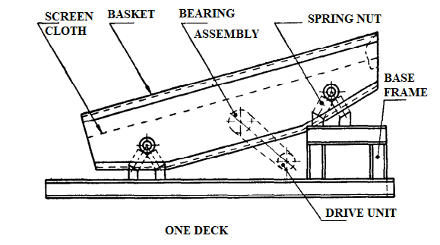

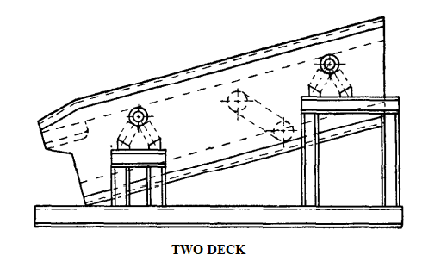

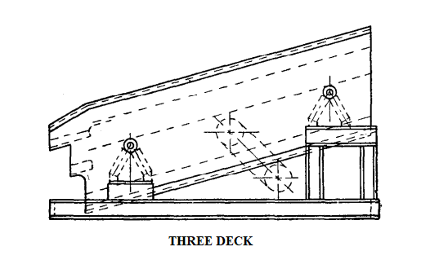

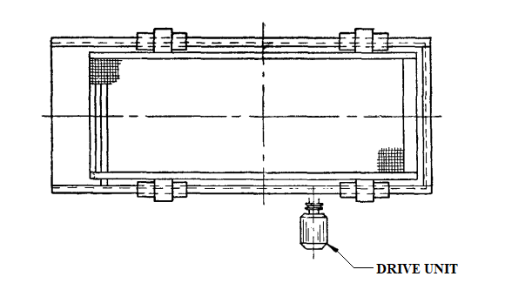

Fig. 1 Vibration Screen without Dust Cover and Chute

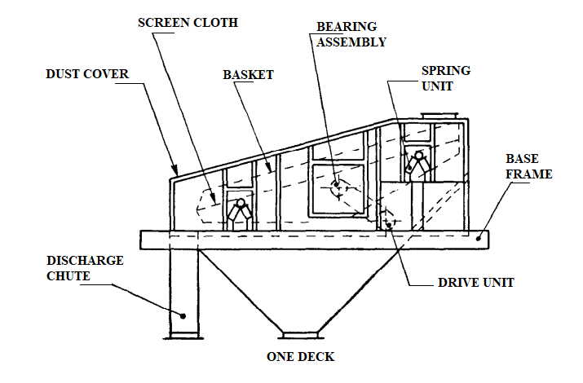

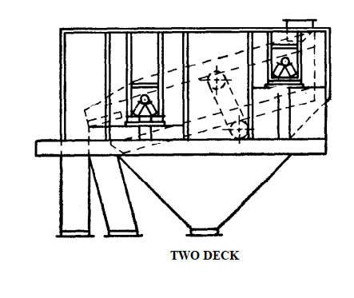

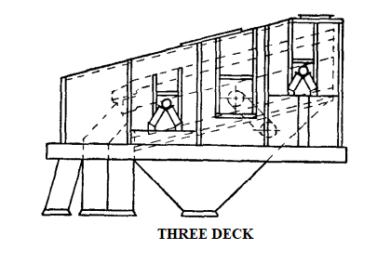

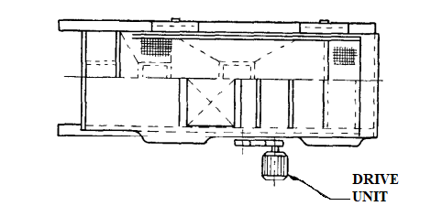

Fig. 2 Vibration Screen with Dust Cover and Discharge Chute

**4.3.2** *Vibrating Screen without Dust Cover*

These vibrating screens are without dust cover. The screen is fitted with open basket/live frame where dust generation is not envisaged.

**4.4 Number of Decks**

**4.4.1** *Single Deck*

The screens are provided with one deck vibrating basket/live frame.

**4.4.2** *Double Deck*

The screens are provided with two decks.

**4.4.3** *Triple Deck*

The screens are provided with three decks.

**4.4.4** *Four Deck*

The screens are provided with four decks.

**4.5** **Type of Cloth Fixing**

**4.5.1** *Longitudinal Tensioning Arrangement*

Where cloth is fitted with vibrating screen, fixing, and tensioning is done at the end of the screen.

**4.5.2** *Side Tensioning Arrangement*

Screens are provided with cross tensioning arrangement. Fixing and tensioning is done from the side of screen basket/live frame.

**4.6 Type of Screening**

**4.6.1** *Vibrating Screen*

The screens are used for gradation of sizing purpose. The openings of deck are fine, medium, and large.

**4.6.2** *Grizzly Scalper*

The screens have comparatively large opening. The screens are used where percentage of undersize particles are less.

**4.6.2.1** *Vibrating type*

This screen is similar to vibrating screens.

**4.6.2.2** *Roller grizzle*

Material rolls over the rollers which are rotated along its axis.

**4.7 Basket Mounting**

**4.7.1** *V-Spring*

The screens are supported on base frame.

**4.7.2** *Vertical Spring*

The screens are supported on base frame.

**4.7.3** *Vertical Spring*

The screens are suspended from top support.

**4.8 Screen Inclination**

**4.8.1** *Horizontal Type*

Screen almost horizontal with downslope 0º to 5º.

**4.8.2** *Inclined Type*

Screen downslope is decided, based on screening capacity and material characteristics and is normally between 15º to 25º from horizontal.

**5 PRINCIPLE OF OPERATION**

The vibrations are given to basket/live frame by unbalanced masses. The vibration may be of either circular motion or straight motion. Material is fed from feed end on vibrating basket/live frame. Undersize material flows down the deck and oversize material flows ahead on separate zone. The zone may be divided in different chutes connected down below.

**6 CONSTRUCTION**

**6.1** Vibrating screens/grizzly shall consist mainly of:

1. Vibrating basket/live frame;
2. Vibrating unit;
3. Screen cloth, or perforated plate/grizzly bars;
4. Supporting frame or dust cover; and
5. Drive unit.

**6.2 Vibrating Basket/Live Frame**

Vibrating basket/Live frame shall be of bolted or welded construction. It shall consist of two side plates and cross members. Cross members shall either be of standard rolled section or frame section with adequate strength.

**6.3 Vibrator Unit**

**6.3.1** *Circular Motion Vibration*

The vibrator unit shall consist of concentric/eccentric shaft mounting in spherical/cylindrical roller bearing. The bearing shall be of vibration duty with special clearance. Unbalanced masses are provided at either end of bearings. Adjustment arrangement for unbalanced masses shall be provided. Bearing unit shall be properly lubricated by grease/oil. Circular motion vibration shall normally be applied to inclined screen.

**6.3.2** *Straight Line Motion Vibration*

The vibrator unit shall consist of two shafts with unbalanced masses rotating in opposite directions and mounted so that the line of action between them passes through the centre of gravity of screen assembly resulting in near straight line or little elliptical motion at an angle of approximately 45° with screen surface in the direction of material flow. Vibrating duty bearing shall be used. Bearing unit shall be properly lubricated, either by oil or grease. Unbalanced mass direction shall be adjusted to give required angle of throw in straight line direction. Straight line motion vibration shall normally be applied to horizontal screen.

**6.4 Bearing Arrangement**

The circular motion screens may have the following bearing arrangement.

**6.4.1** *Two Bearing System*

The vibrator unit shall consist of an eccentric shaft mounted on two bearings each bearing being supported by one of the side plates.

**6.4.2** *Four Bearing System*

The vibrator unit shall consist of an eccentric shaft mounted on the outboard bearings attached to the stationary main frame in addition to the bearing arrangement as in case of two bearing system. The side plate bearings being eccentric to the outboard bearings, the eccentric shaft serves as both a crank arm and a counterbalance and produces positive action.

**6.5 Mounting of Vibrator Unit**

The vibrator unit shall be attached to the side plates through or near the centre of gravity of the screen to generate uniform vibration throughout the entire screen.

**6.6 Screen Cloth**

Screen cloth shall be fitted with edge binding plate in case of smaller opening and thin wire size.

Screen cloth shall be fitted with straight plates only in case of large opening and bigger wire size.

Cloth may be provided with middle fixing arrangement in case of bigger size cloth.

**6.7 Base Frame, Dust Cover and Feed Box (Optional)**

Sturdy base frame may be provided to support vibrating units. The natural frequency of base frame shall not be near or equal to the operating frequency of screen. This shall preferably be higher than the screen operating frequency. Dust cover may be provided with inspection and maintenance door for spare part replacement. Dust hood vent may be provided for connecting to the dust collection system. Hinge door may be provided for spring unit and unbalanced mass inspection. Width of dust cover may be selected such that proper clearance is available during vibrating motion. Necessary feed box may be provided in such a way that the material is fed to the screen across its entire width in the direction of flow.

**6.8** **Drive Unit**

V-belt drive shall normally be provided for all types of vibrating screen drive. However, drive motor with universal coupling may also be used for drive. Drive motor may be provided with pivoted motor/sliding base for proper tensioning as well as to take up V-belt stretch due to start/stop bounces.

**7 MATERIAL OF CONSTRUCTION**

**7.1 Shaft**

The material of the shaft shall be 45C8 of IS 1570 (Part 2/Sec 1) equivalent or as per designer’s recommendation depending upon duty condition.

**7.2 Bearing Housing**

The material of bearing housing shall be of cast iron conforming to IS 210 or cast steel conforming to IS 1030 or fabricated type as per designer’s recommendation.

**7.3 Side Plate**

The material of side plate shall be steel designated as St42S conforming to IS 2062 or flow alloy steel or boiler quality conforming to IS 200 or low alloy steel.

**7.4 Sheave**

The material of sheave shall be of cast iron conforming to IS 210 or fabricated as per designer’s recommendation.

**7.5 Screen Cloth**

Screen cloth material shall be 0.5 percent carbon steel or as per purchaser’s requirements depending upon duty condition.

**7.6 Hardware**

High tensile hardware shall be used for connecting the live frame and cross members.

**7.7 Dust Cover/Base Frame (Optional)**

The material of dust cover/base frame shall be steel designated as St42S conforming to IS 2062.

**8 GENERAL REQUIREMENTS**

**8.1 Safety Requirement**

The design of the screen shall minimize hazards to the operator. The pulleys, belts and unbalanced mass which are rotating at high speed shall be well protected with a guard. The screen shall be provided with dust covers for dust containment and/or dust extraction. The screen may be supplied with a screen base frame.

**8.2 Maintenance Accessibility**

The design of the vibrating screen shall provide accessibility to all component sub-assemblies and parts for maintenance and repairs.

**8.3 Lubrication**

Lubrication means shall be provided for the bearings. All lubricated nipples shall be located at approachable distances. The lubrications may be with grease arrangement or oil type. Lubrication shall be selected as per duty condition.

**8.4 Designation**

The designations of vibrating screens shall include the following:

1. Horizontal or inclined screens;
2. Grading or scalping or dewaterizing;
3. Width and length;
4. Number of decks provided;
5. Dust cover or base frame; and
6. Type of vibration.

**8.5 Supply**

The manufacturer shall supply certificate to the purchaser for main components. The supplier shall give the certificate of the test run items to be covered under this certificate as given in Annex B.

**ANNEX A**

(*Clause* 2)

**LIST OF REFERRED INDIAN STANDARDS**

|  |  |
| --- | --- |
| *IS No.* | *Title* |
| IS 200 : 1989 | Textiles — Determination of copper number of cotton textile materials (*second revision*) |
| IS 210 : 2009 | Grey iron castings — Specification (*fifth revision*) |
| IS 1030 : 1998 | Carbon steel castings for general engineering purposes — Specification (*fifth revision*) |
| IS 1570 (Part 2/Sec 1) : 1979 | Schedules for wrought steels: Part 2 Carbon steels (unalloyed steels), Section 1 Wrought products (other than wires) with specified chemical composition and related properties (*first revision*) |
| IS 2062 : 2011 | Hot rolled medium and high tensile structural steel — Specification (*seventh revision*) |
| IS 2405 | Industrial sieves — Specification: |
| (Part 1) | Wire cloth sieves (*second revision*) |
| (Part 2) | Wire sieves (*second revision*) |
| (Part 3) | Perforated plates sieves |

**ANNEX B**

(*Clause* 8.5)

**INFORMATION TO BE GIVEN IN THE CERTIFICATE BY THE MANUFACTURER  
TO THE PURCHASER AT THE TIME OF SUPPLYING THE MACHINE**

**B-l** The inspection report shall state that each part of the mechanical vibrating screen has been inspected before assembly to ensure that it is free-from visible defect in casting, machining, etc. The report shall include overall dimensions and specifications as per order.

**B-2 TEST RUN**

Test run report shall include the following:

1. Number of hours the equipment has been run continuously under no load after completion of assembly.
2. In the test run, the following points shall be observed:
3. Bearing temperature;
4. Amplitude of the vibrations;
5. If the construction of the machine is satisfactory; and
6. If the lubrication condition is satisfactory.

**ANNEX C**

(*Foreword*)

**COMMITTEE COMPOSITION**

Chemical Engineering Plants and Related Equipment Sectional Committee, MED 17

| *Organization* | *Representative*(s) |
| --- | --- |
| CSIR - Indian Institute of Petroleum, Dehradun | Dr Mritunjay Kumar Shukla **(*Chairperson*)** |
| Auma India Private Limited, Bengaluru | Shri Yashwant M. Jannu |
| Bharat Heavy Electrical Limited, New Delhi | Shri Y. Srinivasa Rao  Shri Abhishek Kumar Pandey (*Alternate* I)  Shri Rajesh Ranjan (*Alternate* II)  Shri Subhashish Gupta (*Alternate* III) |
| [Bharat Petroleum Corporation Limited Corporate Research & Development Centre, Greater Noida](javascript:;) | Ms Isha Khullar  Shri Vinod Kumar (*Alternate*) |
| Blast Carboblocks Private Limited, Mumbai | Shri Dhawal Saxena |
| Chemtrols Industries Private Limited, New Delhi | Shri P. Krishna Kumar |
| Confederation of Indian Industry, New Delhi | Shri Nandakumar Kalath  Shri Abhilash Uttam (*Alternate)* |
| Directorate General Factory Advice Service and Labour Institutes, Mumbai | Shri Tanoj Chandan  Shri Kunal Sharma (*Alternate*) |
| Engineers India Limited, Gurugram | Shri Hasmukh K. Parmar  Shri Mragang Sheakhar (*Alternate*) |
| Fab-Tech Works And Constructions Private Limited, Mumbai | Shri Aashish Jayprakash Lakhani  Shri Pradeep Gawate (*Alternate*) |
| GMM Pfaudler Limited, Anand | Shri Dhiren Panchal  Shri Satvik Patel (*Alternate*) |
| Kejriwal Casting Limited, Kolkata | Shri Sandeep Kejriwal  Shri Sabarna Roy (*Alternate*) |
| L&T Valves, Chennai | Shri Rohit Sharma  Shri Suriyanarayanan (*Alternate*) |
| MECON Limited, Ranchi | Shri Yogendra Kumar Singh  Shri Arvind Bhushan (*Alternate*) |
| [Nuclear Power Corporation of India Limited, Mumbai](javascript:;) | Shri Chandrakant Rajaram Kakade  Shri Arunava Sinha (*Alternate*) |
| Project and Development India Limited, Noida | Shri Sanjiv Kumar Mishra  Shri Rajeev Ranjan Kumar (*Alternate*) |
| Tata Consulting Engineers Limited, Navi Mumbai | Shri Shivnarayan Pareek  Shri Shireesh S. Swami (*Alternate*) |
| BIS Directorate General | Shri K. Venkateswara Rao, Scientist ‘F’/Senior Director And Head (Mechanical Engineering) [Representing Director General (*Ex-officio*)] |

*Member Secretary*

Ms Neha Thakur

Scientist ‘C’/Deputy Director

(Mechanical Engineering), BIS