**IS 8421 : 2024**

***भारतीय मानक***

द्रवचालित ट्रेक — विशिष्टि

*( पहला पुनरीक्षण )*

*Indian Standard*

**Hydraulic Props — Specification**

*( First Revision )*

ICS73.100.01

 BIS 2024

भारतीय मानक ब्यूरो

**B U R E A U O F I N D I A N S T A N D A R D S**

मानक भवन, 9 बहादुर शाह ज़फर मार्ग, नई दिल्ली - 110002

MANAK BHAVAN, 9 BAHADUR SHAH ZAFAR MARG

NEW DELHI - 110002

www.bis.gov.in www.standardsbis.in

**August 2024 Price Group X**

Mining Techniques and Equipment Sectional Committee, MED 08

FOREWORD

This Indian Standard (First Revision) was adopted by the Bureau of Indian Standards after the draft finalized by the Mining Techniques and Equipment Sectional Committee had been approved by the Mechanical Engineering Divisional Council.

This standard was first published in 1977. The present revision has been brought out with a view to incorporate the modification found necessary as a result of experience gained in the use of this standard. Also, in this revision, the standard has been brought into the latest style and format of Indian Standards, and references to   
Indian Standards, wherever applicable have been updated. BIS certification marking clause has been modified to align with the revised *Bureau of Indian Standard Act*, 2016.

The composition of the Committee responsible for the formulation of this standard is given in Annex A.

For the purpose of deciding whether a particular requirement of this standard is complied with, the final value, observed or calculated, expressing the result of a. test or analysis, shall be rounded off in accordance with   
IS 2 : 2022 ‘Rules for rounding off numerical values (*second revision*)’. The number of significant places retained in the rounded-off value should be the same as that of the specified value in this standard.

*Indian Standard*

HYDRAULIC PROPS — SPECIFICATION

*( First Revision )*

**1 SCOPE**

This standard specifies the requirements for hydraulic props for use in mines.

**2 TERMINOLOGY**

For the purpose of this standard the following terminology shall apply (*see* Fig. 1).

**2.1 Extended Length (*L*1) —** The length measured from the bottom surface of the base plate to the sealing surface of the crown on the fully extended inner member.

**2.2 Closed Length (*L*2)** — The length measured from the bottom surface of the base plate to the seating surface of the crown on the fully collapsed inner member.

**2.3 Hydraulic Travel** — The difference between the extended length *L*1 and closed length *L*2.

**2.4 Extension** — The difference between any arbitrarily extended length and closed length *L*2,

**2.5 Yield** — The change in extension of hydraulic prop under load, measured in mm.

**2.6 Rate of Yield** — The yield per unit time, measured in mm/min.

**2.7 Nominal Yield Load** — The rated value of the maximum resistance which the hydraulic prop offers continuously in operating condition. It is also the load at which the hydraulic prop yields due to the operation of the relief valve.

**2.8 Yield Pressure** — The pressure of the hydraulic fluid inside the hydraulic prop corresponding to nominal yield load.

**2.9 Setting Load** — The load at which the hydraulic prop is initially set against a roof bar in underground mines or against a rigidly held frame or testing machine.

**2.10 Setting Pressure** — The pressure of the hydraulic fluid of the hydraulic prop corresponding to setting load.

**3 TYPES**

*Type A* — Hydraulic prop with closed hydraulic system; and

*Type B* — Hydraulic prop with external feed.

**4 DIMENSIONS**

It shall be as shown in Fig. 1.

**4.1** The values of extended length (*L*1) and corresponding closed length (*L*2), in millimeters, shall be as given below:

|  |  |  |  |  |  |  |  |  |  |  |  |  |  |  |  |  |  |  |
| --- | --- | --- | --- | --- | --- | --- | --- | --- | --- | --- | --- | --- | --- | --- | --- | --- | --- | --- |
| *L1*  *Min* | 610 | 710 | 840 | 940 | 1 065 | 1 195 | 1 290 | 1 400 | 1 525 | 1 650 | 1 745 | 1 880 | 2 030 | 2 160 | 2 390 | 2 600 | 2 800 | 3 000 |
| *L2, Max* | 485 | 560 | 650 | 710 | 810 | 890 | 970 | 1 045 | 1 145 | 1 220 | 1 245 | 1 320 | 1 450 | 1 680 | 1 680 | 1 850 | 2 050 | 2 200 |

**5 NOMINAL YIELD LOAD**

The nominal yield load of the hydraulic prop in kN shall be one of the following:

200 250 300 350 400

**6 DESIGNATION**

A hydraulic prop of Type A with a nominal yield load of 200 kN and 2 390 mm extended length shall be designated as:

Hydraulic prop A200 × 2 390 IS 8421

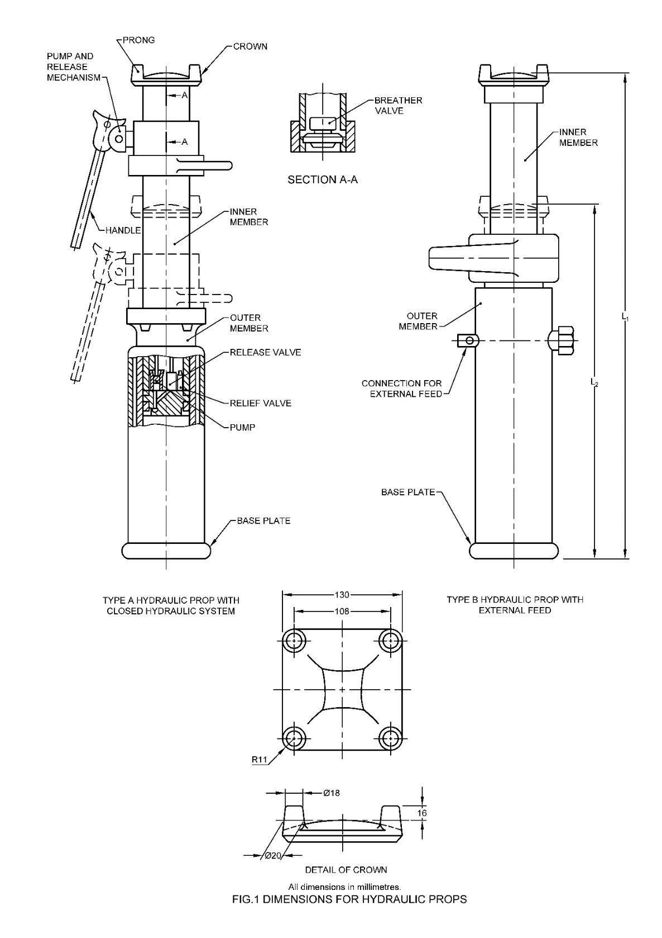

All dimensions in millimetres.

Fig. 1 Dimensions for Hydraulic Props

**7 GENERAL REQUIREMENTS**

**7.1** The design of the hydraulic props shall ensure that:

1. There are no external sharp corners or edges which may injure human body while handling the props;
2. Suitable handles are provided for convenience of handling;
3. The working chamber of the cylinder is protected against penetration of dust in it; and
4. The props can be used with various operating liquids depending on the application.

**7.2** The pressure of the base plate of the prop on the ground, corresponding to nominal yield load, shall not exceed 24.6 MPa. To reduce the pressure on the ground, suitable attachment with the base plate with larger contact area may be used.

**7.3** The parts of the hydraulic prop, liable to be exposed to the atmosphere, shall have suitable anticorrosive coating.

**7.4** The prop shall incorporate means enabling it to be preloaded, to yield under load and, as a part of the process of withdrawal, to be relieved of load.

**8 MARKING**

Hydraulic props shall be marked with the manufacturer’s name, registered trademark or both, serial number, nominal yield load and extended length of the prop.

**8.1 BIS Certification Marking**

The product(s) conforming to the requirements of this standard may be certified as per the conformity assessment schemes under the provisions of the *Bureau* *of Indian Standards Act*, 2016 and the Rules and Regulations framed thereunder, and the products may be marked with the Standard Mark.

**9 TEST**

**9.1 Type Tests**

At least two hydraulic props together with any accessory shall be subjected to tests laid down in **9.3** to **9.8**.

**9.2 Routine Tests**

**9.2.1** The number of props as given in col (2) of Table 1 shall be subjected to tests laid down in **9.3**, **9.4.1** and **9.6**.

|  |  |  |
| --- | --- | --- |
| **Table 1 Sample Size for Routine Tests** | | |
| **Lot Size** | **Sample Size**  **for 9.2.1** | **Sample Size**  **for 9.2.2** |
| (1) | (2) | (3) |
| 2 to 15 | 2 | 2 |
| 16 to 25 | 3 | 3 |
| 26 to 50 | 5 | 3 |
| 51 to 100 | 5 | 5 |
| 101 to 150 | 8 | 5 |
| 151 to 300 | 13 | 8 |
| 301 to 500 | 20 | 8 |
| 501 to 1 000 | 32 | 13 |
| 1 001 to 3 000 | 50 | 13 |
| 3 001 and above | 80 | 20 |

**9.2.2** The number of props as given in col (3) of the Table 1 shall be subjected to tests laid down in **9.4.2**, **9.5**, **9.7** and **9.8** also. For the purpose of these tests, the props shall be selected from the propsalready tested in accordance with **9.2.1.**

**9.2.3** The lot shall be considered conforming to this standard if all the props tested in accordance with **9.2.1** and **9.2.2** satisfy the corresponding requirements.

**9.3 Setting Load Test**

The prop shall be set vertically against the testing machine by different operators in the mannerlaid down by manufacturers. The average and maximum rates of setting load shall be determined. For props of Type A the number and length of strokes on the pump handleshall also be noted for a series of setting loads.

**9.4 Load Yield Test**

**9.4.1** *Axial Load Test*

The test shall be conducted at any point over the full available hydraulic travel with the crown in contact with a short length of roof bar securely fastened to the top crosshead of the machine.

A gradually increasing load shall be applied on the prop and the maximum and minimum loads  
at which the relief valve opens and closes shall be recorded. Autographic records of these loads  
shall be obtained when possible to as certain the characteristics of props, In case of spot readings,  
there number shall be sufficient to give a reasonable indication of the performance of the relief valve during the test.

**9.4.1.1** With a maximum rate of yield of 10 mm/min, the test shall be conducted for a minimum,  
yield of 100 mm or with 8 litre of fluid passing through the relief valve whichever is more. This  
test shall be repeatedly conducted till a total yield of 1 000 mm minimum is achieved.

**9.4.1.2** The effect of an impact on prop during yield shall be investigated:

1. By striking the prop towards its axis, and
2. Where possible, by giving a downward blow to the crown.

The effect of interruptions in yield shall also be noted.

**9.4.2** *Eccentric Load Test*

With test length as LI and the prop set with an eccentricity of 54 mm at the crown (the line of thrust shall pass through the centre of the base plate and a point 54 mm off. set from the centre of the crown), the load on the prop shall be gradually increased till the prop yields. This test shall normally be made over small lengths of yield.

**9.5 Release Test**

Ease and method of release shall be investigated over a range of working loads and the rate of closure noted while the release valve is held open. Particular note shall be taken as to whether release may be effected from a safe position.

**9.6 Static Leakage Tests**

These tests (*see***9.6.1** to **9.6.3**) shall be carried out after conducting an axial load test (*see* **9.4.1**).

**9.6.1** *Leakage in Unloaded Props*

Note shall be taken of any tendency for hydraulic fluid to leak from the prop. With the prop lying on the ground either in a horizontal or in an inclined position, it shall be noted if any hydraulic fluid leaks from the prop.

**9.6.2** *Leakage in Prop Loaded with Low Pressure*

The prop shall be set vertically in a rigid frame at various loads up to its maximum setting load. The rate of loss of load and the total loss of load shall be recorded over a period of 72hours.

**9.6.3** *Leakage in Prop Loaded with High Pressure*

The prop shall be set vertically in testing, machine and loaded gradually up to 90 percent of the nominal yield load. The prop shall be held at this, load for at least 10 minutes and fall in load if any shall be noted.

**9.7 Overload Test**

**9.7.1** *With Prop Extended*

With the test length as *L1*and relief valve blocked, the prop shall be set vertically in the testing machine. An axial load gradually increasing to one and a half times the nominal yield load shall be applied on the prop. The prop shall be held at this load for 5 minutes. Any damage to the prop or its components shall be recorded. The prop conforming to this test shall be subjected to axial load test (*see* **9.4.1**) again and change in characteristic of prop noted.

**9.7.2** *With Prop Closed*

With test length as *L2*the prop shall be set vertically in the testing machine and the load on the prop shall be gradually increased to twice the nominal yield load. The prop shall be held at this load for five minutes. Any damage or change of characteristics of the prop shall be noted as specified in **9.7.1**.

**9.8 Internal Examination of Prop**

After conducting the tests specified in **9.3** to **9.7** the prop shall be dismantled for the following observations:

1. Any damage to prop or its component;
2. Any dirt;
3. Any flaking of surface plating; and
4. Any erosion or pitting of valve member.

**9.9** This standard does not prevent any other tests in addition to those already described in **9.3**  
to **9.8**, to be carried out optionally by the testing authority of the institute or by the manufacturer. Additional tests may also be carried out to investigate any novel feature.

**10 MINIMUM PERFORMANCE REQUIREMENTS**

**10.1** A minimum setting load (*see* **9.3**) of 50 kN (≈ 5t) shall be attainable.

**10.2** The average characteristics of the prop in load yield test (*see* **9.4**) shall be within +15 percent  
and -5 percent of the rated nominal yield load.

**10.3** The fall in load due to relief valve operation during yield shall not exceed 15 percent of rated  
nominal yield load.

**10.4** The volume of fluid leaked from the prop over a period of 24 h shall not exceed 5 cm3 in  
static leakage test with unloaded prop (*see* **9.6.1**).

**10.5** The load shall not fall below 20 kN (≈ 2t) in a period of 72 h, in a static leakage test with  
prop loaded with low pressure (*see* **9.6.2**).

**10.6** No fall in load shall occur in static leakage test with prop loaded with high pressure (*see* **9.6.3**).

**10.7** There shall be no failure or damage to the mechanism of the prop in overload tests (*see* **9.7**).  
The load-yield characteristics of the prop in axial load tests recorded after the overload tests shall not deviate from the initial characteristics.

**10.8** There shall be no abnormal wear, distortion or failure of any part of the prop in any of the tests.

**ANNEX A**

(*Foreword*)

**COMMITTEE COMPOSITION**

Mining Techniques and Equipment Sectional Committee, MED 08

|  |  |
| --- | --- |
| *Organization* | *Representative*(*s*) |
| Directorate General of Mines Safety, Dhanbad | Shri Saifullah Ansari **(*Chairperson*)** |
| Automotive Research Association of India, Pune | Shri Milind Kandalkar  Shri Dhondiram Mole (*Alternate*) |
| BEML Limited, Bengaluru | Shri V. R. S. Prasad Rao  Shri H. G. Suresh (*Alternate*) |
| CSIR - Central Institute for Mining and Fuel Research, Dhanbad | Dr Manoj Kumar Singh  Shri Surajit Dey (*Alternate* I)  Prof S. K. Kashyap (*Alternate* II) |
| Directorate General of Mines Safety, Dhanbad | Shri M. Arumugam |
| Eastern Coalfields Limited, Dishergarh | Shri Sarvesh Kumar  Shri Ajay Bhowmik (*Alternate*) |
| Eimco Elecon (India) Limited, Vallabh Vidyanagar | Shri Ram Ramesh Kale  Shri Vinay Jaynarayan Sharma (*Alternate*) |
| Hutti Gold Mines Company Limited, Bengaluru | Dr Prabhakar Sangoormath  Shri Mallikarjun Sarapur (*Alternate* I)  Ms Mega Hiremath (*Alternate* II) |
| Indian Institute of Technology (ISM), Dhanbad | Shri L. A. Kumaraswamidhas |
| Manganese Ore Limited, Nagpur | Shri Rakesh Kumar Verma  Shri Atul Sharma (*Alternate* I)  Shri Ashwini Baghele (*Alternate* II) |
| Metso Outotec India Private Limited, Vadodara | Shri Sandeep Deokisan Bhattad |
| Nanda Millar Company, Kolkata | Shri J. P. Goenka  Shri Madhur Goenka (*Alternate*) |
| Tata Steel Limited, Dhanbad | Shri Soumendhu Manjhi  Shri Abinash Jha (*Alternate*) |
| BIS Directorate General | Shri K. Venkateswara Rao, Scientist ‘F’/Senior Director and Head (Mechanical Engineering) [Representing Director General (*Ex-officio*)] |

*Member Secretary*

Shri Shubham Tiwari

Scientist ‘C’/Deputy Director

(Mechanical Engineering), BIS