***भारतीय मानक***

***Indian Standard***

**IS 9910 : 2024**

***लेड-ऑन टंगस्टन-कार्बाइड टिप्स सहित कोयले और चट्टान काटने के उपकरणों के ब्रेज़ सामर्य्थ परीक्षण की पद्धति***

*(* पहला पुनरीक्षण )

**Method for Braze Strength Testing of Coal and Rock Cutting Tools With Laid-On Tungsten-Carbide Tips**

( *First Revision )*

ICS 25.100.01

© BIS 2024

भारतीय मानक ब्यूरो

BUREAU OF INDIAN STANDARDS

मानक भवन, 9 बहादुर शाह ज़फर मार्ग, नई दिल्ली - 110002

MANAK BHAVAN, 9 BAHADUR SHAH ZAFAR MARG

NEW DELHI - 110002

[www.bis.gov.in](http://www.bis.org.in) [www.standardsbis.in](http://www.standardsbis.in)

**December 2024 Price Group 4**

Mining Techniques and Equipment Sectional Committee, MED 08

FOREWORD

This Indian Standard (First Revision) was adopted by the Bureau of Indian Standards after the draftfinalized by the Mining Techniques and Equipment Sectional Committee had been approved by the Mechanical Engineering Division Council.

This standard was first published in 1981. The present revision has been taken up with a view incorporating the modification found necessary as a result of experience gained in the use of this standard. Also, in this revision, the standard has been brought into latest style and format of Indian Standards, and references to Indian Standards, wherever applicable have been updated.

This standard lays down the method for testing braze strength of the coal and rock-cutting tools with laid-on tungsten-carbide tips. Although this method is an arbitrary method for testing the quality of the brazing as the shear strength of the brazed joint is an important factor in the performance of the cutting tools, it is expected that the testing of the tools by this method will help in the assessment of the quality of the brazing in the tools.

The composition of the Committee responsible for the formulation of this standard is given in Annex A.

For the purpose of deciding whether a particular requirement of this standard is complied with, the final value, observed or calculated, expressing the result of a test or analysis, shall be rounded off in accordance with   
IS 2 : 2022 ‘Rules for rounding off numerical values (*second revision*)’. The number of significant places retained in the rounded-off value should be the same as that of the specified value in this standard.

*Indian Standard*

METHOD FOR BRAZE STRENGTH TESTING OF COAL AND ROCK CUTTING TOOLS WITH LAID-ON TUNGSTEN-CARBIDE TIPS

*( First Revision )*

**1 SCOPE**

This standard lays down the method for testing and examination of the brazed surfaces on coal and rock-cutting tools with laid-on tungsten-carbide tips.

**2 TESTING PROCEDURE**

**2.1 Apparatus**

The apparatus for the test shall consist of a jig (a typical design is shown in Fig. 1) and a testing machine in which the tool to be tested may be held rigidly in such a way that a load is applied through a plunger to the side of the tip, adjacent to the braze.

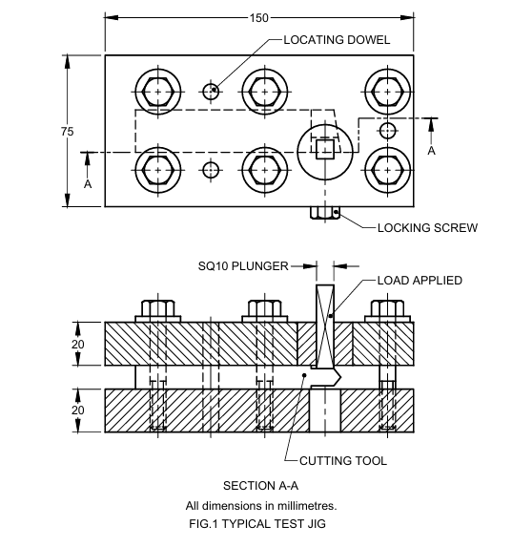

All dimensions in millimetres.

Fig. 1 Typical Test Jig

**2.1.1** During the test, appreciable deflection of the plunger shall not take place, and the plunger shall not contact the tool body during the test.

**2.1.2** The apparatus shall be so constructed that the tool under test may be held rigidly so that:

1. The tool does not deflect;
2. The side of the tip on which the load is to be applied is normal to the direction of the load; and
3. The brazed faces are parallel with respect to the direction of the applied load.

**2.1.3** The load shall be applied uniformly over the area of the side of the tip. In case it is difficult to achieve this condition, it is permissible to apply the load along a line parallel to the end immediately adjacent to the carbide/braze interface.

**2.1.4** The plunger shall have an adequate bearing area on its guide bush to be free from any tendency to rock.

**2.2 Preparation of Sample**

The tools to be tested shall be ground on one or both sides to ensure that they will fit properly into the jig and that it will be possible to apply the load normally to the side of the tip in accordance with **2.1.l** to **2.1.4**. Care shall be taken during the preparation of the sample to prevent the generation of excessive heat which may affect the strength of the braze.

**2.3 Method of Test**

The tools shall be held normally in the jig and the load shall be applied on the tip of the tool through the plunger in accordance with **2.1**. The load shall be applied at a rate within the range of 20 kN/min and 100 kN/min. The rate of the loading shall be such that the tests take not less than 60 s from the application of the load. The load shall be applied at this rate till the fracture occurs.

**3 ASSESSMENT OF RESULTS**

Brazing shall be assumed to be of good quality if:

1. The fracture takes place substantially through the braze alloy;
2. After shearing, the surfaces show adequate wetting of the tungsten-carbide and the steel; and
3. The shear strength calculated by dividing the applied load by the total area of the brazing between the tip and the tool body shall be not less than the strength specified for the individual standard.

**ANNEX A**

(*Foreword*)

**COMMITTEE COMPOSITION**

Mining Techniques and Equipment Sectional Committee, MED 08

|  |  |
| --- | --- |
| *rganization* | *Representative*(*s*) |
| Directorate General of Mines Safety, Dhanbad | Shri Saifullah Ansari **(*Chairperson*)** |
| Automotive Research Association of India, Pune | Shri Milind Kandalkar  Shri Dhondiram Mole (*Alternate*) |
| BEML Limited, Bengaluru | Shri V. R. S. Prasad Rao  Shri H. G. Suresh (*Alternate*) |
| CSIR**-**Central Institute for Mining and Fuel Research, Dhanbad | Dr Manoj Kumar Singh  Shri Surajit Dey (*Alternate* I)  Prof S. K. Kashyap (*Alternate* II) |
| Directorate General of Mines Safety, Dhanbad | Shri M. arumugam |
| Eastern Coalfields Limited, Dishergarh | Shri Sarvesh Kumar  Shri Ajay Bhowmik (*Alternate*) |
| Eimco Elecon (India) Limited, Vallabh Vidyanagar | Shri Ram Ramesh Kale  Shri Vinay Jaynarayan Sharma (*Alternate*) |
| Hutti Gold Mines Company Limited, Bengaluru | Dr Prabhakar Sangoormath  Shri Mallikarjun Sarapur (*Alternate* I)  Ms Mega Hiremath (*Alternate* II) |
| Indian Institute of Technology (ISM), Dhanbad | Shri L. A. Kumaraswamidhas |
| Manganese Ore Limited, Nagpur | Shri Rakesh Kumar Verma  Shri Atul Sharma (*Alternate* I)  Shri Ashwini Baghele (*Alternate* II) |
| Metso Outotec India Private Limited, Vadodara | Shri Sandeep Deokisan Bhattad |
| Nanda Millar Company, Kolkata | Shri J. P. Goenka  Shri Madhur Goenka (*Alternate*) |
| Tata Steel Limited, Dhanbad | Shri Soumendhu Manjhi  Shri Abinash Jha (*Alternate*) |
| BIS Directorate General | Shri K. Venkateswara Rao, Scientist ‘F’/Senior Director and Head (Mechanical) [Representing Director General (*Ex-officio*)] |

*Member Secretary*

Shri Shubham Tiwari

Scientist ‘D’/Joint Director

(Mechanical), BIS