***भारतीय मानक***

**वायरलाइन हीरक क्रोड वेधन उपस्कर — पद्धत्ति ए**

**भाग 1 मीटरी इकाइयाँ**

*( पहला पुनरीक्षण )*

*Indian Standard*

**Wireline Diamond Core Drilling Equipment — System A**

**Part 1 Metric Units**

*( First Revision )*

ICS 73.100.30

© BIS 2024

भारतीय मानक ब्यूरो

B U R E A U O F I N D I A N S T A N D A R D S

मानक भवन, 9 बहादुरशाह ज़फर मार्ग, नई दिल्ली 110002

MANAK BHAVAN, 9 BAHADUR SHAH ZAFAR MARG,

NEW DELHI 110002

www.bis.gov.in www.standardsbis.in

**May 2024****Price Group**

Diamond Core and Waterwell Drilling Sectional Committee, MED 21

FOREWORD

This Indian Standard (Part 1) (First Revision) was adopted by the Bureau of Indian Standards, after the draft finalized by the Diamond Core and Waterwell Drilling Sectional Committee had been approved by the Mechanical Engineering Division Council.

This standard was first published in 2004. This standard is being revised again to keep pace with the latest technological developments and international practices. Also, in this revision, the standard has been brought into the latest style and format of Indian Standards, and references of Indian Standards, wherever applicable have been updated. The following major modifications have been incorporated in this revision of the standard:

1. Mechanical properties have been revised;
2. Eccentricity limit has been revised; and
3. Straightness has been modified.

In the preparation of this standard, considerable assistance has been derived from the following standard:

ISO 10097-1:1999 Wireline diamond core drilling equipment — System A – Part 1: Metric units.

The composition of the Committee, responsible for the formulation of this standard is given in Annex B.

For the purpose of deciding whether a particular requirement of this standard is complied with, the final value, observed or calculated, expressing the result of a test or analysis, shall be rounded off in accordance with IS 2 : 2022 ‘Rules for rounding off numerical values (*second revision*)’. The number of significant places retained in the rounded off value should be the same as that of the specified value in this standard.

*Indian Standard*

WIRELINE DIAMOND CORE DRILLING EQUIPMENT — SYSTEM A

**PART 1 METRIC UNITS**

*( First Revision )*

## **1 SCOPE**

This standard specifies the nomenclature and the leading dimensions necessary for the interchangeability of the following wireline drilling equipment for drilling holes 48 mm to 96 mm in diameter, yielding cores of 27 mm to 63 mm in diameter.

The equipment is illustrated in Fig. 1 and comprises the following:

1. Core bit;
2. Reaming shell;
3. Core lifter;
4. Core lifter case;
5. Outer tube;
6. Inner tube; and
7. Drill rod (smooth pipe only).

## **2 REFERENCES**

The standards listed below contain provisions which, through reference in this text, constitute provisions of this standard. At the time of publication, the editions indicated were valid. All standards are subject to revision, and parties to agreements based on this standard are encouraged to investigate the possibility of applying the most recent editions of the standards listed below.

|  |  |
| --- | --- |
| *IS/Other Standards* | *Title* |
| IS 9439 : 2022 | Glossary of terms used in water well drilling technology (*first revision*) |
| IS/ISO 18758-1 : 2018 | Mining and earth-moving machinery — Rock drill rigs and rock reinforcement rigs — Part 1 : Vocabulary |
| ISO 3551-1 : 1992 | Rotary core diamond drilling equipment — System A — Part 1 : Metric units |

**3 TERMINOLOGY**

For the purpose of this standard the terminologies given in IS 9439 and IS/ISO 18758-1 shall apply.

**4 DESIGNATION**

Items made in accordance with this part shall be designated by the identification letters WL and hole dimensions *A, B, N,* and *H.*

*Example*:

Core bit for wireline drilling hole *B* dimensions: WLB core bit.

## **5 MATERIALS**

Materials used in the manufacture of the wireline drilling equipment specified in this standard shall have the minimum mechanical properties as specified in Table 1.

**Table 1 Mechanical Properties**

(*Clause* 5)

|  |  |  |  |  |  |  |
| --- | --- | --- | --- | --- | --- | --- |
| **Sl No.** | **Component** | **Minimum Tensile**  **Strength, y**  N/mm2 (MPa) | **Minimum Yield Stress, Re,**  N/mm2 (MPa) | **Minimum Brinell Hardness** | **Minimum Elongation After Fracture, A**  % | **Condition** |
| (1) | (2) | (3) | (4) | (5) | (6) | (7) |
|  | Drill rods | 690 | 550 | 200 | 15 | Induction hardened |
|  | Core tubes | 780 | 680 | 229 | 15 | Tempered/stress relieved |
|  | Other items | Not specified | | | | |

**6 DIMENSIONS AND TOLERANCES**

**6.1 General**

All dimensions and tolerances are in millimetres unless otherwise stated and shall be in accordance with Table 3 to Table 9 inclusive.

**6.2 Conformity**

In those industries where drilling depths are measured in metres, the rod lengths shall be 3 m, 1.5 m, or 0.75 m.

**6.3 Eccentricity**

The eccentricity is defined as the distance between the centres of the outer and inner diameters and may not exceed 5 percent of nominal wall thickness Q. The eccentricity is calculated according to the formula:

$$\frac{Q_{max}-Q_{min}}{{2Q}_{nom}}×100$$

where

*Q*max and *Q*min are measured values in the same section.

**6.4 Straightness**

When measured over the whole length of the tube by rolling against a straightedge, the maximum deviation shall not be greater than following:

1. For drill rods 1 in 2 000; and
2. For core tubes 1 in 2 000.

**6.5 Technical conditions**

Tubes should be made seamless. Tube rolling technique and machining operations are optional. Tube straightness is checked by rolling the tube on a horizontal or slightly inclined flat surface. When rolling, no clearances shall be seen between the rod ends and the surface, nor between the middle of the rod (tube) and the surface. Hole drilling by wireline system A equipment shall be cased by system A casing as specified in ISO 3551-1.

**Table 2 System of Dimensional Identification Letters**

(*Clause* 6.5)

|  |  |  |
| --- | --- | --- |
| **Sl No.** | **Identification Letters** | **Meanings of Identification Letters** |
| (1) | (2) | (3) |
|  | *A, A*1*,* etc*.* | Outside diameters; *A* being largest; *A*1, *A*2, etc progressively smaller |
|  | *B, B*1*,* etc | Inside diameters; *B* being smallest; *B*1, *B*2, etc progressively larger |
|  | *C, C*1*,* etc | External lengths; *C* being longest; *C*1, *C*2, etc progressively shorter |
|  | *D, D*1*,* etc | Internal lengths; *D* being longest; *D*1, *D*2, etc progressively shorter |
|  | *E, E*1*,* etc | Major diameter of pin threads; *E* being largest; *E*1, *E*2, etc smaller |
|  | *F, F*1*,* etc | Minor diameter of pin threads; *F* being largest; *F*1, *F*2, etc smaller |
|  | Thread pitch (threads per inch) | Pin threads |
|  | *G, G*1*,* etc | Width at root of pin thread |
|  | *H, H*1*,* etc | Length of o.d. machined for external threading |
|  | *J, J*1*,* etc | Minimum length for full depth of pin threads |
|  | *K, K*1,etc | Length of relief at the starting point of pin threads |
|  | *L, L*1,etc | Angle of bevel for pin thread shoulder |
|  | *M, M*1*,* etc | Major diameter of box threads; *M* being largest; *M*1, *M*2, etc smaller |
|  | *N, N*1*,* etc | Minor diameter of box; *N* being largest; *N*1, *N*2, etc smaller |
|  | Thread pitch (threads per inch*)* | Box threads |
|  | *P, P*1*,* etc | Width at root of box threads |
|  | *Q, Q*1*,* etc | Length of i.d. machined for internal threading |
|  | *R, R*1*,* etc | Minimum length for full depth of box threads |
|  | *S, S*1*,* etc | Length of counter bore at the starting of box threads |
|  | *T, T*1*,* etc | Angle of bevel for thread shoulder |
|  | *U, U*1*,* etc | Included angles, Internal and external |
|  | *V, V*1*,* etc | Internal angles, not pertaining to threaded connections |
|  | *W, W*1*,* etc | External angles, not pertaining to threaded connections |
|  | *X* | Diamond set dimensions: External (o.d.) |
|  | *Y* | Diamond set dimensions: Internal (i.d.) |
| NOTES  **1** All decimal dimensions indicate allowable tolerances.  **2** The following common abbreviations have sometimes been used in tables in the English version for the sake of simplicity:  o.d. = outside diameter; and  i.d. = inside diameter. | | |

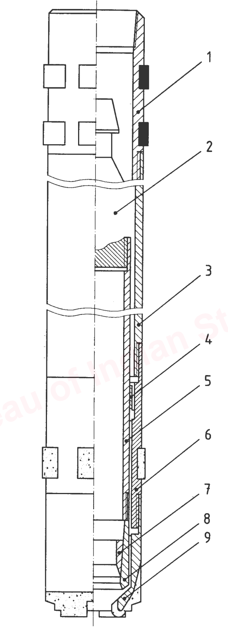

Key

|  |  |  |  |
| --- | --- | --- | --- |
| 1 | Head (not standardized) | 6 | Reaming shell |
| 2 | Bearing unit (not standardized) | 7 | Core lifter |
| 3 | Outer core barrel | 8 | Core lifter case |
| 4 | Stabilizer (not standardized) | 9 | Bit |
| 5 | Retractable core barrel |  |  |

Fig. 1 Wireline Core Barrel Assembly

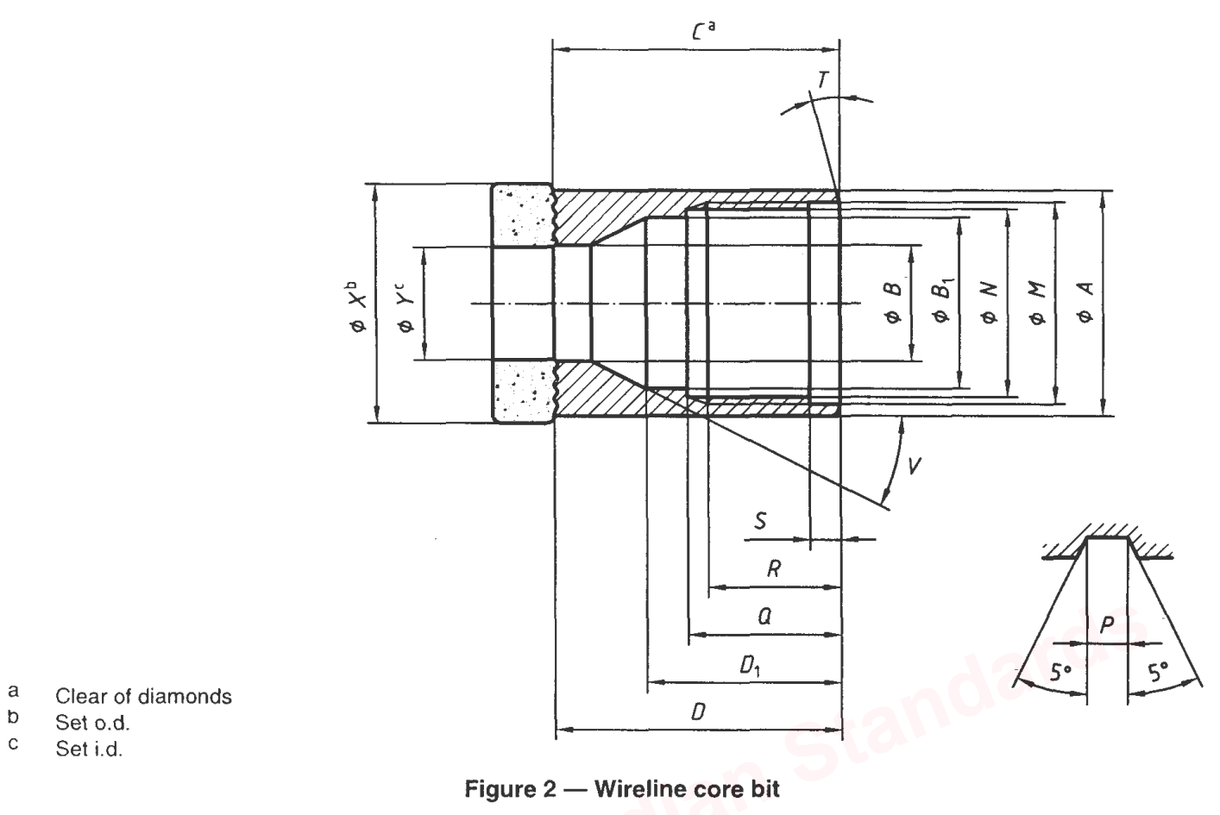

where

a = Clear of diamond

b = Set o.d.

c = Set i.d.

**Table 3 Wireline Core Bit**

(*See* Fig. 2)

| **Sl No.** | **Dimension** | | **WLA** | **WLB** | **WLN** | **WLH** |
| --- | --- | --- | --- | --- | --- | --- |
| (1) | (2) | | (3) | (4) | (5) | (6) |
|  | *A* | *Max* | 46.66 | 57.96 | 73.91 | 94.31 |
| *Min* | 46.56 | 57.86 | 73.81 | 94.21 |
|  | *B* | *Max* | 27.89 | 37.70 | 48.82 | 64.69 |
| *Min* | 27.76 | 36.91 | 48.02 | 63.90 |
|  | *B*1 | *Max* | 36.91 | 46.43 | 60.72 | 78.18 |
| *Min* | 36.12 | 45.64 | 59.93 | 77.39 |
|  | *C* | *Min* | 57.91 | 66.04 | 65.41 | 96.22 |
|  | *D* | *Max* | 58.71 | 66.83 | 66.20 | 97.01 |
| *Min* | 57.91 | 66.04 | 65.41 | 96.22 |
|  | *D*1 | *Max* | 49.61 | 57.55 | 54.37 | 83.74 |
| *Min* | 48.82 | 56.75 | 53.58 | 82.95 |
|  | *M* | *Max* | 42.09 | 52.43 | 67.51 | 85.78 |
| *Min* | 42.04 | 52.37 | 67.46 | 85.70 |
|  | *N* | *Max* | 40.59 | 50.85 | 65.99 | 84.20 |
| *Min* | 40.51 | 50.80 | 65.94 | 84.12 |
|  | Thread pitch | | 6.35 | 6.35 | 6.35 | 6.35 |
|  | *P* | *Max* | 3.20 | 3.20 | 3.20 | 3.20 |
| *Min* | 3.12 | 3.12 | 3.12 | 3.12 |
|  | *Q* | *Max* | 42.29 | 42.52 | 42.55 | 42.75 |
| *Min* | 42.16 | 42.39 | 42.42 | 42.62 |
|  | *R* | *Min* | 38.89 | 38.89 | 38.89 | 38.89 |
|  | *S* | *Max* | 7.4 | 7.4 | 7.4 | 7.14 |
| *Min* | 6.35 | 6.35 | 6.35 | 6.35 |
|  | *T* | | 15° | 15° | 15° | 15° |
|  | *V* | | 30° | 30° | 30° | 30° |
|  | *X* | *Max* | 47.75 | 59.69 | 75.44 | 95.76 |
| *Min* | 47.50 | 59.44 | 75.18 | 95.38 |
|  | *Y* | *Max* | 27.10 | 36.53 | 47.75 | 63.63 |
| *Min* | 26.85 | 36.27 | 47.50 | 63.37 |

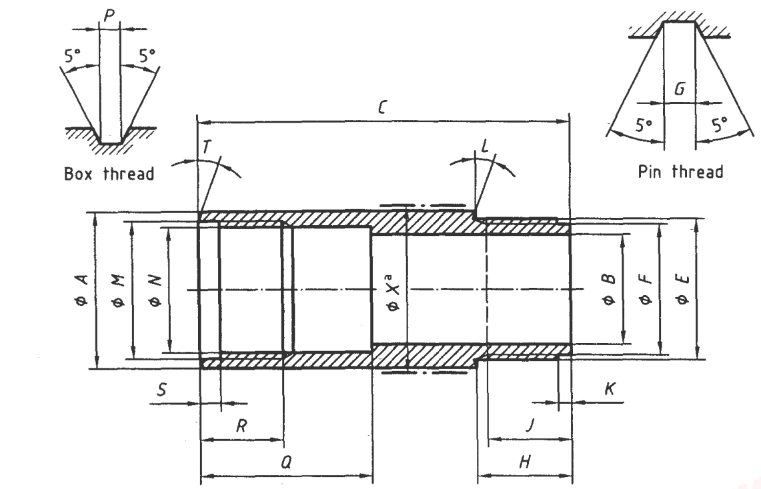

where

a = Set o.d.

| *Sl No.* | *Dimension* | | *WLA* |  | *WLB* | *WLN* | *WLH* |
| --- | --- | --- | --- | --- | --- | --- | --- |
| (1) | (2) | | (3) |  | (4) | (5) | (6) |
|  | *A* | *Max* | 46.66 |  | 57.96 | 73.91 | 94.31 |
| *Min* | 46.56 |  | 57.86 | 73.81 | 94.21 |
|  | *B* | *Max* | 36.51 |  | 46.04 | 60.33 | 77.79 |
| *Min* | 36.36 |  | 45.86 | 60.12 | 77.53 |
|  | *C* | *Max* | 162.32 |  | 159.15 | 171.85 | 182.96 |
| *Min* | 161.53 |  | 158.35 | 171.05 | 182.17 |
|  | *E* | *Max* | 41.96 |  | 52.30 | 67.39 | 85.62 |
| *Min* | 41.91 |  | 52.25 | 67.34 | 85.55 |
|  | *F* | *Max* | 40.44 |  | 50.72 | 65.86 | 84.05 |
| *Min* | 40.39 |  | 50.67 | 65.81 | 83.97 |
|  | Thread pitch | | 6.35 |  | 6.35 | 6.35 | 6.35 |
|  | *G* | *Max* | 3.20 |  | 3.20 | 3.20 | 3.20 |
| *Min* | 3.12 |  | 3.12 | 3.12 | 3.12 |
|  | *H* | *Max* | 41.28 |  | 41.38 | 41.28 | 41.20 |
| *Min* | 41.15 |  | 41.25 | 41.15 | 41.07 |
|  | *J* | *Min* | 38.89 |  | 38.89 | 38.89 | 38.89 |
|  | *K* | *Max* | 7.14 |  | 7.14 | 7.14 | 7.14 |
| *Min* | 6.35 |  | 6.35 | 6.35 | 6.35 |
|  | *L* | | 15° |  | 15° | 15° | 15o |
|  | *M* | *Max* | 42.09 |  | 52.43 | 67.51 | 85.78 |
| *Min* | 42.04 |  | 52.37 | 67.46 | 85.70 |
|  | *N* | *Max* | 40.59 |  | 50.85 | 65.99 | 84.20 |
| *Min* | 40.51 |  | 50.80 | 65.94 | 84.12 |
|  | Thread pitch | | 6.35 |  | 6.35 | 6.35 | 6.35 |
|  | *P* | *Max* | 3.20 |  | 3.20 | 3.20 | 3.20 |
| *Min* | 3.12 |  | 3.12 | 3.12 | 3.12 |
|  | *Q* | *Max* | 61.01 |  | 61.32 | 67.69 | 74.04 |
| *Min* | 60.88 |  | 61.19 | 67.56 | 73.91 |
|  | *R* | *Min* | 38.89 |  | 38.89 | 38.89 | 38.89 |
|  | *S* | *Max* | 7.14 |  | 7.14 | 7.14 | 7.14 |
| *Min* | 6.35 |  | 6.35 | 6.35 | 6.35 |
|  | *T* | | 15° |  | 15° | 15° | 15° |
|  | *X* | *Max* | 48.13 |  | 60.07 | 75.82 | 96.27 |
| *Min* | 47.88 |  | 59.82 | 75.57 | 95.89 |

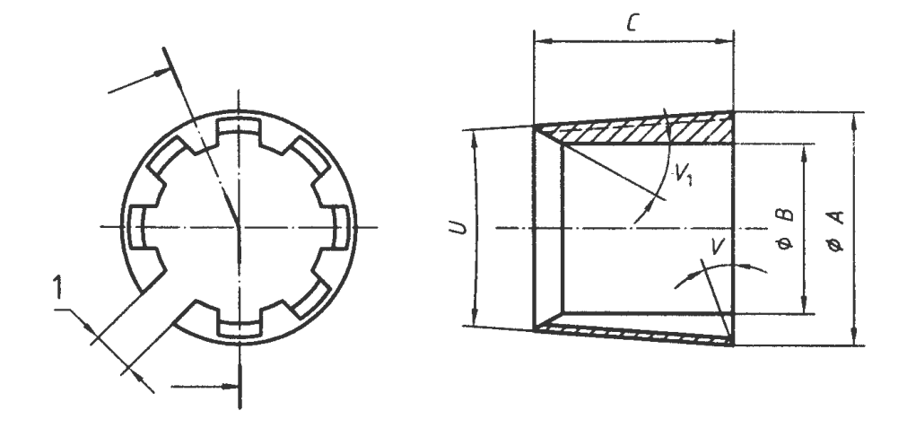

*Key*

1 Gap

|  |  |  |  |  |  |  |
| --- | --- | --- | --- | --- | --- | --- |
| *Sl No.* | *Dimension* | | *WLA* | *WLB* | *WLN* | *WLH* |
| (1) | (2) | | (3) | (4) | (5) | (6) |
|  | *A* | *Max* | 30.23 | 40.23 | 52.04 | 68.94 |
| *Min* | 30.18 | 40.18 | 51.99 | 68.88 |
|  | *B* | *Max* | 26.59 | 36.02 | 47.12 | 62.87 |
| *Min* | 26.54 | 35.97 | 47.07 | 62.81 |
|  | *C* | *Max* | 22.62 | 25.80 | 28.97 | 38.50 |
| *Min* | 21.83 | 25.00 | 28.18 | 37.70 |
|  | *U* | *Max* | 5o to 15’ | 5o to 15’ | 5o to 15’ | 5o to 15’ |
| *Min* | 4o to 45’ | 4o to 45’ | 4o to 45’ | 4o to 45’ |
|  | *V* | | 0o | 0o | 0o | 0o |
|  | *V*1 | | 30o | 30o | 30o | 30o |
|  | | | | | | |

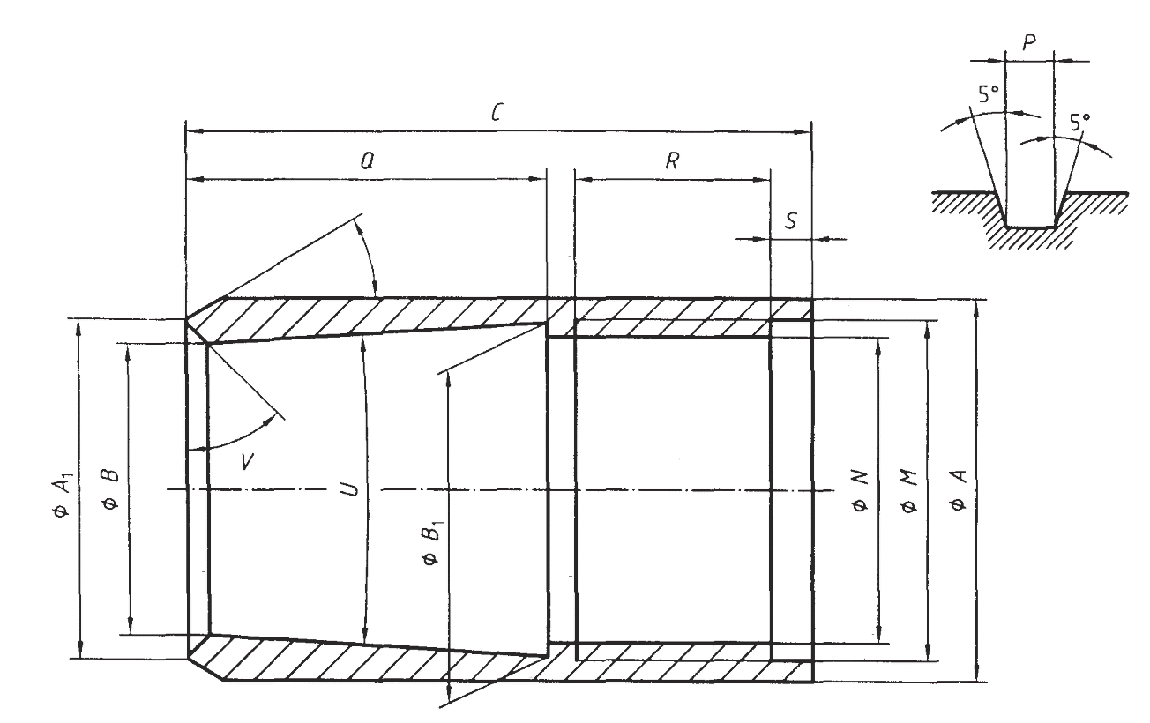

|  |  |  |  |  |  |  |
| --- | --- | --- | --- | --- | --- | --- |
| *Sl No.* | *Dimension* | | *WLA* | *WLB* | *WLN* | *WLH* |
| (1) | (2) | | (3) | (4) | (5) | (6) |
|  | *A* | *Max* | 32.94 | 43.00 | 55.93 | 73.23 |
| *Min* | 32.89 | 42.95 | 55.88 | 73.18 |
|  | *A*1 | *Max* | 30.68 | 40.41 | 52.73 | 67.99 |
| *Min* | 30.63 | 40.35 | 52.68 | 67.94 |
|  | *B* | *Max* | 28.30 | 38.02 | 49.56 | 65.61 |
| *Min* | 28.24 | 37.97 | 49.50 | 65.56 |
|  | *B*1 | *Max* | 31.09 | 41.43 | 53.21 | 70.38 |
| *Min* | 31.01 | 41.33 | 53.14 | 70.31 |
|  | *C* | *Max* | 63.90 | 70.25 | 75.01 | 89.30 |
| *Min* | 63.10 | 69.45 | 74.22 | 88.50 |
|  | *M* | *Max* | 31.32 | 41.10 | 53.47 | 70.69 |
| *Min* | 31.27 | 41.05 | 53.42 | 70.64 |
|  | *N* | *Max* | 30.18 | 39.93 | 52.20 | 69.29 |
| *Min* | 30.12 | 39.88 | 52.15 | 69.24 |
|  | Thread pitch | | 3.175 | 3.175 | 3.175 | 3.175 |
|  | *P* | *Max* | 1.63 | 1.63 | 1.63 | 1.63 |
| *Min* | 1.55 | 1.55 | 1.55 | 1.55 |
|  | *Q* | *Max* | 40.08 | 44.85 | 51.59 | 67.07 |
| *Min* | 39.29 | 44.05 | 50.80 | 66.28 |
|  | *R* | *Min* | 20.64 | 20.64 | 20.64 | 20.64 |
|  | *S* | *Max* | 3.97 | 3.97 | 3.97 | 3.97 |
| *Min* | 3.18 | 3.18 | 3.18 | 3. 18 |
|  | *T* | | 30° | 30° | 30° | 30° |
|  | *U* | *Max* | 5° to 15°’ | 5° to 15°’ | 5° to 15°’ | 5° to 15°’ |
| *Min* | 4° to 45°’ | 4° to 45°’ | 4° to 45°’ | 4° to 45°’ |
|  | *V* | | 45° | 45° | 45° | 45° |

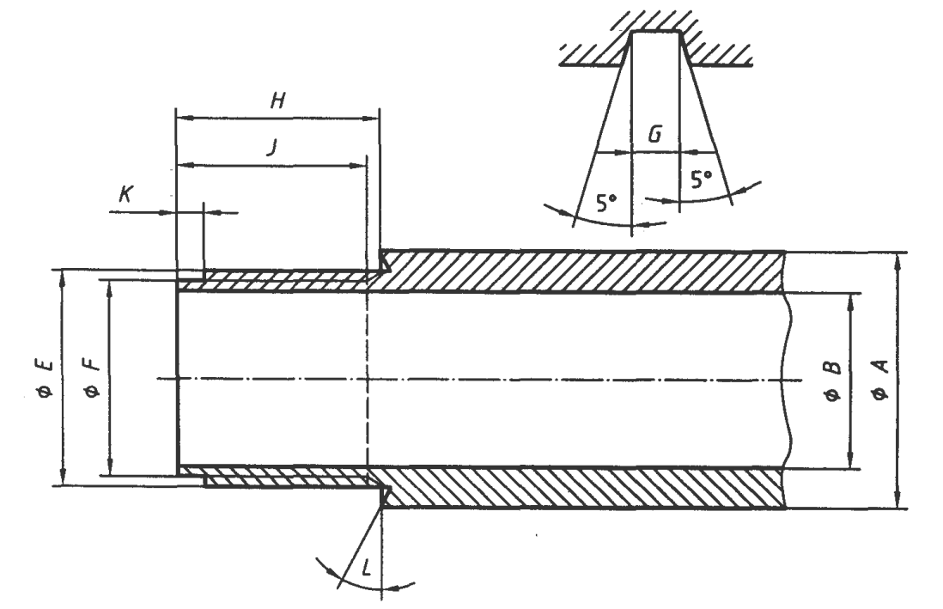

|  |  |  |  |  |  |  |
| --- | --- | --- | --- | --- | --- | --- |
| *Sl No.* | *Dimension* | | *WLA* | *WLB* | *WLN* | *WLH* |
| (1) | (2) | | (3) | (4) | (5) | (6) |
|  | *A* | *Max* | 46.19 | 57.33 | 73.23 | 92.33 |
| *Min* | 46.04 | 57.15 | 73.03 | 92.08 |
|  | *B* | *Max* | 36.51 | 46.04 | 60.53 | 77.79 |
| *Min* | 36.36 | 45.86 | 60.33 | 77.53 |
|  | *E* | *Max* | 41.96 | 52.30 | 67.39 | 05.62 |
| *Min* | 41.91 | 52.25 | 67.34 | 85.55 |
|  | *F* | *Max* | 40.44 | 50.72 | 65.86 | 84.05 |
| *Min* | 40.39 | 50.67 | 65.81 | 83.97 |
|  | Thread pitch | | 6.35 | 6.35 | 6.35 | 6.35 |
|  | *G* | *Max* | 3.20 | 3.20 | 3.20 | 3.20 |
| *Min* | 3.12 | 3.12 | 3.12 | 3.12 |
|  | *H* | *Max* | 41.28 | 41.48 | 41.38 | 41.28 |
| *Min* | 41.15 | 4135 | 41.25 | 41.15 |
|  | *J* | *Min* | 38.89 | 38.89 | 38.89 | 38.89 |
|  | *K* | *Max* | 7.14 | 7.14 | 7.14 | 7.14 |
| *Min* | 6.35 | 6.35 | 6.35 | 6.35 |
|  | *L* | *Min* | 15° | 15° | 15° | 15° |

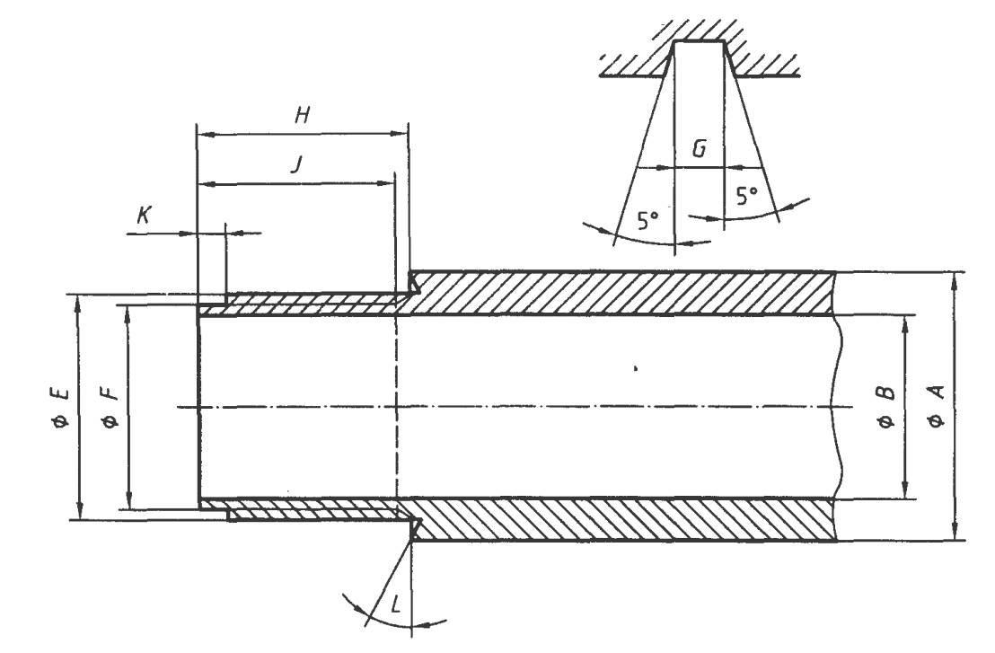

|  |  |  |  |  |  |  |
| --- | --- | --- | --- | --- | --- | --- |
| *Sl No.* | *Dimension* | | *WLA* | *WLB* | *WLN* | *WLH* |
| (1) | (2) | | (3) | (4) | (5) | (6) |
|  | *A* | *Max* | 32.67 | 42.99 | 55.74 | 73.23 |
| *Min* | 32.54 | 42.86 | 55.56 | 73.03 |
|  | *B* | *Max* | 28.58 | 38.10 | 50.01 | 66.93 |
| *Min* | 28.45 | 37.97 | 49.83 | 66.73 |
|  | *E* | *Max* | 31.24 | 40.97 | 53.34 | 70.56 |
| *Min* | 31.19 | 40.92 | 53.29 | 70.51 |
|  | *F* | *Max* | 30.07 | 39.80 | 52.07 | 69.16 |
| *Min* | 30.02 | 39.75 | 52.02 | 69.11 |
|  | Thread pitch | | 3.175 | 3.175 | 3.175 | 3.175 |
|  | *G* | *Max* | 1.63 | 1.63 | 1.63 | 1.63 |
| *Min* | 1.55 | 1.55 | 1.55 | 1.55 |
|  | *H* | *Max* | 22.10 | 22.10 | 22.10 | 22.10 |
| *Min* | 21.97 | 21.97 | 21.97 | 21.97 |
|  | *J* | *Min* | 20.64 | 20.64 | 20.64 | 20.64 |
|  | *K* | *Max* | 3.97 | 3.97 | 3.97 | 3.97 |
| *Min* | 3.18 | 3.18 | 3.18 | 3.18 |
|  | *L* | *Min* | 0° | 0° | 0° | 0° |

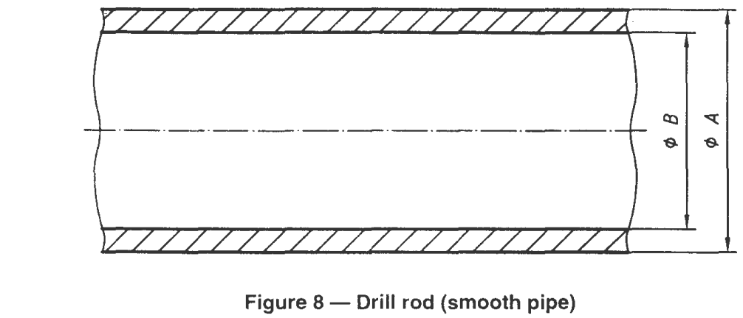

NOTE — For dimensions refer Table 9.

|  |  |  |  |  |  |  |
| --- | --- | --- | --- | --- | --- | --- |
| *Sl No.* | *Dimension* | | *WLA* | *WLB* | *WLN* | *WLH* |
| (1) | (2) | | (3) | (4) | (5) | (6) |
|  | *A* | *Max* | 44.60 | 55.75 | 70.05 | 89.15 |
| *Min* | 44.45 | 55.58 | 69.85 | 88.90 |
|  | *B* | *Max* | 35.08 | 46.20 | 60.33 | 78.00 |
| *Min* | 34.93 | 46.02 | 60.12 | 77.77 |

NOTE — Further details are given in Annex A.

**ANNEX A**

(*Informative*)

**PRINCIPAL DIMENSIONS OF DRILL ROD THREADS**

|  |  |  |  |  |  |
| --- | --- | --- | --- | --- | --- |
| **Sl No.** | **Dimensions** | **WLA** | **WLB** | **WLN** | **WLH** |
| (1) | (2) | (3) | (4) | (5) | (6) |
| i) | Thread tapering | 1:28.64 | 1:28.64 | 1:28.64 | 2:28.64 |
| ii) | Angle of thread arrival | 1° | 1° | 1° | 1° |
| iii) | Angle of thread profile | 29° | 29° | 29° | 29° |
| iv) | Thread pitch | 6.350 | 8.466 | 8.466 | 8.466 |
| v) | Maximum outside diameter of box thread in stop batt axis | 41.325 | 52.125 | 66.425 | 84.655 |
| vi) | Maximum outside diameter of box thread in stop shoulder axis | 39.805 | 50.595 | 64.895 | 83.135 |
| vii) | Mean spire depth of box thread | 0.752 | 0.785 | 0.785 | 0.785 |
| viii) | Width at root of box thread | 3.00 | 4.06 | 4.06 | 4.06 |
| ix) | Mean length of box thread from stop batt to internal angle of stop shoulder | 41.8 | 44.9 | 44.9 | 45.0 |
| x) | Minimum length for full depth of box thread | 39.7 | 43.3 | 43.3 | 43.3 |
| xi) | Minimum inside diameter of pin thread in stop batt axis | 38.18 | 48.84 | 63.12 | 81.38 |
| xii) | Minimum inside diameter of pin thread in shoulder axis | 39.80 | 50.47 | 64.74 | 83.01 |
| xiii) | Mean spire depth of pin thread | 0.740 | 0.800 | 0.800 | 0.800 |
| xiv) | Width at root of pin thread | 3.00 | 4.06 | 4.06 | 4.06 |
| xv) | Mean length of pin thread from stop batt to external angle of stop shoulder | 41.3 | 44.4 | 44.4 | 44.4 |
| xvi) | Minimum length for full depth of pin thread | 39.7 | 43.7 | 43.7 | 43.7 |
| xvii) | Angles of bevel for thread stop battes and stop shoulders | 15° | 15° | 15° | 15° |
| NOTE — Many dimensions are approximate. | | | | | |

**ANNEX B**

(*Foreword*)

**COMMITTEE COMPOSITION**

Diamond Core and Waterwell Drilling Sectional Committee, MED 21

| *Organization* | *Representative (s)* |
| --- | --- |
| Geological Survey of India, New Delhi | Shri Ajay Agarwal (***Chairperson***) |
| Aqseptence Group (India) Pvt Ltd (Formaly Known as Johanson Screens India Pvt Ltd) Gujarat | Shri Shiv Narayan Singh  Shri Shiven Amin (*Alternate*) |
| Atlas Copco (I) Ltd, Pune | Shri Shudhanshu Nigam  Shri S. Datta Majumdar (*Alternate*) |
| Central Ground Water Board, Faridabad | Shri G. L. Meena  Shri Nidhish Verma (*Alternate*) |
| Central Mine Planning and Design Institute, Ranchi | Shri Anil Savanur  Shri A. V. Ramakrishna (*Alternate*) |
| Epiroc Mining India Limited, Nashik | Shri Sujeet Kumar  Shri Chandan Ghosh (*Alternate*) |
| Geological Survey of India | Shri Anup Kumar Johri (*Alternate* I)  Shri C. B. Tiwari (*Alternate* II)  Shri S. Shankar (*Alternate* III) |
| Indian Institute of Technology, Kanpur | Prof J. Ramkumar  Prof Sudhanshu Shekhar Singh (*Alternate*) |
| Indian Institute of Technology Kharagpur, Kharagpur | Prof Khanindra Pathak  Shrimati Sunita Mishra (*Alternate*) |
| Indian Institute of Technology, Roorkee | Prof B. K. Gandhi  Shri Varun Kumar Sharma (*Alternate*) |
| Indian Pump Manufacturers Association, Mumbai | Shri Yogesh Mistry  Shri Utkarsh A. Chhaya (*Alternate*) |
| Indian Institute of Technology (ISM), Dhanbad | Mohammed Hamid Siddique  Shri Pawan Gupta (*Alternate* I)  Shri Vinay Kumar Rajak (*Alternate* II) |
| Kores (India) Ltd, Mumbai | Shri Sandeep Dholi |
| Mining Associates Pvt Ltd, West Bengal | Shri Ram Babu Bansal |
| Rites Ltd, Gurugram | Shri S. Kunal |
| Rockdrill (India), Jodhpur | Shri Kamal Kishor Gupta  Shri Ravindra Ku. Gupta (*Alternate*) |
| Sandvik Smith Asia Limited, Medak | Shri Rangayya Naidu  Shri N. Bhaskara Reddy (*Alternate*) |
| In Personal Capacity (*90 Mayur Vihar, Sec 48, Chandigarh*) | Shri Mahesh Chandra Jindal |
| In Personal Capacity (*F-401, Maruti Sadan,Begumpet, Hydrabad*) | Shri A. B. Anand |
| In Personal Capacity (*D-5/10, Rail Vihar, Indirapuram, Ghaziabad*) | Shri P. C. Dewli |
| BIS Directorate General | Shri K. V. Rao, Scientist ‘F’/Senior Director and Head (Mechanical Engineering) [Representing General (*Ex-officio*)] |

*Member Secretary*

Shri Shubham Yadav

Scientist ‘C’/Deputy Director

(Mechanical Engineering), BIS