**Doc: FAD 01(25478) F**

**IS 6438 : 2024**

***भारतीय मानक***

***Indian Standard***

***एल्युमिनियम फॉस्फाइड फॉर्मूलेशन — विशिष्टि***

*( दूसरा पुनरीक्षण )*

**Aluminium Phosphide Formulation — Specification**

*( Second Revision )*

ICS No. 65.100.99

© BIS 2024

**B U R E A U O F I N D I A N S T A N D A R D S**

MANAK BHAVAN, 9 BAHADUR SHAH ZAFAR MARG

NEW DELHI 110002

**November 2024** **Price Group**

Pesticides Sectional Committee, FAD 01

FOREWORD

This Indian Standard (Second Revision) was adopted by the Bureau of Indian Standards, after the draft finalized by the Pesticides Sectional Committee had been approved by the Food and Agriculture Division Council.

Aluminium phosphide in the form of tablets and pellets is popular in fumigating stored food-grains for protection against storage pests. Its popularity is mainly due to the convenience of its application and efficacy in comparison to other conventional fumigants. This fumigant has also been found useful in the control of rodents living in burrows. This formulation in contact with environmental moisture, releases 33 percent of its mass as phosphine gas.

This standard was first published in 1972. In the first revision issued in 1980, the amendment issued to earlier version of the standard and the modified test method to detect the initial evolution of phosphine gas were incorporated.

In this revision, the standard has been brought out in the latest style and format of the Indian Standards, and references to Indian Standards wherever applicable have been updated. It also incorporates three amendments issued to the previous version of this standard.

In the preparation of this standard, due consideration has been given to the provisions of the *Insecticides Act*, 1968 and the rules framed thereunder. However, this standard is subject to the restrictions imposed under these, wherever applicable.

For the purpose of deciding whether a particular requirement of this standard is complied with, the final value, observed or calculated, expressing the result of a test or analysis, shall be rounded off in accordance with IS 2 : 2022 ‘Rules for rounding off numerical values (*second revision*)’. This number of significant places retained in the rounded off value should be the same as that of the specified value in this standard.

*Indian Standard*

ALUMINIUM PHOSPHIDE FORMULATION — SPECIFICATION

*( Second Revision )*

**1 SCOPE**

This standard prescribes the requirements and methods of sampling and test for aluminium phosphide formulations in the form of tablets or pellets.

**2 REFERENCES**

The standards given below contain provisions which through reference in this text, constitute provision of this standard. At the time of publication, the editions indicated were valid. All standards are subject to revision and parties to agreements based on this standard are encouraged to investigate the possibility of applying the most recent edition of these standards:

|  |  |
| --- | --- |
| *IS No.* | *Title* |
| IS 1070 : 2023 | Reagent grade water — Specification (*fourth revision*) |
| IS 8190 (Part 4) : 1988 | Requirements for packing of pesticides: Part 4 Fumigants (*first revision*) |
| IS 4905 : 2015/ ISO 24153 : 2009 | Random sampling and randomization procedures (*first revision*) |

**3 REQUIREMENTS**

**3.1 Constituents**

**3.1.1** The material shall essentially consist of:

1. aluminium phosphide as the only active ingredient;
2. a chemical fire retardant; and
3. a suitable binding material.

**3.1.2** If required by the purchaser, the tablets or pellets may also contain chemicals emanating a separate innocuous warning gas, such as, ammonia.

**3.2 Physical**

**3.2.1** *Description*

When unpacked, the material shall be in the form of whole tablets or pellets, greyish in colour. The material shall show no evidence of spontaneous combustion when exposed to air. The average mass of 20 tablets or pellets shall not be less than the declared nominal value.

**3.3 Chemical**

**3.3.1** *Aluminium Phosphide Content*

When determined by the method prescribed in Annex A, aluminium phosphide content shall be not less than 56 percent by mass.

**3.3.2** The tablets/pellets shall not evolve any gas as observed by disintegration of tablets/pellets (losing their original shape) up to 30 min of their unpacking from the original container and after subjecting them to the test described in Annex B.

**4 PACKING**

The material shall be packed according to the requirement given in IS 8190 (Part 4).

**5 MARKING**

**5.1** The containers shall be securely closed and shall bear legibly and indelibly the following information:

1. Name of the material;
2. Name and address of the manufacturer;
3. Batch number;
4. Date of manufacture;
5. Date of expiry;
6. Net quantity;
7. Nominal aluminium phosphide content, percent (*m*/*m*);
8. Cautionary notice as worded in the *Insecticides Act*, 1968 and rules framed thereunder; and
9. Any other information required under the *Legal Metrology* (*Packaged Commodities*) *Rules*, 2011.

**5.2 BIS Certification Marking**

The product(s) conforming to the requirements of this standard may be certified as per the conformity assessment schemes under the provisions of the *Bureau of Indian Standards Act*, 2016 and the Rules and Regulations framed thereunder, and the products may be marked with the Standard Mark.

**6 SAMPLING**

Representative samples of the material shall be drawn as prescribed in Annex C.

**7 TESTS**

Tests shall be carried out by the appropriate methods referred to in **3.3.1** and **3.3.2**.

**8 QUALITY OF REAGENTS**

Unless specified otherwise, pure chemicals and distilled water (*see* IS 1070) shall be employed in tests.

NOTE — ‘Pure chemicals’ shall mean chemicals that do not contain impurities which affect the results of analysis.

**ANNEX A**

(*Clause* 3.3.1)

**DETERMINATION OF ALUMINIUM PHOSHIDE CONTENT**

**A-1 APPARATUS**

**A-1.1** The assembly of the apparatus is shown in Fig. 1.

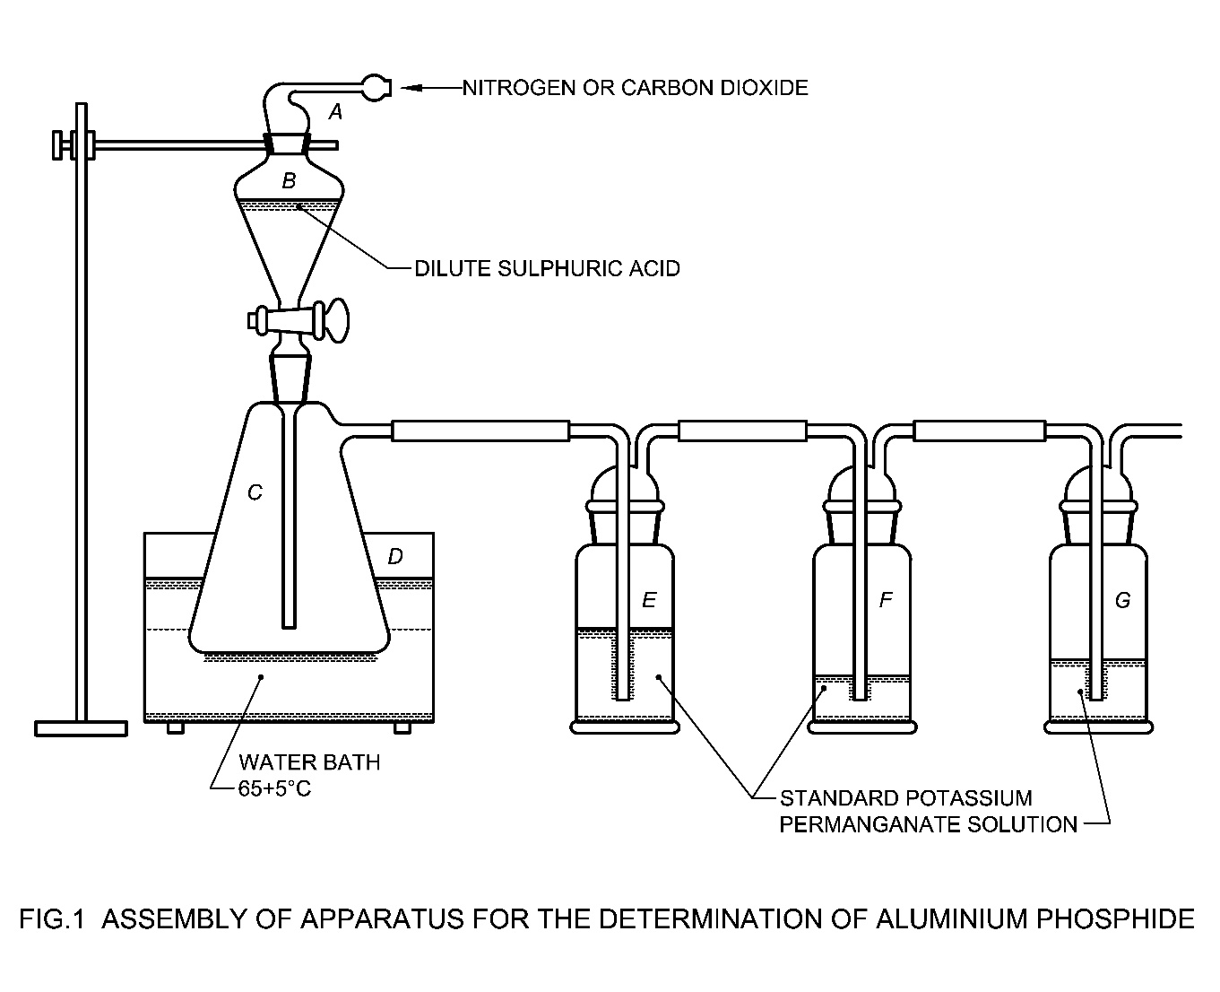

*Key*

*A* = Adapter tubing (for nitrogen gas)

*B* = Separating funnel conical shape with cone and socket 250 ml

*C* = Reaction flask (Buchner) 250 ml

*D* = Thermostatically controlled water-bath

*E* =

*F* = Absorption bottle (gas with bottles) (200/250 ml each)

*G* =

Fig. 1 Assembly of Apparatus for the Determination of Aluminium Phosphide

**A-1.2** The apparatus consists of a 250 ml reaction flask *C* with a standard interchangeable socket. A 250 ml separating funnel *B* and delivery tube (PVC tube surgical soft type) are to be connected according to Fig. 1. The side tube is serially connected with three 200/250 ml absorption bottles *E*, *F* and *G* respectively. To the mouth of the separating funnel is attached a nitrogen or carbon dioxide inlet tube *A* as indicated in Fig. 1. The reaction flask is so mounted on a stand where it is possible to immerse it in the water bath *D* maintained at a temperature of (65 ± 5) °C.

**A-2 REAGENTS**

**A-2.1 Standard Potassium Permanganate Solution** —approximately 0.5 N

**A-2.2 Dilate Sulphuric Acid** —10 percent (*m*/*v*) and 1 : 1 (*v*/*v*)

**A-2.3 Nitrogen Gas or Carbon-Dioxide Gas** —from a cylinder

**A-2.4 Standard Oxalic Acid Solution**

Approximately 0.5 N and acidified with sulphuric acid. Weigh accurately about 15.8 g of oxalic acid (H2C2O4.2H2O) and dissolve in about 200 ml of water contained in a 500 ml volumetric flask. Add to the volumetric flask 125 ml of sulphuric acid [1 : 1 (*v*/*v*)], make up the volume with water and mix.

**A-3 PROCEDURE**

**A-3.1** Measure 100 ml of standard potassium permanganate solution into the gas wash bottles (absorption bottles) *E*, *F* and *G*. Assemble the apparatus as shown in Fig. 1 (without dilute sulphuric acid in the separating funnel *B*). Pass the nitrogen or carbon dioxide gas slowly through the apparatus so as to displace the air. Weigh accurately about 0.2 g to 0.3 g of the material and transfer it into the reaction flask *C* quantitatively.

**A-3.2** Disconnect the nitrogen gas or carbon dioxide gas tube and place 100 ml of dilute sulphuric acid in the separating funnel *B*. Connect the nitrogen or carbon dioxide gas tube to the funnel again. Add the dilute sulphuric acid to the reaction flask slowly, regulating the rate of addition in such a way that a steady stream of bubbles appears in the absorption bottles *E*, *F* and *G*. When the addition of dilute sulphuric acid is complete, adjust the pressure of nitrogen or CO2 gas so that a steady flow of bubbles is maintained in the reaction flask and the absorption bottles *E*, *F* and *G*. During this process, immerse the reaction flask *C* in the water bath maintained at a temperature of (65 ± 5) °C. Continue the reaction for at least 1 h. Sweep the last traces of phosphine from the flask with more rapid stream of nitrogen or carbon dioxide for at least 5 min. At the end of the reaction and sweeping period, disconnect the apparatus and quantitatively transfer the reduced potassium permanganate solution, contained in the three absorption bottles *E*, *F* and *G* to a 1 000 ml or a convenient size beaker. Rinse the absorption bottles and the connecting tubes with 100 ml of standard oxalic acid solution, taking care to dissolve all the manganese dioxide. Add the rinsings to the reduced potassium permanganate solution contained in the beaker. Rinse the absorption bottles and connecting tubes with water and transfer the rinsings to the same beaker. Warm the contents of the beaker to approximately 60 °C and titrate the excess oxalic acid with standard potassium permanganate solution.

**A-4 CALCULATION**

Aluminium phosphide content, percent by mass **=**

where

*A* = volume, in ml, of the standard potassium permanganate solution required for the titration of excess oxalic acid;

N1 = normality of standard potassium permanganate solution;

N = normality of standard oxalic acid solution; and

*M* = mass, in g, of the material taken for the test.

**ANNEX B**

(*Clause* 3.3.2)

**DETERMINATION OF EVOLUTION OF PHOSPHINE GAS**

**B-1 APPARATUS**

**B-1.1 Humidified Chamber —** consisting of a glass desiccator of diameter not less than 30 cm saturated with water vapours at room temperature

**B-2 PROCEDURE**

[**CAUTION** — Phosphine gas is highly poisonous. Test shall be performed in a fume cupboard having a protective shield.]

Unpack three tablets/pellets directly from the original container on to a watch glass kept in the desiccator as quickly as possible. Keep the desiccator undisturbed for 30 min and observe the shape of tablets or pellets for any disintegration (losing their original shape) during this period. For comparison purposes a control be kept in a desiccator having an efficient and suitable desiccant like silica gel.

**CAUTION —** The tablets/pellets shall be removed from the desiccator as soon as the test is over.

**ANNEX C**

(*Clause* 6)

**SAMPLING PLAN FORALUMINIUM PHOSPHIDE FORMULATIONS**

**C-1 GENERAL REQUIREMENTS**

In drawing, preparing, storing and handling the test samples, the following precautions shall be taken.

**C-1.1** Samples shall not be taken in an exposed place.

**C-1.2** Proper precautions shall be taken while drawing the samples as the material is poisonous.

**C-1.3** Precautions shall be taken to protect the samples, the material being sampled and the containers from adventitious contamination.

**C-2 SCALE OF SAMPLING**

**C-2.1 Lot**

All the material in consignment drawn from the same batch of manufacture shall constitute a lot. If the consignment is declared or known to consist of different batches of manufacture, the tubes, cans and aluminium bottles belonging to the same batch shall be grouped together and each such group shall constitute a lot.

The samples shall be tested from each lot for ascertaining the conformity of the material to the requirements of the specification.

**C-2.2** The number of tubes, cans and aluminium bottles to be selected from the lot shall be according to col (l) and col (2) of Table 1. When the containers containing tubes, cans and aluminium bottles are presented in wooden cases, 10 percent of the cases shall be opened with a minimum of two cases. From the cases which are opened, 10 percent of containers shall be taken out at random. From each of the selected containers approximately equal number of tubes, cans and aluminium bottles shall be selected to give the sample size given in col (2) of Table 1.

**Table 1 Number of Tubes, Cans and Aluminium Bottles to be Selected for Sampling**

(*Clause* C-2.2)

|  |  |  |
| --- | --- | --- |
| **Sl No.** | **Lot Size** | **No. of Tubes, Cans and**  **Aluminium Bottles to Selected** |
| (1) | (2) | (3) |
|  | 101 to 500 | 9 |
|  | 501 to 1 000 | 12 |
|  | 1 001 to 3 000 | 15 |
|  | 3 001 to 10 000 | 21 |
|  | 10 001 and above | 30 |
| — | | |

These tubes, cans and aluminium boules shill be selected at random from the lot. In order to ensure the randomness of selection, procedures given in IS 4905 may be followed.

**C-3 TEST SAMPLE AND REFEREE SAMPLE**

**C-3.1** The tubes, cans and aluminium bottles selected as in **C-2.2** shall be divided at random into three equal sets and labelled with all the particulars of sampling. One of these sets of tubes, cans and aluminium bottles shall be for the purchaser, another for the supplier and the third for the referee.

**C-3.2** **Referee Sample**

The referee sample shall consist of a set of sample tubes, cans and aluminium bottles marked for this purpose and shall bear the seals of the purchaser and the supplier (or their representatives) and shall be kept at a place agreed to between the two so as to be used in case of a dispute.

**C-3.3** For the purpose of requirement given in **3.2.1** of the specification, 20 tablets/pallets shall be drawn from the test samples. These tablets/pallets shall be selected at random from the chosen tubes/cans/aluminium bottles covering the top, middle and bottom layers of each package.

**C-4 CRITERIA FOR CONFORMITY**

**C-4.1** The lot shall be declared as conforming to the requirements of this specification if **C-4.1.1**, **C-4.1.2** and **C-4.1.3** are satisfied.

**C-4.1.1** For requirement given in **3.2.1**, individual test results shall satisfy the corresponding requirements.

**C-4.1.2** For requirements given in **3.3.2**, individual test results shall satisfy the corresponding requirements.

**C-4.1.3** For aluminium phosphide content given in **3.3.1**, the mean and range of the corresponding test results shall be calculated as below:

The sum of the test results

Mean (*x̄*) =

Range (*R*) = The difference between the highest and the lowest value obtained for the test results

The lot shall be deemed to have met the requirements given in **3.3.1** of the specification if the expression *x̄* - 0.6 *R* is greater than or equal to the minimum requirement given in this specification.