FAD 11 (24876) F

IS 3108 : 2024

**भारतीय मानक**

**डबल एक्शन प्रूनिंग आरी — विशिष्टि**

*( तीसरा पुनरीक्षण )*

**Indian Standard**

**Double Action Pruning Saw — Specification**

*( Third Revision )*

ICS 65.070.40

© BIS 2024

**B U R E A U O F I N D I A N S T A N D A R D S**

MANAK BHAVAN, 9 BAHADUR SHAH ZAFAR MARG

NEW DELHI 110002

Agricultural Machinery and Equipment Sectional Committee, FAD 11

FOREWORD

This Indian Standard (Third Revision) was adopted by the Bureau of Indian Standards, after the draft finalized by the Agricultural Machinery and Equipment Sectional Committee had been approved by the Food and Agriculture Division Council.

The pruning saw is one of the essential hand tools, extensively used in tea, coffee and rubber plantation for trimming those twigs and branches which are inconvenient to cut with shears, secateurs or pruning knives. It is also used in orchards and sometimes in vegetable gardens. Nowadays, double action pruning saws are available which combine forward and reverse cutting action. The double action pruning saw with special tooth form results in more efficient cutting, lesser force with higher volume removal of saw dust in each stroke.

This standard was first published 1965 and it was revised in 1982 to include certain essential dimensions. Subsequently, the standard was again revised in 1991 to incorporate the requirements of pruning saw used for pruning of branches of a tree. The revision of this standard incorporates the following modifications:

1. The double action pruning saw has replaced the light and heavy duty pruning saw which were covered in earlier version of this standard as per the usage and latest manufacturing practices. The title of the standard has been modified accordingly;
2. Double action pruning saw has been classified into two types based on teeth;
3. Raw material requirements for saw blade and handle have been updated as per latest manufacturing practices; and
4. Hardness value of the blade has also been updated.

The figures given in this standard are meant only for illustration and should not be considered as suggestive of any standard design.

In revision of this standard, considerable assistance has been derived from the information provided by Agricultural Machinery Manufacturers Association, Pune, India

The composition of the Committee responsible for the formulation of this standard is given in Annex B.

For the purpose of deciding whether a particular requirement of this standard is complied with, the final value, observed or calculated, expressing the result of a test, or analysis shall be rounded off in accordance with   
IS 2 : 2022 ‘Rules for rounding of numerical values (*second revision*)’. The number of significant places retained in the rounded off value should be the same as that of the specified value in this standard.

*Indian Standard*

DOUBLE ACTION PRUNING SAW — SPECIFICATION

*( Third Revision )*

**1 SCOPE**

This standard specifies material dimensions and other requirements for double action pruning saw.

**2 REFERENCES**

The standards listed in Annex A contain provisions, which through reference in this text, constitute provision of this standard. At the time of publication, the editions indicated were valid. All standards are subject to revision, and parties to agreements based on this standard are encouraged to investigate the possibility of applying the most recent edition of these standards.

**3 TERMINOLOGY**

For the purpose of this standard, the following definitions shall apply.

**3.1** **Curved Edge —** A saw blade, on which the toothed edge is concave.

**3.2** **Flat Ground** **—** A saw blade, which is ground so as to be of the same thickness across the entire width, from the toothed edge to the back edge.

**3.4** **Skew Back —** A saw blade, on which the edge opposite to the toothed edge is concave.

**3.3** **Straight Edge —** A saw blade, on which the toothed edge is straight.

**4 GRADES**

The double action pruning saws shall be of the following two grades and types:

**4.1 Grade 1**

1. Folding handle (*see* Fig. 1):
2. Type 1 *—* with relieving groove teeth; and
3. Type 2 *—* without relieving groove (continuous teeth).

**4.1** **Grade 2**

1. Fixed handle (*see* Fig. 2):
2. Type 1 *—* with relieving groove teeth; and
3. Type 2 *—* without relieving groove (continuous teeth).

Fig. 1A Typical Example of Double Action Pruning Saw, Grade 1, Type 1 (Folding Handle)

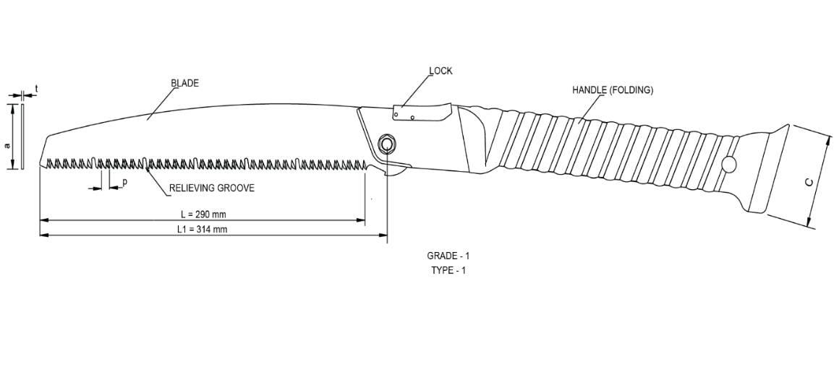

Fig. 1B Typical Example of Double Action Pruning Saw, Grade -1, Type -1 (Folding Handle)

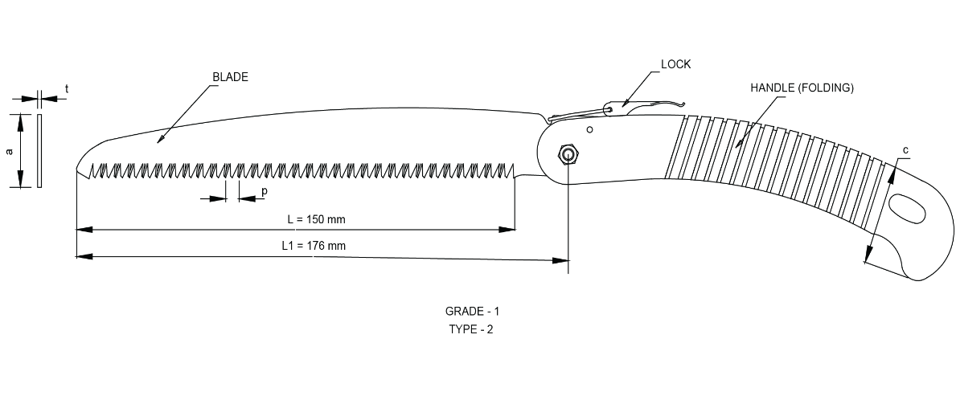

Fig. 2 Typical Example of Double Action Pruning Saw, Grade-1 (Folding Handle)

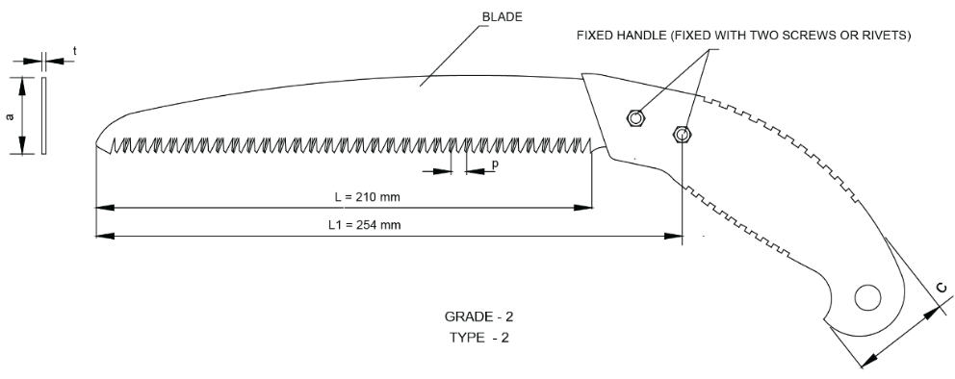 Fig. 3 Typical Example of Double Action Pruning Saw, Grade - 2 (Fixed Handle) 

PITCH (p)

Fig. 4 Double Action Pruning Saw With Detail Tooth Profile

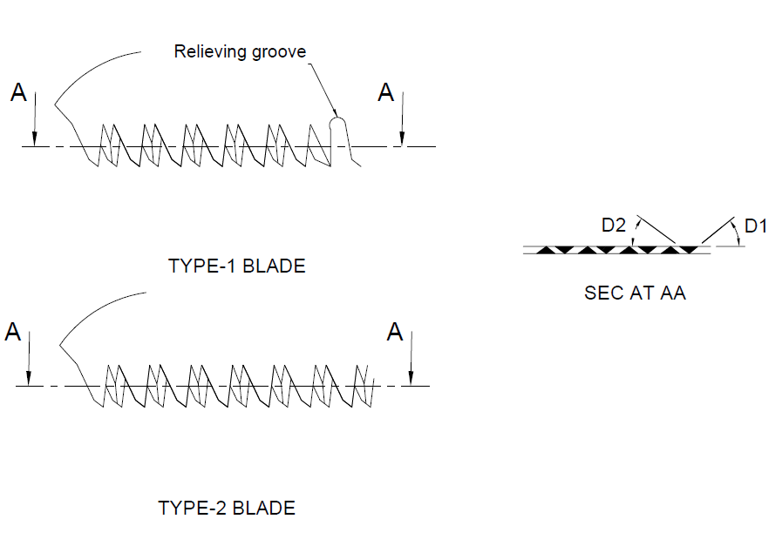

TYPE-1 BLADE

Continuous teeth

Fig. 5 Type-1 and Type-2, Double Action Pruning Saw With Relieving Groove And Continuous Teeth

TYPE-2 BLADE

**5 MATERIALS**

**5.1 Blade of Double Action Pruning Saw**

For the double action pruning saw, the saw blades shall be manufactured from a suitable steel having a carbon content of not less than 0.7 percent. Suitable steels that may be used for this purpose are C70, C75, C80, C85 [*see* IS 1570 (Part 2/Sec 1)] or SK5 grade of steel with a maximum sulphur and phosphorus content of 0.05 percent each.

**5.2 Handle** ­

For the double action pruning saw, the saw handles shall be made of teak wood or mild steel handle with nylon/Plastic/PVC sleeve (*see* IS 9766) or plastic handle (*see* IS 15226). Suitable locking arrangement shall be provided for folding handle pruning saw.

**6 HARDNESS**

The saw blades shall be heat-treated to have a hardness in range of 48 to 55 HRC [*see* IS 1586 (Part 1)]. The hardness shall be measured anywhere on the surface, preferably as near to the sawing edge as possible.

**7 DIMENSIONS**

The main and critical dimensions of the double action pruning saws shall be as given in Table 1, Table 2 and Table 3. The connotations for the symbols used in the tables are as per figures.

**8 OTHER REQUIREMENTS**

**8.1** The saw shall be stamped and annealed before cutting the teeth.

**8.2** The teeth shall be alternatively set on either side of the blade.

**8.3** The handle shall be centrally slit. The width of slot shall not be greater than necessary to receive the blade tang.

**8.4** The steel handle is fixed with the blade using one screw or rivet and locking pin in case of folding handle pruning saw. In case of fixed handle pruning saw, the steel handle is fixed with the blade using two screws or rivets. Riveting is not required for PVC handle.

**8.5** A blade cover made of rexin, canvass or plastics should be provided for safe handling of saw.

**8.6 Teeth Grinding**

Teeth profile should be ground on a suitable grinding machine with the help of special fixture or through some indigenously made special purpose machine.

**8.6.1** *Type-*1

Double action saw with relieving groove shall be formed by grinding as per Table 1 and Fig. 5.

**8.6.2** *Type-*2

Double action saw with continuous teeth shall be formed by grinding as per Table 2 and Fig. 5.

**8.7 Designation**

The saws shall be designated by:

1. commonly used name;
2. grade and type; and
3. nominal size.

*Example:*

Grade 1, Type-1 of double action saw of nominal size 200 mm shall be designated as:

Double action saw: DA — S1/10 — 200

**9 TESTS**

**9.1 Cutting Test/Performance Test**

**9.1.1** The cutting edge of the pruning saw shall be tested by sawing 600 branches of 25 mm diameter or near about diameter of green wood. Upon completion of the test the saw teeth shall not show any sign of damage.

**9.1.2** Each saw, when properly sharpened and set, should make clean and effortless cuts without bending when tested on well-seasoned Indian oak or an appropriate hardwood substitute. This applies to both cutting along and across the grain.

**9.2 Bend Test**

The entire length of the blade shall be made to lie on the periphery of a 150 mm radius segment and kept for one minute. The blade shall not show any sign of damage during test or take any permanent set when released.

**9.3 Straightness Test**

When checked with the aid of a straight edge, or any angle protector, blade shall be visually straight and free from twist.

**10 WORKMANSHIP AND FINISH**

**10.1** The blade shall be ground flat.

**10.2** The tooth edge shall be flat.

**10.4** The components shall be free from cracks, pits splits and other visual defects.

**10.5** The handle shall be finished smooth. It shall be suitably gripped tight to prevent slippage in operation.

**10.6** The blade shall be smeared all over with a mineral jelly or with any other rust preventive paint (*see* IS 1153). The wooden handle may be varnished.

**11 PACKING AND MARKING**

**11.1 Marking**

The saw shall be marked clearly with the following information on its blade/handle:

1. Manufacturer’s name or recognized trademark, if any;
2. Grade and type;
3. Nominal size; and
4. Batch or code number.

**11.2 Packing**

Because of highly sharp edges the exposed metallic parts shall be packed with proper thick paper or plastic sheet, such as blister type or pouch type of packing to prevent any accidental damage of the product or injury to any human being.

**11.3 BIS Certification Marking**

The product(s) conforming to the requirements of this standard may be certified as per the conformity assessment schemes under the provisions of the *Bureau of Indian Standards Act*, 2016 and the Rules and Regulations framed thereunder, and the products may be marked with the Standard Mark.

**12 SAMPLING FOR LOT ACCEPTANCE**

Unless otherwise agreed to between the purchaser and the supplier the sampling criteria for conformity of pruning saw shall be done in accordance as per IS 7201 (Part 1).

**Table 1 The Main Dimensions of the Double Action Pruning Saws (Grade- 1)**

(*Clause* 7)

(All dimensions are in millimetres.)

|  |  |  |  |  |  |  |  |  |  |
| --- | --- | --- | --- | --- | --- | --- | --- | --- | --- |
| **Sl No.** | **Types** | **Nominal**  **Size, L**  **Grade-1** | **Total Length of Blade, L1**  **Grade-1** | **Width of Blade, a**  **Grade-1**  **± 3** | **Width of Handle, C**  **Grade-1** | **Thickness, t**  **Grade-1**  **± 0.04** | **Pitch, p** | **Handle Fastening**  **Grade - 1**  **1 Screw, 1 Lock Pin** | **Referred Figures** |
| (1) | (2) | (3) | (4) | (5) | (6) | (7) | (8) | (9) | (10) |
| i) | Type 1 | 205 | 220 | 36 | 38 | 1.0 | 5.0 | Yes | *see* Fig. 1A |
| 290 | 314 | 44 | 48 | 1.0 | 5.0 | Yes | *see* Fig. 1B |
| iii) | Type 2 | 150 | 176 | 30 | 45 | 0.8 | 9.0 | Yes | *see* Fig. 2 |

**Table 2 The Main Dimensions of the Double Action Pruning Saws (Grade-2)**

(*Clause* 7)

d

| **Sl No.** | **Types** | **Nominal**  **Size (L)**  **Grade-2** | **Total Length of Blade, L1**  **Grade-2** | **Width of Blade, a**  **Grade-2**  **± 3** | **Width of Handle, C**  **Grade-2** | **Thickness, t**  **Grade-2**  **± 0.04** | **Pitch, P** | **Handle Fastening**  **Grade-2**  **2 Screws** | **Referred Figures** |
| --- | --- | --- | --- | --- | --- | --- | --- | --- | --- |
| (1) | (2) | (3) | (4) | (5) | (6) | (7) | (8) | (9) | (10) |
| i) | Type 2 | 210 | 254 | 35 | 40 | 0.8 | 9.0 | Yes | *see* Fig.3 |

**Table 3 Critical Dimensions for Double Action Pruning Saws**

(*Clause* 7 )

|  |  |  |  |
| --- | --- | --- | --- |
|  |  |  |  |
|  |  |  |  |
|  |  |  |  |
|  |  |  |  |
|  |  |  |  |
|  |  |  |  |
|  |  |  |  |
|  |  |  | - |
|  |  |  |  |
|  |  |  | - |
|  |  |  | - |

All dimensions are in millimetres.

|  |  |  |  |
| --- | --- | --- | --- |
|  |  |  |  |
|  |  |  |  |
|  |  |  |  |
|  |  |  |  |
|  |  |  |  |
|  |  |  |  |
|  |  |  |  |
|  |  |  |  |
|  |  |  |  |
|  |  |  |  |
|  |  |  |  |

**ANNEX A**

(*Clause* 2)

**LIST OF REFERRED STANDARDS**

|  |  |
| --- | --- |
| *IS No.* | *Title* |
| IS 1153 : 2021 | Temporary corrosion preventives, hard film, solvent deposited — Specification (*third revision*) |
| IS 1570 (Part 2/Sec 1) : 1979 | Schedules for wrought steels: Part 2 Carbon steels (unalloyed steels), Section 1 Wrought products (other than wires) with specified chemical composition and related properties (*first revision*) |
| IS 1586 (Part 1) : 2018/ ISO 6508-1 : 2016 | Metallic materials — Rockwell hardness test: Part 1 Test method (*fifth revision*) |
| IS 7201 (Part 1) : 1987 | Methods of sampling of agricultural machinery and equipment: Part 1 Hand-tools and hand-operated/animal-drawn equipment (*first revision*) |
|  |  |
| IS 15226: 2002 | Rigid polyvinyl chloride (PVC) compounds — Specification |
|  |  |

**ANNEX B**

(*Foreword*)

**COMMITTEE COMPOSITION**

Agricultural Machinery and Equipment Sectional Committee, FAD 11



| *Organization* | *Representative(s)* | | |
| --- | --- | --- | --- |
| ICAR - Central Institute of Agricultural Engineering, Bhopal | Dr C. R. Mehta **(*Chairperson*)** | | |
| Agricultural Machinery Manufacturers Association (AMMA-India), Gandhinagar | Dr Surendra Singh  Shri Mitul Panchal (*Alternate*) | | |
| All India Coordinated Research Project on Mechanization of Animal Husbandary, Bhopal | Dr S. P. Singh | | |
| All India Farmers Alliance, New Delhi | Dr Rajaram Tripathi  Shrimati Apurva Tripathi (*Alternate*) | | |
| Aspee Agro Equipment Private Limited, Mumbai | Shri Jatin S. Patel  Shri Gangadhar Varpe (*Alternate*) | | |
| Automotive Research Association of India, Pune | Shri A. Akbar Badusha  Shri Girish Tanawade (*Alternate* I)  Shri Gangaram Auti (*Alternate* II) | | |
| CCS Haryana Agricultural University, Hisar | Dr Vijaya Rani | | |
| Central Farm Machinery Training and Testing Institute, Budni | Shri Anil Kumar Upadhyay  Shri Babul Nath Dixit (*Alternate* I)  Shri Parth Lodh (*Alternate* II) | | |
| CLAAS India Private Limited, Chandigarh | Shri Krishna Prabhakar Singh | | |
| CNH Industrial India Private Limited, Pune | Shri Santhosh Rao  Shri Sujit Hinge (*Alternate*) | | |
| Consumer Guidance Society of India, Mumbai | Shri Sitaram Dixit | | |
| Dasmesh Mechanical Works Private Limited, Malerkotla | Shri Sarbjeet Singh Panesar  Shri Gurdeep Singh Panesar (*Alternate*) | | |
| ICAR - All India Coordinated Research Project on Ergonomics and Safety in Agriculture, Bhopal | Dr Sukhbir Singh  Dr Rahul R. Potdar (*Alternate* I)  Shrimati Sweeti Kumari (*Alternate* II) | | |
| ICAR - All India Coordinated Research Project on Farm Implements and Machinery, Bhopal | Dr K. N. Agrawal | | |
| ICAR - Central Institute of Agricultural Engineering, Bhopal | Dr V. P. Chaudhary  Dr U. R. Badegaonkar (*Alternate* I)  Dr Dilip Jat (*Alternate* II) | | |
| Indian Council of Agricultural Research, New Delhi | Dr Panna Lal Singh | | |
| John Deere India Private Limited, Pune | Shri Anand Raj  Shri Chandrashekhar Deshmukh (*Alternate* I)  Shri Pratik Duraphe (*Alternate* II) | | |
| Kerala Agro Machinery Corporation Ltd (KAMCO), Athani | Shri A. Unnikrishnan  Shri P. C. Sajimon (*Alternate*) | | |
| KisanKraft Limited, Bangaluru | Shri Ravindra Agarwal  Shri Ankit Chitalia (*Alternate* I)  Shri Sunil Prasad (*Alternate* II) | | |
| Kubota Agricultural Machinery India Private Limited, Faridabad | Shri Ashok Kumar  Shri Ashish Kumar Mallarh (*Alternate*) | | |
| Maharana Pratap University of Agricultural and Technology, Udaipur | Dr Sanwal Singh Meena | | |
| Mahatma Phule Krishi Vidyapeeth, Rahuri | Dr Sachin Madhukar Nalawade  Shri Vikram Parasharam Kad (*Alternate* I)  Dr Avdhut Ashok Walun (*Alternate* II) | | |
| Mahindra and Mahindra Limited, Mumbai | Shri Pradeep Shinde | | |
| Ministry of Agriculture, Department of Agriculture, New Delhi | Dr V. N. Kale  Shri Arvind N. Meshram (*Alternate*) | | |
| National Innovation Foundation, New Delhi | Shri Rakesh Maheshwari  Shri Mahesh Patel (*Alternate*) | | |
| National Institute of Plant Health Management, Hyderabad | Dr Vidhu Kampurath P.  Shri Mutyala Udaya (*Alternate*) | | |
| North Eastern Region Farm Machinery Training and Testing Institute, Biswanath Chariali | Dr P. P. Rao  Shri S. G. Pawar (*Alternate* I)  Shri Khagendra Bora (*Alternate* II) | | |
| Northern Region Farm Machinery Training and Testing Institute, Hisar | Dr Mukesh Jain  Shri Sanjay Kumar (*Alternate*) | | |
| Power Tillers Manufacturers Association, Kolkata | Shri A. R. Ganesh Kumar | | |
| Punjab Agricultural University, Ludhiana | Dr Mahesh Kumar Narang  Dr Rajesh Goyal (*Alternate* I)  Shri Apoorv Prakash (*Alternate* II) | | |
| Southern Region Farm Machinery Training and Testing Institute, Anantpur | Dr B. M. Nandede | | |
| Tamil Nadu Agricultural University, Coimbatore | Dr R. Kavitha  Dr A. Surendra Kumar (*Alternate* I)  Dr A. P. Mohan kumar (*Alternate* II) | | |
| Tirth Agro Technology Private Limited 'Shaktiman', Rajkot | Shri Parag Devidas Badgujar  Shri V. Audhi Narayan Reddy (*Alternate*) | | |
| Tractor and Mechanization Association, New Delhi | Shri Philip Koshy  Shri Veenit Negi (*Alternate* I)  Shrimati Devyani (*Alternate* II) | | |
| Tube Investments Clean Mobility Private Limited, Chennai | Shri Abhishek Sinha  Shri S. O. Tyagi (*Alternate*) | | |
| Voluntary Organisation in Interest of Consumer Education (VOICE), New Delhi | Shri B. K. Mukhopadhyay | | |
| In Personal Capacity (*201, Memnon Tower, Omaxe The Nile, Sector 49, Sohna Road, Gurugram - 122018*) | Shri Vivek Gupta | | |
| BIS Directorate General | Shrimati Suneeti Toteja, Scientist ‘F’/Senior Director and Head (Food and Agriculture) [Representing Director General (*Ex-officio*)] | | |

*Member Secretary*

Shri Vikrant Chauhan

Scientist ‘B’/Assistant Director

(Food and Agriculture), BIS

Panel to Formulate and Review Indian Standards on Gardening and Forestry Tools and Agricultural Implements, FAD 11/P 3

| *Organization* | *Representative(s)* |
| --- | --- |
| Agricultural Machinery Manufacturers Association (AMMA-India), Gandhinagar | Dr Surendra Singh **(*Convenor*)** |
| ASPEE Agro Equipment Private Limited, Mumbai | Shri Jatin S. Patel  Shri Gangadhar Varpe (*Alternate*) |
| Falcon Garden Tools Private Limited, Ludhiana | Shri Gurchintan Singh Dua |
| ICAR - Central Institute of Agricultural Engineering, Bhopal | Dr Dilip Jat |
| John Deere India Private Limited, Pune | Shri Chandrashekhar Deshmukh |
| Mahatma Phule Krishi Vidyapeeth, Rahuri | Dr Sachin Madhukar Nalawade |