***भारतीय मानक***

***Indian Standard***

**IS 12065 : 2024**

( *IS 4758 : 1968)*

**विद्युत घूर्णन मशीनों के लिए शोर स्तर की अनुमेय सीमा**

**(IEC 60034-9 : 2021, संशोधित)**

*(* पहला पुनरीक्षण )

**Permissible Limits of Noise Levels for Rotating Electrical Machines**

**(IEC 60034-9 : 2021, MOD)**

( *First Revision )*

ICS 29.160.01

© BIS 2024



भारतीय मानक ब्यूरो

BUREAU OF INDIAN STANDARDS

मानक भवन, 9 बहादुर शाह ज़फर मार्ग, नई दिल्ली - 110002

MANAK BHAVAN, 9 BAHADUR SHAH ZAFAR MARG

NEW DELHI - 110002

[www.bis.gov.in](http://www.bis.org.in) [www.standardsbis.in](http://www.standardsbis.in)

**October 2024 Price Group X**

Rotating Machinery Sectional Committee, ETD 15

FOREWORD

This Indian Standard (First Revision) was adopted by the Bureau of Indian Standards, after the draft finalized by the Rotating Machinery Sectional Committee had been approved by the Electrotechnical Division Council.

This standard was first published in 1987. This revision has been brought out to align it with the international practices to the extent possible. This standard supersedes IS 12065 : 1987 andIS 4758 : 1968.

In the preparation of this standard, assistance has been derived from IEC 60034-9 : 2021 ‘Rotating electrical machines — Part 9: Noise limits’ issued by the International Electrotechnical Commission.

Clause **5.3** has been added to the existing IEC text. Table 3 from original IEC has also not been included as it describes values at 60 Hz which is not applicable for India. Further tables have been renumbered accordingly. Text identical to IEC 60034-9 : 2021 must be read with the IEC 60034 series and respective Indian adoptions.

The composition of the Committee responsible for the formulation of this standard is given in Annex D.

For the purpose of deciding whether a particular requirement of this standard is complied with, the final value, observed or calculated, expressing the results of a test, shall be rounded off in accordance with IS 2 : 2022 ‘Rules for rounding off numerical values (*second revision*)’. The number of significant places retained in the rounded off value should be the same as that of the specified value in this standard.

*Indian Standard*

PERMISSIBLE LIMITS OF NOISE LEVELS FOR ROTATING ELECTRICAL MACHINES

*( First Revision )*

### 1 SCOPE

**1.1** This standard specifies that:

1. Test methods for the determination of sound power level of rotating electrical machines;
2. Maximum A-weighted sound power levels for factory acceptance testing of network-supplied, rotating electrical machines in accordance with IS 15999 (Part 1)/IEC 60034-1, having methods of cooling according to IS 6362/IEC 60034-6 and degrees of protection according to IS/IEC 60034-5, and having the following characteristics:
3. Standard design, either a.c. or d.c., without additional special electrical, mechanical, or acoustical modifications intended to reduce the sound power level;
4. Rated output from 1 kW (or kVA) up to and including 5 500 kW (or kVA); and
5. Rated speed not greater than 3 750 min–1.

**1.2** Excluded are noise limits for a.c. motors supplied by converters. For these conditions see Annex Cfor guidance.

**1.3** The object of this document is to determine maximum A-weighted sound power levels, *LWA* in decibels, dB, for airborne noise emitted by rotating electrical machines of standard design, as a function of power, speed and load, and to specify the method of measurement and the test conditions appropriate for the determination of the sound power level of the machines to provide a standardized evaluation of machine noise up to the maximum specified sound power levels. This document does not provide correction for the existence of tonal characteristics.

**1.4** Sound pressure levels at a distance from the machine may be required in some applications, such as hearing protection programs. Information is provided on such a procedure in **7** based on a standardized test environment.

NOTES

**1** This document recognizes the economic reason for the availability of standard noise-level machines for use in non-critical areas or for use with supplementary means of noise attenuation.

**2** Where sound power levels lower than those specified in Table 1, or Table 2 are required, these are agreed between the manufacturer and the purchaser, as special electrical, mechanical, or acoustical design may involve additional measures.

### 2 REFERENCES

The standards listed at Annex A contain provisions, which through reference in this text, constitute provisions of this standard. At the time of publication, the editions indicated were valid. All standards are subject to revision, and parties to agreements based on this standard are encouraged to investigate the possibility of applying the most recent editions of the standards.

**3 TERMS AND DEFINITIONS**

For the purposes of this document, the following terms and definitions apply. ISO and IEC maintain terminological databases for use in standardization at the following addresses:

1. IEC electropedia ­vailable at [http://www.electropedia.org](http://www.electropedia.org/); and
2. ISO Online browsing platform available at <http://www.iso.org/obp>.

**3.1 Maximum Value** —Value that defines the upper limit without further tolerance.

**3.2 Measurement Surface Index (L*S*)** —Ten times the logarithm to the base 10 of the ratio of the measurement surface S to the reference surface (S0 = 1 m2) expressed in decibels.

**3.3 Sound Power Level (L*W*)** —Ten times the logarithm to the base 10 of the ratio of the sound power radiated by the source under test to the reference sound power [Wo = 1 pW (10–12 W)] expressed in decibels.

**3.4 Sound Pressure Level (L*p*)** —Ten times the logarithm to the base 10 of the ratio of the square of the sound pressure to the square of the reference sound pressure [Po = 20 µPa (2 × 10–5 Pa)] expressed in decibels.

**4 METHODS OF MEASUREMENT**

**4.1** Sound pressure level measurements and calculation of sound power level produced by the machine shall be made in accordance with ISO 3744, unless one of the alternative methods specified in **4.3** or **4.4** below applies.

NOTE ­­­— It is general practice to use the parallelepiped method for all shaft heights.

**4.2** The maximum sound power levels specified in Table 1, and Table 2 or adjusted by Table 3 relate to measurements made in accordance with **4.1**.

**4.3** When appropriate, one of the methods of precision or engineering grade accuracy, such as the methods of ISO 3741, ISO 3743-1, ISO 3743-2, ISO 3745, ISO 9614-1 or ISO 9614-2, may be used to determine sound power levels.

**4.4** The simpler but less accurate method specified in ISO 3746 or ISO 3747 may be used, especially when the environmental conditions required by ISO 3744 cannot be satisfied (for example, for large machines).

However, to prove compliance with this document, unless a correction due to inaccuracy of the measurement has already been applied to the values determined by this method in accordance with ISO 3746 or ISO 3747, the levels of Table 1, and Table 2 shall be decreased by 2 dB.

**4.5** If testing under rated load conditions, the methods of ISO 9614-1 or ISO 9614-2 is applicable. However, other methods are allowed when the load machine and auxiliary equipment are acoustically isolated or located outside the test environment.

**5 TEST CONDITIONS**

**5.1 Machine Mounting**

**5.1.1** *Precautions*

Care should be taken to minimize the transmission and the radiation of structure-borne noise from all mounting elements including the foundation. This can be achieved by the resilient mounting for smaller machines; however, larger machines can usually only be tested under rigid mounting conditions.

**5.1.2** *Resilient Mounting*

The natural frequency of the support system and the machine under test shall be lower than a third of the frequency corresponding to the lowest rotational speed of the machine.

The effective mass of the resilient support shall be not greater than one-tenth of that of the machine under test.

**5.1.3** *Rigid Mounting*

The machines shall be rigidly mounted to a surface with dimensions adequate for the machine type (for example, by foot or flange fixed in accordance with the manufacturer's instructions). The machine shall not be subject to additional mounting stresses from incorrect shimming or fasteners.

**5.2 Test Operating Conditions**

The following test conditions shall apply:

1. The machine shall operate at rated voltage(s), rated frequency or rated speed(s) and with appropriate field current(s) (when applicable). These shall be measured with instruments of an accuracy of 1 percent or better;
2. The standard load condition shall be no-load, except for series wound motors; and
3. When required, the machine shall be operated at an agreed load condition.
4. Machines shall be tested in their operating position within their specified duty that generates the greatest noise;
5. For an a.c. motor, the waveform and the degree of unbalance of the supply system shall comply with the requirements of IS 15999 (Part 1)/IEC 60034-1;

NOTE — Any increase of voltage (and current) waveform distortion and unbalance will result in an increase of noise.

1. A synchronous motor with adjustable excitation field shall be run with excitation to obtain unity power factor or for large machines tested as a generator;
2. A generator shall be either run as a motor or driven at rated speed with excitation to obtain the rated voltage on open circuit;
3. A machine suitable for more than one speed shall be evaluated over the operating speed range; and
4. A motor intended to be reversible shall be operated in both directions unless no difference in sound power level is expected. A unidirectional motor shall be tested in its design direction.

**5.3 Background Noise**

The background noise reading when the machine is not on test shall be determined at the same points as for the test. The reading at each point with the machine on test ought to exceed that due to the background alone by at least 10 dB. When the differences are less than 10 dB, corrections can be obtained from the background correction curve shown in Fig. 1.

**5.3.1** In the case of rapidly fluctuating background noise a difference of 10 dB between the maximum background level and the machine on test is essential.

**5.3.2** When corrections of 3 dB or greater are applied, the corrected levels should be indicated in brackets.

**5.3.3** When the increase in noise level due to the machine is less than 3 dB, measurements, in general cases to have any significance.

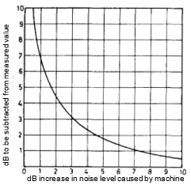

Fig. 1 Background Noise Correction Curve

**6 SOUND POWER LEVEL LIMITS**

Where a machine is tested under the conditions specified in **5,**the sound power level of the machine shall not exceed the relevant value(s) specified as follows:

1. A machine, other than those specified in b), operating at no-load shall be as specified in Table 1.
2. A single-speed three-phase cage induction motor with cooling classification IC411. IC511, IC611, IC01, IC11, IC21, IC31, IC71 and IC81, at 50 Hz or 60 Hz, shaft heights from 90 up to and including 560, and with rated output not less than 1,0 kW and not exceeding 1 000 kW:
3. Operating at no-load shall be as specified in Table 2;
4. Operating at rated load shall be the sum of the values established in Table 2, and Table 3;
5. Grade A in Table 2 is the maximum level that a standard motor shall meet for 50Hz;
6. Grade B in Table 2 is a reduced level for 50Hz motors that will meet the more stringent requirements of the end-user and
7. Unless grade B is specifically requested, grade A is to be used as the default noise level for 50 Hz motors as per Table 2.

NOTES

**1** The limits of Table 1, Table 2 recognize Class 2 accuracy grade levels of measurement uncertainty and production variations.

**2** Sound power levels, under full-load condition, are normally higher than those at no-load. Generally, if ventilation noise is predominant the change may be small, but if the electromagnetic noise is predominant the change may be significant.

**3** The limits are irrespective of the direction of rotation. A machine with a unidirectional ventilator is generally less noisy than one with a bi-directional ventilator. This effect is more significant for high-speed machines, which may be designed for unidirectional operation only.

**4** For some machines, the limits in Table 1 may not apply for speeds below nominal speed. In such a case, or where the relationship between noise level and load is important, limits should be agreed between the manufacturer and the purchaser.

**5** For multispeed machines the values in the Table 1 apply.

**7 DETERMINATION OF SOUND PRESSURE LEVEL**

Sound pressure levels are not required as part of this document. However, if requested by end user to provide pressure levels, for example in accordance with Annex B, it shall be per agreement between user and manufacturer. An A-weighted sound pressure level may be determined directly from the sound power level as follows:

𝐿*p* = 𝐿*W* − 𝐿*S*

𝐿*S* = 10 log10

where

|  |  |  |
| --- | --- | --- |
| *Lp* | = | sound pressure level in a free field over a reflecting plane at 1 m distance from the machine; |
| *LW* | = | sound power level determined according to this document. |
| *LS* | = | measurement surface index; |
| *S0* | = | 1,0 m2; and |
| *S* | = | area of the surface enveloping the machine at a distance of 1 m according to ISO 3744 **7.2.4** (parallelepiped measurement surface). |

NOTES

**1** These sound pressure levels are for free field, over a reflecting plane. The sound pressure level for in situconditions (that is, for hearing protection requirements) is different.

**2** For typical values of the measurement surface index used for conversions from sound power to sound pressure levels for machines in Table 2, *see* Annex B.

**8 DECLARATION AND VERIFICATION OF SOUND POWER VALUES**

**8.1** A machine can be declared to comply with this document if, when tested under the conditions specified in **5**, the sound power level of the machine does not exceed the value specified in **6**.

**8.2** The method selected and the type of measurement surface used shall be reported.

**8.3** When requested sound power values determined according to this document can be reported according to the procedures of IS/ISO 4871using the dual-number presentation (determined sound power level *L* and uncertainty *K*).

Values for the uncertainty *K* are:

1. Single machine

1,5 dB (Grade 1 : Laboratory)

2,5 dB (Grade 2 : Expertise)

4,5 dB (Grade 3 : Verification) (confidence 95 %).

1. Set of machines of the same batch

1,5 dB to 4,0 dB (Grades 1 and 2).

4,0 dB to 6,0 dB (Grade 3).

#### Table 1 Maximum A-Weighted Sound Power Level, LWA in dB, at No-Load (Excluding Motors According to Table 2) (Method of Cooling, IC Code, see IS 6362/IEC 60034-6, Method of Protection, IP Code, see IS/IEC 60034-5)

#### (Clauses 1.4, 4.2, 4.4 and 6)

| **Sl No.** | **Rated Speed**  ***n*N min**–**1** | ***n*N ≤ 960** | | | **960 <*n*N ≤ 1 320** | | | **1 320 <*n*N ≤ 1 900** | | | **1 900 <*n*N ≤ 2 360** | | | **2 360 <*n*N ≤ 3 150** | | | **3 150 <*n*N ≤ 3 750** | | | |
| --- | --- | --- | --- | --- | --- | --- | --- | --- | --- | --- | --- | --- | --- | --- | --- | --- | --- | --- | --- | --- |
| Methods of Cooling  (Simplified Code) | IC01 IC11 IC21 | IC411  IC511  IC611 | IC31  IC71W  IC81W IC8A1W7 | IC01  IC11 IC21 | IC411  IC511  IC611 | IC31  IC71W  IC81W IC8A1W7 | IC01  IC11 IC21 | IC411  IC511  IC611 | IC31  IC71W  IC81W IC8A1W7 | IC01  IC11 IC21 | IC411  IC511  IC611 | IC31  IC71W  IC81W IC8A1W7 | IC01  IC11 IC21 | IC411  IC511  IC611 | IC31  IC71W  IC81W IC8A1W7 | IC01  IC11 IC21 | IC411  IC511  IC611 | IC31  IC71W  IC81W IC8A1W7 |
| Note 1 | Note 2 | Note 2 | Note 1 | Note 2 | Note 2 | Note 1 | Note 2 | Note 2 | Note 1 | Note 2 | Note 2 | Note 1 | Note 2 | Note 2 | Note 1 | Note 2 | Note 2 |
| Rated Output  *PN* kW (or kVA) |  |  |  |  |  |  |  |  |  |  |  |  |  |  |  |  |  |  |
|  |  |  |  |  |  |  |  |  |  |  |  |  |  |  |  |  |  |  |  |
|  | 1≤*P*N≤1,1 | 73 | 73 | – | 76 | 76 | – | 77 | 78 | – | 79 | 81 | – | 81 | 84 | – | 82 | 88 | – |
|  | 1,1<*P*N≤2,2 | 74 | 74 | – | 78 | 78 | – | 81 | 82 | – | 83 | 85 | – | 85 | 88 | – | 86 | 91 | – |
|  | 2,2<*P*N≤5,5 | 77 | 78 | – | 81 | 82 | – | 85 | 86 | – | 86 | 90 | – | 89 | 93 | – | 93 | 95 | – |
|  | 5,5<*P*N≤11 | 81 | 82 | – | 85 | 85 | – | 88 | 90 | – | 90 | 93 | – | 93 | 97 | – | 97 | 98 | – |
|  | 11<*P*N≤22 | 84 | 86 | – | 88 | 88 | – | 91 | 94 | – | 93 | 97 | – | 96 | 100 | – | 97 | 100 | – |
|  | 22<*P*N≤37 | 87 | 90 | – | 91 | 91 | – | 94 | 98 | – | 96 | 100 | – | 99 | 102 | – | 101 | 102 | – |
|  | 37<*P*N≤55 | 90 | 93 | – | 94 | 94 | – | 97 | 100 | – | 98 | 102 | – | 101 | 104 | – | 103 | 104 | – |
|  | 55<*P*N≤110 | 93 | 96 | – | 97 | 98 | – | 100 | 103 | – | 101 | 104 | – | 103 | 106 | – | 105 | 106 | – |
|  | 110<*P*N≤220 | 97 | 99 | – | 100 | 102 | – | 103 | 106 | – | 103 | 107 | – | 105 | 109 | – | 107 | 110 | – |
|  | 220<*P*N≤550 | 99 | 102 | 98 | 103 | 105 | 100 | 106 | 108 | 102 | 106 | 109 | 102 | 107 | 111 | 102 | 110 | 113 | 105 |
|  | 550<*P*N≤1 100 | 101 | 105 | 100 | 106 | 108 | 103 | 108 | 111 | 104 | 108 | 111 | 104 | 109 | 112 | 104 | 111 | 116 | 106 |
|  | 1 100<*P*N≤2 200 | 103 | 107 | 102 | 108 | 110 | 105 | 109 | 113 | 105 | 109 | 113 | 105 | 110 | 113 | 105 | 112 | 118 | 107 |
|  | 2 200<*P*N≤5 500 | 105 | 109 | 104 | 110 | 112 | 106 | 110 | 115 | 106 | 111 | 115 | 107 | 112 | 115 | 107 | 114 | 120 | 109 |

NOTES

**1** Typical enclosure classification IP22 or IP23.

**2** Typical enclosure classification IP44 or IP55.

**Table 2Maximum A-Weighted Sound Power Level, *L*WA in dB, at no-Load, 50 Hz, Sinusoidal Supply (for Single Speed Three-Phase Cage Induction Motors)**

(*Clauses* 1.4, 4.2, 4.4, 6, 7 *and Table* 1)

| **Sl No.** |  | **IC411, IC511, IC611** | | | | | | | | **IC01, IC11, IC21 IC31, IC71, IC81** | | | | | | | |
| --- | --- | --- | --- | --- | --- | --- | --- | --- | --- | --- | --- | --- | --- | --- | --- | --- | --- |
|  | Shaft Height, *H*  in mm | 2 Pole | | 4 Pole | | 6 Pole | | 8 Pole | | 2 Pole | | 4 Pole | | 6 Pole | | 8 Pole | |
|  |  | Grade A | Grade B | Grade A | Grade B | Grade A | Grade B | Grade A | Grade B | Grade A | Grade B | Grade A | Grade B | Grade A | Grade B | Grade A | Grade B |
|  |  |  |  |  |  |  |  |  |  |  |  |  |  |  |  |  |  |
|  | 71 | 78 | 76 | 68 | 64 | 67 | 63 | 67 | 63 | 83 | 83 | 71 | 71 | 65 | 65 | 65 | 65 |
|  | 80 | 79 | 77 | 69 | 65 | 67 | 63 | 67 | 63 | 84 | 84 | 72 | 72 | 66 | 66 | 66 | 66 |
|  | 90 | 80 | 78 | 70 | 66 | 67 | 63 | 67 | 63 | 85 | 85 | 73 | 73 | 67 | 67 | 67 | 67 |
|  | 100 | 83 | 82 | 74 | 70 | 68 | 64 | 68 | 64 | 89 | 89 | 77 | 77 | 68 | 68 | 68 | 68 |
|  | 112 | 83 | 83 | 76 | 72 | 74 | 70 | 74 | 70 | 90 | 90 | 79 | 79 | 74 | 74 | 74 | 74 |
|  | 132 | 86 | 85 | 79 | 75 | 77 | 73 | 75 | 71 | 92 | 92 | 82 | 82 | 77 | 77 | 75 | 75 |
|  | 160 | 89 | 87 | 81 | 77 | 77 | 73 | 76 | 72 | 94 | 94 | 84 | 84 | 77 | 77 | 76 | 76 |
|  | 180 | 89 | 88 | 85 | 80 | 77 | 77 | 77 | 76 | 95 | 95 | 87 | 87 | 81 | 81 | 80 | 80 |
|  | 200 | 95 | 90 | 86 | 83 | 80 | 80 | 80 | 79 | 97 | 97 | 90 | 90 | 84 | 84 | 83 | 83 |
|  | 225 | 96 | 92 | 92 | 84 | 83 | 80 | 83 | 79 | 99 | 99 | 91 | 91 | 84 | 84 | 83 | 83 |
|  | 250 | 97 | 92 | 95 | 85 | 87 | 82 | 86 | 80 | 99 | 99 | 92 | 92 | 86 | 86 | 84 | 84 |
|  | 280 | 102 | 94 | 102 | 88 | 97 | 85 | 94 | 82 | 102 | 101 | 100 | 95 | 96 | 89 | 92 | 86 |
|  | 315 | 108 | 98 | 105 | 94 | 100 | 89 | 97 | 88 | 106 | 105 | 105 | 101 | 99 | 93 | 95 | 92 |
|  | 355 | 111 | 100 | 108 | 95 | 103 | 94 | 99 | 92 | 107 | 107 | 106 | 102 | 104 | 98 | 98 | 96 |
|  | 400 | 111 | 100 | 108 | 96 | 103 | 95 | 99 | 94 | 107 | 107 | 107 | 103 | 104 | 99 | 98 | 98 |
|  | 450 | 111 | 100 | 110 | 98 | 103 | 98 | 102 | 96 | 109 | 107 | 107 | 105 | 104 | 102 | 100 | 100 |
|  | 500 | 113 | 103 | 110 | 99 | 105 | 98 | 104 | 97 | 110 | 110 | 107 | 106 | 106 | 102 | 104 | 101 |
|  | 560 | 113 | 105 | 110 | 100 | 106 | 99 | 104 | 98 | 112 | 112 | 107 | 107 | 106 | 103 | 104 | 102 |

NOTES

**1** The sound-power levels for 2 and 4 pole motors with shaft heights > 315 mm recognize a directional fan configuration. All other values are for bi directional fans.

**2** Limits related to 60Hz operation to be referred from latest valid standard IEC 60034-9.

#### Table 3 Expected Increase, Over no-Load Condition, in A-Weighted Sound Power Levels, ΔLWA in dB, for Rated Load Condition (for Motors According to Table 2)

#### (Clauses 1, 4.2, 4.4,6 and 7)

|  |  |  |  |  |  |
| --- | --- | --- | --- | --- | --- |
| **Sl No.** | **Shaft Height, *H***  mm | **2 Pole** | **4 Pole** | **6 Pole** | **8 Pole** |
| (1) | (2) | (3) | (4) | (5) | (6) |
|  | 71 ≤ *H* ≤ 160 | 2 | 5 | 7 | 8 |
|  | 180 ≤ *H* ≤ 200 | 2 | 4 | 6 | 7 |
|  | 225 ≤ *H* ≤ 280 | 2 | 3 | 6 | 7 |
|  | *H* = 315 | 2 | 3 | 5 | 6 |
|  | 355 ≤ *H* | 2 | 2 | 4 | 5 |

NOTES

**1** This table gives the expected increase at rated load condition to be added to any declared no-load value.

**2** This table does not give guaranteed values. Values can be different for various machines and manufacturers.

# ANNEX A

(*Clause* 2)

**LIST OF REFERRED STANDARDS**

|  |  |
| --- | --- |
| *IS No./Other Standards* | *Title* |
|  | — |
|  |  |
|  | :c— |
|  | : |
| ISO 3741 : 2010 | Acoustics — Determination of sound power levels and sound energy levels of noise sources using sound pressure — Precision methods for reverberation test rooms |
| ISO 3743-1 : 2010 | Acoustics — Determination of sound power levels and sound energy levels of noise sources using sound pressure — Engineering methods for small, movable sources in reverberant fields — Part 1: Comparison method for a hard-walled test room |
| ISO 3743-2 : 2018 | Acoustics — Determination of sound power levels of noise sources using sound pressure — Engineering methods for small, movable sources in reverberant fields — Part 2: Methods for special reverberation test rooms |
| ISO 3744 : 2010 | Acoustics — Determination of sound power levels and sound energy levels of noise sources using sound pressure — Engineering methods for an essentially free field over a reflecting plane |
| ISO 3745 : 2012 | Acoustics — Determination of sound power levels and sound energy levels of noise sources using sound pressure — Precision methods for anechoic rooms and hemi-anechoic rooms |
| ISO 3746 : 2010 | Acoustics — Determination of sound power levels and sound energy levels of noise sources using sound pressure — Survey method using an enveloping measurement surface over a reflecting plane |
| ISO 3747 : 2010 | Acoustics — Determination of sound power levels and sound energy levels of noise sources using sound pressure — Engineering/survey methods for use in situ in a reverberant environment |
| ISO 9614-1 : 1993 | Acoustics — Determination of sound power levels of noise sources using sound intensity — Part 1: Measurement at discrete points |
| ISO 9614-2 : 1996 | Acoustics — Determination of sound power levels of noise sources using sound intensity: Part 2 Measurement by scanning |
|  |  |
|  |  |
|  |  |
|  |  |

# ANNEX B

(*Clause* 7)

**TYPICAL VALUES FOR MEASUREMENT SURFACE INDEX**

**B-1** Typical values for measurement surface index for the conversion from sound power level to sound pressure level based on using parallelepiped measurement surface according to ISO 3744.

$$L_{s}={10 log}_{ 10}( \frac{s}{s_{o}})$$

|  |  |  |
| --- | --- | --- |
| *Sl No.* | *Shaft Height*, H  mm | *LS*  dB |
| (1) | (2) | (3) |
|  | 71 | 11 |
|  | 80 | 12 |
|  | 90 | 12 |
|  | 100 | 12 |
|  | 112 | 12 |
|  | 132 | 12 |
|  | 160 | 12 |
|  | 180 | 13 |
|  | 200 | 13 |
|  | 225 | 13 |
|  | 250 | 14 |
|  | 280 | 14 |
|  | 315 | 14 |
|  | 355 | 15 |
|  | 400 | 16 |
|  | 450 | 16 |
|  | 500 | 17 |
|  | 560 | 17 |

NOTE — The values above are only for guidance and are not used for sound power level determination according to ISO 3744 or other relevant standards.

**ANNEX C**

(*Clause* 1.2)

**INFORMATION ON TYPICAL NOISE INCREMENTS CAUSED BY CONVERTER SUPPLY**

**C-1** Noise emissions of electromagnetic origin at the converter supply can be considered as the superposition of:

1. The noise generated by the voltages and currents of fundamental frequency, which is identical with the noise at sinusoidal supply of the same values; and
2. An increment caused by voltages and currents at other frequencies.

**C-2** Two features mainly influence this increment:

1. The frequency spectrum at the converter terminals,

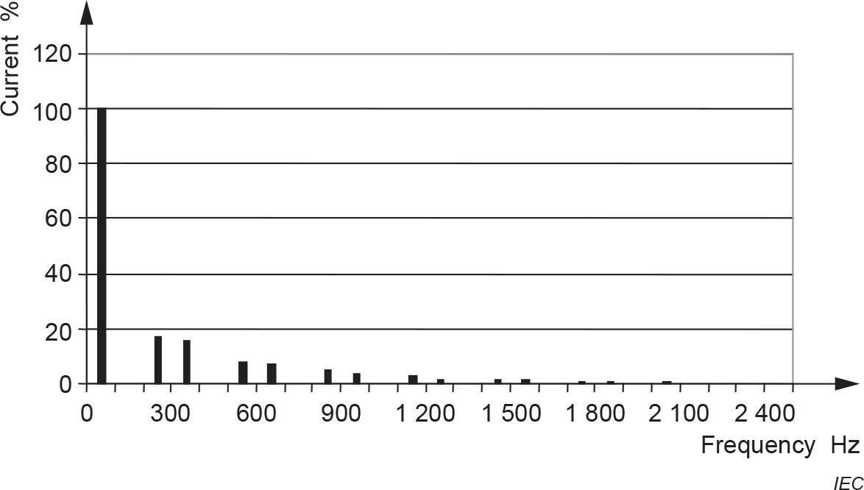Three typical frequency spectra can be identified in Fig. 2, Fig. 3 andFig. 4.

Fig. 2 Frequency Spectrum of the Currents at the Output Terminals of a 6-Pulse Block-Type Current-Source Converter *f*1 = 50 Hz

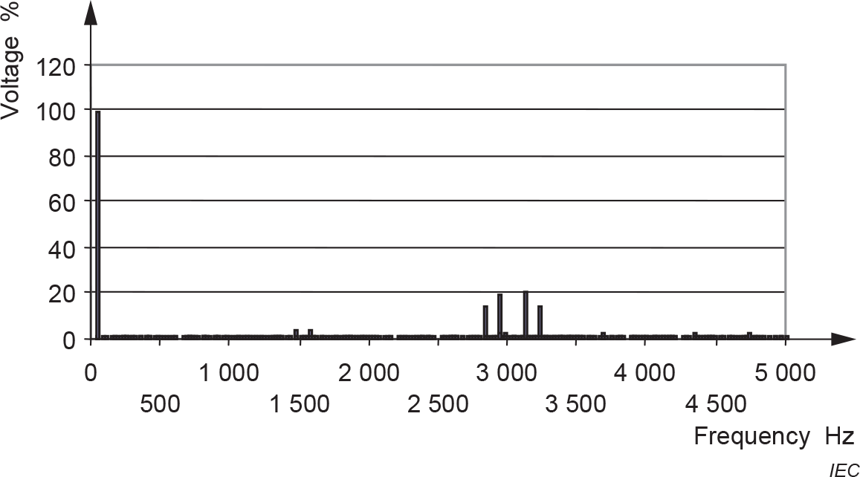

Fig. 3 Frequency Spectrum of the Voltages at the Terminals of a Type A Voltage Source Converter (Characterized by Pronounced Spikes Close to the Switching Frequency and its Multiples) *f*1 = 50 Hz, *f*s = 3 kHz.

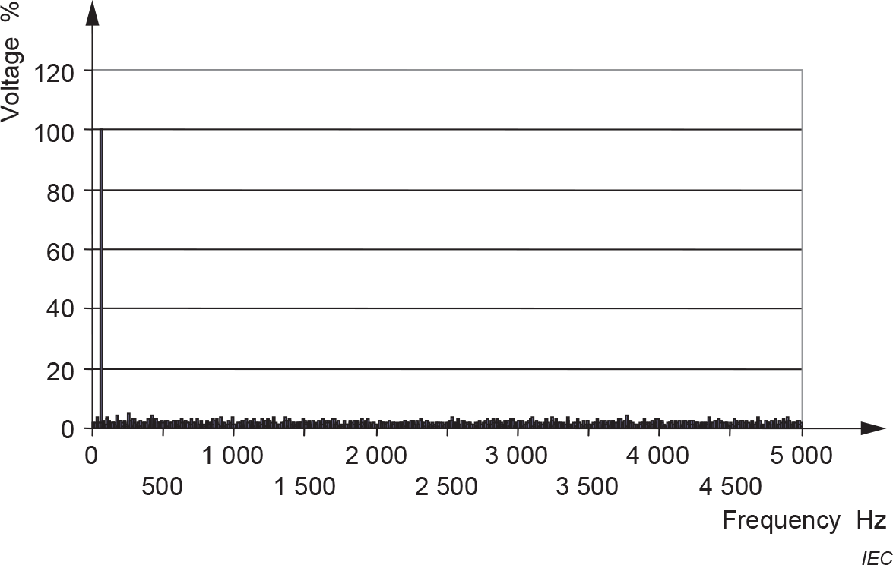

Fig. 4 Frequency Spectrum of the Voltages of a Type B Voltage-Source Converter (Characterized by a Broad Voltage Spectrum Without Pronounced Spikes) *f*1 = 50 Hz, *f*s Average = 4,5 kHz

Specific considerations are necessary when the spectrum deviates significantly from a typical spectrum.

1. Typical values, historically based, for resonance frequencies of the motor for the modes of a vibration caused by the harmonics.

The relevant resonance frequencies of motors can be grouped according to Table 4.

#### Table 4 Resonance Frequencies of Vibration Mode r

(*Clause* C-2)

|  |  |  |  |  |  |
| --- | --- | --- | --- | --- | --- |
| **Sl No.** | **Shaft Height *H*** | **Resonance Frequencies of Vibration Mode r** | | | |
| (1) | (2) | r = 0 | r = 2 | r = 4 | r = 6 |
| (3) | (4) | (5) | (6) |
|  | *H* ≤ 200 mm | > 4 000 Hz | > 600 Hz | > 4 000 Hz | > 5 000 Hz |
|  | *H* ≥ 280 mm | < 3 000 Hz | < 500 Hz | < 2 500 Hz | < 4 000 Hz |

A magnetically excited tone is generated by the interaction of the fundamental fields of the number of pole pairs *p* of the fundamental frequency *f*1 at the motor terminals and of one of the harmonic frequencies *n × f*1, as shown in the relevant frequency spectrum. The tones are of:

franchise *fr = f1* X (n ± 1) =

vibration modes *r* = *p* ± *p = $〈$ $\begin{matrix}2p \\ 0\end{matrix}$*

Usually combinations with *n × f*1, close to the switching frequency generate objectionable tones.

A reasonable increase of the audible noise is to be expected, if the frequency and the vibration mode of a tone are close to the corresponding values of the resonant structure of the motor. In some cases, objectionable tones may be avoided by changes to the parameter assignment of the converter.

Table 5 shows the typical increase of noise, at converter supply, when compared to the noise at sinusoidal supply, with the same fundamental values of voltage and frequency.

**Table 5 Increments of A-Weighted Noise Values**

(*Clause* C-2)

|  |  |  |  |
| --- | --- | --- | --- |
| **Sl No.** | **Kind of Converter** | **Case** | **Expected Increment** |
| (1) | (2) | (3) | (4) |
|  | Block-type current-source converter | 6-pulse or 12-pulse | 1 dB to 5 dB  The higher values relate to motors with low ventilation noise.  Increment depends on load. |
|  | Type A  voltage-source converter | High frequency voltages of high  amplitudes excite resonances of the motor | Up to 15 dB  Increment does not depend on load.  Initial calculation possible by adequate software. |
| High frequency voltages of high  amplitudes do not excite resonances of the motor | 1 dB to 5 dB  Increment does not depend on load. |
|  | Type B  voltage-source converter | Broad voltage spectrum without pronounced spikes | 5 dB to 10 dB  Increment does not depend on load. |

## **C-3** Bibliography

IEC TS 60034-25, *Rotating electrical machines – Part 25: AC electrical machines used in power drive system – Application guide.*

ISO 1680, *Acoustics – Test code for the measurement of airborne noise emitted by rotating electrical machines*

ISO 80000-8, *Quantities and units* – *Part 8: Acoustics*

NEMA MG 1, *Motors and Generators – Part 9: Rotating Electrical Machines – Sound Power Limits and Measurement Procedures*

**ANNEX D**

(*Foreword*)

**COMMITTEE COMPOSITION**

Rotating Machinery Sectional Committee, ETD 15

| *Organization* | *Representative(s)* |
| --- | --- |
| Bharat Heavy Electricals Limited, Bhopal | Shri Mukesh Kumar Maravi **(*Chairperson*)** |
| Asea Brown Boveri Limited, Faridabad | Shri Sumit Tyagi  Shri Lokesh B. M. (*Alternate*) |
| Bharat Bijlee Limited, Mumbai | Shri Salil Kumar  Miss Bhagyashree Sanjay Pawar (*Alternate*) |
| Bharat Heavy Electrical Limited, New Delhi | Shri Krushna Chandra Panda  Shri P. Dali Naidu (*Alternate*) |
| Central Electricity Authority, New Delhi | Shri Jitesh Shrivas  Shri Rishabh Gaur (*Alternate*) |
| Central Power Research Institute, Bengaluru | Shri S. Prashob |
| Electrical Research and Development Association, Vadodara | Shri Ravi Singh  Shri Jitendra Tahilwani(*Alternate*) |
| Engineers India Limited, New Delhi | Shri Raman Sood  Shri Ravish K. Raman (*Alternate* I) |
| Havells India Limited, Noida | Shri Vinayak Atre  Shri Anil Sukumar Akole (*Alternate*) |
| Hindustan Electric Motors, Mumbai | Shri Sanjay P. Jadia  Shri Dilip Bhave (*Alternate*) |
| Indian Electrical and Electronics Manufacturers Association, New Delhi | Shri Seetharaman K.  Shri Praveen Kumar (*Alternate*) |
| Indian Pump Manufacturers Association, Mumbai | Shri K. V. Karthik  Shri Utkarsh A. Chhaya (*Alternate* I)  Shri Anoop Agarwal (*Alternate* II) |
| Integrated Electric Company Private Limited, Bengaluru | DR Praveen Vijayraghavan |
| International Copper Association India, Mumbai | Shri K. N. Hemanth Kumar  Shri Jyotish Pande(*Alternate*) |
| NTPC Limited, New Delhi | Shri B. V. V. S. Ganesh  Shri S. N. Tripathi (*Alternate*) |
| Nuclear Power Corporation of India Limited, Mumbai | Shri Ritesh M. Chovatia  Shri Jayanth Kumar Boppa (*Alternate*) |
| PICL India Private Limited, Faridabad | Shri Rabindra sahoo  Shri Pankang Taneja (*Alternate*) |
| Rotomag Motors and Controls Private Limited, Gujarat | Shri Umesh Balani |
| Scientific and Industrial Testing and Research Centre, Coimbatore | Shri V. Krishnamoorthy  Dr K. Ulaganathan (*Alternate*) |
| Siemens Limited, Mumbai | Shri Prasad Hardikar  Shri Ashish Shere(*Alternate*) |
| Southern India Engineering Manufacturers Association, Coimbatore | Dr R. Subramanian  Shri S. Arunkumar (*Alternate*) |
| Thyssenkrupp Industrial Solutions (India) Private Limited, Mumbai | Miss Charuta Vikram Mulay  Shri Vaijnath G. Sangekar (*Alternate*) |
| Toshiba Mitsubishi-Electric Industrial Systems Corporation, Bengaluru | Shri Sudheer Tapaskar  Shri Manish Joshi (*Alternate*) |
| BIS Directorate General | Shri Asit Kumar Maharana, Scientist ‘E’/ Director and Head (Electrotechnical) [Representing Director General (*Ex-officio*)] |

*Member Secretary*

Jatin Tiwari

Scientist ‘C’/Deputy Director

(Electrotechnical), BIS