IS 8060: 2024

***भारतीय मानक***

***Indian Standard***

**Doc: CHD 19 (25550) F**

**November 2024**

**जूते के लिए कील के साथ हील - टिप और टो - टिप—** विशिष्टि

(***पहला पुनरीक्षण***)

**Heel-Tip And Toe-Tip With Nails For Footwear —Specification**

(*First Revision*)

ICS 61.060

© BIS 2024



भारतीय मानक ब्यूरो

BUREAU OF INDIAN STANDARDS

मानक भवन, 9 बहादुर शाह ज़फर मार्ग, नई दिल्ली –110002

MANAK BHAVAN, 9 BAHADUR SHAH ZAFAR MARGNEW DELHI - 110002

[www.bis.gov.in](http://www.bis.org.in) [www.standardsbis.in](http://www.standardsbis.in)

**November 2024 Price Group X**

Footwear Sectional Committee, CHD 19

FOREWORD

This Indian Standard (First Revision) was adopted by the Bureau of Indian Standards, after the draft finalized by the Footwear Sectional Committee had been approved by the Chemical Division Council.

Heel-tips and toe-tips are important footwear accessories. They are used in industrial and safety leather boots and other types of ankle boots for heavy duty and general purposes.

This standard was first published in 1976. This revision has been brought out to in order to bring out the standard in latest style and format of the Indian Standards. The Reference clauses has been added and the references has been updated.

The composition of the Committee responsible for the formulation of this standard is given in Annex B.

For the purpose of deciding whether a particular requirement of this standard is complied with, the final value, observed or calculated, expressing the result of a test or analysis, shall be rounded off in accordance with IS 2 : 2022 ‘Rules for rounding off numerical values (*second revision*)’*.* The number of significant places retained in the rounded off value should be the same as that of the specified value in this standard.

*Indian Standard*

**HEEL-TIP AND TOE-TIP WITH NAILS FOR**

**FOOTWEAR — SPECIFICATION**

( *First Revision* )

**1 SCOPE**

This standard prescribes the requirements and method of sampling for heel-tip and toe-tip with nails intended for use in footwear.

**2 REFERENCES**

The Indian standards given in contain provisions which through reference in this text, constitute provisions of this standard. At the time of publication, the editions indicated were valid. All standards are subject to revision, and parties to agreements based on this Indian standard are encouraged to investigate the possibility of applying the most recent edition of these standards:

|  |  |
| --- | --- |
| *IS No.* | *Title* |
| IS 1573 : 1986 | Specification for electroplated coatings of zinc on iron and steel (*second revision*) |
| IS 2050 : 1991 | Glossary of terms & elating to footwear (*first revision*) |
| IS 2633 : 1986 | Method for testing uniformity of coating on zinc coated articles (*second revision*) |
| IS 4905: 2015/  ISO 24153 : 2009 | Random sampling and randomization procedures (*first revision*) |

**3 TERMINOLOGY**

For the purpose of this standard, definition given in IS 2050 shall apply.

**4 REQUIRMENTS**

**4.1** Heel-tip and toe-tip shall be made of rust-proofed mild steel. The treatment for rust-proofing shall be as given in **4.1.1**

**4.1.1** After manufacture the tips shall be either electroplated with zinc to service condition no. 4 of IS 1573 or hot- tip galvanized conforming to IS 2633.

**4.2** Hell-tip and toe-tip shall conform to the shape and design shown in Fig 1.

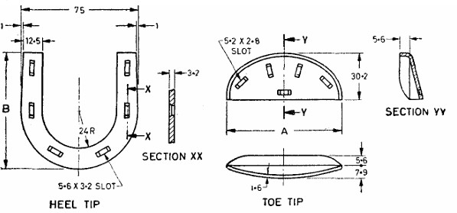

All dimensions in millimetres FIG. 1 HEEL-TIP AND TOE-TIP

**4.3 Dimensions**

**4.3.1** Heel-tip and toe-tip shall conform to the dimensions given in Fig. and Table 1.

# TABLE 1 DIMENSION OF HEEL-TIP AND TOE-TIP

(*Clause* 4.3.1)

|  |  |  |  |
| --- | --- | --- | --- |
| **Sl No** | **Boot or Shoe Size** | **Dimension, mm** |  |
|  |  | *B* for Heel-Tip | *A* for Toe-Tip |
| (1) | (2) | (3) | (4) |
| i) | 3 to 5 | 73 | 70 to 73 |
| ii) | 6 to 7 | 76 | 73 |
| iii) | 8 to 9 | 79 | 76 |
| iv) | 10 to 11 | 82.5 | 79 |
| v) | 12 to 14 | 86 | 82.5 |



**4.3.3** *Tolerance —* A tolerance of ± 1 mm shall be allowed on the length and ± 0.25 mm on other dimensions of the heel-tip and toe-tip.

**4.4 Heel-Tip Nail and Toe-Tip Nail**

**4.4.1** Heel-tip nail and toe-tip nail shall be made of rust-proofed mild steel. The treatments for rust-proofing shall be as given in **4.1.1.**

**4.4.2** *Shape and Dimension —* Heel-tip nail and toe-tip nail shall conform to the shape, design and dimension shown in Fig. 2.

++++++++++++++++++++++

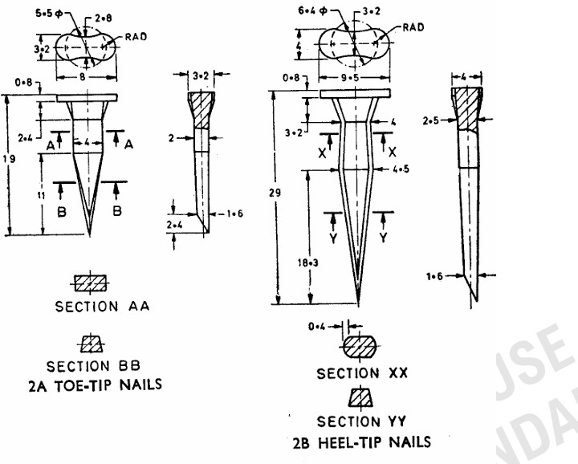

All dimension in millimetres.

Fig. 2 Toe-Tip And Heel-Tip Nails

**4.4.2.1** *Tolerance —* The following tolerance shall be allowed on the various dimensions:

|  |  |
| --- | --- |
| Length | ± 1.6 mm |
| Other dimensions except for the tip and thickness of  head | ± 0.25 mm |
| thickness of head | ± 0.1 mm |

**5 PACKING AND MARKING**

**5.1 Packing**

**5.1.1** Heel-tip and toe-tip shall be packed in suitable containers as agreed to between the purchaser and the supplier.

**5.1.2** Heel-tip nail and toe-tip nail shall be packed in suitable containers as agreed to between the purchaser and the supplier.

**5.1.3** Each container shall be marked with the following:

1. Name of the material;
2. Size and quality;
3. Batch number;
4. Manufacturer’s name and recognized trade-mark, if any; and
5. Date of manufacture.

**5.2 Marking**

**5.2.1** *BIS Certification Marking*

The product(s) conforming to the requirements of this standard may be certified as per the conformity assessment schemes under the provisions of the *Bureau of Indian Standards Act,* 2016and the Rules and Regulations framed thereunder, and the products may be marked with the Standard Mark.

**6 SAMPLING**

The method of drawing representative samples and the criteria for conformity shall be as prescribed in Annex A.

**ANNEX A**

(*Clause* 6)

**SAMPLING OF HEEL-TIP AND TOE-TIP WITH NAILS A-1 SCALE OF SAMPLING**

**A-1.1 Lot**

All tips and nails of the same size, shape, and similar dimensions in a consignment shall be grouped together to constitute a lot.

**A-1.2** The conformity of tips and nails to the requirements of this specification shall be ascertained for each lot separately. The number of tips and nails to be selected from each lot shall depend on the size of the lot and shall be in accordance with col (2) and (3) of Table 2.

**A-1.3** These tips and nails shall be selected at random from the lot. In order to ensure the randomness of selection, random sampling procedures given in IS 4905 may be followed. If the tips and nails are packed in a number of containers, at least 20 percent of them shall be opened and equal number of tips and nails shall be selected from each container to constitute the required sample**.**

**TABLE 2 SCALE OF SAMPLING AND PERMISSIBLE NUMBER OF DEFECTIVE TIPS AND NAILS**

(*Clauses* A-1.2 *and* A-2.1)

|  |  |  |  |
| --- | --- | --- | --- |
| **Sl. No** | **Lot Size** | **No. of Tips and Nails to be Selected** | **Permissible Number of Defectives** |
|  | *N* | *n* |  |
| (1) | (2) | (3) | (4) |
| i) | Up to 1 000 | 5 | 0 |
| ii) | 1 001 to 3 000 | 8 | 0 |
| iii) | 3 001 to 5 000 | 13 | 0 |
| iv) | 5 001 to 10 000 | 20 | 1 |
| v) | 10 001 and above | 32 | 1 |

**A-2 NUMBER OF TESTS AND CRITERIA FOR CONFORMITY**

**A-2.1** All tips and nails selected under **A-1.2** shall be examined for rust-proofness of mild steel, shape, design and dimensions (**4.1**, **4.2**, **4.3** and **4.4**). A tip or a nail failing to satisfy any of these requirements shall be considered as defective. The lot shall be accepted as conforming to the requirements of this specification if the number of defective tips and nails found in the sample does not exceed the respective permissible number of defective tips and nails given in col (4) of Table 2.

**ANNEX B**

(*Foreword*)

**COMMITTEE COMPOSITION**

Footwear Sectional Committee, CHD 19

|  |  |
| --- | --- |
| *Organization* | *Representative(s)* |
| In Personal Capacity *(Flat F1, Bhoopathy Apartment, 10, Ethiraj Street, Palipattu, Chennai –600113*) | DR B. N. DAS **(*Chairperson*)** |
| Atharva Laboratories Private Limited, Noida | MS APARNA PARVATIKAR  Shri J. BASAK (*Alternate*) |
| Bata India Limited, Kolkata | Shri HITESH KAKKAR  Shri GOVINDARAJU (*Alternate*) |
| CSIR - Central Leather Research Institute, Chennai | DR R. MOHAN  DR MAHESH KUMAR .J (*Alternate*) |
| Central Footwear Training Institute, Chennai | Shri K MURALI |
| Central Reserve Police Force, New Delhi | Shri SANJEEV KUMAR SINGH  Shri D. P. UPADHYAY (*Alternate*) |
| Confederation Of Indian Footwear Industries, New Delhi | Shri RAJ KR. GUPTA  Shri V NOUSHAD (*Alternate*) |
| Council For Leather Exports, Chennai | Shri A. FAYAZ AHMAD  Shri D. GOKULAKRISHNAN (*Alternate*) |
| Directorate General of Mines Safety, Dhanbad | Shri SAIFULLAH ANSARI  Shri A RAJESHWAR RAO (*Alternate*) |
| Footwear Design And Development Institute, Noida | Shri SHAILENDAR SAXENA  Shri SAROJ KUMAR PANDA (*Alternate*) |
| Indian Footwear Components Manufacturers Association, Noida | Shri SHARAD KANT VERMA  Shri SANJAY GUPTA (*Alternate*) |
| Laghu Udyog Bharati, New Delhi | Shri JATINDER PAUL CHUGH  Shri AMIT SANCHETI (*Alternate*) |
| Lancer Footwear India Private Limited, New Delhi | Shri SAURABH GUPTA |
| Liberty Shoes Limited (P.U. Division), Karnal | Shri SHRI S. S. LAHIRI  Shri ADESH GUPTA (*Alternate*) |
| MB Rubber Private Limited, Delhi | Shri VIPAN MEHTA |
| MSME Technology Development Centre (PPDC), Meerut | Shri ADITYA PRAKASH SHARMA  Shri TULARAM BHARTI (*Alternate*) |
| Pinza Footwear, New Delhi | Shri PREM MEHANI |
| Prolific Engineers, Noida | Shri G P KEDIA |
| SGS India Private Limited, Gurugram | Shri P. VENKATESAN  Shri K PACHAIYAPPAN (*Alternate*) |
| Top Lasts, Agra | Shri ANURAG SHARMA  Shri DEEPAK MANCHANDA (*Alternate*) |
| Xo Footwear Private Limited, Delhi | Shri NALIN GUPTA  Shri. MANOJ KUMAR (*Alternate*) |
| BIS Director General | SHRI AJAY KUMAR LAL, SCIENTIST ‘F’/SENIOR DIRECTOR AND HEAD, (CHEMICAL) [REPRESENTING DIRECTOR GENERAL (*Ex*-*officio*)] |

*Member Secretary*

MS PREETI PRABHA

SCIENTIST ‘D’/JOINT DIRECTOR

(CHEMICAL), BIS