**IS 11484 : 2024 Doc. : CHD 05 (24804) F**

***भारतीय मानक***

***Indian Standard***

**इलेक्ट्रोप्लेटिंग के लिए फिनोल सल्फोनिक एसिड — विशिष्टि**

(*पहला पुनरीक्षण* )

**Phenol Sulphonic Acid for Electroplating — Specification**

(*First Revision*)

ICS 25.220.40

© BIS 2024

**भारतीय मानक ब्यूरो

BUREAU OF INDIAN STANDARDS

मानक भवन, 9 बहादुर शाह ज़फर मार्ग, नई दिल्ली –110002

MANAK BHAVAN, 9 BAHADUR SHAH ZAFAR MARGNEW DELHI - 110002

[www.bis.gov.in](http://www.bis.org.in) [www.standardsbis.in](http://www.standardsbis.in)

**October 2024 Price Group X**

Electroplating Chemicals and Photographic Materials Sectional Committee, CHD 05

FOREWORD

This Indian Standard (First Revision) was adopted by the Bureau of Indian Standards, after the draft finalized by the Electroplating Chemicals and Photographic Materials Sectional Committee had been approved by the Chemical Division Council.

Phenol sulphonic acid is largely used in acid tin plating to control the atmospheric oxidation of stannous ions present in the manufacture of electrolytic tinplate and cold reduced black plate. It is also used in acid Copper plating for increasing hardness in the copper deposit. Phenol sulphonic acid is normally manufactured by reaction of concentrated sulphuric acid onphenol. This acid is also known as sulphocarbolic acid.

This standard was first published in 1985. In this revision, alternative instrumental test methods AAS, ICP-MS and ICP-OES have been incorporated for the determination of iron and the standard has been updated based on the experience of last four decades and on the currently available data.

The composition of the Committee responsible for formulation of this standard is given in Annex C.

For the purpose of deciding whether a particular requirement of this standard is complied with, the final value, observed or calculated, expressing the result of a test or analysis, shall be rounded off in accordance with IS 2 : 2022 ‘Rules for rounding off numerical values (*second revision*)’. The number of significant places retained in the rounded off value should be the same as that of the specified value in this standard.

*Indian Standard*

PHENOL SULPHONIC ACID FOR ELECTROPLATING — SPECIFICATION

*( First Revision )*

**1 SCOPE**

This standard prescribes the requirements and the methods of sampling and test for phenol sulphonic acid in the form of para isomer used for electroplating, especially in the manufacture of electrolytic tinplate, electrotinned wires and copper plating and electrotinning.

**2 REFERENCES**

The standards given below contain provisions which, through reference in this text, constitute provision of this standard. At the time of publication, the editions indicated were valid. All standards are subject to revision, and parties to agreements based on this standard are encouraged to investigate the possibility of applying the most recent editions of these standards:

|  |  |
| --- | --- |
| *IS No.* | *Title* |
| IS 1070 : 2023 | Reagent grade water — Specification *(fourth revision)* |
| IS 1260 (Part 1) : 1973 | Pictorial markings for handling and labelling of goods: Part 1 Dangerous goods |
| IS 3025  (Part 2) : 2019/ ISO 11885 : 2007 | Methods of sampling and test (Physical And Chemical) for water and wastewater: Part 2 Determination of selected elements by inductively coupled plasma optical emission spectrometry (ICP-OES) (*first revision*) |
| (Part 65) : 2022/ ISO 17294-2 : 2016 | Application of inductively coupled plasma mass spectrometry (ICP-MS) — Determination of selected elements including uranium isotopes (*first revision*) |
| IS 4905 : 2015/ ISO 24153 : 2009 | Random sampling and randomization procedures (*first revision*) |
| IS 13320 : 1992 | Determination of iron by atomic absorption spectrophotometry — Test method |

**3 REQUIREMENTS**

**3.1 Description**

Phenol sulphonic acid shall be a clear brown or yellowish liquid and shall be free from suspended matter and other visible impurities and shall correspond essentially to the formula C6H4(OH)SO3H.

**3.2** The material shall also comply with the requirements given in Table 1 when tested according to the methods specified in Annex A. Reference to the relevant clauses of Annex A is given in col (4) of the table.

**Table 1 Requirements for Phenol Sulphonic Acid**

|  |  |  |  |
| --- | --- | --- | --- |
| **SI No.** | **Characteristic** | **Requirement** | **Method of Test (Ref to Clause No. of Annex A)** |
| (1) | (2) | (3) | (4) |
|  | Relative density, *Max* | 1.34 | **A-2** |
|  | Phenol sulphonic acid, percent by mass, *Min* | 65.0 | **A-3** |
|  | Free sulphurif bggggggggggggg Free sulphuric acid, percent by mass, *Max* | 3.0 | **A-3.2** |
|  | Free phenol, percent by mass, *Max* | 2.0 | **A-4** |
|  | Sulphur dioxide, percent by mass, *Max* | 0.01 | **A-5** |
|  | Iron, percent by mass, *Max* | 0.01 | **A-6** |
|  | Freezing point, oC, *Max* | 3.00 | **A-7** |

**4 PACKING AND MARKING**

**4.1 Packing**

**4.1.1** The material shall be packed in high density polyethylene carbuoys not exceeding 35 kg in mass when packed.

**4.1.2** The carbuoys shall be fitted with leak tight stopper with screwed caps over the stopper and sealed as agreed to between the manufacturer and the purchaser.

**4.2 Marking**

**4.2.1** The carbuoys shall be marked in letters not less than 2.5 cm in height.

**4.2.2** The containers shall be marked with the following:

1. Name of the material;
2. Name of the manufacturer and/or his recognized trade-mark, if any;
3. Net mass of the material; and
4. Date and batch number of the manufacture to enable the material to be traced from records**.**

**4.2.3** The containers shall be labelled as shown in Fig. 7 of IS 1260 (Part 1).

**4.2.4** *BIS Certification Marking*

The product(s) conforming to the requirements of this standard may be certified as per the conformity assessment schemes under the provisions of the *Bureau of Indian Standards Act*, 2016 and the Rules and Regulations framed thereunder, and the products may be marked with the Standard Mark.

**5 SAMPLING**

The method of preparing representative samples of the material and criteria for its conformity with the specification shall be as prescribed in Annex B.

**ANNEX A**

(*Clause* 3*.*2 *and* *Table* 1**)**

**METHODS OF TEST FOR PHENOL SULPHONIC ACID**

**A-1 QUALITY OF REAGENTS**

Unless specified otherwise, pure chemicals and distilled water (*see* IS 1070) shall be used in tests.

NOTE — ‘Pure chemicals’ shall mean chemicals that do not contain impurities which affect the results of analysis.

**A-2 DETERMINATION OF RELATIVE DENSITY**

**A-2.1 Apparatus**

**A-2.1.1** *Squibb Specific Gravity Bottle*

The specific gravity bottle is of 100 ml capacity, having a ground graduated capillary tube and a glass stopper as shown in Fig. 1.

**A-2.2 Procedure**

Clean and thoroughly dry the specific gravity bottle and weigh it. Fill it up to the mark with freshly boiled and cooled water, which has been maintained at a temperature of 27 oC ± l oC, and weigh. Remove the water, dry the bottle again and fill it with the material maintained at the same temperature. Weigh the bottle again.

**A-2.3 Calculation**

**A-2.3.1** Relative density $=\frac{C - A}{B - A}$

where

*C* = mass, in g, of the specific gravity bottle with the material;

*A* = mass, in g, of the empty specific gravity bottle; and

*B =*mass, in g, of the-specific gravity bottle with water.

**A-3** **DETERMINATION OF PHENOL SULPHONIC ACID**

**A-3.1 Total Free Acid**

**A-3.1.1** *Reagents*

**A-3.1.1.1** *Standard sodium hydroxide* solution — 0.1 N

**A-3.1.1.2** *Methyl purple indicator Solution —* 0.2 percent in distilled water

**A-3.1.2** *Procedure*

Weigh accurately 10 g sample of the phenol sulphonic acid, transfer it to a one litre volumetric flask, and dilute to one litre with distilled water. Aliquots of this solution are used for determining total free acid and free sulphuric acid. Dilute a 50 ml aliquot to 100 ml in a 500 ml Erlenmeyer flask. Titrate with 0.1 N sodium hydroxide solution using 5 to 10 drops of methyl red or preferably the mixed indicator of methyl purple (0.2 percent methylene blue + 0.2 percent methyl red in alcohol) for end point detection.

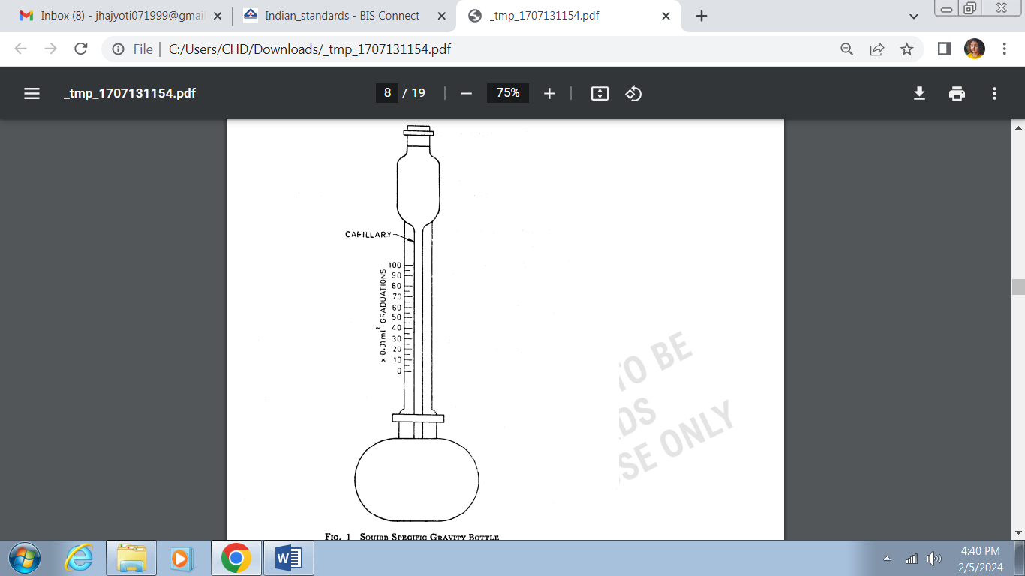

Fig. 1 Squibb Specific Gravity Bottle

**A-3.1.3** *Calculation*

$$Total free acid, percent by mass (T)=\frac{V × N × 98}{M}$$

where

*V**=*volume; in ml; of standard sodium hydroxide consumed in titration;

N = normality, of standard sodium hydroxide solution; and

*M* ***=*** mass; in g, of the material taken for the test.

**A-3.2 Free Sulphuric Acid**

**A-3.2.1** *Reagents*

**A-3.2.1.1***Hydrochloric acid**—*approximately 2 percent (*m*/*v*)

**A-3.2.1.2** *Barium chloride solution**—*approximately 10 percent (*m/v*)

**A-3.2.1.3** *Silver nitrate**—*approximately 2 percent (*m/v*)

**A-3.2.2** *Procedure*

To a 50ml aliquot (*see* **A-3.1.2**), add 5 ml concentrated hydrochloric acid. Filter the solution, add dilute to approximately 100 ml with distilled water. Add 10 ml of 10 percent barium chloride solution and stir the solution with a glass rod. Allow to stand for about 12 h or longer and filter through a Whatman filter paper no. 42 orits equivalent. With the aid of filter pulp wash the precipitate well with cold 2 percent hydrochloric acid. Then wash with distilled water until the precipitate is free from chloride ions (determined by testing portion of the filtrate with silver nitrate). Place the paper containing the precipitate in a previously weighed porcelain/silica crucible. Heat the crucible slowly to char the paper and burn off the carbon. Finally ignite at about 900 °C for one hour in a muffle furnace. Cool in a desiccator and weigh as barium sulphate.

**A-3.2.3** *Calculation*

$$Free sulphuric acid (S), percent by mass=\frac{M_{1 }×0.42 × 20}{M}×100$$

where

*M1*=mass, in g, of barium sulphate; and

*M*=mass, in g, of the sample taken for test.

**A-3.3 Phenol Sulphonic Acid**

Percent by mass = 3.551 × (*T ̶ S*)

where

*T* = as obtained under **A-3.1.3**; and

*S* = as obtained under **A-3.2.3**.

**A-4 DETERMINATION OF FREE PHENOL**

**A-4.1 Apparatus** — 500 ml round bottom distillation flask with ground glass.

**A-4.2 Reagents**

**A-4.2.1** *Potassium Bromide*-*Bromate Solution* (0.1 N)

Dissolve2.784 g of recrystallized and dried potassium bromate (KBrO3) in distilled water. Add 10 g potassium bromide (KBr) and dilute to one litre. Standardize against 0.1 N sodium thiosulphate (Na2S2O3) using starch paste as indicator.

**A-4.2.2** *Sodium Thiosulphate Solution* (0.1 N)

Weigh 25 g sodium thiosulphate solution (Na2S2O3.5H2O) and dilute to exactly one litre with distilled-water. After mixing thoroughly allow the solution to stand for two weeks. If free sulphur has separated, siphon off the clear liquid. Standardize the solution by titration with 0.1 N potassium permanganate (KMnO4).

**A-4.2.3** *Starch Indicator*

Transfer 5 g of starch to a 500 ml beaker and make a thick slurry with cold distilled water. Pour rapidly 500 ml of boiled distilled water over the slurry. Cool to room temperature.

**A-4.2.4** *Potassium Iodide —* Reagent grade

**A-4.3 Procedure**

Dilute with distilled water a 50 ml portion of the phenol-sulphonic acid sample to one litre in a volumetric flask. Boil the solution gently until 50 ml of distillate has been collected. Cool, add 50 ml of distilled water to the residue and continue distilling until an additional distillate has been obtained. Continue this intermittent distillation until the distillate does not yield a purple colour when treated with ferric chloride solution. Never allow the volume of the residue to go below 50 ml, otherwise the phenol sulphonic acid will decompose liberating free phenol. Dilute the total distillate to 250 ml, in a volumetric flask. Place 10 ml aliquot of this solution in an iodine flask. Add 100 ml of distilled water and 5 ml of concentrated sulphuric acid (H2SO4). After cooling the solution to room temperature add exactly 10 ml of standard potassium bromide-bromate solution and permit the flask to stand in the dark for 30 min. Determine the excess bromidebromate by adding 5 g of potassium iodide and titrating the liberated iodine with standard sodium thiosulphate solution using 5 ml starch solution as an indicator.

**A-4.4 Calculation**

$$Free phenol, percent by mass =\frac{31.37 ×\left( V-V_{1 }\right) ×N ×25}{D}$$

where

*V* = volume, of 0.1 N potassium bromide-bromate solution;

*V1* = volume, of 0.1 N sodium thiosulphate solution consumed in titration;

N= normality, of sodium thiosulphate solution; and

*D =* relative density of phenol sulphonic acid.

**A-5 DETERMINATION OF SULPHUR DIOXIDE IN PHENOL SULPHONIC ACID**

**A-5.1 Apparatus**

The apparatus used for the generation of hydrogen sulphide (H2S) consists of a 500 ml Erlenmeyer flask (generating flask), a thistle tube that extends to the bottom of the flask, and a delivery tube that extends from the top of the generating flask to the bottom of 400 ml tall form beaker containing the absorbing solution. Sulphur-free rubber stopper shall be used for all connections.

**A-5.2 Reagents**

**A-5.2.1** *Cadmium Chloride Solution*

Dissolve 10 g of cadmium chloride (CdCl2) in 200 ml of distilled water. Add 300 ml of ammonium hydroxide (NH4OH).

**A-5.2.2** *Potassium Iodide-Iodate Solution* (KI-KIO3)

Dissolve 0.356 7 g of potassium iodate (KIO3) in 500 ml of distilled water, add a pellet of sodium hydroxide (NaOH) and 15 g of potassium iodide (KI). Standardize this solution against a steel sample whose sulphur content is known. Place 5 g of steel in the generating flask. Use a smaller size sample if the sulphur content is over 0.04 percent. Add 75 ml of 1 : 1 hydrochloric acid through the thistle tube. (Do not add zinc).

**A-5.2.3** *Starch*

Transfer 5 g of starch to a 600 ml beaker and make a thick slurry with cold distilled water. Pour rapidly 500 ml of boiling distilled water over the slurry. Cool to room temperature.

**A-5.2.4** *Metallic zinc —* 99.5percent content

**A-5.3 Procedure**

Add 10 ml of alkaline cadmium chloride solution to the absorption beaker and dilute to 100 ml with distilled water. Transfer 5 g metallic zinc to the generating flask. Insert the generating flask stopper containing the thistle tube and delivery tube. Add 50 ml of the sample to the generating flask through the thistle tube, followed by 75 ml of 1 : 1 hydrochloric acid. Heat the flask sufficiently to cause a rapid evolution of hydrogen. When the zinc has been nearly all dissolved, boil the solution until steam just begins to condense in the delivery tube. Do not allow any of the condensate to pass into the absorbing solution. Disconnect the delivery tube, make the absorbing solution and with 50 ml of 1: 1 HCl, add 5 ml of starch solution and titrate at once with standard potassium iodide-iodate solution. A blank determination shall be run on the reagents

**A-5.4 Calculation**

$$Factor (f)=\frac{m×p}{V×100}$$



where

*m =* mass, in g, of the steel sample;

*p* = percentage of sulphur;

*V =* volume, in ml, of (KI-KIO3); and

*V1 =* volume, in ml, of the sample taken for the test.

$$Sulphur dioxide (as SO_{2}), percent by mass=\frac{V × f × 1.998 ×1 000}{V_{1}}×0.075$$

**A-6 DETERMINATION OF IRON IN PHENOL SULPHONIC ACID**

**A-6.1** **General**

Five methods are described for the determination of iron. Either of these may be used for general routine purposes, but in case of a dispute Method D shall be the referee method.

**A-6.2 Method A**

**A-6.2.1** *Apparatus*

**A-6.2.1.1** *Spectrophotometer*

**A-6.2.2** *Reagents*

**A-6.2.2.1** *Buffer Solution*

Dilute 114 ml of glacial acetic acid to 1 000 ml with distilled water. Dissolve 80 g of sodium hydroxide in 200 ml of water, cool to room temperature and dilute to 1 000 ml. Add the sodium hydroxide solution to the acetic acid solution slowly. Mix thoroughly and allow to stand overnight. Filter through a Whatman filter Paper No. 42 or its equivalent before using. The *p*H shall be 6 to 6.5.

**A-6.2.2.2** 2, 2’**-***Bipyridyl Solution*

Dissolve 63 mg of the reagent in oneml of 3 percent hydrochloric acid and dilute to 100 ml with distilled water.

**A-6.2.2.3** *Hydroxylamine Hydrochloride*

Dissolve 10 g of the reagent in 100 ml of distilled water.

**A-6.2.3** *Procedure*

Weigh accurately 10 g sample of the phenol sulphonic acid and transfer it to a 250 ml beaker. Dilute the sample to approximately 100 ml. Neutralize with ammonium hydroxide, and add 10 ml in excess. Heat to boiling and saturate the solution with hydrogen sulphide. Allow the precipitate to settle and then filter through Whatman filter paper No. 42 or its equivalent. Wash with one percent ammonium hydroxide solution which has been saturated with hydrogen sulphide (H2S). Transfer the filter paper containing the precipitate to the beaker from which it was precipitated. Add 3 ml of concentrated sulphuric acid (H2SO4), 20 ml of concentrated nitric acid (HNO3) and heat to decompose the filter paper. After destruction of the filter paper, evaporate to fumes of SO3, add 5 ml of distilled water and evaporate to fumes. Add a second 5 ml portion of water and again evaporate to fumes to make sure that all the HNO3 has been removed. Next add 10 ml of water, one ml of hydroxylamine hydrochloride, and heat to boiling, then cool and transfer the solution to a 50 ml volumetric flask and dilute to volume. Transfer a 10 ml aliquot to a 50 ml volumetric flask, add one ml of hydroxylamine hydrochloride, 30 ml of buffer solution and 3 ml of 2, 2’-bipyridyl. Dilute to volume, mix and measure the absorbance at 550 nm after 30 min. Compare with a previously prepared standard curve as given in **A-6.3.3**.

**A-6.3 Method B** **— 2, 2’- Bipyridyl Method**

**A-6.3.1** *General*

Ferrous iron with 2, 2’-bipyridyl gives red coloured complex having maximum absorption at 550 nm. The molecular absorption coefficient of the complex is 8 000. The iron is first reduced into ferrous state for complex formation.

**A-6.3.2** *Reagent****s***

**A-6.3.2.1** *Standard iron solution*

Dissolve 7.02 g of ammonium ferrous sulphate (NH4)2SO4FeSO4.6H2O in water containing 10 ml of concentrated sulphuric acid and dilute with water to 1 000 ml. One millilitre of this solution contains 1 mg of iron (as Fe), it may be diluted suitably to contain 10 µg, 25 µg or 100 µg of iron per millilitre.

**A-6.3.2.2** 2, 2’**-***Bipyridyl solution*—0.1 percent solution in water.

**A-6.3.2.3** *Hydrazine hydrochloride solution*—10 percent solution in water.

**A-6.3.2.4** *Ammonium acetate* —Acetic acid buffer solution (*p*H 5).

Prepare by mixing 300 ml of 0.2 N acetic acid and 700 ml of 0.2 M sodium acetate.

**A-6.3.2.5** *Dilute hydrochloric acid —* approximately 0.1 N solution.

**A-6.3.3** *Procedure*

Toseveral aliquots of the standard iron solution containing known amounts of iron, add 5 ml of hydrazine hydrochloride solution, 10 ml of 2, 2’-bipyridyl solution and 10 ml of buffer solution. Bring *p*H to 5 and make up to 50 ml. After 30 min, determine the absorbance against a reagent blank at 550 nm using a l cm cell. Plot absorbance against concentration of iron (in µg/ml).

Take an aliquot of clear solution of the material, prepared as prescribed in the relevant material specification, containing 0.01 mg to 0.2 mg of iron. Determine the absorbance of the test solution by treating an aliquot of the sample solution in the same manner described above against a reagent blank using a 1 cm cell. Read the concentration of iron (in µg/ml) from the calibration curve and calculate the total amount of iron present

NOTE — If smaller quantities of iron are involved, the calibration curve may be drawn using aliquots of more dilute solution of iron (2.5 $µ$ g/ml) and a 4 cm cell for measurement of absorbance.

**A-6.3.4** *Calculation*

$$Iron (as Fe), percent by mass =\frac{m ×0.5}{m_{1}}$$

where

*m*= mg, of Fe read from calibration curve; and

*m*1= mass, in g, of the material taken for test.

**A-6.4 Method C**

Determine iron content by atomic absorption spectrophotometer (AAS) in accordance with the method prescribed in IS 13320.

**A-6.5 Method D**

Determine iron content by ICP-MS in accordance with the method prescribed in IS 3025 (Part 65).

**A-6.6 Method E**

Determine iron content by ICP-OES in accordance with the method prescribed in IS 3025 (Part 2).

**A-7 DETERMINATION OF THE FREEZING POINT OF PHENOL SULPHONIC ACID**

**A-7.1 Apparatus**

**A-7.2 Freezing Point Apparatus** — consisting of freezing tube, cooling bath and stirrer.

**A-7.3 Thermometer** — mercury filled with a range of - 20℃ to 100 ℃, subdivisions of 0.5 or smaller.

**A-7.4 Procedure**

Place about 50 ml of phenol sulphonic acid in the freezing tube of the freezing point apparatus, and immerse in a cooling bath of crushed ice and sodium chloride (NaCl). Begin stirring and stir at a rate of one stroke per second. While stirring, observe and record the temperature at regular time intervals. As the expected freezing point is approached, the time intervals should be short, about 15 s if possible. At the freezing point, crystallization will occur after which the sample solidifies. Plot the temperature in a degrees Celsius versus the time in minutes. Where the curve shows a definite plateau during freezing, the freezing point is taken as the intersection of the projections of the cooling curve and the freezing curve. If the solution undercools, the freezing point is the maximum temperature reached immediately after undercooling. The amount of undercooling shall be held to a minimum. If the undercooling exceeds 0.5 ºC, the test should be repeated.

**ANNEX B**

(*Clause* 5)

**SAMPLING OF PHENOL SULPHONIC ACID AND CONFORMITY OF CRITERIA**

**B-1 GENERAL REQUIREMENTS OF SAMPLING**

**B-1.1** In drawing, preparing and storing test samples, the following precautions and directions shall be observed.

**B-1.2** The sampling instrument shall be clean and dry when used.

**B-1.3** Precautions shall be taken to protect the samples, the material being sampled, the sampling instrument and the containers for samples from adventitious contamination.

**B-1.4** To draw a representative sample, the contents of each container selected for sampling shall be mixed thoroughly, shaking or stirring by suitable means and with necessary caution.

**B-1.5** The samples shall be placed in suitable clean, dry and air-tight glass containers.

**B-1.6** Each sample container shall be sealed air-tight after filling and shall be marked with full details of sampling, the date of sampling and the year of manufacture of the material.

**B-2 SAMPLING PROCEDURE AND SCALE**

**B-2.1 Sampling Tube**

The sampling tube shall be made of glass and shall be 20 mm to 40 mm in diameter and 350 mm to 750 mm in length (*see* Fig. 2). The upper and lower ends are conical and reach 6 mm to 12 mm diameter at the narrow ends. Handling is facilitated by two rings at the upper end. For drawing sample, the apparatus is first closed at the top with the thumb or a stopper and lowered till a desired depth is reached. It is then opened for a short time to admit the material and finally closed and withdrawn.

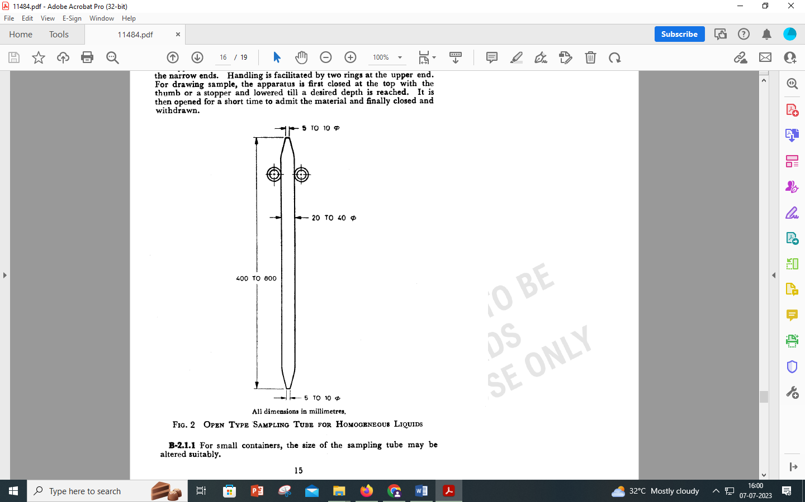

All dimension in millimetres.

Fig. 2 Open Type Sampling Tube for Homogeneous Liquids

**B-2.1.1** For small containers, the size of the sampling tube may be altered suitably.

**B-3 SCALE OF SAMPLING**

**B-3.1 Lot**

All the carbuoys in a single consignment of the material drawn from a single batch of manufacture shall constitute a lot. If a consignment is declared to consist of different batches of manufacture, the batches shall be marked separately and the groups of carbuoys in each batch shall constitute separate lots.

**B-3.1.1** For ascertaining the conformity of the material in the lot to the requirements of the specification, samples shall be tested from each lot separately.

**B-3.2** The number of carbuoys to be selected from a lot shall depend on the size of the lot. Unless otherwise agreed to between the buyer and manufacturer the number of carbuoys to be selected from a lot shall be in accordance with Table 2.

**Table 2 Number of Carbuoys to be Selected**

(*Clause* B-3.2)

|  |  |  |
| --- | --- | --- |
| **Sl No.** | **No. of Carbuoys in the Lot** | **No. of Carbuoys to be Selected** |
| (1) | (2) | (3) |
|  | Up to 50 | 3 |
|  | 51 to 150 | 4 |
|  | 151 to 300 | 5 |
|  | 301 and above | 7 |

**B-3.2.1** The sample carbuoys shall be selected at random from the lot. In order to ensure the randomness of selection, procedure given in IS 4905 may be followed.

**B-3.3 Number of Tests**

The test for relative density, phenol sulphonic acid, free phenol, and free sulphonic acid and sulphur dioxide shall be conducted on individual samples. The test for iron and freezing point shall be conducted on composite sample,

**B-3.4 Criteria for Conformity**

**B-3.4.1** For all those characteristics for which individual tests have been conducted, average ($\overline{X}$) and range (R) shall be calculated, range being the difference between the maximum and minimum of the test results, and

$$Average=\frac{Sum of the test results }{Number of tests}$$

**B-3.4.2** The lot shall be declared as conforming to the specification if the following conditions are satisfied:

1. If the value of the expression $\overline{X}$ + 0.6 *R* ≤maximum value specified in Table 1;
2. If the value of the expression $\overline{X }$ ̶ 0.6 *R* ≥ minimum value specified in Table 1; and
3. For composite sample, the test results shall meet the relevant requirements given in Table 1.

NOTE —When the sample size is ten, it shall be divided into two sub-groups of five test results each taking them consecutively in the same order as obtained. The range of each sub-group shall be calculated and mean range x shall be calculated by dividing the sum of the ranges by two. The expression ( $\overline{X}$ + 0.6 R) or ( $\overline{X}$ ̶ 0.62 R) shall be calculated.

**ANNEX C**

(*Foreword*)

**COMMITTEE COMPOSITION**

Electroplating Chemicals and Photographic Materials Sectional Committee, CHD 05

|  |  |
| --- | --- |
| *Organization* | *Representative*(*s*) |
| CSIR - Central Electrochemical Research Institute, Karaikudi | Dr B. Subramanian **(*Chairperson*)** |
| Bhabha Atomic Research Centre, Hyderabad | Shri M. Ramanamurthy |
| Bharat Electronics Limited, Bengaluru | Ms Padma Sharma  Shri Satish S. (*Alternate*) |
| CMP Private Limited, Mumbai | Shri D. T. Thakur  Shri R. K. Chug (*Alternate*) |
| CSIR - Central Electrochemical Research Institute, Karaikudi | Dr N. Rajasekaran  Dr B. Ramesh Babu (*Alternate*) |
| Directorate General of Quality Assurance, New Delhi | Shri Manohar Kumbhalkar  Shri Ramalala (*Alternate*) |
| Indian Space Research Organization (ISRO) - Space Applications Centre, Ahmedabad | Shri Sharad Shukla  Shri Ghotekar Yogesh (*Alternate*) |
| MSME Testing Center, New Delhi | Shri Imran Mujawar  Shri Vipul Gaikwad (*Alternate*) |
| Research Designs and Standards Organization (RDSO), Lucknow | Shri Kamal Prakash Singh  Shri P. K. Bala (*Alternate*) |
| Security Printing and Minting Corporation of India Limited, New Delhi | Shri S. N. Lahiri  Shri P. Mehrotra (*Alternate*) |
| BIS Directorate General | Shri Ajay Kumar Lal, Scientist ‘F’/Senior Director, (Chemical) [Representing Director General (*Ex-officio*)] |

*Member Secretary*

Ms Puja Priya

Scientist ‘D’/Joint Director

(Chemical), BIS