**IS 5182 (Part 27) : 2024**

***भारतीय मानक***

***Indian Standard***

**Doc No.: CHD 35 (19220) F**

**May 2024**

वायु प्रदूषण — मापने की विधियाँ

**भाग 27 वाष्प-चरण कार्बनिक रसायन विनाइल क्लोराइड से nC22 वायु और गैसीय उत्सर्जन में हाइड्रोकार्बन – सॉर्बेंट ट्यूब या कार्ट्रिज पर डिफ्यूसिव (निष्क्रिय) सैंपलिंग के बाद थर्मल डिसॉर्शन (टीडी) और केशिका गैस क्रोमैटोग्राफी (जीसी)** विश्लेषण

**Air Pollution — Methods for Measurement**

Part 27 Vapour-Phase Organic Chemicals Vinyl Chloride to nc22 Hydrocarbons in air and Gaseous Emissions by Diffusive (Passive) Sampling onto Sorbent Tubes or Cartridges Followed by Thermal Desorption (TD) and Capillary gas Chromatography (GC) Analysis**.**

ICS 13.040.20

© BIS 2024



भारतीय मानक ब्यूरो

BUREAU OF INDIAN STANDARDS

मानक भवन, 9 बहादुर शाह ज़फर मार्ग, नई दिल्ली –110002

MANAK BHAVAN, 9 BAHADUR SHAH ZAFAR MARG

NEW DELHI - 110002

[www.bis.gov.in](http://www.bis.org.in) [www.standardsbis.in](http://www.standardsbis.in)

**May 2024 Price Group**

Air Quality Sectional Committee, CHD 35

FOREWORD

This Indian Standard (Part 27) was adopted by the Bureau of Indian Standards after the draft finalized by the Air Quality Sectional Committee had been approved by the Chemical Division Council.

This Indian Standard addresses a wide range of air monitoring applications and is prepared in two parts. IS 5182 (Part 27) covers diffusive (passive) sampling of vapour phase organic chemicals onto sorbent tubes or cartridges followed by analysis using thermal desorption-gas chromatography (TD-GC). Compatible matrices include ambient air, indoor/in-vehicle air and workplace air. Target compounds include the important pollutants benzene, toluene and xylene, together with industrial solvents, fuel components, odorous compounds and many other volatile and semi-volatile organic compounds. IS 5182 (Part 28) covers pumped sampling of vapour phase organic chemicals onto sorbent tubes followed by analysis using TD-GC and addresses a similar wide range of air monitoring applications plus product emission testing.

Useful additional information is provided in various international standards, referenced in each respective sub-part, but these standard harnesses the measuring techniques available and used in India.

The composition of the Committee responsible for formulation of this standard is given in Annex D

In reporting the results of a test or analysis made in accordance with this standards, if the final value, observed or calculated, is to be rounded off, it shall be done in accordance with IS 2 : 2022 ‘Rules for rounding off numerical values (*second revision*)’*.*

*Indian Standard*

AIR POLLUTION — METHODS FOR MEASUREMENT

**PART 27 VAPOUR-PHASE ORGANIC CHEMICALS VINYL CHLORIDE TO NC22 HYDROCARBONS IN AIR AND GASEOUS EMISSIONS BY DIFFUSIVE (PASSIVE) SAMPLING ON TO SORBENT TUBES OR CARTRIDGES FOLLOWED BY THERMAL DESORPTION (TD) AND CAPILLARY GAS CHROMATOGRAPHY (GC) ANALYSIS**

**1 SCOPE**

This standard prescribes to measure the vapour-fraction of target gas chromatography-compatible organic compounds ranging in volatility from vinyl chloride to nC22 hydrocarbons at concentrations ranging from low micrograms per cubic meter to milligrams per cubic meter in ambient, indoor and workplace air.

**2 REFERENCE**

The standards given below contain provisions which, through reference in this text, constitute provisions of this standard. At the time of publication, the editions indicated were valid. All standards are subject to revision, and parties to agreements based on this standard are encouraged to investigate the possibility of applying the most recent edition of these standards:

|  |  |
| --- | --- |
| *IS No./Other Standard* | *Title* |
| IS 1640 : 2007 | Glossary of terms relating to hides, skins and leather (*first revision*) |
| IS 5182 (Part 11) : 2006 | Methods for measurement of air pollution: Part 11 Benzene, toluene and xylene (BTX) (*second revision*) |
| ISO 16017-1 : 2000 | Indoor, ambient and workplace air — Sampling and analysis of volatile organic compounds by sorbent tube/thermal desorption/capillary gas chromatography — Part 1: Pumped sampling |
| ISO 16017-2 : 2003 | Indoor, ambient and workplace air — Sampling and analysis of volatile organic compounds by sorbent tube/thermal desorption/capillary gas chromatography — Part 2: Diffusive sampling |

**3 TERMINOLOGY**

For the purpose of this standard the definitions given in IS 1640 shall apply.

**4 TERMS AND DEFINITIONS**

**4.1 Axial Diffusive Sampler** — A tube-form device with precisely controlled dimensions that samples gaseous organic chemicals in air diffusively though one end of the tube onto the sorbent surface held inside the tube at a fixed distance from the sampling end.

**4.2 Desorption Efficiency** — The ratio of the mass of analyte that actually reaches the analytical GC column from the sorbent tube relative to the mass of analyte that is expected to reach the analytical GC column from the sorbent tube during analysis.

**4.3 Diffusive (passive) Sampler** — A device which is capable of collecting vapours from the air at a rate controlled by a physical process such as gaseous diffusion though a static air layer or porous material and/or permeation though a membrane, but which does not involve active (pumped) sampling of air though the device.

**4.4 Diffusive Uptake Rate or Diffusive Sampling Rate (U)** — The constant which links the rate of analyte adsorption/collection to atmospheric concentration, expressed in nanograms per parts per million (volume/volume) per minute (ng/ppm/min) or picograms per parts per billion (volume/volume) per minute (pg/ppb/min). It may also be expressed as cubic centimeters per minute (cm3/min).

**4.5 Field Blank** — A conditioned sampler from the batch used for the sampling exercise, subjected to the same handling procedure in the field, including removal and replacement of storage caps/covers, but not used for sample collection. These blanks are analyzed with the samples.

**4.6 Internal Standard** — Readily-distinguished compound of known concentration added to a sample to facilitate the qualitative identification and/or quantitative determination of sample components.

**4.7 Laboratory Blank** — Conditioned sampler from the batch selected for each sampling exercise, retained in the laboratory, sealed with long term storage caps or covers throughout the sampling exercise to be used as a blank. These blanks are analyzed with the samples.

**4.8 Radial Diffusive Sampler** — A tube form device which allows controlled diffusive sampling around the walls of the sampler; that is parallel to the radius, to increase the sampling surface and rate relative to axial samplers.

**4.9 Retention Volume** — Volume of air or carrier gas that has passed through a sorbent tube pre-loaded with a small aliquot of the organic vapour at the sampling end, at the point when the concentration of organic compound eluting from the far end of the tube reaches a peak.

NOTE

**1** The retention volume varies with compound, temperature, humidity and with type of sorbent.

**2** The retention volume is determined chromatographically (*see* ISO 16017-1).

# 4.10 Safe Sampling Volume (SSV) — The volume of sampled air below which there is negligible risk of that compound breaking though during sample collection.

NOTE — This is traditionally calculated as 50 percent of the chromatographically-determined retention volume or 70 percent of the breakthrough volume (*see* ISO 16017-1).

**4.11 Sorbent Strength** — Term to describe the affinity of sorbents for vapour phase organic chemicals (VOCs); a stronger sorbent is one which offers higher safe sampling volumes for VOCs relative to another, weaker, sorbent.

**5 SIGNIFICANCE AND USE**

**5.1** Convenient sorbent based sampling together with laboratory GC analysis, is extensively used for the collection of time weighted average concentration data for organic vapours in air and gas. It is applied to workplace, indoor and ambient atmospheres. Two categories of sampler are deployed; those containing charcoal (subsequently desorbed with 1 ml to 2 ml solvent, typically carbon disulfide) and those compatible with thermal desorption [*see* IS 5182 Part (11)].

**5.2** Both solvent extraction (desorption) and thermal desorption (extraction) methods have their place. However, as limit levels fall in industrial environments and as interest grows in ppb-level toxic and odorous pollutants in urban and indoor/in-vehicle air, the significant (1 000 fold) sensitivity advantage of thermal desorption is increasingly necessary to deliver accurate results. Generally speaking, either solvent extraction or thermal desorption methods can be applied to workplace air monitoring, but the extra sensitivity of TD methods is usually required for monitoring indoor, in-vehicle and ambient air. A more detailed comparison of the two approaches is summarized in informative Annex A.

**6 PRINCIPLE**

**6.1** The method involves exposing diffusive (passive) samplers to the atmosphere under test, for fixed lengths of time. The samplers comprise a sorbent tube or cartridge housed in such a way as to define a fixed diffusion barrier – typically a permeable barrier or air gap. Subsequent analysis is by thermal desorption (TD) and gas chromatography (GC) employing a capillary column and a mass spectrometric (MS) detector.

**6.2** This procedure gives a time-weighted average result. It is not applicable to the measurement of rapid fluctuations in concentration or to instantaneous measurements.

**6.3** Two forms of sampler are applicable for this method:

1. Axial diffusive (passive) samplers (*see* Fig. 1). These comprise standard stainless steel or inert coated stainless steel sorbent TD tubes, with a well-defined air gap (15 mm long × 5 mm internal diameter) at the sampling end. The dimensions of the air gap are controlled by positioning the sorbent retaining gauze   
   14 mm from the sampling end of the tube and by fitting a diffusive cap over the sampling end of the tube throughout the exposure period (s*ee* Fig. 1).

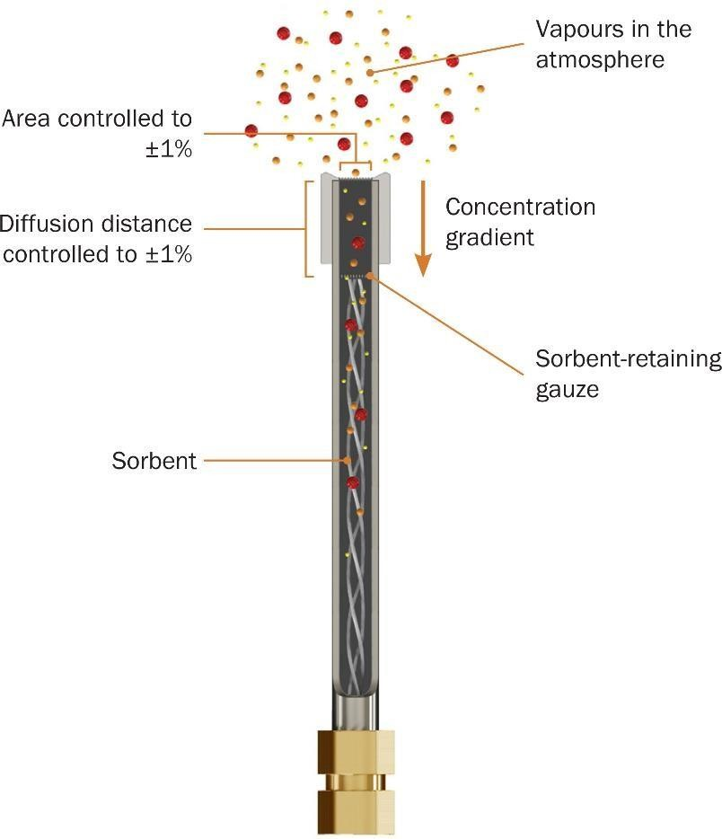

Fig. 1 Schematic of a TD Sorbent Tube Being Used to Sample Diffusively (*see* Fig. 6 for a More Detailed Illustration of the Diffusive Sampling Mechanism)

1. Radial diffusive (passive) samplers (*see* Fig. 2). During sampling, these comprise a sorbent cartridge housed in a permeable diffusive body — typically constructed of sintered metal or porous polymer. The sorbent cartridges are stringently sealed and protected from analyte losses and contamination both before and after sampling. They are transferred to clean, empty TD tubes as soon as possible after sampling to ensure leak-tight storage and to be ready for TD-GC analysis.

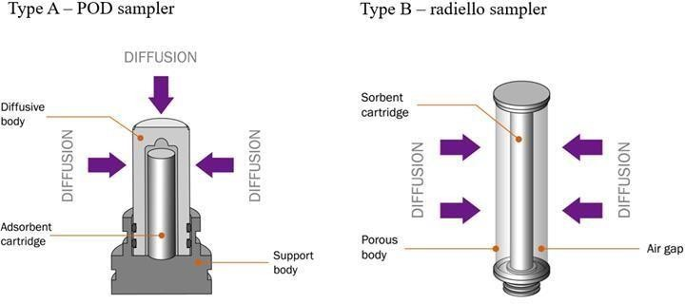

Fig. 2 Schematic of Type A (POD) and Type B (Radiello) Radial Diffusive Samplers in Monitoring Mode

**6.4** Once sampled and sealed, sorbent tubes and TD tubes containing sampled sorbent cartridges are stored in a clean environment (at or below 25 °C ) and analyzed within 4 weeks by two-stage thermal desorption (TD) with capillary gas chromatography (GC) using mass spectrometric (MS) detection.

**6.5** Each tube is loaded into the thermal desorber in turn, checked for leaks and purged of air. It is then heated in a flow of inert carrier gas passing though tube from the sampling end. This releases the retained compounds and sweeps them into an electrically-cooled sorbent focusing trap where they are concentrated. Once primary (tube) desorption is complete, the focusing trap is heated rapidly in a reverse flow of carrier gas to inject the compounds directly into the capillary GC column in a concentrated band of vapour. Desorption from the tube to the focusing trap and from the focusing trap to the column can be split or splitless depending on the air concentrations being monitored and the mass of compounds sampled.

**6.6** Secondary (focusing trap) desorption and injection of the organic compounds into the capillary GC column triggers the start of the GC program. The desorbed compounds are separated, measured and identified by the analytical system. The concentration of each target compound in the sampled air is then calculated from the measured mass, the respective uptake rate for each compound and diffusive sampling time (exposure period).

# 7 REAGENTS AND MATERIALS

**7.1 Organic Compounds for Calibration** —must be of chromatographic quality

**7.2 Dilution Solvent**

For preparing calibration blend solution for liquid spiking of conditioned sorbent tubes shall be of chromatographic quality and free from interfering compounds that could co-elute chromatographically with the compound(s) of interest.

# 7.3 Solid Sorbents

**7.3.1** Many types of sorbent, suitable for packing thermal desorption sample tubes, cartridges and focusing traps, are available. Sorbents can be classified by material and the most common types used are as follows.

**7.3.1.1** *Graphitised carbon black* — examples include carbograph, carbopack and carbotrap sorbents

**7.3.1.2** *Poly* (*diphenyl-p-phenylene oxide*) — examples include tenax TA

**7.3.1.3** *Graphitised poly* (*diphenyl-p-phenylene oxide*) — examples include tenax GR

**7.3.1.4** *Carbon molecular sieve* — examples include carboxen, sulficarb and carbosieve

**7.3.2** They range in strength from very strong (retentive) sorbents, required to quantitatively retain and release very volatile substances such as C3 hydrocarbons, to very weak sorbents, suitable for quantitative sampling and release of high boiling semi-volatiles such as nC30. The required sorbent particle size is 0.18 mm to 0.60 mm   
(80 mesh to 30 mesh). Listed in order of increasing sorbent strength starting from the weakest, example TD-compatible sorbents that are suitable for diffusive sampling include:

**7.3.2.1** Tenax TA® particle size 0.25 mm to 0.6 mm (60 mesh to 30 mesh). Tenax TA is an inert, hydrophobic porous polymer based on 2,6-diphenyleneoxide. Suitable for organic compounds ranging in volatility from   
nC6/7 (depending on air sampling volume) to nC26 or more.

**7.3.2.2** Carbon black sorbents, such as carbopack XTM or carbograph 5 TDTM particle size 0.25 mm to 0.5 mm (60 mesh to 40 mesh). Hydrophobic carbon sorbents suitable for organic compounds with vapour pressures below those for C4 hydrocarbons and above those for nC10.

**7.3.2.3** Carbon molecular sieve sorbents such as carboxen 1 003TM or sulficarbtm. These are very strong and are used for trapping compounds more volatile than C4 hydrocarbons.

NOTE — Carbon molecular sieve sorbents are not completely hydrophobic. If such sorbents are used, the tube will require dry purging before analysis, to remove residual water.

# 7.4 Preparing Calibration Standards on Sorbent Tubes

Target compounds should be calibrated using original reference compounds whenever possible. Standards should be introduced to the sampling end of conditioned sorbent tubes using either liquid or gas phase standards. This method is used for calibrating both axial diffusive sorbent tubes and radial diffusive cartridges. Table 1 below shows the various calibration range for workplace, ambient and indoor air monitoring. Calibration solution concentrations will vary depending on the concentration of the atmosphere which is being measured. Additional information and illustrative examples for preparing calibration standards suitable for workplace air monitoring, ambient or indoor air monitoring and for material/product emission testing are all given in Annex B.

NOTE — It is advisable to include toluene as one of the compounds in a calibration mix as unknowns are conventionally ‘semi-quantified’ using the response factor for toluene.

# Table 1 Typical Calibration Ranges for Each Type of Sampler and Type of Atmosphere

(*Clause* 7.4)

|  |  |  |  |  |
| --- | --- | --- | --- | --- |
| **Sl No.** | **Measurement Atmosphere** | **Typical Minimum**  **Mass per**  µl | **Typical Maximum**  **Mass per**  µl | **Section Reference** |
| (1) | (2) | (3) | (4) | (5) |
|  | Using axial samplers: |  |  |  |
| 1. Workplace air (8 h) | 0.5 µg | 10 µg | 11.1 and Annex B |
| 1. Ambient air (14 days) | 25 ng | 500 ng | 11.1 and Annex B |
| 1. Indoor/in-vehicle air (14 days) | 25 ng | 500 ng | 11.1 and Annex B |
|  | Using POD samplers: |  |  |  |
| 1. Workplace air (4 h) | 0.5 µg | 10 µg | 11.2 and Annex B |
| 1. Ambient air (48 h) | 25 ng | 500 ng | 11.2 and Annex B |
| 1. Indoor air (24 h) | 25 ng | 500 ng | 11.2 and Annex B |
|  | Using radiello samplers: |  |  |  |
| 1. Workplace air (1 h) | 0.5 µg | 10 µg | 11.2 and Annex B |
| 1. Ambient air (24 h) | 25 ng | 500 ng | 11.2 and Annex B |
| 1. Cindoor air (8 h) | 25 ng | 500 ng | 11.2 and Annex B |
| NOTE — Typical calibration ranges for each type of sampler and type of atmosphere, given the duration of passive monitoring specified *see* **9.4**, **9.5** *and see* Annex B. | | | | |

**7.4.1** *Gas-phase Standards*

Standard atmospheres containing known concentrations of the compound(s) of interest are prepared using a recognized procedure such as ISO 61411 or ISO 61452. The concentration(s) of the compounds in the standard atmosphere should be similar to those expected to be collected during the respective field monitoring exercise.

Alternatively, gas standards of appropriate quality shall be sourced commercially. The mass of each compound of interest loaded on to the sorbent tube in the introduced aliquot (volume) of gas standard should be similar to the masses expected to be collected during field monitoring.

NOTE

**1** It is notoriously difficult to produce stable standard atmospheres that are traceable to primary standards, particularly if target compounds include reactive and/or high boiling species. Frequent monitoring of the standard atmosphere is recommended as a check on stability.

**2** Pressurized commercial gas standards, containing relatively high concentrations of key target compounds are often the most stable and affordable form of gas-phase standard providing the optimum calibration stock for very volatile target analytes, for example, compounds that are in the gas phase at room temperature.

**7.4.2** *Loading Sorbent Tubes with Gas-phase Standards*

Standard tubes are prepared either by passing a known volume of standard atmosphere though a conditioned sorbent tube from the sampling end (for example, by means of a pump operating at 50 ml/min) or by introducing a metered volume of de-pressurized gas standard using a gas syringe or gas sampling valve and mass flow controller. The total volume of gas passing though the sorbent tubes when loading calibration standards shall not exceed the breakthrough volume for any of the compounds of interest. After loading, tubes shall be disconnected and sealed.

Fresh standard tubes should be prepared for each batch of samples.

**7.4.3** *Liquid Calibration Solutions for Preparing Spiked Sorbent Tubes*

A series of liquid standard solutions shall be prepared over a range of concentrations such that injecting 1 µl aliquots of each standard onto respective conditioned sorbent tubes introduces the range of analyte masses that is expected to be collected during field monitoring (*see* **9.3**).

The selected compound(s) shall be prepared in chromatographic-grade solvent (for example in methanol). Liquid standards shall be maintained at a stable temperature. The stability of calibration solutions shall be monitored and a fresh series of standards shall be prepared if there is evidence of deterioration, for example reactions between alcohols and ketones.

**7.4.4** *Loading Sorbent Tubes with Liquid Standards*

The sampling end of a conditioned sorbent tube is fitted to some form of unheated injector though which inert gas is passed at 50 ml/minto 100 ml/min(*see* **8.7**).

A suitably precise micro-syringe (*see* **8.6**) shall be used to inject a maximum of 1 µl of standard solution though the septum of the injector and into the tube immediately above the sorbent bed. After 5 min, the tube is disconnected and sealed.

NOTES

**1** It is normally recommended to keep injection volumes to 1 µl or below to minimize the risk of solvent interference during subsequent analysis.

**2** Introducing liquid standards onto sorbent tubes in a gas stream via a suitable injector is considered the optimum approach to liquid standard introduction, as volatile components reach the sorbent bed in the vapour phase. However, when preparing standards containing high boiling compounds, analyte transfer is enhanced if the injector allows the tip of the syringe to make gentle contact with the sorbent retaining mechanism (for example gauze or quartz wool) at the sampling end of the tube.

**3** If standard tubes are being prepared by introducing aliquots from more than one standard solution or gas, it is appropriate to introduce the standard(s) containing higher boiling components first and those containing the most volatile organic compounds last. This minimizes risk of analyte break though during the standard tube loading process.

**4** The purity of the inert carrier gas used to purge sorbent tubes during standard introduction should be such that 0.5 ng toluene can be measured without significant interference. The quality of the carrier gas is of great importance, as any contaminants contained in the gas are enriched on the sorbent together with the substances to be analyzed (*see* **7.7**).

**5** For guidance on estimating the mass of analyte that will be collected during diffusive monitoring (*see* Annex B).

Fresh standard tubes shall be prepared for each batch of samples.

# 7.5 Internal Standards

**7.5.1** Suitable internal standard compounds should not be present in the sample and should be readily distinguished from sample components. They should also behave in a similar way, chemically, to the compounds of interest. Toluene **D-8** is often used, for example, if subsequent analysis is by TD-GCMS.

**7.5.2** A gas or liquid-phase internal standard can be added to the sampling end of sample or standard sorbent tubes by mixing with the calibration solution or by spiking separately.

NOTE — Internal standards can be added to tubes just before field monitoring (as an extra check on tube transportation and handling procedures in the field) or immediately before analysis, for analytical quality control.

**7.5.3** Some makes of automated thermal desorber allow gas phase internal standard to be introduced to the sampling end of sorbent tubes or focusing traps automatically, as part of the 2-stage thermal desorption process. If available, this facility can be also used to introduce internal standard to the focusing trap during desorption of radial diffusive sampling cartridges.

# 7.6 Certified Standard Tubes Available

Standard tubes pre-loaded with certified masses of representative compounds of interest are available and can be used for establishing analytical quality control and for routine calibration.

# 7.7 Carrier Gas

As thermal desorption is a powerful enrichment (concentration) and desorption technique, it is essential to use the highest quality carrier gas installation; 99.999 5 percent is an example of a suitable grade of GC carrier gas.

# 8 APPARATUS

Ordinary laboratory apparatus and the following:

**8.1 Sorbent Tubes** —used both for axial diffusive sampling and for calibration of axial and radial diffusive samplers

**8.1.1** Tubes with outside diameter of 6.4 mm (0.25 in), inside diameter of 5 mm (stainless steel) and of length 89 mm (3.5 in) have been found to work well for this method and are used in many TD systems (*see* Fig. 1). Such tubes typically contain an overall sorbent bed length of 40 mm to 60 mm, retained in the central, directly heated portion of the tube using stainless steel gauzes. A precise 14 mm air space is left free of sorbent at the sampling end to define the diffusive air gap. A similar or longer air gap is left at the other end of the tube to minimize interference from diffusive ingress – for example when replacing storage caps with analytical caps.

**8.1.2** Inert-coated stainless steel tubes are preferred if reactive organic compounds are of interest.

NOTE — Glass TD tubes are thicker walled and typically have a narrower and more variable internal diameter. It is also more difficult to precisely and repeatably define the air gap in glass tubes. For these reasons, glass tubes are not commonly used for diffusive (passive) sampling.

**8.1.3** Each tube requires a unique alphanumeric identification number. Indelible bar codes or some other form of electronically-read label are also useful. Solvent-containing paints and markers or adhesive labels should not be used on the tubes.

**8.1.4** Sorbent tubes suitable for diffusive sampling are available or can be filled in the laboratory. Only the sorbent nearest the sampling end of the tube plays a part in the diffusive sampling process so single sorbent tubes are most commonly used for diffusive (passive) sampling.

NOTE

**1** There is a strong relationship between sorbent strength, that is tube retention volumes and safe sampling volumes in pumped sampling [*see* ISO 16017-1 and IS 5182 (Part 28)], and the stability of the axial diffusive sampling uptake rate over extended time periods3. As a general rule, if the retention volume of a given compound on a given single-sorbent tube is in the order of 20 l or more, back-diffusion of the analyte from that sorbent surface during sampling will be negligible. This means that uptake rates will be stable for extended periods (weeks).

**2** Example axial diffusive sampling uptake rates for a range of compounds using stainless steel or inert-coated stainless steel TD tubes packed with specified sorbents are given in Annex C.

# 8.2 Diffusion Caps

Inert metal caps, fitted with a low-emission o-ring seal and with a fine stainless gauze across the surface (*see* Fig. 3). The gauze in the cap defines the fixed air gap between the ambient air and sorbent sampling surface. The gauze in the cap also prevents large particles entering the diffusive tube when sampling in dusty environments.

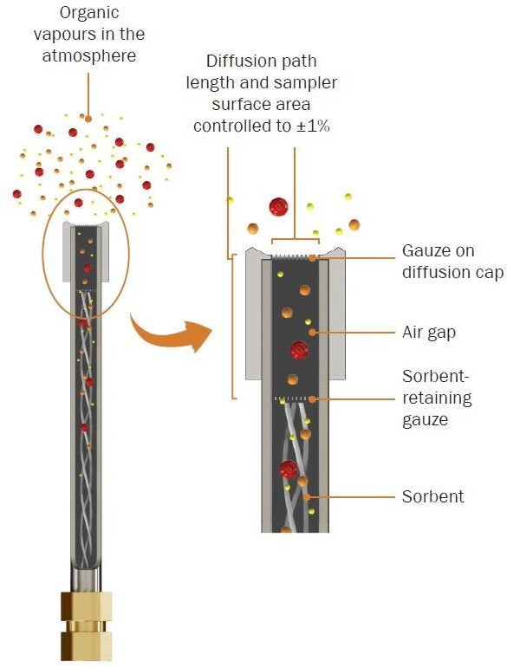

Fig. 3 Illustration of a Diffusion Cap on the Sampling end of a Sorbent Tube During Axial Diffusive (Passive) Sampling

# 8.3 Radial Diffusive Samplers and their Key Components

Radial diffusive samplers (*see* Fig. 2) comprise a sorbent cartridge housed in some form of permeable diffusive body. The diffusive body is typically constructed of sintered metal or porous polymer. The sorbent cartridge is packed with TD-compatible sorbent of suitable sorbent strength to retain the target compound or compounds of interest and is sized to fit into an empty TD tube for long term storage and for desorption and analysis. Key components of radial sampler are shown in Fig. 4.

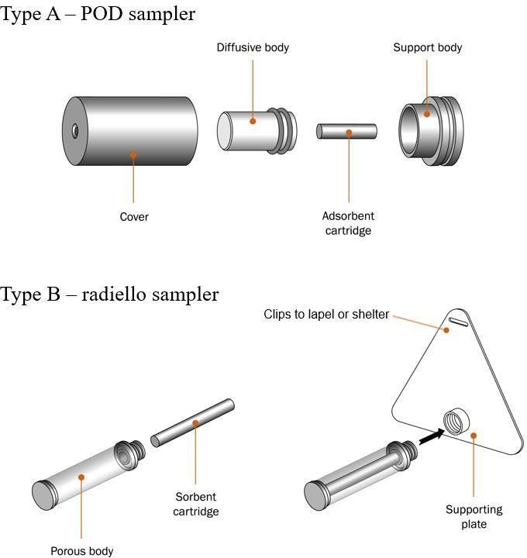

Fig. 4 Exploded Diagrams of Type A (Pod) and Type B (Radiello) Samplers Showing All Components and How They Go Together

# 8.4 Long Term Storage Caps for Conditioned and Sampled Sorbent Tubes/Cartridges

Reliable long-term tube storage caps are a critical component of air monitoring, particularly at trace (ppb and sub-ppb) levels. They are required for transportation and storage of conditioned and sampled sorbent tubes and cartridges to prevent both contaminant ingress and analyte loss. Two-piece metal screw caps fitted with combined polytetrafluoroethylene (PTFE) ferrules have been found to provide the most secure and readily-available option. Validated studies have shown that they remain effective for many months at ambient and refrigerated temperatures (*see* also ISO 16017-1).

# 8.5 Storage Containers for Conditioned and Sampled Sorbent Tubes and Cartridges

Clean, non-emitting containers made of inert materials such as unused paint cans or aluminum tins and glass jars with an air tight seal are used for storage and transportation of sealed diffusive (passive) samplers before and after exposure. Suitable containers maintain artefact levels below required levels (*see* **12**).

# 8.6 Precision Syringe

Syringe used for injecting liquid standards shall be readable to at least 0.1 µl.

**8.7 Injection Facility** — for preparing standard tubes by injecting liquid (or gas) standards.

Calibration loading rigs designed specifically for spiking TD tubes with liquid or gas standards in a controlled flow of carrier gas, are available. Alternatively, it is possible to use an unheated packed-column GC injector adapted with a push fit connector and o-ring seal for easy insertion and removal of sorbent tubes without damaging tube ends.

# 8.8 Carrier Gas Installation

Only high-quality, stainless steel diaphragm regulators shall be used on carrier gas cylinders. Carrier gas lines shall be constructed using medical grade tubing and connected using appropriate swage fittings with no brazed joints. Oxygen and organic filters should be installed in the carrier gas lines and maintained regularly.

# 8.9 Gas Chromatograph (GC)

Fitted with a mass spectrometric detector capable of detecting target compounds at the lowest levels of interest with a signal-to-noise ratio of at least 5 to 1, preferably 10 to 1 under practical routine operating conditions. The GC may also be fitted with a conventional GC detector such as a flame ionisation detector (FID) for routine operation if required.

# 8.10 Capillary GC Column.

A polar or moderately polar, bonded capillary columns of 30 m to 60 m length, with an internal diameter 0.25 mm to 0.32 mm and phase thickness 0.25 μm to 1.0 μm are examples of columns proven to be suitable for analyzing a wide range of trace organic air pollutants. Polar or more specialist columns may also be required for some applications.

# 8.11 Two-stage Thermal Desorption Apparatus

**8.11.1** To accommodate one or multiple TD tubes which are uploaded into the carrier gas flow path for analysis. During thermal desorption, sorbent-packed TD tubes and tubes containing sorbent cartridges are heated with inert (carrier) gas flowing from the sampling end. Desorbed vapours swept from the sample tube are focused (concentrated) on a small, electrically-cooled sorbent trap which is then itself desorbed by heating it rapidly with carrier gas flowing in the opposite direction to that used during focusing. This fast secondary (trap) desorption ‘injects’ the analytes into the GC column in a narrow, concentrated band of vapour, compatible with capillary chromatography, and triggers the start of the GC program (*see* Fig. 5).

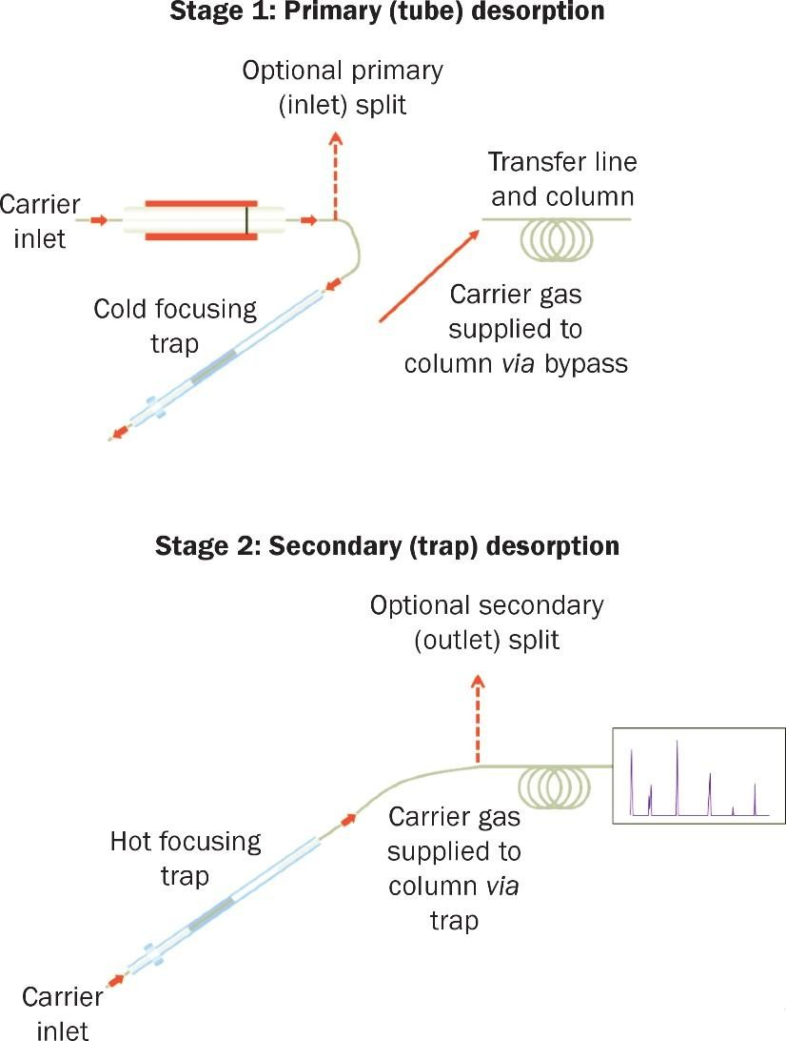

FIG. 5 TWO MAIN STAGES OF THERMAL DESORPTION

**8.11.2** *Required features and functions of the thermal desorber*:

1. Leak-tight tube seals or 'analytical' caps to protect sampled and desorbed tubes from analyte loss and contaminant ingress while they are on the analytical system. This is particularly critical for automated operation where multiple tubes may be in situ for extended periods;
2. Stringent leak testing of each tube after it is loaded into the sample flow path and before heat or gas flow is applied. Any tubes which fail the leak test should not be heated but retained intact for operator attention, while the system continues to analyze subsequent tubes in the sequence;

NOTE — As the carrier gas flow path of the chromatographic system is effectively broken into every time a new sample is uploaded for analysis, leak testing is essential for data confidence.

1. Exclusion of artefacts from outer tube surfaces - The mechanism for sealing tubes into the sample flow path must exclude external contaminants, for example from handling tubes in the field;
2. Pre-purging of air - Tubes shall be pre-purged with carrier gas (after leak testing and before desorption) to remove residual air, prevent sorbent and analyte oxidation and extend system life; and
3. The secondary desorption process must allow quantitative splitting of the sample for compatibility with both trace ambient-level and higher workplace-level air contamination.

**8.11.3** Other useful TD options include:

1. Cryogen-free (typically electrical) cooling of the focusing trap to controlled sub-zero temperatures – to ensure the repeatable retention of very volatile compounds without liquid cryogen;
2. Automatic addition of gas-phase internal standard onto a series of pre-conditioned sorbent tubes before field monitoring or onto the sampling end of the sorbent tube or focusing trap immediately before primary desorption. For analytical quality control best practice;
3. Automatic dry purging of tubes (in the sampling direction) before primary desorption to selectively eliminate water and minimize analytical interference during analysis of humid samples;
4. Sample splitting during primary (tube) as well as secondary (trap) desorption to allow quantitative analysis of very high-level samples (*for example* confined work spaces) as well as trace-level monitoring; and
5. Quantitative re-collection of sample split flow for repeat analysis and validation of desorption efficiency and compound recovery (*see* **4.2** and **9.1**).

# 9 PREPARING FOR FIELD MONITORING

**9.1 Developing and Validating the Analytical Method**

**9.1.1** The approximate masses of each target analyte that will be collected during air monitoring can be estimated from the expected air concentrations (or regulated limit levels), the expected exposure duration and analyte uptake rates (*see* Annex B for more information). Using conditioned sorbent tubes (*see* **9.4**) prepare a number of mid-range standards containing these analyte levels (*see* **7.4** and Annex B).

**9.1.2** Ensure the mass spectrometer detector is tuned and performing according to manufacturer’s specifications. Use the relevant list of target compounds or preliminary screening data to check the suitability of the analyser configuration (choice of capillary GC column, focusing trap sorbents and settings, etc.) and choice of sorbents in the sampling tubes or cartridges (*see* **8.3**). Use the mid- range standards to develop and optimize the analytical method – GC program, mass spectrometer settings, TD temperatures and times, desorption flows, split ratios, etc. – and to confirm system stability.

**9.1.3** The sensitivity and linearity of the analytical method can then be evaluated by running a multi- level calibration (*see* **9.3**).

**9.1.4** Desorption efficiency (that is the recovery of analytes from the sorbent tube and though the 2-stage TD process to the GC column) must be above 95 percent. This can be tested by re-running desorbed standard tubes to check there is no carryover and comparing the results obtained by thermal desorption with those obtained for a liquid injection of the same standard under the same GC conditions (temperature program, gas flow, split flow, etc). Alternatively, if the selected thermal desorber offers the option of quantitative re-collection of split flow; repeat analysis of the re- collected samples will quickly show if one or more compounds is not being fully recovered as it passes though the 2-stage TD process, relative to other stable compounds in the mix such as toluene. Parameters can then be amended accordingly.

NOTE — Most TD methods readily offer > 99percent recovery. If analyte loss occurs, possible causes include incomplete desorption, thermal degradation and condensation or sorption of compounds within the sample flow path.

# 9.2 Checking System and Sorbent Tube/Cartridge Blanks

**9.2.1** Using a clean empty TD tube and analytical conditions, check the TD-GC-MS system blank meets method requirements (*see* **9.4**). Repeat this exercise with representative blank sorbent tubes or cartridges from the batch that will be used for field monitoring. These ‘laboratory blank’ tubes must contain the same sorbent as the field monitoring tubes, have been conditioned at the same time and stored in the same container. Ideally they should also have been packed at the same time and had a similar history of use.

**9.2.2** If the system or laboratory blank levels do not meet method requirements condition the system and/or tubes using more stringent conditions (temperatures and gas flows) than will be used for analysis, then repeat the above blank analysis.

**9.2.3** Take care not to exceed the maximum temperature of the least stable sorbent in the sample tubes.

NOTE — Tubes may need repacking or cartridges might need replacing if they can no longer reach the required cleanliness after extensive conditioning.

**8.3.1** Prepare conditioned sorbent tubes (*see* **9.4**) with standards of the target compounds (*see* **7.4**) at 5 different levels (for more information *see* Annex B). The analyte masses introduced in each standard should cover the range expected to be collected during field monitoring with a factor of at least 20 between the analyte masses on the lowest and highest level standards.

**9.3.2** A mid-range standard should be analyzed at least every ten samples during routine operation and the results compared with the 3 previous mid-range standards to ensure system performance remains stable. A multi-level calibration, with replicates at each level, should be carried out whenever analysis of the single level standards shows system responses have drifted by 10 percent or more. A multi-level calibration, with replicates at each level, should also be repeated whenever the analytical method or target compound list is changed and immediately before analysis of a new batch of samples – ideally as part of the same analytical sequence.

**9.3.3** Replicates for at least 4 of the 5 calibration levels, including the lowest and highest levels, should agree within 10 percent or the multi-level calibration exercise shall be repeated. The linear regression coefficient should also be above 0.99 for toluene over the calibration range.

# 9.4 Sorbent Tube or Cartridge Conditioning

**9.4.1** Newly-packed sorbent tubes or cartridges should be obtained pre-conditioned from the manufacturer or be stringently conditioned on receipt in the laboratory, following manufacturer’s instructions. Once sorbent tubes and cartridges have been conditioned they should remain sealed with long term storage caps (*see* **8.4**), kept in a suitable clean storage container (*see* **8.5**) and maintained at a controlled, stable temperature (ideally between   
20 °C and 30 °C) at all times when not in use.

**9.4.2** The total number of sorbent tubes and diffusion caps or clean sorbent cartridges and radial sampler assemblies required for a field monitoring exercise should be calculated, including those for required for sampling, field blanks and lab blanks.

NOTE — Air monitoring studies carried out using radial diffusive samplers will also require conditioned sorbent tubes for multi-level and single-level n calibration.

**9.4.3** If a batch of sorbent tubes or cartridges has only just been desorbed and analyzed for a previous study (within 2 weeks) and if pollutant levels encountered during the previous study were low, and provided they have been kept properly sealed and stored since their last use, they can be re-used for field monitoring without further conditioning. In all other cases the required batch of sorbent tubes or cartridges should be conditioned within 2 weeks of the start of a field monitoring exercise by desorbing them for 10 min to 15 min and at 100 ml/min inert (carrier) gas flow using slightly more stringent conditions than those required for analysis, but taking care not to exceed the safe maximum temperature of any sorbent present.

**9.4.4** In either case, a representative selection of the batch of tubes or sorbent cartridges (at least 1 in 10) should be analyzed using routine analytical parameters (*see* **9.1**), to ensure that the analytical blank is sufficiently small before being sent to the field for air sampling. The blank level is acceptable if interfering peaks are at 10 percent or less of the areas of target compounds at the lowest level interest. If the blank is unacceptable, the sorbent tubes or cartridges should be reconditioned.

**9.4.5** At least two of the conditioned tubes or cartridges from each batch shall be retained sealed and stored in the laboratory though out the field monitoring exercise. These are the laboratory blanks (*see* **4.5**).

NOTE — All sorbents are subject to inherent artefacts the level of which will vary with sorbent type and desorption temperature. Follow manufacturer’s guidance with respect to conditioning and analysis parameters to keep artefact levels to a minimum. It is normally possible to keep individual artefacts below 5 mg to 10 mg on conditioned Tenax tubes/cartridges and around 2 ng on conditioned carbon tubes/cartridges. It is also usually possible to chromatographically separate sorbent artefacts from low level of compounds of interest such that the resultant analytical interference is not significant.

**10 SAMPLING**

**10.1 General Preparation for Sampling**

Before monitoring begins, estimate the ideal exposure time based on study requirements, the relevant uptake rates for the compounds and sampler type selected, the expected concentration range, available analytical detection limits and required reporting limits.

NOTES

**1** Stable uptake rates on axial diffusive tubes packed with an appropriate sorbent tube for the target analytes are typically in the order   
of 2 ng/ppm/min (or 2 pg/ppb/min) for exposure periods ranging from 8 h to 2 weeks or more (s*ee* Annex C). This number can be used as a rough guide when calculating the masses expected to be collected during monitoring (s*ee* Annex B).

**2** Stable sampling rates on type a radial diffusive samplers housing cartridges packed with an appropriate sorbent tube for the target analytes are typically in the order of 5 ml/min to 8 ml/min for exposure periods ranging from 4 h to 3 days (*see* Annex C). This number can be used as a rough guide when calculating the masses expected to be collected during monitoring (*see* Annex B).

**3** Stable uptake rates on type B radial samplers housing cartridges packed with an appropriate sorbent tube for the target analytes are typically in the order of 20 ml/min to 30 ml/min for exposure periods ranging from 8 h to 24 h *see* Annex C. This number can be used as a rough guide when calculating the masses expected to be collected during monitoring (s*ee* Annex B).

**4** Quantitative diffusive sampling is robust and reproducible provided a sorbent of sufficient strength is selected for the given target compounds. Using a sufficiently strong sorbent means that the vapour concentration at the surface of the sorbent is maintained at or near zero for the duration of sampling (*see* Fig. 6). If the sorbent used is too weak, retained compounds back- diffuse from the sorbent over time causing the concentration of analyte in the air at the sorbent surface to increase. When this happens, the ‘diffusion gradient’ is reduced, lowering the sampling rate (*see* Fig. 6) and causing under-reporting.

**5** Most diffusive samplers only have one sorbent exposed meaning that each sampler addresses a limited analyte volatility range. If the compounds of interest cover a wider volatility range, two or more samplers, packed with different sorbents, can be used in parallel. The samplers described in this standard are re-usable and don’t need a pump so using two or more samplers in parallel remains a cost-effective monitoring option.

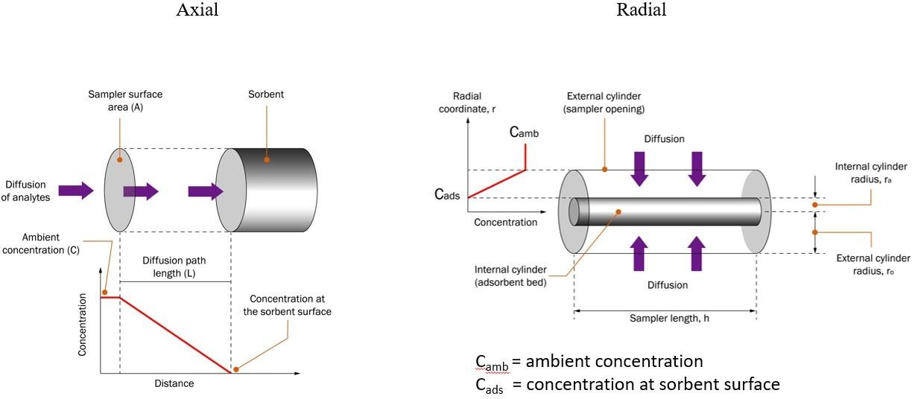

Fig. 6 Illustration of the Mechanism And Principles of Diffusive Sampling Examples for Axial and Radial Samplers

**10.2 Area Monitoring**

Identify representative sampling locations that will not be impacted by exceptional localized pollution sources or ventilation conditions. Moderate air speeds are recommended. Samplers should be protected from particulate ingress by orientating them downwards. They should also be protected from precipitation when monitoring outdoors, using simple, well-ventilated and non- emitting shelters.

**10.3 Personal Exposure Assessment**

When used for personal exposure assessment, diffusive samplers should be positioned near the breathing zone of the wearer (for example on a collar or lapel), unimpeded by clothing and with the sampling end of axial tubes pointing down.

**10.4 Sample Collection with Axial Diffusive Sorbent Tubes**

**10.4.1** Transport all conditioned sorbent tubes and diffusion caps to the field in clean storage containers (*see* **8.5**). Leave tubes capped and in the storage container until they have equilibrated with ambient conditions. The non-sampling end of sorbent tubes remain sealed with long term storage caps (*see* **8.4**) throughout the diffusive monitoring process. When ready to start sampling, replace the long- term storage cap at the sampling end of the tube with the diffusion cap (*see* Fig. 3). Keep the long- term storage caps in the tube storage container (*see* **8.5**) throughout the monitoring exercise.

**10.4.2** Note and record the unique identification number of the tube. Check and record the time and date when monitoring starts and again at the end of the monitoring period when the diffusion cap is removed and replaced with a long term storage cap (*see* **8.4**) using appropriate tools. Place the sealed and sampled tubes back into the storage and transportation container without delay. If the container of tubes is to be held under refrigerated conditions, ensure storage caps are retightened once tubes have equilibrated at their minimum storage temperature.

**10.4.3** Recommended exposure times for axial diffusive samplers in workplace air are 8 h. recommended exposure times or axial diffusive samplers in ambient and indoor air are 7 days to to14 days. For more information   
(*see* Annex B)

NOTE — Refrigerated storage is not usually necessary provided samples can be maintained at a stable temperature below 25 oC and analyzed within 4 weeks.

**10.5 Sample Collection with Radial Diffusive Samplers**

**10.5.1** Follow manufacturer’s instructions with respect to preventing contamination and analyte loss when transporting the various components of radial diffusive samplers to and from the field.

NOTE — Some manufacturers specify transporting radial diffusive samplers ready assembled and covered, others recommend completing sampler assembly in the field.

**10.5.2** Clean containers (*see* **8.5**) should be used for storing and transporting samplers and their components at all times. Leave the samplers or sampler components sealed and in the storage container until they have equilibrated with ambient conditions. This prevents condensation. Assemble the samplers as quickly as possible at the start of sampling (*see* Fig. 2 and Fig. 4) and store any unused components in the transport container (*see* **8.5**) throughout the monitoring exercise.

**10.5.3** Note and record the sampler’s unique identification number and the time and date of monitoring start and end. At the end of the monitoring period follow manufacturer’s instructions with respect to sealing the sampler or sampler components to prevent contamination or analyte loss before analysis. Place the sealed samplers or sampler components back into the storage and transportation container without delay. Follow manufacturer’s advice with respect to storing samples under refrigerated or ambient conditions.

**10.5.5** Recommended exposure times for radial diffusive samplers in workplace air are 1 h to 4 h. and samplers in ambient and indoor air are 8 h to 72 h. For more information *see* Annex B.

**10.6 Quality Control During Sampling**

**10.6.1** *Field Blanks*

This should be prepared using devices identical to those used for sampling. They should be transported to the field monitoring location and subjected to the same handling procedure except for the actual period of diffusive sampling. Record these as blanks and analyze them in the same sequence as the samples.

**10.6.2** *Replicate Samples*

This should normally be collected in parallel at 10 percent of sampling locations. At least one replicate sample pair should be collected during each monitoring exercise. Replicate samples should be analyzed in the same sequence as the samples.

**11 DESORPTION AND ANALYSIS**

**11.1 Preparing for Analysis**

**11.1.1** Keep all diffusively sampled sorbent tubes and radial sampler components associated with a monitoring exercise (samples and blanks) sealed and inside the sealed storage/transportation container (*see* **8.5**) until ready for analysis. If they have been stored under refrigerated conditions, allow them to equilibrate with the laboratory temperature before removing any caps or seals to minimize risk of condensation which could cause analytical interference.

**11.1.2** Quickly transfer sampled or field blank radial sorbent cartridges into clean empty TD tubes if this has not already been done. Ensure the sorbent cartridge is supported within the central, directly heated portion of the TD tube and seal the ends of the tube with long term storage caps or directly with analytical end caps (*see* **8.10**) if analysis by automated TD-GC is imminent. Ensure that blank and sampled sorbent tubes and cartridges are not left exposed to lab air contamination for any length of time.

**11.1.3** When ready for analysis, replace long-term tube storage caps with analytical end caps and load the sample tubes into the TD auto sampler (*see* **8.10**). Alternatively, if using a single-tube desorber, only uncap each sample tube immediately before it is sealed into the system for analysis.

Plan the analytical sequence (manual or automated) such that samples are interspersed with calibrants (mid-range and multi-level as required), field blanks, lab blanks and replicate samples.

**11.2 Analyzing Sorbent Tubes and TD Tubes Containing Radial Sorbent Cartridges**

**11.2.1** Once uploaded and sealed into the TD flow path (manually or automatically as part of a multi-tube sequence), each sample tube proceeds through a series of automatic checks and operations:

**11.2.2** While maintained at ambient temperature each tube is first pressurized and subjected to a stringent, no flow leak test.

NOTES

**1** Without such a test, a leak could go undetected, undermining confidence in data quality.

**2** Any tubes which fail the leak test should not be analyzed, but retained intact for user inspection and intervention to prevent sample loss.

**11.2.3** Air is then purged from the tube, to vent, before heat is applied to avoid analyte and sorbent oxidation, artefact formation and degradation of the analytical system.

NOTE — It usually requires 10 x the volume of the tube (that is 20 ml to 30 ml of carrier gas) to completely displace air, but larger volumes of carrier gas will be required for complete air displacement when strong sorbents such as carbon molecular sieves are used.

**11.2.4** If the selected thermal desorber offers automated dry purging to remove residual water, this step can be included here, if required, and takes place with inert gas flowing though the tube from the sampling end. Similarly, if the TD system offers the option of automated addition of gas-phase internal standard, it is usually introduced onto the sampling end of the sorbent tube at this point or (if analyzing radial sorbent cartridges) onto the inlet/outlet end of the focusing trap.

**11.2.5** The TD tube is then heated with carrier gas flowing (typically at 20 ml/*Min* to 100 ml/*Min*) though from the non-sampling end. Organic vapours are desorbed from the sorbent and swept into the cold focusing trap where they are re-concentrated.

NOTE — Some TD systems allow sample splitting during tube desorption such that only a small proportion of the total sample reaches the focusing trap. This facilitates analysis of highly contaminated industrial air samples.

**11.2.6** Once primary (tube) desorption is complete, the focusing trap is heated rapidly (typically at 40 °C to   
100 °C) in a reverse flow of carrier gas (typically 2 ml/*Min* to 50 ml/*Min*). This desorbs the organic vapours and transfers (injects) them into the GC column in a narrow, concentrated band of vapour, triggering the start of the GC run. (*see* Fig. 7 to Fig. 8) Secondary (trap) desorption can be carried out split or split less (s*ee* Fig. 5).

**11.2.7** The respective response factors obtained during system calibration can then be applied to the measured peak areas to determine the mass of each analyte in samples and blanks.

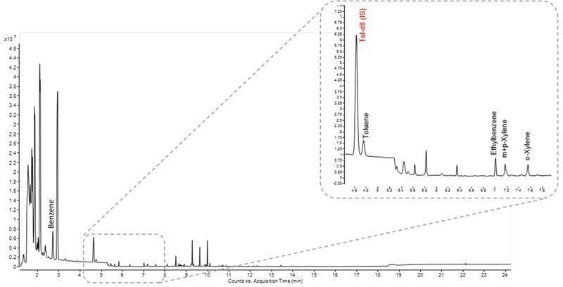**11.2.8** Once analysis of each individual tube or sequence of tubes has been completed (manual or automated desorbers respectively), it (they) should be removed from the system, resealed with long-term storage caps   
(*see* **8.4**) and replaced in the clean storage container (*see* **8.5**). Tube desorption automatically cleans the sorbent tubes and cartridges and leaves them ready for immediate re-use in many cases (s*ee* **8.4** for more details.)

Fig. 7 Example Analysis of an Air Sample Collected Using a Pod Radial Diffusive Sampler from an Indoor Environment and Run Using Thermal Desorption Gcms. Note That All Identified Peaks are at or Below Low Ppb-Level

**Table 2 Instrument Parameters**

(*Fig.* 7)

|  |  |  |  |
| --- | --- | --- | --- |
| **Sl No.** | **Sampler** | **Pod** | **Graphitized Carbon** |
| (1) | (2) | (3) | (4) |
|  | Instrumentation — Fig. 4 | | |
| 1. Thermal desorber | Two stage system, capable of ‘re-collection’, with peltier cooled backflush trap |  |
| 1. Gas chomatograph | Single split/splitless injector, running in constant flow when thermal desorber is interfaced |  |
| 1. Mass spectrometer | Single quadrupole | |
|  | Instrument parameters — Thermal desorber | | |
| 1. Focusing trap | Capable of collecting compounds from C-4 to C-30 | Quartz wool/Porous polymer/Graphitised carbon |
| 1. Flowpath temperature | 180 °C |  |
| 1. Tube prepurge | 50 ml/min | 1 min |
| 1. Tube desorb | 350 °C | 10 min |
| 1. Trap low temperature | - 30 °C |  |
| 1. Trap desorb | 300 °C | 3 min |
| 1. Outlet split | 5 ml/min |  |
|  | Instrument parameters — Gas chromatograph | |  |
| 1. Carrier gas | Helium |  |
| 1. Column | (5 percent-phenyl)-methylpolysiloxane | 30 m × 0.25 mm × 0.25 μm |
| 1. Column flow | 1.5 ml/m*in* | Constant flow mode |
| 1. Oven ramp | 40°C (5 min), 20 °C/min to 325 °C (5 min) |  |
| 1. Inlet temperature | 210 °C |  |
|  | Instrument parameters — Mass spectrometer | |  |
| 1. MS source temperature | 250 °C |  |
| 1. MS quad temperature | 200 °C |  |
| 1. MSD transfer line temperature | 335 °C |  |
| 1. Data acquisition mode | Full scan | m/z 30 to 350 |

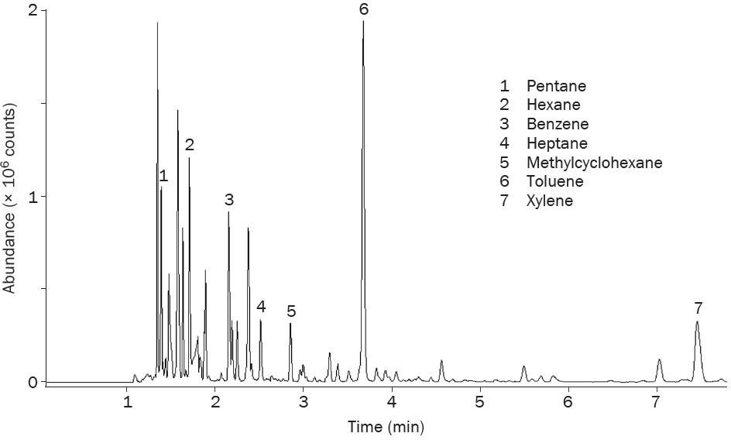

Fig. 8 Example Analysis of an Air Sample Collected Using an Axial Diffusive Sampler from and Industrial Location Over a Two Week Period and Run Using Thermal Desorption Gcms

# Table 3 Instrument Parameters

(*Fig.* 8)

|  |  |  |  |
| --- | --- | --- | --- |
| **Sl No.** | **Sampler** | **Pod** | **Graphitized Carbon** |
| (1) | (2) | (3) | (4) |
|  | Instrumentation — Fig. 4 |  |  |
| 1. Sorbent tube | Compliant with USEPA method carbon 325 | Graphitised |
| 1. Thermal desorber | Two stage system, capable of ‘re-collection’, peltier cooled  backflush trap |  |
| 1. Gas chomatograph | Single Split/Splitless Injector, running in constant flow when thermal desorber is interfaced. |  |
| 1. Mass spectrometer | Single quadrupole |  |
|  | Instrument parameters — Thermal desorber | |  |
| 1. Focusing trap | Capable of collecting ‘air toxics’ | Porous polymer/graphitised carbon/carbonised molecular sieve |
| 1. Flowpath temperature | 150 °C |  |
| 1. Tube prepurge | 50ml/min | 1 min |
| 1. Tube desorb | 350 °C | 10 min |
| 1. Trap low temperature | 25 °C |  |
| 1. Trap desorb | 320 °C | 3 min |
| 1. Outlet split | 5 ml/min |  |
|  | Instrument parameters — Gas chromatograph | |  |
| 1. Carrier gas | Helium |  |
| 1. Column | (5percent-phenyl)- methylpolysiloxane | 30 m × 0.25 mm × 0.25 μm |
| 1. Column flow | 1.5 ml/min | Constant flow mode |
| 1. Oven ramp | 40 °C (5 min), 20 °C/min to 325 °C (5 min) |  |
| 1. Inlet temperature | 210 °C |  |
|  | Instrument parameters — Mass spectrometer | |  |
| 1. MS source temperature | 250 °C |  |
| 1. MS quad temperature | 200 °C |  |
| 1. MSD transfer line temperature | 335 °C |  |
| 1. Data acquisition mode | Full scan | m/z 30 - 350 |

**12 CALCULATIONS**

**12.1 Axial Samplers**

The concentration of each analyte in the sampled air, *C*m, can then be calculated in ppm or ppb as follows:

$$C_{m}\left(nnm\right)=\frac{\left(M_{s}-M_{b}\right)ng}{U×t}$$

or

$$C_{m}\left(ppb\right)=\frac{\left(M_{s}-M_{b}\right)ng}{U×t}$$

where

*M*s = mass, in nanograms, of analyte measured on the sample tube or pictograms;

*Mb* = mass, in nanograms, of that analyte detected on the field blank or pictograms;

*U* = is the uptake rate constant for the analyte (ng.ppm-1.min-1 or pg.ppb-1.min-1); and

*t =* is the time of exposure in mins.

**12.1.1** *Example Calculation Ambient Air*

Ambient air was monitored for compound X, with an uptake rate of 2.0 pg/ppb/min (ng/ppm/*Min*), over a 14 days period. This equates to 20 160 min 142 500 pg of compound X were detected on the sample tube and 2.500 pg were detected in the field blank.

$$\frac{C_{m}\left(ppb\right)=(142 500 pg)}{2×20 160}$$

C*m* = approximately 3.5 ppb

**12.1.2** *Example Calculation Workplace Air*

Workplace air was monitored for compound Y, with an uptake rate of 2.5 ng/ppm/min (pg/ppb/*Min*), over an 8 h period. This equates to 480 mins 2 410 ng of compound Y were detected on the sample tube and 10 ng in the field blank.

$$\frac{C_{m}\left(ppm\right)=(2 410 ng)}{2.5×480}$$

C*m* = approximately 2 ppm

Concentrations stated in vol/vol (ppm or ppb) terms can readily be converted to mass per unit volume terms (µg/m3) using the molecular weight of the relevant compound (*see* Annex B for more example calculations and information

NOTE — To apply uptake rates quoted in ml.min-1 (cm3.min-1) and for other supportive information, please (*see* ISO 16017-2)

# 12.2 Radial Samplers

NOTE — Uptake rates for radial samplers are typically quoted in units of ml.min-1 not ng.ppm-1.min-1

The average concentration, Cm, of each analyte in the sampled air can be calculated in µg/m3 as follows:

$$(µg {m)}^{-3}=\left(\frac{M_{s}-M_{b}}{Uk×t}\right)µg ×1 000 000$$

Or

$$(µg {m)}^{-3}=\left(\frac{M_{s}-M_{b}}{Uk×t}\right)ng ×1 000$$

where

*M*s = mass, in micrograms, of analyte measured on the sample tube;

*M*b = mass, in micrograms, of that analyte detected on the field blank;

*Uk* = is the uptake rate at temperature K for the analyte; and

*t* = is the exposure time in mins.

**12.2.1** *Example Calculation Indoor Air*

Indoor air was monitored for compound X using a POD sampler with an uptake rate of 8 ml/min over a 24 h period. This equates to 1 440 min

235 ng of compound X were detected on the sample cartridge and 5 ng were detected in the field blank.

$$C_{m}(µg {m)}^{-3}=\left(\frac{235 ng-5 ng}{8×1 440}\right)×1 000$$

C*m* = approximately 20 µ𝑔 𝑚−3

**12.2.2** *Example Calculation Workplace Air*

Workplace air was monitored for compound Y using Radiello sampler with an uptake rate of 20 ml/*Min*, over a 1 h period. This equates to 60 min.

1 210 ng of compound Y were detected on the sample cartridge and 10 ng in the field blank.

$$C_{m}(µg {m)}^{-3}=\left(\frac{1 210 ng-10 ng}{20×60}\right)×1 000$$

C*m* = approximately 1 000 µ𝑔 𝑚−3 𝑜𝑟 1 mg m-3

Concentrations stated in mass per unit volume terms (µg/m3) can readily be converted to vol/vol (ppm or ppb) terms using the molecular weight of the relevant compound (*see* Annex B for more example calculations and supportive information).

# 13 QUALITY CONTROL

The following quality control criteria shall be met:

1. The desorption efficiency shall be > 95 percent (> 99 percent should be readily achievable) (*see* **9.1**);
2. The linear regression co-efficient shall be above 0.99 for toluene across the calibration range (*see* **9.3**);
3. The chromatographic system and method must be capable of detecting target compounds at the lowest levels of interest with a signal-to-noise ratio of at least 5 to 1, preferably 10 to 1;
4. The blank level is acceptable if interfering peaks are below 10 percent of the areas of target compounds at the lowest level interest (*see* **9.4**);
5. If field blank chromatograms reflect the same profile of organics as on the samples, and if the levels of these components are 5 percent or more of the sampled compounds, this must be noted in the final report (*see* **13**). If levels are 10 percent or more of those on samples, the sample data are invalid;
6. Replicate mid-level standards should agree within 10 percent; and
7. Replicate samples (*see* **10.6.2**) should agree within 15 percent for > 80 percent of reported analytes.

NOTE — Replicate samples provide a measure of the precision achievable for the entire monitoring procedure including the sampling and analysis.

**14 TEST REPORT**

The laboratory test reports should contain the details specified for the respective monitoring campaign. The sort of information which may be required includes:

1. Details of the sampler (unique identification number, sampler type, sorbents, etc), analytical system used and associated data file identification;
2. Chain of custody information (for example details of who collected the samples and who ran the analysis);
3. Reference to this standard and any supplementary standards referenced;
4. The sampling location, sampling start and end times/dates and the total duration of sampler exposure; and
5. The test results for each sample, including target compounds (calibrated using reference compounds) and any unknowns present in significant concentrations (> 5 percent of the total peak area) calibrated using the response factor for toluene.

NOTES

**1** When reporting results for locations that were monitored using replicate samples, the mean result should be reported for all analytes that agree within 15 percent (*see* **11**). Only the higher result should be reported for all other analytes. (*see* below)

* 1. Other relevant test results – including:
     + - 1. the most recent multi-level calibration (report and example chromatogram from the lowest level standard);
         2. any mid-range, single-level standards analysed during the sample sequence (reports and chromatograms); and
         3. any field and/or laboratory blank tubes analysed during the sample sequence (reports and chromatograms).

**2** Identify any monitoring locations where replicate samples were collected and where most of the measured target compound concentrations differ by more than 15 percent:

* + - 1. Any unusual features noted during sample collection or analysis; and
      2. Any operation not included in this standard.

# ANNEX A

(*Clause* 5.2)

# COMPARING THERMAL DESORPTION (TD) WITH SOLVENT EXTRACTION (SE) FOR AIR MONITORING

**A-1 SENSITIVITY**

Solvent extraction typically involves 1 µl to 2 µl GC injections of 1ml to 2 ml solvent extracts taken from the charcoal tubes. In contrast, TD enables 100percent transfer of collected compounds to the GC column. This factor alone means TD is 1 000 times more sensitive – compatible with ppb and sub-ppb detection limits as well as higher level samples.

# A-2 DESORPTION/EXTRACTION EFFICIENCY

National and international standard methods specifying thermal desorption (*see* **A-3**), including this standard, require at least 95percent desorption efficiency from the sorbent sampling tube and, in practice, complete extraction/desorption and transfer of target analytes to the GC in a single desorption cycle is invariably straightforward. This is because TD is a dynamic process, with gas continually purging compounds away from the sorbent or sample matrix as soon as they are released into the vapour phase by the rising temperature. In contrast, typical solvent extraction procedures are static, with analytes partitioning, in equilibrium, between the sorbent, solvent and vapour (headspace) phases. Standard solvent extraction methods therefore typically require only 75 percent recovery and even this can be difficult to achieve reliably in practice (*see* **A-3**).

# A-3 DESORPTION/EXTRACTION REPEATABILITY

Desorption efficiencies have been reported to drop below 30 percent when charcoal tubes and CS2 extraction are used for polar compounds in humid air. This compromises repeatability and can lead to significant under-reporting, as the analyst may not be aware of field/sample conditions.

# A-4 EXPOSURE RISK

The solvent most commonly used for charcoal tube extraction is CS2. CS2 is toxic, odorous and presents a potential health and safety hazard to laboratory staff. Thermal desorption procedures often require the preparation of a liquid standard for calibration, but no hazardous extraction solvent.

# A-5 COSTS

Cost should only be a taken into consideration if both methods work equally well for the given air monitoring application. However, as a general rule, thermal desorption costs less per sample unless operation is infrequent, in which case solvent extraction is more cost effective.

The initial investment required for TD operation is typically higher than that for solvent extraction, even allowing for installation of a solvent fume hood in the laboratory to extract CS2. TD tubes are also more expensive than charcoal tubes, but as they are re-usable (typically at least 100 times or 200 times) the cost per sample is much lower than one-use charcoal tubes. TD can also be fully automated, reducing errors and cost relative to labour intensive solvent extraction.

# A-6 ANALYTICAL INTERFERENCE

One of the reasons CS2 was originally selected as a preferred solvent for charcoal-based air sampling methods is that it gives little or no signal on a GC flame ionization detector (FID). However, this advantage does not hold for GC-MS detection. Common solvent interference concerns include masking of peaks of interest, signal quenching (for components co-eluting with the solvent) and baseline disturbances. All these make peak integration difficult and more prone to error. TD is inherently free from solvent and other chromatographic interference (*also see* **A-7**).

# A-7 SELECTIVE ELIMINATION OF INTERFERENTS

Depending on the sorbent and compounds of interest, TD procedures can generally be optimized to selectively purge air, water and other volatile interferences while target species are retained and enriched/concentrated. This is rarely possible for charcoal tube and CS2 extraction methods.

# A-8 VERSATILITY

TD sorbent tubes can be used for pumped sampling or in axial diffusive (passive) mode.

# A-9 REPEAT ANALYSIS

Historically, the main advantage of solvent extraction vs TD methods was that each liquid extract could be analyzed several times whereas thermal desorption was a one-shot technique. However, most TD systems now offer quantitative re-collection of samples for repeat analysis, meaning the one-shot limitation no longer applies.

**ANNEX B**

(*Clauses* 1, 6.4, 1, 6.4.4, 8.1,8.3, 9.1, 9.4,9.5, 11.1 *and* 11.2)

**GUIDANCE ON ESTIMATING THE MASS OF ANALYTE THAT WILL BE COLLECTED ON A SORBENT TUBE OR CARTRIDGE DURING DIFFUSIVE (PASSIVE) AIR MONITORING**

**AND**

**GUIDANCE ON THE RELATIONSHIP BETWEEN CONCENTRATION EXPRESSED IN VOL/VOL TERMS (PPM OR PPB) AND CONCENTRATION EXPRESSED AS MASS PER UNIT VOLUME**

**B-1 ESTIMATING THE MASS OF ANALYTE THAT WILL BE RETAINED DURING MONITORING**

The approximate mass of target analyte that will be retained during diffusive (passive) monitoring can be derived from the expected atmospheric concentration or (alternatively) the safe air limit level (if applicable), the exposure (monitoring) period and the uptake rate for that compound on the type of diffusive monitor selected. Example calculations for nominal compounds are presented in Section 11. Additional real world examples for specified compounds are presented here.

*Example* 1: monitoring benzene in urban air for 2 weeks using axial diffusive tubes packed with Carbopack X and an uptake rate of 2 pg/ppb/min, where the limit level is 5 µg/m3 or 1.6 ppb.

In this case the expected mass of benzene retained can be estimated as follows:

t = Two weeks = 20 160 mins

$$If 2 = pg adsorbed per ppb per min of exposure: 2 =\frac{pg}{ppb×t(mins)}$$

Therefore pg benzene expected = 2 ×1.6 (ppb) × 20 160 = 64 512 pg which is roughly 65 ng

*Example* 2: monitoring 1,1-dichloroethene (vinylidene chloride) in workplace air for 8 h using axial diffusive tubes packed with Sulficarb and an uptake rate of 2.5 ng/ppm/min, where the limit level is 4 mg/m3 or 1 ppm.

In this case the expected mass of 1,1-dichloroethene retained can be estimated as follows:

t = 8 h = 480 mins

$$if 2.5=ng adsorbed per ppm per min of exposure 2.5 = \frac{ng}{ppb×t(mins)}$$

Therefore ng 1, 1-dichloroethene expected = 2.5 × 1 (ppm) × 480 = 1 200 ng which is 1.2 µg

*Example* 3 : monitoring toluene for 48 h using radial Fast-PAS diffusive samplers packed with Carbopack X and an uptake rate of 6.04 (cm3/min), in an ambient environment where the usual concentration is known to be around 10 µg.m-3.

In this case the expected mass of toluene retained can be estimated by applying the equation shown in   
Section 11.2 as follows:

t = 48 h = 2 880 mins

$$\frac{10 µg.m^{-3}×6.04{cm}^{3} }{min×2880\min{=} mass in µg 1 000 000 }$$

# B-2 BRIEF GUIDANCE ON CONVERTING CONCENTRATION EXPRESSED AS MASS/UNIT VOLUME TO PPM OR PPB

**B-2.1** Go back to first principles and apply the gas laws as follows:

**B-2.1.1** A mole of pure vapour occupies 25 l at room temperature and pressure.

**B-2.1.2** For a nominal compound x with molecular weight 100, this means that a mole (100 g) of pure × vapour occupies 25 l at room temperature and pressure.

**B-2.1.3** Therefore a cubic meter (m3) of pure x vapour would contain around 4 000 g (4 kg) of ×

**B-2.1.4** Therefore 1 m3 of air with × at 1 ppm would contain 4 mg of × or 1 ppm × equates to 4 mg/m3.

**B-2.1.5** Therefore 1 m3 of air with × at 1 ppb would contain 4 µg of × or 1 ppb x equates to 4 µg/m3 and so on.

# ANNEX C

(*Clauses* 8.1 *and* 10.1)

# EXAMPLE UPTAKE RATES FOR EXAMPLE TARGET ORGANIC VAPOURS USING DIFFUSIVE SAMPLERS AT 20 °C

Sources used in this Annex are denoted by the superscript III*x* and are listed at the bottom of each table.

# Table 4 Uptake Rates on Industry Standard Stainless Steel Tube-based Axial Samplers Packed with Specified Sorbents (Available from Standard Sources)

(*Annex* C)

| **Sl No.** | **Compound name** | **B.pt (°C)** | **Sorbent** | **Uptake rate** | **Exposure Time** | **Sources** |
| --- | --- | --- | --- | --- | --- | --- |
| (1) | (2) | (3) | (4) | (5) | (6) | (7) |
|  | **Aliphatic hydrocarbons** | | | | | |
|  |  |  | Carbopack X | 0.61ml/min | 24 h 1 | 9 |
|  |  |  | Carbopack X | 1.24ng/ppm/min | week | 9, 10, 12 |
|  | 1,3-butadiene | - 4.5 °C | Carbopack X | 0.55 ml/min | 1 week | 10 |
|  |  |  | Carbpoack X | 0.45 ml/min | 2 weeks | 10 |
|  | n-butane | - 0.5 °C | Carbopack X | 1.3ng/ppm/min | 2 week | 8 |
|  | i-butane | - 12 °C | Carbopack X | 0.8ng/ppm/min | 2 week | 8 |
|  |  |  | Carbopack B | 0.60 ml/min | 8 h | 13 |
|  |  |  | Carbopack B | 1.77 ng/ppm/min | 8 h 2 | 13 |
|  | n-pentane | 36 °C | Carbopack B | 1.34 ng/ppm/min | week | 8 |
|  |  |  | Carbopack X | 1.8 ng/ppm/min | 2 week | 8 |
|  | i-pentane | 28 °C | Carbopack X | 1.6 ng/ppm/min | 2 week | 8 |
|  | n-hexane | 69 °C | Carbopack X  Carbopack B | 2.0 ng/ppm/min  1.75 ng/ppm/min | 2 week  2 week | 8  8 |
|  |  |  | Tenax TA | 1.77 ng/ppm/min | 8 h | 13 |
|  | n-heptane | 98 °C | Tenax TA | 0.43 ml/min | 8 h | 13 |
|  |  |  | Tenax TA | 0.26 ml/min | 1 week | 12 |
|  | n-octane | 126 °C | Tenax TA  Tenax TA | 2.00 ng/ppm/min  0.43 ml/min | 8 h  8 h | 13  13 |
|  |  |  | Tenax TA | 0.27 ml/min | 1 week | 12 |
|  | n-nonane | 150 °C | Tenax TA  Tenax TA | 2.40 ng/ppm/min  0.46 ml / min | 8 h  8 h | 13  13 |
|  | n-decane | 174 °C | Tenax TA  Tenax TA  Tenax TA | 0.34 ml/min  2.3 ng/ppm/min  0.40 ml / min | 1 week  8 h  8 h | 12  13  13 |
|  |  |  | Tenax TA | 0.51 ml/min | 4 weeks | 5 |
|  | n-undecane | 196 °C | Tenax TA | 0.53 ml/min | 4 weeks | 5 |
|  | n-dodecane | 216 °C | Tenax TA | 0.26 ml/min | 1 weeks | 12 |
|  | Cyclohexane | 81 °C | Tenax TA | 0.25 ml/min | 1 weeks | 12 |
|  | Methylcyclohexane | 101 °C | Tenax TA | 0.20 ml/min | 1 weeks | 12 |
|  | Aromatic hydrocarbons |  |  |  |  |  |
|  |  |  | Tenax TA  Tenax TA | 1.3 ng/ppm/min  0.40 ml / min | 8 h  8 h | 13  13 |
|  |  |  | Tenax GR | 1.81 ng/ppm/min | 8 h | 13 |
|  | Benzene | 80 °C |  |  |  |  |
|  |  |  | Tenax GR | 0.57 ml / min | 8 h | 13 |
|  |  |  | Carbopack X | 0.67 ml/min | 24 h | 9 |
|  |  |  | Tenax TA | 0.27 ml/min | 1 week | 12 |
|  |  |  | Carbopack X | 1.85 ng/ppm/min | 1 week | 10 |
|  |  |  | Carbopack B | 0.42 ml/min | 1 week | 2 |
|  |  |  | Carbograph 1 TD or Carbopack B | 2.14 ng/ppm/min | 1 week | 6 |
|  |  |  | Carbograph 1 TD or  Carbopack B | 2.16 ng/ppm/min | 1 week | 11 |
|  |  |  | Carbopack X | 2.1 ng/ppm/min | 2 weeks | 8 |
|  |  |  | Carbopack X | 1.98 ng/ppm/min | 2 Weeks | 3 |
|  |  |  | Carbopack X | 1.93 ng/ppm/min | 2 weeks | 10 |
|  |  |  | Carbograph 1 TD or  Carbopack B | 1.75 ng/ppm/min | 2 weeks | 8 |
|  |  |  | Carbograph 1 TD or  Carbopack B | 2.03 ng/ppm/min | 2 weeks | 6 |
|  |  |  | Carbograph 1 TD or  Carbopack B | 2.00 ng/ppm/min | 2 weeks | 11 |
|  |  |  | Carbograph 1 TD or  Carbopack B | 1.83 ng/ppm/min | 4 weeks | 11 |
|  |  |  | Carbograph 1 TD or  Carbopack B | 1.85 ng/ppm/min | 4 weeks | 6 |
|  | Toluene | 110.6 °C | Tenax TA  Tenax TA  Tenax GR  Tenax GR | 1.67 ng/ppm/min  0.44 ml/min  2.12 ng/ppm/min  0.56 ml/min | 8 h  8 h  8 h  8 h | 13  13  13  13 |
|  |  |  | Carbopack B | 2.06 ng/ppm/min | 8 h | 13 |
|  |  |  | Carbopack B | 0.55 ml/min | 8 h | 13 |
|  | Xylene | 138 to 144 °C | Tenax TA  Tenax TA  Tenax GR | 1.82 ng/ppm/min  0.42 ml/min  2.48 ng/ppm/min | 8 h  8 h  8 h | 13  13  13 |
|  |  |  | Tenax GR | 0.57 ml/min | 8 h | 13 |
|  | m,p-Xylene | 138 to 139 °C | Carbopack B  Tenax TA  Tenax TA  Tenax GR | 0.47ml/min  2.0 ng/ppm/min  0.46 ml/min  2.38 ng/ppm/min | 1 week  8 h  8 h  8 h | 2  13  13  13 |
|  | Ethyl benzene | 136 °C | Tenax GR | 0.55 ml/min | 8 h | 13 |
|  |  |  | Tenax TA  Carbopack B | 0.35 ml/min  0.47 ml/min | 1 week  1 week | 12  2 |
|  | Trimethylbenzene | 165 to 176 °C | Tenax TA  Tenax TA | 2.37 ng/ppm/min  0.48 ml/min | 8 h  8 h | 13  13 |
|  | 1,2,4-trimethylbenzene | 169 °C | Tenax TA | 0.54 ml/min | 4 week | 5 |
|  | 1,3,5-trimethylbenzene | 165 °C | Carbopack X | 0.41ml/min | 24 h | 9 |
|  | Styrene | 145 °C | Tenax TA  Tenax TA | 2.0 ng/ppm/min  0.47 ml/min | 8 h  8 h | 13  13 |
|  | Naphthalene | 218 °C | Tenax TA  Tenax TA | 0.41 ml/min  2.26 ng/ppm/min | 8 h  8 h | 7  13 |
|  | Cumene | 152.4 °C | Tenax TA | 0.46 ml/min | 8 h | 13 |
|  | 4-ethyltoluene | 162 °C | Carbopack X | 0.41 ml/min | 24 h | 9 |
|  | Halocarbons |  |  |  |  |  |
|  | Carbon tetrachloride | 77 °C | Carbopack X | 0.51 ml/min | 24 h | 9 |
|  | 1,1-dichloroethane | 57 °C | Carbopack X | 0.57 ml/min | 24 h | 9 |
|  | Cis-1,2-dichloroethene | 55 °C | Carbopack X | 0.58 ml/min | 24 h | 9 |
|  | 1,2-dichloroethane | 83.5 °C  83.5 °C | Carbopack X Tenax TA | 0.57 ml/min  0.20 ml/min | 24 h  1 week | 9  12 |
|  | 1,1,1-trichloroethane | 74 °C | Carbopack X | 0.51 ml/min | 24 h | 9 |
|  | 1,1,2 trichloroethane | 114 °C | Carbopack X | 0.49 ml/min | 24 h | 9 |
|  | 1,2-dichloro, | 4 °C | Carbopack X | 0.44 ml/min | 24 h | 9 |
|  | 1,1,2,2 tetraflorethane |
|  | 1,1,2-trichloro,  1,2,2trifloroethane | 48 °C | Carbopack X | 0.46 ml/min | 24 h | 9 |
|  | Hexachloroethane |  | Tenax TA | 2.4 ng/ppm/min | 4 Weeks | 1 |
|  | 1-chloropropene | 45 °C | Carbopack X | 0.51 ml/min | 24 h | 9 |
|  | 1,2-dichloropropane | 95.5 °C | Carbopack X | 0.52 ml/min | 24 h | 9 |
|  | Hexachlorobutadiene | 215 °C | Tenax TA | 3.5 ng/ppm/min | 4 Weeks | 1 |
|  | Chlorobenzene | 132 °C | Carbopack X | 0.46 ml/min | 24 h | 9 |
|  | Other |  |  |  |  |  |
|  | Benzaldehyde | 179 °C | Tenax TA | 0.41 ml/min | 1 week | 12 |
|  | Ethylacetate | 77 °C | Tenax TA | 0.23 ml/min | 1 week | 12 |
|  | Alpha-pinene | 156 °C | Tenax TA | 0.20 ml/min | 1 week | 12 |
|  | Limonene | 176.0 °C | Tenax TA | 0.27 ml/min | 1 week | 12 |

**Table 5 Uptake Rates for Fast-PAS Radial Samplers**

(*Annex* C)

| **Sl No** | **Compound Name** | | **B.pt (◦C)** | **Sorbent** | **Uptake rate** | | **Exposure Time** | **Sources** |
| --- | --- | --- | --- | --- | --- | --- | --- | --- |
| (1) | (2) | | (3) | (4) | (5) | | (6) | (7) |
|  | Aliphatic hydrocarbons | | | | | | | |
|  | n-butane | | - 0.5 | Carbopack X | 4.94 (cm3/min) | | 72 h | 1 |
|  | 1-butene | | - 6.3 | Carbopack | 3.01 (cm3/min) | | 72 h | 1 |
|  | 1, 3-butadiene | | - 4.59 | Carbopack X | 4.29 (cm3/min) | | 72 h | 1 |
|  | trans-2-butene | | 0. | Carbopack X | 5.97 (cm3/min) | | 72 h | 1 |
|  | cis-2-butene | | 3.73 | Carbopack X | 4.13 (cm3/min) | | 72 h | 1 |
|  | 2-methylpropane | | - 12 | Carbopack X | 1.28 (cm3/min) | | 72 h | 1 |
|  |  | |  |  | 8.47 (cm3/min) | | 24 h | 2 |
|  | n-pentane | | 36 | Carbopack X | 8.59 (cm3/min) | | 72 h | 1 |
|  | 1-pentene | | 29.9 | Carbopack X | 9.55 (cm3/min) | | 72 h | 1 |
|  | trans-2-pentene | | 36.3 | Carbopack X | 8.83 (cm3/min) | | 72 h | 1 |
|  | 2-methyl-butane | | 27.8 | Carbopack X | 8.56 (cm3/min) | | 72 h | 1 |
|  | isoprene | | 34 | Carbopack X | 9.89 (cm3/min) | | 72 h | 1 |
|  | n-hexane | | 68.7 | Carbopack X | 8.1 (cm3/min) | | 72 h | 1 |
|  | 2-methylpentane | | 60.2 | Carbopack X | 9.9 (cm3/min) | | 72 h | 1 |
|  | 2,2-dimethyl-butane | | 49.7 | Carbopack X | 6.76 (cm3/min) | | 72 h | 1 |
|  | 2,3-dimethyl-butane | | 57.9 | Carbopack X | 6.76 (cm3/min) | | 72 h | 1 |
|  |  | |  |  | 6.82 (cm3/min) | | 24 h | 2 |
|  | n-heptane | | 98.5 | Carbopack X | 7.13 (cm3/min) | | 72 h | 1 |
|  | 2-methylhexane | | 90 | Carbopack X | 5.77 (cm3/min) | | 72 h | 1 |
|  | 3-methylhexane | | 91 | Carbopack X | 5.77 (cm3/min) | | 72 h | 1 |
|  |  | |  |  | 6.58 (cm3/min) | | 24 h | 2 |
|  | n-octane | | 125.6 | Carbopack X | 6.29 (cm3/min) | | 72 h | 1 |
|  | n-decane | | 174.1 | Carbopack X | 3.73 (cm3/min) | | 72 h | 1 |
|  | methylcyclopentane | | 71.8 | Carbopack X | 7.89 (cm3/min) | | 72 h | 1 |
|  | cyclohexane | 80.7 | | Carbopack X | | 6.84 (cm3/min) | 72 h | 1 |
|  | methylcyclohexane | 100.9 | | Carbopack X | | 6.79 (cm3/min) | 72 h | 1 |
|  | 1,3-dimethylcyclohexane | 122.4 | | Carbopack X | | 6.8 (cm3/min) | 72 h | 1 |
|  | 1,4-dimethylcyclohexane | 120 | | Carbopack X | | 6.78 (cm3/min) | 72 h | 1 |
|  | 2,2,4-trimethylpentane | 99.2 | | Carbopack X | | 5.5 (cm3/min) | 72 h | 1 |
|  | Aromatic hydrocarbons | | | | | | | |
|  |  |  | |  | | 8.15 (cm3/min) | 24 h | 2 |
|  | SS | 80 | | Carbopack X | | 8.89 (cm3/min) | 72 h | 1 |
|  |  |  | |  | | 6.04 (cm3/min) | 24 h | 2 |
|  | toluene | 110.6 | | Carbopack X | | 8.1 (cm3/min) | 72 h | 1 |
|  |  |  | |  | | 5.96 (cm3/min) | 24 h | 2 |
|  | ethyl-benzene | 136 | | Carbopack X | | 6.92 (cm3/min) | 72 h | 1 |
|  |  |  | |  | | 5.28 (cm3/min) | 24 h | 2 |
|  | m,p-xylene | 138 to 139 | | Carbopack X | | 5.93 (cm3/min) | 72 h | 1 |
|  |  |  | |  | | 7.67 (cm3/min) | 24 h | 2 |
|  | o-Xylene | 144.5 | | Carbopack X | | 5.69 (cm3/min) | 72 h | 1 |
|  | cumene | 152.4 | | Carbopack X | | 5.29 (cm3/min) | 72 h | 1 |
|  | 1,3,5-trimethylbenzene | 165 | | Carbopack X | | 5.5 (cm3/min) | 72 h | 1 |
|  | 1,2,4-trimethylbenzene | 169 | | Carbopack X | | 5.85 (cm3/min) | 72 h | 1 |
|  | 1,2,3-trimethylbenzene | 176.1 | | Carbopack X | | 5.85 (cm3/min) | 72 h | 1 |

**Table 6 Uptake Rates for Radiello Radial Samplers**

(*Annex* C)

| **Sl No.** | **Compound Name** | **B.pt (°C)** | **Sorbent** | **Uptake Rate** | | **Maximum Exposure Time** | **Sources** |
| --- | --- | --- | --- | --- | --- | --- | --- |
| (1) | (2) | (3) | (4) | (5) | | (6) | (7) |
|  | Aliphatic hydrocarbons | | | | | | |
|  | 1. n-hexane | 68.7 | Carbograpgh 4TD | 25.5 (ml/min) | 7 days | | 1 |
|  | 1. n-heptane | 98.5 | Carbograpgh 4TD | 25.3 (ml/min) | 14 days | | 1 |
|  | 1. n-octane | 125.6 | Carbograpgh 4TD | 24.1 (ml/min) | 14 days | | 1 |
|  | 1. n-nonane | 150 | Carbograpgh 4TD | 21 (ml/min) | 14 days | | 1 |
|  | 1. n-decane | 174.1 | Carbograpgh 4TD | 22.3 (ml/min) | 14 days | | 1 |
|  | 1. n-undecane | 196 | Carbograpgh 4TD | 12.0 (ml/min) | 14 days | | 1 |
|  | 1. Cyclohexane | 80.0 | Carbograph 4 TD | 27.6 (ml/min) | 7 days | | 1 |
|  | Aromatic hydrocarbons | | | | | | |
|  | 1. benzene | 80 | Carbograpgh 4TD | 27.8 (ml/min) | 7 days | | 1 |
|  | 1. toluene | 110.6 | Carbograpgh 4TD | 30 (ml/min) | 14 days | | 1 |
|  | 1. m,p-xylene | 138 to 139 | Carbograpgh 4TD | 26.6 (ml/min) | 14 days | | 1 |
|  | 1. o-xylene | 144.5 | Carbograpgh 4TD | 24.6 (ml/min) | 14 days | | 1 |
|  | 1. ethylbenzene | 136 | Carbograpgh 4TD | 25.7 (ml/min) | 14 days | | 1 |
|  | 1. styrene | 145 | Carbograpgh 4TD | 27.1 (ml/min) | 14 days | | 1 |
|  | 1. 1,2,4 trimethylbenze | 169 | Carbograpgh 4TD | 21.9 (ml/min) | 14 days | | 1 |
|  | Halocarbons | | | | | | |
|  | 1. 1,1,1-trichloroethane | 74 | Carbograpgh 4TD | 20 (ml/min) | 7 days | | 1 |
|  | 1. trichloroethylene | 87.2 | Carbograpgh 4TD | 27.1 (ml/min) | 7 days | | 1 |
|  | 1. tetrachloroethylene | 121.3 | Carbograpgh 4TD | 25.4 (ml/min) | 7 days | | 1 |
|  | 1. 1,4-dichlorobenzene | 174 | Carbograpgh 4TD | 22 (ml/min) | 14 days | | 1 |
|  | Alcohols | | | | | | |
|  | 1. 2-butoxyethanol | 168.4 | Carbograpgh 4TD | 19.4 (ml/min) | 14 days | | 1 |
|  | 1. 2-ethyl-1-hexanol | 184.6 | Carbograpgh 4TD | 14.3 (ml/min) | 14 days | | 1 |
|  | 1. 2-ethoxyethanol | 135 | Carbograpgh 4TD | 26.0 (ml/min) | 14 days | | 1 |
|  | 1. 2-methoxyethanol | 124.1 | Carbograpgh 4TD | 4.0 (ml/min) | 14 days | | 1 |
|  | 1. 1-methoxy-2propanol | 119 | Carbograpgh 4TD | 26.6 (ml/min) | 14 days | | 1 |
|  | Esters and Ethers | | | | | | |
|  | 1. methyl-tert-butyl ether 2. (MTBE) | 55.2 | Carbograpgh 4TD | 30 (ml/min) | 7 days | | 1 |
|  | 1. ethyl-tert-butyl ether (ETBE) | 73.1 | Carbograpgh 4TD | 30 (ml/min) | 7 days | | 1 |
|  | 1. butyl acetate | 126.1 | Carbograpgh 4TD | 24.5 (ml/min) | 14 days | | 1 |
|  | 1. 2-methoxyethyl acetate | 143 | Carbograpgh 4TD | 21.0 (ml/min) | 7 days | | 1 |
|  | 1. 2-ethoxyethyl acetate | 156.4 | Carbograpgh 4TD | 20.9 (ml/min) | 14 days | | 1 |
|  | 1. isopropyl acetate | 88.6 | Carbograpgh 4TD | 25.8 (ml/min) | 7 days | | 1 |
|  | Other | | | | | | |
|  | 1. dimethyl disulfide | 109.8 | Carbograpgh 4TD | 23.7 (ml/min) | 7 days | | 1 |
|  | 1. limonene | 176 | Carbograpgh 4TD | 12.8 (ml/min) | 14 days | | 1 |
|  | 1. a-pinene | 156 | Carbograpgh 4TD | 6.4 (ml/min) | 7 days | | 1 |

**For Information Only**

(*Clause* 7.3)

Below listed products are included to aid readers of this standard and do not indicate an endorsement. Equivalent products may be used.

1. Tenax TA®
2. Carbopack XTM and Carboxen 1003TM
3. Carbograph 5 TDTM
4. SulficarbTM Fast-PAS
5. radiello®

**BIBLIOGRAPGHY**

The following national and international standard methods provide useful background information:

1. **US EPA Method 325A**: Volatile organic compounds from fugitive and area sources: sampler deployment and VOC sample collection
2. **US EPA Method 325B:** Volatile organic compounds from fugitive and area sources: Sampler preparation and analysis
3. **ISO 16017:** Indoor, ambient and workplace air — Sampling and analysis of volatile organic compounds by sorbent tube/thermal desorption/capillary gas chromatography. Part 1: Pumped sampling and   
   Part 2: Diffusive sampling
4. **EN 14662-4:** Ambient air quality — Standard method for measurement of benzene concentrations —   
   Part 4: Diffusive sampling followed by thermal desorption and gas chromatography.
5. **ASTM D6196:** Standard practice for choosing sorbents, sampling parameters and thermal desorption analytical conditions for monitoring volatile organic chemicals in air
6. **UK Health and Safety Executive:** Methods for the Determination of Hazardous Substances #80: Volatile organic compounds in (workplace) air: Laboratory method using diffusive solid sorbent tubes, thermal desorption and gas chromatography

**ANNEX D**

(*Foreword*)

**COMMITTEE COMPOSITION**

Air Quality Sectional Committee, CHD 35

| *Organization* | *Representative(s)* |
| --- | --- |
| In Personal Capacity (*Former Head, Environmental Testing and Analysis Division, BARC*) | DR GAURI PANDIT (***Chairperson***) |
| Bhabha Atomic Research Centre, Mumbai | DR A. VINOD KUMAR  DR S. K. SAHU (*Alternate*) |
| Central Pollution Control Board, New Delhi | SHRI ADITYA SHARMA |
| Confederation of Indian Industry, New Delhi | SHRI MOHIT SHARMA  SHRI SHUBHAM MISHRA (*Alternate*) |
| CSIR- National Physical Laboratory, New Delhi | DR SHANKAR AGARWAL  SHRI TUHIN KUMAR MANDAL (*Alternate*) |
| CSIR -National Environmental Engineering Research Institute, Nagpur | DR S. K. GOYAL  DR P. K. LABHASETWAR (*Alternate* I)  DR SMITHA AGGARWAL (*Alternate* II) |
| Ecotech Instruments, Greater Noida | DR RAJENDRA PRASAD |
| Envirotech East Private Limited, kolkata | SHRI ASOKE KUMAR BANERJEE  SHRI SANJIB KUMAR GOSWAMI (*Alternate*) |
| Envirotech Instruments Private Limited, New Delhi | DR BALBIR SINGH  SHRI ASHISH GUPTA |
| Green Economy Initiatives Private Limited, Mohali | DR R. S. SAINI  MS SONIKA PAWAR |
| Indian Association for Air Pollution Control, New Delhi | DR J. S. SHARMA |
| Indian Chemical Council, Mumbai | SHRI DHRUMIL SONI |
| Maharashtra State Pollution Control Board, Govt of Maharashtra, Mumbai | DR P. D. KHADKIKAR  SHRI KISHORE GAWANKAR (*Alternate*) |
| NTPC Ltd, New Delhi | SHRI VIJAY PRAKASH  SHRI RAJIV RANJAN (*Alternate* I)  DR SUDHIR DAHIYA (*Alternate* II) |
| National Council for Cement and Building Materials, Ballabhgarh | SHRI ANAND BOHRA  SHRI K. R. P. NATH (*Alternate* I)  SHRI M. SELVARAJAN (*Alternate* II) |
| The Fertilizer Association of India, New Delhi | SHRI MANISH GOSWAMI  SHRI ARUN KUMAR MONDAL (*Alternate*) |
| Uniphos Envirotronics Pvt Ltd, Gujarat | SHRI VIJAY PANDEY  SHRI VINAYAKA PRABHAKAR VALSANGKAR (*Alternate* I)  DR R. C. NAIK (*Alternate* II) |
| In personal capacity (*Flat 403, Neha apartment Vinayaka Nagar, Gachibowli Hyderabad — 500032*) | DR N RAVEENDHAR |
| In personal capacity (*Development House P.Ltd C 10, Sector 06, Noida*) | DR S. N. A RIZVI |
| In personal capacity (*B-31/F3, Rampuri, Suryanagar Ghaziabad - 201011*) | DR S. K. TYAGI |
| BIS Directorate General | SHRI AJAY KUMAR LAL, SCIENTIST ‘F’/SENIOR DIRECTOR AND HEAD (CHEMICAL) [REPRESENTING DIRECTOR GENERAL (*Ex-officio*)] |

*Member Secretary*

SHRIMATI PREETI PRABHA

SCIENTIST ‘C’/DIPUTY DIRECTOR

(CHEMICAL), BIS