***भारतीय मानक***

***Indian Standard***

**IS 13365 (Part 3) : 2024**

**शैल संहति का मात्रात्मक वर्गीकरण तंत्र — दिशानिर्देश सिद्धांत**

**भाग 3 ढलान संहति रेटिंग का निर्धारण**

*( पहला पुनरीक्षण )*

**Quantitative Classification Systems of**

**Rock Mass — Guidelines**

**Part 3 Determination of Slope Mass Rating**

*( First Revision )*

ICS 93.020

© BIS 2024

भारतीय मानक ब्यूरो

BUREAU OF INDIAN STANDARDS

मानक भवन, 9 बहादुर शाह ज़फर मार्ग, नई दिल्ली - 110002

MANAK BHAVAN, 9 BAHADUR SHAH ZAFAR MARG

NEW DELHI - 110002

[www.bis.gov.in](http://www.bis.org.in) [www.standardsbis.in](http://www.standardsbis.in)

**November 2024 Price Group…**

Rock Mechanics Sectional Committee, CED 48

FOREWORD

This Indian Standard (Part 3) (First Revision) was adopted by the Bureau of Indian Standards, after the draft finalized by the Rock Mechanics Sectional Committee had been approved by the Civil Engineering Division Council.

Quantitative classification of rock masses has many advantages. It provides a basis for understanding characteristics of different groups. It also provides a common basis for communication besides yielding quantitative data for designs for feasibility studies of project. This is the reason why quantitative classifications have become very popular all over the world.

This standard covers the procedures for obtaining the value of slope mass rating (SMR) for preliminary assessment of the stability of rock slopes. The approach is based on modification of RMR system using adjustment factors related to discontinuity orientation with reference to slope as well as failure mode and slope excavation methods. Slope mass rating (SMR) is a measure of degree of stability of rock slopes. The determination of slope mass rating is very easy and yet reliable. This method is recommended for landslide hazard zonation for feasibility studies in the hilly areas where rock is exposed.

Slope mass rating takes into account orientation of joints, seepage forces, fracture spacing, degree of weathering and method of excavation. It also considers mode of failures; for example, planar slide, wedge slide and toppling failure. Detailed study of rock slopes is needed, if SMR is found to be less than 60 or slope appears to be in distress.

This standard has been published in four parts. The other parts in the series are:

Part 1 Rock mass rating (RMR), for predicting engineering properties

Part 2 Rock mass quality for prediction of support pressure, support system and engineering properties in underground openings

Part 4 Geological strength index (GSI)

This standard was first published in 1997. This revision of the standard has been brought out based on the experience gained in use of the standard since its last revision. In this revision, the following major modifications have been mode:

1. Slope height of cut slope angle has been clarified;
2. Ambiguity in the formula for estimation of slope mass rating has been remove;
3. Improved table has been introduced for the adjustments rating for joints;
4. Notation, symbol and their explanation has been improved as per the current practices; and
5. Reference of various Indian Standard has been updated.

The composition of the Committee responsible for the formulation of this standard is given in Annex B.

For the purpose of deciding whether a particular requirement of this standard is complied with, the final value, observed or calculated, expressing the result of a test or analysis, shall be rounded off in accordance with IS 2 : 2022 ‘Rules for rounding of numerical values (*second revision*)’*.* Thenumber of significant places retained in the rounded off value should be the same as that of the specified value in this standard.

*Indian Standard*

QUANTITATIVE CLASSIFICATION SYSTEMS OF ROCK MASS — GUIDELINES

**PART 3 DETERMINATION OF SLOPE MASS RATING**

*( First Revision )*

**1 SCOPE**

This standard (Part 3) covers the procedures for obtaining the value of slope mass rating (SMR) for preliminary assessment of the stability of rock slopes. The approach is based on modification of RMR system using adjustment factors related to discontinuity orientation with reference to slope as well as failure mode and slope excavation methods.

**2 REFERENCES**

The standards listed in Annex A contain provisions which through reference in this text, constitute provisions of this standard. At the time of publication, the editions indicated were valid. All standards are subject to revision, and parties to agreements based on this standard are encouraged to investigate the possibility of applying the most recent edition of these standards.

**3 PROCEDURE**

**3.1 Estimation of Rock Mass Rating (${RMR}_{basic}$)**

The geomechanical properties of rock mass shall be evaluated by RMR system. The ${RMR}_{basic}$ shall be determined by adding the rating values for the following five parameters as given in Table 1. The procedure has been elaborated in detail in IS 13365 (Part 1):

1. Uniaxial compressive strength of intact material (*see* IS 8764);
2. Spacing of discontinuities (*see* IS 11315 (Part 2)];
3. Condition of discontinuities (*see* IS 11315 (Part 4)];
4. Ground water conditions (*see* IS 11315 (Part 8)]; and
5. Rock quality designation (RQD) (*see* IS 11315 (Part 11)].

**3.2 Determination of Failure Modes in Rock Slopes**

The slope failures in rock mass are governed by geological discontinuities and movement occurs along surfaces formed by one or several sets of geological discontinuities. Basic modes of failures are given in IS 11315 (Part 1) and summarised below.

**3.2.1** *Plane Failure* (*Plain Wedge Slide*)

Plane failure takes place along continuous joints dipping towards the slope or valley with strike nearly parallel to the slope face [Fig. 1(a)]. The instability conditions occur if critical joint dips less than slope, and the mobilised shear strength along the joint is not enough for stability.

**3.2.2** *Wedge Failure* (3*D Wedge Slide*)

Wedge failure takes place along two geological discontinuities of different sets, whose line of inter-section is towards the slope or valley, but the plunge is less than the inclination of the slope [Fig. 1(b)]. It is generally more frequent than the planar slides.

It may be noted that plane failure is a special case of wedge failure.

**Table 1 ${RMR}_{basic}$ Rating**

(*Clause* 3.1)

|  |  |  |  |  |  |  |  |  |
| --- | --- | --- | --- | --- | --- | --- | --- | --- |
| **Parameter** | **Ranges of Values** | | | | | | | |
| Strength of intact rock | Point load strength index | > 10 MPa | 4 MPa to 10 MPa | 2 MPa to 4 MPa | 1 MPa to 2 MPa | < 1 MPa for this low range, uniaxial compressive test is preferred | | |
| Uniaxial compressive strength | > 250 MPa | 100 MPa to 250 MPa | 50 MPa to 100 MPa | 25 MPa to 50 MPa | 5 MPa to 25 MPa | 1 MPa to 5 MPa | < 1 MPa |
| **Rating** |  | 15 | 12 | 7 | 4 | 2 | 1 | 0 |
| Drill core quality | RQD | 90 percent to 100 percent | 75 percent to 90 percent | 50 percent to 75 percent | 25 percent to 50 percent | < 25 percent | | |
| **Rating** |  | 20 | 17 | 13 | 8 | 3 | | |
| Spacing of discontinuities |  | > 2 m | 0.6 m to 2 m | 200 mm to 600 mm | 60 mm to 200 mm | < 60 mm | | |
| **Rating** |  | 20 | 15 | 10 | 8 | 5 | | |
| Condition of discontinuities |  | Very rough surfaces; Not continuous No separation unweathered wall rock | Slightly rough separation < 1 mm slightly weathered walls | Slightly rough surfaces separation < 1 mm highly weathered walls | Slickensided surfaces or gouge 5 mm thick or separation 1 mm to 5 mm continuous | Soft gouge > 5 mm or separation > 5 mm continuous | | |
| **Rating** |  | 30 | 25 | 20 | 10 | 0 | | |
| Ground water condition |  | Completely dry | Damp | Wet | Dripping | Flowing | | |
| **Rating** |  | 15 | 10 | 7 | 4 | 0 | | |

**3.2.3** *Toppling Failure*

Toppling failure takes place along a continuous set of joints, which dips against the slope, and with strike nearly parallel to slope face [Fig. 1(c)]. Joints are generally weathered in these cases. In practice, two kinds of instability can happen, that is, minor toppling near the surface of slope, and deep toppling, which can produce large deformations. In both the cases, the failures develop slowly, and are not prone to sudden rock falls.

**3.2.4** *Collection of Field Data*

The determination of failure modes in rock slopes shall be done on the basis of graphical analysis of the geological discontinuities observed on the slope. Depending upon the structural complexity of the area, 100 to 500 readings of the geological discontinuities shall be taken, the poles shall be plotted in an equal area stereonet and contoured to get the maximas of pole concentrations. The failure modes can be identified from the pattern of maximas of pole concentrations [Fig.1 (a), (b) and (c)].

**3.3 Determination of Adjustment Rating for Rock Slopes**

The adjustment rating for joints in rock slopes is a product of the following three factors:

1. $F_{1}$ depends on parallelism between the slope dip and the discontinuity dip direction;
2. $F_{2}$ depends on the dip of discontinuity; and
3. $F_{3}$ depends on the relationship of dips of discontinuity and slope.

NOTES

**1** Discontinuity refers to the planar discontinuity or the line of intersection of two planar discontinuities whichever is important from the point of view of instability of rock slopes.

**2** The effect of ground water on the SMR has been considered indirectly by ${RMR}_{basic}$.

**3** The SMR shall not be applicable where length of joints along dip direction is less than 5 percent of affected slope height.

Table 2 gives rating for $F_{1}$, $F_{2}$ and $F_{3}$. The notations are as follows:

$a_{s}$ = dip direction or inclination direction of the slope face;

$β_{s}$ = dip or inclination of slope face;

$a_{j}$ = dip direction of discontinuity in the case of planar slide;

= plunge or dip-direction of line of intersection of the unstable wedge;

$β_{j}$ = dip of discontinuity in the case of planar slide;

$P$ = planar failure or wedge failure; and

$T$ = toppling failure.

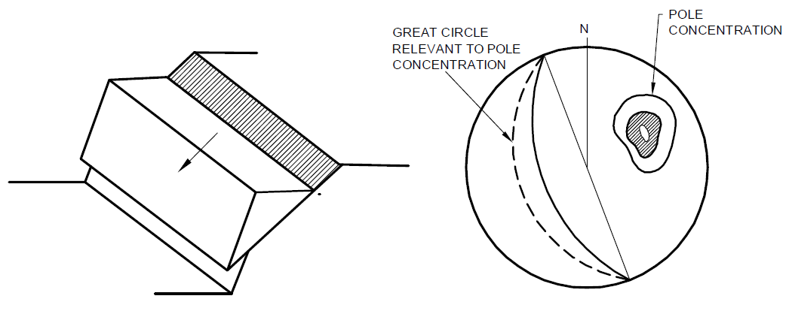

1(A) PLANE FAILURE IN HIGHLY ORDERED STRUCTURE SUCH AS SLATE

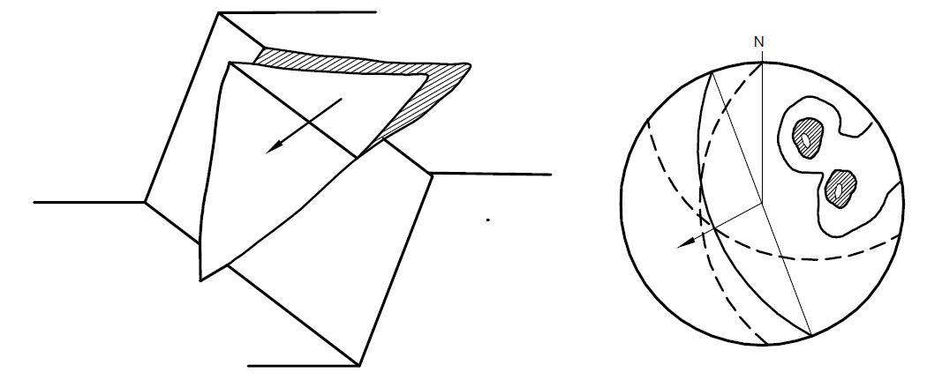

1(B) WEDGE FAILURE ON TWO INTERSECTIONS SETS OF JOINTS

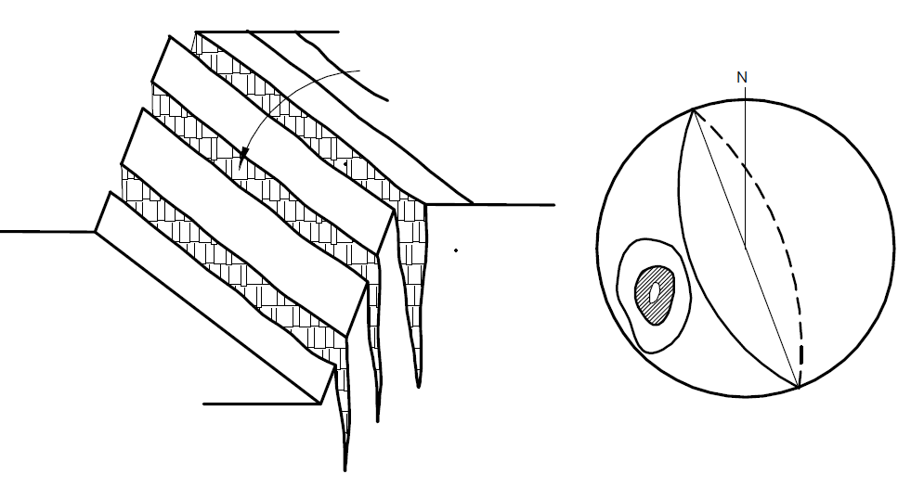

1(C) TOPPLING FAILURE BY STEEPLY DIPPING JOINTS

Fig. 1 Representation of Structural Data Concerning Three Possible Slope Failure Modes in Rocks Based on Stereonet Ploiting

**Table 2 Adjustments Rating for Joints**

(*Clauses* 3.3 *and* 3.6)

| **Sl No.** | **Case** | **Adjustment Factors** | **Very**  **Favourable** | **Favourable** | **Fair** | **Unfavourable** | **Very Unfavourable** |
| --- | --- | --- | --- | --- | --- | --- | --- |
| (1) | (2) | (3) | (4) | (5) | (6) | (7) | (8) |
|  | $$P$$ | [- $a_{s}$] | > 30° | 30° to 20° | 20° to 10° | 10° to 5° | < 5° |
|  | $$T$$ | [-- 180°] |  |  |  |  |  |
|  | $P$ or $T$ | $$F_{1}$$ | 0.15 | 0.40 | 0.70 | 0.85 | 1.00 |
|  | $P$ or $T$ | ${[β}_{j}$] | < 20° | 20° to 30° | 30° to 35° | 35° to 45° | > 45° |
|  | $$P$$ | $$F_{2}$$ | 0.15 | 0.40 | 0.70 | 0.85 | 1.00 |
|  | $$T$$ | $$F_{2}$$ | 1 | 1 | 1 | 1 | 1 |
|  | $$P$$ | | > 10° | 10° to 0° | 0° | 0°- (-10°) | < - 10° |
|  | $$T$$ | $$β_{j}+β_{s}$$ | < 110° | 110° to 120° | ­> 120° | – | – |
|  | $P$ or $T$ | $$F_{3}$$ | 0 | - 6 | - 25 | - 50 | - 60 |
| $P$*=* plane failure; $T$ = topping failure; $a_{s}$ = slope dip direction; $a_{j}$ = joint dip direction; $β_{j}$ = dip of joint; and = dip of slope. | | | | | | | |

The adjustment rating $F_{4}$ for slope in a natural condition or excavated by pre-splitting blasting, smooth blasting, mechanical or poor excavation methods is given in Table 3.

**Table 3 Adjustments Rating for Methods of Excavation of Slopes**

(*Clause* 3.3)

|  |  |  |  |  |  |  |
| --- | --- | --- | --- | --- | --- | --- |
| **Sl No.** | **Method** | **Natural Slope** | **Presplitting** | **Smooth Blasting** | **Blasting or Mechanical** | **Deficient Blasting** |
| (1) | (2) | (3) | (4) | (5) | (6) | (7) |
|  | $$F_{4}$$ | + 15 | + 10 | + 8 | 0 | - 8 |
| $SMR={RMR}_{basic}+\left(F_{1}×F_{2 }×F_{3}\right)+F_{4}$ | | | | | | |

**3.4 Estimation of Slope Mass Rating**

The product of $F_{1}$, $F_{2 }$ and $F_{3}$ shall be added to ${RMR}_{basic}$ rating and add $F_{4}$ to obtain slope mass rating (SMR).

Slope mass rating $SMR={RMR}_{basic}+\left(F_{1}×F_{2 }×F_{3}\right)+F_{4}$

On the basis of the values of slope mass rating, the stability of rock slopes should be classified as fully stable (81 to 100), stable (61 to 80), partially stable (41 to 60), unstable (21 to 40) and very unstable (< 20) as given in Table 4.

**3.5 Remedial Measures**

Accordingly, the very unstable cut slope may require re-excavation, unstable slope may need extensive corrective measures, partially stable slopes may have to be supported with systematic supports such as rock bolts, and rock anchors and stable to fully stable slopes may need occasional to no supports.

**3.6** **Cut Slope Angle (Slope Height < 20 m)**

Safe cut slope angle can be determined from Table 2 by varying slope angle $β_{s}$ till SMR of cut slope is more than 60. In weaker rocks cut slope angle may be taken equal to or less than apparent dip/dip of discontinuity in planar slide or dip of line of intersection of unstable wedges wherever excavation is feasible.

**Table 4 Tentative Description of SMR Classes**

(*Clause* 3.4)

|  |  |  |  |  |  |  |
| --- | --- | --- | --- | --- | --- | --- |
| **Sl No.** | **Class No.** | **V** | **IV** | **III** | **II** | **I** |
| (1) | (2) | (3) | (4) | (5) | (6) | (7) |
|  | SMR | 0 to 20 | 21 to 40 | 41 to 60 | 61 to 80 | 81 to 100 |
|  | Description | Very bad | Bad | Normal | Good | Very good |
|  | Stability | Completely unstable | Unstable | Partially stable | Stable | Completely stable |
|  | Probable type of failure | Big planar or rotational | Planar or big wedge | Planar or many wedges | Blocks | None |
|  | Support | Re-excavation | Important corrective measures | Systematic supports | Occasional supports | None |

**ANNEX A**

(*Clause* 2)

**LIST OF REFERRED STANDARDS**

|  |  |
| --- | --- |
| *IS No.* | *Title* |
| IS 8764 : 1998 | Method of determination of point load strength index of rocks (*first revision*) |
| IS 11315 | Method for quantitative description of discontinuities in rock masses: |
| (Part 1) : 2023 | Orientation (*first revision*) |
| (Part 2) : 2023 | Spacing (*first revision*) |
| (Part 4) : 2023 | Roughness (*first revision*) |
| (Part 8) : 2023 | Seepage (*first revision*) |
| (Part 11) : 2023 | Core recovery and rock quality designation (*first revision*) |
| IS 13365 (Part 1) : 1998 | Quantitative classification systems of rock mass — Guidelines: Part 1 Rock mass rating (*RMR*) for predicting engineering properties |

**ANNEX B**

(*Foreword*)

**COMMITTEE COMPOSITION**

Rock Mechanics Sectional Committee, CED 48

| *Organization* |  | *Representative(s)* |
| --- | --- | --- |
| Indian Institute of Technology Roorkee, Roorkee |  | Dr N. K Samadhiya **(*Chairperson*)** |
| Amberg Engineering AG India Private Limited,  Gurugram |  | Shri Kripal Choudhary  Shri Rakesh Pandita (*Alternate*) |
| Aquagreen Engineering Management Private Limited, Gurugram |  | Shri Imran Sayeed |
| Central Soil & Materials Research Station,  New Delhi |  | Shri Hari Dev  Shri Mahabir Dixit (*Alternate*) |
| Central Water Commission, New Delhi |  | Shri Darpan Talwar  Ms M. S. Harshitha (*Alternate*) |
| Central Water and Power Research Station, Pune |  | Shri Rizwan Ali  Dr S. A. Burele (*Alternate*) |
| CSIR - Central Building Research Institute, Roorkee |  | Dr Manojit Samanta  Dr Anindya Pain (*Alternate* I)  Shrimati Aswathy M. S. (*Alternate* II) |
| CSIR - Central Institute of Mining & Fuel Research,  Dhanbad |  | Dr J. K. Mohnot  Dr R. D. Dwivedi (*Alternate* I)  Dr Ashok Kumar Singh (*Alternate* II) |
| CSIR - Central Road Research Institute, New Delhi |  | Dr Pankaj Gupta  Shri R. K. Panigrahi (*Alternate*) |
| Engineers India Ltd, New Delhi |  | Dr altaf usmani  Shri Saikat Pal (*Alternate*) |
| Geological Survey of India, Kolkata |  | Shri Santosh Kumar Tripathi  Shri D. P. Dangwal (*Alternate*) |
| Indian Institute of Technology Kharagpur,  Kharagpur |  | Shri Abhiram Kumar Verma  Shri Rakesh Kumar (*Alternate*) |
| Indian Institute of Technology Roorkee, Roorkee |  | Dr Mahendra Singh  Dr Priti Maheshwari (*Alternate* I)  Shri Sumit Sen (*Alternate* II) |
| Irrigation Research Institute, Roorkee |  | Shri Dinesh Chandra  Shri Shankar Kumar Saha (*Alternate*) |
| MVerman, Gurugram |  | Dr Manoj Verman |
|  |  |  |
| National Hydroelectric Power Corporation Ltd,  Faridabad |  | Shri Rajesh Kumar  Shri Ajay Kumar Verma (*Alternate* I)  Shri Pradeep Kumar Garnayak (*Alternate* II) |
|  |  |  |
| National Institute of Rock Mechanics, Bengaluru |  | Shri B. H. Vijay Sekar |
|  |  |  |
| RITES Limited, Gurugram |  | Shrimati Jyotsna Dixit  Shri Sandeep Singh Nirmal (*Alternate* I)  Shri Ahmed Shaz (*Alternate* II) |
|  |  |  |
| In Personal Capacity (*Flat No. 4123, Tower 4,*  *ACE Golfshire, Sector - 150, Noida*) |  | Shri R. K. Goel |
| BIS Directorate General |  | Shri Dwaipayan Bhadra, Scientist ‘E’/Director and Head (Civil Engineering) [Representing Director General (*Ex*-*officio*)] |

*Member Secretary*

Dr Manoj Kumar Rajak

Scientist ‘E’/Director

(Civil Engineering), BIS