Doc No.: CED 22 (14938)

IS 9972 : 2021

*भारतीय मानक*

**अग्नि संरक्षण सेवा हेतु स्वचलित स्प्रिंकलर हैड — विशिष्टि**

( *पहला पुनरीक्षण*  )

*Indian Standard*

**Automatic Sprinkler Heads for Fire Protection Service — Specification**

( *First Revision* )

ICS 13.220.20

© BIS2021

BUREAU OF INDIAN STANDARDS

MANAK BHAVAN, 9, Bahadur Shah Zafar Marg,

NEW DELHI – 110 002

July 2021 Price Group

Fire Fighting Sectional Committee, CED 22

Foreword

This Indian Standard (First Revision) was adopted by the Bureau of Indian Standards after the draft finalized by the Fire Fighting Sectional Committee had been approved by the Civil Engineering Division Council.

A sprinkler system consists of a water supply and one or more sprinkler installations; each installation consisting of a set of installation control valve and a pipe array fitted with sprinkler heads. The sprinkler heads are fitted at specified locations at the roof or ceiling, walls and where necessary between racks, below shelves, and in ovens or stoves.

The sprinklers operate at pre-determined temperatures to discharge water over the affected part of the area below, the flow of water through the installation control valve initiating a fire alarm. The operating temperature is generally selected to suit ambient temperature conditions. Only the sprinklers in the vicinity of the fire, that is, those which become sufficiently heated, operate.

A sprinkler has two functions to perform. It must first detect a fire, and must then provide an adequate distribution of water to control or extinguish it. Each function is performed separately and one is independent of the other except in so far as early detection makes extinction easier because the fire has not grown large.

A sprinkler head is, in essence, a thermally operated valve which when opens acts as a distributor of water over a specified area. It consists of a body which screws into a pressurized pipe, and which contains a discharge orifice. The orifice is normally sealed by a valve assembly which is held in place by a thermally sensitive fusible element or glass bulb. The latter will separate or burst when its operating temperature is reached. The other end of the fusible element or glass bulb is supported by the yoke arms, which also serve to support the deflector plate. On operation, the element or the bulb falls away and allows the valve to open under the pressure of water, which is ejected from the orifice and strikes the deflector plate thus distributing the water over a pre-determined area beneath the sprinkler. This standard has been formulated so as to cover the requirements of automatic sprinkler heads of both fusible element and glass bulb types.

This standard was first published in 1981 and since then there has been a revolution in the industry worldwide in respect of fire protection particularly in sprinkler installation. Several new types of sprinklers have been developed and testing procedures for the sprinklers have been drastically changed keeping in view the variety of fire protection requirements. Hence, this standard has been revised in tune with the international trends.

In this revision, the following major changes have been made:

1. New types of special sprinklers, such as cut off sprinkler and rack storage sprinkler, have been included.
2. Information regarding identification marks of each sprinkler complying with the requirements of this standard have been included in detail.
3. Colour coding of sprinklers and bulbs have been updated with respect to modified nominal release temperature.
4. Testing conditions for sprinkler have been included and examination of sprinklers have been updated.
5. Existing tests in the standard for the performance of the sprinklers have been modified.
6. Various tests on performance of sprinklers [such as hydrostatic strength test, operating temperature (liquid bath) test, operating temperature (air bath) test, high temperature exposure test, freezing test, minimum operating pressure test, moist air test, vacuum test, drop and tumble test, test for discharge coefficient (K-factor), salt spray corrosion test, carbondioxide and sulphur dioxide corrosion test, hydrogen sulphide corrosion test and test for conductivity (C-factor)] have been included in detail.
7. Fire test for sprinklers has been added and its test method for all types of sprinklers has also been explained.
8. Terminology has been updated.

In the formulation of this standard due weightage has been given to international coordination among the standards and practices prevailing in different countries in addition to relating it to the practices in the field of this country.

The composition of Committee responsible for the formulation of this standard is given in Annex B.

For the purpose of deciding whether a particular requirement of this standard is complied with the final value, observed or calculated, expressing the result of a test or analysis shall be rounded off in accordance with IS 2 : 1960 ‘Rules for rounding off numerical values (*revised*)’. The number of significant places retained in the rounded off value should be the same as that of the specified value in this standard.

*INDIAN STANDARD*

**AUTOMATIC SPRINKLER HEADS FOR**

**FIRE PROTECTION SERVICE — SPECIFICATION**

( *First Revision* )

**1 SCOPE**

This standard covers the mechanical properties and performance requirements of automatic sprinkler heads for installation in fire protection service.

**2 REFERENCES**

The Indian Standards listed below contain provisions which through reference in this text, constitute provisions of this standard. At the time of publication, the editions indicated were valid. All standards are subject to revision, and parties to agreements based on this standard are encouraged to investigate the possibility of applying the most recent editions of the standards which are as follows:

|  |  |
| --- | --- |
| *IS No.* | *Title* |
| 15105 : 2021 | Design, installation and maintenance of fixed  Automatic sprinkler fire extinguishing systems — Code of practice *(first revision)* |
| 2643 : 2005 | [Pipe threads where pressure — Tight joints are not made on the threads — Dimensions, tolerances and designation (](https://www.services.bis.gov.in:8071/php/BIS/ShowDocument.php?row=9166" \t "_blank)*[third revision](https://www.services.bis.gov.in:8071/php/BIS/ShowDocument.php?row=9166" \t "_blank)*[)](https://www.services.bis.gov.in:8071/php/BIS/ShowDocument.php?row=9166" \t "_blank) |

**3 TERMINOLOGY**

For the purpose of this standard, following definitions shall apply:

**3.1 Angle of Protection**

**3.1.1** *Centre Strut or Glass Bulb Sprinkler* — For this sprinkler, if a line drawn to the edge of the lower seat of the actuator or bulb rather than to the extremity of the actuator or bulb produces a larger angle, then that larger angle shall be the "angle of protection" for that sprinkler.

**3.1.2** *Link and Lever Sprinkler* — For this sprinkler, this would be the lowermost edge of the link or lever, measured with the link and lever assembly rotated 90° to the frame arm plane.

**3.1.3** *Rack Storage Sprinklers* — For such sprinklers, the "angle of protection" is that angle measured between the plane of the water shield and the line drawn from its outer edge to the lowest and outermost extremity of the actuator.

**3.2 Assembly Load**

The force which is applied to the sprinkler frame due to assembly of the operating parts plus the equivalent force resulting from the maximum rated inlet pressure.

**3.3 Coated or Plated Sprinkler**

A sprinkler which has a factory applied coating or plating for corrosion protection or decorative purposes.

**3.4 Concealed Sprinkler**

A sprinkler in which the entire body, including the operating mechanism, is above a concealing plate.

**3.5 Conductivity (C-Factor)**

A measure of the conductance between the sprinkler's heat responsive element and the other components of the sprinkler expressed in units of (m/s)1/2.

**3.6 Corrosion Resistant**

Materials having resistance to corrosion equal to or exceeding that of bronze alloy having a minimum copper content of 80 percent. Stainless steel and other alloys of brass, titanium are also possible.

**3.7 Decorative Sprinkler**

A sprinkler which is factory-painted or coated or plated to improve its aesthetics. The coating is not considered a corrosion-resistant barrier.

**3.8 Design Load (Element)**

The load actually applied on the operating element (fusible element or bulb) at the maximum rated inlet pressure.

**3.9 Discharge Coefficient (K-Factor)**

The coefficient of discharge, $K$, as expressed in the equation:

$Q=KP^{1/2}$

Where $Q$ is the flow in litres per min (lpm), and $P$ is the pressure in bar.

**3.10 Dry-type Sprinkler**

A device consisting of a sprinkler permanently attached to an extension nipple which has a closure at the inlet end to prevent system water from entering the nipple until the sprinkler operates.

**3.11 Hang-Up (Lodgment)**

A malfunction in the operation of a sprinkler which, when operated under a typical system water pressure, experiences the lodging of an operating part (cap, gasket, lever, etc.) on or between the frame, deflector and/or compression screw, adversely affecting the water distribution for a period in excess of 60 s. A momentary hesitation of an operating part to clear itself from temporary contact with the frame, deflector and/or compression screw does not constitute a hang-up.

NOTE — For quick response sprinklers, and hang ups, they generally need to eject within 10 s.

**3.12 Heat Responsive Element**

The component of a sprinkler assembly that, when subjected to the influence of heat, ruptures, bursts or otherwise functions, causing water to be discharged through the sprinkler orifice.

**3.13 Leak Point**

The pressure at which leakage of water in excess of one drop per min occurs and sprinkler operates.

**3.14 Light Hazard Occupancy**

An occupancy in which the quantity and/or combustibility of contents is low and fires with relatively low rates of heat release are expected (*see also* IS 15105).

**3.15 Maximum Service Pressure**

The maximum rated working pressure of a sprinkler, typically 12.1 bar.

**3.16 Operating Temperature**

The temperature, in degree Celsius (°C), at which the heat responsive element of a sprinkler operates when subjected to a controlled rate-of-temperature-rise liquid bath.

**3.17 Ordinary Hazard Occupancy**

An occupancy where quantity and combustibility of contents is greater than that of a light hazard occupancy (*see also* IS 15105).

**3.18 Orientation, Best Case**

When testing sprinklers for sensitivity in the plunge tunnel, the orientation of a sprinkler which results in the fastest operating time, or the lowest response time index (RTI). Typically, this orientation is one in which the sprinkler waterway axis and the plane of the frame arms are both perpendicular to the air flow and, in the case of non-symmetric elements, the heat responsive element is upstream of the frame arms.

**3.19 Orientation, Worst Case**

For use in this standard, when testing sprinklers for sensitivity in the plunge tunnel, the worst case orientation is a given angular offset from the orientation which results in the slowest operating time, or the highest response time index (RTI). For standard response sprinklers this angular offset is 15 degrees. The angular offset for quick response sprinklers is 25 degrees.

**3.20 Orifice**

The opening in a sprinkler body through which the water is discharged.

**3.21 Response Time Index (RTI)**

A measure of sprinkler sensitivity expressed as $RTI= τ {(u)}^{1/2}$ where $τ$ is the time constant of the heat responsive element in units of seconds, and $u$ is the gas velocity expressed in feet per second (or meters per second). The quantity $J$ relates the properties of the heat responsive element and the heated gas flow. $RTI$ can be used to predict the response of a sprinkler in fire environments defined in terms of gas temperature and velocity versus time. $RTI$ is expressed in units of ${(m.s)}^{1/2}$.

**3.22 Service Pressure**

The working hydrostatic pressure of a sprinkler system.

**3.23 Standard Response Sprinkler**

This is a sprinkler having an RTI between 80 and 350 ${(m.s)}^{1/2}$ and a C-factor equal to or less than 2.0 ${(m/s)}^{1/2}$ when the sprinkler is tested in the best-case orientation.

**3.24 Strutting**

Partial fracture of a glass bulb or partial rupture of a fusible element which does not result in sprinkler operation.

**3.25 Weep Point**

The pressure at which any visible leakage of water is detected.

**3.26 Yoke**

The part of a sprinkler that retains the heat responsive element in load bearing contact with the sprinkler head valve.

**3.27 Early Suppression Fast Response Automatic Sprinkler (ESFR)**

Sprinkler that is intended to provide early suppression of a fire when installed on the appropriate sprinkler piping.

**3.28 Fusible Element Sprinkler**

Sprinkler that opens under the influence of heat by the melting of a component (fusible link, generally an alloy).

**3.29 Glass Bulb Sprinkler**

Sprinkler that opens under the influence of heat by the bursting of the glass bulb through pressure resulting from expansion of the fluid enclosed therein.

**3.30 Horizontal Sidewall Sprinkler**

Sprinkler arranged such that the orifice directs the water stream horizontally towards the deflector giving a one-sided distribution pattern.

**4 TYPES OF SPRINKLERS**

Sprinklers of the following types are covered under this standard.

**4.1 Sprinklers According to Release Mechanism**

**4.1.1** *Fusible Element Sprinklers*

A fusible element sprinkler is opened under influence of heat by melting of a component (fusible link, generally an alloy).

**4.1.2** *Glass Bulb Sprinklers*

A glass bulb sprinkler is opened under the influence of heat by the bursting of the glass bulb through pressure resulting from expansion of the fluid enclosed therein.

**4.2 Sprinklers According to Type of Discharge**

**4.2.1** *Conventional Sprinklers*

The conventional sprinkler has a spherical water distribution directed towards the ground and the ceiling over a definite protection area. A conventional sprinkler shall discharge from 40 to 60 percent of the total water flow initially in a downward direction.

**4.2.2** *Spray Sprinklers*

The spray sprinkler has a paraboloidal water distribution directed towards the ground over a definite protection area. A spray sprinkler shall discharge from 80 to 100 percent of the total water flow in a downward direction.

**4.2.3** *Sidewall Sprinklers*

The sidewall sprinkler has a one-sided (half paraboloid) water distribution directed towards the adjacent walI and the ground over a defined protection area.

**4.3 Sprinklers According to Mounting Pattern**

**4.3.1** *Pendent Sprinkler*

A sprinkler intended to be installed so that its deflector is located below the orifice and the water flows downward through the orifice.

**4.3.2** *Upright Sprinkler*

A sprinkler intended to be installed so that its deflector is located above the orifice and the water flows upward through the orifice.

**4.3.3** *Horizontal Sprinklers (Sidewall Only)*

Horizontal sprinklers are designed to give the specified distribution when the jet of water is directed horizontally against the deflector. This applies to sidewall sprinklers only.

**4.3.4** *Ceiling Sprinklers*

Ceiling sprinklers are in which part of the body of the sprinkler (other than shank) may be mounted above the lower plane of the ceiling.

NOTE — Approved Sprinkler dropper pipes having matching pressure ratings and rosette plates for mounting are required for interconnection of upright and pendant sprinklers.

**4.4 Special Sprinklers**

**4.4.1** *Dry Upright Sprinklers*

Dry upright sprinklers are installed in an upright position on special rise pipes. These pipes are kept free from water.

**4.4.2** *Dry Pendent Sprinklers*

Dry pendent sprinklers are installed in a pendent position on special drop pipes. These pipes are kept free from water.

**4.4.3** *Flush Sprinklers*

Flush sprinklers are installed in a pendent position close to the ceiling, such that part of the body may be above the ceiling line, and the heat responsive element is completely below the ceiling line.

**4.4.4** *Recessed Sprinklers*

Recessed sprinklers are installed in a pendent position partly or wholly above the ceiling line. The sprinkler is fitted into a recess cup, the rim of which is flush with the ceiling.

**4.4.5** *Concealed Sprinklers*

Concealed sprinklers are installed position above the ceiling line. The concealed sprinkler incorporates a recessing cup which enclose the sprinkler, such that is flush with the ceiling and conceals the sprinkler.

**4.4.6** *Intermediate Level Sprinklers*

A sprinkler installed below, and in addition to roof sprinklers with a specific purpose.

**4.4.7** *Detector Sprinkler*

A sealed sprinkler mounted on a pressurized pipeline used to control a deluge valve. Operation of this sprinkler causes loss of air pressure and water pressure which opens the deluge valve.

**4.4.8** *Cut off Sprinkler*

A sprinkler protecting a door and/or window between two areas of which only one is protected by sprinklers.

**4.4.9** *Extended Coverage (EC) Sprinklers*

A control mode sprinkler with an intended area of coverage which exceeds the standard coverage area applicable to that type of sprinkler. Extended coverage ordinary hazard (ECOH) and extended coverage ordinary hazard (ECLH) sprinklers have an intended area of coverage between 21 m2 and 37 m2.

**4.4.10** *Flow Control (FC) Sprinklers*

A sprinkler that is intended to control water flow by automatically cycling open and closed within a specified temperature range.

**4.4.11** *Fast Response Sprinkler*

A sprinkler that complies with the applicable requirements for such sprinklers in the sensitivity tests and that is intended to be installed at standard spacing.

**4.4.12** *Rack Storage Sprinkler*

A sprinkler intended for use in racks or beneath open gratings, which is equipped with a shield mounted above the heat responsive element to protect it from water discharge from nearby sprinklers at higher elevations. Rack storage sprinklers are also commonly known as an in-rack or intermediate level sprinklers.

**5 GENERAL REQUIREMENTS**

All the sprinklers shall comply with the various requirements specified below.

**5.1 Orifice Sizes**

**5.1.1** Orifice sizes shall comply with Table 1.

**Table 1 Orifice Sizes**

(*Clauses* 5.1.1 and 5.1.4)

|  |  |  |
| --- | --- | --- |
| **Sl No.** | **Nominal Orifice Diameter** mm | **Nominal Thread Size**  inch |
| (1) | (2) | (3) |
|  | 10 | 3/8 |
|  | 15 | 1/2 |
|  | 20 | 3/4 |
|  | 25 | 1 |
|  | 32 | 1 1/4 |

**5.1.2** All automatic sprinklers shall allow a sphere of 8 mm + 0.010 mm size to pass through each waterway of the device.

**5.1.3** Nominal thread sizes for fittings shall be according to IS 2643.

**5.1.4** Dry and flush sprinklers may have larger thread sizes than specified in Table 1.

**5.2 Identification** (*see also* **13.1**)

**5.2.1** Each sprinkler, complying with the requirements of this standard shall be marked with sprinkler type and model identification details, and batch number, nominal release temperature and is colour coded (*see* **5.3.1, 5.3.2** and **13.1**). The manufacturer's catalogue identification shall define uniquely the design size, distribution type and mounting position. In particular, the identification symbol used shall be changed where there is any significant alteration in the shape, materials or method of manufacture.

**5.2.2** The deflectors of sidewall sprinklers shall show the intended direction of discharge with respect to the rear wall. An arrow or similar symbol indicating the direction of spray discharge is acceptable. Horizontal sidewall sprinklers shall include the word ‘top’ on the deflector to indicate orientation.

**5.3 Nominal Release Temperatures and Colour Coding for Sprinklers and Bulbs**

**5.3.1** *Glass Bulbs*

The nominal temperature in case of sprinklers with glass bulbs, shall be colour coded as indicated in Table 2 with a variability in operating temperatures within the ranges specified.

**Table 2 Colour Code for Sprinklers**

(*Clause* 5.3.1)

|  |  |  |  |
| --- | --- | --- | --- |
| **Sl No.** | **Nominal Release Temperature**  °C | **Colour Code** | |
| **Sprinkler** | **Bulb** |
| (1) | (2) | (3) | (4) |
|  | 57-67 | Uncoloured or Black | Orange |
|  | 68-78 | Uncoloured or Black | Red |
|  | 79-92 | White | Yellow |
|  | 93-107 | White | Green |
|  | 121-149 | Blue | Blue |
|  | 163-191 | Red | Mauve |
|  | 204-246 | Green | Black |
|  | 260-302 | Orange | Black |

**5.3.2** *Fusible Elements*

The nominal temperature in case of sprinklers with fusible elements, shall be colour coded as indicated in Table 3 with a variability in operating temperatures within the ranges specified.

**Table 3 Colour Code for Fusible elements**

(*Clause* 5.3.2)

|  |  |  |
| --- | --- | --- |
| **Sl No.** | **Nominal Release Temperature**  °C | **Yoke Arm Colour code** |
| (1) | (2) | (3) |
|  | 57 to 77 | Uncoloured |
|  | 80 to 107 | White |
|  | 121 to 149 | Blue |
|  | 163 to 191 | Red |
|  | 204 to 246 | Green |
|  | 260 to 302 | Orange |
| NOTE — For ultra high category having release temperature of 260 to 302 °C, the colour of yoke shall be orange. | | |

**5.3.3** *Testing conditions*

Unless otherwise specified, a) all tests shall be carried out in an ambient temperature of 25 ºC ± 10 °C and b) sprinkler specimens shall be conditioned at 25 ºC ± 10 °C for at least 24 h before the test.

**5.3.4** *Examination of Sprinklers*

Sprinklers shall be examined visually for the following points:

a) Conformance with **5.1.1** (sprinkler orifice sizes);

b) Comparison of sprinkler specimens with manufacturer's drawings and specification; and

c) Conformance as per **5.2** (identification).

**6 PERFORMANCE TESTS**

**6.1** Number of sprinklers to be selected for each of the tests given below are enumerated in Annex A.

**6.1.1** *Leakage Test*

**6.1.1.1** At least twenty (previously untested) sprinklers (each type) shall be subjected to a water pressure of 30 bar ± 1 bar. The pressure shall be raised from 0 bar to 30 bar at an average rate of ≤ 1 bar/s. The pressure of 30 bar shall then be maintained for a period of 3 min ± 5 s and then allowed to fall to 0 bar in not less than 5 s.

After releasing the pressure, it shall be then raised to 0.5 bar ± 0.1 bar in not more than 5 s. This pressure shall be maintained for 15 min ± 5 s.

The pressure shall then be raised to 10 bar + 0.5 bar at an average rate of increase of ≤ 1 bar/s. The 10 bar pressure shall be maintained for 15 min ± 5 s.

No leakage shall be observed within the prescribed conditions.

**6.1.1.2** *Pneumatic leakage*

Four (previously untested) sprinklers shall be individually conditioned at -25 ± 5°C for 24 h. Each sample shall be pneumatically pressurized to 2 ± 0.1 bar and immersed in glycol liquid conditioned to -25 ± 5°C, and observed for 5 min.

No leakage shall be observed within the prescribed conditions.

**6.1.2** *30-Day Leakage Test*

At least five sprinklers (each type) when tested as per the following procedures shall:

1. Experience no leakage when subjected to a hydrostatic pressure of 20 bar for 30 days. Five samples shall be tested and the same shall be checked every week for evidence of leakage;
2. Not leak when subjected to a pressure of 35 bar for one min following the 30 days. The pressure shall be increased at a rate not exceeding 20 bar per min. Similarly after the test, the pressure shall be brought down to 0 bar at a rate not exceeding 20 bar/min; and
3. Show no distortion or other mechanical damage following the leakage testing, as determined by visual examination.

**6.2 Hydrostatic Strength**

Samples that passed the test under **6.1.1.1** shall be further subjected to a gradually increasing hydrostatic pressure to 45 bar at a rate not to exceed 20 bar per min. The test pressure shall be maintained for 1 min. If leakage at the orifice prevents testing at 45 bar, the maximum attainable test pressure shall be maintained for 1 min. Leakage at the orifice above a hydrostatic pressure of 35 bar shall be deemed acceptable but there shall be no rupture.

**6.3 Water Hammer test**

**6.3.1** When tested as detailed in the procedure below, the sprinkler shall:

1. experience no leakage when subjected to 100 000 applications of a pressure surge increasing rapidly from 3.5 bar to 35 bar;
2. not leak when subjected to a pressure of 35 bar for one min, following 100 000 cycles of water hammer; and
3. show no distortion or other physical damage following the water hammer testing as determined by visual examination.

**6.3.2** Sprinkler samples (at least five) shall be installed in a water filled test line connecting with a small motor operated piston pump that produces a rapid rise in discharge pressure from 3.5 to 35 bar at the rate of not more than 60 cycles/min. The test piping shall be filled so that there is water at the sprinkler seat, and the pump is to be placed in operation and adjusted to produce the specific test pressure cycle.

**6.3.3** During pressure cycling, observations made for the evidence for leakage, if any.

**6.3.4** Following the completion of the pressure cycling, the samples shall be tested to verify that they do not leak at 35 bar pressure. The pressure shall be increased to 35 bar at a rate not exceeding 20 bar a min. The pressure shall be maintained at 35 bar for a min and then released at a rate not exceeding 20 bar a min to 0 bar. The samples shall then be physically checked to verify evidence of distortion or other mechanical damage.

**6.4 Hang-up of Operating Parts (Lodgment Test)**

**6.4.1** When tested as described below, not more than 1 percent of the samples shall exhibit a hang-up, or lodgment, of operating parts on the non-operating components (that is, frame, compression screw, deflector, etc) of the sprinkler.

Samples shall operate fully and completely, and shall exhibit no binding of internal components. Upon operation, the measured discharge coefficient (K-factor) of all samples shall comply with **6.20**.

Any non-operation caused by binding of an operating element or improper fracturing of a glass bulb, shall be considered a hang-up. Momentary obstructions which clear in less than 60 s are not considered hang-ups.

A lodgment is considered to have occurred when a part of the release element lodges in the deflector/frame assembly for a period of more than one min. However, in the case of quick/fast response sprinklers, lodging period shall not be more than 10 s.

**6.4.2** *Tests/Verification*

Samples shall be selected in accordance with Table 4 and shall be individually installed in their intended installation position, on a pipe manifold as described in Fig. 1. Each sample shall be subjected to an inlet water pressure in accordance with Table 4, operated using a suitable open flame heat source, and observed for complete and proper functioning. A total of 50 sprinklers shall be tested.

Dry sprinklers shall be tested at both the minimum and maximum lengths, requiring more sample quantity.

The samples shall be tested with the pipe manifold configured for single-fed flow. Five samples shall be tested at each pressure with the pipe manifold configured for double-fed flow, and the remaining samples shall be tested with single-fed flow (*see* Fig. 1).

A tolerance of ± 5 percent applies to all pressures specified in the table.

Upon activation of each sample, the discharge coefficient may be measured to verify proper and complete operation as per **6.20**.

A delay of not more than 5 s between activation of the heat-sensitive element and complete opening of the sprinkler is acceptable.

**Table 4 Hang-up Test Samples**

(*Clause* 6.4.2)

|  |  |  |
| --- | --- | --- |
| **Sl No.** | **Pressure**  Bar | **Number of Samples** |
| (1) | (2) | (3) |
|  | 0.5 | 10 |
|  | 1.7 | 15 |
|  | 3.4 | 15 |
|  | 5.2 | 15 |
|  | 6.9 | 15 |
|  | 8.6 | 10 |
|  | 10.3 | 10 |
|  | 12.1 | 10 |

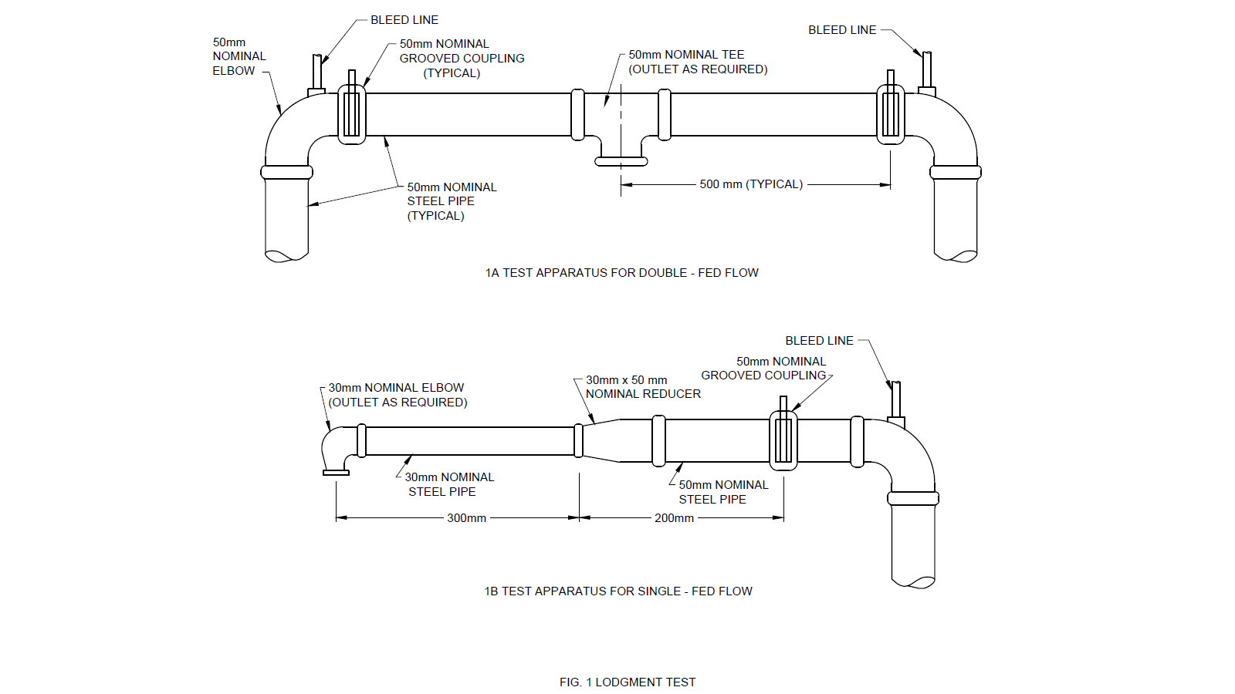

FIG. 1 LODGMENT TEST

**6.5 Operating Temperature (Liquid Bath) Test**

Ten previously untested sprinklers shall be immersed in a vessel containing a liquid as specified in Table 5.

**Table 5 Liquid Bath Status**

(*Clause* 6.5)

|  |  |  |  |
| --- | --- | --- | --- |
| **Sl No.** | **Nominal Temperature Rating of Sprinkler**  °C | **Bath Liquid** | **Maximum Rate of Temperature Rise**  °C/min |
| (1) | (2) | (3) | (4) |
| 1. 1) | 0 - 79 | Water | 0.4 |
| 1. 2) | 80 - 182 | Glycerin | 0.3 |
| 1. 3) | ≥ 183 | Vegetable oil | 0.3 |

1. The sprinklers shall be placed on a grate or rack suspended above the bottom of the vessel. The liquid level shall not exceed 25 mm above the top of the sprinkler, and whenever possible, shall not exceed 40 mm above the top of the temperature sensitive element. The vessel shall be provided with a source for heating the liquid, a means to agitate the liquid, and a device to measure the temperature of the liquid (*see* Fig. 2) for a typical test set-up. The liquid shall be agitated at a constant rate of 200 ±10 rpm via a paddle measuring 100 mm long by 20 mm high. The device used to measure the temperature of the liquid shall be calibrated. It shall be immersed such that readings are taken at the same depth as the sprinkler temperature sensitive element.
2. The temperature of the bath shall be raised until the liquid is 10 ± 1 °C below the nominal temperature rating of the sprinkler. The temperature rise shall then be controlled at a rate not exceeding that specified in Table 5 until operation of all sprinklers occurs. If one or more sprinklers fails to operate at, or below, the maximum temperature as stated below, the rate of rise shall continue to be controlled until all the sprinklers have operated, or until the bath reaches a temperature ten percent above the nominal temperature rating of the sprinklers, at which point the test shall be terminated. The temperature of the liquid bath at the time of operation shall be recorded for each sprinkler.
3. Partial fracture of a glass bulb or partial rupture of a fusible element which does not result in sprinkler operation, that is, strutting, shall necessitate an additional sensitivity test (air bath test, **6.6**) in order to verify proper operation of the sprinkler in air.
4. All sprinklers and cover plates having nominal temperature ratings less than 200 °C shall have an actual operating temperature within ± 3.5 percent of the marked nominal temperature rating, when immersed in a constant rate-of-temperature-rise liquid bath. Sprinklers and cover plates with nominal temperature ratings of 200 °C or greater shall meet the requirements stated above, or shall have an actual operating temperature within +107 percent of the marked nominal temperature rating.

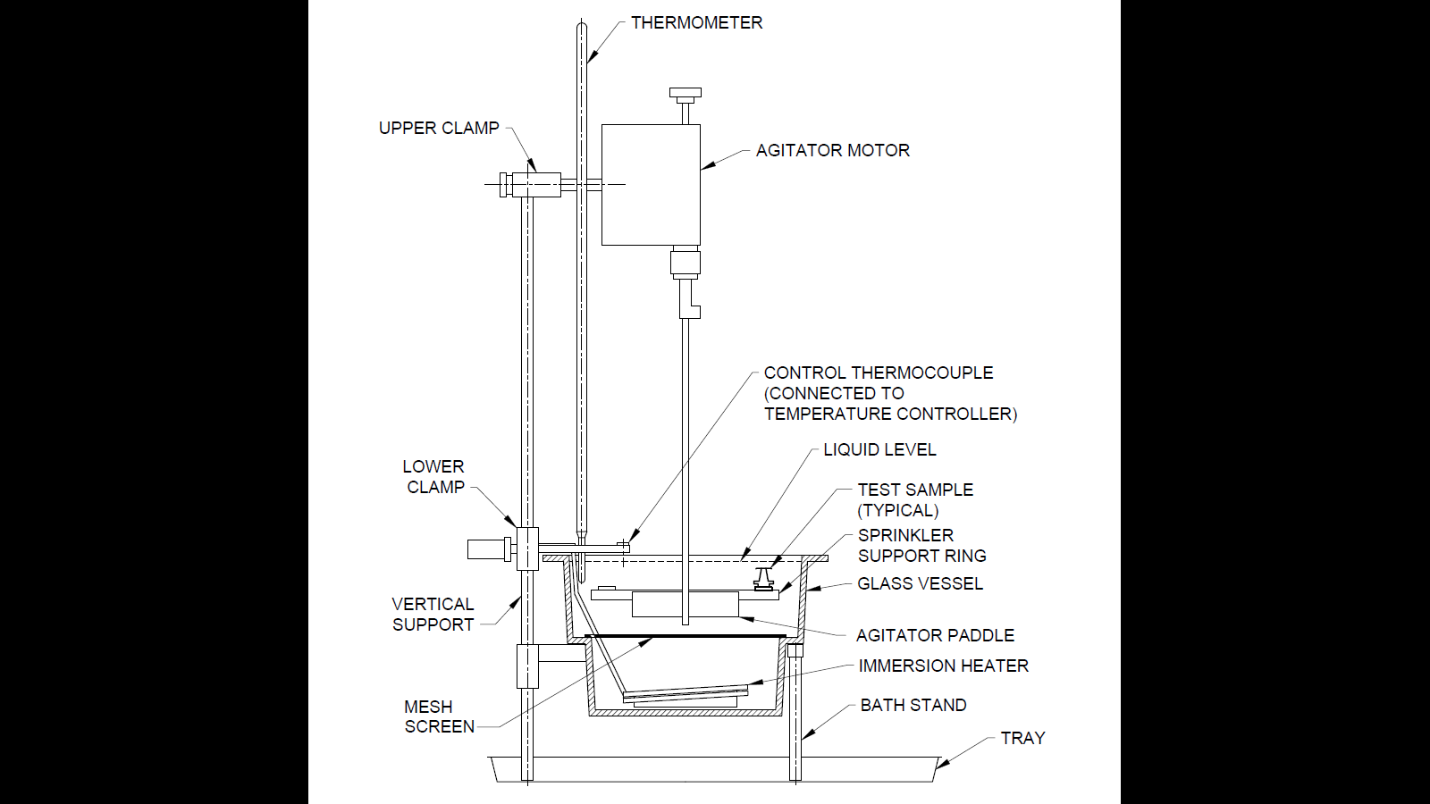

FIG. 2 LIQUID BATH TEST

**6.6 Operating Temperature (Air Bath) Test** [Additional Test – *See* **6.5**(c)]

Fifty previously untested sprinklers shall be placed on their threaded inlets in a programmable oven circulating air at ambient temperature. The temperature in the oven shall be steadily raised to 10 ± 1 °C below the nominal temperature rating of the sprinklers over a 20 min period. Once this temperature is reached, the oven shall be maintained at constant temperature for a period of 60 ± 5 min. The temperature shall then be raised at a constant rate of 0.5 °C ± 0.3 °C per min until the temperature reaches 20 ± 2 °C above the nominal temperature rating of the sprinklers.

Partial fracture of a glass bulb or partial rupture of a fusible element, that is, strutting, shall be deemed a failure.

The heat responsive element of all sprinklers shall operate properly when the sprinklers are subjected to a constant rate-of-temperature-rise air bath.

**6.7 Heat Exposure Test (for Glass Bulb Sprinklers)**

A sprinkler when subjected to fatigue conditions as indicated below shall remain intact and undamaged so that it can be subjected to satisfactory functional test thereafter.

The sequence of the test is as follows.

**6.7.1** Heat the sprinkler in a liquid bath from room temperature to 20 ºC ± 2 ºC under its normal release temperature at a rate of rise of temperature not exceeding 20 ºC/min.

**6.7.2** The temperature shall then be raised at a rate of 1 to 7 ºC ± 2 ºC below the normal release temperature (bubble disappears).

**6.7.3** The sprinkler shall then be removed from the liquid bath and cooled in air at room temperature for two min. During the cooling period, the point of the glass bulb (seal end) shall be pointing downwards (bubble reappears).

**6.7.4** The sprinkler shall then be returned to the liquid bath, which is maintained at 7 ºC ± 2 ºC below the nominal release temperature for 10 min ± 10 s.

**6.7.5** Repeat the action specified in **6.7.3**.

**6.7.6** Repeat the actions specified in **6.7.3** and **6.7.4** twice.

The test shall be carried out in a bath of distilled water for nominal temperatures not exceeding 80 ºC. Refined vegetable oil shall be used for nominal temperatures above 80 ºC and below 301 ºC, the liquid bath shall be so constructed that the temperature deviation within the test zone does not exceed 1 ºC. The sprinkler shall then be subsequently tested in accordance with **6.1.1** at a pressure of 10 bar.

**6.8 High Temperature Exposure Test**

Five previously untested, but open, sprinklers, supported on its threaded inlet, shall be heated in an oven or furnace having a temperature of 650 ± 10 °C for a period of 15 min. Following this exposure, the sprinklers shall be removed with tongs, preferably by holding the threaded inlet portion, and promptly submerged in a water bath with a temperature of 15 ± 5 °C.

Sprinklers, less operating mechanisms, shall not show significant deformation, blistering, or fracture following exposure to an elevated temperature as detailed above.

**6.9 Freezing Test**

1. Five previously untested sprinklers shall be hydrostatically tested to confirm that there are no weep or leak points at, or below, 35 bar. Each sprinkler shall be attached to one end of a 250 mm minimum length of 25 mm nominal diameter Schedule 40 or 80 steel pipe using an appropriate fitting. Each assembly shall then be filled to capacity with water and sealed. The samples shall then be exposed to a temperature of -30°C ± 5 °C for a period of 24 h, or until operation occurs.
2. Following exposure to freezing temperatures, sprinklers shall not either:
3. Operate,
4. leak subsequent to thawing when hydrostatically pressurized from 0.35 to 12.1 bar, or
5. sustain no damage.

NOTE — For (3), sprinklers shall not weep or leak at, or below, 35 bar.

**6.10 High Ambient Temperature (Ageing) Test for All Sprinklers**

Sprinklers shall withstand exposure to an increased ambient air temperature without evidence of weakness or failure.

**6.10.1** Ten sprinklers shall be exposed for a period of 90 days to an ambient temperature which is 16 ºC below the operating temperature of the sprinkler, but not less than 48 ºC. Following the exposure, the sprinklers shall be allowed to cool for not less than 2 h, and shall then be subjected to any of the tests under **6.1.1**, **6.3**, **6.5** or **6.9** as required.

Concealed sprinkler cover plates shall be exposed for a period of 90 days, hung in pendent position, to an ambient temperature which is 16 ºC below the rated release temperature of the cover plate. Following exposure, the concealed sprinkler shall be assembled and subjected to test as given in **6.1.1**.

**6.10.2** Glass bulbs shall also be subjected to the increased ambient air temperature as enumerated in **6.5**.

**6.10.3** Fifty glass bulbs from the same manufacturing batch shall be subjected to 90 day ageing as specified above. Following exposure and cooling, the loose glass bulbs shall be tested to determine their operating temperature distribution as specified in **6.5** and meet the requirements of **6.5**(b) thereof.

**6.11 Thermal Shock Test (for Glass Bulb Sprinklers)**

Glass bulb sprinklers shall remain intact and undamaged during thermal conditioning and shall pas s functional test thereafter.

Following procedure shall be carried out on the specimen (10 sprinklers) for the test on the specimen (10 sprinklers) as specified in **6.5**.

**6.11.1** The glass bulb sprinklers shall be submerged in a liquid bath the temperature of which shalI be 10 ºC ± 2 ºC below the nominal release temperature of the sprinklers. After 10 min, the sprinklers shall be taken out of the heated liquid bath, and with the bulb seal downwards, submerged in a water bath, maintained at a temperature of 10 ºC ± 1 ºC for 10 to 15 s. The sequence of heating and submerging of glass bulb sprinklers shall be repeated three times for each sample. The sprinklers shall then be stabilized at room temperature before being tested in accordance with **6.1.1** at a pressure as stated therein.

**6.12 Minimum Operating Pressure Test**

**6.12.1** Ten previously untested sprinklers shall be subjected to an inlet water pressure at, or below, that shown in Table 6 and operated using a suitable heat source. If a sample does not operate fully as described above, the pressure shall be slowly increased to determine the actual minimum operating pressure.

**6.12.2** Sprinklers shall be designed to produce positive operation and release of all operating parts at the minimum operating pressure stated in Table 6. Following operation of the heat responsive element, all parts which are intended to prohibit the discharge or leakage of water shall clear the exit of the waterway within 5 s.

**Table 6 Minimum Operating Pressure**

(*Clause* 6.12.2)

|  |  |  |
| --- | --- | --- |
| **Sl No.** | **Type of Sprinkler** | **Operating Pressure**  bar |
| (1) | (2) | (3) |
|  | Only dry upright | 0.7 |
|  | All those with K-Factors 40 and 80 | 0.2 |
|  | All others including other dry type | 0.3 |

**6.13 Moist Air Test**

Sprinklers shall withstand an exposure to high temperature and humidity for a continuous period of 90 days. The test method is as below:

**6.13.1** Five previously untested sprinklers shall be hydrostatically tested to confirm that there are no weep or leak points at, or below, 35 bar. They shall then be exposed to an atmosphere having a relative humidity of 98 ± 2 percent and a temperature of 95 ± 1°C for a period of 90 ± 1 days.

**6.13.2** Following the exposure, samples shall not weep or leak at, or below, 12 bars when tested in accordance with **6.1.1** (leakage) and **6.2**. Subsequently, the samples shall exhibit positive operation and release of all operating parts at the minimum operating pressure stated in Table 6 when tested in accordance with **6.12.1** (minimum operating pressure). The heat responsive element shall be specially fabricated to prevent operation during this test. The sprinklers shall be installed on a pipe manifold which contains water in approximately 50 percent of its volume. The entire manifold, along with the sprinklers, shall be placed in the high temperature and humidity enclosure for the duration of the test.

**6.14 Vacuum Test**

**6.14.1** Five previously untested sprinklers shall be hydrostatically tested to confirm that there are no weep or leak points at, or below, 35 bar. The sprinklers shall then be subjected to a vacuum of 650 mm of Hg (0.88 bar) for a period of one min.

**6.14.2** Sprinklers shall be designed such that when the inlet of an assembled sprinkler is subjected to a vacuum, as might be experienced during draining of a sprinkler system, the sprinkler shall not be damaged or leak when tested as described in **6.14.1**. Following this test, each sample shall not weep or leak at a pressure of 0.3 ± 0.03 bar when tested in accordance with **6.1.1** (leakage). Additionally, each sample shall not weep or leak at a pressure at, or below 35 bar.

**6.15 Assembly Load/Frame Strength**

**6.15.1** The frame of a control mode sprinkler shall be capable of withstanding twice the assembly load without sustaining permanent elongation or deformation in excess of 0.2 percent of the distance between the load bearing parts of the sprinkler.

**6.15.2** Fifteen previously untested sprinklers shall be individually tested to determine the assembly load. With the threaded portion of the sprinkler restrained from movement, the heat responsive element of the test sample shall be removed and the negative axial deflection of the frame, resulting from the release of the assembly shall be recorded. Deflection measurements shall be made using an indicator capable of reading to an accuracy of 0.001 mm. A force necessary to return the deflection of the frame to the original zero position shall then be applied and the value of the force recorded.

**6.15.3** Each of these sprinklers shall then be subjected momentarily (for 1 to 5 s) to twice the sum of the force recorded in **6.16.2**, plus the force applied to the sprinkler as a result of the maximum rated working pressure [typically 12.1 bar]. The amount of permanent set after the load application shall be determined. The percentage of permanent frame elongation shall be calculated using the minimum distance between the load bearing points, determined to the nearest 0.03 mm, from the plane of the sprinkler orifice to the centre of the compression bearing surface of the sprinkler.

**6.16 Strength of Heat Responsive Element**

**6.16.1** *Heat Responsive Element of the Fusible Type*

**6.16.1.1** Fifteen samples shall be loaded with a weight representing the equivalent of 15 times the design load. All samples shall remain undamaged after sustaining this load for a period of 100 h.

**6.16.1.2** Fusible type heat responsive elements which cannot pass the test described above in the **6.16.1.1** shall meet the following requirements.

1. Sample fusible type heat-responsive elements shall be subjected to loads in excess of the design load which will produce failure both within and after 1 000 h.
2. The test samples shall be maintained at an environmental temperature of 21 ± 2.6 °C. At least 15 samples shall be loaded to various degrees in order to establish a basis of time as a function of load. Failures which are not related to the solder bond shall be disregarded.
3. A least square, full logarithmic regression curve shall be plotted from which both the load to failure at 1 h ($L_{0}$) and the load to failure at 1 000 h ($L_{m}$) shall be determined.
4. The actual maximum design load ($L_{d}$) on the fusible element, as determined using the upper tolerance limit of assembly load from **6.15.2**, shall be less than or equal to the value determined in the expression:

$L_{d}=\frac{1.02 {{(L}_{m})}^{2}}{L_{0}}$.

Where,

$L_{d}$ = Maximum design load for the heat responsive element;

$L_{m}$ = Load resulting in failure at 1 000 h; and

$L_{0}$ = Load resulting at failure in 1 h.

**6.16.1.3** Where physical limitations of the fusible element prevent the application of the loads described in **6.15.2**, alternate methods of determining the adequacy of the design shall be developed to ensure that such elements should not fail during the anticipated life span.

**6.16.2** *Heat Responsive Element of the Bulb Type*

1. The results of the assembly load test, **6.15.2**, shall form the basis for calculating the upper tolerance limit of the sprinkler assembly load.
2. The lower tolerance limit for bulb strength shall be determined using the results obtained from subjecting a minimum of 25 sample bulbs to an increasing load until the bulbs fail.
3. Each test shall be conducted with the bulb mounted in hardened steel inserts with seating surfaces having dimensions which conform to the actual mating components of the sprinkler. The inserts shall have a hardness within the range rockwell C 38-50 (*see* Fig. 3). They shall be provided by the manufacturer each time the test is specified. The load shall be applied at a rate of compression not exceeding 1.25 mm/min. The results obtained from the two sets of data shall be utilized for the tolerance limit calculations.

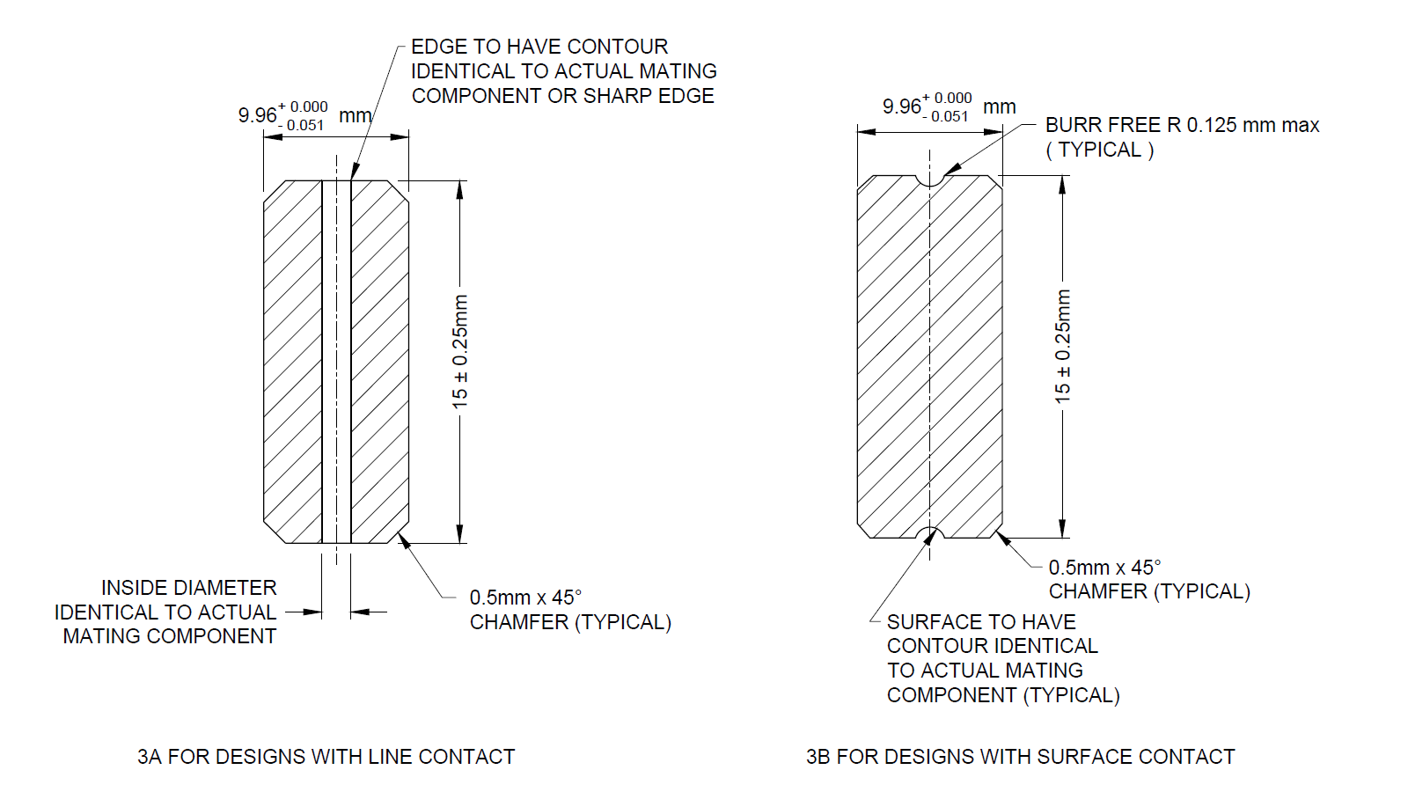

FIG. 3 STRENGTH OF HEAT RESPONSIVE ELEMENT

**6.17 Deflector Strength Test**

Deflector strength test sprinkler deflectors shall be capable of withstanding a force without permanent deformation.

Sprinkler deflectors shall be capable of withstanding a force of 190 N without any permanent deformation of any of their parts or cause their disengagement from the sprinklers. The force shall be applied at a rate of 30 N/s by means of a rigid flat metal edge and where possible shall form a line contact at least 15 mm long with the deflector.

Following the above test, sprinklers shall be individually installed in the test apparatus detailed in Fig. 1 to 4 in their intended orientation. Water shall be introduced to the inlet of each sprinkler at a pressure of 15 ± 0.5 bar. Each sprinkler shall then be operated using a suitable heat source and water flow shall be adjusted to and maintained at 15 ± 0.5 bar for a period of 15 min.

Sprinklers with detached components shall be capable of satisfying the distribution tests specified in **6.23** after the test.

**6.18 Vibration Test**

**6.18.1** Five previously untested sprinklers shall be hydrostatically tested to confirm that there are no weep or leak points at, or below 35 bar. The samples shall then be subjected to the vibration conditions stated in Table 7.

**6.18.2** For the variable frequency conditions, the frequency shall be varied with a cycle period of 25 ± 5 s.

1. The sprinklers shall be attached to a rigid mounting plate and the plate bolted to the table of a vibration machine so that the sprinklers are vibrated vertically. This test shall be conducted with the sprinklers unpressurized. The sprinklers may be pressurized for this test at the sole discretion of testing authorities if so deemed necessary.
2. The sprinklers shall be subjected to the above vibration conditions and continuously monitored for 15 min at each condition (75 min total). If one or more resonant point(s) is detected, the sprinklers shall be vibrated for the remainder of the test at such frequency(ies) for a period of time proportionate to the number of resonant frequencies. Otherwise the sprinklers shall be subjected to each vibration condition for a period of 5 h (25 h total).

Sprinklers shall be capable of withstanding the effects of vibration without deterioration of their performance characteristics. Following the vibration test detailed in **6.18.2**, the sprinklers shall not weep or leak at, or below 35 bar when tested in accordance with **6.1.1** (Leakage). Subsequently, the sprinklers shall be tested for conformance to the requirements for time constant determination and sensitivity as described in **6.26** and **7** at the discretion of authorities.

**Table 7 Vibration Test Conditions**

(*Clause* 6.18.1)

|  |  |  |  |
| --- | --- | --- | --- |
| **Sl No.** | **Total Displacement** mm | FrequencyHz | Timeh |
| (1) | (2) | (3) | (4) |
|  | 0.5 | 28 | 5 |
|  | 1 | 28 | 5 |
|  | 3.8 | 28 | 5 |
|  | 1 | 18 to 37 variable | 5 |
|  | 1.8 | 18 to 37 variable | 5 |

**6.19 Drop and Tumble Tests**

**6.19.1** *Drop Test*

Five previously untested sprinklers shall be hydrostatically tested so as to ascertain/confirm that there are no weep or leak points at, or below, 35 bar. Each sprinkler shall then be tested by dropping a weight equal to that of the sprinkler ± 5 g, onto the deflector end of the sprinkler along the axial centreline of the waterway (*see* Fig. 5). The weight shall be dropped from a height of 1.0 m above the deflector. The weight shall be prevented from impacting the test sample more than once.

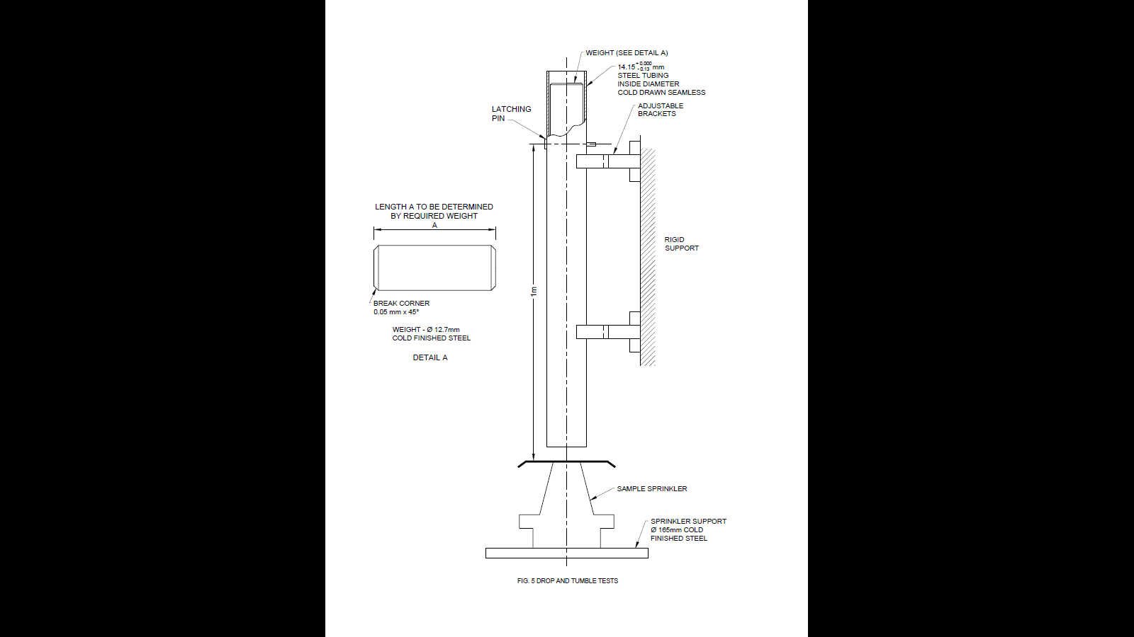

FIG. 5 DROP TEST

**6.19.2** *Tumble Test*

Five previously untested sprinklers shall be hydrostatically tested so as to ascertain/confirm that there are no weep or leak points at, or below 35 bar. Each sprinkler shall then be individually subjected to a tumbling test for three min. Sprinklers provided with shipping caps, which are intended for removal only after completion of the sprinkler installation, shall be tested with the caps in place. Each sample shall be placed in a vinyl lined right hexagonal prism shaped drum designed to provide a tumbling action. The drum shall have a length along the axis of rotation of 250 mm. The internal distance between two opposite and parallel sides of the drum shall be 300 mm. For each test, the drum shall contain one sprinkler and five wood blocks. The blocks shall be 40 ± 3 mm cubes made of hardwood (that is, oak, maple, etc). The drum shall be rotated at one revolution per second about its longitudinal axis.

**6.19.3** *Impact Test*

1. For rack storage sprinklers, five previously untested samples shall not sustain damage when the assembled sprinklers are individually dropped from a height of 750 ± 25 mm onto a concrete surface such that the shield impacts the floor at an angle. The shield shall not shear off or bend as a result of this impact. If rotation of the shield is possible, such rotation shall not alter the assembly load on the sprinkler.
2. For sprinklers with guards, five previously untested samples shall not sustain damage when the sprinkler/guard assemblies are individually dropped 3 times from a height of 3 m onto a concrete surface. Sprinklers shall not show evidence of damage after the drop sequence. The guards shall not make contact with the sprinkler deflector or become separated from the sprinkler as a result of the drop sequence.

Following all the tests detailed above, a visual examination of each sprinkler shall reveal no permanent distortion, cracks, breaks, or other evidence of impending failure. Also, each sprinkler shall not weep or leak at, or below 35 bars when tested in accordance with **6.2**. Subsequently, the samples shall be tested for conformance to the requirements for sensitivity as described in **6.24**, **6.25** and **6.26**.

* 1. **Discharge Co-efficient (K-Factor)**

**6.20.1** The mean value of the discharge coefficient (K-factor) shall be consistent with Table 8 when tested as detailed in **6.20.2**. Additionally, not more than one individual value shall fall outside of the stated range.

**6.20.2** Four samples shall be individually tested using the test apparatus for determining K-factor shown in Fig. 6 at increasing and decreasing pressures over the complete operating range 1.0 to 12.1 bar in 0.7 bar increments. With the deflector and a portion of the frame removed, if necessary, to facilitate testing, each sample shall be inserted into the test fixture and torqued to a rotation one-half turn (180 degrees) beyond "hand tight" using an appropriate wrench.

At ambient temperature conditions. Water flow of the sprinkler is calculated by the equation

$Q=KP^{1/2}$

Where,

$Q$ = Water flow, in LPM;

$P$ = Pressure, in bar; and

$K$ = Flow constant.

It is acceptable to adjust the pressures for differences in height between the gauge and the sprinkler outlet orifice.

The flow test shall be carried out at ambient temperature 25 ± 5 ˚C

**Table 8**

(*Clause* 6.20.2)

|  |  |  |
| --- | --- | --- |
| Sl No. | Nominal K-Factor(Based on LPM) | Tolerance |
| (1) | (2) | (3) |
|  | 40 | 38-42 |
|  | 58 | 57-60 |
|  | 80 | 76-84 |
|  | 115 | 107-118 |
|  | 160 | 154-168 |
|  | 200 | 195-209 |
|  | 240 | 231-254 |
|  | 360 | 344-382 |
| NOTE — Depending on usage, other sprinklers having higher K factor, say 480 may also be used depending on the protection required. | | |

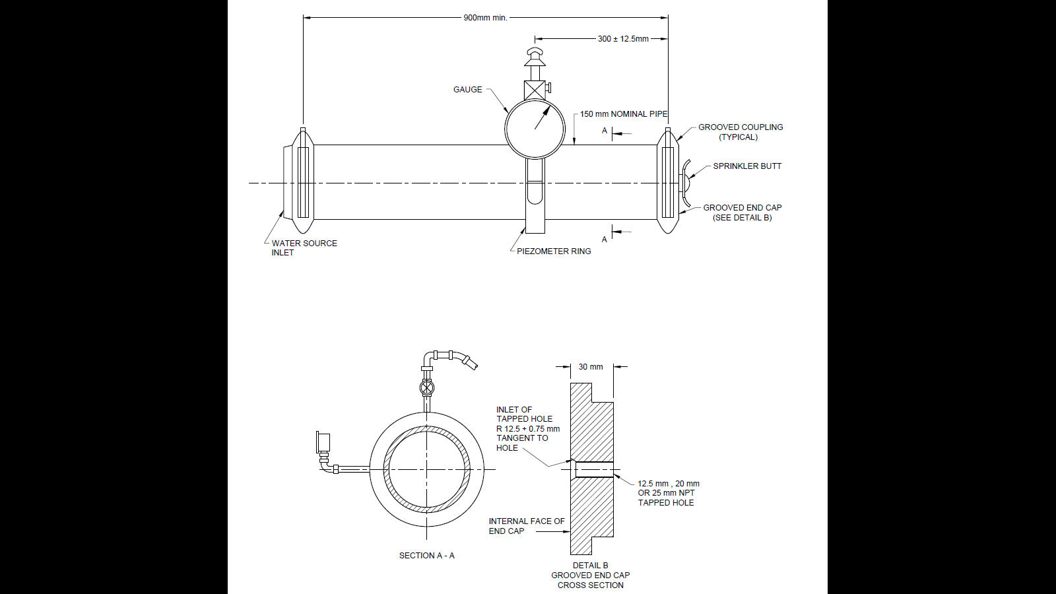

FIG. 6 WATER FLOW TEST

**6.21 Endurance Test**

An automatic sprinkler shall withstand for 30 min, without evidence of cracking, deformation, or separation of any part, a water flow at a pressure equal to the maximum rated pressure plus 1.5 bar. One sample of an automatic sprinkler shall be installed on an elbow in a pressurized system. The heat responsive element of the sprinkler shall be activated, and the sprinkler subjected to water flow at the above specified pressure for 30 min.

**6.22 Corrosion Test**

**6.22.1** *Salt Spray Test (Optional Test)*

1. Eight previously untested samples shall be hydrostatically tested to confirm that there are no weep or leak points at, or below 35 bar.
2. Each sprinkler inlet shall be filled with deionized water and sealed with a non-reactive material (for example, plastic cap) so as to prevent the introduction of salt fog into the waterway of the sprinkler. When feasible, each sprinkler shall be supported in its intended installation position.
3. Cover plates, common to the design of concealed sprinklers, shall be tested separately and shall be oriented such that salt fog residue cannot pool on the plate.
4. The samples shall be exposed to salt spray (fog). The salt solution shall consist of 20 percent by weight of common salt (sodium chloride) dissolved in deionized water.
5. The samples shall be exposed for a period of 10 days.
6. For sprinklers having a corrosion resistant coating, the samples shall be exposed for a period of 30 days.
7. Following exposure to the salt fog, the samples shall be removed from the test chamber and permitted to air dry for a two- to four-day drying period. Following this drying period, the samples shall be subjected to the post-exposure tests as detailed below:
8. All of the samples shall be subjected to a hydrostatic pressure of 12 bars for one min (as detailed in **6.2**) without leakage;
9. Subsequently, the sprinklers shall be tested for conformance to the requirements for sensitivity as described in Section **7** for different types of sprinklers as applicable;
10. At the discretion testing authorities, some or all of the samples may be tested for operating temperature as described in **6.5** [operating temperature (liquid bath)]; and
11. Should the deflector or other non-operating components, or their attachment method exhibit questionable corrosive attack, at least one sample shall be tested for compliance with the requirements in **6.17**.

**6.22.2** *Stress Cracking Test*

Sprinklers shall be resistant to stress corrosion cracking, as determined through the process described below. Following exposure, the samples shall not show evidence of cracking, delamination, or degradation.

**6.22.2.1** *Copper bases materials (ammonia test)*

1. In order to determine the susceptibility of copper based sprinkler parts to stress corrosion cracking, four previously untested sprinklers shall be hydrostatically tested to confirm that there are no weep or leak points at, or below, 35 bar. They shall then be subjected to a moist ammonia environment for a period of 10 days.
2. The inlet end of each sample shall be filled with deionized water and sealed with a non-reactive material (for example, plastic cap) so as to prevent the introduction of the ammonia atmosphere into the waterway of the sprinkler. The samples to be tested shall be free from any non-permanent protective coating and, if necessary, shall be degreased. When feasible, the samples shall be tested in their intended orientation.
3. There shall be provisions in the test chamber to prevent droplets of condensation from falling from the top of the enclosure directly onto the sprinklers. Such shield or other means shall be constructed of glass or other non-reactive materials.
4. The samples shall be exposed to the moist ammonia-air mixture maintained in a glass chamber with a volume of 0.02 ± 0.01 m3.
5. Aqueous ammonia having a density of 0.94 ± 0.01 g/cm3 shall be maintained in the bottom of the chamber, approximately 40 mm below the bottom of the samples. A volume of aqueous ammonia equal to 10 ± 0.86 L/m3 of the test chamber volume shall result in approximately the following atmospheric concentrations: 35 percent ammonia, 5 percent water vapor, and 60 percent air. Prior to beginning the exposure, the test chamber shall be conditioned to a temperature of 34 ± 2°C for a period of not less than 1 h, and shall be maintained as such throughout the exposure period. The moist ammonia-air mixture shall be maintained at essentially atmospheric pressure. Provision shall be made for venting the chamber, such as by the use of a capillary tube, to avoid buildup of pressure.
6. Upon removal, sprinklers shall be rinsed in potable water and air dried. Following a two- to four-day drying period, visual examination of the samples shall be made. The samples shall then be subjected to the post-exposure tests as detailed below.
7. The sprinklers shall not weep or leak at, or below 12 bars when hydrostatically tested for one minute as per **6.2**.
8. Subsequently, half of the samples shall exhibit positive operation and release of all operating parts at the minimum operating pressure when tested in accordance with **6.12**.
9. The remaining samples shall be subjected to a water flow at a pressure of 12 bars for a period of one minute.

Upon completion of this test, the deflector shall not show evidence of fracture, distortion or impending separation from the frame.

**6.22.2.2** *Stainless steel and other materials (boiling magnesium chloride test)*

1. In order to determine the susceptibility of stainless steel sprinkler parts to stress corrosion cracking, four previously untested sprinklers shall be degreased and then exposed to a boiling magnesium chloride solution for a period of 500 ± 12 h as described below, special fixtures or elevated temperature operating elements may be employed to simulate assembly loading on parts, where appropriate.
2. Samples are to be placed in a flask fitted with a wet condenser. The flask shall be filled approximately one-half full with a nominal 44 percent by weight magnesium chloride solution, placed on a thermostatically-controlled electrically-heated mantle, and maintained at a boiling temperature of 150°C ± 2 °C.
3. Following exposure, the samples shall be removed and rinsed in potable water. Following a two- to four-day drying period, visual examination of the samples shall be made. Samples which show evidence of cracking, delamination, degradation, or evidence of separation of permanently attached parts shall then be subjected to the post-exposure tests as detailed below:
4. The sprinklers shall not weep or leak at, or below 12 bars when hydrostatically tested for one minute as per **6.2**.
5. Subsequently, half of the samples shall exhibit positive operation and release of all operating parts at the minimum operating pressure when tested in accordance with **6.12**.
6. The remaining samples shall be subjected to a water flow at a pressure of 12 bars for a period of one minute.

Upon completion of this test, the deflector shall not show evidence of fracture, distortion or impending separation from the frame.

**6.22.3** *Corrosion – Carbon-dioxide and Sulphur-dioxide Tests*

Sprinklers shall be resistant to corrosion resulting from exposures to a moist carbon dioxide-sulfur dioxide-air mixture. Following the exposure period, the samples shall be examined for deterioration or impending failure of any component. Such condition is unacceptable and constitutes failure. The carbon-dioxide and sulphur-dioxide test is not required for concealed or flush type sprinklers.”

1. Four previously untested sprinklers shall be hydrostatically tested to confirm that there are no weep or leak points at, or below, 35 bar. The samples shall then be exposed to a moist carbon dioxide-sulfur dioxide-air mixture for a period of 10 days.
2. For sprinklers having classified as corrosion resistant, eight previously untested samples shall be exposed to this test for a period of 30 days.
3. The inlet end of each sample shall be filled with deionized water and sealed with a non-reactive material (for example, plastic cap) so as to prevent the introduction of the gas mixture into the waterway of the sprinkler. When feasible, each sprinkler shall be tested in its intended installation position.
4. Cover plates, common to the design of concealed sprinklers, shall be tested separately and shall be oriented such that residue cannot pool on the plate.
5. There shall be provisions in the test chamber to prevent droplets of condensation from falling from the top of the enclosure directly onto the sprinklers. Such shield or other means shall be constructed of glass or other non-reactive materials.
6. The samples shall be tested in a chamber having provisions for gas inlet and outlet. Sulfur dioxide and carbon dioxide are to be supplied to the test chamber from commercial cylinders. An amount of sulfur dioxide equivalent to one percent of the volume of the test chamber, and an equal volume of carbon dioxide shall be introduced into the chamber each day after the chamber has been purged. Approximately 2.0 litres of deionized water shall be maintained in the bottom of the chamber.
7. Following the exposure, the samples shall be removed from the test chamber and permitted to air dry for a two- to four-day drying period. Following this drying period, the samples shall be subjected to the post-exposure tests detailed below:
8. Following the visual examination, the samples shall not weep or leak at, or below 12 bars when hydrostatically tested for one min.
9. Subsequently, half of the samples shall be tested for compliance with **6.5** [operating temperature (liquid bath)], and half of the samples shall be tested for conformance to the requirements for sensitivity and time constant determination as per **6.24** and **7**.
10. Should the deflector or other non-operating components, or their attachment exhibit questionable corrosive attack, at least one sample shall be subjected to water flow at a pressure of 12 bars for a period of one min.

Upon completion of this test, the deflector shall not show evidence of fracture, distortion or impending separation from the frame.

**6.22.4** *Corrosion - Hydrogen Sulphide Test*

Sprinklers shall be resistant to corrosion resulting from exposures to a moist hydrogen sulfide-air mixture. Following the exposure period, the samples shall be examined for deterioration or impending failure of any component. Such condition is unacceptable and constitutes failure. The hydrogen sulphide test is not required for concealed or flush type sprinklers.

1. Four previously untested sprinklers shall be hydrostatically tested to confirm that there are no weep or leak points at, or below, 35 bar. The samples shall then be exposed to a moist carbon dioxide-sulfur dioxide-air mixture for a period of 10 days.
2. For sprinklers having corrosion-resistant coatings, eight previously untested samples shall be exposed to this test for a period of 30 days.
3. The inlet end of each sample shall be filled with deionized water and sealed with a non-reactive material (for example, plastic cap) so as to prevent the introduction of the gas mixture into the waterway of the sprinkler. When feasible, each sprinkler shall be tested in its intended installation position.
4. Cover plates, common to the design of concealed sprinklers, shall be tested separately and shall be oriented such that residue cannot pool on the plate.
5. There shall be provisions in the test chamber to prevent droplets of condensation from falling from the top of the enclosure directly onto the sprinklers. Such shield or other means shall be constructed of glass or other non-reactive materials.
6. The samples shall be tested in a chamber having provisions for gas inlet and outlet. Hydrogen sulfide is to be supplied to the test chamber from a commercial cylinder. An amount of hydrogen sulfide equivalent to one percent of the volume of the test chamber shall be introduced into the chamber each day after the chamber has been purged. Approximately 2.0 litres of deionized water shall be maintained in the bottom of the chamber.
7. Following the exposure, the samples shall be removed from the test chamber and permitted to air dry for a two- to four-day drying period. Following this drying period, the samples shall be subjected to the post-exposure tests detailed below:
8. Following the visual examination, the samples shall not weep or leak at, or below 12 bars when hydrostatically tested for one min.
9. Subsequently, half of the samples shall be tested for compliance with **6.5** [operating temperature (liquid bath)], and half of the samples shall be tested for conformance to the requirements for sensitivity and time constant determination as per **6.24** and **7**.
10. Should the deflector or other non-operating components, or their attachment exhibit questionable corrosive attack, at least one sample shall be subjected to water flow at a pressure of 12 bars for a period of one min.

Upon completion of this test, the deflector shall not show evidence of fracture, distortion or impending separation from the frame.

**6.23 Water Distribution Test**

**6.23.1** *Conventional, Spray and Dry Sprinklers*

Tests shall be carried out using square arrays of 4 sprinklers over 100 equal sized pans at ambient conditions of 20 oC ± 15 oC. In a test room of a size 7.5 m + 0.5 m and a height of 3.2 m ± 25 mm, 4 sprinklers of the same type shall be installed, arranged in a square array, on piping constructed for the purpose. The arrangement of the piping and measuring containers is shown in Fig. 7, 8, 9 and 10.The yoke arms of the sprinklers shall be in line with the range pipes. The distance between the ceiling and the centre of the range pipe shall be 165 mm ± 20 mm. Flush, recessed and concealed sprinklers shall be mounted in a simulated false ceiling.

The size of the protected area and the density of the coverage for each of the three nominal sizes of sprinkler are specified in Table 9. The number of low content containers shall not exceed that stipulated in column 7 of Table 9.

**Table 9 Protected Area, Density of Coverage for Nominal Sizes of Sprinklers**

(*Clause* 6.23.1)

|  |  |  |  |  |  |  |  |  |  |  |  |  |
| --- | --- | --- | --- | --- | --- | --- | --- | --- | --- | --- | --- | --- |
| **Sl No.** | **Nominal Orifice Diameter** mm | **Water Coverage** lpm/m2 | | | **Nominal Flow Rate per Sprinkler**  lpm | **Nominal Protected Area**  m2 | | | **Sprinkler Spacing**  m | | **Allowable Low Content Container** | |
| (1) | (2) | (3) | | | (4) | (5) | | | (6) | | (7) | |
|  | 10 | | 2.5 | 50.6 | | | 21 | 4.5 | | 8 | |
|  | 15 | | 5.0 | 61.3 | | | 12 | 3.5 | | 5 | |
|  | 15 | | 15.0 | 135.0 | | | 9 | 3.0 | | 4 | |
|  | 20 | | 10.0 | 90.0 | | | 9 | 3.0 | | 4 | |
|  | 20 | | 30.0 | 187.5 | | | 6.25 | 2.5 | | 3 | |

The water distribution shall be collected in square containers of side measuring 0.5 m × 10 mm. The distance between the ceiling and the upper edge of the containers shall be 2.7 m × 25 mm. The containers shall be positioned centrally in the room under the 4 sprinklers.

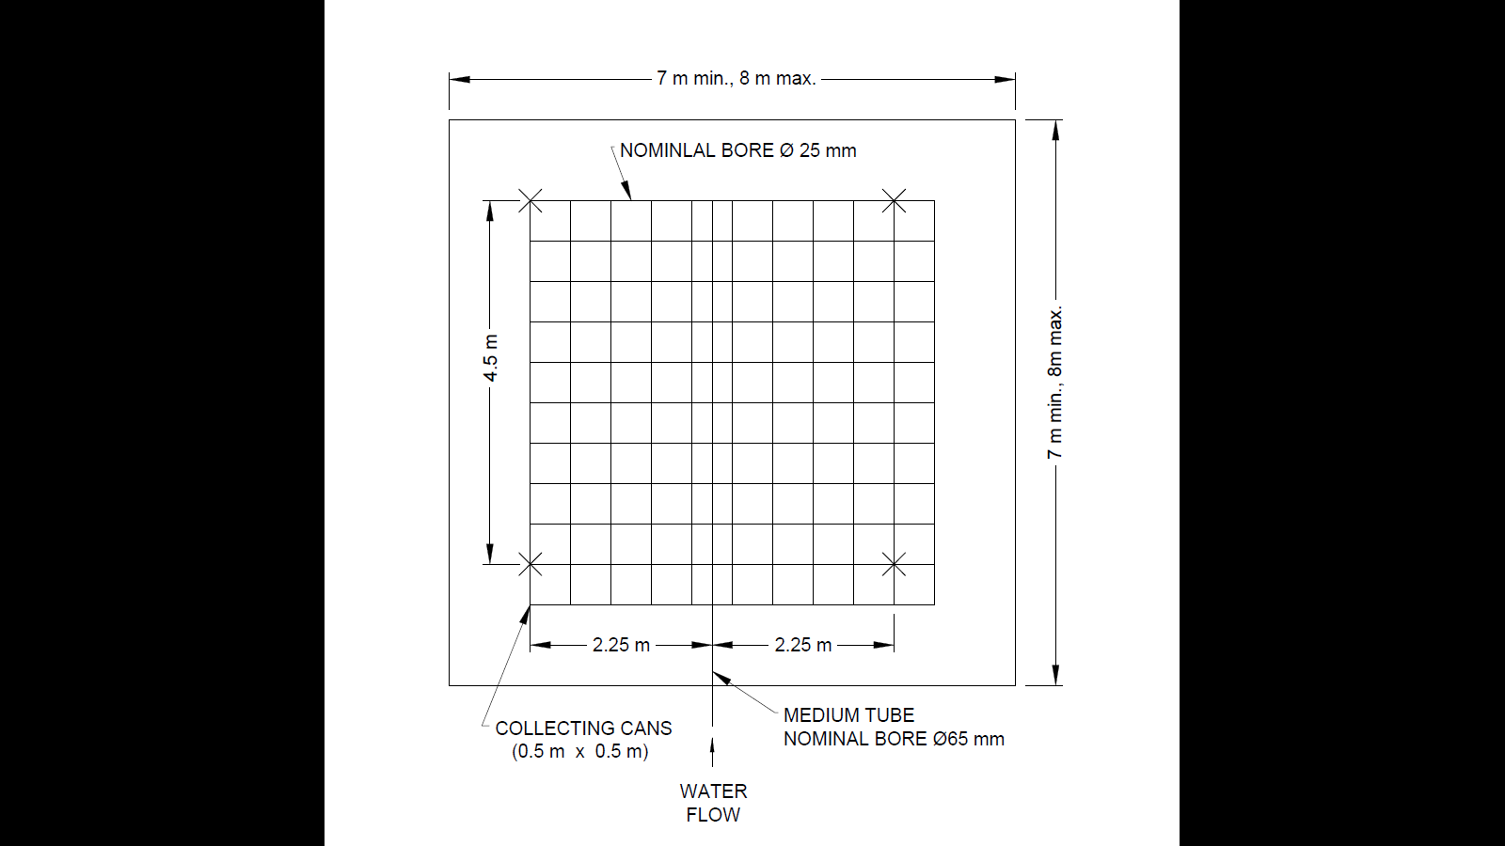

FIG. 7 WATER DISTRIBUTION TEST

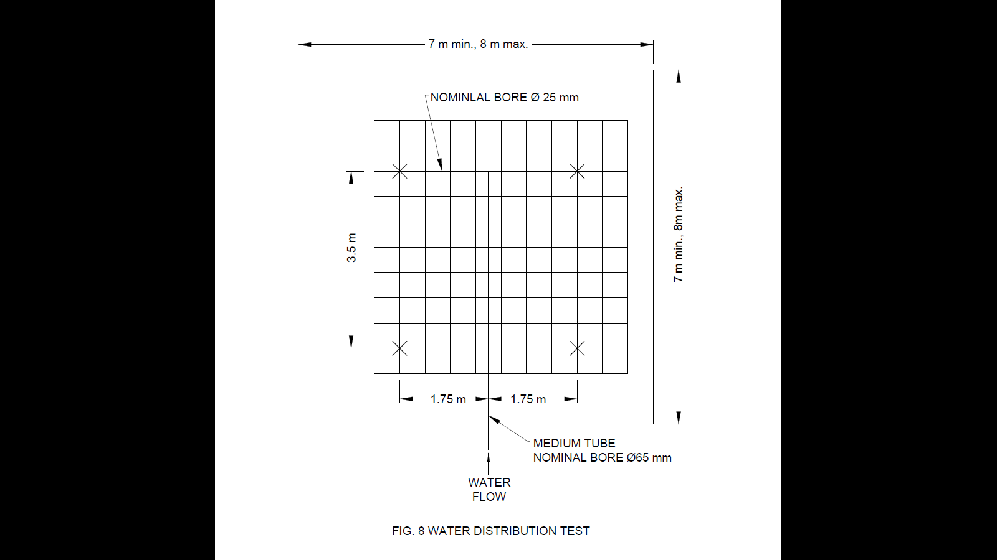

FIG. 8 WATER DISTRIBUTION TEST

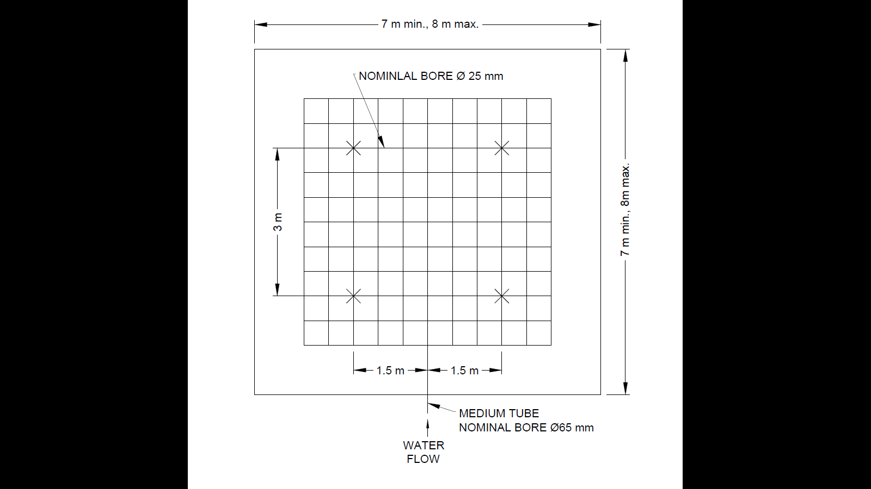

FIG. 9 WATER DISTRIBUTION TEST

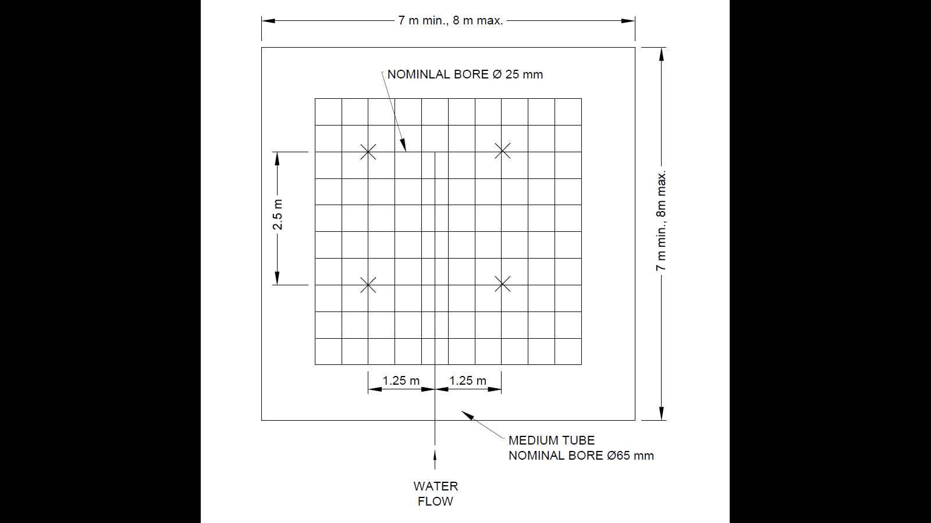

FIG. 10 WATER DISTRIBUTION TEST

**6.23.2** *Sidewall Sprinklers (15 mm)*

The tests shall be made in a room measuring 3.75 m × 7.0 m × 3.21 m. One sprinkler shall be mounted in an appropriate position on a distribution pipe passing through one wall so that the sprinkler centre line is situated 50 mm from that wall and at a distance of 1.8 m from an adjacent wall. For an upright sprinkler, the deflector of the sprinkler shall be 100 mm below the ceiling and for a pendent sprinkler 150 mm below the ceiling (*see* Fig. 11 and 12). Water shall be collected in cans having square open tops measuring 0.5 m x 0.5 m array with its edges 1 m from the adjacent wall and 10 mm from the sprinkler mounting wall. With the sprinkler discharging at 60 l/min, the discharge density into each can shall be determined and the height of the boundary between the wetted and the unwetted parts of the absorbent strip shall be measured. The distribution of water and wall wetting in an area bounded by two sprinklers 3.7 m apart is derived by overlapping two identical wall wetting profiles and distributions obtained from one test using single sprinkler.

The testing shall be considered as satisfactory if not more than 10 percent of the bounded area receives less than 1.125 l/min. In addition, wetting of the adjacent and opposite walls shall be achieved to a height of 1 m below the level of the sprinkler deflector.

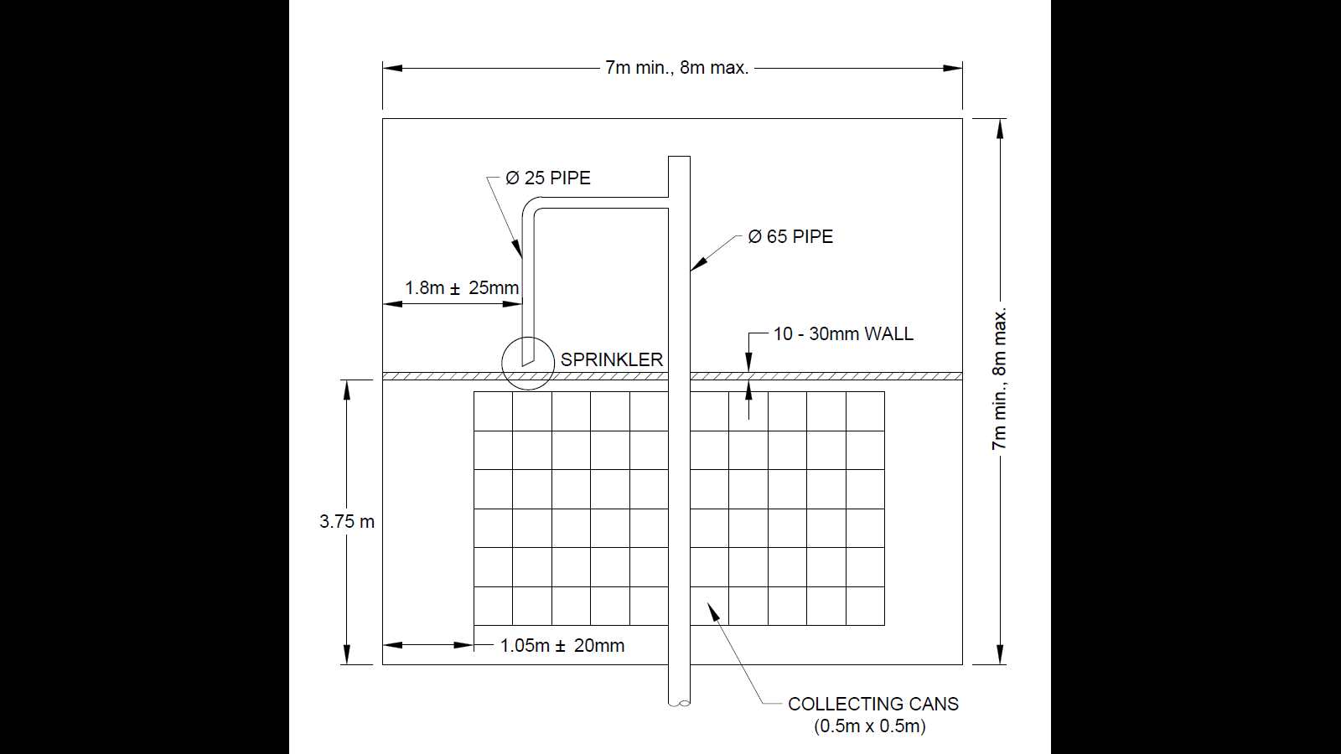

FIG. 11 WATER DISTRIBUTION TEST

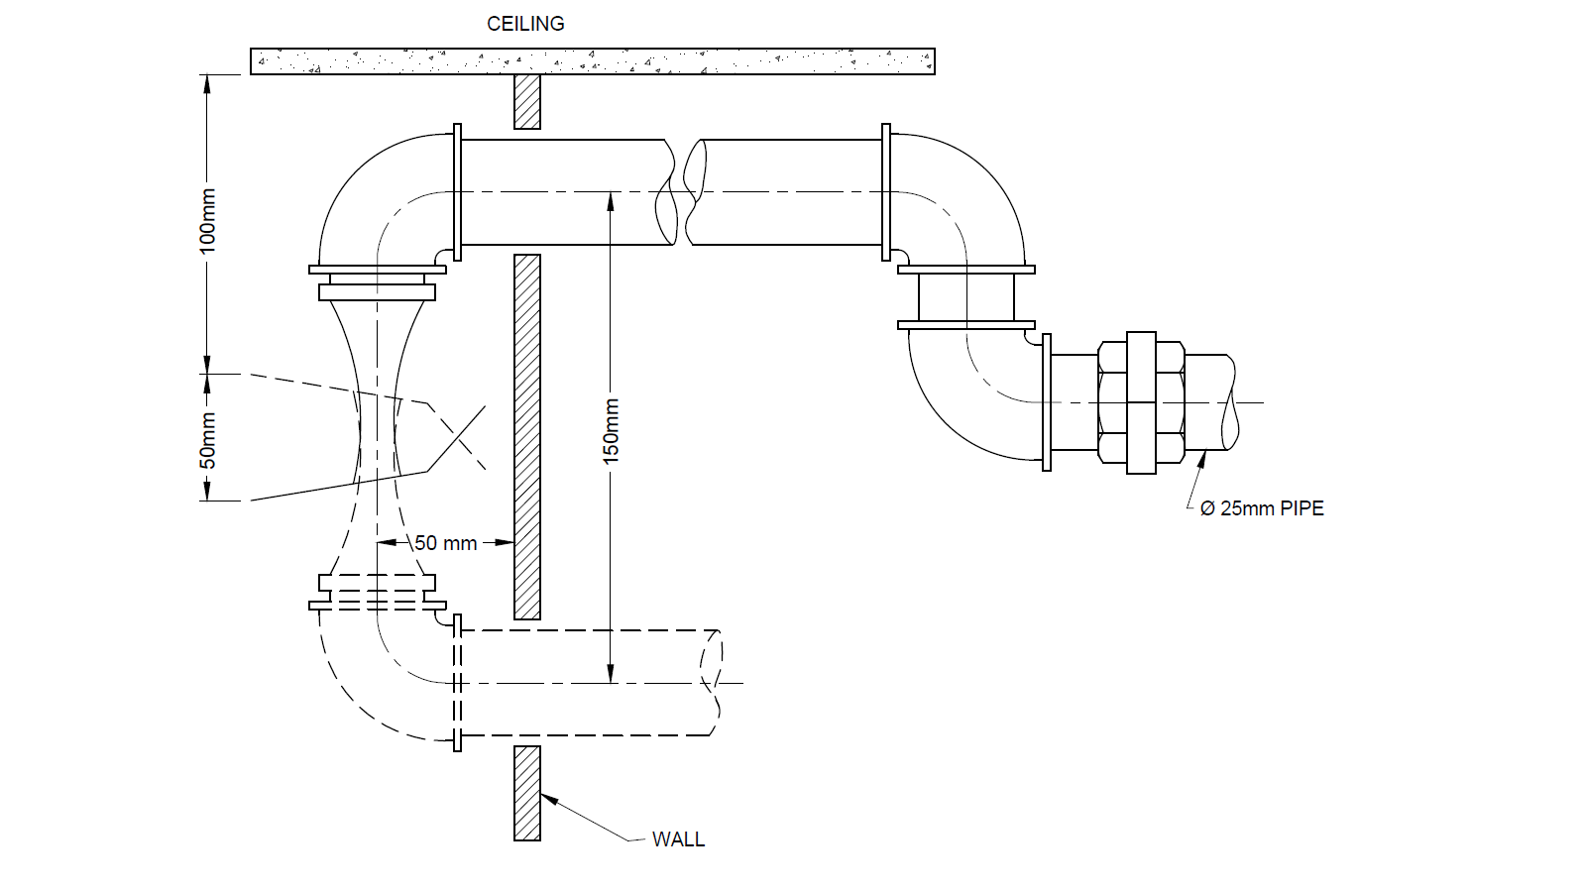

FIG. 12 WATER DISTRIBUTION TEST

**6.23.3** *Water Distribution Above and Below the Sprinkler Deflectors (Not Applicable to Sidewall Sprinklers)*

The water discharge of sprinklers downwards from the deflectors shall be 40 percent to 60 percent for conventional sprinklers and 80 percent to 100 percent for spray sprinklers. Sprinklers shall be installed horizontally in a testing rig and the features of which are shown in Fig. 13.

The deflector is positioned within the apparatus, such that a theoretical dividing line between the two collecting volumes intersects a point on the axis of the sprinkler where the water spray is traveling substantially parallel to the plane of the partition. (The results shall be given assuming that the conventional sprinkler is mounted in the upright position).

Sprinklers shall be tested under flow conditions as shown in Table 10.

**Table 10 Flow Condition for Water Distribution Test**

(*Clause* 6.23.3)

|  |  |  |
| --- | --- | --- |
| **Sl No.** | **Nominal Orifice diameter** mm | **Sprinkler Water Flow Rate**  lpm |
| (1) | (2) | (3) |
|  | 10 | 50 |
|  | 15 | 60 |
|  | 20 | 90 |

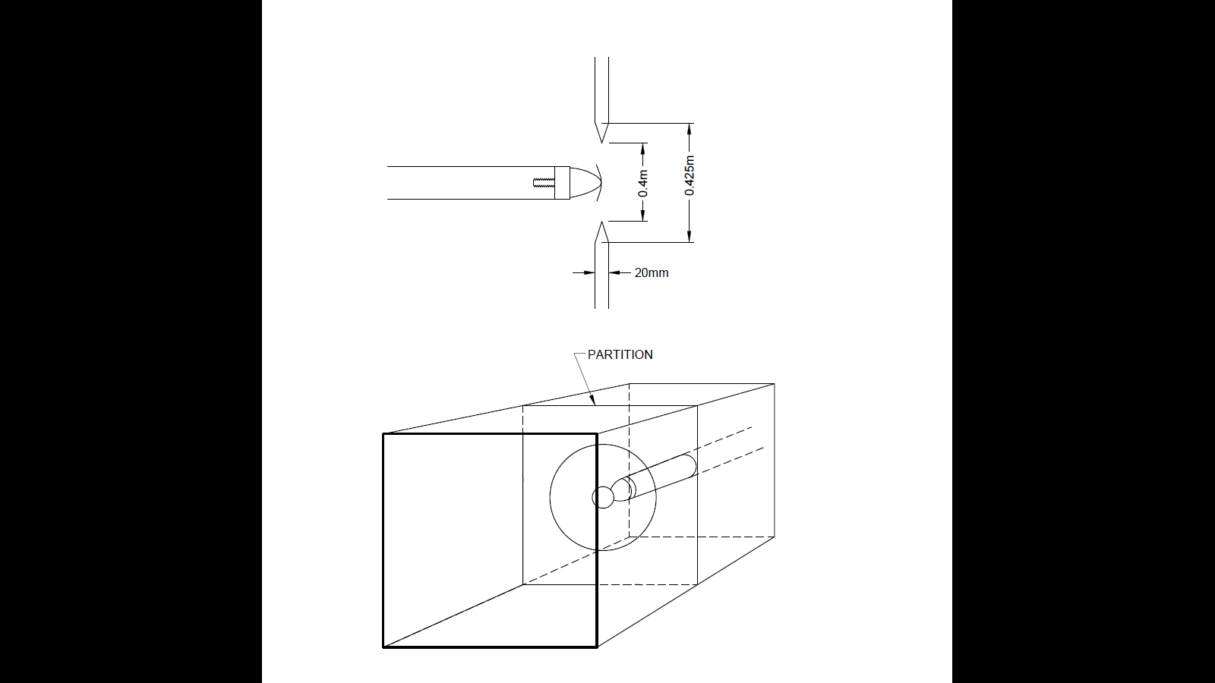

FIG. 13 WATER DISTRIBUTION TEST

**6.24 Determination of Time Constant**

The sprinklers shall be tested in each designed operating position. The sprinklers shall be mounted in the test section of the wind tunnel (*see* Fig. 14) in such a way that the release element is exactly in the middle of the tunnel. The air mass flow rate in the tunnel is adjusted to the equivalent of 80 cm/s at 20 ˚C and is maintained at this figure as the temperature of the air in the tunnel is raised in uniform steps in the range of 1 ˚C/min to 30 ˚C/min. The temperature inside the tunnel is stabilized prior to the start of the test. The sprinklers shall be charged to a pressure of 0.35 bar during the test. The response time of the sprinklers is noted for each rate of rise of temperature. Then the time to operate ‘t’ against rate of rise curve is plotted which comes to a straight line. The intercept of the straight line is a measure of time constant $T$. If the rate of rise of temperature in ˚C/min is $α$ and the temperature rating in ˚C is $β$ then the following equation will apply:

$$t = (β/α) + T$$

The value of $T$ thus calculated shall be always less than 150 s.

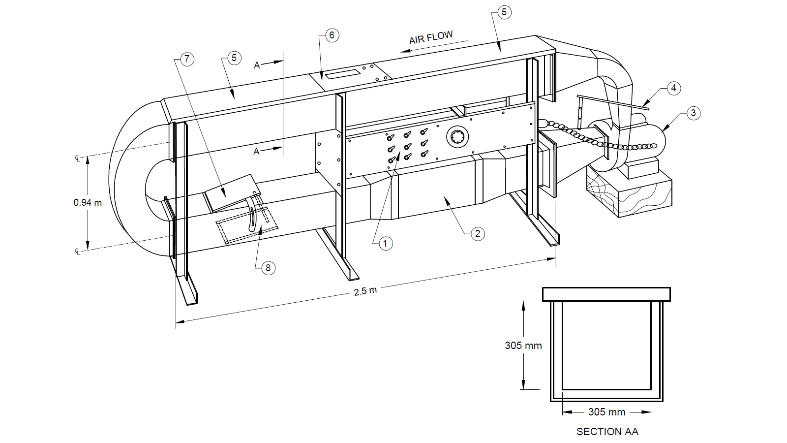

FIG. 14 APPARATUS FOR DETERMINATION OF TIME CONSTANT

**6.25 Response Test for Ceiling, Flush, Recessed and Concealed Sprinklers**

**6.25.1** Sprinklers shall operate within the times specified when tested in accordance with **6.25.2** or **6.25.3**.

**6.25.2** The sprinkler to be tested shall be installed in a ceiling panel in the centre of a closed room with floor dimensions of 4.57 m ± 0.1 m × 4.57 + 0.1 m and ceiling height of 2.4 m ± 0.1 m as shown in Fig. 15. The heat source shall consist of a propane gas pot burner, positioned in a comer with its centre 450 ± 25 mm from two adjacent walls and its top surface 560 ± 25 mm above the floor. Adequate ventilation shall be provided for the burner.

The room temperature shall be monitored 180 mm from the centre of the room and 30 ± 2 mm below the ceiling. For the duration of the test the room temperature at the measuring point shall conform to the time/temperature curve in Fig. 16. The temperature shall also be monitored 5 ± 1 mm below the ceiling. At the start of the test the room shall have been preconditioned to 30 ± 5 ˚C with a ceiling structure temperature of between 25 ˚C and 40 ˚C, and the specimens shall have been preconditioned to 20 ± 5 ˚C for at least 24 h. The specimen shall be installed, the burner ignited, and the time of operation recorded. For concealed sprinklers, the time for detachment of the cover plate shall also be recorded.

The statistical limit in seconds, is calculated following expression:

$$x + 3.47 µN$$

Where,

$x$ = arithmetic mean response time of specimens tested;

$3.47$ = constant, used where 10 specimens tested; and

$µN$ = standard deviation for specimens tested.

The following requirements shall be met as specified in Table 11.

**6.25.3** When tested in accordance with **6.25.3.1** and **6.25.3.2** using the time constant apparatus in Fig. 14, concealed and recessed sprinklers shall operate such that the mean response time of three samples tested at each of the noted test conditions does not exceed the theoretical maximum response time calculated utilizing the following information:

1. RTI according to Table 12;
2. Gas temperature and velocity according to Table 13 — for standard and special response, utilize test conditions 1 to 9; for fast response, utilize test conditions 1 to 6;

|  |
| --- |
| 1. Upper permitted temperature limit of the sprinkler in accordance with 6.5; and 2. Ambient temperature during testing. |

**Table 11 Response Test**

(*Clause* 6.25.2)

|  |  |  |
| --- | --- | --- |
| **Sl No.** | **Sprinkler Nominal Temperature Rating**  **ºC** | **Statistical Limit of Operating Time**  **s** |
| (1) | (2) | (3) |
|  | Upto and including 78 | 170 |
|  | 79 | 212 |
|  | 80 – 100 | 285 |

1. **Table 12 Maximum Permitted RTI**
2. [*Clause* 6.25.3(a)]

|  |  |  |
| --- | --- | --- |
| **Sl No.** | **Sprinkler Response** | **RTI**  **m/s0.5** |
| (1) | (2) | (3) |
| i) | Standard | 350 |
| ii) | Special | 80 |
| iii) | Fast | 50 |

**Table 13 Time Constant Apparatus Conditions for Concealed**

**and Recessed Sprinklers**

[Clause 6.25.3(b)]

|  |  |  |  |  |
| --- | --- | --- | --- | --- |
| **Sl No.** | **Test Condition** | **Gas Temperature**  °C | **Gas Velocity**  m/s | **Applied Vacuum**  mm Hg1) |
| (1) | (2) | (3) | (4) | (5) |
| i) | 1 | 128 | 1.0 | 0.007 |
| ii) | 2 | 128 | 2.6 | 0.007 |
| iii) | 3 | 128 | 3.5 | 0.007 |
| iv) | 4 | 197 | 1.0 | 0.010 |
| v) | 5 | 197 | 2.6 | 0.010 |
| vi) | 6 | 197 | 3.5 | 0.010 |
| vii) | 7 | 290 | 1.0 | 0.013 |
| viii) | 8 | 290 | 2.6 | 0.013 |
| ix) | 9 | 290 | 3.5 | 0.013 |
| 1 mm Hg = 133 322 4 Pa | | | | |

**6.25.3.1** Three samples shall be tested at each of the test conditions and orientations determined from the calculations obtained according to **6.25.3**. Each sprinkler under test shall have 1 wrap to 1.5 wraps of PTFE sealant tape applied to the sprinkler threads. Each sample shall be screwed into the test plate (*see* Fig. 17) to a torque of (15 ± 3) N·m and maintained in a conditioning chamber to allow the sprinkler and test plate to reach ambient temperature for a period of not less than 30 min. The sprinkler shall be installed such that the sprinkler’s heat-sensitive element is at the minimum protrusion (as permitted by the sprinkler design) into the time constant apparatus laminar gas stream. The orientations according to Table 13 shall be based on the sprinkler as if it were not concealed or recessed.

**6.25.3.2** A timer accurate to ±0.01 s with suitable measuring devices to sense the time between when the sprinkler is plunged into the tunnel and the time it operates shall be utilized to obtain the response time. As soon as the sprinkler is plunged into the time constant apparatus, the applied vacuum (as noted in Table 13) shall be applied and maintained throughout the remainder of the testing.

Record the operating time of each sprinkler.

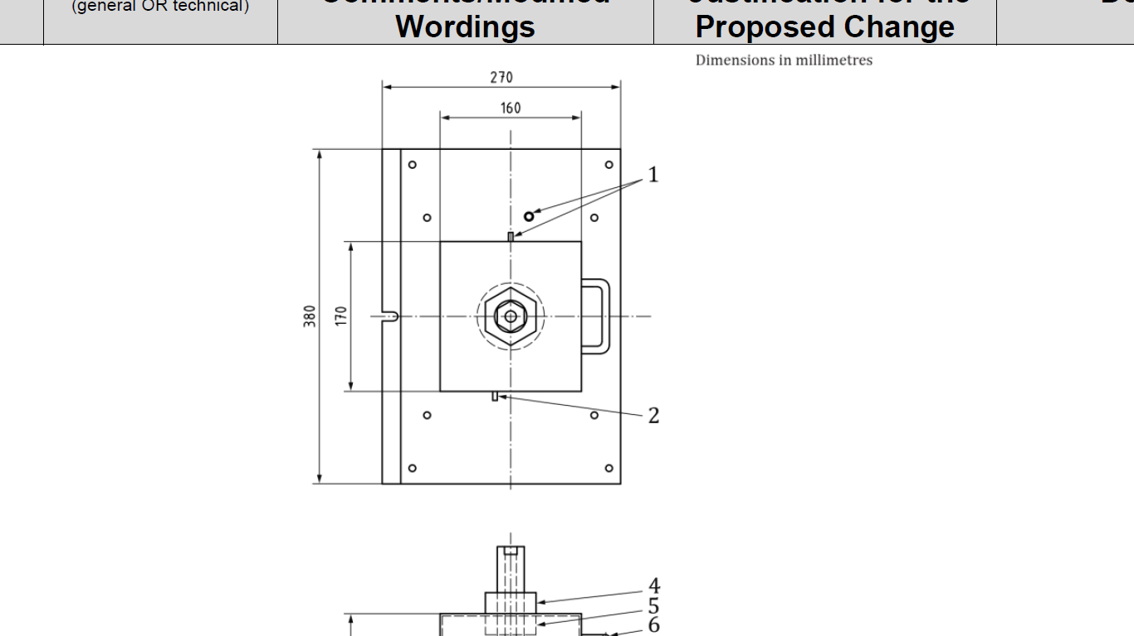

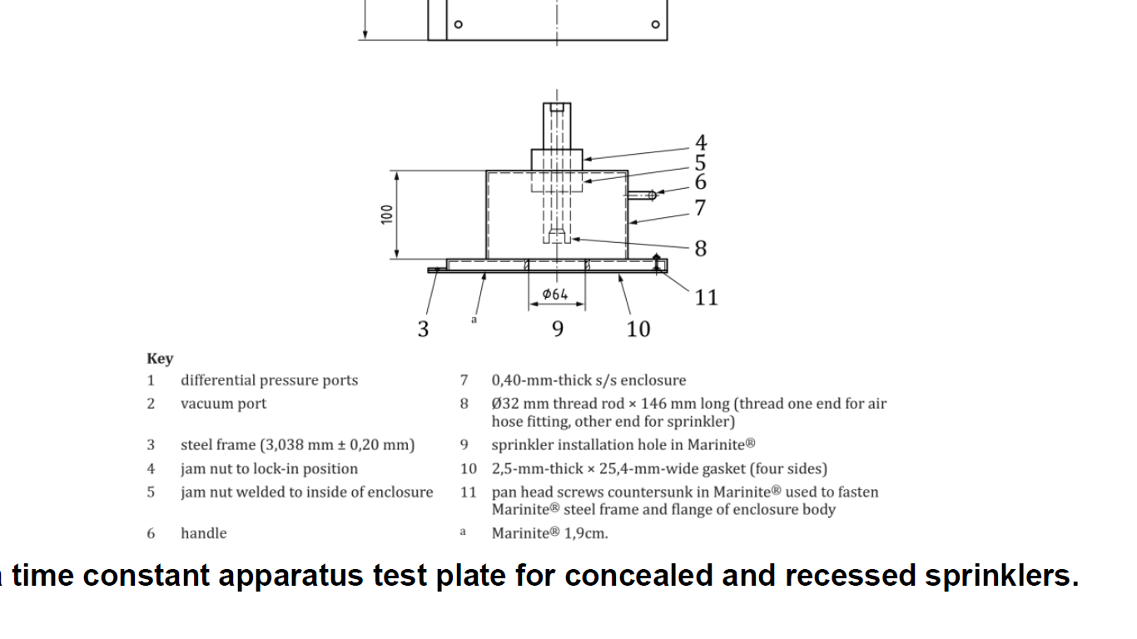

**KEY**

1 Differential pressure ports

2 Vacuum port

3 Steel frame (3 m + 0.20 mm)

4 Jam nut to lock-in-position

5 Jam nut welded to inside of enclosure

6 Handle

7 0.40 mm thick stainless steel enclosure

8 32 mm dia. threaded rod, 146 mm long (thread one end for air hose fitting, other end for sprinkler)

9 Sprinkler installation hole in Marinite

10 2.5 mm thick, 25 mm wide gasket (on 4 sides)

11 Pan head screws countersunk in Marinite used to fasten steel frame and flange of enclosure body

a Marinite 1.9 cm

FIG. 17 TYPICAL TIME CONSTANT APPARATUS TEST PLATE FOR CONCEALED AND RECESSED SPRINKLERS

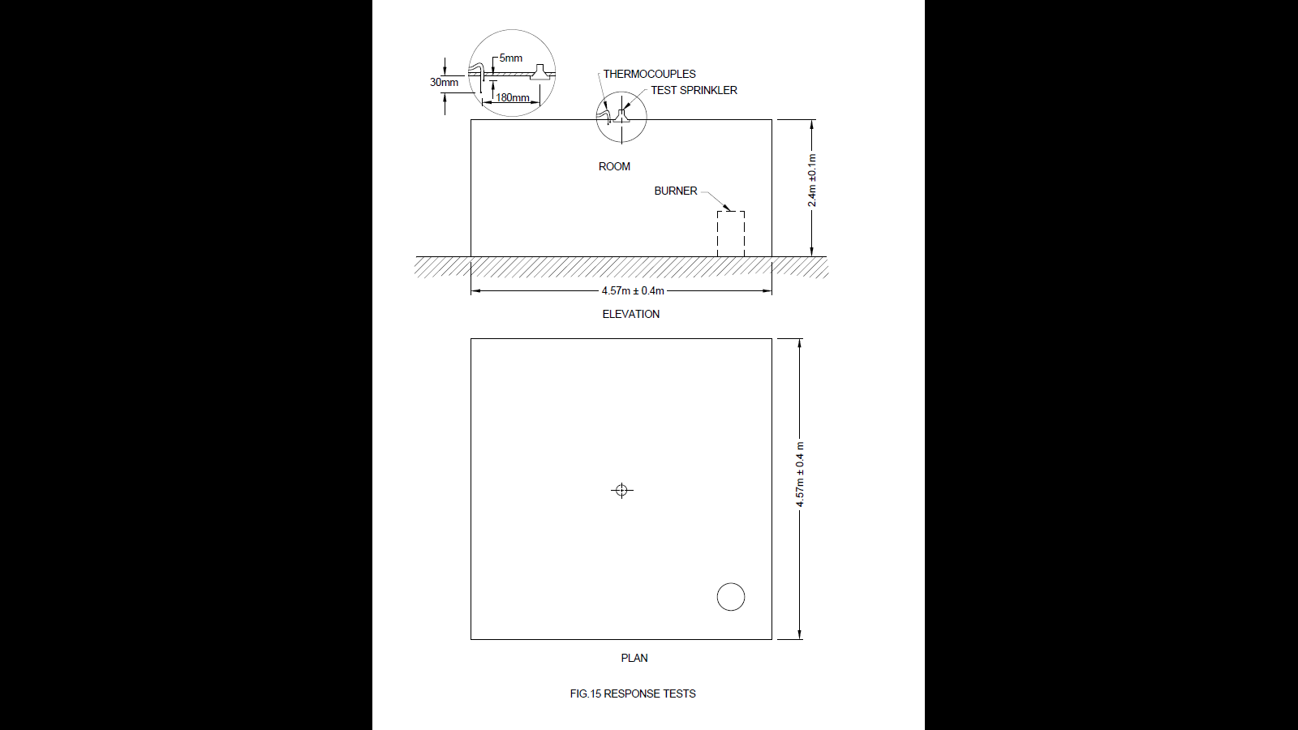

FIG. 15 RESPONSE TEST

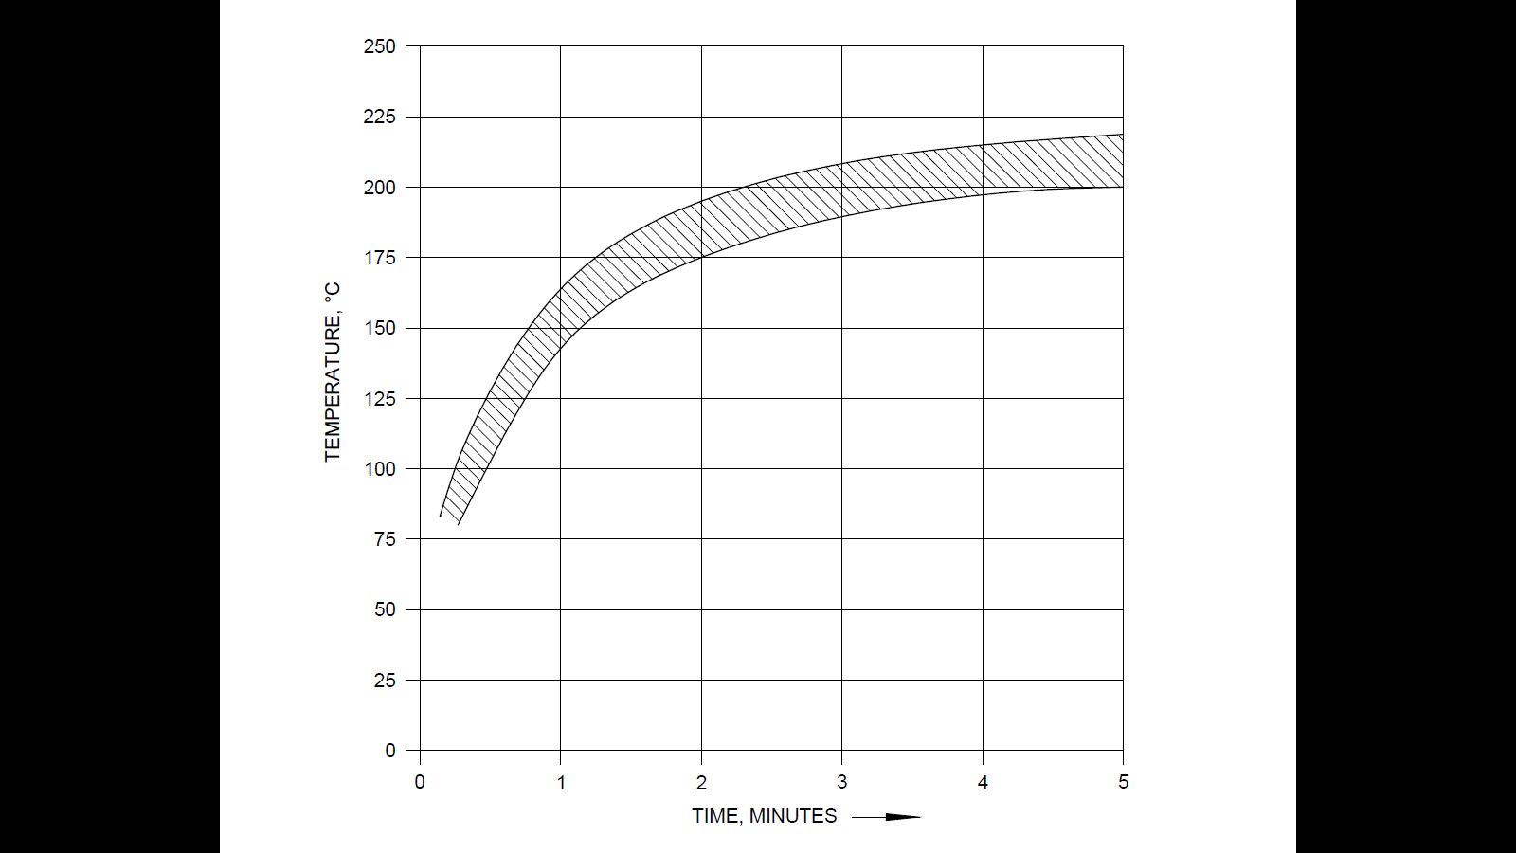

FIG. 16 RESPONSE TEST

**6.26 Conductivity (C-Factor)**

**6.26.1** *Requirements*

The conductivity (C-factor) shall not exceed 1.0 (m/s)1/2 for quick response and extended coverage type sprinklers. Standard response sprinklers shall have a C-factor not exceeding 2.0 (m/s)1/2. Coated, flush, recessed and concealed sprinklers are not subject to these requirements.

**6.26.2** *Test/Verification*

The C-factor shall be determined using the prolonged plunge test method. The prolonged plunge test is an iterative process to determine the C-factor and may require up to twenty sprinkler samples. A new sprinkler sample shall be used for each test even if the sample does not operate during the test.

Determination of the C-factor shall be performed with sprinklers of each nominal temperature rating in the "best case" orientation as determined in the sensitivity test (*see* **4.31**).

Prior to testing, each sprinkler shall have one to three wraps of PTFE sealant tape applied to the threads. Sprinklers shall be allowed to reach ambient temperature for a period of not less than 30 min.

A minimum of 0.025 L of water, conditioned to ambient temperature, shall be introduced into the sprinkler inlet and mounting fixture prior to testing. All sprinklers are to be tested with the inlet end of each sample connected to a source of pressure at 0.3 (with tolerance of +0.04 and -0) bar. All tests shall be conducted with the geometric centre of the heat responsive element located at least 38 mm from the interior horizontal surfaces of the test section, and with the centreline of the waterway perpendicular to the airflow in the test chamber.

A timer accurate to ± 0.01 s with suitable measuring devices to sense the time between when the sprinkler is plunged into the tunnel and when it operates shall be utilized to obtain the response time.

The mount temperature shall be maintained at 20 ± 1°C for the duration of each test. The mount temperature shall be recorded at the beginning of the test and at the time of sprinkler operation. If a sample does not operate, the mount temperature shall be recorded after 15 min has elapsed. Testing shall start with a tunnel gas temperature from the range detailed in Table 14.

To determine the C-factor, each sprinkler shall be immersed in the test stream at a selected gas velocity and air temperature for a maximum of 15 min. The average gas velocity in the tunnel test section at the sprinkler location shall be maintained within ± 0.07 m/s of the selected velocity. Velocities are to be chosen such that actuation is bracketed between two successive test velocities. That is, two velocities shall be established such that, at the lower velocity ($u_{L}$), actuation does not occur in the 15 min test interval. At the next higher velocity ($u_{H}$), actuation shall occur within the 15 min time limit. To establish $u_{L}$ and $u_{H}$ the velocity shall be raised by 10 percent increments within the range detailed in Table 14. If the sprinkler does not operate at the highest velocity in the range, a higher temperature shall be used and the same procedure repeated.

**Table 14 Tunnel Parameters**

(*Clause* 6.26.2)

|  |  |  |  |  |
| --- | --- | --- | --- | --- |
| **Sl No.** | **Sprinkler Nominal Operating Temperature1**  ºC | **Tunnel Gas Temperature**  ºC | **Tunnel Gas Velocity**  m/sec | **Maximum Variation of Temperature During the Tests from Selected Temperatures**  ºC |
| (1) | (2) | (3) | (4) | (5) |
|  | 57-77 | 88-407 | 0.2-3.05 | ± 6 |
|  | 79-107 | ± 9 |
|  | 121-149 | ± 25 |
|  | 163-191 | ± 25 |

NOTE **—** 1For temperature ratings between those shown, a linear interpolation shall be used to determine themaximum variation from selected temperature.

Test velocity selection shall insure that:

$(u_{H}$*/ $u_{L})1/2 ≤ 1.1$*

The C-factor of the sprinkler is determined by computing the average of the C-factors calculated at the two velocities ( $u_{H}$ and $u_{L}$) using the following equations:

|  |  |  |  |  |  |
| --- | --- | --- | --- | --- | --- |
| $$C_{L} = ({∆T}_{g}/ {∆T}_{b}-1) {u_{L}}^{1/2}$$ | | *. $$C_{H} = ({∆T}_{g}/ {∆T}_{b}-1) {u_{H}}^{1/2}$$* |  | |  |
| where: |  |  |  |  | | |  |
| $$C = (C_{L} + C_{H}) / 2$$ |  |  | | |  |
|  |  |  |  | | |  |
| $$C_{H}$$ | is the C-factor at velocity $u_{H}$ | |  |  | | |  |
| $$C_{L}$$ | is the C-factor at velocity $u_{L}$ | |  |  | | |  |
| $$C$$ | is the average C-factor of the sprinkler | |  |  | | |  |
| $${∆T}_{g}$$ | is the actual gas (air) temperature minus the mount temperature | |  |  | | |  |
| $${∆T}_{b}$$ | is the mean liquid bath operating temperature minus the mount temperature | | | |  |
| $$u_{H}$$ | is the actual gas velocity in the test section at which the sprinklers operated | | | |  |
| $$u_{L}$$ | is the actual gas velocity in the test section at which the sprinklers failed to operate within 15 min | | | |  |
|  |  |  |  |  | | |  |

The sprinkler C-factor is determined by repeating the bracketing procedure. The C-factor values from at least two non-operations shall be averaged. The C-factor values from at least two operations shall be averaged. The final C-factor value is the calculated numerical average of these two values.

**7 REQUIREMENT AND TESTING METHODS FOR THE DETERMINATION AUTOMATIC SPRINKLER HEAT SENSITIVITY**

**7.1** The automatic sprinklers having an external primary heat sensitive element which will normally be positioned not closer than 5 mm to any mounting surface shall be subjected to the tests as described in **7.2.1** and **7.2.2**. These test methods are not applicable for determining the sensitivity of ceiling flush, recessed or concealed sprinkler types.

**7.2** Test Requirements Sprinklers shall operate satisfactorily and the time of operation shall be measured and recorded when tested using the `plunge test' and `rate of rise' test. Sprinklers having an RTIP (metric) of less than 100 when measured in the fastest orientation in accordance with the requirements of **7.2.1** shall be classified as fast response sprinklers.

**7.2.1** *Plunge Test*

It determines the variations in sensitivity due to orientation and it provides sensitivity performance record to enable efficient quality assurance.

**7.2.1.1** Sprinkler samples of each temperature rating shall be tested. Each sprinkler shall be mounted in a test jig (*see* Fig. 17) and shall be stabilized at 30 ˚C ± 2˚c.

**7.2.1.2** The jig mounted sprinklers shall be inserted in a wind tunnel with an airflow at a constant temperature and velocity to determine the times to operate from insertion. The tunnel conditions at the test section shall be in accordance with Table 10 (a supervisory air pressure of not less than 0.35 bar shall be applied at the sprinkler outlet).

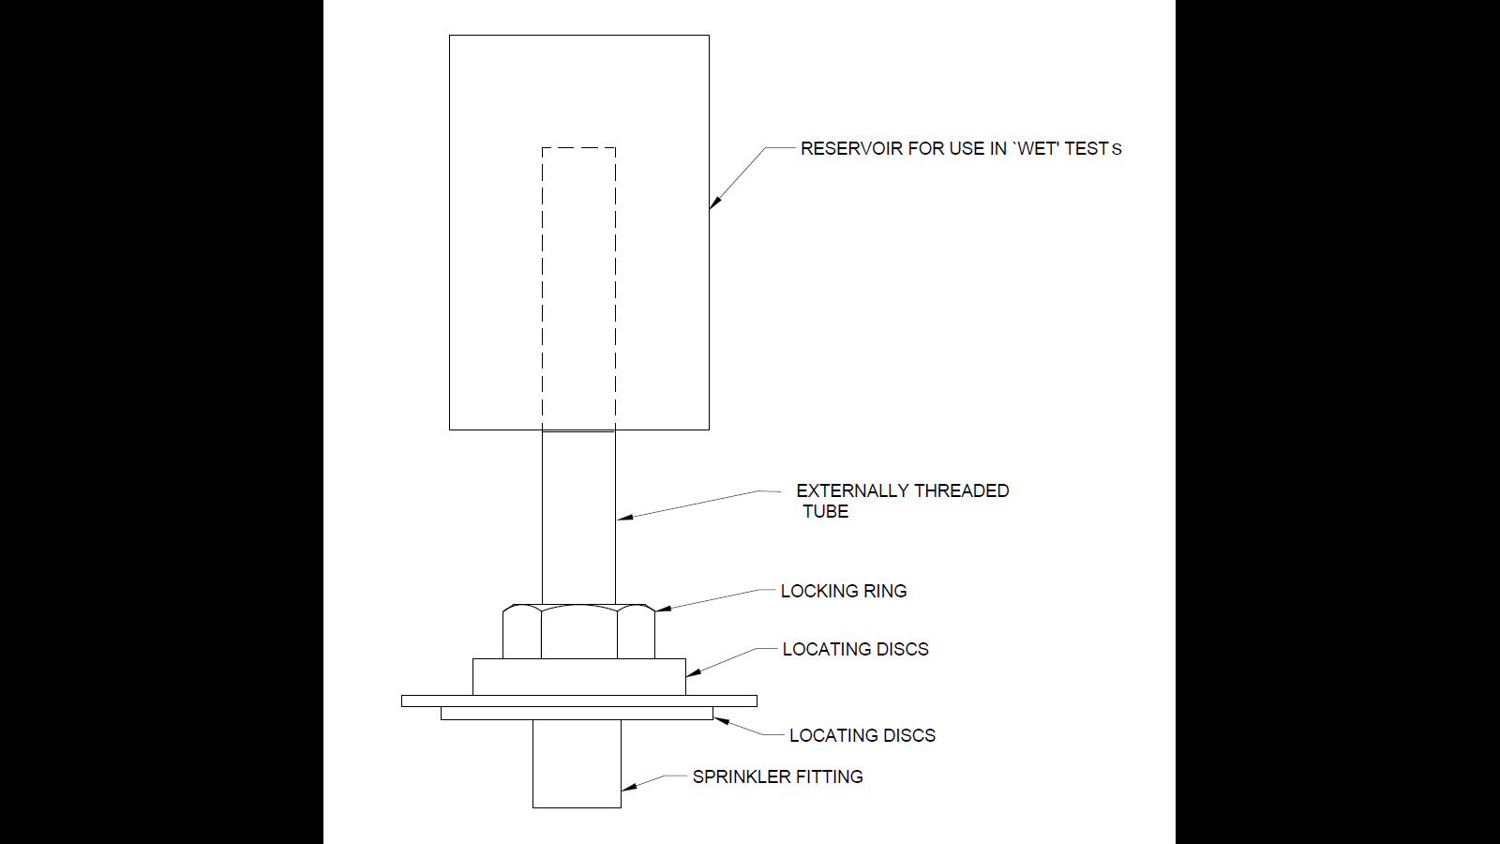

FIG. 17 PLUNGE TEST

**7.2.1.3** Sprinklers shall be tested with the waterway axis perpendicular to the airflow in the orientations detailed below.

Sprinklers symmetrical about the waterway axis shall be tested with:

1. Frame arms normal to the airflow (such that the thermal element is fully exposed to the airflow) (*see* Fig. 18A), and
2. Frame arms in line with the airflow (*see* Fig. 18B).

Sprinklers which are asymmetric about the waterway axis shall be additionally tested with:

1. Frame arms rotated 180֯ about the waterway axis from position a, and
2. The centre of the heat collector directly downstream of a frame arm.

**7.2.1.4** The following numbers of sprinklers shall be tested for each rating and orientation:

a) Fusible element sprinklers : 2

b) Glass bulb sprinklers : 3

**7.2.2** *Rate of Rise Test*

It determines the sensitivity performance characteristic of sprinklers to determine their suitability for use in applications specifying particular performance criteria.

**7.2.2.1** Sprinkler specimens shall be suitably mounted in a test jig. At the start of each test the test jig and the sprinkler shall be inserted in the tunnel test section and shall be stabilized at a temperature of 30 ˚C ± 2 ˚C, before commencement of the heating rate of rise cycle.

**7.2.2.2** Sprinklers shall be tested in the following appropriate positions and orientations in relation to the wind tunnel test section:

a) All sprinklers types — Sprinklers shall be tested with the waterway axis perpendicular to the airflow in the orientation which resulted in the longest mean time to operate when tested in accordance with **7.2.1.3**.

b) Sprinklers for in-rack use

1) Pendant spray and conventional sprinkler types shall be tested with the waterway axis parallel to the airflow direction with the sprinkler waterway inlet downstream relative to the airflow (*see* Fig. 18C).

2) Upright spray and conventional sprinklers shall be tested with the waterway axis parallel to the airflow direction with the waterway inlet upstream relative to the airflow (*see* Fig. 18D).

**7.2.2.3** Prior to the start of the test the sprinkler pipe work shall be filled with a specified volume of water above the sprinkler inlet.

**7.2.2.4** Sprinkler specimens of each rating shall be tested in the wind tunnel in the appropriate positions and orientations described at **7.2.2.2** and shall be subjected to a steadily increasing airstream temperature at a constant mass flow. Tests shall be undertaken at the following rates of temperature rise:

a) 2 ˚C/min,

b) 12 ˚ C/min, and

c) 20 ˚C/min.

The sprinkler operating time shall be measured from initiation of the rate of rise, starting at a stable condition of 30˚C.

**7.2.2.5** The following numbers of sprinklers shall be tested for each temperature rating, position and rate of rise:

a) Fusible element sprinklers : 2

b) Glass bulb sprinklers : 3

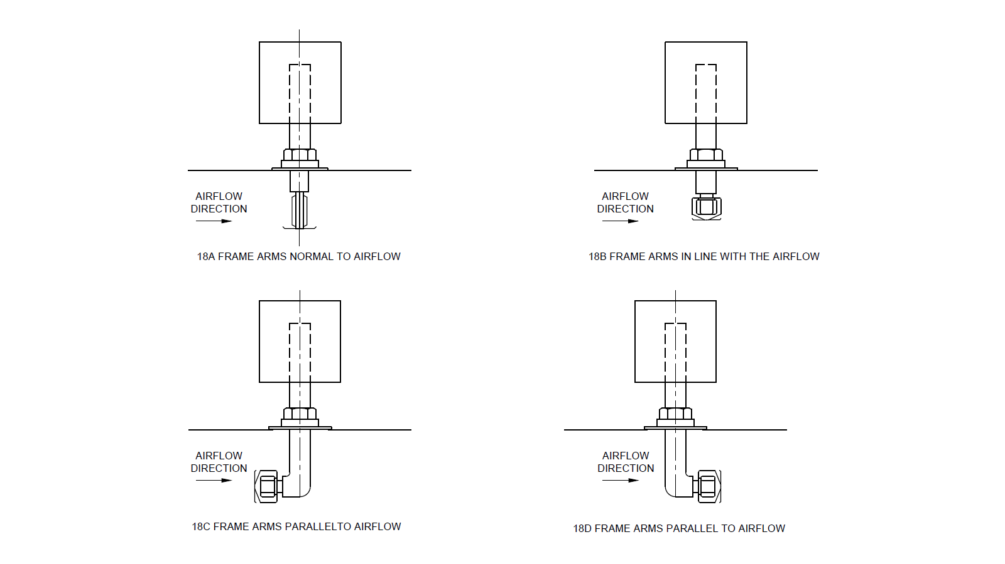

FIG. 18 WIND TUNNEL TEST SECTION

**7.3 Analysis of Test Results**

**7.3.1** *Plunge Test Results Analysis*

**7.3.1.1** The arithmetic mean time to operate each sprinkler rating at each orientation shall be determined.

**7.3.1.2** The time constant for each sprinkler rating at any orientation may be determined by the formula:

$$T_{p}=\frac{t_{r}}{\ln{(1-{∆T}_{i}/{∆T}_{g}) }}$$

Where,

$T_{p}$ = Time constant,

$t_{r}$ = Time to operate,

${∆T}_{i}$ = Sprinkler nominal rating – starting temperature, and

${∆T}_{g}$ = Tunnel temperature – starting temperature

**7.3.1.3** The ${RTI}_{p}$ shall then be determined by the following formula:

${RTI}_{p}$ $=$ $T_{p}$ $V^{0.5}$

Where,

$V$ = Airstream velocity in test section, and

$T_{p}$ = Time constant.

**7.3.2** *Rate of Rise Analysis*

The time constant $T$ and the effective operating temperature $θ_{e}$ shall be determined for each sprinkler orientation and temperature rating. The values may be graphically by plotting tunnel air temperature at operation $θ_{g}$ against the rate of rise $β$.

A graphical plot of $θ_{g}$ against $β$ will describe a line with slope equal to the time constant T having an intercept at the $θ_{g}$ axis (at $β$ = 0) equal to the effective operating temperature ${ θ}_{e}$ for the sprinkler rating and orientation (*see* Fig. 18E).

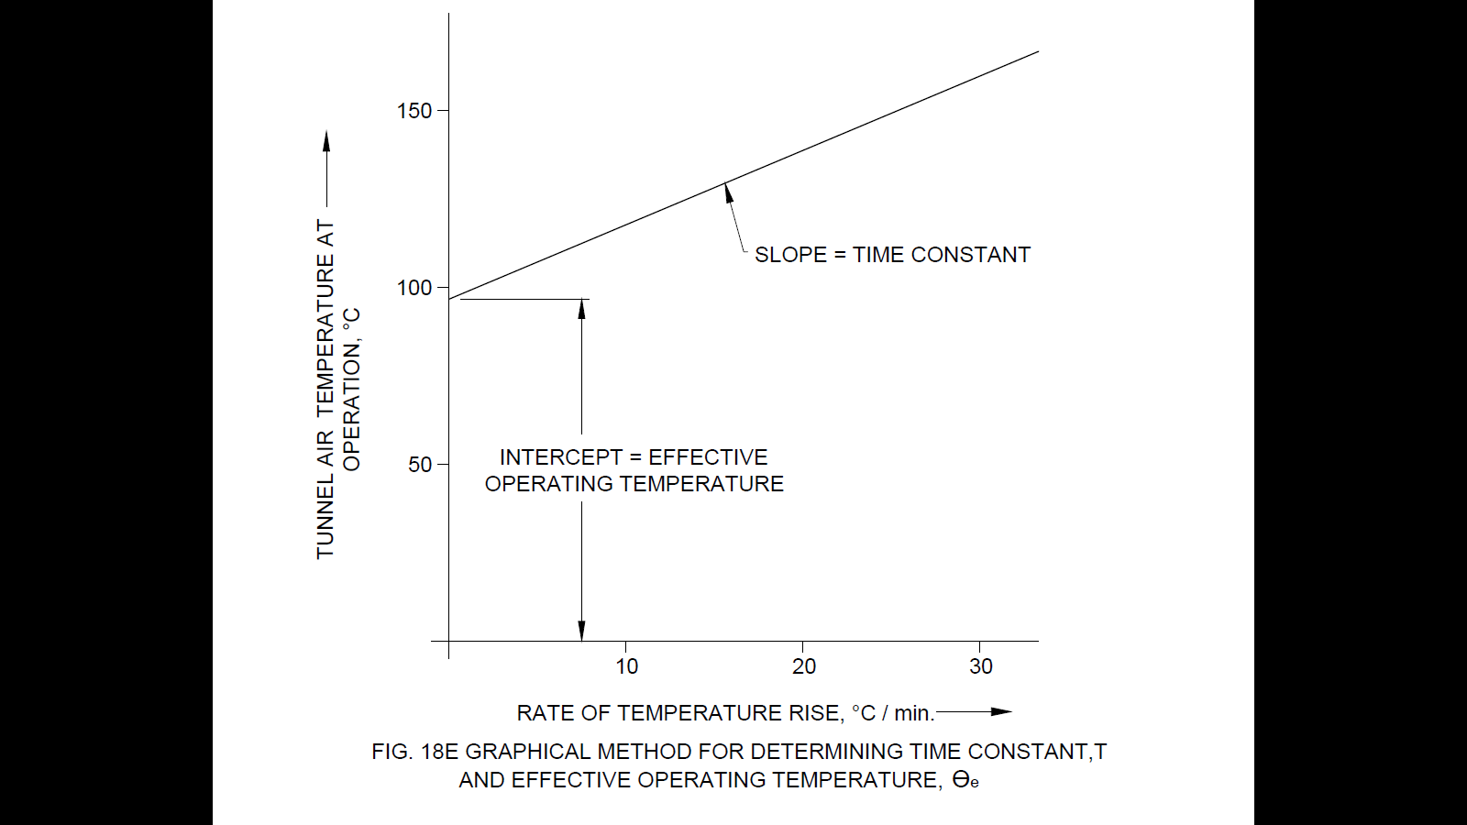

FIG. 18E GRAPHICAL METHOD FOR DETERMINING TIME CONSTANT, T

AND EFFECTIVE OPERATING TEMPERATURE, $θ_{e}$

**7.4 Test Apparatus**

**7.4.1** *Apparatus for Plunge Test*

A wind tunnel with approximate test section dimensions of 305 mm width x 305 mm depth shall be capable of developing the conditions at the test sections in accordance with Table 15.

**Table 15 Plunge Test Tunnel Condition**

(*Clause* 7.4.1)

|  |  |  |  |
| --- | --- | --- | --- |
| **Sl No.** | **Sprinkler Nominal Temperature Rating**  ºC | **Tunnel Temperature at Test Section\***  ºC | **Airstream Velocity at Test Section\*\***  m/s |
| (1) | (2) | (3) | (4) |
|  | 57 to 107 | 197 ± 5 | 2.5 ± 0.2 |
|  | 121 to 149 | 291 ± 7 | * 1. ± 0.2 |
|  |  |  |  |
| \* Monitored at the inlet to the working section using a sheathed type K (Cr/Al)  thermocouple 0.5mm O.D.  \*\* Measured at the working section using a pitostatic tube connected to a micro manometer calibrated for measuring velocity at airstream ‘temperatures up to 800°C.Checked between runs using a vane anemometer in the open end of the tunnel. | | | |

**7.4.2** *Apparatus for Rate of Rise Test*

A wind tunnel with approximate test section dimensions of 240 mm width x 150 mm depth shall be capable of developing the conditions at the test sections in accordance with Table 16.

**Table 16 Rate of Rise Test Tunnel Conditions**

(*Clause* 7.4.2)

|  |  |  |  |  |  |
| --- | --- | --- | --- | --- | --- |
| **Sl No.** | **Start Temperature** ºC | **Rate of Temperature Rise**  ºC/min | **Max Temperature** ºC | **Temperature Variation from Ideal Ramp**  ºC | **Airstream Velocity in Test Section at 25ºC** |
| (1) | (2) | (3) | (4) | (5) | (6) |
|  | 30 ± 2 | 2 | 250 | ± 3 | 1 ± 0.1 |
|  | 30 ± 2 | 12 | 250 | ± 3 | 1 ± 0.1 |
|  | 30 ± 2 | 20 | 250 | ± 3 | 1 ± 0.1 |

**8 TESTING PROCEDURE**

**8.1** The complete type testing of the sprinkler heads involves evaluation through all the tests enumerated in **6**. However, for the evaluation of both types of sprinklers, that is, fusible element and glass bulb types, at least 60 sprinklers from each type shall be tested as per the following scheme for various requirements and sprinklers shall be reused for subsequent tests in certain cases as detailed in Annex A.

**9 ROUTINE TESTING PROCEDURES IN PRODUCTION LINE**

The testing program suggested in **8** is applicable for the evaluation of the prototype sprinklers in the initial stage and also at the time of renewal of the acceptance by the authorities having jurisdiction. However, during the production of sprinklers the following testing requirements shall be met for all the sprinklers in the production line:

1. Examination of sprinklers for its orifice size, colour coding and key features as per manufacturer’s drawing, and
2. Each automatic sprinkler shall be subjected to hydrostatic test at 35 bar pressure and the pressure shall be maintained for a period of not less than 5 s. There shall be no leakage during the test.

**10 TEST FACILITIES EXPECTED AT THE MANUFACTURERS WORKS**

**10.1** The manufacturer shall provide regular production control, inspection and tests to maintain the quality of the sprinklers produced from time to time. For this purpose, it is necessary to provide atleast the following facilities so that these tests can be carried out at regular intervals:

1. Leak resistance test,
2. Lodgment test,
3. Release temperature test,
4. Strength of frame test,
5. Water flow test,
6. Distribution test,
7. Response test, and
8. Sensitivity test.

**11 FIRE TESTS**

**11.1 Ceiling, Sidewall, Pendent, Upright or Extended Coverage Types**

**11.1.1** A sprinkler of the ceiling, pendent, or upright type is to be installed in its intended installation position with the deﬂector 250 mm below the ceiling, unless speciﬁcally designed for other positions (such as recessed or ceiling type installations). *See* Fig. 19.

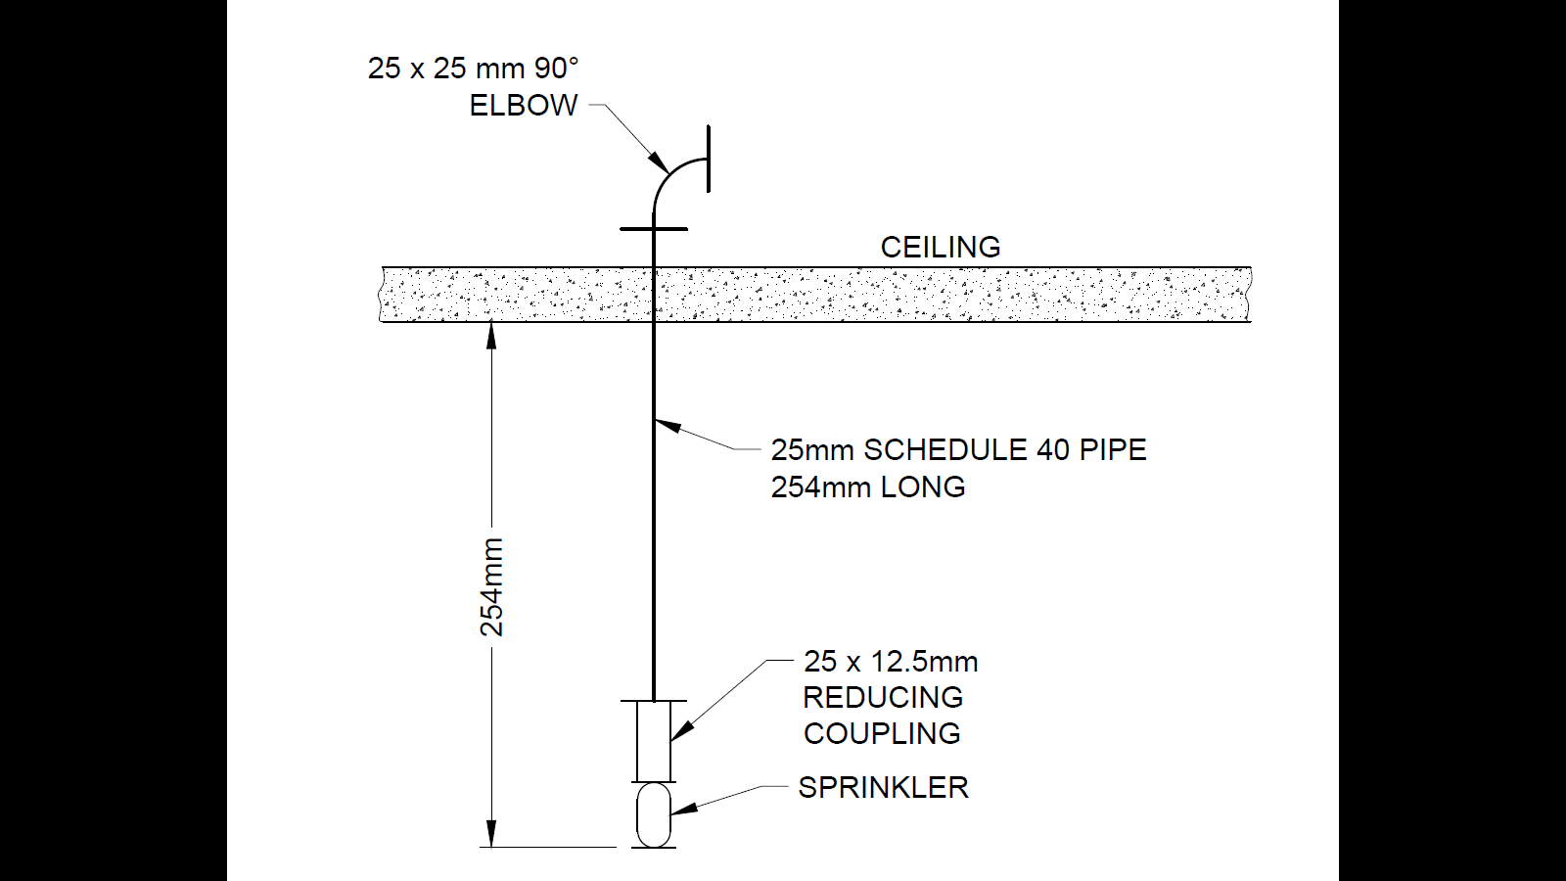

FIG.19 FIRE TEST

**11.2 Test Method – All Types**

**11.2.1** Water distribution measurements shall be conducted in an enclosed room with an open sprinkler discharging water at the minimum ﬂow rate and maximum area of coverage speciﬁed by the manufacturer. The minimum ﬂow rate is to be not less than a minimum water density of 4.0 lpm for the speciﬁed coverage area. For sprinklers rated at a pressure exceeding 12 bar, tests shall also be conducted using a ﬂow rate corresponding to a pressure of 5 bar less than the rated pressure for the largest rated spacing. Water collection pans that are 300 mm square, and 300 mm deep with a lip on one edge, shall be located on the ﬂoor of the enclosed room in the areas of the 11 crib locations as shown in Fig. 20. The distribution data shall be recorded and used in determining the speciﬁc positions of the wood cribs as required for the second and third ﬁre tests speciﬁed in **11.2.2**.

**11.2.2** A series of three ﬁre tests shall be conducted at each ﬂow rate using automatic sprinklers in the maximum temperature rating. For the ﬁrst ﬁre test, a wood crib as speciﬁed in **11.2.4** to **11.2.6** shall be located at crib location 1 of the test enclosure, see Fig. 20. For the second ﬁre test, the wood crib is to be located at crib location 2, 3, 4, 5, 6, or 7, see Fig. 20, whichever location had the least amount of water collected during the distribution determinations. However, when crib location 5, 6, or 7 had the least amount of water collected then:

a) A sprinkler other than a sidewall type is to be rotated 180 degrees and the crib placed in crib location 1, 3, or 4, whichever is opposite the crib location that had the least amount of water collected; and

b) A sidewall type sprinkler is to be installed on the wall near crib location 2.

**11.2.3** For the third ﬁre test, the wood crib is to be located in the centre of one of the four quadrants of the test room (*see* Fig. 20, Crib Location 8, 9, 10, or 11), whichever had the least amount of water collected during the distribution determination. However, when crib location 8 or 9 had the least amount of water collected, then:

a) A sprinkler other than a sidewall type is to be rotated 180 degrees and the ﬁre placed in crib location 10 or 11, whichever is opposite the crib location that had the least amount of water collected; and

b) A sidewall type sprinkler is to be installed on the wall near crib location 2.

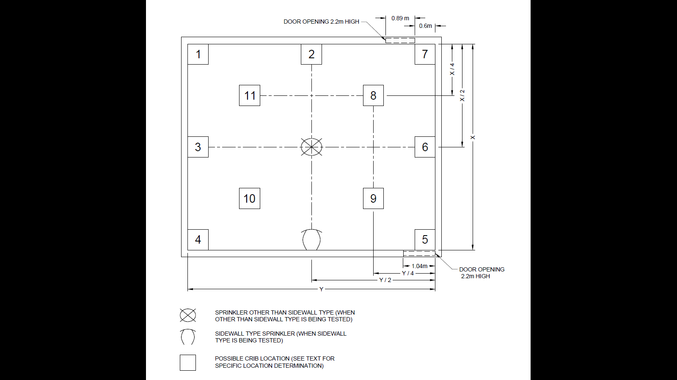

FIG. 20 FIRE TESTS

**11.2.4** The wood crib is to be dimensioned 500 mm × by 500 mm by 380 mm high and weigh 15 ±1 kg.

**11.2.5** The wood crib is to consist of ten alternate layers of ﬁve trade size 50 mm × 50 mm (nominal 38 mm × 38 mm) kiln-dried spruce or ﬁr lumber 500 mm long. The alternate layers of the lumber are to be placed at right angles to the adjacent layers. The individual wood members in each layer are to be evenly spaced along the length of the previous layer of wood members and stapled to the adjacent members.

**11.2.6** After the wood crib is assembled, it is to be conditioned at a temperature of 50 ±5 °C) for not less than 48 h. Following the conditioning, the moisture content of the crib is to be measured with a probe type moisture meter. The moisture content of the crib at any measurement location is not to exceed 5 percent prior to weighing the crib for the ﬁre test.

**11.2.7** For each test, the crib is to be placed on four bricks, one at each corner of the crib, that are contained in a 525 × 525 by 100 mm deep steel pan ﬁlled with 1 litre of heptane on a 25 mm) layer of water. When the crib position is in a corner, the edge of the crib is to be positioned 12.5 mm from both walls.

**11.2.8** The test room enclosure and sprinkler sample are to be maintained at a temperature of 24 ± 8 °C prior to each test. The room is not to have provisions for ventilation other than that provided by the two door openings shown in Fig. 20.

**11.2.9** The water ﬂow for the sprinkler is to be preset for the ﬂow rate speciﬁed in **11.2.1**. The test room doors are to be fully opened. The heptane is to be ignited. The test is to be conducted for 10 min after the ignition of the heptane. Ten minutes after ignition, the water for the sprinkler is to be turned off. When the ﬁre in the crib has not been extinguished, it is to be carefully extinguished to prevent further destruction of the crib. The crib is to be removed from the test enclosure and is to be conditioned at a temperature of 49 ± 5 °C for not less than 16 h. Following the conditioning, the moisture content of the crib is to be measured with a probe type moisture meter. The moisture content of the crib at any measurement location is not to exceed 5 percent prior to weighing the crib to determine the crib weight loss.

**12 WOOD CRIB FIRE TEST (160 KG)**

**12.1 General**

**12.1.1** When tested as described in **12.2.1** to **12.4.15** while discharging water at the ﬂow rates as shown in Table 17 and for sprinklers having a rated pressure exceeding 12 bar, at a ﬂow rate corresponding to a pressure of 5 bar less than the rated pressure; four open sprinklers shall:

a) Limit the loss in weight of the wood crib to not more than 20 percent; and

b) Result in the ceiling temperature reduced to a value less than 295 °C above ambient within 5 min after start of water discharge. Additionally, from the time the temperature initially falls below 295 °C above ambient to the end of the test, the ceiling temperature shall not exceed this value for more than three consecutive minutes and the average temperature for this period shall not exceed 295 °C above ambient.

**12.1.2** Sidewall sprinklers with K-factors less than 80, and extended coverage type sprinklers, intended for use in light hazard occupancies only, are not to be subjected to the 160 kg wood crib fire test.

**Table 17 Flows for 160 kg Wood Crib Fire Test**

(*Clause* 12.1.1)

|  |  |  |  |
| --- | --- | --- | --- |
| **Sl No.** | **Description of Sprinkler** | **Spacing**  m | **Test Flow Per Sprinkler**  lpm |
| (1) | (2) | (3) | (4) |
|  | Spray type, Nominal KF 80 | 3 × 3 | 56 and 95 |
|  | Spray type, Nominal KF 115 | 3 × 3 | 79 and 132 |
|  | Sidewall, Nominal KF 80 | 3 × 6 | 56 and 95 |
|  | Sidewall, Nominal KF 115 | 3 ×6 | 79 and 132 |
|  | EC Sprinklers for OH occupancies | 3.7 × 3.7 | 83 and 110 |
| 4.3 × 4.3 | 113 and 147 |
| 4.9 × 4.9 | 147 and 192 |
| 5.5 × 5.5 | 185 and 245 |
| 6 × 6 | 225 and 300 |

**12.2 Test Method – Spray Upright, Spray Pendent, Ceiling, Dry, or Recessed or Extended Coverage for Ordinary Hazard Occupancies Types**

**12.2.1** Four open standard coverage sprinklers of the upright, pendent, ceiling type, or dry type shall be installed on 3 m × 3 m spacing. Extended coverage sprinklers for ordinary hazard occupancies shall be installed at their rated spacing. Sprinkler frame arms are to be parallel to the piping and the wood crib centered between the four sprinklers. For extended coverage sprinklers, an additional ﬁre test is to be conducted at the maximum rated spacing, using the highest ﬂow indicated in Table 15 for the applicable spacing, with the crib positioned in a location yielding the least amount of water collected during the distribution tests for extended coverage sprinklers intended for ordinary hazard occupancies (*see* IS 15105 for list). The test room is to be a minimum of 18 m × 18 m square. The piping grid is to be connected to a water-supply piping system. See Fig. 21.

**12.2.2** Dry-type sprinklers are to be tested using the shortest available length produced by the manufacturer and installed into tees rather than elbows in the piping system.

**12.2.3** The deﬂectors of upright sprinklers are to be located 180 mm below the ceiling. The deﬂectors of pendent sprinklers are to be located 300 mm below the ceiling. Each ceiling sprinkler (ﬂush, concealed, or recessed type) is to be mounted in the centre of a 1.2 m × 1 m) ceiling section in accordance with the manufacturer’s installation instructions.

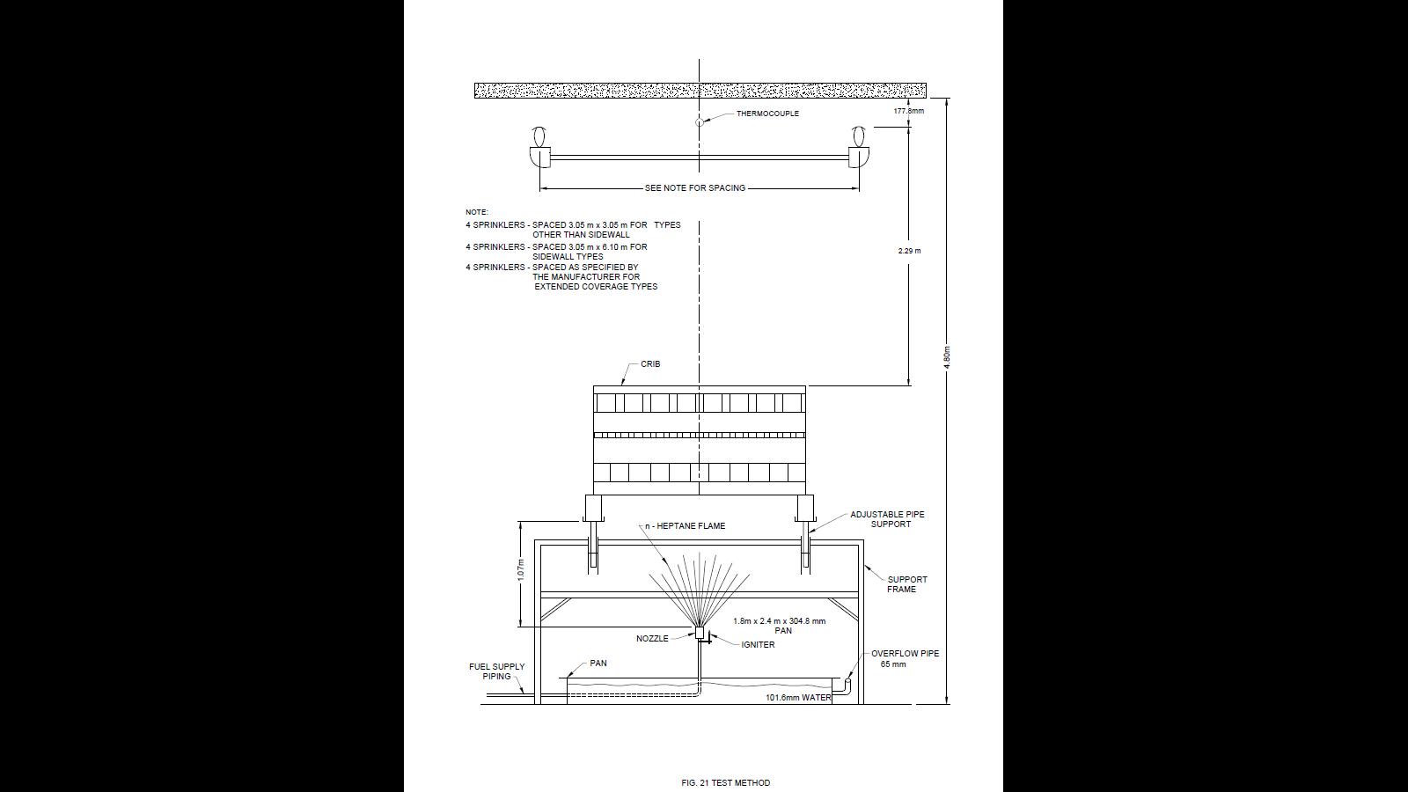

FIG. 21 TEST METHOD

**12.3 Test Method – Sidewall Types for Ordinary Hazard Use**

**12.3.1** Four open sidewall sprinklers are to be installed at the corners of a 3 m × 6 m piping grid with the deﬂectors located 180 mm for upright sprinklers, 240 mm for horizontal sprinklers, and 300 mm for pendent sprinklers from the ceiling. Sprinklers located at the extremities of each 6 m dimensional line are to face each other and are to be set to discharge in an opposing pattern with the line forming the axis of the spray.

**12.4 Test Method – All Types**

**12.4.1** The test is to be conducted in a vented test room having a 4.8 m high smooth, ﬂat, horizontal ceiling. The piping grid is to be connected to the water supply.

**12.4.2** The ﬁre employed for these tests is to combine the use of a combustible liquid Commercial grade heptane having the following characteristics:

a) Minimum initial boiling point of 190 °F (88 °C);

b) Maximum dry point of 212 °F (100 °C); and

c) Speciﬁc gravity (60 °F/60 °F) (15.6 °C/15.6 °C) of 0.68 to 0.73; and a torch and a crib of wood weighing approximately 160 kg.

**12.4.3** The wood crib is to consist of layers of trade size 50 mm × 100 mm [nominal (38 mm X 90 mm)], trade size 100 mm X 100 mm [nominal (90 mm X 90 mm)] and trade size 100 mm × 150 mm [nominal (90 mm X 140 mm)] kiln-dried spruce or ﬁr lumber (moisture content 6 to 12 percent) having the conﬁguration and support illustrated by Fig. 22.

**12.4.4** The alternate layers of lumber are to consist of the sizes speciﬁed in **12.4.3** of the lengths speciﬁed in Fig. 22, and placed at right angles to the adjacent layers as illustrated in Fig. 22. The individual wood members in each layer are to be evenly spaced from each other, and form a square crib 1.22 m X 1.22 m in area and 550 mm high, supported, in turn, by the two 2.5 m long, 100 mm X 150 mm) stringers. The total crib weight is to be determined and recorded.

**12.4.5** The crib is to be supported by a steel framework as illustrated in Fig. 21 and 22, or the equivalent. The crib supports are to be located beyond the edges of a 1.8 m× 2.5 m steel pan.

**12.4.6** The top of the wood crib is to be 2.3 m below the deﬂectors of the test sprinklers.

**12.4.7** The steel pan is to be 1.8 m X 2.5 m, 300 mm deep, constructed of steel not less than 6 mm thick. The top edges are to be reinforced by a continuous steel angle section. The pan is to be liquid-tight and is to be ﬁlled prior to test with water to a depth of approximately 100 mm. The pan is to be provided with a means for draining to maintain the 100 mm water level.

**12.4.8** At a location in the pan and directly under the vertical axis of the wood crib, an atomizing nozzle is to be placed and arranged to spray heptane vertically upward. The nozzle and its supply piping are to be arranged as shown by Fig. 22. To prevent ﬂameout, an igniter is to be located near the nozzle. The igniter shall be any convenient device that prevents ﬂameout, such as a container partially ﬁlled with heptane.

**12.4.9** The atomizing nozzle is to form a hollow-spray pattern having an included angle of 75 degrees when atomizing heptane at the rate of 3.4 lpm.

**12.4.10** A means for supplying and metering the fuel is to be furnished.

**12.4.11** The temperatures at the ceiling level are to be continuously recorded during the test, utilizing an unprotected 0.52 mm2 chromel-alumel thermocouple centrally located above the test crib 50 mm from the ceiling. The relation of the thermocouple to the ceiling and the crib is to be as illustrated in Fig. 21.

**12.4.12** The fuel ﬂow is to be started and the torch ignited immediately. The 30 min test period is to begin when the torch is ignited. Water application is to be started after a minimum free-burning time of 1 min or after a ceiling temperature of 760 °C is attained, whichever occurs last. Thirty minutes after ignition, the fuel ﬂow to the torch is to be stopped, and after any residual ﬁre in the crib is extinguished, the water is to be turned off.

**12.4.13** The crib is then to be dried and weighed. The drying is to be accomplished either by using an oven or by storing the crib for 7 days after the test in a sheltered area. The values of the crib weight measured before the test (6 to 12 percent moisture content) and after drying are to be corrected to the value at 0 percent moisture before calculations are performed to determine compliance with the 20 percent weight loss requirement speciﬁed in **12.1.1.**

**12.4.14** The average temperature for the time interval between the time at which the ceiling temperature ﬁrst falls below a temperature of 295 °C above initial ambient and the time at the end of the test is to be computed by comparing the area under the curve determined by the recorded ceiling temperatures with the area beneath a straight line drawn at the temperature point 295 °C above initial ambient. The area beneath the curve of the recorded ceiling temperatures shall be the lesser of the two areas.

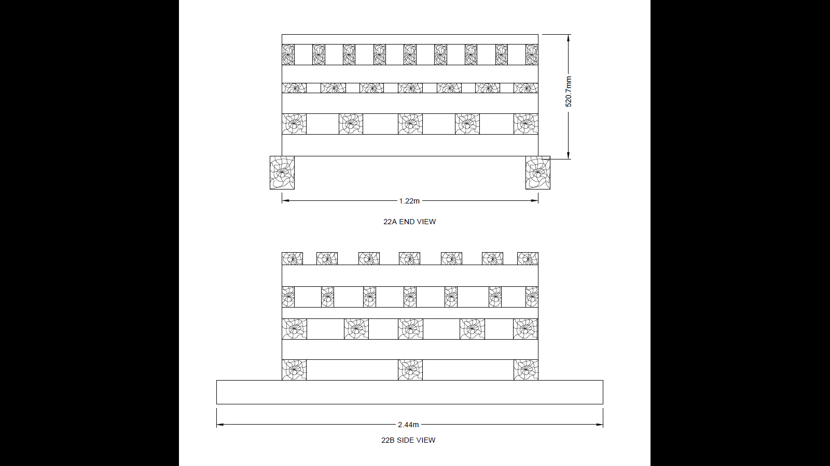

FIG. 22 TEST METHOD

**13 MARKING**

**13.1** Each sprinkler shall be legibly and indelibly marked with the following:

1. Manufacturer’s name or trade-mark;
2. Model identification to be used in conjunction with the manufacturer's catalogue (*see* **5.2.1**);
3. Month and year of manufacture with batch number;
4. Nominal release temperature;
5. Cover plates of the concealed sprinklers shall be marked ‘DO NOT PAINT';
6. Sprinklers shall be marked with the nominal release temperature rating in ˚C or colour code on a part of the sprinkler remaining after operation and on the yoke arm of the sprinkler with fusible assembly element;
7. In case of sidewall sprinklers, the deflectors shall show the intended direction of discharge with respect to the rear wall; and
8. The word ‘TOP’ on the deflector to indicate orientation in the case of horizontal sidewall sprinklers.

**13.2 BIS Certification Marking**

The sprinklers conforming to the requirements of this standard may be certified as per the conformity assessment schemes under the provisions of the *Bureau of Indian Standards Act*, 2016 and the Rules and Regulations framed thereunder, and the sprinklers may be marked with the ‘Standard  Mark’.

**ANNEX A**

(*Clauses* 6.1 and 8.1)

**QUANTITY OF SAMPLES OF SPRINKLERS FOR TESTING**

| **SI No.** | **Test** | **Number of Sprinklers Required** | **Ref. Clause** |
| --- | --- | --- | --- |
| 1. | Leakage test | 20, min | 6.1.1 |
| 2. | 30-day leakage test | 5, min | 6.1.2 |
| 3. | Hydrostatic strength | As per (1) | 6.2 |
| 4. | Water hammer test | 5, min | 6.3 |
| 5. | Lodgment test | 10 or 15 applicable as per Table 4 | 6.4 |
| 6. | Liquid bath test | 10 | 6.5 |
| 7. | Air bath test | 10 | 6.6 |
| 8. | Heat exposure test (glass bulb) |  | 6.7 |
| 9. | High temperature exposure test | 5 | 6.8 |
| 10. | Freezing test | 5 | 6.9 |
| 11. | Ageing test  (high ambient temperature) | 50 | 6.10 |
| 12. | Thermal shock test  (for glass bulb sprinklers) | 10 | 6.11.1 |
| 13. | Minimum quality pressure test | 10 | 6.12 |
| 14. | Moist air test | 5 | 6.13 |
| 15. | Vacuum test | 5 | 6.14 |
| 16. | Assembly load/frame strength | 15 | 6.15 |
| 17. | Strength of heat responsive element | 15 | 6.16 |
| 18. | Deflector strength test |  | 6.17 |
| 19. | Vibration test | 5 | 6.18 |
| 20. | Drop test | 5 | 6.19.1 |
| 21. | Tumble test | 5 | 6.19.2 |
| 22. | Impact test | 5 | 6.19.3 |
| 23. | K-factor (discharge Coefficient) | 4 | 6.20 |
| 24. | Endurance test | 1 | 6.21 |
| 25. | Corrosion test  \*Salt spray  \*Stress cracking test  \*Boiling magnesium chloride test  \*Cabo dioxide & Sulphur dioxide test  \*Hydrogen sulphide test | 8  4  4  4  4 | 6.22.1  6.22.2.1  6.22.2.2  6.22.3  6.22.4 |
| 26. | Water distribution test  \* Conventional/spray dry sprinkler  \* Side wall sprinklers | 4  1 | 6.2.3.1  6.23.2 |
| 27. | Response test  (ceiling/flush/recessed/concealed |  | 6.25 |
| 28. | Conductivity  (C - Factor)   * Prolonged plunge test method | 20 | 6.26.2 |
| 29. | Heat Sensitivity   * Plunge test * Rate of rise test | 20 for fusible element sprinkler)  3 (for glass bulb sprinkler)  -do- | 7.2.1  7.2.2 |
| 30. | Fire test  (3 no. of fire test 15 kg wood crib) | 1 | 11 |
| 31. | 160 kg wood crib fire test | 4 | 12.1 |

**ANNEX B**

( *Foreword* )

**COMMITTEE COMPOSITION**

| *ORGANIZATION(S)* | *REPRESENTATIVE(S)* |
| --- | --- |
|
| Ministry of Home Affairs, New Delhi | Fire Advisor (Shri D. K. Shami)  **(*Chairman*)** |
| Agni Controls, Chennai | Shri D. Balachandran  Shri Arun Kumar Balachandran (*Alternate*) |
| Airports Authority of India, New Delhi | Shri Subhash Kumar  Shri P. K. Deshmukh  (*Alternate*) |
| Bhabha Atomic Research Centre, Mumbai | Chief Fire Officer |
| CSIR-Central Building Research Institute, Roorkee | Dr R. S. Chimote  Shri Suvir Singh (*Alternate*) |
| Central Industrial Security Force, New Delhi | Shri Rajnath Singh  Shri A. K. Verma (*Alternate*) |
| Central Public Works Department, New Delhi | Shri Chaitanya Kumar Verma  Shri D. K. Tulani (*Alternate*) |
| Centre for Fire Explosive and Environment Safety (DRDO), Delhi | Shri M. K. Jain  Shri Amit Saini (*Alternate*) |
| Chennai Petroleum Corp. Ltd., Chennai | Shri J. P. K. Hepat |
| Chhatariya Rubber and Chemicals Industries, Mumbai | Shri S. A. Haveliwala  Shri H. S. Haveliwala (*Alternate*) |
| City and Industrial Development Corporation, Navi Mumbai | Shri Arvind P. Mandke |
| Directorate General of Quality Assurance, Ministry of Defence, New Delhi | Controller of QA (FE), Pune  Jt Controller of QA (FA), Pune (*Alternate*) |
| Delhi Fire Services Headquarters, New Delhi | Director  Chief Fire Officer (*Alternate*) |
| Directorate of Fire and Emergency Services, Goa | Shri Ashok Menon  Shri Nitin V. Raiker (*Alternate*) |
| Engineers India Ltd,  New Delhi | Shri Amitabh Kishore  Shri Gyasuddin (*Alternate*)  Shri Akash Deep Patel (YP) |
| F. M. Engineering International India Branch, Bengaluru | Shri Srikanth Yajjala  Shri Mani Kandan Krishna Moorthy (Alternate) |
| Fire and Emergency Services J&K, Srinagar | Shri V. K. Singh  Shri Bashir Ahemed Shah (*Alternate*) |
| Fire and Security Association Of India, Chennai | Shri Anas Rizvi |
| Fire Protection Association of India, Mumbai | President |
| GAIL (India) Limited, Noida | Shri S. P. Garg  Shri Sanjeev Kumar Kalkal (*Alternate*) |
| Gunnebo India Pvt Limited, Maharashtra | Shri Ashutosh Satpute  Shri Gajanan Medewar (*Alternate*) |
| H. D. Fire Protect Co., Thane | Shri Harish N. Dharamshi  Shri K. T. Chaudhari (*Alternate*) |
| Indian Oil Corporation Limited, Pipelines Division, --------- | Shri Aashish R. Gokhale |
| Institution of Fire Engineers (India), New Delhi | President  General Secretary (*Alternate*) |
| Johnson Controls (India) Private Limited, Gurugram | Shri Santhosh Muzumdar  Shri Nitin Rastogi (*Alternate*) |
| K. V. Fire Chemicals (India) Pvt. Ltd., Navi Mumbai | Shri Rajesh H. Sabadra  Shri Uday K. Shroff (*Alternate*) |
| Karnataka State Fire and Emergency Services, Bengaluru | Shri K. U. Ramesh  Shri K Srinivasa (*Alternate*) |
| Maharashtra Fire Services, Mumbai | Shri S. S. Warick |
| Military Engineer Services, Engineer-in-Chief's Branch, Integrated HQ of MoD (Army), New Delhi | Shri Rajiv Khare  Col Sumeet Singh Makkar (*Alternate*) |
| Mumbai Fire Brigade, Mumbai | Shri P. S. Rahangdale  Shri H. D. Parab (*Alternate*) |
| National Association of Fire Officers, Mumbai | President |
| NBCC (India) Limited, New Delhi | Smt Sunita Puruswani  Shri R. K. Aggarwal (*Alternate*) |
| Nohmi Bosai (India) Pvt. Ltd., Gurugram | Shri Iswar Iyer  Shri Neeraj Sehgal (*Alternate*) |
| Oil Industry Safety Directorate, New Delhi | Shri S. K. Nandy |
| Proion Consultants, New Delhi | Shri Sandeep Goel |
| Reliance Industries Limited, Mumbai | Shri Varadendra Koti  Shri Umesh Khandalkar |
| RESQ Technologies, Ahmedabad | Shri Rohit V. Shah |
| Safex Fire Services Limited, Mumbai | Shri Jitendra Shah  Shri Sandip Shah (*Alternate*) |
| Shah Bhogilal Jethalal and Bros, Ahmedabad | Shri Mukesh M. Shah  Shri Abhay D. Purandare (*Alternate*) |
| State Bank of India, Mumbai | Shri Vinayak Gokhale  Fire Officer (*Alternate*) |
| Surex Production and Sales Private Limited, Kolkata | Shri Debashis Neogi |
| Swastik Synergy Engineering Pvt Ltd, Mumbai | Shri Mukesh D. Shah  Shri Kunal Zatakia (*Alternate*) |
| The Supreme Industries Limited, | Shri Kisan Kundalkar  Shri G. K. Saxena (*Alternate*) |
| T. T. S. Consutants, Kolkata | Shri Tarak Chakraborty |
| Tamil Nadu Fire and Rescue Services Department, Chennai | Shri S. Vijayasekar  Smt. N. Priya (*Alternate*) |
| U L India Pvt Ltd, Bengaluru | Shri Jagdish V.  Shri S. P. Tej Kumar Behara (*Alternate*) |
| Uttar Pradesh Fire Services, Lucknow | Shri P. K. Rao  Shri Aman Sharma (Alternate) |
| West Bengal Fire and Emergency Service, Kolkata | Shri Abhijit Pandey  Shri Kamal Nandy (*Alternate*) |
| In Personal Capacity, *(D-317, 2nd Floor, Nirman Vihar, New Delhi)* | Shri R. C. Sharma |
| In Personal Capacity, *(27A, Tapovan Senior Citizens Foundation, Coimbatore 641010)* | Shri T. R. A. Krishnan |
| In personal capacity, New Delhi | Shri Hemant Kumar |
| In Personal Capacity, *(K-33A, Green Park, New Delhi)* | Shri S. K. Dheri |
| In Personal Capacity, *A-45, Sector - 70, Noida* | Dr H. S. Kaparwan |
| BIS Directorate General | Sri Sanjay Pant, Scientist ‘F’ and Head (Civil Engg)  [Representing Director General (*Ex-officio*)] |

*Member Secretary*

Shri Arun Kumar S

Scientist ‘E’ (Civil Engineering), BIS

COMPOSITION OF FIRE DETECTION ALARMS AND SUPRESSION SYSTEM

SUBCOMMITTEE, CED 22:4

|  |  |
| --- | --- |
| *Organization(s)* | *Representative(s)* |
| Ministry of Home Affairs, New Delhi | Shri D.K. Shami (*Convener*) |
| Agni Controls, Chennai | Shri D. Balac handran  Shri Selvakumar Balachandran  (*Alternate*) |
| ASTRAL Polytechnik Ltd, Ahmedabad | Shri Ritesh Patel  Shri Manoj Dhar (*Alternate*) |
| Bhabha Atomic Research Centre, Mumbai | Chief Fire Officer |
| CSIR-Central Building Research  Institute, Roorkee | Shri Rajiv Goel  Shri R. S. Chimote (*Alternate*) |
| Central Public Works Department,  New Delhi | Shri Chaitanya Kumar Verma  Shri D K Tulani (*Alternate*) |
| Centre for Fire and Explosive Environment  Safety (DRDO), Delhi | Shri M. K. Jain  Shri Amit Saini (*Alternate*) |
| Chennai Petroleum Corporation Limited,  Chennai | Shri J.P.K. Hepat |
| Controllerate of Quality Assurance | Col V. V. Kadam  Col N. K. N. Rao (*Alternate*) |
| Delhi Fire Service, New Delhi | Director  Chief Fire Officer (*Alternate*) |
| DSPA Fire Suppressions India  Pvt. Ltd., Pune | Shri Chetan Udgir |
| EAST Corp, Thane | Shri Hemant Khadse |
| Engineers India Ltd, New Delhi | Shri Vipan Goel  Shri R. B. Bhutda (*Alternate*) |
| FOGTEC Brandschutz GmbH and Co. KG, Mumbai | Shri Jackson Jose |
| FM Global India, Bengaluru | Shri Srikanth Yajjala  Shri Manikandan Krishnamoorthy  (*Alternate*) |
| FYRPROTEK (Fire Engineers and  Consultants), New Delhi | Shri Gulshan Khurana |
| Gunnebo India Pvt Limited, Mumbai | Shri Ashutosh Satpute  Shri Gajanan Medewar (*Alternate*) |
| Honeywell International (I) Pvt. Ltd,  Bengaluru | Shri Mandar Sawant  Shri Akhand Kumar (*Alternate*) |
| Johnson Controls (India) Private Limited, Gurugram | Shri Santosh Majumdar  Shri Ashish Dileep Sawant (*Alternate*) |
| Maple Engineering Design Services  (India), Pvt.Ltd, Bengaluru | Shri B. S. A. Narayan  Shri H. R. Rangannath (*Alternate*) |
| Municipal Corporation of Greater Bombay,  Mumbai | Chief Fire Officer  Deputy Chief Fire Officer (*Alternate*) |
| Newage Industries, Mumbai | Shri Ashok M. Shah  Shri Shetul A Shah (*Alternate*) |
| Nitin Fire Protection Industries Ltd.,  Mumbai | Shri Nitin M. Shah  Shri Pravin Shah (Alternate) |
| Nohmi Bosai (India) Pvt. Ltd., Gurugram | Shri Ajit Raghavan |
| Proion Consultants, New Delhi | Shri Sandeep Goel |
| Realty Automation and Security Systems  Pvt. Ltd., Pune | Shri Anant Gokhale |
| Reliance Industries Limited, Mumbai | Shri Varadendra Koti  Shri Umesh Khandalkar (*Alternate*) |
| Saviram Engineering Consultants Pvt.  Ltd., Noida | Shri Girish Mishra |
| SCHRACK SECONET AG, Gurgram | Shri Ajit Saini |
| Steel Authority of India, Salem | Shri D. Kumaresan |
| The Supreme Industries Ltd, Mumbai | Shri Kisan Kundalkar  Shri G.K. Saxena (*Alternate*) |
| T. T. S. Consultants, Kolkata | Shri Tarak Chakraborty |
| West Bengal Fire and Emergency Service,  Kolkata | Representative |
| In Personal Capacity, *(D-317, 2nd Floor, Nirman Vihar, New Delhi)* | Shri R. C. Sharma |
| In Personal Capacity, *(27A, Tapovan Senior Citizens Foundation, Coimbatore 641010)* | Shri T. R. A. Krishnan |
| In personal capacity, New Delhi | Shri Hemant Kumar |
| In Personal Capacity, *(K-33A, Green Park, New Delhi)* | Shri S. K. Dheri |
| In Personal Capacity, *A-45, Sector - 70, Noida* | Dr H. S. Kaparwan |
| In Personal Capacity, Noida | Shri Kanwar A Singh |