IS XXXXX : 2024
भारतीयमानक
Indian Standard

सामान्य योग प्रोटोकॉल - योग अभ्यास

Common Yoga Protocol – Yoga Practices

ICS 11.020.10

© BIS 2024

भारतीय मानक ब्यूरो
BUREAU OF INDIAN STANDARDS
मानक भवन, 9 बहादुर शाह ज़फर मार्ग, नई दिल्ली - 110002
MANAK BHAVAN, 9 BAHADUR SHAH ZAFAR MARG
NEW DELHI - 110002
www.bis.gov.in www.standardsbis.in

December 2024 Price Group 9

Yoga Sectional Committee, AYD 02

FOREWARD

This Indian Standard was adopted by Bureau of Indian Standards, after the draft finalized by the Yoga Sectional Committee had been approved by the Ayush Division Council.
Yoga, a philosophy rooted in ancient Indian wisdom, offers a path to self-awareness and holistic well-being. It combines physical postures, breath control, and meditation to harmonize the body, mind, and spirit, fostering health and resilience. Globally, millions of people use yoga in various forms for its preventive and therapeutic potential.
Recognized by UNESCO in 2016 as an intangible cultural heritage, yoga has achieved global acclaim. The International day of yoga, celebrated annually on June 21, highlights its universal appeal and transformative power. Initiatives like the common yoga protocol provide a structured approach to promote health and wellness through standardized practices accessible to all.
Standardization ensures the safe, effective, and consistent practice of yoga, benefiting practitioners, researchers, and the global community. The development of Indian Standards for yoga, including loosening exercises, Asanas, Prāņāyāma, and Dhyāna, promotes accessibility and trust. Such measures help preserve yoga's authenticity while adapting it to contemporary needs, ensuring its enduring impact on health and well-being.

The composition of the Committee responsible for the formulation of this standard is given in Annex A.

Significant inputs for the formulation of this standard have been drawn from the booklet common yoga protocol published by the Morarji Desai National Institute of Yoga (MDNIY), Ministry of AYUSH. Additional references include information from authoritative yoga texts and publicly available resources in both print and electronic media. It is recommended that the yoga practices outlined in the standard be performed under the guidance or supervision of a qualified yoga expert.

Indian Standard
COMMON YOGA PROTOCOL — YOGA PRACTICES

1 SCOPE

This standard covers the description of common yoga protocol and the techniques of performing yoga practices.

2 REFERENCES

The standards given below contain provisions which, through reference in this text, constitute provision of this standard. At the time of publication, the editions indicated were valid. All standards are subject to revision, and parties to agreements based on this standard are encouraged to investigate the possibility of applying the most recent edition of these standards:

IS No. Title
IS 17873 : 2022 Cotton yoga mat — Specification
IS 17874 (Part 1) : 2022 Glossary of yoga terminology: Part 1 Standardized terminology for commonly used terms related to yoga

3 TERMINOLOGY

For the purpose of this standard, terminologies given in 3 of IS 17874 (Part 1):2022 shall apply.

4 GENERAL GUIDELINES FOR YOGA PRACTICE

The following guidelines shall be followed by the practitioner while performing the yoga practices.

4.1 Before the Practice (Pre-Requisite)

4.1.1 Cleanliness (Śauca) is an important prerequisite for yogic practice. The yoga practitioner shall maintain the cleanliness of surroundings, body and mind.

4.1.2 Yogic practice should be performed in a calm and quiet atmosphere with a relaxed body and mind.

4.1.3 Yoga practitioner should be empty stomach or light stomach while performing the yoga practices. One may consume small amount of honey in lukewarm water if one feels weakness before doing yoga practices. Bladder and bowel should be empty before starting yogic practices.

4.1.4 A Yoga mat or folded blanket shall be used for the yoga practice.

4.1.5 Yoga practice should be performed in light and comfortable cotton clothes as preferred to facilitate easy movement of the body.

4.1.6 A prior consultation from yoga therapist shall be required for performing yoga practices in case of pregnancy, menstruation or any discomfort or illness.

4.2 During the Practice

4.2.1 Yoga practice session may start with a prayer or invocation as it creates a conducive environment to relax the mind.

4.2.2 Yogic practices shall be performed in a relaxed manner, with awareness of the body and breath.

4.2.3 Yoga practitioner should not hold the breath unless it is specially mentioned to do so during the yoga practice.

4.2.4 Yoga practitioner should not hold his/her body tightly or jerk the body during the yoga practices. One should perform the practices according to his own capacity.

4.2.5 Yoga practitioner shall do persistent and regular yoga practices for better results.

4.2.6 There are contra-indications/limitations for each yoga practice and such contra-indications should always be kept in mind while practicing.

4.2.7 Yoga session should be ended with meditation/deep silence/Śhāntipaṭha (Alert posture).

4.3 After the Practice

4.3.1 Yoga practitioner should take bath only after 20 min to 30 min of practices. Food may be consumed only after 20 min to 30 min of yoga practices.

5 SADILAJA/CĀLANA KRIYĀS/LOOSENING PRACTICES

The Cālana Kriyās/loosening practices/Yogic Sūkṣma Vyāyāmas help to increase microcirculation. These practices can be done while standing and sitting.

  - Neck Bending (Grivā Śakti Vikāsaka)

5.1.1 Stage 1: Forward Backward Bending

Stand with the feet 2.0 inches to 3.0 inches apart. Keep the hands straight beside the body. This is called Samasthiti. Now place the palms on the waist. While exhaling, move the head forward slowly and try to touch the chin to the chest (Fig 1A). While inhaling, move the head up and bend back comfortably. (Fig 1B).

NOTE — This is one round and yoga practitioner may repeat 2 more rounds.

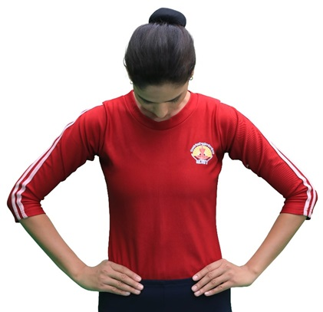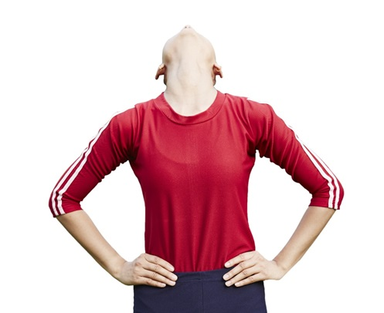

Fig. 1A Forward Bending Fig. 1B Backward Bending

Fig. 1 Forward and Backward Bending/Stretching

5.1.2 Stage 2: Right and Left Bending

Maintain the same position as mentioned above in 5.1.1.1, while exhaling, bend the head slowly to the right. Bring the ear as close as possible to the shoulder without raising the shoulder (Fig 2A). While inhaling, bring the head to the normal position. Similarly, while exhaling bend the head to the left side (Fig 2B). Inhale and bring the head up to the normal position.

NOTE — This is one round and repeat two more rounds.
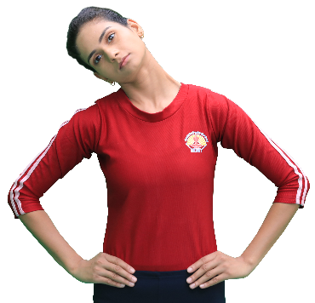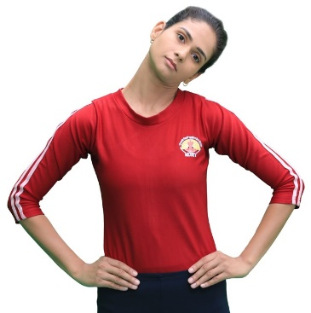

Fig. 2A Right Bending Fig. 2B Left Bending
Fig. 2 Right and Left Bending

5.1.3 Stage 3: Right and Left Twisting

Keep the head upright, while exhaling, gently turn the head to the right so that the chin is in line with the shoulder (Fig 3A). While inhaling, bring the head to the normal position. Similarly, while exhaling, turn the head to the left (Fig 3B). Inhale and bring the head to the normal position.
NOTE — This is one round and repeat two more rounds.

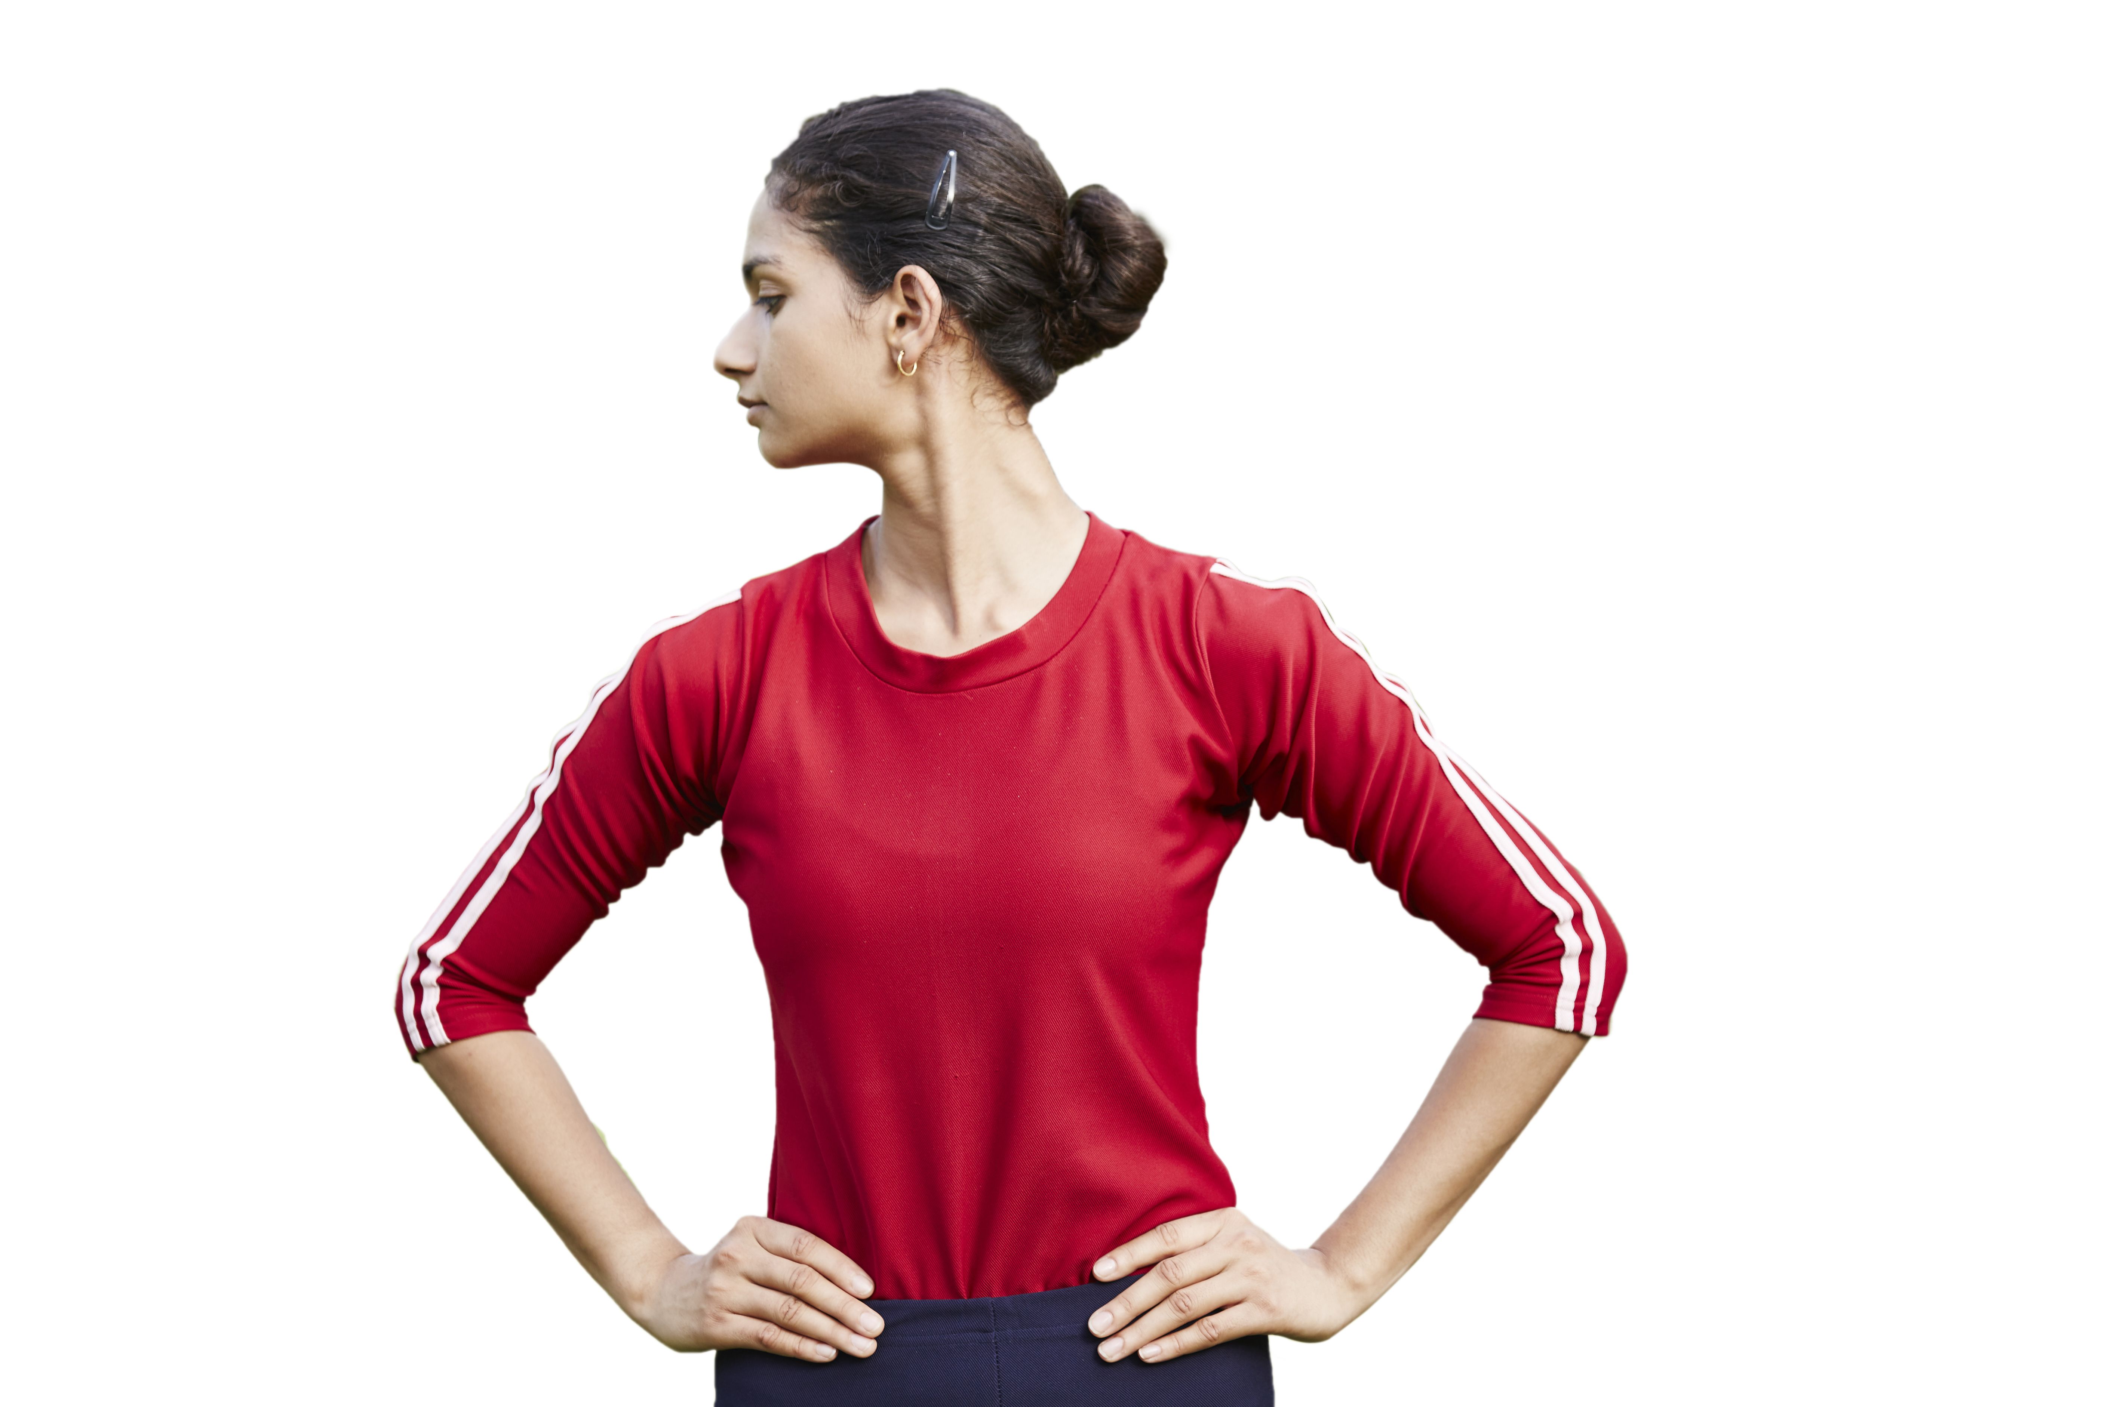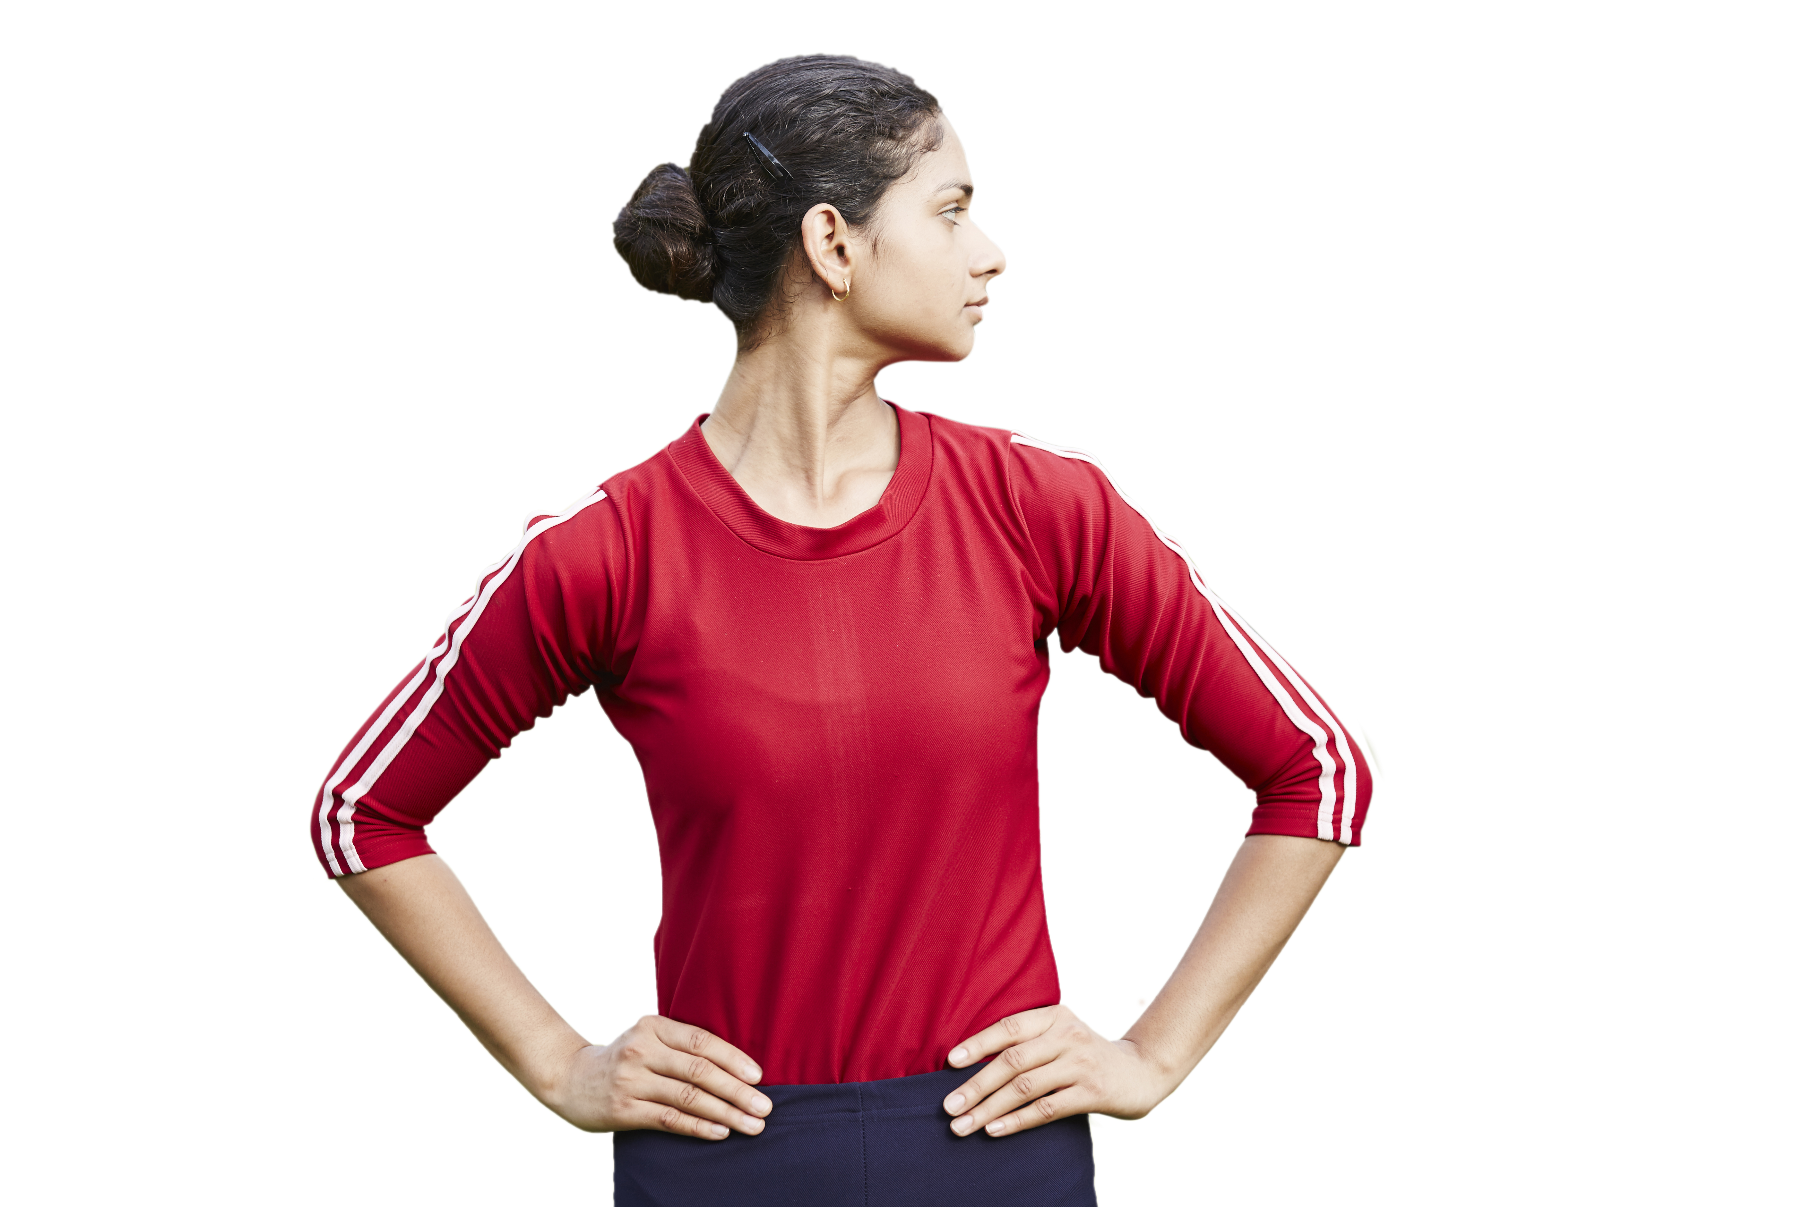

Fig. 3A Right Twisting Fig. 3B Left Twisting

Fig. 3 Right and Left Twisting

5.1.4 Stage 4: Neck Rotation

Exhale and bend the head forward to touch the chin to the chest. Inhale and slowly rotate the head clockwise in a circular motion, exhale while coming down. Do a full rotation and then rotate the head in an anti-clockwise direction. Inhale; go back and exhale, come down. (Fig 4A and 4B).

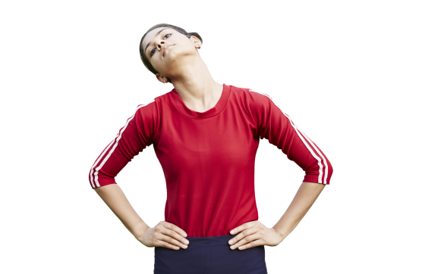
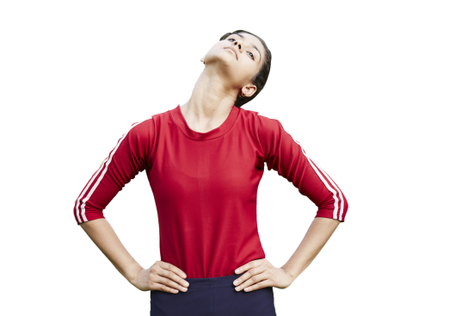

Fig. 4a Fig. 4b
Fig. 4 Neck Rotation

NOTES

1 This is one round and repeat two more rounds.
2 Move the head as far as possible. Do not overstrain.
3 Keep the shoulders relaxed and steady.
4 Feel the stretch around the neck and loosening up of the joints and muscles of the neck.
5 Can also be practised sitting on a chair.
6 People with neck pain can do the practice gently; especially when taking the head back to the extent, it is comfortable.
7 Elderly people and persons with chronic cervical spondylitis may avoid these practices.

  - Shoulder Movement

    - Stage 1: Shoulder Stretch

Keep the feet together, the body straight, and the arms by the sides (Fig 5A). While inhaling, raise both arms sideways above the head with the palm outward. Exhale and bring it down in the same manner. Palms must be opened, with fingers together (Fig 5B and 5C).

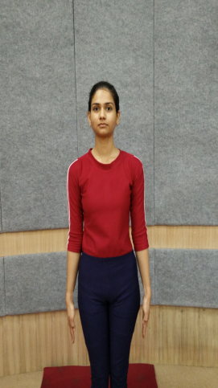 | 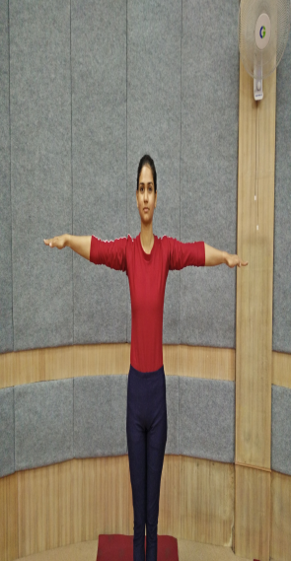 | 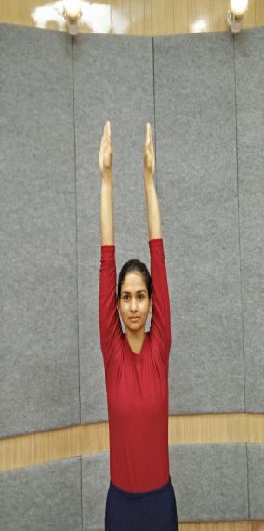
Fig. 5A Shoulder Down | Fig. 5B Shoulder Sideways | Fig. 5C Shoulder Up

Fig. 5 Shoulder Stretch
5.2.2 Stage 2: Shoulder Rotation (Skandha Cakra)
Stand erect and place the fingers of left hand on the left shoulder and the fingers of right hand on the right shoulder (Fig 6A). Rotate both the elbows in a circular manner. Inhale and raise the elbows and bring them back while exhaling. Try to touch the elbows in front of the chest on the forward movement (Fig 6B), stretch the elbows back in the backward movement (Fig 6C) and touch the side of the trunk while coming down. Repeat this two times rotating from front to back. Do the same in reverse manner (Fig 6D). Inhale while raising the elbows and exhale while bringing them down.
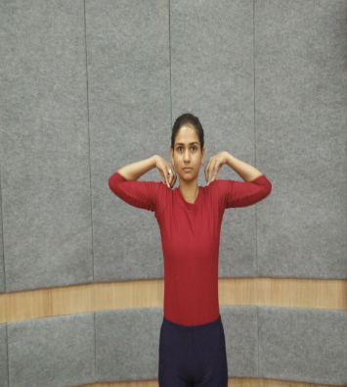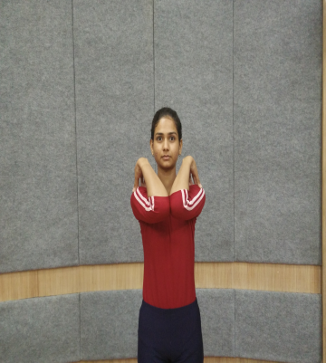
FIG. 6A FIG. 6B
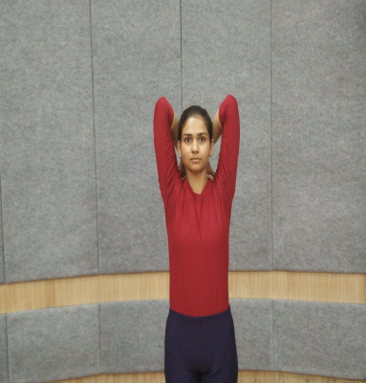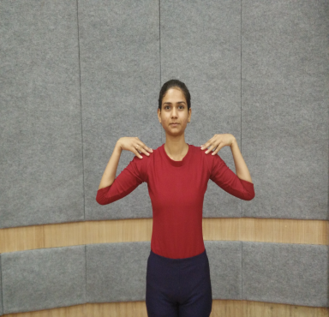
Fig. 6C Fig. 6D
Fig. 6 Shoulder Rotation (Skandha Cakra)
5.3 Trunk Movement (Kaṭiśakti Vikāsaka)
Keep the legs about 2 feet to 3 feet apart. Raise both the arms up to shoulder level with palms facing each other and keep them parallel. While exhaling, twist the body towards the left side so that the right palm touches the left shoulder (Fig 7A), come back with inhalation. While exhaling, twist the body towards the right side so that the left palm touches the right shoulder (Fig 7B), come back with inhalation. This is one round; repeat it two more times. Relax in Samasthiti.

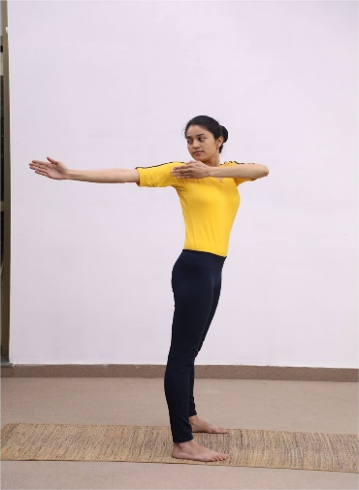 | 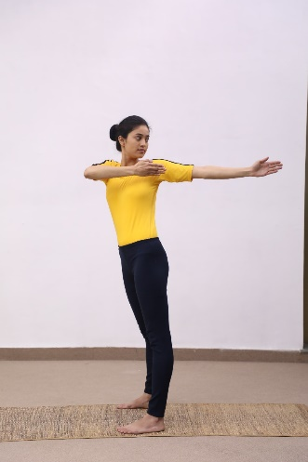
Fig. 7A Fig. 7B
Fig.7 Trunk Movement

NOTES
1 Perform it slowly with coordination of breathing.
2 Cardiac patients shall do with care.
3 Avoid this practice in case of severe back pain, vertebral and intervertebral disc disorders, and during menstruation.

5.4 Knee Movement

Inhale and lift the arms up to the shoulder level, palms facing downwards. Exhale and bend the knees and bring down the body to the semi-squatting position. In the final position, both the arms and thighs should be parallel to the ground (Fig 8). Inhale and straighten the body. Exhale while bringing down the hands. Repeat it two more times.

NOTE — Avoid this asana in case of acute conditions of arthritis.
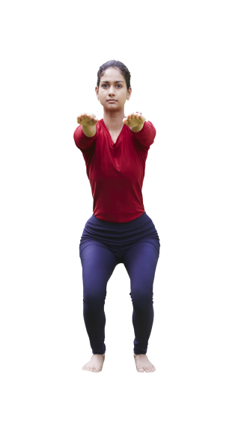
Fig. 8 Knee Movement
6 STANDING ASANA

6.1 Tādāsana

In Sanskrit Tāḍāsana is derived from two words tāḍa means mountain and āsana means posture. It is also mentioned with the name of palm tree or mountain pose. The final position of this āsana resembles the shape of a palm tree/mountain.

6.1.1 Technique

Stand on yoga mat with 2 inches (approx.) apart. Take the arms up in front of the chest and interlock the fingers and turn the wrist outwards. Raise the arms upwards over the head and bring them in line with the shoulders. Raise the heels off the floor and balance on the toes while performing Tādāsana (Fig 9). Stay in Tādāsana position for a minimum three breaths and then exhale and bring the heels down. Release the interlock of the fingers and bring the arms down parallel to the trunk and come back to original position.

NOTE — Avoid lifting the heels in case of arthritis, varicose veins and vertigo.

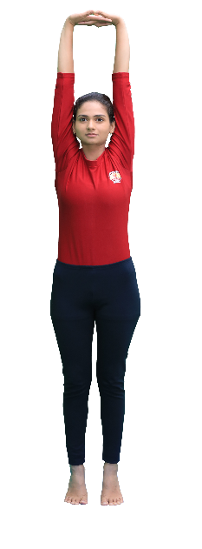
Fig. 9 Tādāsana
6.2 Vrksāsana

Vṛkṣāsana is derived from two words vṛkṣa and āsana. The meaning of vṛkṣa is tree. In the final Stage of this āsana, the body resembles a tree.

6.2.1 Technique

Stand straight and erect with a gap of 2 inches (approx) between the feet and look straight. Exhale, hold and bend the right leg then place the foot on the inner side of the left thigh. The heel of the right foot should be touching the perineum region. Inhale and extend the arms up and join the palms together for Namaskar Mudra (Fig 10). Stay in the position for 10 seconds to 30 seconds and breathe normally. Exhale and bring the arms down. Release the right leg and bring it to down to the initial position. Repeat the same step from the left leg.

NOTE — Avoid vṛkṣāsana in case of knee arthritis and vertigo.

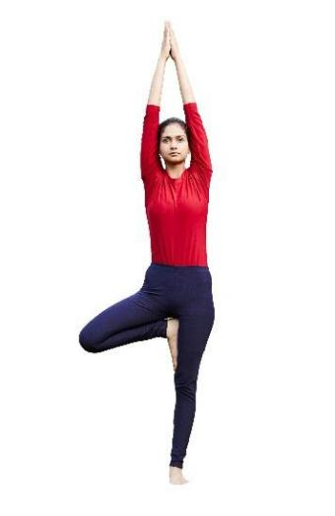
Fig. 10 VrksĀsana

6.3 Pāda-Hastāsana (The Hands to Feet Posture)

Pāda means feet, hasta means hands. Pādhastāsana means keeping the palms down towards the feet. This is also referred to as Uttānāsana.

6.3.1 Technique

Stand straight with a gap of 2 inches (approx.) and raise the arms up and stretch up the body from the waist. Exhale and bend forward until both palms rest on the ground. Stretch the back to make it straight as much as possible maintain this final posture for 10 seconds to 30 seconds with normal breathing (Fig. 11). Now inhale, come up slowly to the upright position and stretch the arms straight above the head. Exhale, slowly return to the starting position in the reverse order and relax in Samasthiti (Alert posture).

NOTES

1 Those who are suffering with stiff back should bend according to their capacity.
2 Avoid in case of cardiac disorder, spinal disorder, abdominal inflammation, ulcers, myopia, glaucoma and vertigo.

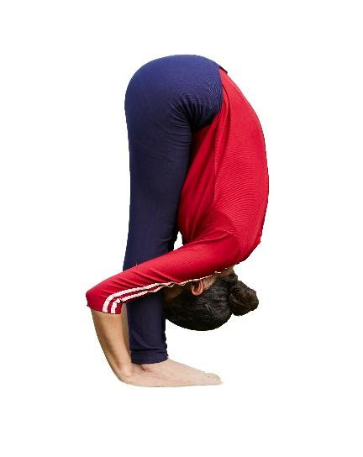
Fig. 11 PĀda HastĀsana

6.4 Ardhacakrāsana (The Half Wheel Posture)

Ardha means half, cakra means wheel. In this posture, as the body takes the shape of a half wheel, it is called Ardha Cakrāsasna.

6.4.1 Technique

Stand straight with feet 2 inches apart, support the back at the sides of the waist with the fingers. Inhale and bend backward from the lumbar region (Fig. 12). Try to hold the Ardha Cakrāsasna posture for minimum 10 seconds to 30 seconds with normal breathing. Come back to the original position while inhaling.

NOTES

1 Try to keep the elbows parallel to each other.
2 While practicing Ardha Cakrāsasna one should try to drop the head backward and stretch the neck muscles and exhale.

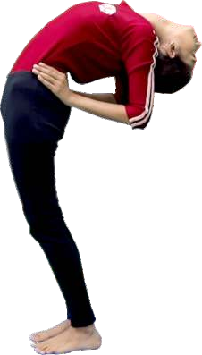

Fig. 12 Ardhacakrāsana

6.5 Trikonāsana (The Triangle Posture)

Trikoṇā means triangle. The āsana resembles the triangle made by the trunk, arms and legs, hence the name Trikoṇāsana. In some yoga text it is also called as Utthita Trikonasana in which Utthita means extended or stretched.

6.5.1 Technique

Stand straight with the distance of 3 feet (approx.) between the foot. Inhale and slowly raise both the arms sideways up to the shoulder level. After that, turn the right foot towards the right side. Exhale, slowly bend to the right side and place the right hand fingers just behind the right foot. Turn the left palm forward. Turn the head and gaze at the tip of the left middle finger (Fig. 13). One should maintain the posture for 10 seconds to 30 seconds with normal breathing. After that inhale, slowly come up and repeat the same procedure with the left side.

NOTE — During the practice of Trikoṇāsana, the left arm should be maintained straight in line with the right arm.

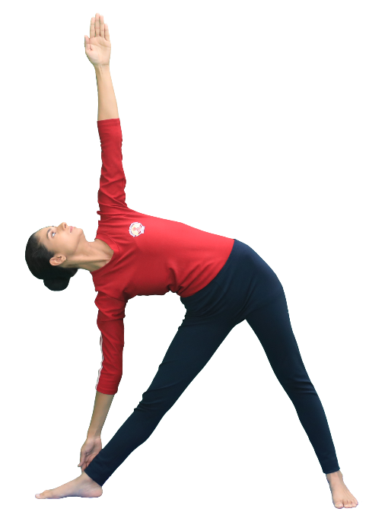

Fig. 13 Trikonāsana

7 SITTING ASANA

7.1 Bhadrāsana

Bhadrāsana means firm or auspicious.

7.1.1 Technique

Sit straight on yoga mat with legs stretched out in the front. Keep the hands beside the hips and palms resting on the floor. This āsana is called as Dandāsana. Put the soles of feet together. Exhale and clasp the hands together over the toes. Inhale and pull the heels as close as possible up to perineum region (Fig 14). Stay in this position for 10 seconds to 30 seconds with normal breathing.

NOTE — A person who is having severe arthritis and sciatica should avoid Bhadrāsana parctice.

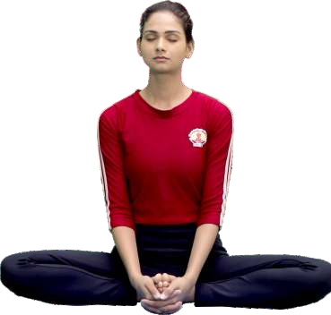

Fig. 14 Bhadrāsana
7.2 Vajrāsana

Vajrāsana is considered as one of the meditative postures. While practicing it for meditative purpose, one should close his/her eyes at the final stage.

7.2.1 Technique

Sit with extended legs together, hands by the side of the body, palm resting on the ground, fingers pointing forward. Fold the right leg at the knee and place the right foot under the right buttock. Similarly, fold the left leg and place the left foot under the left buttock. Place both the heels such that the big toes touch each other. Position of the buttocks is in the space between the heels. Keep both hands on knees respectively. Keep the spine erect, gaze in front or close the eyes (Fig. 15). Remain in the posture for 10 seconds to 30 seconds with normal breathing.

NOTE — Avoid Vajrāsana in case of piles, knee disorder and ankle injury.

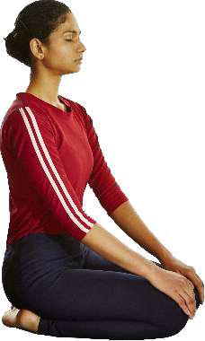

Fig. 15 Vajrāsana

7.3 Ardhustrāsana (The hands to feet posture)

Ustra means camel. The final Version of this āsana will resemble the hump of the camel. In this version, only the first stage that is, Ardhaustrāsana is being practiced.

7.3.1 Technique

Fold the leg and sit in Vajrāsana (7.2), stand on the knees. Place the hands on the hips with fingers pointing downwards. Keep the elbows and shoulder parallel. Inhale, and bend the head back and stretch the neck muscles; exhale and bend the trunk backwards as much as possible. Keep the thighs perpendicular to the ground (Fig. 16). Remain in the posture for 10 seconds to 30 seconds with normal breathing. Return with inhalation and sit in Vajrāsana (7.2).

NOTE — Avoid this āsana in case of abdominal hernia, abdominal injuries, vertigo and arthritis.

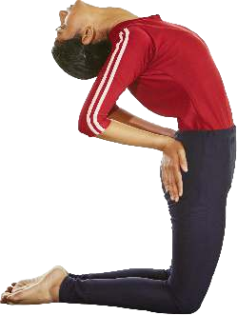
Fig. 16 Ardhaustrāsana

7.4 Ustrāsana (The Half Wheel Posture)

Ustra means camel. The body in this pose will resemble the hump of a camel, hence the name.

7.4.1 Technique

Sit in Vajrāsana (7.2), bring the knees and the feet a few inches apart and stand on knees. While inhaling, bend backwards with right palm on right heel and left palm on heel and exhale. Be careful not to jerk the neck while bending backward. In the final position, the thighs will be vertical to the floor and head tilted backwards. The weight of the body should be evenly distributed on the arms and legs (Fig. 17). Remain in the posture for 10 seconds to 30 seconds with normal breathing. Return with inhalation and sit in Vajrāsana (7.2).

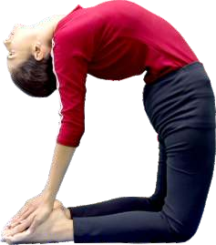

Fig. 17 Ustrāsana

7.5 Śasankāsana (The Hare Posture)

Śaśanka means hare. The body in this pose will resemble a hare, hence the name.

7.5.1 Technique

Sit in Vajrāsana (7.2), then spread both the knees wide apart, keep the big toes touching. Inhale, keep the palms between the knees. Exhale, bend forward with arms outstretched and place the chin on the ground (Fig. 18). Keep the arms parallel, maintain the posture for 10 seconds to 30 seconds with normal breathing. Come back to Vajrāsana (7.2).

NOTE — Patients with osteoarthritis of the knees and acute backache should avoid this āsana.

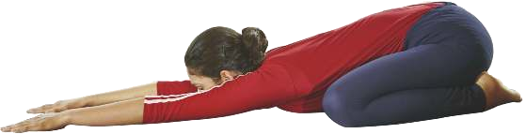

Fig. 18 Śasankāsana

7.6 Uttāna Mandūkāsana (Stretched-up Frog Posture)

Uttāna means upright and Maṇḍūka means frog. The final position of Uttāna Maṇḍūkasana would resemble an upright frog, hence the name.

7.6.1 Technique

Sit in Vajrāsana (7.2), spread both the knees wide apart while big toes touching each other. Raise the right arm, fold it from elbow, and take it backwards above the left shoulder and place the palm on the left shoulder blade. Fold the left arm similarly and place the palm on the right shoulder blade (Fig. 19). Maintain the position for 10 seconds to 30 seconds with normal breathing, then come back slowly in the reverse order. While returning to the starting position, bend a little the right side; take out the left leg and extend it. Similarly extend the right leg and sit with the extended legs together. Relax in Viśrāmāsana.

NOTE — Person with severe knee joint pain should avoid this practice.

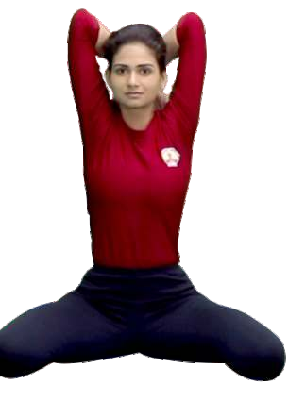

Fig. 19 Uttāna Mandūkāsana

7.7 Vakrāsana (The spinal twist posture)

Vakra means twisted. In this āsana, the spine is twisted, which has a rejuvenating effect on its functioning.

7.7.1 Technique

Sit with extended legs together, hands by the sides of the body, and palms resting on the ground in Daṇḍāsana. Bend the right leg and place the right foot beside the left knee. Bring the left arm around the right knee and clasp the right big toe or place the palm beside right foot. Take the right arm back and keep the palm on the ground with the back straight. Exhale, twist the body to the right (Fig. 20). Remain in the posture for 10 seconds to 30 seconds with normal breathing and relax. Inhale, take out the hands, and exhale extend the right leg. Repeat the same on the other side.

NOTE — Avoid this posture in case of acute back pain, spinal disorders, abdominal surgery and during menstruation.

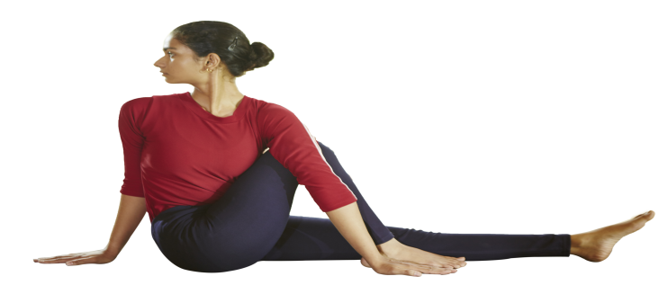

Fig. 20 Vakrāsana
8 PRONE POSTURES

8.1 Makarāsana (The Crocodile Posture)

In Sanskrit, Makara means crocodile. In this āsana, the body would resemble a crocodile, hence the name.

8.1.3 Technique

Sit in prone relaxation posture. Lie down on stomach with feet wide apart, toes pointing outwards. Bend both the arms and place the right palm on the left palm. Place the head either the left or the right side on the hands. Keep the eyes closed and relax the whole body. (Fig. 21)

NOTE — Avoid this practice in case of pregnancy and frozen shoulders. This āsana is practiced for relaxation in all prone postures.

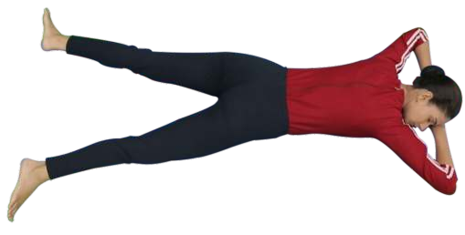
Fig. 21 Makarāsana

8.2 Bhujaṅgāsana (The cobra posture)

Bhujaṅga means snake or cobra. In this āsana, the body is raised like the hood of a snake, hence the name.

8.2.1 Technique

Lie down on stomach, rest head on hands, and relax the body. Now join legs and stretch the arms. Keep the forehead on the ground. Place the hands just beside the body; keep palms and elbows on the ground. Inhale slowly, lift the head and chest up to the navel region without changing the position of hands. Stay comfortably in this position. This is called Sarala Bhujaṅgāsana. Now come back and place the forehead on the ground. Keep palms besides the chest and raise elbows from where they are. Inhale, slowly lift the head and chest up to the navel region (Fig. 22). Keep the elbows parallel and maintain the posture for 10 seconds to 30 seconds with normal breathing. This is Bhujaṅgāsana. Exhale, rest the forehead on the ground, come back to Makarāsana (8.1) and relax.

NOTE — Keep the legs firm so that no strain is felt on the lumbar spine. Those who have undergone abdominal surgery should avoid this āsana for 2 months to 3 months. Those who are suffering from hernia or ulcers should not practise this āsana.

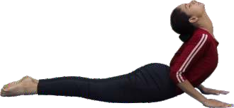

Fig. 22 Bhujaṅgāsana

8.3 Śalabhāsana (The Locust Posture)

Śalabha means a locust.

8.3.1 Technique

Yoga practitioner shall lie down on stomach in Makarāsana (8.1). Rest the chin on the floor, keep both hands beside the body, palms facing upwards. Inhale, raise the legs off the floor as per one’s capacity without bending the knees. Extend the arms and legs well to ease lifting the body off the floor (Fig. 23). Stay in this position for 10 seconds to 30 seconds, with normal breathing. Exhale, bring the legs down towards the floor. Rest in Makarāsana (8.1).

NOTE — Pull up the knee caps and squeeze the buttocks to improve the posture. This āsana is more beneficial when performed after Bhujaṅgāsana. One should proceed cautiously in case of severe lower back pain. People with high blood pressure, peptic ulcer, or hernia should avoid this posture.

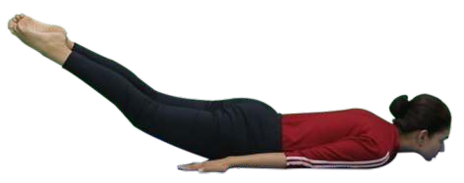

Fig. 23 Śalabhāsana (The Locust Posture)
9 SUPINE POSTURES

9.1 Setubandhāsana (The Bridge Posture)

Setubandha means formation of bridge. In this posture, the body is positioned like a bridge, hence the name. This is also called as Catuspādāsana.

9.1.1 Technique

Bend both the legs at the knees and bring the heels near the buttocks. While holding both the ankles firmly, keep the knees and feet in one straight line. Inhale, slowly raise your buttocks and trunk up as much as you can to form a bridge (Fig. 24). Remain in this position for 10 seconds to 30 seconds, with normal breathing. Exhale, slowly return to the original position and relax in Śavāsana (9.5).

NOTE — In the final position, both the shoulders, the neck, and the head remain in contact with the floor. If required, in the final position, you can support the body at the waist with the hands. People suffering from ulcer, hernia, etc. should not practise this āsana.

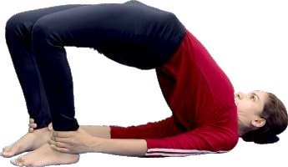

Fig. 24 Setubandhāsana
9.2 Uttāna Pādāsana (Raised Feet Posture)

Uttāna means raised-upward and Pāda means leg. In this āsana, the legs are raised upwards in supine position, hence the name.

9.2.1 Technique

Lie comfortably on the ground with legs stretched out. Hands should be placed by the sides. While inhaling, slowly raise both the legs without bending them at the knees and bring them to thirty-degree angle with the ground (Fig. 25). Maintain the position for 10 seconds to 30 seconds with normal breathing. Exhale, slowly bring both the legs down and place them on the ground. Relax in Śavāsana (9.5).

NOTE — People with hypertension and back pain shall practise it with one leg alternatively without holding the breath.

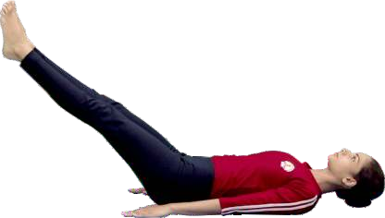

Fig. 25 Uttānapādāsana

9.3 Ardha Halāsana (Half-Plough Posture)

Ardha means half and hala means plough. This posture is known as Ardhahalāsana because in its final position, the body would resemble half the shape of an Indian plough.

9.3.1 Technique

Take supine position, keep hands besides the body and palms resting on the ground. Inhale, slowly raise the legs together without bending knees and bring them up to 90 degree angle with the ground. The body from hips to shoulder should be kept straight (Fig. 26). Maintain this position comfortably for 10 seconds to 30 seconds with normal breathing. Exhale, slowly bring the legs down to the ground without lifting the head. Relax in Śavāsana (9.5).

NOTE — Those who have lumbo-sacral (lower back) pain should not perform this asana. Avoid this practice in case of abdominal injuries, hernia, etc.

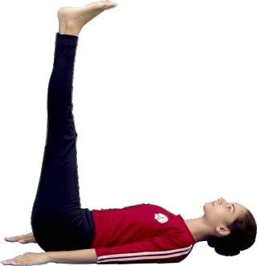

Fig. 26 Ardha Halāsana

9.4 Pavana Muktāsana (The Wind-Releasing Posture)

Pavana means wind and mukta means to release or to make free. As the name suggests, this āsana is useful in removing wind or flatulence from the stomach and the intestines.

9.4.1 Technique

Lie down flat on the back, bend both the knees. Exhale, bring both the knees towards the chest. Inhale, interlock the fingers and clasp the shin below the knees. Exhale, raise the head till chin touches the knees and relax (Fig. 27). Maintain the position for 10 seconds to 30 seconds with normal breathing. Bring the head back to the ground. While exhaling, bring the legs back to the floor. Rest in Śavāsana (9.5)

NOTE — One should synchronize breathing with the leg movement. While touching the knee with the nose/forehead, one should be able to feel the lumbar region stretch; keep the eyes closed and focus on the pelvic and lumbar regions. Avoid this practice in case of abdominal injuries, hernia, sciatica, severe back pain, and during pregnancy.

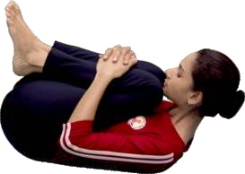

Fig. 27 Pavana Muktāsana

9.5 Śavāsana (The Corpse/Dead Body Posture)

The final position in this āsana would resemble a corpse/dead body.

9.5.1 Technique

Lie down on back with arms and legs comfortably apart, palms facing upward and eyes closed. Relax the whole body consciously. Become aware of natural breath and allow it to become slow and shallow. Remain in the position till feel refresh and relaxed. (Fig. 28)

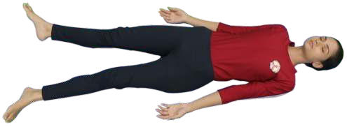
Fig. 28 Śavāsana

10 KAPĀLABHĀTI

Kapāla means skull, bhāti means to shine or to cleanse. It is a cleansing practice which helps to clean the frontal sinuses and upper respiratory tract.

10.1 Technique

Sit in any comfortable posture like Sukhāsana/ Padmāsana/ Vajrāsana. Close the eyes and relax the whole body. Inhale deeply through both nostrils and expand the chest. Expel the breath with forceful contractions of the pelvic and abdominal muscles and inhale passively (Fig. 29). Do not strain. Continue active/forceful exhalation and passive inhalation. Complete 30 rapid breaths, then take a deep breath, exhale slowly, and relax completely. This is one round of Kapālabhāti. Repeat 2 more rounds. Each round shall be followed by being still for a while.

NOTES
1 Breathing pattern - Forceful exhalation by contracting the abdominal muscles, without any undue movements in the chest and shoulder region. Inhalation should be passive throughout the practice.
2 Number of rounds - Beginners can practise up to 3 rounds of 20 rapid breaths each. The count and rounds can be increased gradually over a period of time.
3 Avoid this practice in case of cardiac conditions, giddiness, high blood pressure, vertigo, chronic bleeding in the nose, epilepsy, migraine, stroke, hernia, gastric ulcer, pregnancy, and during menstrual cycle.

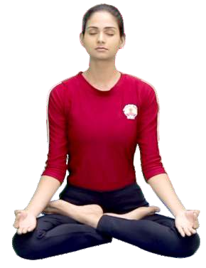

Fig. 29 Kapālabhāti

11 PRĀNĀYĀMA

11.1 Naḍīśodhana or Anuloma Viloma Prānāyāma (Alternate nostril breathing)

The main characteristic feature of this prānāyāma is alternate breathing through the left and right nostrils without or with retention of breath (kumbhaka).

11.1.2 Technique

Sit in any comfortable posture like Sukhāsana/Padmāsana/ Vajrāsana. Keep the spine and head straight with eyes closed. Relax the body with a few deep breaths. Keep the left palm on the left knee in Jnāna mudra and the right palm should be in Nāsāgra mudra. Place the ring and small fingers on the left nostril and fold the middle and index finger. Place the right thumb on the right nostril (Fig. 30). Open the left nostril and breathe in from the left nostril; close the left nostril with the small and ring fingers and release the thumb from the right nostril; exhale through the right nostril. Next, inhale through the right nostril. At the end of inhalation, close the right nostril, open the left nostril and exhale through it. This completes one round of the Nādiśodhana or Anuloma viloma prāṇāyāma. Repeat for another 4 rounds.

NOTES
1 Ratio and timing for beginners, the duration of inhalation and exhalation should be equal. Gradually make the ratio 1:2 (inhalation: exhalation) respectively.
2 Breathing- Breath should be slow, steady, and controlled. It should not be forced or restricted in anyway.

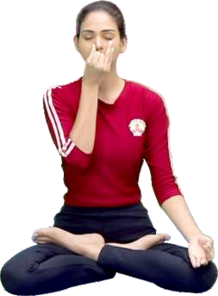

Fig. 30 Naḍīśodhana or Anuloma Viloma
Prānāyāma (Alternate Nostril Breathing)

11.2 Śītalī Prāṇāyāma

Śītalī means cooling, calm and passionless. As the name indicates, this prāṇāyāma cools the mind and body. It is specially designed to reduce the body temperature. Practice of this prāṇāyāma brings harmony in the body system and calms the mind

11.2.1 Technique

Sit in any comfortable posture like Sukhāsana/Padmāsana/ Vajrāsana. Place the hand on the knees in Jñānamudrā or anjalimudrā; roll the tongue from the sides to shape it as a tube (Fig. 31). Inhale through the tube-shaped tongue; fill the lungs with air to their maximum capacity; take the tongue inside the mouth and close the mouth. Exhale slowly through both the nostrils. This is one round of Śītalī Prāṇāyāma. Repeat it 4 more times.

NOTE — Those who are suffering from severe cold, cough or tonsillitis should not do this prāṇāyāma.

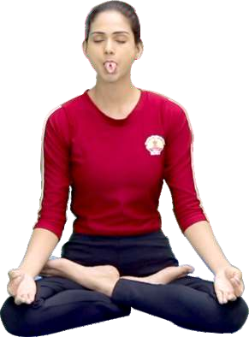

Fig. 31 Śītalī Prāṇāyāma
11.3 Bhrāmarī Prāṇāyāma (Bhrāmarī Recaka)

Bhrāmarī is derived from bhramara, which means black bee. During the practice of this prāṇāyāma, the sound produced resembles the buzzing of a black bee, hence the name.

11.3.1 Technique

11.3.1.1 Type 1

Sit in any comfortable posture like Sukhāsana/Padmāsana/Vajrāsana with eyes closed. Inhale deeply through the nose. Exhale through the nostrils in a controlled manner while making a deep, steady humming sound such as that of a black bee. This is one round of Bhrāmarī. Repeat for 4 more rounds. This is simple version of Bhrāmarī Pranayama.

11.3.1.2 Type 2

Sit in any comfortable posture with eyes closed. Inhale deeply through the nose. Close the eyes with index fingers, place the middle finger on sides of the nose (don't close it), mouth with ring and small fingers, ears from respective thumbs as shown in the figure (Fig. 32). This is also called Śanmukhi Mudrā. Exhale through the nostrils in a controlled manner while making a deep, steady humming sound such as that of black bee. This is one round of Bhrāmarī. Repeat it for 4 more rounds.

NOTE — Avoid this practice in case of nose and ear infections.

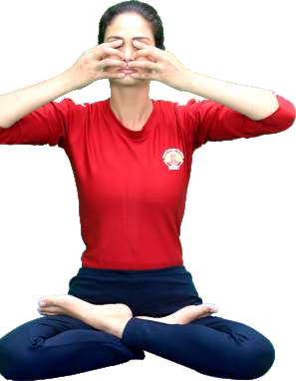

Fig. 32 Bhrāmarī Pranayama.
12 DHYĀNA

12.2 Technique

Sit in any comfortable posture and adopt Jnāna mudra or Dhyana mudra (Fig. 33). Keep the palms facing upwards upon the thighs. Arms and shoulders should be loose and relaxed. Gently close the eyes and sit with a slightly upturned face. Maintain a mild focus between the eyebrows and be conscious of the breath. Dissolve thoughts and try to attain single and pure thought and meditate.

NOTE — For beginners, soothing music may be played in the background during meditation.

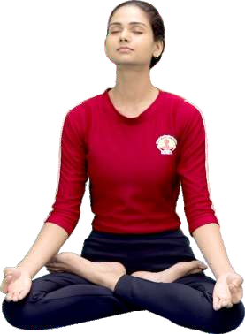

Fig. 33 Figure of Dhyāna

ANNEX A
(Foreword)

COMMITTEE COMPOSITION
Yoga Sectional Committee, AYD 02

Organization | Representative(s)
Krishnamacharya Yoga Mandiram (KYM), Chennai | Yogacharya S. Sridharan (Chairperson)
Dev Sanskriti Vishwavidyalaya, Haridwar | Dr Suresh Barnwal
Government Nature Cure Hospital, Hyderabad | Dr N. Bhanu Kiran
Heartfulness Institute, Gurugram | Shri Anuj Setya
Indian Institute of Technology, Center for Biomedical Engineering, New Delhi | Prof K. K. Deepak  Dr Deepak Joshi (Alternate I)  Dr Ayushee Khajuria (Alternate II)
Indian Yoga Association (IYA), New Delhi | Dr S. P. Mishra  Shri P. C. Kapoor (Alternate I)  Dr Rajanish Sharma (Alternate II)
Institute of Salutogenesis and Complementary Medicine (ISCM), Puducherry | Dr Ananda Balayogi Bhavanani  Dr Meena Ramanathan (Alternate)
Isha Foundation, Coimbatore | Swami Ullasa  Shri Arun Mehta (Alternate)
Kaivalyadhama, Lonavla | Shrimati Renu Jain  Shrimati Shalini Srivastava (Alternate I) Shri Sanjeev Kumar Dwivedi (Alternate II)
Krishnamacharya Yoga Mandiram (KYM), Chennai | Shri T. Swaminathan
Morarji Desai National Institute of Yoga, New Delhi | Shri S Lakshmi Kandhan  Shrimati Himani Shokhand (Alternate)
Patanjali Yogpeeth, Haridwar | Dr Nidheesh Kumar Yadav  Dr Aarti Pal (Alternate)
Ramamani Iyengar Memorial Yoga Institute, Pune | Shri Birjoo H. Mehta  Shri Malav Dani (Alternate)
Sivananda Yoga Vedanta Nataraja Centre, New Delhi | Shri Prakash Chand Kapoor  Shri Vijay (Bijayender Singh) (Alternate)
Shiv Naresh Sports Private Limited, New Delhi | Shri Shiv Prakash Singh  Shri Vishnu Bhagat (Alternate I)  Shri Gurmehar Kaur Modi (Alternate II)
Sri Sri School of Yoga, Bengaluru | Shri Mayur Karthik  Shri Pushpdant (Alternate I) Shrimati Niyati Puri (Alternate II)
Swami Vivekananda Yoga Anusandhana  Samsthana, Bengaluru | Dr B. R. Ramakrishna  Dr Vasudev Vaidya (Alternate I)  Ms Anupa Chhantyal (Alternate II)
The Yoga Institute, Mumbai | Shrimati Padmini Rathore  Ms Prema Parab (Alternate I)  Ms Rohini Ghosh (Alternate II)
Wintex Appare Limited, New Delhi | Shri Mayank Gupta  Ms Ranu Gupta (Alternate I)  Shri Krishna Gupta (Alternate II)
Yoga Vidya Niketan, Mumbai | Shri Durgadas Shamba Savant  Neha Abhimanyu Kerure (Alternate I) Utkarsha Srivastava (Alternate II)
In Personal Capacity (1/3 B, Second Floor, Jangpura - B, Mathura Road, New Delhi – 110014) | Ms Laxmi Devi Aere
BIS Directorate General | Shri S. K. Kanogia Scientist ‘F’/Senior Director and Head (Ayush), [Representing Director General (Ex-officio)]

Member Secretary
Dr Raghavendra Naik
Scientist ‘C’/Deputy Director
(Ayush), BIS

