**IS/IEC TS 62600-20: 2019** 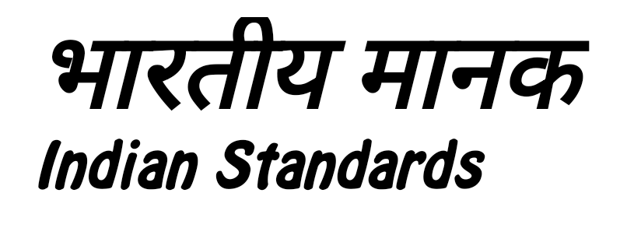



**समुद्री ऊर्जा -**

**तरंग, ज्वार और अन्य जल धारा परिवर्तक**

**भाग 20 महासागर तापीय ऊर्जा रूपांतरण (ओटीईसी) संयंत्र का डिजाइन और विश्लेषण - सामान्य मार्गदर्शन**

**Marine Energy -**

**Wave, Tidal and Other Water Current Converters**

**Part 20 Design and Analysis of an Ocean Thermal Energy Conversion OTEC plant General Guidance**

ICS 27.140

© BIS 2024

© IEC 2020





भारतीय मानक ब्यूरो



BUREAU OF INDIAN STANDARDS

मानक भवन, 9 बहादुर शाह ज़फर मार्ग, नई दिल्ली - 110002

MANAK BHAVAN, 9 BAHADUR SHAH ZAFAR MARG

NEW DELHI - 110002

[www.bis.gov.in](http://www.bis.org.in) [www.standardsbis.in](http://www.standardsbis.in)

**May 2024 Price Group**

Marine Energy Conversion Systems Sectional Committee, ETD54

NATIONAL FOREWORD

This Standard (Part 20) which is identical with IEC 62600-20-2019 ‘Marine Energy – wave tidal and other water current converters Part 20: Design and Analysis of an Ocean Thermal Energy Conversion (OTEC) plant – General Guidance’ issued by the International Electrotechnical Commission (IEC) was adopted by the Bureau of Indian Standards on the recommendation of the Marine Energy Conversion Systems Sectional Committee and approval of the Electrotechnical Division Council.

The text of the IEC Standard has been approved as suitable for publication as an Indian Standard without deviations. Certain conventions are, however, not identical to those used in Indian Standards. Attention is particularly drawn to the following:

1. Wherever the words ‘International Standard’ appears referring to this standard, they should be read as ‘Indian Standard’.

| *International Standard* | *Corresponding Indian Standard* | *Degree of Equivalence* |
| --- | --- | --- |
| IEC 60079-0:2017, Explosive atmospheres – Part 0: Equipment – General requirements | IS/IEC 60079-0:2017, Explosive Atmospheres Part 0 Equipment — General Requirements ( Third Revision ) | Identical |

1. Comma (,) has been used as a decimal marker, while in Indian Standards the current practice is to use a point (.) as the decimal marker.

In this adopted standard, reference appears to International Standards for which Indian Standards also exists. The corresponding Indian Standards, which are to be substituted, are listed below along with their degree of equivalence for the editions indicated:

The technical committee has reviewed the provisions of the following international standards referred in this adopted standard and decided that they are acceptable for use in conjunction with this standard.

| *International Standard* | *Title* |
| --- | --- |
| IEC TS 62600-1: | Marine energy – Wave, tidal and other water current converters – Part  1: Terminology |
| ISO 13628-5: 2009, | Petroleum and natural gas industries – Design and operation of subsea  production systems – Part 5: Subsea umbilical |
| ISO 13628-11: 2007, | Petroleum and natural gas industries – Design and operation of subsea  production systems – Part 11: Flexible pipe systems for subsea and marine applications |
| ISO 19900, | Petroleum and natural gas industries – General requirements for offshore  structures |
| ISO 19901 (all parts) | Petroleum and natural gas industries – Specific requirements for  offshore structures |
| ISO 19901-1, | Petroleum and natural gas industries – Specific requirements for offshore  structures – Part 1: Metocean design and operating considerations |
| ISO 19901-7:2013, | Petroleum and natural gas industries – Specific requirements for offshore  structures – Part 7: Station keeping systems for floating offshore structures and mobile offshore units |
| ISO 19902, | Petroleum and natural gas industries – Fixed steel offshore structures |
| ISO 19903, | Petroleum and natural gas industries – Fixed concrete offshore structures |
| ISO 19905 (all parts), | Petroleum and natural gas industries – Mobile offshore units – Jackups |
| ISO 19906, | Petroleum and natural gas industries – Arctic offshore structures |
| ISO 21650, | Actions from waves and currents on coastal structures |

For the purpose of deciding whether a particular requirement of this standard is complied with, the final value, observed or calculated expressing the result of a test, shall be rounded off in accordance with IS 2: 2022 ‘Rules for rounding off numerical values (*second revision*)’. The number of significant places retained in the rounded off value should be the same as that of the specified value in this standard.