भारतीय मानक
IS : 7422 (Part 5) :
Indian Standard

भूवैज्ञानिक मानचित्र, खंड और उपसतही अन्वेषी लॉग में प्रयुक्त चिह्न और संक्षिप्त रूप
भाग 5 रचना, सम्पर्क तथा संरचनात्मक आकृतियों के लिए रैखिक चिह्न
(पहला पुनरीक्षण)

SYMBOLS AND ABBREVIATIONS FOR USE IN GEOLOGICAL MAPS, SECTIONS AND SUBSURFACE EXPLORATORY LOGS
PART 5 LINE SYMBOLS FOR FORMATION CONTACTS AND STRUCTURAL FEATURES

(First Revision)

ICS 07.060, 01.080.30

© BIS 2023
भारतीय मानक ब्यूरो
B U R E A U O F I N D I A N S T A N D A R D S
मानक भवन, 9 बहादुरशाह ज़फर मार्ग, नई दिल्ली — 110002
MANAK BHAVAN, 9 BAHADUR SHAH ZAFAR MARG
NEW DELHI-110002
www.bis.gov.in www.standardsbis.in

February 2024 Price Group
Geological Investigations and Subsurface Exploration Sectional Committee, WRD 05
FOREWORD

This Indian Standard (Part 5) was adopted by the Bureau of Indian Standards, after the draft finalized by the Geological Investigation and Sub-Surface Exploration Sectional Committee had been approved by the Water Resources Division Council.

In all spheres of engineering construction, data on the nature of geological formation, constituting the foundations is indispensable. Often, the data are given on maps or in geological sections using symbols and abbreviations. Geological maps and sections are also required for other activities such as mining and mineral prospecting. Such maps and sections are being prepared by various agencies in the country. In the absence of any standard for the guidance of the engineering geologist or engineer different symbols and abbreviations are being used by different agencies, resulting in entirely different representations of the same geological data. The data collected and presented by one agency for a particular purpose is often useful for other agencies investigating for a different job. It, therefore, becomes essential for all agencies to follow the same practice. This standard has been prepared to fulfil this need.

This standard (Part 5) deals with line symbols for formation contacts and structural features while other parts deal with the following:

Part 1 Abbreviations

Part 2 Igneous Rocks

Part 3 Sedimentary Rocks

Part 4 Metamorphic Rocks

The standard was published in 1992. The first revision of this standard has been brought out to bring the standard in latest style and update with respect to the latest field practices. In revision of this standard, due weightage has been given to international co-ordination among the standards and practices prevailing in different countries in addition to relating it to the practices in the field in this country. In this first revision of standard, assistance have been derived from ISO 710 Graphical symbol for use on detailed maps, plans and geological cross section.

The composition of the committee responsible for the formulation of this standard is listed at Annex A.

For the purpose of deciding whether a particular requirement of this standard is complied with, the final value, observed or calculated, expressing the result of a test, shall be rounded off in accordance with IS 2 : 2022 'Rounding off numerical values (second revision)'. The number of significant places retained in the rounded off value should be the same as that of the specified value in this standard.

Indian Standard
SYMBOLS AND ABBREVIATIONS FOR USE IN GEOLOGICAL MAPS, SECTIONS AND SUBSURFACE EXPLORATORY LOGS
PART 5 LINE SYMBOLS FOR FORMATION CONTACTS AND STRUCTURAL, FEATURES
(First Revision)

1 SCOPE

The symbols covered in this standard are:

- Line symbols for formation contacts and other structural features,
- Symbols for surface openings and exploration,
- Symbols for underground working and exploration, and
- Other miscellaneous symbols.

2 BASIC PRINCIPLES OF REPRESENTATION

2.1 The symbols used are intended to characterize the existing state as found in nature and shall not be used to represent genetic processes and their connections.

2.2 The tectonic elements can be regarded as surfaces or Iineations characterized by their situations in space

2.2.1 Planes

Tectonic planes are represented by their traces in the reference plane.

The basic symbols for traces is a continuous line to which additional symbols characterizing the nature of the surface are added.

2.2.2 Lineation

Lineations are represented by their projection on the reference plane.
The basic symbols for the projection of lineations is a compound line of alternate dots and dashes to which additional symbols characterizing the nature of the lineations in question are added.

2.2.3 Indication of Position

The position of the planes and lineations are given by the oriented representation of their traces and projections on the map or plan.

3 LINE SYMBOLS FOR FORMATION, CONTACTS AND STRUCTURAL FEATURES

3.1 The line symbols representing formation contacts and various structural features are given in tabular form as listed below:

- Contacts Table 1

- Faults Table 2

- Folds Table 3

- Planar Features Table 4

- Line Features Table 5

- Slip Plane and Minor Shear Seams Table 6

- Contours and Isopleths Table 7

Note − For representing the fault, letter ‘F’ may be indicate at both the ends of the symbol. Similarly, for lineament, letter ‘L’ may be used at both the ends of the symbol.

4 SYMBOLS FOR SURFACE OPENINGS AND EXPLORATION

4.1 The symbols representing surface openings and exploration are given in tabular form as listed below:

- Symbols for use in Table 8
Large Scale maps

- Symbols for use in Table 9
Small Scale maps

5 SYMBOLS FOR UNDERGROUND WORKING AND EXPLORATION

5.1 The symbols representing underground workings and such exploration are given in table 10.

6 OTHER MISCELLANEOUS SYMBOLS

6.1 Symbols for sections, water wells and springs and other miscellaneous items are given in table 11.

TABLE 1 LINE SYMBOLS FOR CONTACTS
(Clause 3.1)

S No. | Description | Symbol
(1) | (2) | (3)
1 | Contact
2 | Contact showing dip, vertical contact  with topside known | 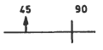
3 | Overturned contact, showing dip | 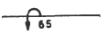
4 | Approximate contact
5 | Possible contact
6 | Concealed contact

TABLE 2 LINE SYMBOL FOR FAULTS
(Clause 3.1)

Sl No. | Description | Symbol
(1) | (2) | (3)
1 | Fault
2 | Fault, showing dip | 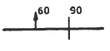
3 | Fault, approximately located
4 | Fault, inferred or doubtful | 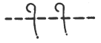
5 | Concealed fault
6 | Lineament
7 | Fault (showing bearing and plunge of grooves, striation or slickensides) | 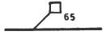
8 | Fault, showing dip (U-upthrown side D-downthrown side) | 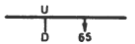
9 | Fault (bar & ball on downthrown side) | 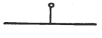
10 | Fault showing relative horizontal movement | 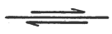
11 | Fault (showing bearing & plunge of apparently downthrown block) | 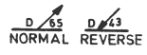
12 | Normal fault (hachures on downthrown side)
13 | Reverse fault (R, upthrown side)
14 | Thrust fault (T, upper plate) | 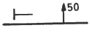
15 | Thrust fault (sawteeth on upper plate, major thrust fault) | 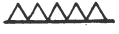
16 | Overturned thrust fault, sawteeth in dip direction, bar on side of tectonically higher plate | 
17 | Fault (shear or mylonite) zone showing dip | 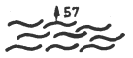
18 | Fault breccia | 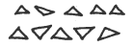
19 | Fault, intruded by dyke
20 | Termination of fault | 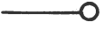

TABLE 3 LINE SYMBOLS FOR FOLDS
(Clause 3.1)

Sl No. | Description | Symbol
(1) | (2) | (3)
1 | Anticline, showing crestline | 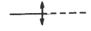
2 | Anticline showing crestline & direction of plunge | 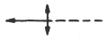
3 | Anticline showing crestline & plunge | 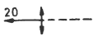
4 | Asymmetric anticline showing crestline & plunge, shorter arrow indicates steeper limb | 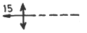
5 | Asymmetric anticline showing dip of limbs & plunge | 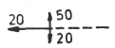
6 | Overturned anticline showing direction of dip of limbs & plunge | 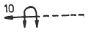
7 | Inverted anticline, Arrows show direction of dip of limbs | 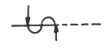
8 | Dome | 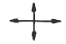
9 | Antiform | 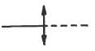
10 | Syncline showing troughline | 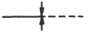
11 | Syncline showing troughline and direction of plunge | 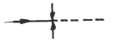
12 | Syncline showing troughline and plunge | 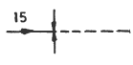
13 | Asymmetric syncline showing trough line and plunge. Short arrow indicates steeper limb | 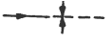
14 | Asymmetric syncline showing dip of limbs and plunge | 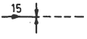
15 | Overturned syncline showing direction of dip of limbs and plunge | 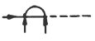
16 | Basin | 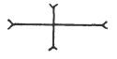
17 | Inverted syncline, arrows show direction of dip of limbs | 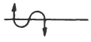
18 | Synform, drawn on foilation, cleavage or bedding | 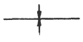
19 | Monocline showing trace and plunge of axes, dashed where approximately located | 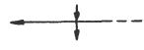
20 | Anticlinal bend showing trace and plunge of axis. Dashed where approximately located | 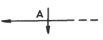
21 | Synclinal bend showing trace and plunge of axis. Dashed where approximately located | 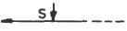
22 | Minor anticline, showing plunge | 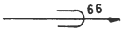
23 | Minor syncline, showing plunge | 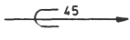
24 | Minor fold axis, showing plunge | 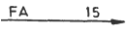
25 | Minor fold axis, horizontal | 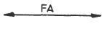
26 | Minor folds showing plunge of axes | 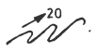
TABLE 4 PLANAR FEATURES
(Clause 3.1)
Sl No. | Description | Symbol
(1) | (2) | (3)
1 | Strike and dip of beds | 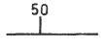
2 | Strike and dip of beds (Top beds known from sedimentary features, used only in areas of complex structure where overturning is also recognized) | 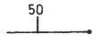
3 | Strike and dip of overturned beds | 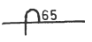
4 | Strike and dip of overturned beds (top of beds known) | 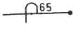
5 | Strike of vertical beds (top of beds known) | 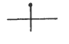
6 | Strike of vertical beds
7 | Component of dip (dot marks point of observation)
8 | Horizontal beds | 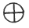
9 | Strike and dip of beds and plunge of slicken - sides | 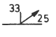
10 | Strike and dip of foliation | 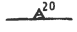
11 | Strike of vertical foliation (relation-ship of foliation or shistosity, to bedding not shown in outcrop) | 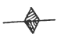
12 | Horizontal foliation | 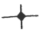
13 | Crumpled, plicated, crenulated, or undulatory beds and average dip | 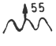
14 | Strike and dip of foliation and parallel bedding | 
15 | Strike of vertical foliation and parallel bedding | 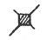
16 | Strike and dip of foliation and parallel bedding | 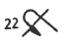
17 | Horizontal foliation and bedding | 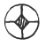
18 | Strike and dip of cleavage | 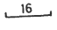
19 | Strike of vertical cleavage
20 | Horizontal cleavage | 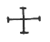
21 | Inclined vertical | 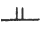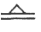
22 | Vertical | 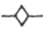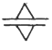
23 | Horizontal | 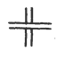
(Contrasting symbols can be used to distinguish between different kinds of planar structures) : Type of planar structure should be specified in explanation

TABLE 5 LINE SYMBOLS FOR LINER FEATURES
(Clause 3.1)

Sl No. | Description | Symbol
(1) | (2) | (3)
1 | Bearing and plunge of lineation
2 | Vertical lineation (use open symbol in combination with line symbols) | 
3 | Vertical beds, showing horizontal lineation
4 | Horizontal beds showing trend of horizontal lineation
5 | Vertical beds showing plunge of lineation
6 | Horizontal lineation
7 | Strike and dip of foliation and plunge of lineation | 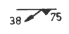
8 | Vertical foliation showing horizontal lineation | 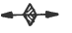
9 | Strike and dip of foliation showing horizontal lineation | 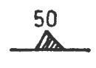
10 | Strike and dip of beds and plunge of lineation | 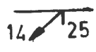
11 | Vertical foliation and vertical lineation | 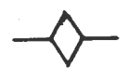
12 | Strike of vertical foliation showing plunge of lineation | 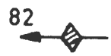
13 | Approximate strike of folded beds showing plunge of fold axes | 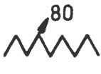
14 | Attitude of overturned beds and parallel foliation | 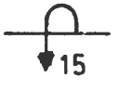
15 | Attitude of foliation and overturned beds, strikes parallel but dips differ | 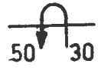
16 | Double lineation | 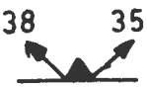
17 | Strike and dip of beds and intersecting slip cleavage (symbols joined at points of observation) | 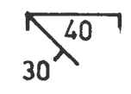
18 | Strike and dip of beds and intersecting slip cleavage | 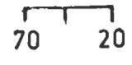
19 | Strike and dip of joints | 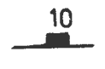
20 | Strike of vertical joints | 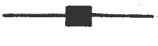
21 | Horizontal joints | 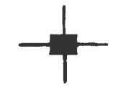
22 | Strike and dips of multiple joints | 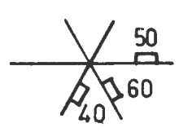

TABLE 6 LINE SYMBOLS FOR SLIP PLANES AND MINOR SHKAR SEAMS
(Clause 3.1)

Sl No. | Description | Symbol
1 | Joint plane | 
2 | Slip plane | 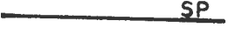
3 | Shear zone – 1 to 5 cm (thick crushed rock) | 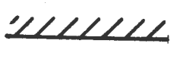
4 | Shear zone – 5 cm to 15 cm (thick crushed rock) | 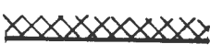
5 | Shear zone – thickness of zone defined by border lines | 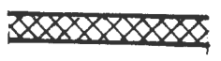
6 | Glide crack | 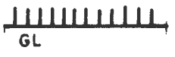

TABLE 7 LINES SYMBOLS FOR CONTOURS AND ISOPLETHS
(Clause 3.1)

Sl No. | Description | Symbol
1 | Structure contours Drawn on top (or base) of given geological horizon, long-dashed where control less accurate, shortdashed where datum is above land surface, contour interval 5 m, arrow indicates direction of dip. (Structure contours generally not shown as  concealed; may be omitted in areas of no information. Arrows used only where  index contours fail to show dip.) | 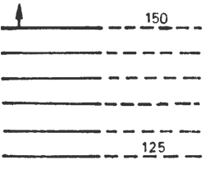
2 | Outcrop point used for structural control | 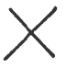
3 | Isopachs | 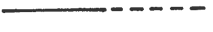
4 | Isograds (add key mineral names to map and describe in explanation) | 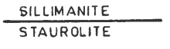

TABLE 8 SYMBOLS FOR SURFACE OPENINGS AND EXPLORATION FOR USE IN LARGE SCALE MAPS
(Clause 4.1)

Sl No. | Description | Symbol
1 | Vertical shaft | 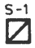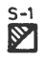
2 | Inclined shaft | 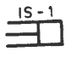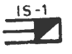
3 | Portal or slit | 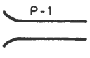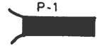
4 | Portal or opencut | 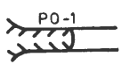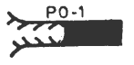
5 | Trench | 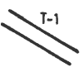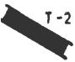
6 | Prospect pit or opencut | 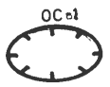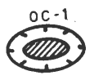
7 | Drill hole (upto and including 150 mm) | 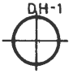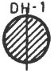
8 | Drill hole, large diameter (more than 150 mm) | 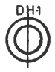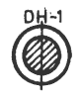
9 | Drill hole (no geological data available) | 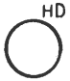
10 | Auger hole (upto and including 150 mm) | 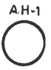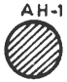
11 | Auger hole, large diameter (above 150 mm) | 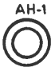
12 | Drill hole, inclined (Showing bearing and inclination for surface) | 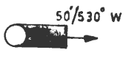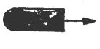
13 | Mine dump | 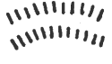
NOTE — Wherever two symbol. are given, the left hand figure denotes the proposed and the right hand figure, the completed working.

TABLE 9 SYMBOLS FOR SURFACE OLPENINGS AND EXPLORATION FOR USE IN SMALL SCALE MAPS
(Clause 4.1)

Sl No. | Description | Symbol
1 | Vertical shaft | 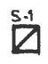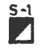
2 | Inclined shaft | 
3 | Portal of tunnel, adit or slope | 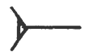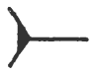
4 | Inaccessible tunnel, adit or slope | 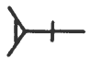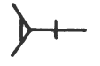
5 | Trench | 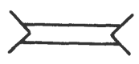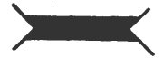
6 | Prospect pit | 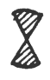
7 | Sand, gravel, clay or placer pit | 
8 | Mine, quarry, glory hole or open pit | 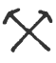
NOTE — The left hand figure denotes the proposed, and the right hand figure, the completed working.

TABLE 10 SYMBOLS FOR UNDER GROUND WORKING AND EXPLORATION
(Clause 5.1)

Sl No. | Description | Symbol
1 | Shaft at surface | 
2 | Shaft, above and below level | 
3 | Bottom of shaft (show bottom of pump by note on map of lower level) | 
4 | Winze or head or raise | 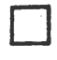
5 | Raise or winze extending through level | 
6 | Raise or foot of winze | 
7 | Stopes (can also be explained by note stoped above or stoped below) | 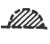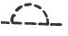
8 | Oil well | 
9 | Shaft or dig | 
10 | Dry hole (Showing formation and altitude at surface, formation at bottom  of hole and total depth) | 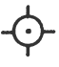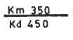

Table 11 Symbols for Sections, Water Welk and Springs and Other Miscellaneous Items
(Clause 6.1)
Sl No. | Description | Symbol
1 | Thrust (Arrow shows relative direction of movement) | 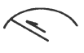
2 | Fault (Arrow shows relative direction of movement) | 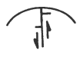
3 | Fault, showing lateral movement  (T towards observer; A away from observer, may be combined with arrows to show strike slip and dip slip movement) | 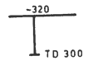
4 | Drill hole or well on section (showing surface altitude and depth in m) (Angle of deviation from vertical plotted) | 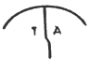
5 | Drill hole or wall projected to section (showing surface altitude and total depth in m) | 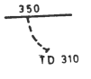
6 | Nonflowing well | 
7 | Flowing well | 
8 | Test hole, abandoned or not in use | 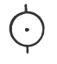
9 | Nonflowing well with pumping plant [Generally shown on blue (drainage) base  plate in ground-water and surface-water reports] | 
10 | Flowing well with pumping plant | 
11 | Spring | 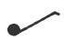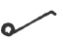
12 | Thermal spring | 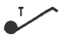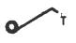
13 | Mineral spring | 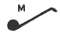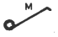
14 | Glacial striae | 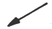
15 | Line of stratigraphic section | 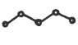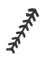
16 | Line of section (generally omitted from explanation, used only to avoid confusion with other line) | 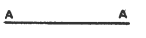

ANNEX A

(Foreword)

COMMITTEE COMPOSITION
Geological Investigations and Subsurface Exploration Sectional Committee, WRD 05
Organization | Representative(s)
IN PERSONAL CAPACITY, GURGAON | DR.P.C. NAWANI (Chairman)
AECS ENGINEERING & GEOTECHNICAL SERVICES PVT. LIMITED, NOIDA | DR. TANU RAGHUVANSHI (MANAGER LABORATORY)  MR. SANJEEV TREHAN DIRECTOR (Alternate)
AFCONS INFRASTRUCTURE LIMITED, MUMBAI | DR. SUNIL BASARKAR, GM (DESIGNS)  DR. LAKSHMANA RAO MANTRI, ASSISTANT GM (DESIGN) (Alternate)
AIMIL LIMITED, NEW | SHRI LAXMIDHAR MOHAPATRA  SHRI HEMAN MANCHANDA (Alternate)
CSIR ⎯ CENTRAL BUILDING RESEARCH INSTITUTE, ROORKEE | SHRI KOUSHIK PANDIT SCIENTIST  DR P. K. S. CHAUHAN PRINCIPAL SCIENTIST (Alternate)
CSIR - CENTRAL INSTITUTE FOR MINING AND FUEL RESEARCH, DHANBAD | DR J. K. MOHNOT, CHIEF SCIENTIST & SCIENTIST-IN-CHARGE  DR. ASHOK KUMAR SINGH, SCIENTIST (Alternate)
CENTRAL SOIL & MATERIAL RESEARCH STATION, NEW DELHI | SHRI N P HONKANDAVAR, SC E  SHRI HARI DEV, SC E (Alternate)
CENTRAL WATER & POWER RESEARCH STATION, PUNE | DR. G. DHANUNJAYA, SC C  SHRI V. CHANDRA SHEKAR, SC C (Alternate)  SHRI B. SURESH KUMAR SC. C (Alternate)
CENTRAL WATER COMMISSION, NEW DELHI | SHRI SAMIR KUMAR SHUKLA DIRECTOR (FE&SA)  SHRI K REKHA RANI, DIRECTOR CMDD (E&NE) (Alternate)
FERRO CONCRETE CONSTRUCTION PVT LTD, INDORE | DR. MAHAVIR BIDASARIA (Alternate)
GEOLOGICAL SURVEY OF INDIA | SHRI P.K. GAJBHIYE, DIRECTOR  SHRI IMTIKUMZUK, DIRECTOR (Alternate)
GUJARAT ENGINEERING RESEARCH INSTITUTE, VADODARA | SHRI N. R. MAKWANA, JOINT DIRECTOR (IRRIGATION)  SHRI R. K. CHAUHAN, SENIOR GEOLOGIST, ENGINEERING GEOLOGY DIVISION (Alternate)
HIMACHAL PRADESH POWER CORPORATION LIMITED, SHIMLA | SHRI ER. R. K. KAUNDAL, GENERAL MANAGER (DESIGNS)  SHRI SANJAY RANA DY GM (Alternate)
INDIAN INSTITUTE OF REMOTE SENSING, DEHRADUN | DR. R.S. CHATTERJEE, SC ‘G’ & HEAD, GEOSCIENCES DEPARTMENT
INDIAN INSTITUTE OF TECHNOLOGY DHANBAD | SHRI LOHITKUMAR NAINEGALI, ASSISTANT PROFESSOR  DR. AVINASH KUMAR SINGH, ASSISTANT PROFESSOR
INDIAN INSTITUTE OF TECHNOLOGY INORE | PROF. MANISH KUMAR GOYAL, PROFESSOR
J&K STATE POWER DEVELOPMENT CORPORATION LIMITED | SHRI RAVI PANDITA
M/S PARSONS OVERSEAS LTD. | SHRI SANJAY RANA, MANAGING DIRECTOR  SHRI ASHUTOSH KAUSHIK, CEO (Alternate)
NARMADA CONTROL AUTHORITY, INDORE | SHRI MK CHAUHAN
NATIONAL INSTITUTE OF ROCK MECHANICS, KARNATAKA | DR. AJAY KUMAR NAITHANI  DR. SANDEEP NELLIAT (Alternate)
NATIONAL HYDROELECTRIC POWER CORPORATION LTD, FARIDABAD | SHRI AJAY SINGH, DEPUTY GM (Alternate)  SHRI MOHINDER PAL SINGH, SENIOR MANAGER (GEOPHYSICS) (Alternate)
NATIONAL THERMAL POWER CORPORATION LIMITED, NOIDA | SHRI NAVEEN KUMAR JAIN  SHRI BHUVNESH KUMAR (Alternate)
NORTH EASTERN ELECTRIC POWER CORPORATION LTD. | SHRI GIRISH KALITA, MANAGER (GEOLOGY)
SATLUJ JAL VIDYUT NIGAM LTD. LIMITED | SH AJAY KUMAR, MANAGER  SH BRIJESH BADONI, MANAGER (Alternate)
TEHRI HYDRO DEVELOPMENT CORPORATION INDIA LIMITED, RISHIKESH | SHRI AJAY KUMAR
UTTARAKHAND JAL VIDYUT NIGAM LTD., DEHRADUN | DIRECTOR (PROJECTS)  DR. HARISH BAHUGUNA (Alternate)
IN PERSONAL CAPACITY | SHRI GOPAL DHAWAN,
IN PERSONAL CAPACITY | SH. IMRAAN SYEED
IN PERSONAL CAPACITY | SHRI R.K. GOEL
IN PERSONAL CAPACITY | SHRI SHYAM LAL KAPIL
BIS DIRECTORATE GENERAL | Shri R. Bhanu Prakash Scientist-E / Director & Head (WRD) [Representing Director General (Ex-Officio)]

Member Secretary

Shri AJAY MEENA
SCIENTIST-B (WRD) / ASSISTANT DIRECTOR, BIS

