**IS 4080 : 2024**

***भारतीय मानक***

***Indian Standard***

|  |
| --- |
|  |

**ऊधर्वाधर दंड प्रमापियों की**

**कार्यकारी अपेक्षाएं**

*(* दूसरा पुनरीक्षण *)*

**VERTICAL STAFF GAUGES-FUNCTIONAL**

**REQUIREMENTS**

*( Second Revision )*

ICS 17.120.01

© BIS 2022

भारतीय मानक ब्यूरो

BUREAU OF INDIAN STANDARDS

मानक भवन, 9 बहादुर शाह ज़फर मार्ग, नई दिल्ली - 110002

MANAK BHAVAN, 9 BAHADUR SHAH ZAFAR MARG

NEW DELHI - 110002

[www.bis.gov.in](http://www.bis.org.in) [www.standardsbis.in](http://www.standardsbis.in)

**September 2022 Price Group X**

Hydrometry Sectional Committee, WRD 01

FOREWORD

This Indian Standard (Second Revision) was adopted by the Bureau of Indian Standards, after the draft finalized by the Hydrometry Sectional Committee had been approved by the Water Resources Division Council.

For the measurement of the water level in streams, different types of gauges, recording and non recording, are used. Non-recording type of gauges include the staff gauges, the chain gauges, the wire gauges, the tape gauges, the float gauges, the hook gauges, and the pointer gauges. The vertical staff gauge is the type most used because of its simplicity in installation and reading and because no mechanical device is involved in its simple design.

This standard was first published in 1967 and first Revised in 1994. This revision has been prepared to incorporate the latest practice in the field and the use of materials like reinforced cement concrete and steel in vertical staff gauges.

In this revision following changes are made:

1. Size of wooden/ concrete gauge is changed to range of 1.5 m to 2.0 m;
2. Length of gauge should be measure excluding embedded length & depending on topography;
3. Minimum size of RCC foundation is added in clause A – 1.3 of Annex A; and
4. Recommended the overlapping of gauges to 30 cm from 50 cm in the previous version of Indian Standard.

The composition of the Committee responsible for formulation of this standard is given at Annex B

For the purpose of deciding whether a particular requirement of this standard is complied with, the final value, observed or calculated, expressing the result of a test or analysis, shall be rounded off in accordance with IS 2 : 2022 ‘Rules for rounding off numerical values (*second revision*)’. The number of significant places retained in the rounded off value should be the same as that of the specified value in this standard.

**IS 4080 : 2024**

*India Standard*

VERTICAL STAFF GAUGES-FUNCTIONAL REQUIREMENTS

*( Second Revision )*

**1 SCOPE**

This standard specifies the functional requirements and materials to be used for vertical staff gauges.

**2 REFERENCES**

The standards listed below contain provisions, which through reference in this text constitute provisions of this standard. At the time of publication, the editions indicated were valid. All standards are subject to revision, and parties to agreements based on this standard are encouraged to investigate the possibility of applying the most recent editions of the standards indicated below:

|  |  |
| --- | --- |
| *IS No* | *Title* |
| IS 1191 : 2016 | Hydrometry — Vocabulary and symbols (*third revision*) |

**3 TERMINOLOGY**

For the purpose of this standard the definitions given in IS 1191: 2016 shall apply.

**4 FUNCTIONAL REQUIREMENTS**

Staff gauges shall meet the following requirements

1. They shall be simple to manufacture, install and use;
2. They shall be durable and easy to maintain;
3. They shall be resistant to wear when exposed to flowing water and the effect of solid matter carried in suspension;
4. They shall be resistant to alternate drying and wetting and also in respect of the resistance to wear or fading of the markings, and the material shall have low coefficient of expansion with respect to temperature and wetting effect; and
5. They shall be accurate and clearly marked.

**5 MATERIALS**

**5.1 Reinforced Cement Concrete**

If reinforced cement concrete is used for the manufacture of staff gauges it shall be ensured that the concrete is cast in steel formwork and is well compacted and cured to ensure strength and durability.

**5.2 Steel**

Standard T-Section or angle section shall be used.

**5.3 Wood**

The wood used shall be straight, uniform, and well-seasoned to avoid warping, shrinkage and swelling due to alternate wetting and drying or due to changes of temperature.

**5.4 Paint**

A base coat of white enamel should protect the concrete, steel and wood. The paints used for the graduations should be permanent in nature and remain unaffected by water.

**6 GRADUATIONS**

**6.1** The graduations shall be marked clearly, either by etching or by painting on the gauge posts or enamelling on steel plates, which are nailed or screwed to gauge post.

**6.2** The graduations shall be such as can be read in centimetres, decimetres and metres distinctly.

**6.3** The smallest graduation shall correspond to 5 mm.

**6.4** Gauge plates shall be manufactured in suitable lengths with the width of scale not less than 50 mm.

**6.5** The markings of the subdivisions shall be accurate to ± 0.5 mm and the cumulative error shall not exceed 0.1 percent or 0.5 mm whichever is greater.

**7 SIZES**

Each gauge length shall be of 2/1.5 m (excluding embedded length & depending on topography) with cut-water shape on the upstream side of the gauge post.

**8 TYPES**

Staff gauges are generally classified as follows:

1. Wooden or concrete type; and
2. Vertical enamelled iron gauges fixed on wooden staff.

Typical examples of both types are given in Annex A.

**ANNEX A**

(*Clause* 8)

**TYPICAL EXAMPLES OF VERTICAL STAFF GAUGES**

**A-1** DETAILS OF WOODEN OR CONCRETE TYPE VERTICAL STAFF GAUGES (See Fig. 1)

**A-1.1 Size**

The size of wooden/concrete gauge is generally 150 $×$ 100 mm in 1.5 to 2 metre lengths (excluding embedded length), having cutwater shape on the upstream side.

**A-l.2 Paint**

For protection of wood or concrete, the gauges should be properly painted with a base coat(s) of white enamel paint. The markings and graduations shall be in metres, decimetres and centimetres and may be either painted in black and white or etched by machine.

**A-1.3 Installation**

The gauges shall be fixed to steel, concrete or wooden piles driven firmly into the river bed or banks or RCC foundation having minimum size 0.60 m $×$ 0.60 m $×$ 0.60 m so as to be safe from sinking, tilting or washing away due to flood current. Where there is considerable wave action, the gauge may be located in a stilling well to dampen wave action. When the difference between total rise and fall in water level is beyond the range of a single vertical staff gauge, several gauges should be installed along the line of cross-section running normal to the Row, taking care that the reading of gauges overlap each other by at least 30 cm. It is very important that all such gauges have the same reduced level (RL) for their zero so that they will read in continuation of each other with reference to only one zero reduced level.

**A-2 DETAILS OF VERTICAL ENAMELLED IRON GAUGES**

**A-2.1** These should be of iron or steel plates with the markings and graduations in enamel (instead of paint). Graduations shall be enamelled in black and white paint alternately and the metre, and the decimetre marking and numerical values should be enamelled in red. Holes should be provided at convenient locations to enable it to be screwed on to a smooth wooden/concrete post by means of brass or other non corrodable screws. They should be made of short lengths not exceeding two metres to avoid difficulty and damage in transport.

**A-2.2 Installation**

The requirements specified in **A-l.3** shall apply.

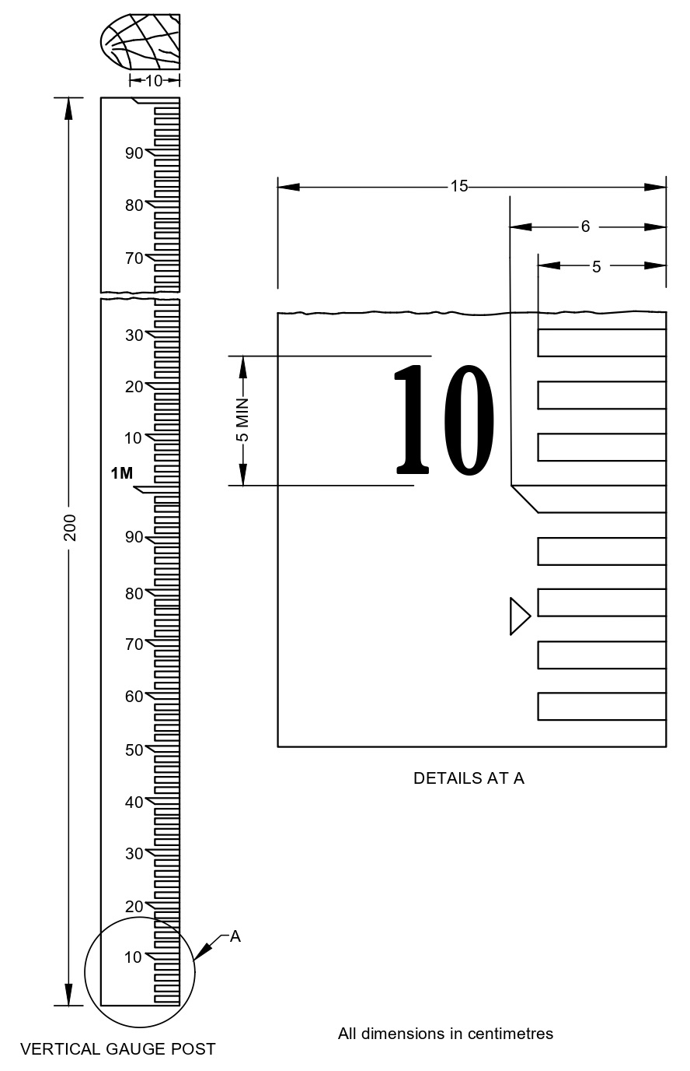

FIG. 1 TYPICAL DETAILS OF VERTICAL STAFF GAUGE

**ANNEX B**

(*Foreword*)

**COMMITTEE COMPOSITION**

Hydrometry Sectional Committee, WRD 01

|  |  |
| --- | --- |
| *Organization* | *Representative(s)* |
| Central Water & Power Research Station, Pune | Shri R.S. Kankara, (***Chairperson***) |
| Aimil Ltd, New Delhi | Shri Anurag Gupta  Shri Kuldeep Sharma (*Alternate*) |
| Bhabha Atomic Research Centre, Radiochemistry and Isotope Group, Mumbai | Shri H.J. Pant  Shri V.K. Sharma (*Alternate*) |
| Bhakra Beas Management Board, Punjab, Chandigarh | Director(Wr)  Senior Design Engineer (Wr) (*Alternate*) |
| Brahmaputra Board, Govt. Of India, Guwahati, Assam | Shri Sher Singh  Shri Shyamal Kumar Deka (*Alternate*) |
| Center For Water Resources  Development And Management Kozikode, Kerala | Dr Manoj P Samuel  Dr Celine George (*Alternate* 1)  Dr Drissia T. K. (*Alternate* 2) |
| Central Water & Power Research Station, Pune | Dr R. G. Patil  Shri B. Suresh Kumar (*Alternate*) |
| Central Water Commission, New Delhi | Shri G. K. Agarwal  Shri Pankaj Kumar Sharma (*Alternate* 1)  Shri N. N. RAI (*Alternate* 2) |
| Fluid Control Research Institute, Palakkad Kerala | Shri J. P. K. Suresh  Shri Gopan C. K. (*Alternate*) |
| Gujarat Engineering Research Institute, Vadodara Gujarat | Shri N. R. Makwana  SHRI V. R. Rathwa (*Alternate*) |
| India Meteorological Department, New Delhi | Shri B. P. Yadav |
| Indian Institute of Science, Bengaluru | Prof D. Nagesh Kumar |
| Indian Institute of Technology Madras | Dr Balaji Narasimhan  Dr Soumendra Nath Kuiry (*Alternate*) |
| Indian Institute of Technology Roorkee, Roorkee | Prof Ashish Pandey  Prof Sumit Sen (*Alternate*) |
| Indian Institute of Technology, New Delhi | Dr D. R. Kaushal  Prof S. Chakma (*Alternate*) |
| L &T – Sargent & Lundy Limited, Gujarat | Shri Yogendra D Mishra  Shri Karthik T (*Alternate*) |
| National Hydroelectric Power Corporation Limited, Faridabad | Smt Manjusha Mishra  Shri Shyan Dhar Shukla (*Alternate* 1)  Shri Sameer Shrivastav (*Alternate* 2) |
| National Institute of Hydrology, Roorkee | Dr Sanjay Kumar  Shri J. P. Patra (*Alternate*) |
| National Physical Laboratory, New Delhi | Dr A. K. Bandyopadhyay  Shri Shiv Kumar Jaiswal (*Alternate*) |
| National Remote Sensing Center, Hyderabad | Dr V. Venkateshwar Rao  Shri K. H. V. Durga Rao (*Alternate*) |
| National Water Development Agency, New Delhi | Shri K. P. Gupta  Shri Afroz Alam (*Alternate*) |
| Research Design and Standards Organization, Lucknow | Shri Pradip Kumar  Shri U. V. Singh (*Alternate*) |
| Sutron Hydromet Systems Pvt. Ltd., New Delhi | Shri Deepak Gupta  Shri Somesh Kumar (*Alternate*) |
| Water Resources Department, Govt. Of Punjab, Chandigarh | Shri H. S. Minhas  Shri Vijay Kumar (*Alternate*) |
| Water Resources Department. Govt. of Andhra Pradesh | Shri P. John Victor  Shri A.G. Manoj Kumar (*Alternate*) |
| Water Resources Organization, Public Works Deptt. Govt Of Tamil Nadu | Shri Er. S. Sridharan  Supted Engineer Design Wro (*Alternate*) |
| In Personal Capacity, *(G-601, Prateek Stylome,*  *Sector 45, Noida - 201 301)* | Dr Nayan Sharma |
| BIS Directorate General | Shri Dushyant Prajapati, Scientist ‘E’ /DIRECTOR AND HEAD (WATER RESOURCES) [REPRESENTING DIRECTOR GENERAL(*Ex-officio*)] |

*Member Secretary*

Shri Ajay Meena

Scientist ‘B’/Assistant Director

(Water Resources), BIS