***भारतीय मानक***

***Indian Standard***

**IS XXXX : 2024**

**कच्चा मूगा रेशम — ग्रेडिंग और परीक्षण पद्धतियाँ**

**Muga Raw Silk — Grading and Test Methods**

ICS 59.080.30

© BIS 2024

भारतीय मानक ब्यूरो

BUREAU OF INDIAN STANDARDS

मानक भवन, 9 बहादुर शाह ज़फर मार्ग, नई दिल्ली - 110002

MANAK BHAVAN, 9 BAHADUR SHAH ZAFAR MARG

NEW DELHI - 110002

www.bis.gov.in www.standardsbis.in

**December 2024 Price Group X**

Silk and Silk Products, Sectional Committee TXD 28

FOREWORD

This Indian Standard was adopted by the Bureau of Indian Standards after the draft finalized by the Silk and Silk Products Sectional Committee had been approved by the Textile Division Council.

Muga silk is distinguished by its golden-yellow hue, is an exclusive heritage of India, and a source of immense pride for the state of Assam. It is obtained from a semi-domesticated multivoltine silkworm, *Antheraea assamensis*. The Muga silk, a high-value product is used in products like sarees, mekhalas, chaddars, etc.The grading of Muga raw silk is very important for assessing the quality of the Muga silk and the subsequent products derived from it. The grading of Muga Silk will help the Muga silk reelers/producers to get the right value for their products and remove malpractices in the Muga silk trade.

For the grading of Mulberry raw silk and Tasar silk, BIS has already published IS 15090 (Parts 1 to 11) ‘Raw silk **—** Grading and methods of tests’ and IS 17618 (Parts 1 to 7) ‘Tasar Raw Silk — Grading and Test Methods’.

The composition of the Committee responsible for the formulation of this standard is listed in Annex G.

In reporting the result of a test or analysis made in accordance with this standard, if the final value, observed or calculated, is to be rounded off, it shall be done in accordance with IS 2: 2022 ‘Rules for rounding off numerical values (*second revision*)’.

*Indian Standard*

**MUGA RAW SILK — GRADING AND TEST METHODS**

**1 SCOPE**

This standard prescribes a method for the grading of Muga raw silk based on the major and auxiliary tests.

**2 REFERENCE**

The standards given below contain provisions, which through reference in this text, constitute provisions of this standard. At the time of publication, the editions indicated were valid. All standards are subject to revision and parties to agreements based on this standard are encouraged to investigate the possibility of applying the most recent editions of the standards.

|  |  |
| --- | --- |
| *IS No.* | *Title* |
| SP 45 : 1988 | Handbook on Glossary of Textile Terms |
| IS 232 : 2020 | Glossary of Textile Terms — Natural Fibres (*Third Revision*) |
| IS 18314 : 2023 | Terms Relating to Silk and Silk Processing — Glossary |

**3 TERMINOLOGY**

For the purpose of this standard, the following definitions in addition to those given in SP 45 : 1988 and IS 232 : 2020 shall apply.

**3.1 Book**—A compressed package of raw silk weighing about 1 kg and containing a suitable number of skeins.

**3.2 Conditioned Mass** —The mass of Muga raw silk obtained at a standard moisture regain of 11 percent.

**3.3 Hand** —The term ‘hand’ shall denote the feel of raw silk in terms of hardness and smoothness.

**3.4 Hank** —Silk reeled and removed from a reeling/re-reeling machine in the form of an open band. It shall be one continuous thread from the outer to the inner layers.

**3.5 Muga Raw Silk** —Muga raw silk is the thread reeled from several Muga cocoons and is understood to be a continuous thread from beginning to end of the skein which is made by tying all the breaks with good, clean knots.

**4 GRADES**

**4.1** The grades shall be expressed in the following order where A is the highest and F is the lowest merit: A, B, C, D, E, and F.

**4.1.1** *Lot Size for Grading / Unit Size for Grading*

The lot size for the purpose of grading shall be a lot of 10 *books* of 1 kg each or as agreed between buyer and seller.

**4.1.2** *Sorting of Bales*

If individual bales appear to be uniform in color, the consignment shall be sorted on the basis of color into groups.

NOTES

**1** All books as sorted out for the purpose of grading shall constitute a lot.

**2** In case a lot is required to be divided into groups, the number of sample skeins to be drawn from each group shall be proportional to the total number of books in each group.

**4.2 Preliminary Examination**

**4.2.1** The Raw Muga Silk shall be identified by the confirmatory test as specified in IS 667.

**4.2.2** The raw silk skeins, books, and bales shall conform to the requirements as given in **6**.

**4.2.3** The Conditioned mass of the bale shall be determined by the method prescribed in Annex A.

**4.3 General Finish of Skein**

The skein shall be inspected for defects and shall be marked based on the number of the defects such as Loop, Loose Ends, Protruding Ends, Slugs, Knots, Badcast, Waste (*see* Annex E).

|  |  |  |
| --- | --- | --- |
| **Sl No.** | **No. of defects in the skein** | **General Finish** |
| (1) | (2) | (3) |
| i) | 0 | Good |
| ii) | 1 | Fair |
| iii) | 2 and 3 | Poor |
| iv) | 4 or more | Inferior |

**4.4 Examination and Tests**

**4.4.1** Each sample lot of Muga raw silk shall be examined visually and tactually as specified in **4.2** and **4.3.**

**4.4.2** Each lot shall be evaluated for characteristics listed in Table 1.

**Table 1 Characteristics and Methods of Tests**

(*Clause* 4.4.2)

|  |  |  |
| --- | --- | --- |
| **Sl No.** | **Characteristics** | **Method of Tests, Ref to** |
| (1) | (2) | (3) |
| i) | Winding breaks | Annex B |
| ii) | Size of Muga raw silk | Annex C |
| iii) | CV of size | Annex C |
| iv) | Tenacity | Annex D |
| v) | Elongation | Annex D |

**5 METHOD OF CLASSIFICATION**

The grade of a lot shall be determined by comparing the test result values with the corresponding values given in classification in the following manner:

**5.1 Grading in Accordance with Major Test (CV of Size Test) (Basic Grade)**

The basic grade of a lot shall be determined according to the test result of the CV of size test of Muga raw silk as given in Table 2.

**5.2 Degrading in Accordance with the Auxiliary Tests**

If the observed test result values of winding breaks, tenacity and elongation is found to be lower than the corresponding value specified in the class of auxiliary tests, then the basic grade established in accordance with **5.1** shall be lowered by as many grades as the highest numerical difference that exists between required test class for basic grade and the class actually found on the lower side.

**5.3** The proforma as given in **8** and Annex F shall be used for the issuance of the grading certificate.

**Table 2 Classification for Muga Raw Silk**

(*Clause* 5.1)

|  |  |  |  |  |  |  |  |  |  |
| --- | --- | --- | --- | --- | --- | --- | --- | --- | --- |
| **Sl No.** | **Characteristic** | **Grade** | **A** | **B** | **C** | **D** | **E** | **F** | **Method of Tests,**  **Ref to** |
| (1) | (2) | (3) | (4) | (5) | (6) | (7) | (8) | (9) | (10) |
| i) | CV of Size  (Tex or Denier) | 60 D (6.7 Tex) and finer | ≤ 15 | 16 to 20 | 21 to 25 | 26 to 30 | 31 to 35 | ≥ 35 | Annex C |
| 61 to 90 D (6.8 to 10 Tex) | ≤ 12 | 13 to 15 | 16 to 20 | 21 to 25 | 26 to 30 | ≥ 30 |
| 91 to 120 D(10.1 to 13.3Tex) | ≤ 10 | 11 to 13 | 14 to 16 | 17 to 20 | 21 to 25 | ≥ 25 |
| 121 D (13.4 Tex) and coarser | ≤ 8 | 9 to 12 | 13 to 16 | 17 to 20 | 21 to 25 | ≥ 25 |
|  |  | **Class** | **(1)** | **(2)** | | **(3)** | **(4)** | **(5)** |  |
| ii) | Winding breaks (breaks/5skeins  /30 min.) | 90 d (10 Tex) and finer | ≤ 2 | 3 | | 4 | 5 | > 5 | Annex B |
| 91 d (10.1 Tex) and coarser | ≤ 1 | 2 | | 3 | 4 | > 4 |  |
|  |  | **Class** | **(1)** | | | **(2)** | | **(3)** |  |
| iii) | Tenacity (g/denier) |  | ≥ 2.9 | | | 2.4 to 2.8 | | < 2.4 | Annex D |
| Elongation, percent | ≥ 27 | | | 22 | | <22 |

**6 REELING AND PACKING OF MUGA RAW SILK**

**6.1 Reeling**

**6.1.1** Muga raw silk shall be carefully cross-reeled on reels of 150 cm ± 2 cm circumference into hanks each weighing approximately 25 g. Each hank shall be of one continuous thread made by tying all breaks with a good knot and with a loose end of the knot not more than 3 mm in length. The outside end and the inside end of the thread shall be tied round the hank in such a way that it can be easily traced while winding.

**6.1.2** Each hank shall be carefully and neatly ‘laced’ at places equally spaced using fine soft twisted, un-dyed cotton or spun silk yarn.

**6.1.3** Each lacing shall pass through at least 5 diamonds in the width of the hank and be neatly tied so that each knot is about 1 cm from the edge of the hank and the loose ends of the knots do not exceed 1 cm in length from the knot.

**6.1.4** Each prepared hank shall be given 2 to 3 turns from one end to the other, and both ends shall be joined and wrapped with the lacing thread.

**6.2 Packaging**

**6.2.1** Suitable number of skeins prepared as given in **4.1.1** shall be made into neat books, each weighing approximately 1 kg of equal dimensions on a skein book-making machine. Each such book shall be neatly tied with separate cotton bands at three or five different places and wrapped with light packing paper.

**6.2.2** The net mass of Muga raw silk in a lot shall be 10 kg.

**7 MARKING**

**7.1** The Raw Muga Silk shall be suitably marked with the following information:

1. Manufacturer’s name, initials, or trade-mark;
2. Colour [(a) Light (b) Medium (c) Deep],
3. Luster [(a) Bright (b) Medium (c) Dull] and
4. General finish [(a) Good (b) Fair (c) Poor (d) Inferior]
5. Linear density (size);
6. Category and Grade;
7. Conditioned mass of bale;
8. Batch No. or Lot No.; and
9. Any other information as required by the buyer or the law in force.

**7.2 BIS Certification Marking**

The product(s) conforming to the requirements of this standard may be certified as per the conformity assessment schemes under the provisions of the *Bureau of Indian Standards Act*, 2016 and the Rules and Regulations framed there under, and the products may be marked with the Standard Mark.

**8 GRADING CERTIFICATE OF MUGA RAW** **SILK**

**8.1** The proforma for grading the certificate of Muga raw silk is as follows:

1. Grading certificate No :
2. Mark of the lot :
3. Serial no. of bales in lot :
4. Name of chop :
5. No. of bales in the lot :
6. Average conditioned size :

|  |  |  |  |  |  |  |  |  |
| --- | --- | --- | --- | --- | --- | --- | --- | --- |
| **Sl No.** | **Character** | **Observed Value** | **Corresponding Major Test grade** | **Character** | **Observed Value** | **Corresponding Auxiliary test class** | **Required Auxiliary**  **Test Class** | **Difference in the case of deficient auxiliary test value** |
| (1) | (2) | (3) | (4) | (5) | (6) | (7) | (8) | (9) |
| i) | CV of Size | 16.5 | C | Winding Breaks | *2* | *1* | *2* | *0* |
| ii) |  |  |  | Tenacity (g/denier) | *2.9* | *1* | *1* | *0* |
| iii) |  |  |  | Elongation (%) | *25* | *2* | *1* | *1* |
| iv) | Grade “C” is lowered by (1) grade, i.e = D  Overall Grade = D grade. | | | | | | | |

**ANNEX A**

(*Clause* 4.2.3)

**DETERMINATION OF NET MASS AND CONDITIONED MASS**

**A-1 METHOD FOR DETERMINATION OF NET MASS**

**A-1.1 Procedure**

**A-1.1.1** Select a bale from the lot and carefully remove the jute cloth. Weigh the bale with its cotton shirt on and record the gross mass. Subsequently, remove the cotton shirt and calculate its mass.

**A-1.1.2** Note down the number of books in the bale. Select at random 5 books from the bale. Remove their packing paper and labels, if any, and determine their mass. Carefully take out the middle cotton band of each of the 5 books and determine the collective mass of the 5 bands. Multiply this value by 3 or 5 as the case may be, to obtain the mass of all the cotton bands on the 5 books.

**A-1.2 Calculation**

**A-1.2.1** Calculate the tare per book by the following formula:

$$T_{1}=\frac{M_{1}+M_{2}}{5}$$

Where,

$T_{1}$ = Tare per book,

$M_{1}$ = Mass of packing paper and the label, and

$M_{2}$ = Mass of all cotton bands.

**A-1.2.2** Calculate the total tare of the bale by the following formula:

$T_{2}$ = *n $T_{1}$* + $M_{3}$ = 12 $T_{1}$ + $M_{3}$

where

$T_{2}$ = Total tare of bale;

*n* = Number of books in the bale, which is 12;

$M_{3}$ = Mass of the cotton shirt; and

$T_{1}$ = Tare per book.

**A-1.2.3** Calculate the net mass of the bale by the following formula:

*\*

*M* = *G* – $T_{2}$

Where

*M* = Net mass of the bale;

*G* = Gross mass of the bale (*see* **A-1.1.1**); and

$T_{2}$ = Total tare of the bale (*see* **A-1.2.2**).

**A-1.3** Determine the net mass of the remaining bales similarly.

**A-1.4** After putting on the middle cotton bands and wrapping the books with the packing paper, replace them in the respective bales from which they were drawn. Seal the bales with identification tickets inside.

**A-2** **DETERMINATION OF CONDITIONED MASS**

**A-2.1 Test Sample**

Six skeins, drawn from books at the rate of one skein per book, shall constitute the test sample. The drawing of the books from the bales in the lot shall be equally distributed as far as possible. The books shall be drawn from different parts of the bale. While drawing skeins, each skein shall be drawn from a different part of the book. The skeins shall be divided into 2 sets of 3 skeins each.

NOTES

**1** The skeins should be drawn at the time when the net mass of the bale is determined. The two sets of skeins should be immediately weighed and their mass recorded separately.

**2** After the skeins have been drawn, the books shall be replaced in the respective bales.

**A-2.2 Apparatus**

**A-2.2.1** *Weighing Balance*

Platform type balance with a capacity of one hundred kilograms and least count of 0.1 kg.

**A-2.2.2** *Skein Balance*

Balance to weigh skeins with a capacity of one kilogram and a least count of 0.1 g.

**A-2.2.3** *Oven*

The conditioning oven with forced ventilation, positive valve control, and capable of drying the sample skeins at 140 °C shall be equipped with a balance arranged to weigh the skeins with an accuracy of 0.1 g while suspended within the drying chamber. The holder of the skeins shall ensure free access to the dry air for all skeins.

**A-2.3 Procedure**

**A-2.3.1** The two sets of 3 skeins each shall be weighed on the skein balance nearest to a centigram, in the same ambient atmosphere surrounding the bale as sampled (*see* Note under **A - 2.1**).

**A-2.3.2** Place one set of 3 skeins in the conditioning oven, dry it for 15 min, and weigh to the nearest 0.1 g. Allow the skeins to dry for another 5 min and weigh to the nearest 0.1 g. The second weighing shall be taken as oven-dry mass provided the loss between the first and second weighing does not exceed 0.25 percent of the first weight. If the loss between the first and second weighing exceeds 0.25 percent, the skeins shall be dried and weighed again at 5-minute intervals until the loss between successive weighing does not exceed 0.25 percent.

**A-2.4 Calculation of Moisture Content**

**A-2.4.1** The moisture content percent of the set of skeins shall be calculated by the following formula:

Moisture content, percent = $\frac{M_{1}-M_{2}}{M_{1}}×100$

Where

$M_{1}$ = Mass of a set of test skeins before drying; and

$M_{2}$ = Mass of the same set of test skeins after drying.

**A-2.4.2** Repeat the test with the remaining set of skeins and calculate the moisture content in percentage. The average moisture content (m) of the two sets of test skeins shall be calculated.

**A-2.4.3** If the two results differ by more than 0.5 percent, the test shall be repeated.

**A-2.5 Determination of Conditioned Mass of the Bales**

**A-2.5.1** The bales under test shall be weighed individually on the platform scale. The net weight of the bale shall be calculated by deducting the tare.

**A-2.5.2** All materials used in packing the raw silk shall be considered as tare, except the cotton lacings in the skeins, provided these lacings do not exceed one meter per skein.

**A-2.5.3** The oven-dry mass of the bale shall be calculated as given below:

Oven dry mass of the bale, D = $M_{n}(1-m/100)$

Where

$M_{n}$ = Net mass of the bale (*see* **A-2.5.1**), and

*m* = Moisture content, percent as obtained in **A-2.4.2** or **A-2.4**.**3**

**A-2.5.4** The conditioned mass of the bale shall be calculated by the following formula:

Conditioned mass of the bale = D + $\frac{(D×11)}{100}$

Where,

*D* = Oven-dry mass of the bale calculated as in **A-2.5.3**.

**A-3 RECORD AND REPORT**

The proforma as given in the following format shall be used for recording the test data and reporting the results of the test.

**A-3.1** Calculation of average moisture content in the bale*:*

1. Mass in g of the first set of skeins before drying
2. Oven-dry mass in g of the first set of skeins
3. Moisture content, percent, of the first set of skeins, *m*1
4. Mass in g of the second set of skeins before drying
5. Oven-dry mass in g of the second set of skeins
6. Moisture content, percent, of the second set of skeins, *m*2 .
7. Average moisture content, percent 𝑚1+ 𝑚2 = *m*

2

**A-3.2** Calculation of the conditioned weight of the bale: kg

* 1. Mass of 'shirt' (*M*cs)
  2. Mass of wrapping papers and labels of 5 books (*M*p1)
  3. Gross mass of the bale (*M*)
  4. Mass of middle cotton bands of 5 books × 3(3*M*mcb)
  5. Net mass of the bale *M*n = (*M* – *T*)
  6. Tare of 5 books = (*M*pl + 3*M*mcb)
  7. Oven-dry mass of the bale *D* = *M*n(l-m/100)
  8. Tare of one book = (*M*pl + 3*M*mcb)/5
  9. Tare of all the books (*n*) in of the bale (1.11D)
  10. Conditioned weight
  11. Total tare of the bale (T = *n*(*M*pl + 3*M*mcb)/5 + *M*cs)

**ANNEX B**

[*Table* 1, Sl No. (i), Table2, Sl No. (ii)]

**CONDUCTING WINDING TEST**

**B-1 TEST SAMPLE**

The sample for the test shall be 5 skeins.

**B-2 ATMOSPHERIC CONDITIONS FOR CONDUCTING THE TEST**

The test shall be carried out in a standard atmosphere i.e. at 65 ± 2 percent relative humidity and (27 ± 2) ºC temperature.

**B-3** **CONDITIONING OF TEST SAMPLE**

Prior to the test, the test sample shall be conditioned for a duration of 24 hrs in a standard atmosphere i.e. at 65 ± 2 percent relative humidity and 27ºC ± 2 ºC temperature.

**B-4 APPARATUS**

**B-4.1 Winding Frame**

The winding frame shall be equipped to drive the double-flanged bobbins from both ends and shall be capable of winding at a uniform speed of 90 m/min.

**B-4.1.1** *Drive*

Bobbins are mounted on frictionless ball bearings & driven by a circular wheel.

**B-4.1.2** *Swift*

Swift with variable circumference adjustable mechanism to accommodate skeins with 150 ± 5 cm circumference.

**B-4.1.2** *Bobbin*

Double flanged bobbin which is well-balanced and has a smooth surface to give regular tension and uniform angular speed. Dimensions – Dia of flange 60mm, Dia of barrel – 38mm, Length between flanges – 85 mm, weight - approximately 105g.

**B-5 APPARATUS**

Out of 5 skeins, two skeins shall be wound from the inner surface and the remaining 3 shall be wound from the outer surface of the skeins. The sample skeins shall be put on the swifts with care to ensure that each skein is in good condition. The break counting period shall be for a duration of 30 minutes or till the thread in the skein exhausts, with a provision of preliminary winding of 5 minutes for the skeins with ends drawn from the inner side of the skeins. The breaks that occurred during the specified period shall be counted and recorded.

**B-6 RECORD**

The results of the winding test shall be recorded in the proforma for record and report given in Annex F-5.

**ANNEX C**

[*Table* 1, Sl. No. (ii) and (iii)]

**DETERMINATION OF SIZE (LINEAR DENSITY)**

**C-1 TEST SAMPLE**

A test sample shall consist of five bobbins specifically prepared for the purpose of conducting the winding test.

**C-2 ATMOSPHERIC CONDITIONS FOR CONDUCTING THE TEST**

The test shall be carried out in a standard atmosphere i.e. at 65± 2 percent relative humidity and (27 ± 2) ºC temperature.

**C-3** **CONDITIONING OF TEST SAMPLE**

Prior to the test, the test sample shall be conditioned for a duration of 24 hrs in a standard atmosphere i.e. at 65 ± 2 percent relative humidity and 27ºC ± 2 ºC temperature.

**C-4 APPARATUS**

**C-4.1 Size Frame/ Wrap Reel**

A machine for making the sizing skeins shall have a reel circumference of 1.125 meters or 1 meter revolving at a uniform speed of 20 rotations per minute. It shall be provided with a dial or counter to show the number of revolutions that occurred. Automatic thread stop motion may also be incorporated to stop the reel immediately in case the thread breaks.

**C-4.2 Yarn Balance**

A quadrant balance or an autosorter (i.e. electronic weighing balance with the in-built processor or computer control) shall be used to determine the count in the denier or tex. The sensitivity of the balance shall be 0.25 D or 0.025 Tex.

**C-5 PROCEDURE**

**C-5.1** Skeins (Kilchas) each 45 m in length shall be reeled from each bobbin, Five bobbins constituting the test samples shall be placed horizontally on the wrap reel so that the unwinding of the thread will be convenient. Four sizing skeins (Kilchas) each of 45m in length shall be reeled from each bobbin, preparing a total of 20 sizing skeins. The sizing skeins shall be conditioned (*see* **C-3**).

**C-5.2** Each sizing skein shall be weighed separately on a yarn balance (*see* **C-4.2**) and the values shall be recorded.

**C-6 CALCULATION**

**C-6.1** If a quadrant balance is used for the yarn weight measurement, the recorded values are statistically analyzed to determine the average value and the coefficient of variation for the size values.

**C-6.2** If an autosorter type of yarn balance is used for the yarn weight measurement, the output is programmed to get the average value and the percentage of coefficient of variation.

**C-7 RECORD**

The size test results shall be recorded in the proforma for record and report as given in Annex F-2.

**ANNEX D**

[*Table* 1, Sl. No. (iv) and (v) and *Table* 2, Sl. No. (iii)]

**DETERMINATION OF TENACITY AND ELONGATION**

**D-1 TEST SAMPLE**

The sample skeins for the test shall be taken from the size skeins prepared for the size test. The ten number of samples shall be drawn for the test.

**D-2 ATMOSPHERIC CONDITIONS FOR CONDUCTING THE TEST**

The test shall be carried out in a standard atmosphere i.e. at 65± 2 percent relative humidity and (27 ± 2) ºC temperature.

**D-3** **CONDITIONING OF TEST SAMPLE**

Prior to the test, the test sample shall be conditioned for a duration of 12 hrs in a standard atmosphere i.e. at 65±2 percent relative humidity and 27ºC ± 2 ºC temperature.

**D-4 APPARATUS**

**D-4.1 Serigraph**

A constant rate of traverse pendulum type yarn strength testing machine, graduate in grams and capable of recording simultaneously the breaking load and the corresponding elongation of the threads shall be used. The machine shall be power-driven so that the moving clamp has a traverse of 30 cm/min. The distance between the clamps shall be adjustable to 10 cm. The clamps for gripping the threads shall be equipped with pneumatic grippers so as to avoid slippage during testing.

**D-4.2 Universal Tensile Testing Machine (UTM)**

A constant rate of extension type yarn testing machine, capable of recording electronically the breaking load and the corresponding elongation of the threads, shall be used. The machine shall be power-driven so that the moving clamp has an extension of 30 cm/min. The distance between the clamps shall be adjustable to 10 cm. The clamps for gripping the threads shall be equipped with pneumatic grippers so as to avoid slippage during testing.

**D-4.3 Wrap Reel and Balance**

The same equipment as used in the size testing of Muga raw silk (*see* **C-4**).

**D-5 PROCEDURE**

**D-5.1** The size (Tex/Denier) of each test skein shall be determined as prescribed (*see* **Annex C**). Take one skein and firmly clamp it between the two jaws, ensuring that the threads are drawn parallel, straight, and taut. The total length of the threads between the jaws should be 10 cm. Ensure that all threads are evenly taut without excessive stretching, and confirm that no portion of the test skein outside the clamps is subjected to the tensile force from the machine.

**D-5.2** The machine is operated in such a way that the moving clamp shall traverse at the rate of 30 cm/min.

**D-5.3** The test shall be repeated for the remaining test skeins.

**D-6 CALCULATION**

Calculate the tenacity of each test skein by the following formula:

Tenacity in g per tex (or g per denier) = $\frac{z}{n×d}$

Where

*z* = breaking load in g of test skein

*n* = number of strands used

*d* = tex (or denier) of test skein.

**D-7 RECORD**

The result shall be indicated by the average of the results of ten test samples. The result of tenacity shall be rounded off to one decimal place and that of elongation to a whole number. The proforma for record and report as given in Annex F-6shall be used for recording the test data and reporting test results.

**ANNEX E**

(*Clause* 4.3)

**STANDARD IMAGES OF DEFECTS OF MUGA SILK**

**E-1 TEST SAMPLE**

The sample shall consist of 3 test pieces taken from 3 bobbins randomly drawn from 5 bobbins prepared at winding test (*see* Annex B).

**E-2 ATMOSPHERIC CONDITIONS FOR TESTING**

The test shall be carried out in a standard atmosphere i.e. at 65 ± 2 percent relative humidity and (27 ± 2)º C temperature.

**E-3 APPARATUS**

**E-3.1 Inspection Board**

The board used for winding the Muga yarn to check the defects is made of either wood covered by black-coloured non-glazy material or an aluminum board coated with non-reflective jet-black painting so that the surface of the yarn is clearly visible. A total of 90 meters of yarn shall be wound around the board, with a spacing of 1 mm and a circumference of 50 cm for each revolution.

**E-3.2 Inspection Board**

An apparatus that rotates the inspection board with a constant rotation of less than 50 rpm so that the yarn is wounded side by side so as to facilitate for clear image of yarn surface and defects. It will feature a mechanism that applies minimal tension to the yarn, ensuring an uninterrupted flow of defects onto the inspection board.

**E-3.3 Inspection Area/Place**

A chamber equipped with D65 lighting provides ample illumination from above the inspection board at an angle of approximately 5 degrees, ensuring that the surface of yarn is clearly visible.

**E-4 PROCEDURE**

To prepare inspection boards, randomly three bobbins are drawn from each sample lot. Mount the boards securely on the board winder and wind the filaments from each bobbin side by side onto the board, maintaining a slight tension. This helps in displaying the yarn surface and any potential defects. Once the winding is complete, visually inspect the wound filaments on the board and use the standard images of defects as provided in **E-6** as a reference. Identify and classify any defects present, such as loop/loose ends, slugs, waste, and knots.

**E-5 RECORD**

The results of the test shall be indicated by the number and the type of defects observed. This standard serves as a reference and guidance; thus, the number of defects provides valuable insight into the overall quality of Muga silk. A higher number of defects indicates poorer quality, while a lower number of defects signifies better quality.

**E-6 IMAGES OF MUGA SILK DEFECTS AND THEIR TYPES**

**6.1** **Loop** — These aresmall openings in the thread, resulting from the excessive length of one or more cocoon filaments, typically measuring less than 10 mm in length when evaluated along the filament (*see* Fig. 1).

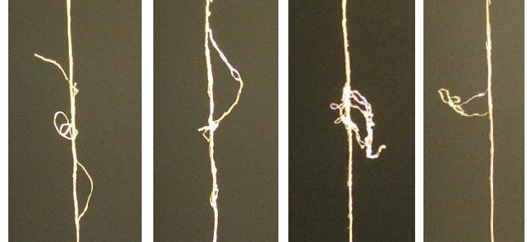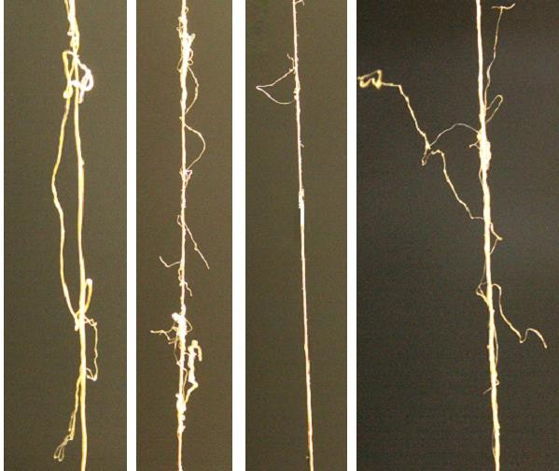

Fig. 1 Loop

**6.2** **Loose Ends** — These aresmall loops or split ends, 10 mm and above in length when measured along the length of filament (*see* Fig. 2).

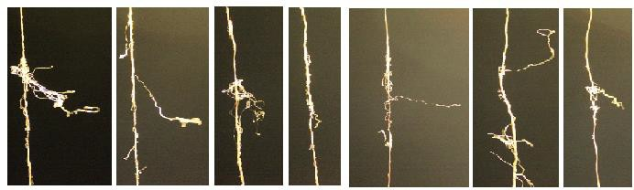

Fig. 2 Loose Ends

**6.3** **Protruding Ends** — Some cocoon filaments extend beyond and protrude out of the main yarn structure (*see* Fig. 3).

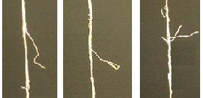

Fig. 3 Protruding Ends

**6.4** **Slugs** — These are considerably thickened places in the thread that are seven millimeters or longer, or areas that are extremely thick but measure less than that (*see* Fig. 4).

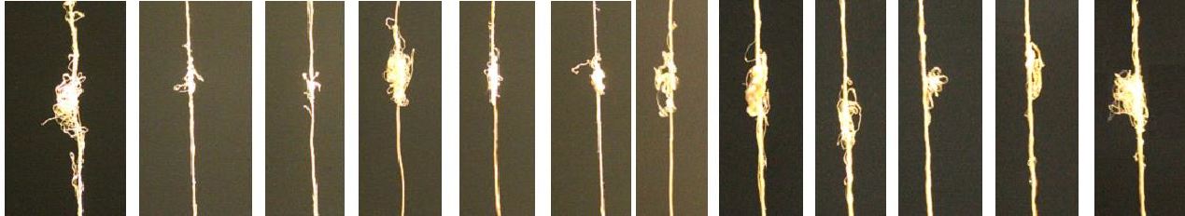

Fig. 4 Slugs

**6.5** **Knots** — Knots that possess loose ends measuring 10 mm or longer, or those resulting from improper tying of threads (*see* Fig. 3).

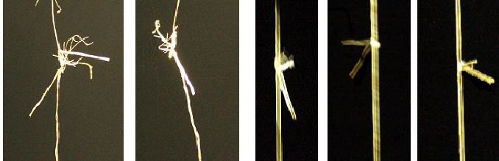

Fig. 5 Knots

**6.6** **Badcast** — These are abrupt thickened places in the thread caused by improper attachment of cocoon filaments to the raw silk thread, or resulting from the addition of multiple cocoon filaments simultaneously (*see* Fig. 6).

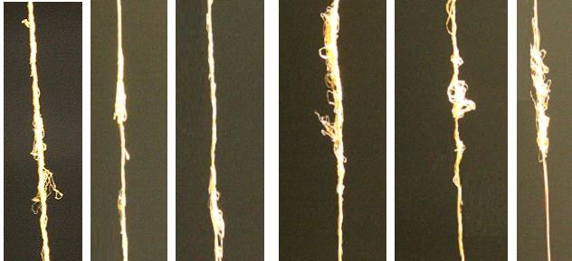

Fig. 6 Badcast

**6.7** **Waste** — A mass of tangled cocoon filaments or fibers that are attached to the thread (*see* Fig. 7).

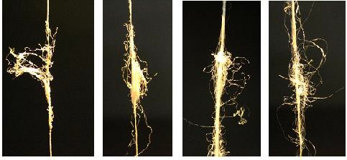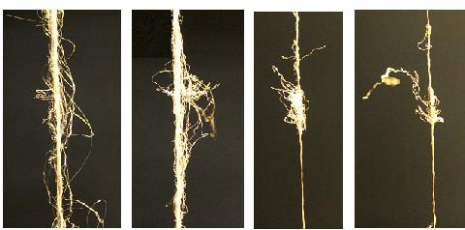

Fig. 7 Waste

**ANNEX F**

|  |  |  |
| --- | --- | --- |
| **Sl No.** | **Mass of the bale** |  |
| (1) | (2) | (3) |
| i) | No. of books or bundles in a bale |  |
| ii) | Mass of a book or bundle |  |
| iii) | Manner of packing of the lot |  |
| iv) | Skein formation |  |
| v) | Skein weight (g) |  |
| vi) | Crossing of the skeins |  |
| vii) | Circumference of the skeins |  |
| viii) | Reeling device/Domestic basin/Cottage basin/Charkha/Multiend/Automatic |  |

|  |  |  |  |  |
| --- | --- | --- | --- | --- |
| **Skein no.** | **Denier (tex) of test skein** | **Breaking load (gf)** | **Tenacity (gf/d or gf/tex)** = 𝒛  𝒏 𝒙 𝒅 | **Elongation (percentage)** |
| (1) | (2) | (3) | (4) | (5) |
| 1 |  |  |  |  |
| 2 |  |  |  |  |
| 3 |  |  |  |  |
| 4 |  |  |  |  |
| 5 |  |  |  |  |
| 6 |  |  |  |  |
| 7 |  |  |  |  |
| 8 |  |  |  |  |
| 9 |  |  |  |  |
| 10 |  |  |  |  |
| Total | | |  |  |

|  |  |  |
| --- | --- | --- |
|  |  |  |
|  |  |  |
|  |  |  |
|  |  |  |
|  |  |  |
|  |  |  |
|  |  |  |
|  |  |  |
|  |  |  |
|  |  |  |

|  |  |  |  |  |
| --- | --- | --- | --- | --- |
|  |  |  |  |  |
|  |  |  |  |  |
|  |  |  |  |  |
|  |  |  |  |  |
|  |  |  |  |  |
|  |  |  |  |  |
|  |  |  |  |  |
|  |  |  |  |  |
|  |  |  |  |  |
|  |  |  |  |  |
|  |  |  |  |  |
|  |  |  |  |  |
|  | | |  |  |

(*Clause 5.3*)

|  |  |  |
| --- | --- | --- |
| **Skein no.** | **Breaks in preliminary winding** | **Breaks during winding** |
| (1) | (2) | (3) |
| 1 |  |  |
| 2 |  |  |
| 3 |  |  |
| 4 |  |  |
| 5 |  |  |
|  | Total |  |

|  |  |  |
| --- | --- | --- |
|  |  |  |
|  |  |  |
|  |  |  |
|  |  |  |
|  |  |  |
|  |  |  |
|  |  |  |
|  |  |  |

|  |  |
| --- | --- |
| * 1. **GRADING**   **F-1.1** Mark of the lot:  **F-1.2** Serial no. of bales in the lot: **F-1.3** Conditioned mass of the bale **F-1.4** Grade   * 1. **REPORT OF SIZE TEST OF MUGA RAW SILK**   **F-2.1** Yarn balance used: **F-2.2** Nominal denier of lot:  **F-2.3** Average size of the lot: denier/Tex  **F-2.4** Coefficient variation of size: % | **F-5 WINDING TEST OF MUGA RAW SILK**  **F-5.1** Starting time: Nominal denier of lot:  **F-5.2** Ending time: Speed of winding (m/min):  **F-5.3** Total Time:  **F-5.4** Breaks per 5 skeins per 30 min:  **F-5.5** Remarks: |
| **F-3 PRELIMINARY INSPECTION**  Preliminary examination of external characters:  Remarks:   1. Admixture of commercial varieties of Muga raw silk 2. Adulteration in any manner: 3. Other peculiarities: Lot accepted / rejected for grading   **F-4 VISUAL AND TACTUAL EXAMINATION**  **F-4.1** a) General Finish :  (a)Good (b)Fair (c)Poor (d)Inferior  **F-4.2** b) Nature :   1. Degree of Colour (Golden yellow colour)   (a) Light (b) Medium (c) Deep   1. Lustre    1. Bright (b) Medium (c) Dull 2. Hand    1. Smooth (b) Medium (c) Rough Presence of abnormal defect if any: |
| **F-6 TENACITY AND ELONGATION TEST OF MUGA RAW SILK**  **F-6.1** Nominal denier of lot:  **F-6.2** Number of strands tensioned:  Average tenacity (gf/d or gf/tex): = 𝑇𝑜𝑡𝑎𝑙 𝑜𝑓 𝑐𝑜𝑙𝑢𝑚𝑛 4  10  Average elongation (percentage): = 𝑇𝑜𝑡𝑎𝑙 𝑜𝑓 𝑐𝑜𝑙𝑢𝑚𝑛 5  10 |

**ANNEX G**

(*Foreword*)

**COMMITTEE COMPOSITION**

Silk and Silk Products, Sectional Committee TXD 28

|  |  |
| --- | --- |
| *Organization* | *Representative* |
| Central Silk Board, Bangalore | DR. S. PERIYASAMY **(*Chairperson*)** |
| Anwar Silk Industries, Sidlaghatta, Karnataka | SHRI IRSHAD AHMED |
| Central Silk Technological Research Institute, Bangalore | DR. Y. C. RADHALAKSHMI  DR. NIVEDITA S. (*Alternate*) |
| Central Silk Board, Bengaluru | DR. P. KUMERESAN |
| Chamundi Textiles (Silk Mills) Limited, Bangalore | SHRI SHASHI SHETTY  SHRI VENU GOPAL (*Alternate*) |
| Directorate of Handlooms & Textiles, Guwahati, Assam | SHRI ATAUR RAHMAN  SHRI NAREN MALAKAR (*Alternate*) |
| Directorate of Handicraft and Handloom, Kashmir, Jammu & Kashmir | SHRI IMTIYAZ AHMAD DAR  SHRI ZAHOOR AHMAD KHAN (*Alternate*) |
| Directorate of Handlooms and Textiles, Govt of Tamilnadu, Chennai | SHRI MINNU SWAMY |
| Indian Silk Export Promotion Council, Mumbai | SHRI SANJEEV KUMAR SHARMA |
| Indian Institute of Chemical Technology, Hyderabad | DR. PRADOSH P. CHAKRABARTI |
| Jaipuria Silk Mills, Bangalore | SHRI VIKRAM JAIPURIA |
| Karnataka State Sericulture Development Institute, Bangalore | SHRI V. H. MAHARADDI  SHRI A. JAMBUNATH (*Alternate*) |
| Khadi and Village Industries Commission, Mumbai | SHRI D. DHANPAL  SHRI J. K. GUPTA (*Alternate*) |
| Lakshmi Weaving Factory, Bangalore | SHRI DINESH PALLEM  SHRI RAVINDRA PALLEM (*Alternate*) |
| National Handloom Development Corp. Ltd., Lucknow | SHRI JITENDRA TOLAMBIYA |
| Office of the Development Commissioner for Handlooms, New Delhi | DR. AMIN HIRENBHAI |
| Office of Director of Handlooms & Textiles, Govt. of Karnataka, Bangalore | MS VRINDA |
| Office of the Textile Commissioner, Mumbai | SHRI SOURABH KULKARNI  SHRI PRANAV PARASHAR (*Alternate*) |
| Shri Ram Institute for Industrial Research, Delhi | SHRI VINAY SAMANIA  SHRI BHUVNESHWAR RAI (*Alternate*) |
| Silk Mark Organization of India, New Delhi/ Bangalore | SHRI K. S. GOPAL  SHRI A. SUBBARAJ (*Alternate*) |
| Textiles Committee, Mumbai | SHRI KARTIKAY DHANDA  DR P. RAVICHANDRAN (*Alternate*) |
| The Bombay Textile Research Association, Mumbai | SHRIMATI SHITAL PALASKAR  SHRI AMOL THITE (*Alternate*) |
| The Tamilnadu Handloom Weavers’ Coop Society Ltd., Chennai | SHRI G. GUNASEKARAN  SHRI ALOK BABELAY (*Alternate*) |
| BIS Directorate General | SHRI J. K. GUPTA, SCIENTIST ‘E’ AND HEAD (TXD)  [REPRESENTING DIRECTOR GENERAL (*Ex-officio*)] |
| MEMBER SECRETARY  MS SHIKHA YADAV  SCIENTIST ‘B’ (TXD), BIS | |