DOC.: TXD 23 (26906)

**AMENDMENT NO. 3 NOVEMBER 2024**

**TO**

**IS 16703 : 2017 TEXTILES — HIGH DENSITY POLYETHYLENE ( HDPE ) / POLYPROPYLENE ( PP ) WOVEN SACKS FOR PACKAGING OF 25 KG POLYMER MATERIALS — SPECIFICATION**

[*Page* 2, *Clause* 4.3, *Figure* 1] **—** Substitute the following for the existing:

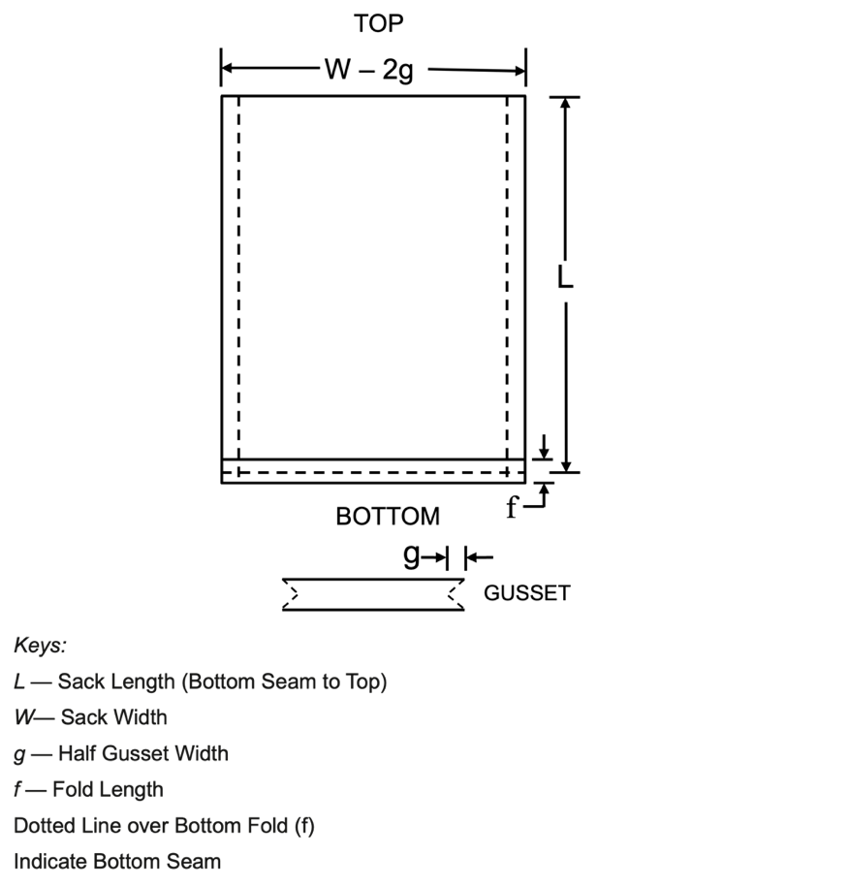

FIG.1 DIMENSIONAL DESIGNATIONS OF GUSSETED SACK WITH CLOSED GUSSET

[*Page* 3, *Table* 1, *Note* 1] **—** Substitute the following for the existing:

“**1** The dimensions and mass of sack given in Table 1 is suggestive. Fabric mesh and sack dimensions may vary according to the material to be packed and its bulk density. The buyer and the seller may agree to the mesh and sack dimensions other than those specified in Table 1. However, tolerances as specified in Table 1 shall apply. The mass of sack with dimensions other than those specified shall be calculated by the method given in Annex E. The tolerances on mass of individual sack shall be ± 6 percent. In case of gusseted sacks, the width of sacks shall be measured after opening of gusset.”

(TXD 23)