***भारतीय मानक***

***Indian Standard***

**IS 13137: 2024**

***वस्त्रादि — ऑटोमोटिव टायरों के लिए निम्मज्जित पॉलीएमाइड टायर कॉर्ड***

***का कपड़ा — विशिष्टि***

*( दूसरा* पुनरीक्षण )

**TEXTILES — DIPPED POLYAMIDE TYRE CORD FABRIC FOR AUTOMOTIVE TYRES — SPECIFICATION**

(  *Second Revision )*

ICS 59.080.30

© BIS 2024

भारतीय मानक ब्यूरो

BUREAU OF INDIAN STANDARDS

मानक भवन, 9 बहादुर शाह ज़फर मार्ग, नई दिल्ली - 110002

MANAK BHAVAN, 9 BAHADUR SHAH ZAFAR MARG

NEW DELHI - 110002

[www.bis.gov.in](http://www.bis.org.in) [www.standardsbis.in](http://www.standardsbis.in)

**September 2024 Price Group X**

Technical Textiles for Mobiltech Applications Sectional Committee, TXD 38

FOREWORD

This Indian Standard (Second Revision) was adopted by the Bureau of Indian Standards, after the draft finalized by the Technical Textiles for Mobiltech Applications Sectional Committee had been approved by the Textiles Division Council.

Polyamide tyre cords play a pivotal role in enhancing the strength and resilience of automotive tyres. Their high tensile strength and flexibility contribute to improved performance and safety on the roads. This Indian Standard on polyamide tyre cords further ensures that these cords meet quality and safety benchmarks, assuring consumers of reliable and durable tyres for automotive vehicles.

IS 11926 ‘Specification for polyamide tyre cord fabric for automotive tyres’ covers the requirements of polyamide tyre cord fabric in an undipped stage. However, this standard is formulated to cover the requirements of polyamide tyre cord fabric in the dipped stage.

This standard was first published in 1991 and subsequently revised in 2003. The second revision has been made in the light of experience gained since its last revision and to incorporate the following major changes:

1. Title of the standard has been modified;
2. Scope of the standard has been modified to incorporate the two additional varieties of yarn

with nominal linear density of 280 (2 ply) and 315 (2 ply);

1. Additional requirements such as thickness, shrinkage, dip pick-up, adhesion, and stiffness

have been incorporated and the elongation is calculated at two additional predetermined

loads 133 N and 153 N as per the current industrial practices;

1. Existing varieties have been rationalised to align the requirements of breaking strength,

elongation at predetermined load, elongation at breaking load as per the current industrial

practices;

1. Requirements of linear density of dipped tyre cord have been removed as per the current

industrial practices;

1. Marking clause has been updated; and
2. References to the Indian standards have been updated.

The composition of the Committee responsible for the formulation of this standard is given in Annex C.

For the purpose of deciding whether a particular requirement of this standard is complied with, the final value, observed or calculated, expressing the result of a test or analysis, shall be rounded off in accordance with IS 2 : 2022 ‘Rules for rounding off numerical values (*second revision*)’. The number of significant places retained in the rounded-off value should be the same as that of the specified value in this standard.

*Indian Standard*

**TEXTILES — DIPPED POLYAMIDE TYRE CORD FABRIC FOR AUTOMOTIVE TYRES — SPECIFICATION**

*( Second Revision )*

**1 SCOPE**

The standard prescribes the requirement of nine varieties of dipped polyamide tyre cord fabric for the manufacturing of automotive tyres.

**2 REFERENCES**

The standards listed in Annex A contain provisions which through reference in this text, constitute provisions of this standard. At the time of publication, the editions indicated were valid. All standards are subjected to revision, and parties to agreements based on this standard are encouraged to investigate the possibility of applying the most recent editions of the standards indicated in Annex A.

**3 TERMINOLOGY**

For the purpose of this standard, the following definitions in addition to those given in IS 4910 (Part 1) shall apply.

**3.1 Tyre Cord**

A particular construction of dipped filaments of polyamide used as the structural reinforcement of pneumatic tyres.

**3.2 Tyre Cord Fabric (Warp-Sheet)**

A planar textile structure consisting of tyre cords with widely spaced weft threads. The latter merely serves to hold the cords in position for further processing.

**4 MANUFACTURE**

**4.1 Tyre Cords**

Tyre cords shall be manufactured from continuous filament yarn of Nylon 6 or Nylon 66. The cords shall be evenly twisted and reasonably free from defects such as cable knots, slubs, corkscrews, kinks, broken filaments, oil stains and other extraneous material which may affect the serviceability of the fabric.

**4.1.1** The maximum number of joints for a particular length of cord shall be as agreed to between the buyer and the seller. Cord joints shall be sewn spliced or air spliced in such a manner so as to obtain at least 85 percent of the breaking load value (specified for the cord) at the joined portion.

**4.2 Weft Yarn**

The weft yarn used in the manufacture of fabric shall be made out of a cotton or any other suitable fibre or blends thereof with the linear density ranging approximately from 14 to 30 tex (20s to 42s count).

**4.3 Tyre Cord Fabric (Warp-Sheet)**

The warp sheet is woven with the required number of cords per decimetre and dipped in resorcinal formaldehyde latex (RFL) dip solution. In this process, the warp-sheet is subjected to other treatments such as drying, stretching, heat-setting, etc.

**4.4 Tabs (or Header)**

These shall be provided at each end of the fabric roll and also at intermediate positions in the roll as agreed to between the buyer and the seller.

**4.5 Tabby**

One test tabby shall be provided for each creel load or for a suitable number of rolls as agreed to between the buyer and the seller.

**5 REQUIREMENTS**

**5.1** Construction parameters of fabric, namely, the total number of ends, ends/dm, picks/dm, fibre used for weft yam, linear density of weft, roll length, width and mass shall be as agreed to between the buyer and the seller subject to the tolerances given in Table 1 when tested as per the test method indicated against corresponding characteristics.

**Table 1 Tolerance Construction Particulars of Tyre Cord Fabric**

# ( *Clause* 5.1 )

|  |  |  |  |
| --- | --- | --- | --- |
| **Sl No.** | **Characteristics** | **Tolerances** | **Method of Test, Ref to** |
| (1) | (2) | (3) | (4) |
| i) | Ends/dm | ± 1.00 percent | IS 1963 |
| ii) | Picks/dm | ± 10 percent | IS 1963 |
| iii) | Width, mm | + 2.0 cm on agreed width | IS 1954 |
| iv) | Mass, g/m2 | ± 3 percent | IS 1964 |
| v) | Total number of warp ends | As declared or as specified | — |

**5.2 Tyre Cords**

Cords of different varieties used in tyre cord fabric shall conform to the requirements given in Table 2.

**Table 2 Requirement for Dipped Polyamide Tyre Cord Fabrics (Warp-Sheets)**

( *Clause* 5.2 )

|  |  |  |  |  |  |  |  |  |  |  |  |  |  |  |  |  |
| --- | --- | --- | --- | --- | --- | --- | --- | --- | --- | --- | --- | --- | --- | --- | --- | --- |
| **Variety No.** | **Nominal Linear Density of Yarn, Tex**  **(Denier)** | **No.**  **of plies** | **Breaking strength**  **on 25 cm**  **Test length, N**  ***Min*** | **Elongation at pre-determined load, Percent** | | | | | | **Elongation at**  **breaking**  **load, *Min* percent,** | **Thick ness, mm** | **Shrinkage (160˚C /2 min/ 0.05**  **gpd), *Max* percent,** | **Shrinkage (177˚C/2 min/0.05 gpd)**  ***Max***  **percent,** | **Dip pickup,**  **perce nt** | **H-**  **adhesion**  **(9.5**  **mm),**  ***Min* N** | **Stiffnes s -**  **for 10**  **cords,cN** |
| **44 N /**  **4.5 kgf** | **66.6 N /**  **6.8 kgf** | **89.2 N /**  **9.1 kgf** | **111 N /**  **11.3 kgf** | **133 N /**  **13.6 kgf** | **153 N /**  **15.6 kgf** |
| (1) | (2) | (3) | (4) | (5) | (6) | (7) | (8) | (9) | (10) | (11) | (12) | (13) | (14) | (15) | (16) | (17) |
| 1 | 94 (846) | 2 | 130.0 | 9.5 | — | — | — | — | — | 20.0 | 0.56 | 6.0 | 9.0 | 5.0 | 110 | 50 |
| 2 | 94 (846) | 2 | 130.0 | 10.5 | — | — | — | — | — | 20.0 | 0.57 | 6.0 | 9.0 | 5.0 | 110 | 50 |
| 3 | 140 (1260) | 2 | 200.0 | — | 9.5 | — | — | — | — | 20.0 | 0.67 | 6.0 | 9.0 | 5.0 | 140 | 60 |
| 4 | 140 (1260) | 3 | 295.0 | — | — | — | 10.5 | — | — | 20.0 | 0.81 | 6.0 | 9.0 | 5.0 | 160 | 75 |
| 5 | 188 (1692) | 2 | 270.0 | — | — | 9.5 | — | — | — | 20.0 | 0.76 | 6.0 | 9.0 | 5.0 | 160 | 70 |
| 6 | 210 (1890) | 2 | 295.0 | — | — | - | 10.0 | — | — | 20.0 | 0.81 | 6.0 | 9.0 | 5.0 | 175 | 75 |
| 7 | 210 (1890) | 3 | 461.0 | — | — | — | — | — | 10.5 | 20.0 | 1.00 | 6.0 | 9.0 | 5.0 | 175 | 75 |
| 8 | 280 (2520) | 2 | 400.0 | — | — | — | — | 10.0 | — | 20.0 | 0.97 | 6.0 | 9.0 | 5.0 | 175 | 75 |
| 9 | 315 (2835) | 2 | 440.0 | — | — | — | — | — | 10.5 | 20.0 | 0.98 | 6.0 | 9.0 | 5.0 | 175 | 75 |
| **TOLE**  **RANC**  **E** | — | — | — | + 1.5 | | | | | | — | +  0.04 | — | — | + 1.0 | — | — |
| **Method of Test,**  **Ref to** | IS 4910 (Part 2) | — |  | IS 4910 (Part 3) | | | | | |  | IS  4910 (Part  8) | IS 4910 (Part 6) | | IS  4910 (Part  4) | IS 4910 (Part 13) | Annex B |

**5.3 Other Requirements**

The requirements for twist, dip pick-up, heat degradation, and creep characteristics shall be as agreed upon between the buyer and the seller.

**5.3.1** In order to determine the conformity of cords to these requirements, IS 832 (Part 1), IS 4910 (Part 4), IS 4910 (Part 7), and IS 4910 (Part 10) respectively, shall be followed.

**6 PACKING**

**6.1** Unless otherwise agreed between the buyer and the seller, the tyre cord fabric shall be packed as detailed in **6.2**.

**6.2** Dipped tyre cord fabric shall be wound evenly and tightly onto a roller of suitable dimensions. The roll shall be covered with at least one layer of black polyethylene of minimum 100-micron thickness (*see* IS 2508) to avoid exposure to sunlight and finally wrapped in one layer of hessian cloth conforming to Type 1 of IS 2818 or any other sacking cloth. Discs of suitable size shall be applied at the roll ends and the final wrapping layer of hessian/sacking cloth shall be securely sewn to protect the roll from contamination of moisture or physical damage.

**7 MARKING**

**7.1** Each roll of the tyre cord fabric shall be marked with the following by attaching the printed label:

1. Manufacturer’s name and recognized trademark, if any;
2. Width of the roll/sheet;
3. Variety of cord;
4. Length, mass of roll;
5. Date of manufacture;
6. Lot number / Batch Number; and
7. Any other information as required by the law in force / provided by the manufacturer.

**7.2 BIS Certification Marking**

The use of the Standard Mark is governed by the provisions of the *Bureau of Indian Standards Act*, 2016 and Rules and Regulations made thereunder. The details of the conditions under which the licence for use of the Standard Mark may be granted to manufacturers or producers may be obtained from the Bureau of Indian Standards.

**8 SAMPLING**

The sampling and criteria for conformity of tyre cords fabric shall be as prescribed in IS 4910 (Part 12).

**ANNEX A**

(*Clause* 2)

**LIST OF REFERRED INDIAN STANDARDS**

|  |  |
| --- | --- |
| *IS No.* | *Title* |
| IS 832 (Part 1) : 2021 | Textiles — Determination of twist in yarns Part 1 Direct counting method (*third revision*) |
| IS 1954 : 2024 | Textiles — Fabrics — Determination of Width and Length (*third revision*) |
| IS 1963 : 1981 | Methods for determination of threads per unit length in woven fabrics (*second revision*) |
| IS 1964 : 2001 | Textiles – Methods for determination of mass per unit length and mass per unit area of fabrics (*second revision*) |
| IS 2508 : 2024 | Polyethylene films and sheets — Specification (*fourth revision*) |
| IS 2818 : 2015 | Textiles – Hessian – Specification (*third revision*) |
| IS 4910 | Tyre Yarns, Cords and Tyre Cord Fabrics Made from Man-Made  Fibres — Methods of Test |
| (Part 1) : 2023 | Definition of terms (*second revision*) |
| (Part 2) : 2023 | Linear density (*second revision*) |
| (Part 3): 2023 | Load and elongation characteristics (*second revision*) |
| (Part 4): 2023 | Dip pick-up (*second revision*) |
| (Part 5) : 2023 | Heat shrinkage and heat shrinkage force (*second revision*) |
| (Part 7) : 2023 | Heat degradation (*second revision*) |
| (Part 10) : 2023 | Creep (*second revision*) |
| (Part 12) : 2023 | Sampling for tyre yarns, cords and tyre cord fabrics made from polyamide (*first revision*) |
| (Part 13) : 2023 | Static adhesion of textile tyre cord to vulcanized rubber (*first revision*) |

**ANNEX B**

[*Table 1, Col (17)*]

**DETERMINATION OF STIFFNESS OF DIPPED TYRE CORD FABRIC**

**B-1 APPARATUS**

**B-1.1 Tensile Testing Machine**

**B-1.2 Load Cell, 20 N**

**B-1.3 Specimen Holder**

**B-1.4 Specimen Depressor**

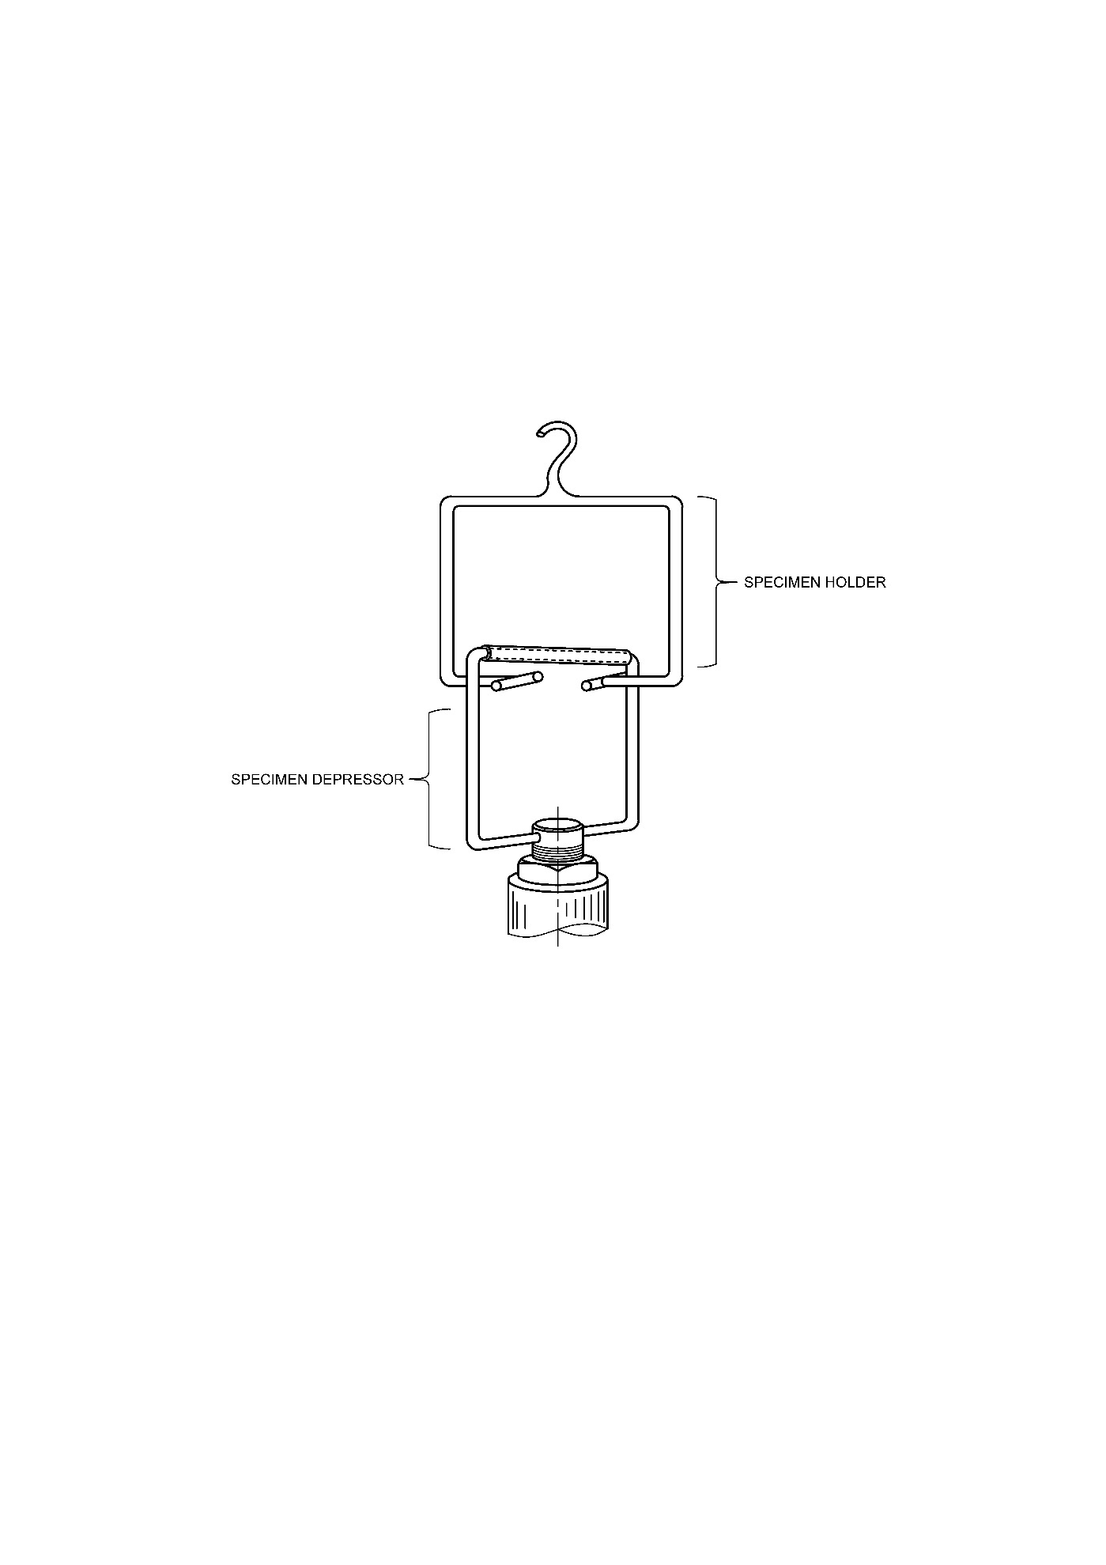

FIG 1 STIFFNESS OF FABRIC TESTING APPARATUS

**B-2 PREPARATION OF SPECIMEN FOR TESTING**

Cut a specimen from the fabric of 5 cm in length with 18 ends. Choose the specimen that exhibits the highest degree of straightness. Avoid preflexing the specimen before testing. Remove the four ends from each edge of each specimen, leaving ten warp ends and all the fillings in the sample.

**B-3 PROCEDURE**

**B-3.1** Mount the specimen holder and depressor in the Testing machine, calibrate, and set the tester at zero.

**B-3.2** Adjust the crosshead with the presser bar of the depressor approximately 6 mm above the opening in the specimen rack.

**B-3.3** Set the crosshead speed at 25 mm/min (1 inch/min). Set the load selector for the minimum scale force to accommodate the specimen and for the bending force to occur between 10 and 90 percent of the full-scale force, preferably at mid-scale.

**B-3.4** Place the specimen on the rack with the middle of the specimen at the midpoint of the rack and the longitudinal axis of the specimen parallel to the 25 mm (1 inch) opening.

**B-3.5** Start the tester to lower the crosshead and pull the presser bar onto the specimen and through the opening in the specimen rack.

**B-3.6** Record the maximum force required to pull the specimen through the opening to the nearest 1 mN (0.1 gf).

**B-4 CALCULATION**

Calculate the average stiffness result for the sample to the nearest 1 mN (0.1 gf).

**ANNEX C**

(*Foreword*)

**COMMITTEE COMPOSITION**

Technical Textiles for Mobiltech Applications Sectional Committee, TXD 38

|  |  |
| --- | --- |
| *Organization* | *Representative(s)* |
| Northern India Textile Research Association, Ghaziabad | Dr M S Parmar (***Chairperson***) |
| Arvind Limited, Ahmedabad | Ms. Mamtha Chaudhary  Shri Pabitra Sahoo (*Alternate*) |
| Autoliv India Ltd, Mysore | Shri Boobalan N  Shri Rahul Guglani (*Alternate*) |
| Automotive Research Association of India, Pune | Shri Khairatkar V Sarai |
| Autotech Nonwovens Private Limited, Surat | Shri Sanjeev Saxena  Shri Punit Sirohia (*Alternate*) |
| BMD Pvt Ltd, Banswara | Dr. Navdeep K Phogat |
| Century Enka Limited, Pune | Shri Veeresh M Hiremath  Shri Krishnagopal Ladsaria (*Alternate*) |
| Consumer VOICE, New Delhi | Shri M A U Khan  Shri B K Mukhopadhyay (*Alternate*) |
| Federation of Indian Chamber of Commerce & Industry, New Delhi | Shri Tushar Patel  Shri A R Rajesh (*Alternate*) |
| Garware Technical Fibres Limited, Pune | Shri Vignesh Kumar  Shri Aviraj Jadhav (*Alternate*) |
| ICAR- Central Institute for Research on Cotton Technology, Mumbai | Dr G Krishna Prasad  Dr A Arputharaj (*Alternate*) |
| Indian Technical Textile Association, Mumbai | Dr Anup Rakshit  Shri Ankit Desai (*Alternate*) |
| Kusumgar Corporates Pvt Ltd, Mumbai | Shri Siddharth Y Kusumgar  Dr M K Talukdar (*Alternate*) |
| Northern India Textile Research Association, Ghaziabad | Dr Neha Kapil |
| Office of the Textile Commissioner, Mumbai | Shri Humayun K |
| RFM Automotives, Binola, Haryana | Shri H K Dua  Shri Anurag Gupta (*Alternate*) |
| Sanrhea Technical Textiles Limited, Kalol, Gandhinagar, Gujrat | Shri Mahendra Singh Hada  Shri Bhavesh B Shah (*Alternate*) |
| S G S Limited, Gurugram | Shri Dr. Karthikeyan K.  Shri Dinesh Sivabalan (*Alternate*) |
| SRF Limited, Gurugram | Shri Bharat kumar  Shri Siva Kumar (*Alternate*) |
| Supreme Nonwoven, Mumbai | Shri Punit Gupta  Shri C K Jain (*Alternate*) |
| Testtex India Laboratories P Ltd, Mumbai | Smt. Meeta Shingala |
| Textiles Committee, New Delhi | Shri Kartikeya Dhanda  Shri Ravichandra (*Alternate*) |
| The Synthetic & Art Silk Mills Research Association, Mumbai | Shri Sanjay Saini  Shri Premnath Surwase (*Alternate*) |
| Uniproducts Pvt Ltd, Rewari, Haryana | Shri Vikas Yadav |
| BIS Directorate General | Shri J. K. Gupta, Scientist ‘E’/ Director and Head (Textiles) [Representing Director General (*Ex-officio*)] |

*Member Secretary*

Ms. SHIKHA YADAV

Scientist ‘B’/ Assistant Director

(Textiles), BIS