***भारतीय मानक***

***Indian Standard***

**TED 22 (23017) F**

**IS 12358: XXXX**

***ट्रैक्टर और ट्रेलर के बीच वैक्यूम और दबाव प्रणाली कनेक्शन के लिए***

***‘ संपर्क’ प्रकार की कपलिंग — विशिष्टि***

(*पहला पुनरीक्षण* )

**‘CONTACT’ TYPE COUPLING FOR VACUUM AND PRESSURE SYSTEMS CONNECTION BETWEEN TRACTOR AND TRAILER — SPECIFICATION**  (*First Revision*)

ICS 43.040.70

© BIS 2024

भारतीय मानक ब्यूरो

BUREAU OF INDIAN STANDARDS

मानक भवन, 9 बहादुर शाह ज़फर मार्ग, नई दिल्ली - 110002

MANAK BHAVAN, 9 BAHADUR SHAH ZAFAR MARG

NEW DELHI - 110002

[www.bis.gov.in](http://www.bis.org.in) [www.standardsbis.in](http://www.standardsbis.in)

**July 2024 Price Group**

Transport Tractors, Trailers and Industrial Trucks Sectional Committee, TED 22

**FOREWORD**

This Indian Standard (*First Revision*) was first published in 1988, after the draft finalized by the Transport Tractors, Trailers and Industrial Trucks Sectional Committee had been approved by the Transport Engineering Division Council.

In the preparation of this standard, assistance has been derived from BS AU 5: 1963 ‘specification for dimensions of a ‘contact’ type coupling for vacuum and pressure braking systems on trailers and semi-trailers’, issued by the British Standards Institution (BSI).

This first revision incorporates the experience gained with the use of this standard and brings the standard in line with the latest development in the field.

The composition of the Committee responsible for the formulation of this standard is given in Annex A.

For the purpose of deciding whether a particular requirement of this standard is complied with, the final value, observed or calculated, expressing the result of test or analysis, shall be rounded off in accordance with IS 2: 2022 ‘Rules for rounding off numerical values (*second revision*)’. The number of significant places retained in the rounded off value should be the same as that of the specified value in this standard.

*Indian Standard*

## ‘CONTACT’ TYPE COUPLING FOR VACUUM AND PRESSURE SYSTEMS CONNECTION BETWEEN TRACTOR AND TRAILER — SPECIFICATION

(*First Revision*)

## SCOPE

This standard specifies the form and dimensions of ‘contact’ type coupling for vacuum and pressure systems connection between tractor and trailer.

NOTE — Coupling for braking system shall be according to IS 9905.

## REFERENCES

The standard given below contain provisions which, through reference in this text, constitutes provision of this standard. At the time of publication, the edition indicated was valid. All standard are subject to revision, and parties to agreements based on this standard are encouraged to investigate the possibility of applying the most recent edition of the standard given below:

|  |  |
| --- | --- |
| *IS No.* | *Title* |
| IS 9905: 1981 | Specification for pneumatic coupling between tractors and trailers |

## DIMENSIONAL

* 1. The dimensions and general arrangements of ‘contact’ type coupling shall be as shown in Fig. 1, 2 and 3.

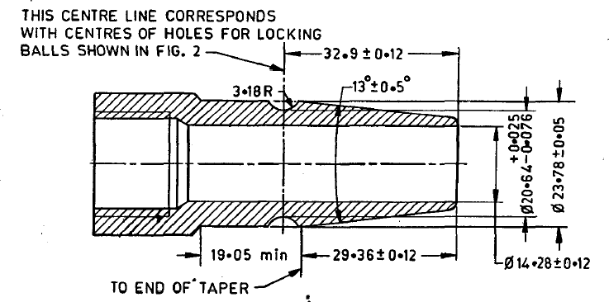

All dimensions in millimetres.

### Fig. 1 MALE MEMBER

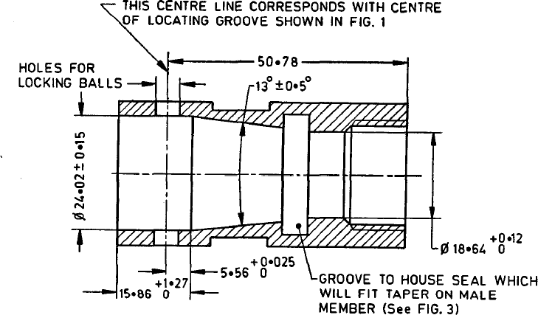

All dimensions in millimetres.

Fig. 2 FEMALE MEMBER

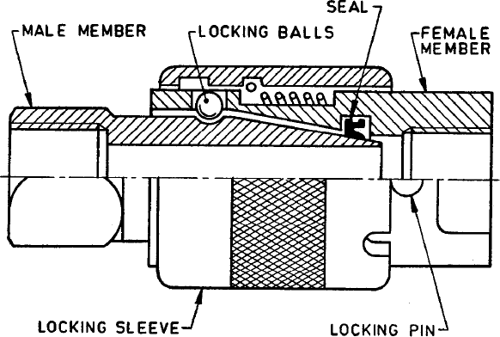

FIG. 3 HALF SECTIONED GENERAL ARRANGEMENT OF CONTACT COUPLING

## BIS Certification Marking

* 1. Each ‘Contact’ type coupling may also be marked with the Standard Mark.
  2. The use of the Standard Mark is governed by the provisions of the *Bureau of Indian Standards Act, 2016* and the Rules and Regulations made thereunder. The details of conditions under which the license for the use of the Standard Mark may be granted to manufacturers or producers may be obtained from the Bureau of Indian Standards.

## ANNEX A

*(Foreword)*

### COMMITTEE COMPOSITION

### Transport Tractors, Trailers and Industrial Trucks Sectional Committee, TED 22

|  |  |
| --- | --- |
| ***Organization*** | ***Representative(s)*** |
| Automotive Research Association of India, Pune | Shri A. Akbar Badusha(***Chairperson***) |
| Action Construction Equipment Limited, Palwal | Shri Chetan Gole  Shri Inderpal Singh Beniwal*(Alternate)* |
| All India Motor Transport Congress, New Delhi | Shri Naveen Gupta  Shri S K Mittal *(Alternate)* |
| Ashok Leyland Limited, Chennai | Shri Prasanna Venkatesh  Shri Faustino V *(Alternate)* |
| Automotive Component Manufactures Association of India, New Delhi | Shri Uday Harite  Shri Jitender Rana *(Alternate)* |
| Automotive Research Association of India, Pune | Shri P. D. Betgeri  Shri Tusharkumar R. Kamble*(Alternate)*  Shri V. P. Rawal *(Young Professional)* |
| BEML Limited, Banglore | Shri Ramesh Raju  Shri Sethu Madhavan*(Alternate)* |
| Black Diamond Motors Private. Limited, Bilaspur | Shri Jacob Thomas  Shri Tanmay Ganguly *(Alternate)* |
| Brakes India Limited, Chennai | Shri P venugopal  Shri G. Devendran*(Alternate)* |
| Central Institute of Road Transport, Pune | Shri S. N. Dhole  Shri S. N. Gutte*(Alternate)*  Shri S. R. Sonawane*(Young Professional)* |
| Directorate General Factory Advice Service and Labour Institutes, Mumbai | Shri N Varadharajan  Shri Karunesh Srivastava *(Alternate)* |
| Global Automotive Research Centre, Oragaram | Shri. A. S. Ramadhas  Shri V M Dhanasekkar (*Alternate*)  Shri Mohammed Suhail*(Young Professional)* |
| Godrej & Boyce Manufacturing Company Limited, Mumbai | Shri Vinay G. Kulkarni  Shri Anand Shankar Tawde*(Alternate)* |
| International Centre for Automotive Technology, Manesar | Shri Keshav Kumar Tripathi  Shri Gavendra Singh *(Alternate)*  Shri Shivam Tandon *(Young Professional)* |
| JCB India Limited, New Delhi | Shri Saurabh Dalela  Shri Alok Gandhi *(Alternate)* |
| Josts Engineering Company Limited, Thane | Shri Pramod M. Pophale  Shri Santosh Saraf *(Alternate)* |
| KION India Private Limited, Pune | Shri Sunil K Gupta  Shri Rizwan Khan *(Alternate)* |
| Knorr-Bremse Systems for Commercial Vehicles India Private Limited, Pune | Shri Arun Bisht  Shri Atul Ingole *(Alternate)* |
| Machine and Mill Stores Corporation Private Limited, Howrah | Shri Dipak Ghosh |
| Mahindra Trucks and Bus Division, Pune | Shri Nagaraju K  Shri V G Kulkarni *(Alternate)* |
| Department of Heavy Industry, New Delhi, Ministry of Heavy Industries and Public Enterprises, | Shri B K Mishra  shri R K Jaiswal *(Alternate)* |
| Ministry of Labour and Employment Directorate, Mumbai | Dr R. N. Meena  Shri K. Durai *(Alternate)* |
| Ministry of Road Transport and Highways, New Delhi | Ms. Dharkat R Luikang |
| National Automotive Test Tracks, Dhar | Shri Sagar Bendre  Shri J K Chakrabarty *(Alternate)* |
| SDR Auto Private Limited, Chennai | Shri B. Ramesh  Shri Praveen Kumar *(Alternate)* |
| Satrac Engineering Private Limited, Bangalore | Shri Santhana Krishnan S  Shri Nithin Kumar *(Alternate)*  Shri Anjan Srivastava *(Young Professional)* |
| Tata International Vehicle Applications Private Limited, Pune | Shri Parikshit Abhimanyu Bhaskar  Shri Krishna Prasad *(Alternate)* |
| Tata Motors Limited, Pune | Shri Rahul Mohanrao Pathak  Shri Sunil Agarwal *(Alternate)*  Shri M Harrish*(Young Professional)* |
| Transport Engineering Solutions India Private Limited, Pune | Shri Manoj Varghese  Shri Anand Singh *(Alternate)* |
| Volvo Trucks, VE Commercial Vehicles Limited, Bengaluru | Shri Challapalli Nithin Roy  Shri Gedela Chaitanya *(Alternate)* |
| ZF Commercial Vehicle Control Systems India Limited, Pune | Shri S Balachandran  Shri Kuldeep Singh *(Alternate)* |
| BIS Directorate General | Shri Deepak Aggarwal, Scientist ‘F’/ director and head (transport engineering) [representing director general (ex-officio)] |

Member Secretary

Shri Mitra Sen Verma

Scientist ‘D’ / Joint Director

(transport engineering), BIS